DUAL-CORE OPTICAL MOTION TESTBED
FIRMWARE, HOST SOFTWARE & RESULTS
STM32H747 MotionIPC, live GUI, telemetry, reliability, and characterization
Customer-facing technical report
Revision 5.3 - 6 August 2026
FIRMWARE, HOST SOFTWARE & RESULTS
STM32H747 dual-core motion control, live telemetry, automated test execution, and measured characterization
ENGINEERING REQUIREMENTS DOCUMENT | REVISION 5.3 | 6 AUGUST 2026
Prepared by | Herder Elektronische Systemen
Document scope | Dual-core firmware, IPC, host GUI, telemetry integrity, safeguards, and measured motion performance
Evidence basis | MotionIPC source, target firmware, GUI recordings, plots, logs, test scripts, and engineering reviews
Distribution | Customer-facing; controlled source excerpts and engineering evidence
DOCUMENT PURPOSE
Defines the controlled functional, performance, interface, safety, verification, and acceptance requirements for the dual-core target firmware and host-side test system. Mechanical construction and PCB manufacturing details are referenced to the companion platform document.

Requirements Basis
Requirements Definition and Verification
Requirements are uniquely identified and paired with rationale, interfaces, constraints, verification methods, and acceptance evidence. Demonstrated prototype performance is distinguished from unverified, unrated, or future production capability.

Purpose, Scope, and System Boundary
This FRD governs the dual-core target firmware, interprocessor communication, host application, telemetry, automated test execution, data retention, safeguards, and measured motion-performance reporting. The mechanical structure and interface PCB are external interfaces documented in the companion platform FRD.
Boundary element | Included in this FRD | Excluded / referenced
Target firmware | M7/M4 workload allocation, motion sequencing, timing, IPC, heartbeat, fault state | Mechanical fabrication and PCB manufacturing details
Host software | Connection control, commands, live plots, test automation, CSV and metadata | General-purpose IT infrastructure and cloud services
Verification | Low-speed tracking, constant-speed, step response, sine-response, integrity counters | Formal environmental, EMC, safety, or optical-system certification

Users and Operational Scenarios
Actor | Primary interaction | Expected outcome
Operator | Connect, configure, command, monitor, stop, and save a test | Controlled motion with visible state and retained evidence
Firmware developer | Build, deploy, inspect IPC and timing behavior | Traceable target revision and diagnosable inter-core operation
Test engineer | Select scripted characterization and review outputs | Repeatable datasets suitable for comparison and analysis
Reviewer/customer | Read requirements, figures, limits, and verification results | Clear distinction between demonstrated capability and open release actions

Functional Requirements
ID | The system shall... | Rationale / explanation | Verification
FW-FR-001 | separate pulse-critical motion control from variable-latency communication and telemetry workloads while retaining the finest tested microstep setting. | At 256 microsteps, required STEP frequency reaches tens of kilohertz as table speed increases. Workload separation protects pulse regularity and control timing. | Architecture review; pulse-rate calculation; high-speed timing test
FW-FR-002 | publish motion records with sequence and integrity information through shared memory. | Sequence, overflow, and heartbeat fields make loss or stalling observable. | Memory-map review; counter observation
FW-FR-003 | accept operator motion commands and expose commanded and measured state in the host GUI. | The operator needs direct confirmation that target behavior follows the requested profile. | GUI demonstration; captured telemetry plots
FW-FR-004 | execute repeatable low-speed, constant-speed, step, and sine-response tests. | Scripted tests reduce operator variation and preserve comparable datasets. | Test selection and completed result files
FW-FR-005 | record CSV telemetry and run metadata sufficient to reproduce the analysis context. | Plots must remain traceable to commands, timestamps, configuration, and source data. | CSV/header inspection; metadata review
FW-FR-006 | limit pulse generation and bound catch-up behavior. | A delayed software loop must not produce an uncontrolled pulse burst. | Source inspection; stress test
FW-FR-007 | detect missing host presence and expose target heartbeat, fault, sequence-gap, and drop state. | Communication silence must be distinguishable from normal idle operation. | Fault-injection and disconnect test
FW-FR-008 | preserve a safe stop path independent of normal scripted completion. | The operator must be able to terminate motion when a test or communication path behaves unexpectedly. | Stop-command and deadman test

Performance and Quality Requirements
ID | Requirement | Acceptance basis
FW-NFR-001 | The reviewed release shall enforce its declared STEP-rate ceiling and document the higher-rate target needed to reach the full 15 deg/s objective at 256 microsteps. | Source constant, pulse-rate calculation, and logic-analyzer timing evidence.
FW-NFR-002 | STEP high time shall be at least 4 microseconds. | Logic trace or source review confirms the minimum.
FW-NFR-003 | Host-presence timeout shall stop or inhibit continued commanded operation after 2 seconds without heartbeat. | Disconnect test produces the defined safe response.
FW-NFR-004 | Telemetry-rate selections shall be explicit and the sustainable serial rate shall not be overstated. | 10/20/50/100 Hz options are visible; report distinguishes configured from demonstrated throughput.
FW-NFR-005 | Shared-memory records shall maintain cache-safe alignment and bounded service behavior. | 64-byte alignment and 128-record service bound confirmed in source.
FW-NFR-006 | Reported performance shall identify test conditions, limits, and unsupported claims. | Result sections state the demonstrated range and avoid unsupported bandwidth or certification claims.

External Interface Requirements
Interface | Required behavior | Failure / boundary condition
STEP/DIR output | Generate direction state and bounded step pulses for the motor driver. | Rate cap, minimum high time, and safe stop remain enforced.
Differential encoder input | Receive conditioned encoder position/count information from the interface PCB. | Missing or implausible motion shall be visible in measured-state telemetry.
Host serial link | Transport commands, status, telemetry, and heartbeat. | Loss of heartbeat invokes the defined timeout behavior.
OpenAMP/RPMsg | Carry low-rate command and status messages between cores. | Endpoint or message failure is reported rather than silently ignored.
AXI-SRAM ring | Carry aligned high-rate records with producer/consumer accounting. | Overflow, dropped records, and sequence gaps remain observable.

1. System Role and Delivered Capability
The system combines a dual-core STM32H747 target with a host application that commands motion, displays live encoder and speed telemetry, executes repeatable tests, and writes analysis-ready records. The public evidence package separates control-plane messaging from high-rate motion-data movement and preserves the distinction between demonstrated behavior and recommended release actions.
- Cortex-M7 and Cortex-M4 workloads connected through OpenAMP/RPMsg and a custom AXI-SRAM shared ring.
- Live host console for connection, scripted test selection, telemetry plots, CSV logging, and metadata capture.
- Measured low-speed tracking, constant-speed error, step response, and closed-loop frequency-response evidence.
- Fault, heartbeat, sequence-gap, dropped-record, and ring-status observability.
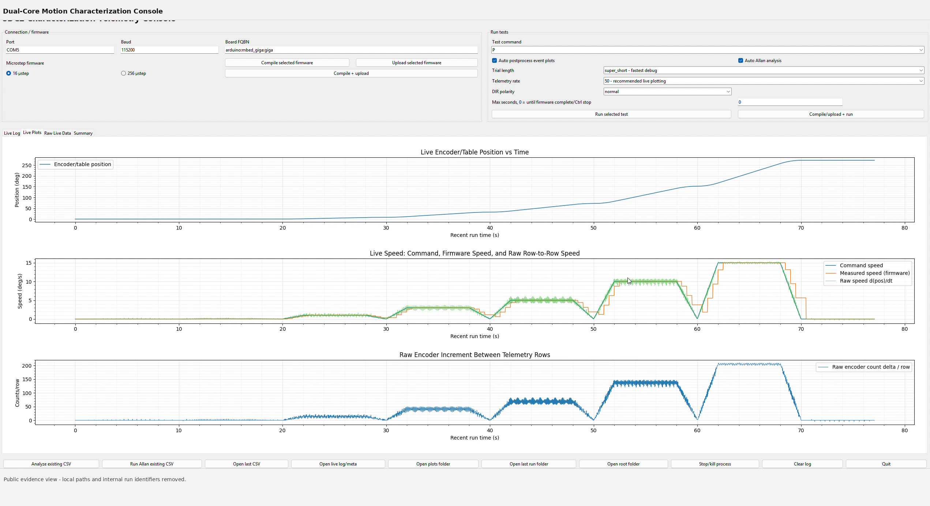
Figure 1. Live host telemetry console during an automated characterization sequence.

2. Dual-Core Firmware Architecture
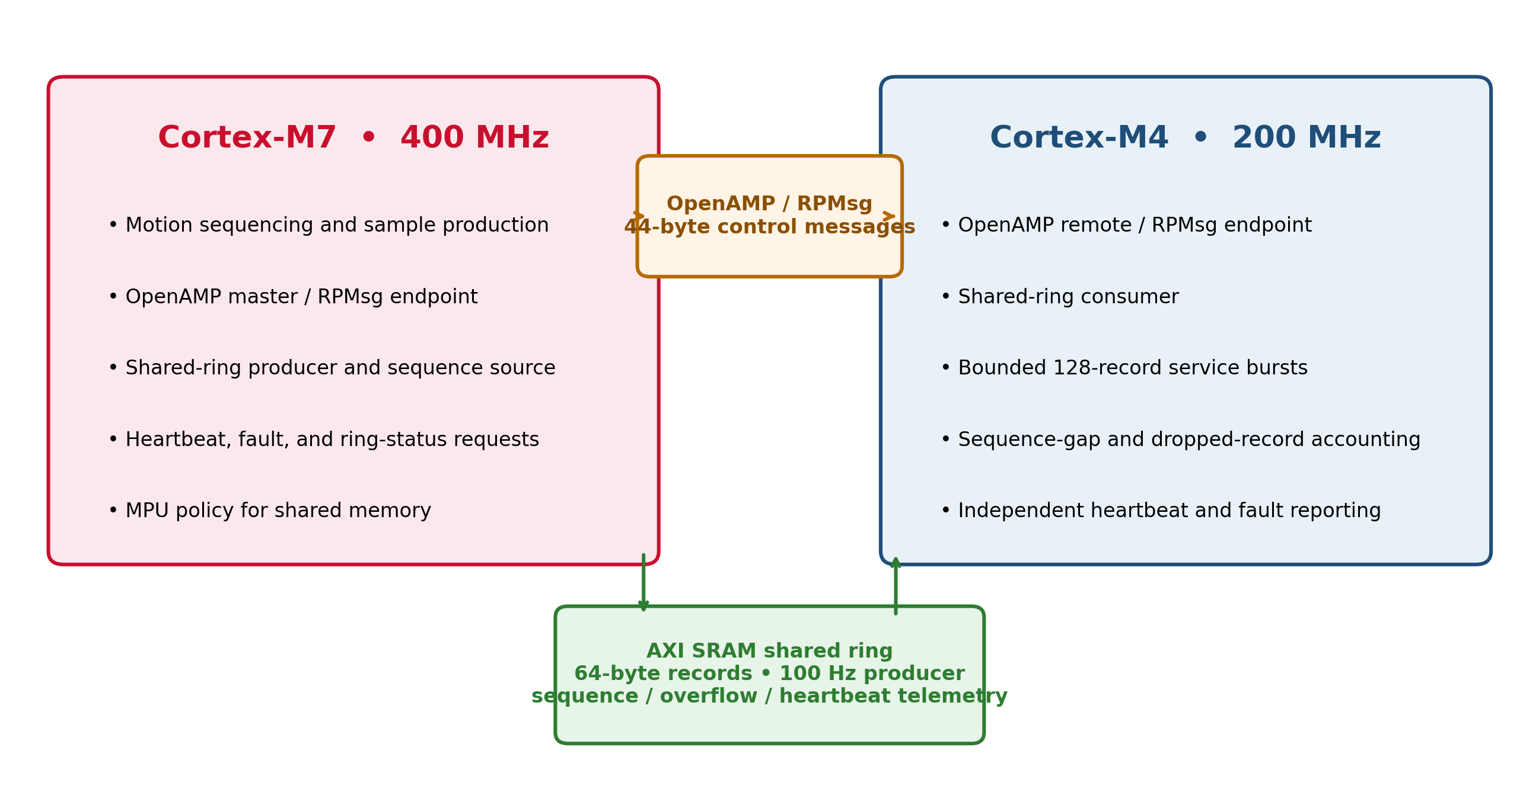

2.1 Architecture Trade-Off Decision
The dual-core architecture was selected to preserve smooth motion at higher table speeds while retaining the finest tested microstep setting. The design objective was not to accommodate the reviewed 100 Hz, 6.4 kB/s telemetry stream; that workload is trivial for a 400 MHz Cortex-M7. The limiting concern was the STEP pulse frequency required when the driver is configured for the smallest angular increment (256 microsteps per full step).
At 200 full steps per motor revolution, 256 microsteps per full step, and a 24.65:1 gearbox, the drivetrain requires 1,262,080 STEP pulses per table revolution, or approximately 3,505.78 pulses per output degree. Pulse demand therefore rises directly with commanded table speed. At 15 deg/s, the required rate is approximately 52.6 kHz. Moving host communication, telemetry handling, and other variable-latency work to the second core protects the motion-control execution budget and reduces pulse-spacing jitter, missed scheduling opportunities, and speed ripple.
Commanded table speed | Required STEP frequency at 256 microsteps | Decision significance
0.1 deg/s | 350.6 Hz | Low pulse demand; either architecture is adequate.
1 deg/s | 3.51 kHz | Still modest, but pulse regularity begins to matter for smoothness.
5 deg/s | 17.53 kHz | Variable-latency communications and formatting should not share the pulse-critical path.
7.13 deg/s | approximately 25 kHz | Matches the reviewed software safety ceiling.
15 deg/s | approximately 52.6 kHz | Target capability requires a higher pulse-rate implementation while preserving fine microstepping.
OpenAMP/RPMsg and the AXI-SRAM ring are supporting mechanisms for that workload split. They provide command/status exchange and continuous record transfer after the control and host-facing responsibilities are separated. They are not presented as necessary for 100 Hz telemetry, and the present 100 Hz MotionIPC sample should be treated as an architectural validation workload rather than the performance justification for using both cores.
Figure 2. Dual-core architecture with physically separated control-message and shared-ring paths.
Interface | Verified role | Representative parameter
OpenAMP / RPMsg | Low-rate command and status coordination | 44-byte application message
AXI-SRAM ring | High-rate aligned motion records | 64-byte records; 4,095 entries; 64-byte metadata; exact 256 KiB fit guarded at compile time
M7 producer | Motion sequencing and sample publication | 100 Hz sample production in the reviewed package
M4 consumer | Bounded service and accounting | Up to 128 records per service burst

3. Shared Memory, Timing, and Integrity
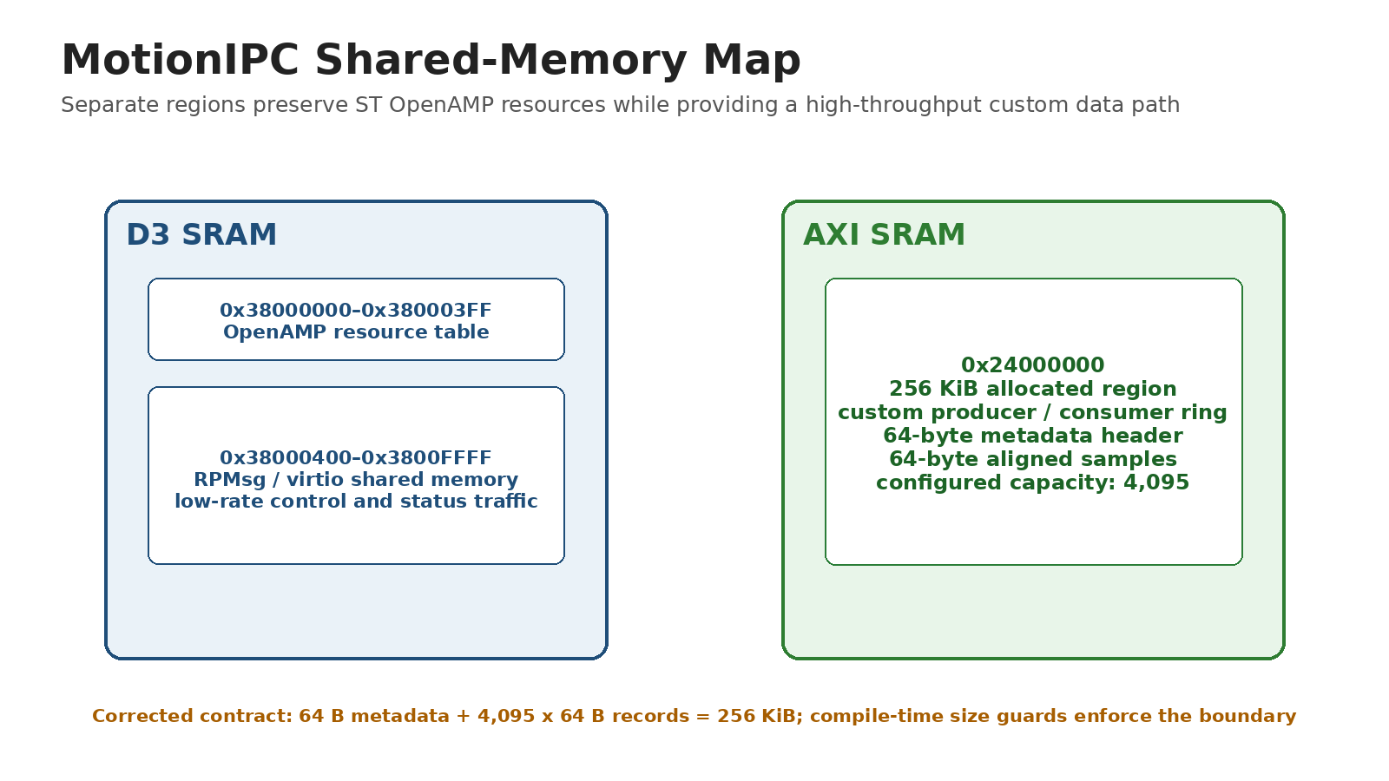
Figure 3. MotionIPC shared-memory allocation after the 4,095-record boundary correction and compile-time layout guard.
- OpenAMP resources occupy D3 SRAM while the custom producer/consumer ring is allocated in AXI SRAM. The public layout now consumes the 256 KiB reservation exactly: one 64-byte metadata block plus 4,095 aligned 64-byte records.
- Records are aligned to cache-line boundaries and include sequence, overflow, and heartbeat information.
- The corrected public ring definition uses 4,095 records. A 64-byte metadata block plus 4,095 aligned 64-byte samples equals exactly 256 KiB, and compile-time assertions reject any layout that exceeds the reserved AXI-SRAM region.
- The target reports independent heartbeat and fault state so host-side silence is distinguishable from target-side failure.

4. Host Application and Test Workflow
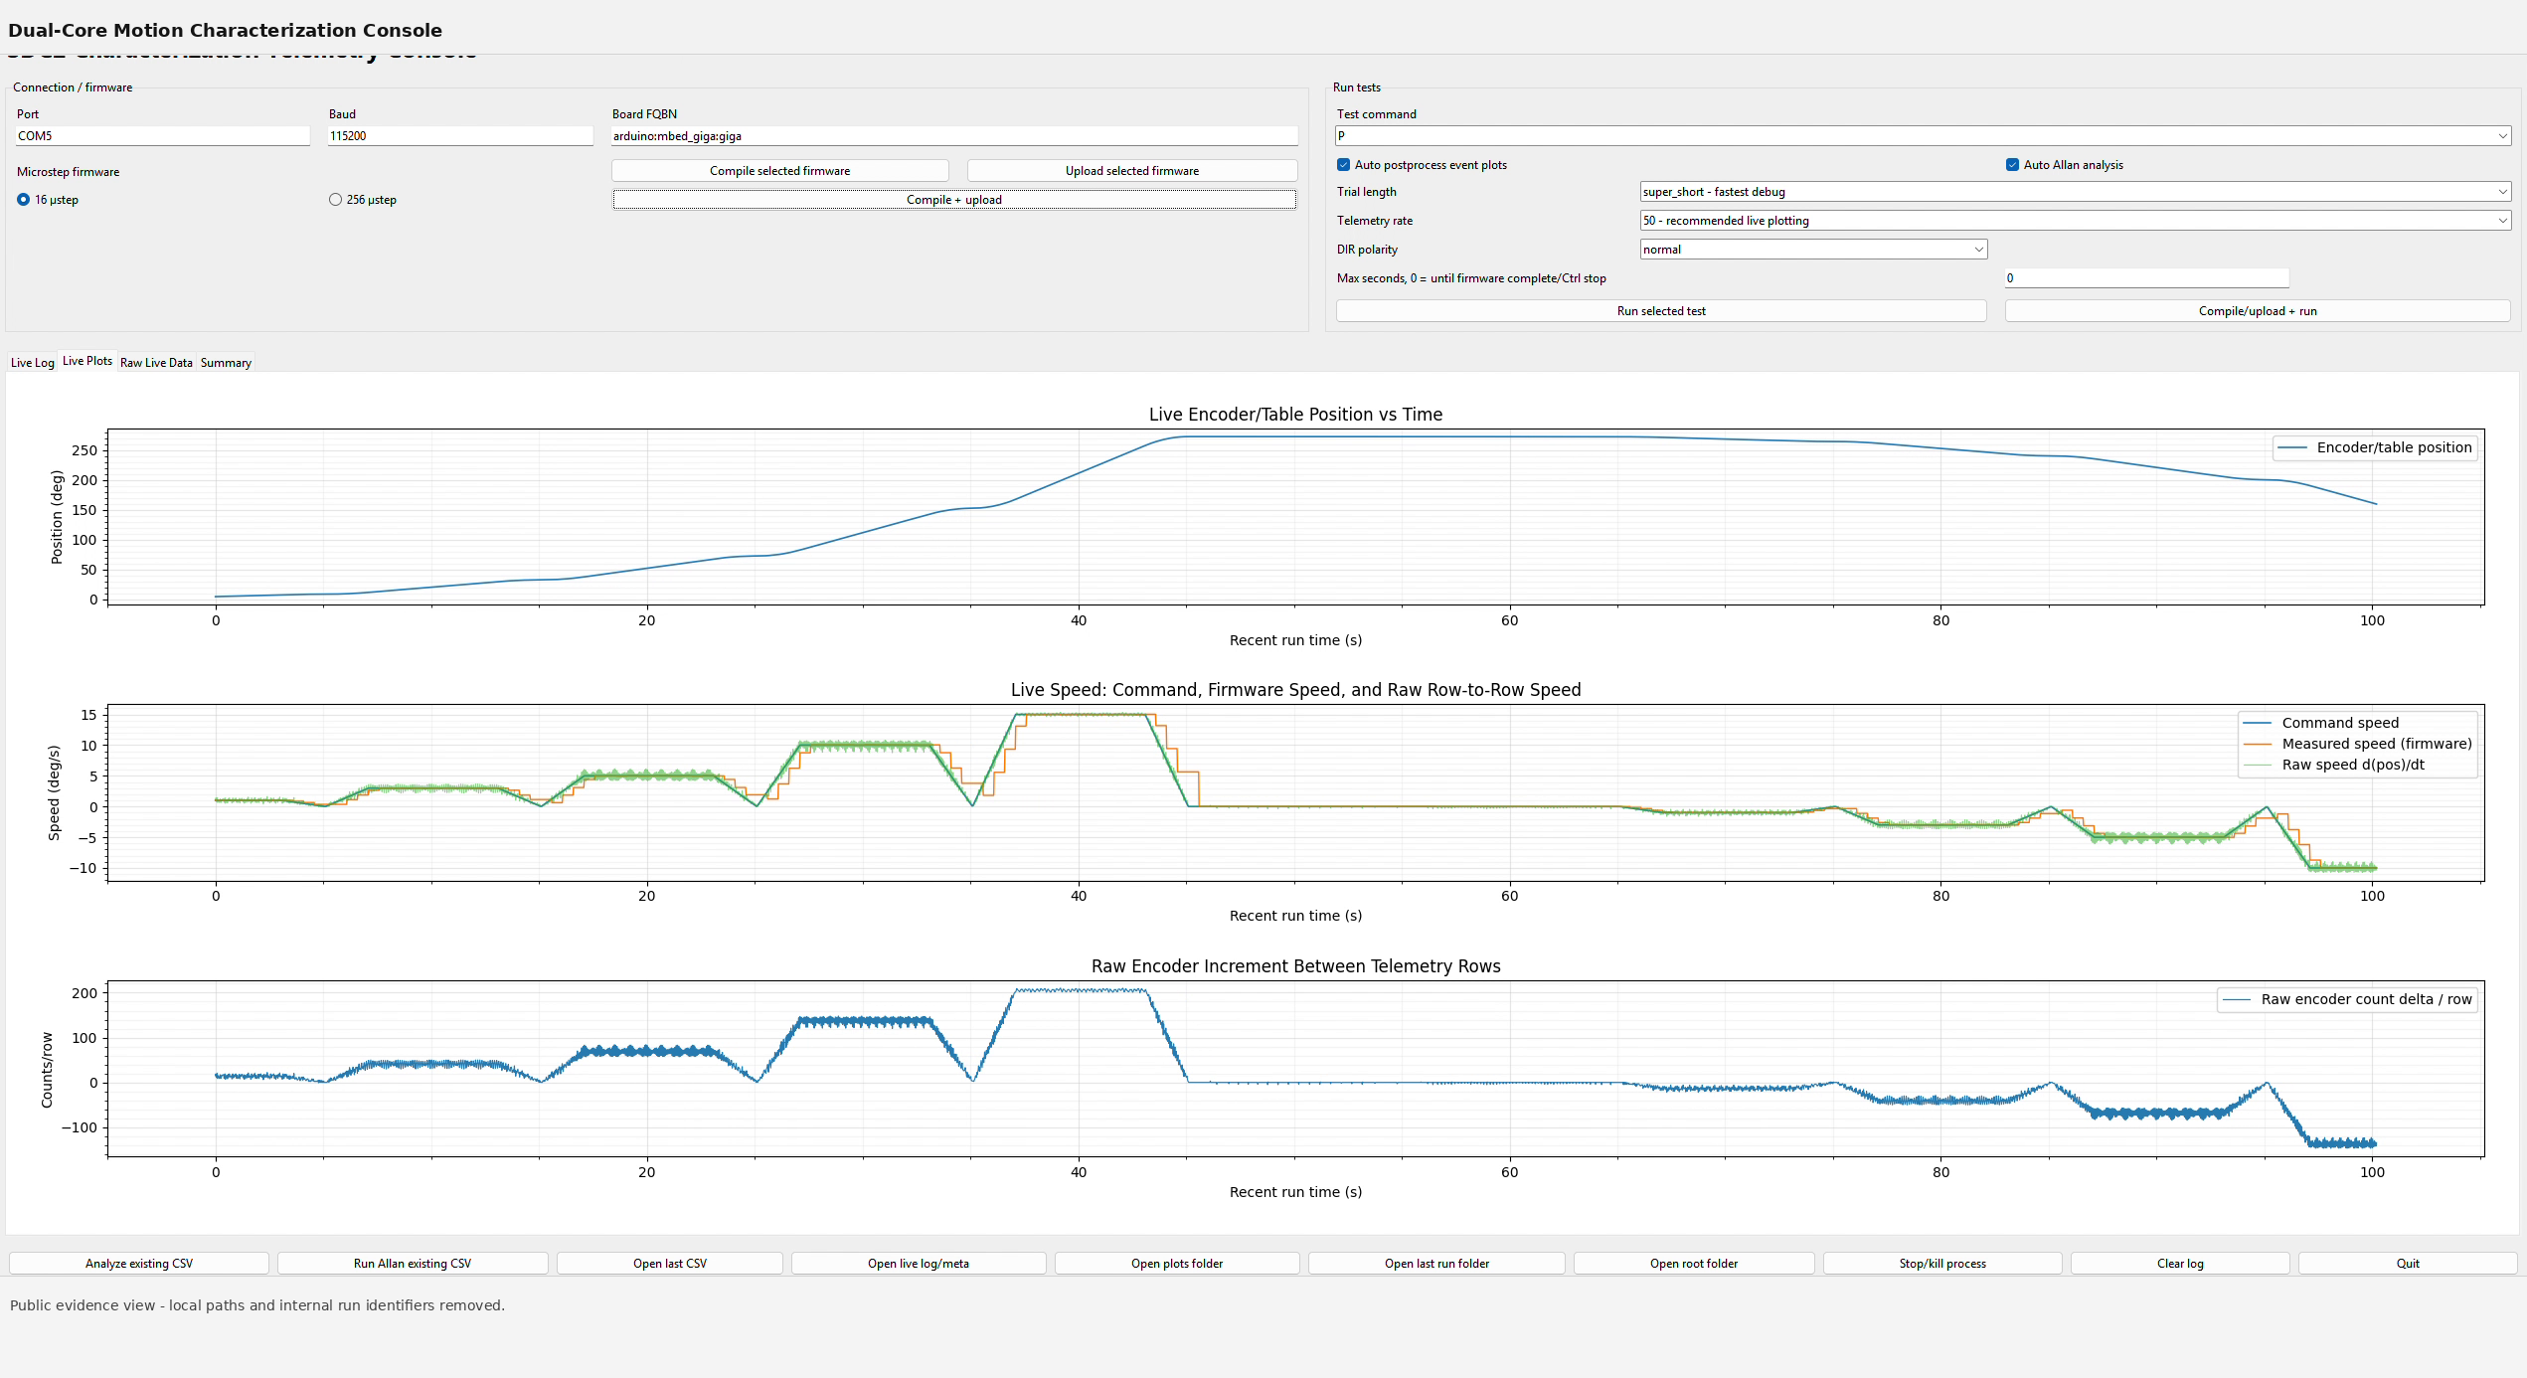
Figure 4. Host console view showing live position, commanded/measured speed, and raw encoder increments.
Workflow stage | Operator action | Recorded output
Connect | Select serial port and baud rate | Target identity and connection state
Configure | Select firmware and test definition | Run metadata and configuration
Execute | Start automated sequence | Live plots and telemetry rows
Review | Open generated outputs | CSV, figures, logs, and summary metrics

5. Low-Speed Tracking Results
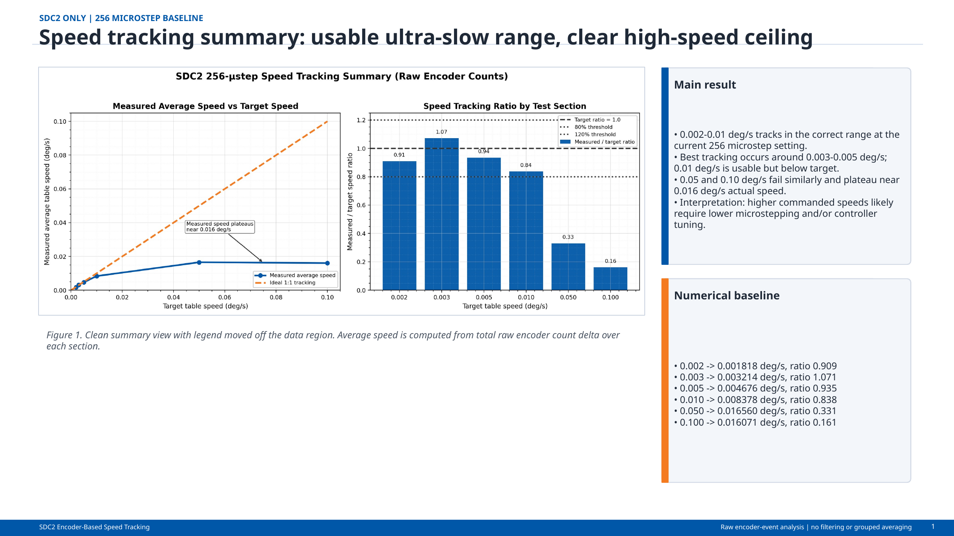
Figure 5. Speed-tracking summary showing the usable ultra-slow range and high-speed ceiling.
Commanded speed (deg/s) | Measured speed (deg/s) | Interpretation
0.002 | 0.001818 | Trackable near the lower practical limit
0.003 | 0.003214 | Best agreement region
0.005 | 0.004676 | Strong low-speed tracking
0.010 | 0.008378 | Usable with increasing bias
0.050-0.100 | ~0.016 plateau | Configuration-limited ceiling

6. Constant-Speed and Step-Response Characterization
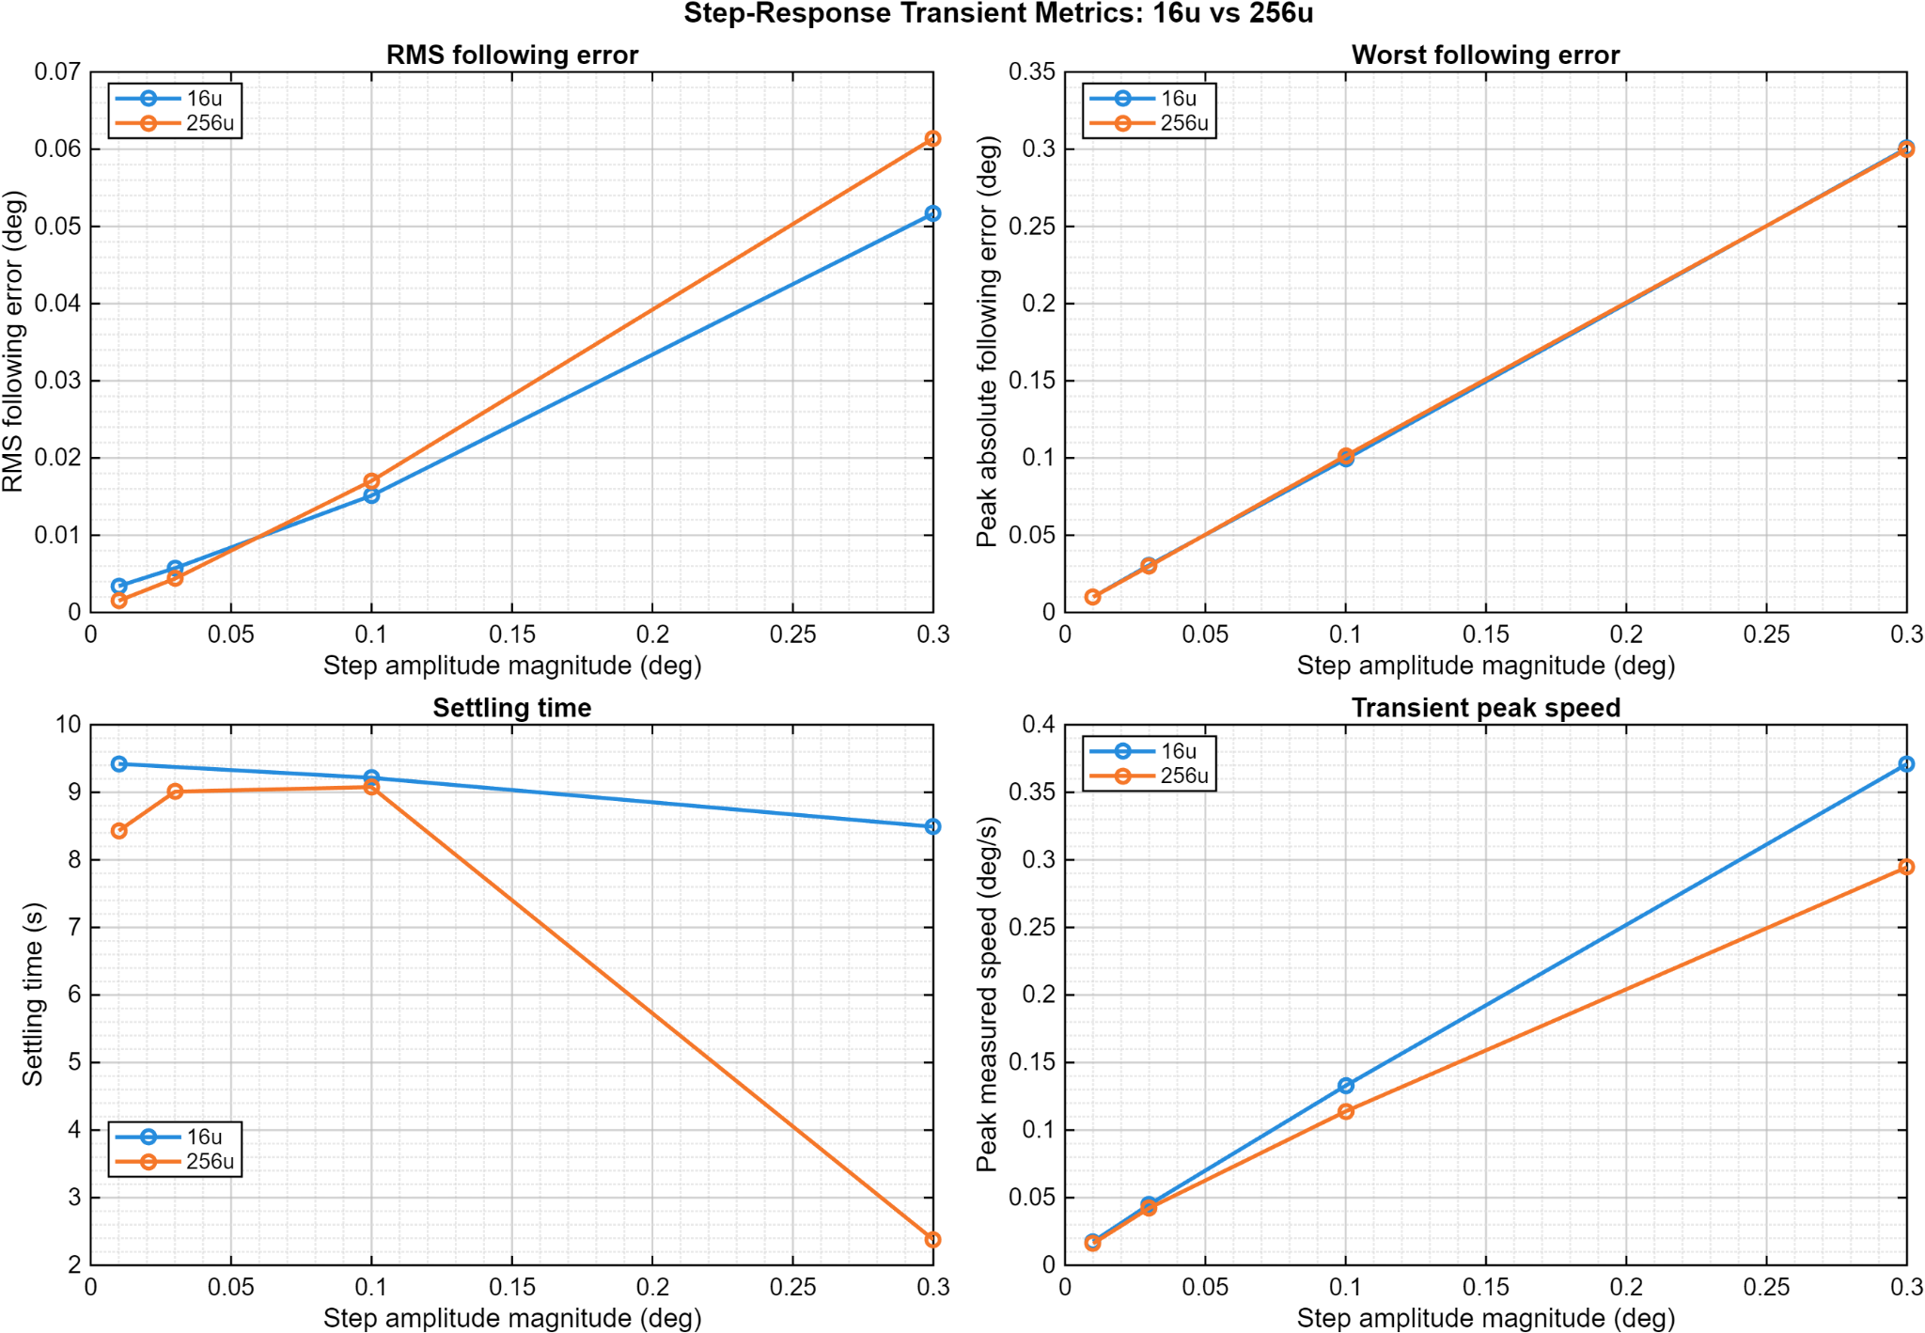
Figure 6. Extended constant-speed tracking and Allan-style stability summary.
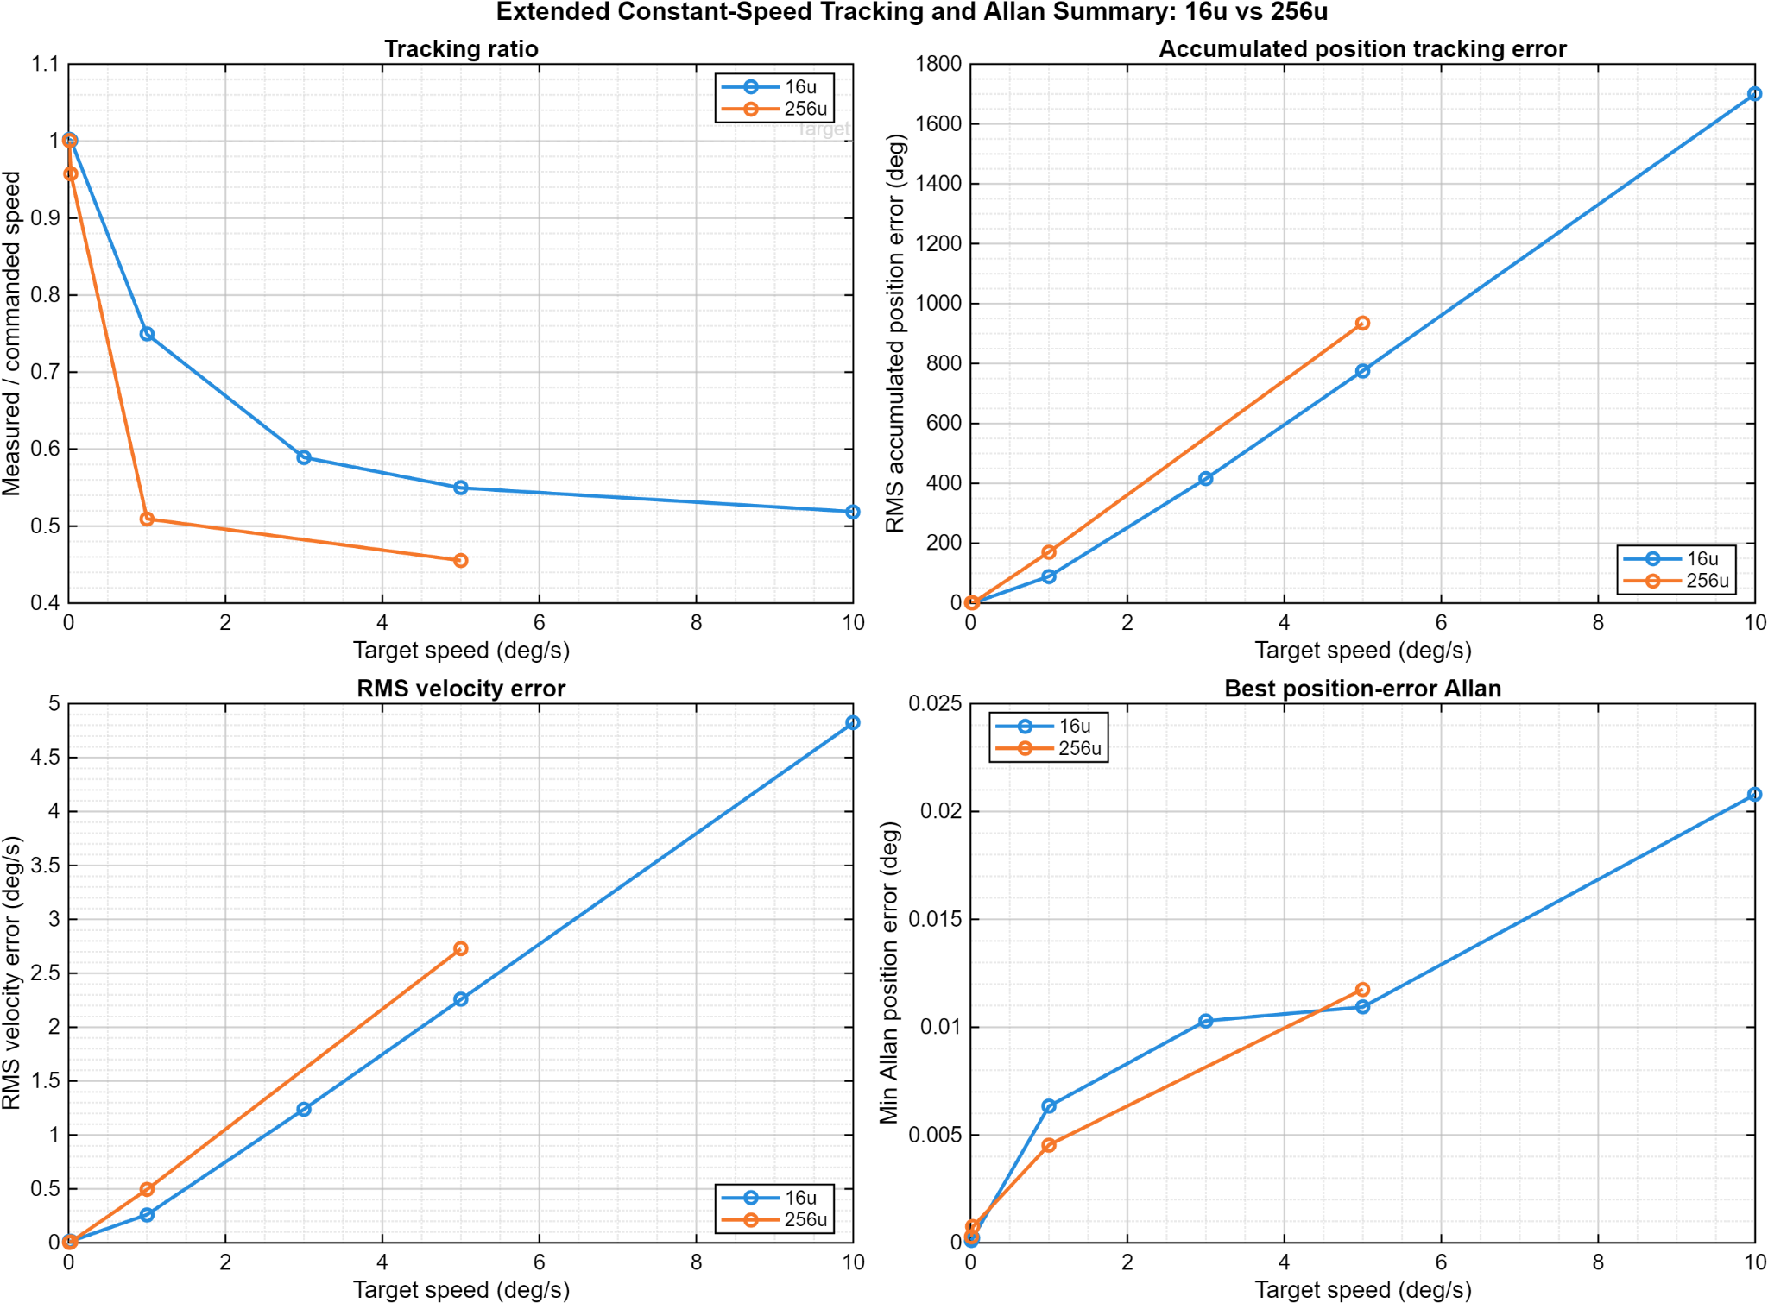
Figure 7. Step-response metrics for RMS following error, worst following error, gain, and position-area measures.

7. Closed-Loop Frequency Response
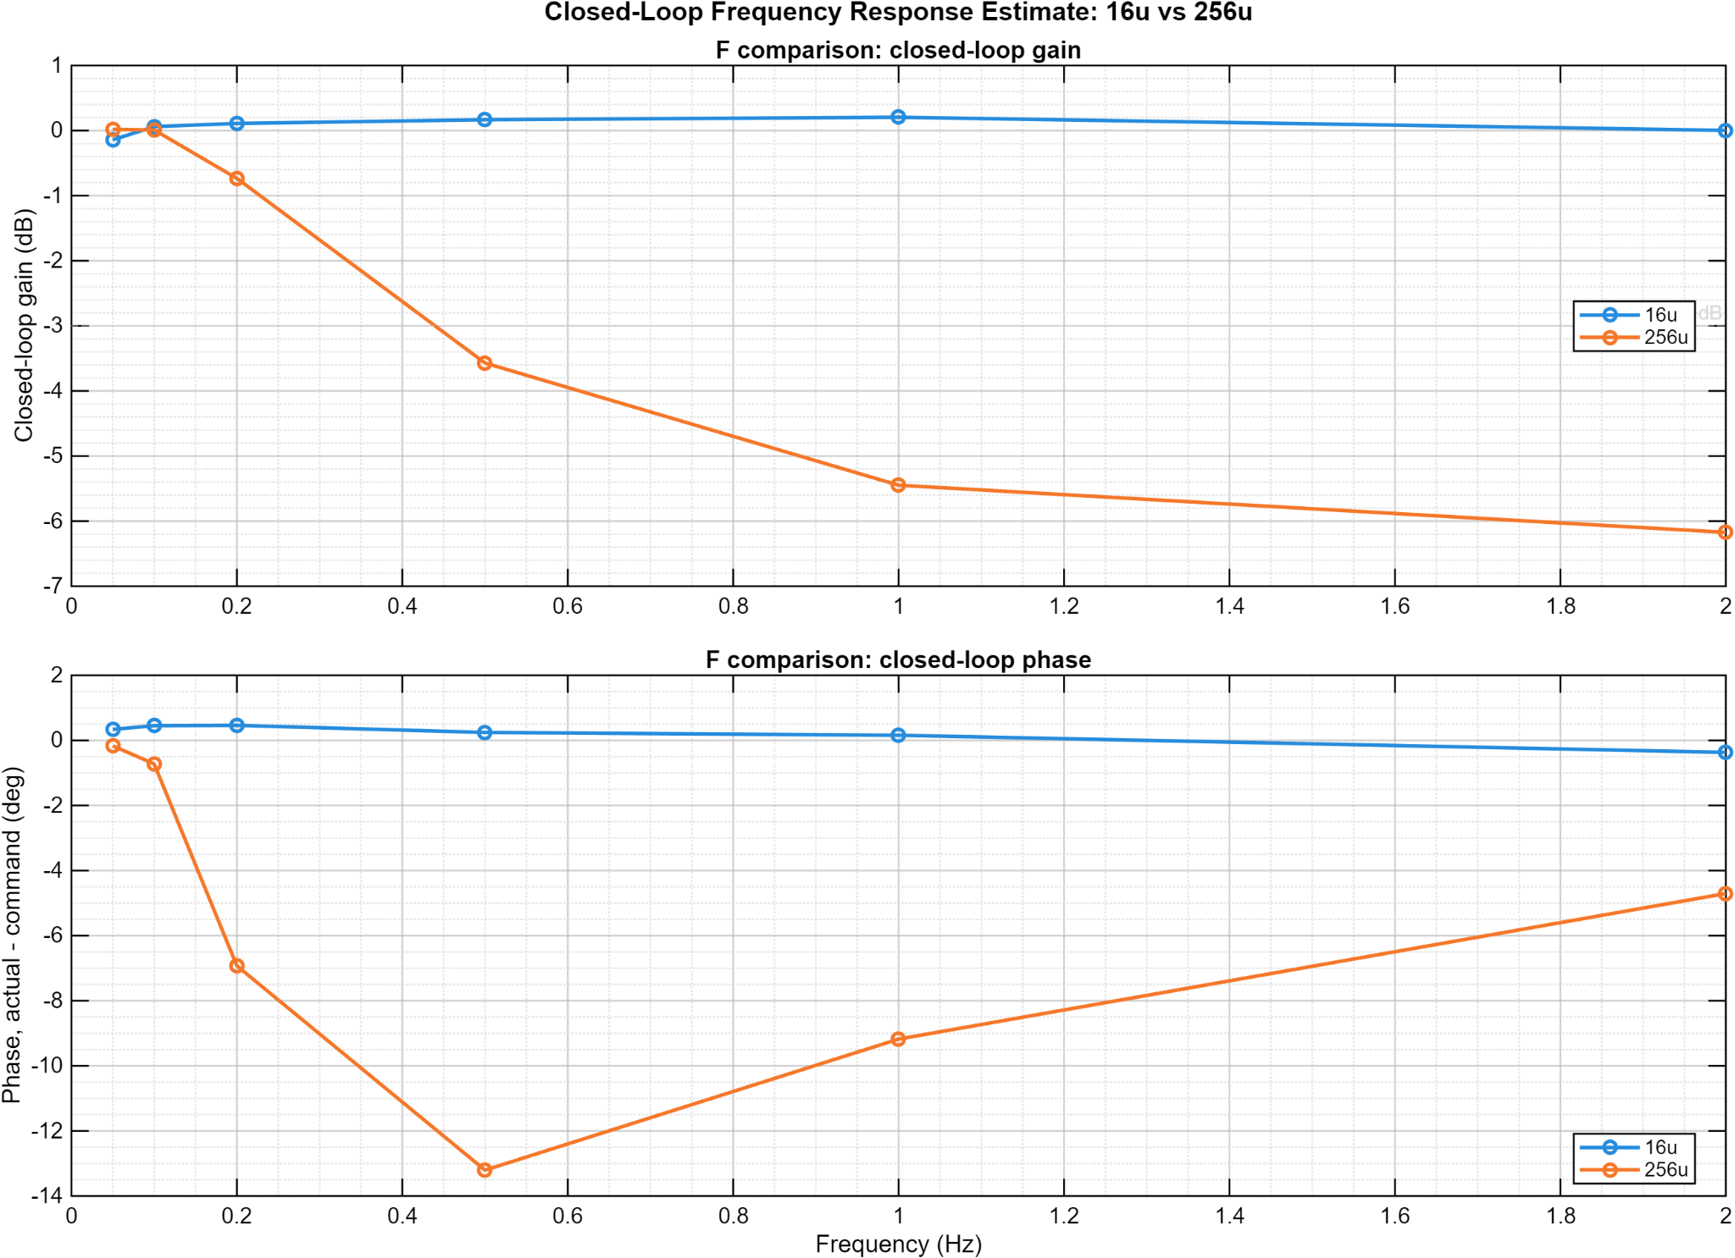
Figure 8. Closed-loop response estimate across the tested 0.33-2 Hz range.
The available evidence supports reporting response across the tested frequencies. It does not, by itself, establish a formal -3 dB bandwidth because the plotted data do not demonstrate a complete crossing with sufficient surrounding points.

8. Detailed Firmware and Host Design
The following parameters define the implemented timing model, inter-core transport, motion conversion, serial limits, safety behavior, and measured operating envelope. The primary architectural driver is the need to sustain higher STEP frequencies at the finest tested microstep setting without allowing host communication or telemetry work to disturb pulse timing.
Subsystem | Implemented detail | Engineering significance
Processor split | STM32H747 Cortex-M7 at 400 MHz and Cortex-M4 at 200 MHz, with pulse-critical control isolated from host-facing and telemetry service work. | Preserves timing margin and pulse spacing at the finest microstep setting as commanded speed and required STEP frequency increase.
Control messaging | OpenAMP/RPMsg; 44-byte application message with eight 32-bit payload words | Low-rate commands and status remain distinct from high-rate motion records.
High-rate path | AXI-SRAM producer/consumer ring at 0x24000000; 64-byte records aligned to 32-byte cache lines | Supports deterministic bulk transfer with sequence and overflow observability.
Resource table | OpenAMP shared resources in D3 SRAM beginning at 0x38000400 | Keeps RPMsg resources separate from the custom motion-data ring.
Service behavior | M4 consumes bounded bursts of up to 128 records per pass | Prevents unbounded ring service from starving other work.
Health reporting | Independent heartbeats, fault state, sequence-gap, dropped-record, and ring-status counters | Allows the host to distinguish silence, backlog, overflow, and target faults.
8.1 Motion Timing and Safety Parameters
Parameter | Value | Notes
Serial link | 115,200 baud | Full 24-field ASCII rows make 100 Hz a configured option, not a guaranteed sustained rate.
Telemetry selections | 10, 20, 50, or 100 Hz; clamped 1-100 Hz | Practical sustained rate depends on row length and host/target overhead.
STEP pulse high time | 4 microseconds | Explicit pulse-width control for the stepper driver interface.
Maximum step rate | 25,000 pulses/s | Hard safety ceiling; equivalent to approximately 7.13 deg/s with the documented drivetrain.
Backlog limit | 25 pulses emitted per loop | Bounds catch-up behavior after temporary host or loop delay.
Overrun warning | 25 ms | Flags excessive loop latency.
Host heartbeat | 500 ms | Periodic host liveness message.
Target deadman | 2 s | Stops or faults commanded operation when host supervision is lost.
Speed estimate window | 500 ms | Reduces encoder quantization noise in ultra-low-speed operation.
8.2 Drivetrain and Encoder Conversion
8.3 Public Memory, Protocol, and Timebase Contracts
Public contract definitions and verification evidence:
AXI-SRAM ring boundary | 64-byte metadata + 4,095 x 64-byte samples = 262,144 bytes (256 KiB). | Static assertions check sample size, metadata offset, and total MotionSharedRing size.
IPC version field | MOTION_IPC_VERSION is 1U and is stored directly in the published uint16_t version field. | Compile-time test asserts the version fits UINT16_MAX and the message remains 44 bytes.
32-bit microsecond timebase | t_us is a uint32_t and wraps modulo 2^32 after about 71.6 minutes. | Host-side unwrapping uses modulo subtraction; the published test crosses UINT32_MAX and verifies monotonic reconstructed time.
Cache-coherency evidence boundary | Public headers define alignment and memory placement. Complete MPU setup, ordering barriers, cache policy, and producer/consumer publication logic remain in the controlled private implementation. | Public claims are limited to the exposed layout contract; full coherency behavior requires review of the private implementation.
These corrections address the public review boundary directly: the ring can no longer silently outgrow its reservation, the protocol version has one unambiguous wire representation, and long-run timestamp behavior has an executable wrap test. The complete cache/MPU and producer/consumer implementation remains private and is therefore not represented as independently validated by the public excerpts.
Quantity | Calculation / value | Interpretation
Motor steps | 200 full steps/rev x 256 microsteps | 51,200 pulses per motor revolution.
Gear ratio | 24.65:1 | Produces 1,262,080 pulses per table revolution.
Command resolution | 3,505.78 pulses/degree | Approximately 0.000285 degree per command pulse.
Encoder decoding | 5,000 CPR, A-channel CHANGE x2 | 10,000 motor-shaft counts/rev.
Table encoder scale | 246,500 counts/rev | 684.72 counts/degree, approximately 0.001460 degree/count.
Correction gain | 20 pulse-Hz/degree | Closed-loop correction term applied to feedforward command.
Correction limits | 250 Hz absolute and 5% of feedforward relative | Prevents the correction term from dominating commanded motion.
8.4 Measured Operating Results
Commanded speed | Measured speed | Observation
0.002 deg/s | 0.001818 deg/s | Lower edge of demonstrated ultra-slow tracking.
0.003 deg/s | 0.003214 deg/s | Best tracking region begins.
0.005 deg/s | 0.004676 deg/s | Strong agreement in the preferred low-speed range.
0.010 deg/s | 0.008378 deg/s | Tracking remains usable but error grows.
0.050-0.100 deg/s | approximately 0.016 deg/s plateau | Observed ceiling in the tested 256-microstep configuration.
Sine tests | 0.33, 0.5, 1, and 2 Hz | Supports response reporting over the tested range, not a formal -3 dB bandwidth claim.
8.5 Host Workflow and Data Products
- The host application provides connection setup, command entry, scripted run selection, live position and speed plots, raw encoder-increment visibility, CSV logging, metadata capture, and post-run analysis launch points.
- Each run preserves command values, measured telemetry, timing, run identity, and analysis context so plots can be traced back to the source recording rather than treated as disconnected screenshots.
- Automated characterization covers low-speed sweeps, constant-speed tracking, step response, and closed-loop sine-response tests; safety and heartbeat state remain visible during those operations.

9. Safety, Reliability, and Release Controls
Control | Implemented behavior | Release consideration
Host heartbeat | Periodic host presence message | Target deadman should remain enabled
Pulse-rate cap | 25,000 pulses/s maximum | Verify against final drivetrain and driver
Backlog bound | Maximum 25 pulses emitted per loop | Prevents unlimited catch-up bursts
Telemetry limits | Selectable 10/20/50/100 Hz | Full ASCII rows may constrain sustainable rate
Fault accounting | Sequence gaps, drops, heartbeat, fault counters | Expose in final operator status panel
At 115,200 baud, full 24-field ASCII telemetry rows cannot be assumed to sustain 100 Hz under all conditions. The configured option should be treated separately from demonstrated end-to-end serial throughput; 50-60 Hz is a more realistic full-row operating range without a binary protocol or higher link rate.

Requirements Verification and Traceability
The matrix below links each requirement to objective evidence and a current disposition. “Demonstrated” means evidence is present in this report or its cited source package; “Release action” means the requirement remains to be completed or formally witnessed before a controlled production release.
Requirement | Evidence / verification artifact | Disposition
FW-FR-001 | Figures 2-3; IPC source review | Demonstrated
FW-FR-002 | Shared-memory map; integrity counters | Verified by public compile-time layout contract and 4,095-record definition
FW-FR-003 | Figure 1 and Figure 4 GUI evidence | Demonstrated
FW-FR-004 | Figures 5-8 and scripted workflow | Demonstrated
FW-FR-005 | CSV/metadata workflow description | Demonstrated
FW-FR-006 | 25 kHz cap, 4 us high time, backlog bound | Demonstrated by source review
FW-FR-007 | Heartbeat/fault/sequence/drop state | Demonstrated; formal fault-injection witness recommended
FW-FR-008 | Stop/deadman behavior | Implemented; formal acceptance witness recommended
FW-NFR-001 to 006 | Detailed design tables and result limitations | Mixed: demonstrated and controlled limitations

Acceptance and Release Criteria
- A tagged target and host revision can execute the defined automated tests without an uncontrolled stop or pulse burst.
- Commanded and measured state remain visible, and the resulting CSV plus metadata can be traced to the run configuration.
- Heartbeat loss, sequence gaps, dropped records, and target faults are observable and produce the documented response.
- The shared-ring capacity is fixed at 4,095 records and compile-time assertions verify record size, metadata offset, and total reserved-region fit.
- Claims remain limited to the demonstrated operating range and test evidence.

10. Limitations and Document Control
Item | Controlled statement
Prototype maturity | No formal shock, vibration, thermal, EMC, or long-duration certification is claimed.
MotionIPC package | The reviewed 100 Hz, 6.4 kB/s sample validates the inter-core transport path but is not the performance reason for the dual-core split. The public layout contract now uses a 4,095-record ring, protocol version 1U in the uint16_t wire field, and a documented uint32 timestamp-wrap test.
Bandwidth claim | Tested response is reported; formal bandwidth is not claimed.
Release package | Preserve tagged source, host build, test definitions, and representative datasets together.

Attribution
Herder Elektronische Systemen developed the public-facing engineering package and documents the dual-core firmware integration, host software, test workflows, and measured evidence represented here. No third-party affiliation or endorsement is claimed.

Revision record
Revision | Date | Description
5.0 | 2026-08-05 | Reframed as a controlled FRD with explicit functional requirements, interfaces, acceptance criteria, traceability, while preserving GUI, architecture, and measured-result imagery; removed inherited layout defects and preserved evidence boundaries.
5.3 | 2026-08-06 | Corrected the public MotionIPC boundary and protocol contracts: ring capacity reduced to 4,095 records, compile-time size guards added, protocol version representation aligned with the uint16_t field, and uint32 microsecond timestamp-wrap handling documented and tested. Retained the higher-STEP-frequency rationale for the dual-core split.

Configuration, Interfaces, and Reproducible Test Setup
This section records the controller-side interfaces and operating conditions needed to reproduce the firmware and host-software tests. Full driver switch settings, physical wiring, and electrical implementation remain controlled by the companion platform/electrical FRD.

Target I/O and Implemented Signal Use
Conn. | Signal | Board pin | MCU pin | Status | Firmware-facing definition
1 | Encoder A | D2 | PA3 | Active | Quadrature channel A from differential receiver
2 | Encoder B | D3 | PA2 | Active | Quadrature channel B from differential receiver
3 | STEP | D10 | PK1 | Active | Pulse output through transistor interface to R725 STEP input
4 | DIR | D13 | PH6 | Active | Direction output through transistor interface to R725 DIR input
5 | Encoder Z / Index | D4 | PJ8 | Wired; unused | Physically present but not consumed by the current firmware
6 | +5 V | 5V | - | Power | Interface logic rail
7 | Ground | GND | - | Power | Common logic/interface reference

The encoder index channel is intentionally documented as wired but unused. Enabling index-based homing requires an explicit firmware change, input configuration, and validation of the resulting reference behavior; it is not implied by the current implementation.

Driver Configuration Assumption
Measured low-speed characterization used the 256-microstep driver configuration. The firmware converts commanded angular speed into pulse frequency using the configured microstep count and 24.65:1 gearbox. The authoritative DIP-switch table is provided in the platform/electrical FRD and repository configuration file.
Parameter | Value used in analysis | Software consequence
Motor full steps | 200 steps/rev | Base motor resolution
Microstep setting | 256 microsteps/full step | 51,200 pulses/motor revolution
Gear ratio | 24.65:1 | 1,262,080 pulses/table revolution
Pulse scale | 3,505.78 pulses/degree | Command-to-pulse conversion
Encoder CPR | 5,000 CPR; A/B CHANGE decoding | 10,000 motor counts/revolution
Table encoder scale | 246,500 counts/table revolution | 684.72 counts/degree

Driver Timing and Logic Constraints
- STEP pulse-high time is 4 microseconds in the characterized firmware.
- The software pulse-rate safety ceiling is 25,000 pulses per second.
- The current implementation limits catch-up emission to 25 pulses per main-loop pass.
- An overrun warning is generated when loop delay exceeds 25 ms.
- R725 supply-voltage, current, and logic-input requirements are hardware constraints and are defined in the platform/electrical FRD.

Repeatable Host and Target Test Procedure
Step | Action | Acceptance / retained evidence
1 | Inspect hardware configuration | Confirm 256-microstep setting, connector seating, encoder wiring, E-stop access, and unobstructed stage travel.
2 | Apply power | Power the controller/interface logic and motor driver using the documented hardware sequence; verify no unexpected motion.
3 | Connect host | Select the correct serial port, use 115,200 baud, and establish the GUI connection.
4 | Establish reference | Confirm encoder position and direction sense; set or record the test origin.
5 | Select test | Choose constant-speed, step-response, or frequency-response sequence and record configuration metadata.
6 | Run and monitor | Observe commanded speed, measured speed, encoder position, heartbeat, dropped-record, and fault indicators.
7 | Retain evidence | Save CSV, metadata, plot outputs, firmware revision, and test notes.
8 | Safe shutdown | Command zero speed, confirm motion has stopped, disconnect host session, and isolate motor power before service.

Software Safety and Fault Response
Condition | Required software response | Verification evidence
Host heartbeat absent for 2 s | Enter safe zero-command state and report timeout | Disconnect or suppress heartbeat during controlled bench test
Invalid or out-of-range command | Reject or clamp command and retain prior safe state | Boundary-command test and log review
Sequence gap / dropped record | Increment diagnostic count without silently presenting contiguous data | Injected or observed ring-gap test
Loop overrun >25 ms | Raise diagnostic warning and retain traceability | Timed-stall or instrumentation test
Communication restart | Recover without uncontrolled motion | Disconnect/reconnect test with zero-command precondition

Firmware Acceptance Tests
ID | Acceptance criterion | Method
FW-AT-01 | Host connects at 115,200 baud and receives parseable telemetry | Demonstration and log inspection
FW-AT-02 | Commanded direction agrees with measured encoder direction | Positive/negative low-speed test
FW-AT-03 | CSV and metadata outputs are created for an automated sequence | Run-script inspection
FW-AT-04 | Heartbeat timeout produces a safe zero-command state | Controlled heartbeat-loss test
FW-AT-05 | Sequence-gap and dropped-record counters remain visible and auditable | Diagnostic field inspection
FW-AT-06 | Representative low-speed results reproduce the documented order of magnitude | Repeat selected 0.002-0.010 deg/s points

