FUNCTIONAL REQUIREMENTS
& VALIDATION REPORT
Dual-Axis Optical Motion Testbed
Customer-facing technical summary
Revision 1.3 • 2 August 2026

Prepared by | Herder Elektronische Systemen
System origin | Original multi-person engineering project; later independently extended
Document purpose | Describe system capabilities, requirements, verification status, and controlled public deliverables
Distribution | Customer-facing; source code, detailed protocols, and fabrication package excluded

DOCUMENT CONTROL
This revision is a rewritten public-facing report. It does not reproduce the original internal FRD, expose proprietary firmware, or represent affiliation with Texas Instruments. The visual language is inspired by modern semiconductor technical reports. Revision 1.3 adds the independently designed interface PCB, schematic, ground-plane implementation, and released bill-of-materials summary.

1. Executive Summary
The Dual-Axis Optical Motion Testbed is an experimental platform for controlled rotation and lateral alignment of optical hardware. The original Phase 2 platform was developed by a four-person engineering team led by the founder of Herder Elektronische Systemen. Following the original project handoff, the inherited embedded platform was independently extended with dual-core target control, timestamped telemetry, automated characterization routines, structured data acquisition, and a host-side graphical interface.
This report presents the public system boundary, customer-relevant requirements, representative verification evidence, and the planned independently redesigned interface PCB. Detailed firmware, serial protocols, analysis implementation, and manufacturing files remain controlled engineering assets.
DEMONSTRATED OUTCOME
The platform combines a mechanically load-bearing optical stage with commanded rotational motion, manual lateral offset, encoder feedback, timestamped acquisition, and an operator-facing host interface.

2. Scope and System Boundary

2.1 Included subsystems
- Rotational stage providing continuous motion about the vertical axis.
- Manual translational offset mechanism for controlled alignment and crosstalk studies.
- Load-bearing structural frame and optical breadboard interfaces.
- Encoder-based position feedback and timestamped telemetry.
- Dual-core embedded target and host-side visualization/data-acquisition workflow.
- Firm-designed interface PCB with a dedicated solid-copper ground plane and documented controller, encoder, and motor-driver interfaces.

2.2 Excluded from this public document
- Firmware source code and target state-machine implementation.
- Complete serial command and telemetry protocol.
- Exact characterization algorithms and analysis source.
- Editable PCB source and fabrication outputs beyond the approved public design evidence.
- Customer-specific optical configuration and controlled experimental data.

3. System Overview
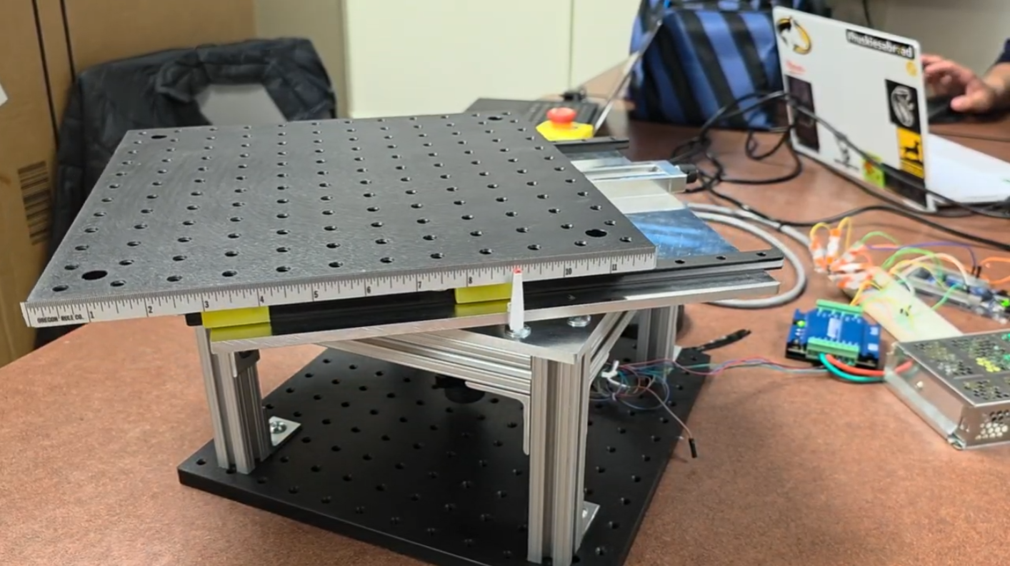
Figure 1. Completed Phase 2 mechanical testbed used as the basis for later embedded and host-interface development.
The testbed comprises a rotating lower stage and a translating upper optical platform. The rotational subsystem provides continuous angular motion. The upper stage supports lateral displacement so the optical axis can be aligned or intentionally offset. The structure was designed around standard optical-table mounting patterns and serviceable mechanical interfaces.
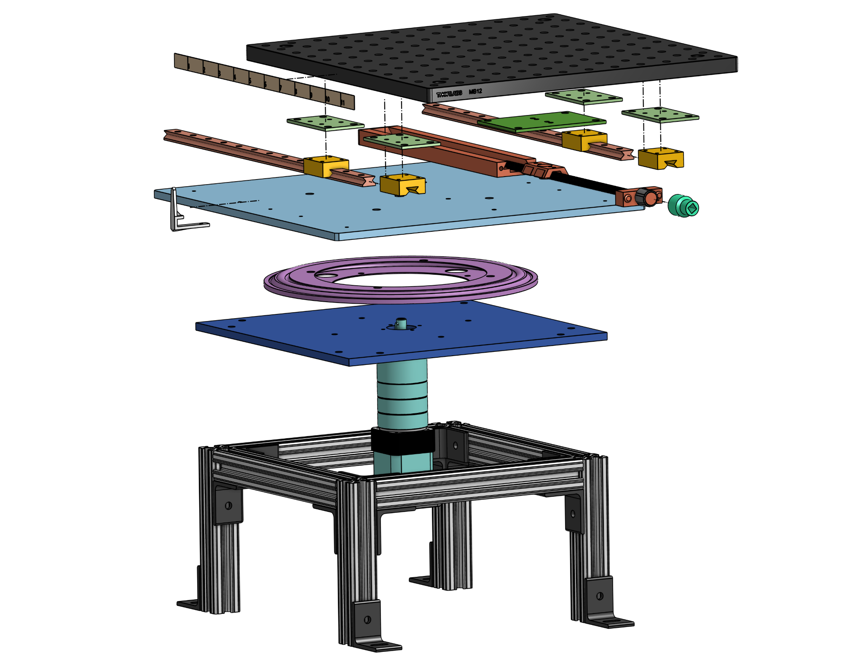
Figure 2. Exploded mechanical architecture showing the stacked rotational, structural, and translational elements.

3.1 Host-target extension
The later system separates time-critical target execution from host-side supervision. The embedded target performs motion execution and telemetry generation, while the host application provides test selection, status, visualization, logging, and post-run analysis. This partition keeps operator interaction outside the real-time control path.

4. Functional Requirements
ID | Requirement | Acceptance statement | Evidence / result | Status
FR-01 | Continuous rotation | The rotational subsystem shall permit motion beyond one complete revolution. | Demonstrated | Pass
FR-02 | Configuration-specific rotation-rate envelope | The system shall support ultra-slow characterization and faster scan operation using documented drive configurations. | At 256 microsteps, 0.002-0.010 deg/s was characterized. Commands of 0.050 and 0.100 deg/s saturated near 0.016 deg/s. Historical 15 deg/s trials used a different configuration. | Partially verified
FR-03 | Lateral offset | The translating stage shall provide at least ±3.0 in of travel. | Measured travel exceeded ±3.0 in. | Pass
FR-04 | Translation readability | The operator shall resolve lateral position to 1/32 in or better. | Needle-and-scale indicator demonstrated. | Pass
FR-05 | Load capacity | The structure shall support up to 40 lb at the specified operating envelope. | Static load demonstration completed. | Pass
FR-06 | Envelope | The core rotating platform shall remain approximately within a 12 × 12 in footprint. | Prototype measured near target footprint. | Pass
FR-07 | Timestamped telemetry | Motion records shall include monotonic timestamps and encoder position data. | Implemented in later host-target workflow. | Pass
FR-08 | Operator interface | The host shall expose connection, test control, live status, plotting, and data logging. | Demonstrated in GUI video. | Pass
FR-09 | Rotational precision | The system shall support verification against a 0.1° precision objective. | Original acquisition chain could not conclusively verify the objective; later instrumentation improved characterization. | Open validation
FR-10 | Electrical robustness | The released interface PCB shall use an intentional ground-reference strategy and durable connectors. | Independent redesign pending final layout and review. | Planned

5. Mechanical Design

5.1 Rotational subsystem
A stepper-driven turntable rotates the optical assembly about a vertical axis. The motor is mounted beneath the structural frame and coupled to the rotating platform. Encoder feedback supports position measurement and derived motion characterization. The design allows motion profiles to be executed without constraining operation to a single revolution.

5.2 Translational subsystem
The upper platform translates on parallel guides using a lead-screw mechanism. This enables optical-axis alignment and controlled offset studies while maintaining the load path through the structural frame. A fixed scale and high-contrast pointer provide direct operator-readable displacement.
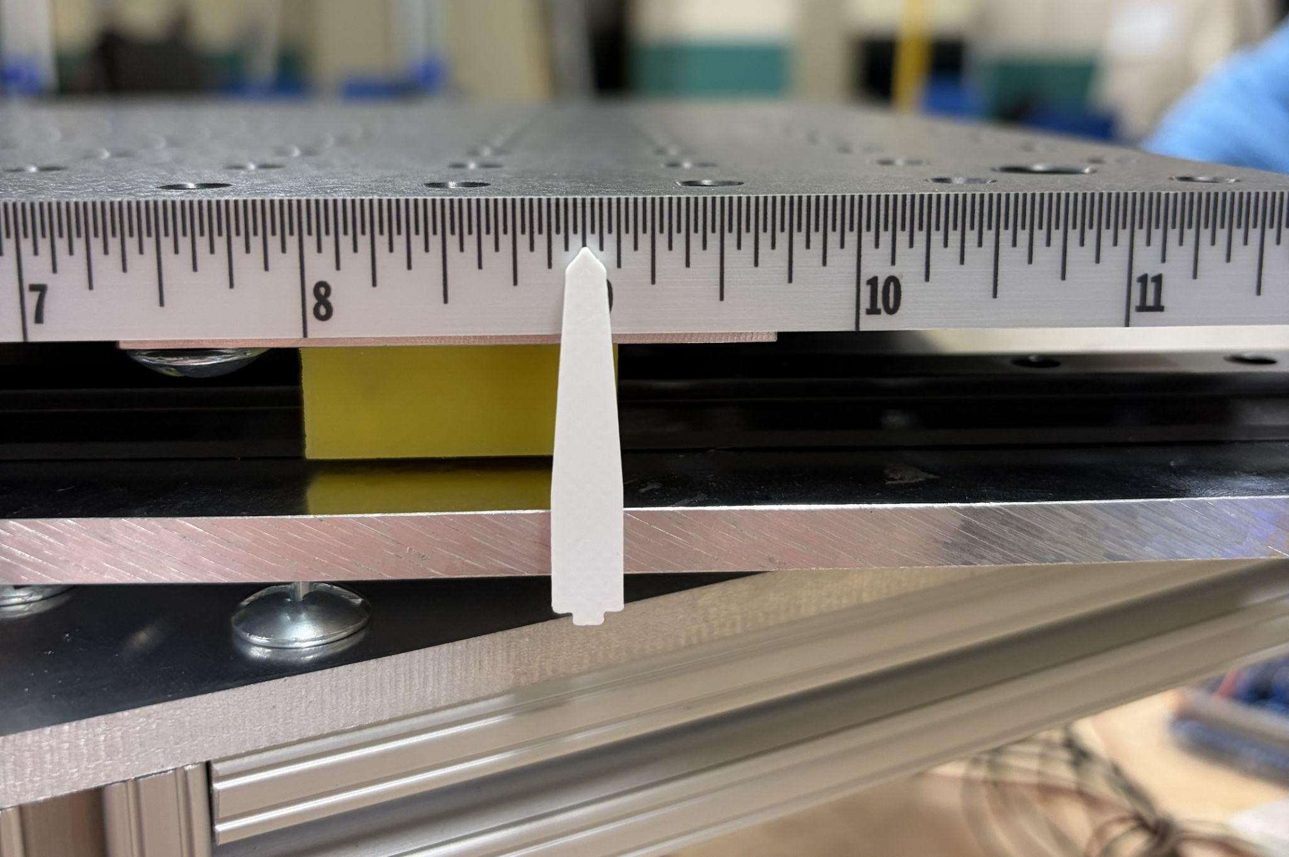
Figure 3. Final high-contrast translation pointer aligned to the fixed measurement scale.

5.3 Structural and safety considerations
- Standard fasteners and accessible interfaces support service and adjustment.
- Low commanded speeds limit rotational kinetic energy during normal operation.
- An emergency stop removes drive power independently of host software.
- Pinch points, moving cables, and optical hardware must be cleared before operation.
- The system requires a stable optical table or equivalent rigid mounting surface.

6. Electrical and Embedded Architecture
The embedded architecture was extended after the original project handoff. The target owns motion timing, encoder sampling, and safety-related timeout behavior. The host owns operator commands, live visualization, file management, and analysis orchestration. Timestamped records preserve the relationship between commanded motion and observed encoder response.
PUBLIC BOUNDARY
This report intentionally documents responsibilities and outcomes rather than the command grammar, scheduling implementation, or firmware source.

6.1 Firm-Designed Interface PCB
Herder Elektronische Systemen redesigned the encoder-receiver and motor-control interface as a dedicated printed circuit board. The board consolidates the differential encoder receiver, controller harness, STEP/DIR motor-driver interface, and 5 V logic distribution into a serviceable assembly. A dedicated solid-copper ground plane provides a low-impedance common reference and intentional return path across the board rather than relying on point-to-point prototype wiring.
DESIGN OWNERSHIP
The PCB shown in this section is an independently recreated firm design prepared after the original original project handoff. The board design may be presented publicly as firm work; editable source and manufacturing outputs remain controlled unless explicitly released.

6.1.1 Electrical interfaces
- J1: six-position differential E5 encoder input for A+/A− and B+/B− channels, plus 5 V and ground.
- P1: six-position Arduino GIGA R1 WiFi interface carrying ENC_A, ENC_B, STEP_CTRL, DIR_CTRL, 5 V, and ground.
- J2: four-position R725 motor-driver interface carrying DIR, STEP, ground, and the 5 V logic supply.
- U3: AM26LS32ACDR quadruple differential line receiver used to convert the differential encoder channels to logic-level feedback.
- U1 and U2: 2N3904-class NPN stages used in the STEP and DIR control interface.
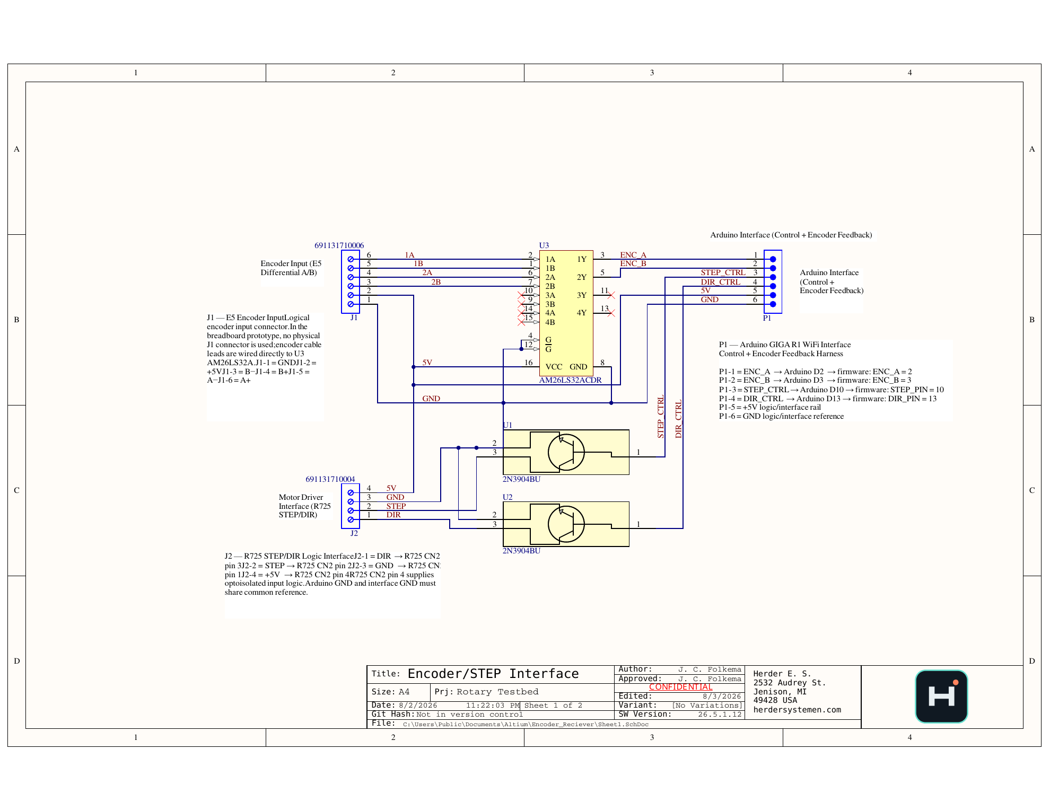
Figure 4. Featured schematic — page 1 of the Encoder/STEP Interface design record, showing the differential encoder receiver, Arduino GIGA control and feedback harness, R725 STEP/DIR interface, and shared 5 V logic reference.

6.1.2 PCB construction and grounding
The routed signal layer carries encoder, control, and interface connections. The opposite copper layer is implemented as one solid ground plane tied to the system logic reference. This gives the encoder receiver and control interface a continuous return structure, reduces loop area compared with loose prototype wiring, and establishes an explicit reference between the Arduino interface and the R725 logic input.
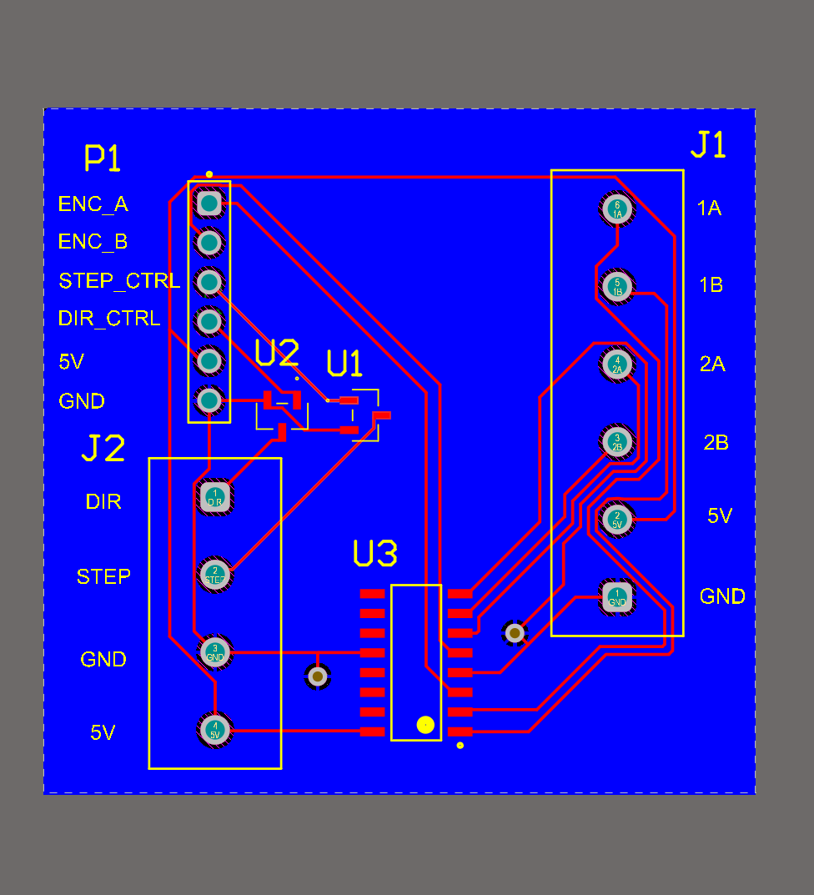
Figure 5. Labeled routed-layer view with connector assignments and component designators.
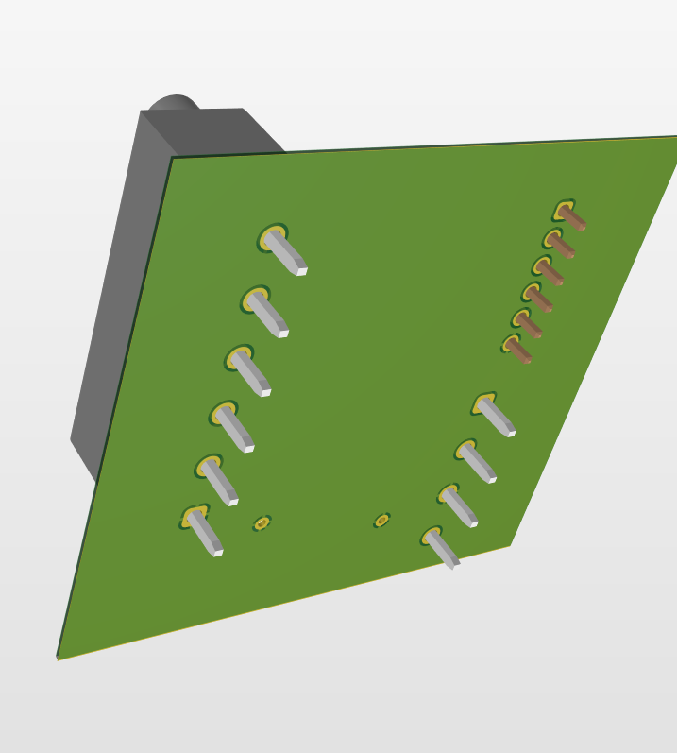
Figure 6. Underside board render. The green copper surface represents the dedicated solid-copper ground plane.

6.1.3 Mechanical arrangement and serviceability
The connector arrangement separates the encoder input, controller harness, and motor-driver interface while preserving direct access to screw terminals and pin labels. Silkscreen identifiers expose signal purpose at the point of connection, supporting assembly, troubleshooting, and future system handoff.
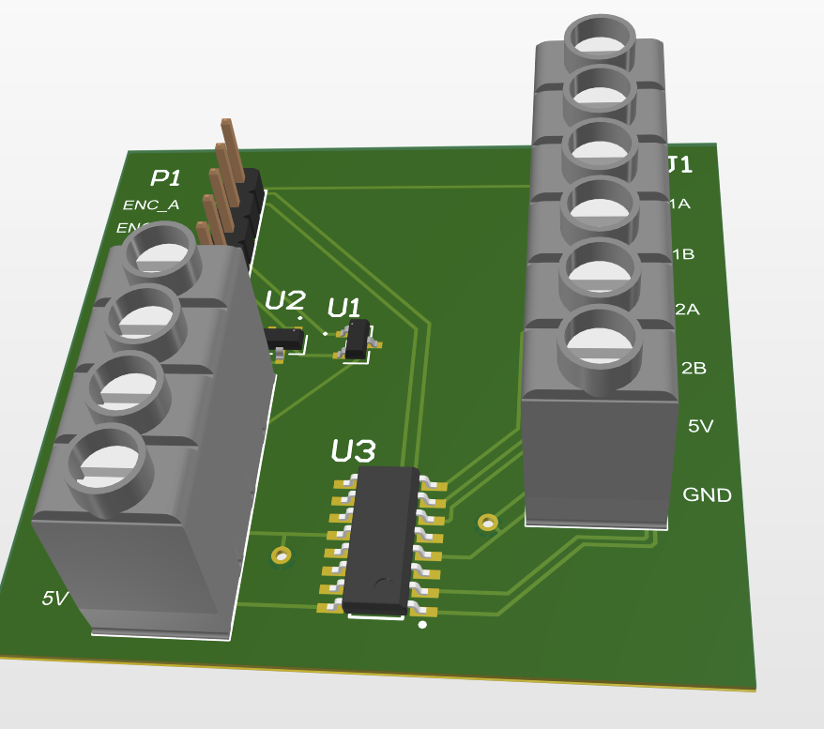
Figure 7. Populated 3D board view showing terminal-block access, controller header, and active-device placement.
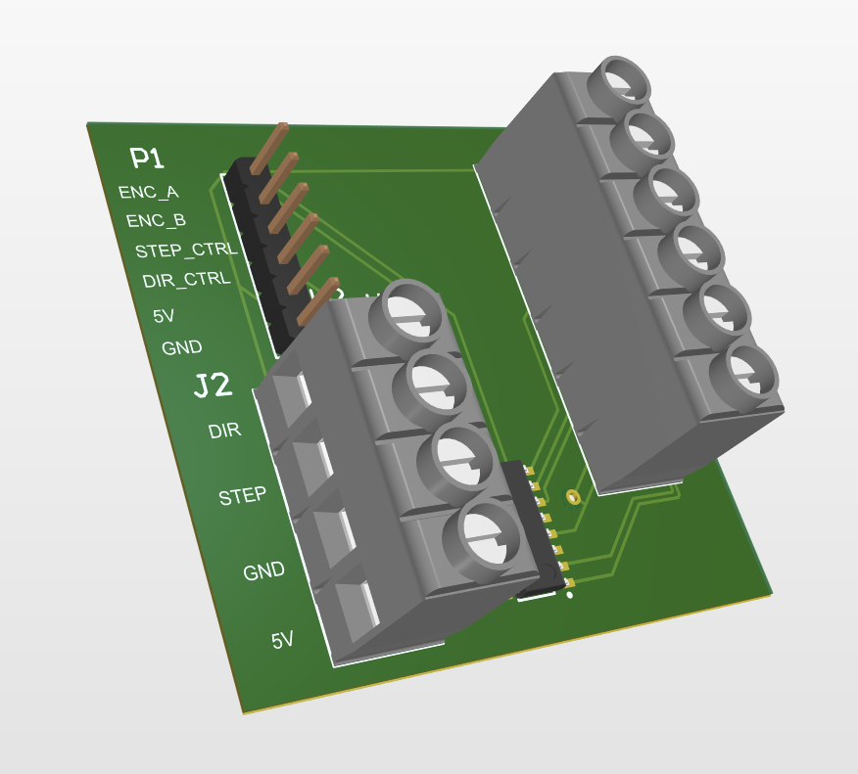
Figure 8. Alternate assembly view emphasizing connector labeling and board-level service access.
ENGINEERING STATUS
The documentation set now includes the schematic, routed-layer views, solid ground-plane render, populated 3D views, and BOM. Fabrication release should still be preceded by final schematic/ERC review, DRC review, polarity checks, connector pinout verification, and prototype electrical test.

7. Verification and Representative Results

7.1 Rotation-rate demonstration
Representative tests demonstrate two distinct operating regimes. Historical trials show the mechanical platform operating at 15 deg/s under the original drive configuration. Later raw encoder-event testing at 256 microsteps characterizes the ultra-slow regime and shows that the usable speed envelope is configuration dependent.
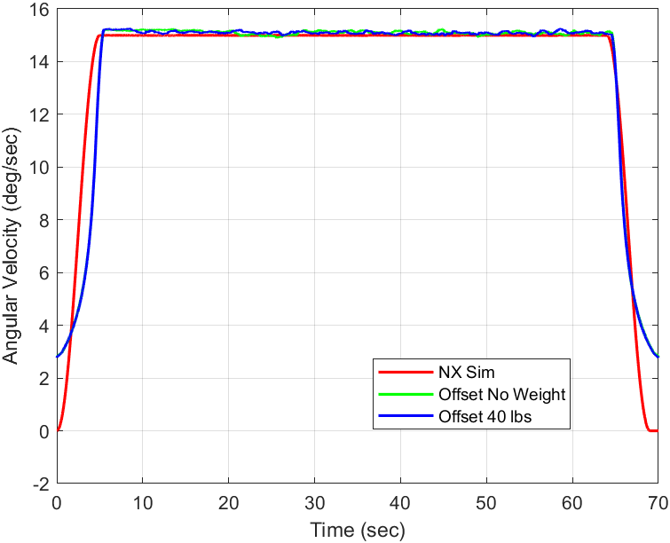
Figure 4. Representative 15 deg/s trials with no load, offset without load, and offset with applied load.

7.2 Configuration-dependent low-speed envelope
At the 256-microstep setting, the strongest ultra-slow tracking occurred around 0.003-0.005 deg/s. A 0.010 deg/s command remained usable but under-tracked. Commands of 0.050 and 0.100 deg/s both plateaued near 0.016 deg/s actual speed, indicating a configuration ceiling rather than a universal mechanical limit.
Command | Measured average | Tracking ratio | Controlled interpretation
0.002 deg/s | 0.001818 deg/s | 0.909 | Correct order of magnitude
0.003 deg/s | 0.003214 deg/s | 1.071 | Strongest low-speed case
0.005 deg/s | 0.004676 deg/s | 0.935 | Strongest low-speed case
0.010 deg/s | 0.008378 deg/s | 0.838 | Usable but below target
0.050 deg/s | 0.016560 deg/s | 0.331 | 256-step ceiling reached
0.100 deg/s | 0.016071 deg/s | 0.161 | Same 256-step ceiling
Design implication: microstep setting is an operating-mode parameter. Higher microstepping supports smoother ultra-slow motion but increases STEP-pulse demand; faster scan commands require a lower microstep setting and revalidation using the same raw encoder-event method.

7.3 Translation and load demonstrations
The mechanical platform demonstrated the required lateral range and supported the specified static load. These tests established mechanical capability but do not substitute for a production structural certification or environmental qualification.
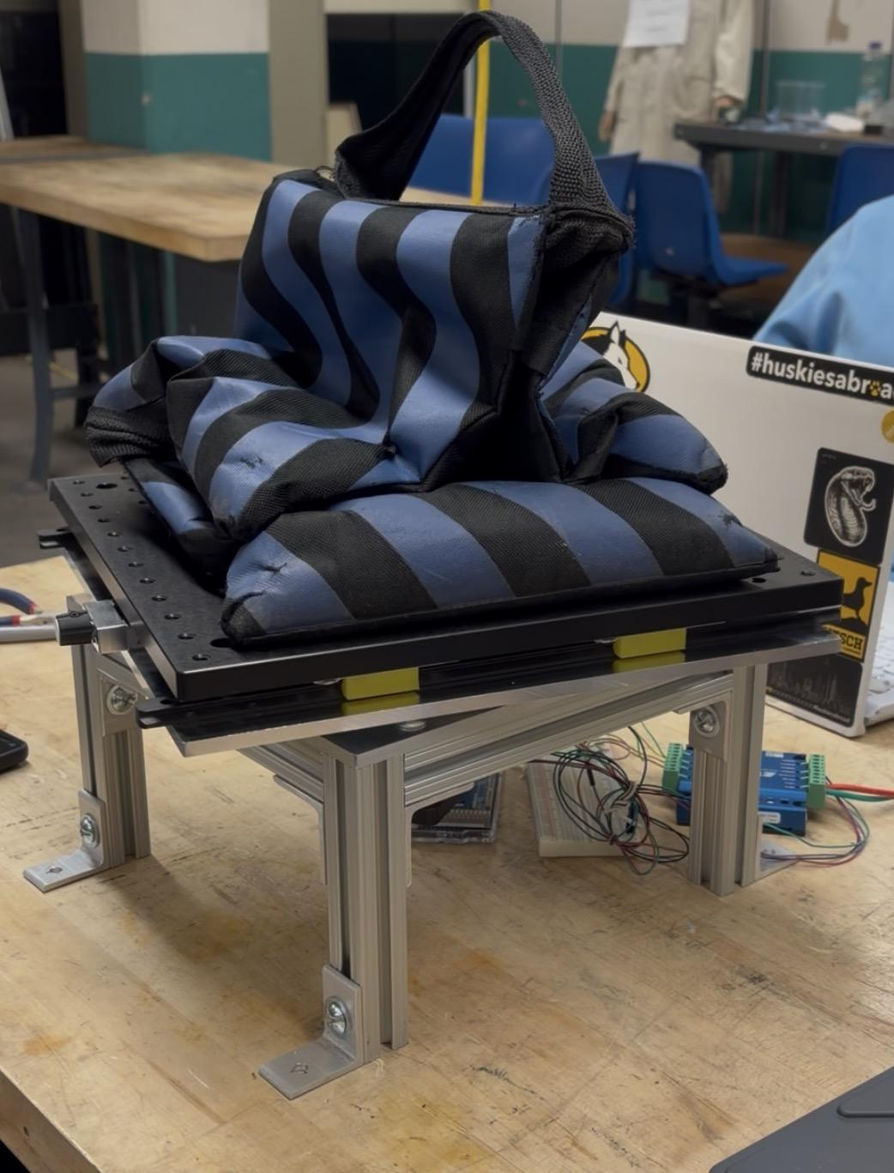
Figure 5. Static load demonstration on the assembled testbed.

7.4 Timestamped data and GUI evidence
The later extension records timestamped encoder and command data and exposes live telemetry through an operator-facing application. The associated host-target demonstration video shows connection controls, commanded and measured motion plots, encoder-rate visualization, logging state, and scripted test progression.
- Evidence asset: Host-Target Interface.mp4
- Evidence asset: Project Solution Video.mp4
- Evidence asset: selected sanitized CSV and plot exports
- Publication rule: remove serial identifiers, local file paths, raw protocol text, and customer-specific data.

8. Limitations and Open Items
Item | Controlled statement
Rotational precision | The original acquisition setup did not conclusively verify the 0.1° objective. Public claims should distinguish demonstrated motion from fully validated metrology.
Prototype manufacture | The original assembly includes prototype-level adjustments and should not be represented as a production-qualified instrument.
PCB status | The firm-designed PCB is documented with a schematic, solid-copper ground plane, 3D renders, and BOM. Fabrication qualification and prototype electrical test remain separate release activities.
Optical performance | This report characterizes the motion platform. It does not certify the performance of the optical gyroscope or downstream navigation technology.
Environmental qualification | No formal shock, vibration, thermal, EMC, or long-duration reliability qualification is claimed.
Speed envelope | The valid operating range depends on microstep and controller configuration. The 256-microstep baseline is demonstrated for ultra-slow tracking and must not be used to imply accurate 0.05-0.10 deg/s operation.

9. Customer-Facing Deliverables
- This Functional Requirements & Validation Report.
- Selected system photographs and simplified architecture graphics.
- Host-target and physical-system demonstration videos.
- Sanitized representative telemetry and plots.
- A public PCB overview including the featured schematic, copper-plane evidence, and 3D assembly renders.
- Release notes identifying demonstrated, open, and planned capabilities.
Not included: complete source code, source-level analysis tools, unreleased board files, customer data, internal troubleshooting records, or duplicate legacy project archives.

10. Attribution and Document Control
The original Phase 2 mechanical and electrical prototype was produced by a four-person engineering team: Jonathan C. Hernandez, Brandon M. Klein, Colin S. Lock, and Cody J. Timmer. Jonathan C. Hernandez served as team lead. Subsequent dual-core firmware, timestamped acquisition, characterization tooling, and host-interface work described here were performed after the original project handoff and are presented under Herder Elektronische Systemen.
The PCB described in Section 6.1 is a new independent firm design. This report releases design evidence for customer review while retaining editable source and fabrication outputs as controlled engineering assets.
Rev | Date | Author | Description
1.1 | 2026-08-02 | HES | Added firm-designed interface PCB, solid-copper ground plane, schematic, 3D views, and public BOM summary.
1.2 | 2026-08-02 | HES | Featured page 1 of the finalized Encoder/STEP Interface PDF; removed the Altium BOM from the customer-facing report.
1.5 | 2026-08-02 | HES | Corrected final pagination and table margins; consolidated the closing material.
1.6 | 2026-08-03 | HES | Added configuration-specific low-speed envelope and corrected rotation-rate claims using raw encoder-event review.
RELEASE GATE
Before publication, verify all media permissions, remove embedded metadata, confirm customer/agency attribution, and complete final technical and legal review. Fabrication files remain controlled pending prototype verification.

