SOFTWARE, FIRMWARE &
CHARACTERIZATION REPORT
Dual-Axis Optical Motion Testbed
Companion to the Functional Requirements & Validation Report
Revision 1.0 • 3 August 2026

Prepared by | Herder Elektronische Systemen
System basis | Inherited dual-core motion platform extended after original project handoff
Document purpose | Describe target control, telemetry, host software, test automation, and validated characterization outputs
Distribution | Customer-facing; source code, exact protocol, tuning constants, and internal debug history excluded

DOCUMENT RELATIONSHIP
The hardware FRD documents the mechanical platform, electrical interface, PCB, and physical verification. This companion report documents the post-handoff embedded, telemetry, GUI, logging, and characterization layer.

1. Executive Summary
The inherited SDC2 motion platform was extended into an operator-facing characterization system. The target-side implementation owns time-critical motion generation, encoder acquisition, telemetry production, and watchdog behavior. The host-side application owns operator configuration, live plots, file creation, metadata capture, automated postprocessing, and report-oriented analysis.
The resulting workflow supports long-duration constant-speed tracking, static position-hold measurement, step-response testing, and closed-loop sine-response characterization. The system records timestamped command and encoder data, validates raw output before postprocessing, and retains evidence products suitable for engineering review.
DEMONSTRATED OUTCOME
A physical motion platform was converted into a repeatable test instrument with deterministic target execution, dual-core health visibility, timestamped acquisition, live telemetry, structured test families, and automated analysis outputs.

2. Scope and Public System Boundary

2.1 Included capabilities
- Dual-core embedded target with separated motion and support responsibilities.
- Commanded motion, encoder feedback, timestamps, and target-status telemetry.
- Host-side GUI for connection, configuration, test launch, live monitoring, and file access.
- Serial logger with header/data validation, metadata retention, completion detection, and partial-run warnings.
- Automated postprocessing for long-duration tracking, Allan deviation, static hold, step response, and closed-loop frequency response.
- Configuration-specific speed-envelope comparison using consistent raw encoder-event analysis.

2.2 Excluded implementation details
- Firmware source, interrupt scheduling, state-machine code, and exact timing implementation.
- Complete serial command grammar, message schema, and recovery protocol.
- Tuning constants, driver configuration tables, and unreleased calibration values.
- Full Python and MATLAB source, development patches, and internal defect history.
- Customer-specific paths, identifiers, raw logs, and editable build packages.

3. Host–Target Architecture
TARGET / REAL TIME | TELEMETRY LINK | HOST / OPERATOR
Motion timing  Encoder acquisition  Safety timeout  M4 health/status | Timestamped command, position, rate, status, and test markers | Configuration  Live plots  Logging  Analysis orchestration
Deterministic execution | Validated stream with metadata | Reviewable evidence products
DESIGN PRINCIPLE
Time-critical behavior remains on the target. The host may visualize, log, and request tests, but it is not used as the real-time pulse scheduler.

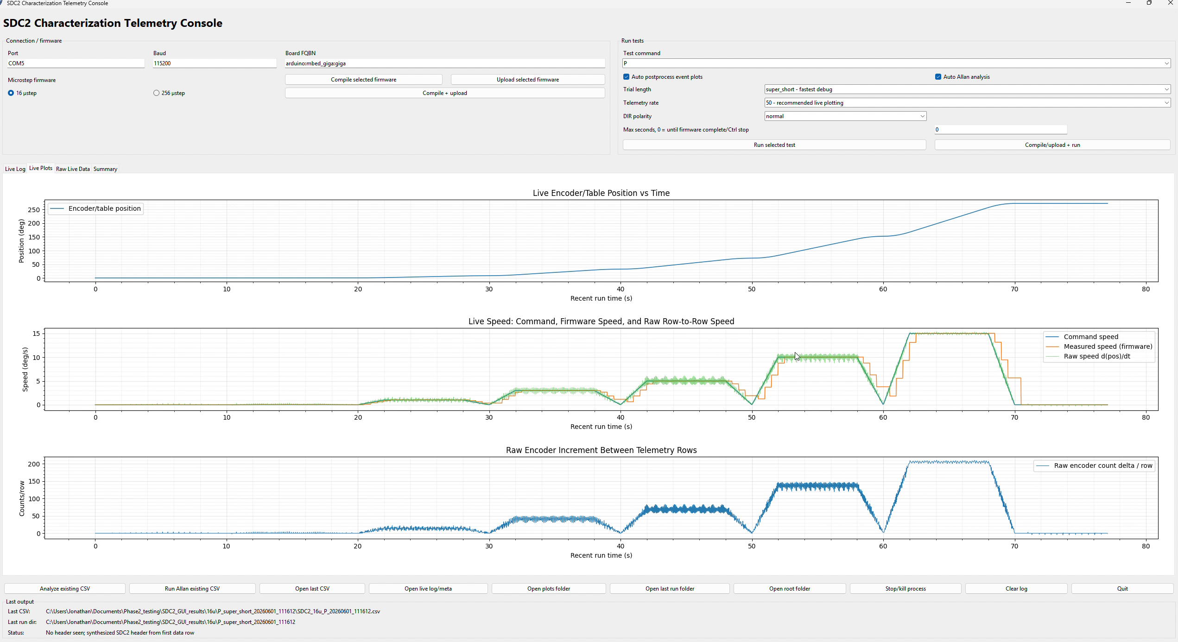
Figure 1. Host–target telemetry console showing connection controls, live plots, test selection, and run status.

4. Software and Firmware Requirements
ID | Area | Requirement | Status
SFW-01 | Target execution | Generate commanded motion independently of host GUI refresh timing. | Demonstrated
SFW-02 | Timestamped telemetry | Record command, encoder response, and target status against a target-derived time base. | Demonstrated
SFW-03 | Dual-core visibility | Expose secondary-core heartbeat or equivalent status for operator review. | Demonstrated
SFW-04 | Host deadman | Support periodic host heartbeat and target-side timeout behavior. | Implemented; hardware validation required per release
SFW-05 | Data validation | Reject or flag files with no recognized header or no data rows. | Demonstrated in logger logic
SFW-06 | Metadata retention | Preserve target comments, completion markers, and logger exceptions separately from numeric CSV data. | Demonstrated
SFW-07 | Test completion | Recognize test-family completion rather than relying only on a global run terminator. | Demonstrated
SFW-08 | Partial-run handling | Retain recoverable data and clearly mark interrupted runs as partial. | Demonstrated
SFW-09 | Automated analysis | Dispatch the appropriate postprocessing workflow after each supported test family. | Demonstrated
SFW-10 | Public release boundary | Provide evidence and architecture without distributing implementation source. | Required

5. Target-Side Control and Telemetry
The target implementation was organized around repeatable test execution rather than manual pulse generation from a PC. Motion timing, encoder-event capture, test progression, and target status remain local to the embedded system. The host receives a time-aligned record of requested and observed behavior.

5.1 Dual-core responsibilities
- Primary target core: test sequencing, command handling, motion generation, and primary telemetry.
- Secondary target core: supporting acquisition/status functions with heartbeat visibility in the host interface.
- Host application: non-real-time supervision, logging, visualization, and analysis launch.

5.2 Supported characterization families
Test family | Public description
Long-duration tracking | Constant-speed segments across selected table speeds; steady portions analyzed separately from ramps.
Static hold | Zero-command position hold for noise-equivalent-angle-style and long-duration stability assessment.
Step response | Position-step sequences for following error, rise/settling behavior, overshoot, and peak speed.
Sine response | Commanded sine segments for closed-loop actual/command gain and phase-lag estimates.
PROTOCOL BOUNDARY
The public report identifies test intent and outputs. Exact command characters, target handlers, transition logic, and timing constants remain controlled implementation details.

6. Host Application and Data-Acquisition Workflow
The desktop interface consolidates connection controls, test selection, live telemetry, run status, output paths, and analysis launch. The GUI starts the logger as a separate process so acquisition and operator interaction remain isolated from plotting and interface refresh behavior.
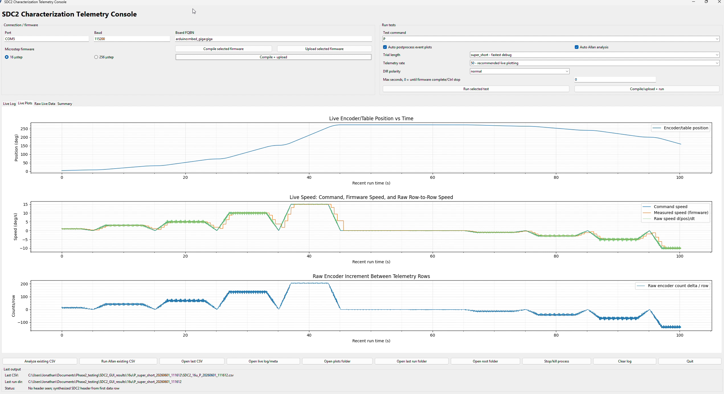
Figure 2. Live command and measured-motion plots during a scripted characterization run.

6.1 Acquisition controls and safeguards
- Configurable serial port, target mode, microstep selection, telemetry rate, and test preset.
- Host heartbeat/deadman pings while logging is active.
- CSV header recognition and row-width checks before a record is accepted.
- Clear failure when a file contains comments but no numeric header or contains a header with zero rows.
- Separate metadata file for target comments, completion markers, and logger exceptions.
- Interrupted serial runs retained as partial evidence rather than silently treated as complete.
- Long static tests may use target telemetry with controlled host-side decimation for manageable output size.

6.2 Evidence output structure
Artifact | Purpose | Public handling
Raw CSV | Timestamped numeric evidence | Sanitize paths and identifiers; retain representative subset
Metadata log | Target markers and run health | Keep private unless specifically curated
Summary CSV | Quantified metrics by segment | Publish selected columns with definitions
Figures | Tracking, stability, transient, and response plots | Publish approved plots with controlled captions
Run directory | Groups all products from one execution | Retain internally as traceability record

7. Characterization Method and Results
The analysis package separates static, dynamic, and transient questions instead of applying one metric to every data set. Constant-speed tracking is evaluated from raw encoder-event timing and command error. Static hold is used for position-hold noise. Step and sine tests are used for dynamic response.
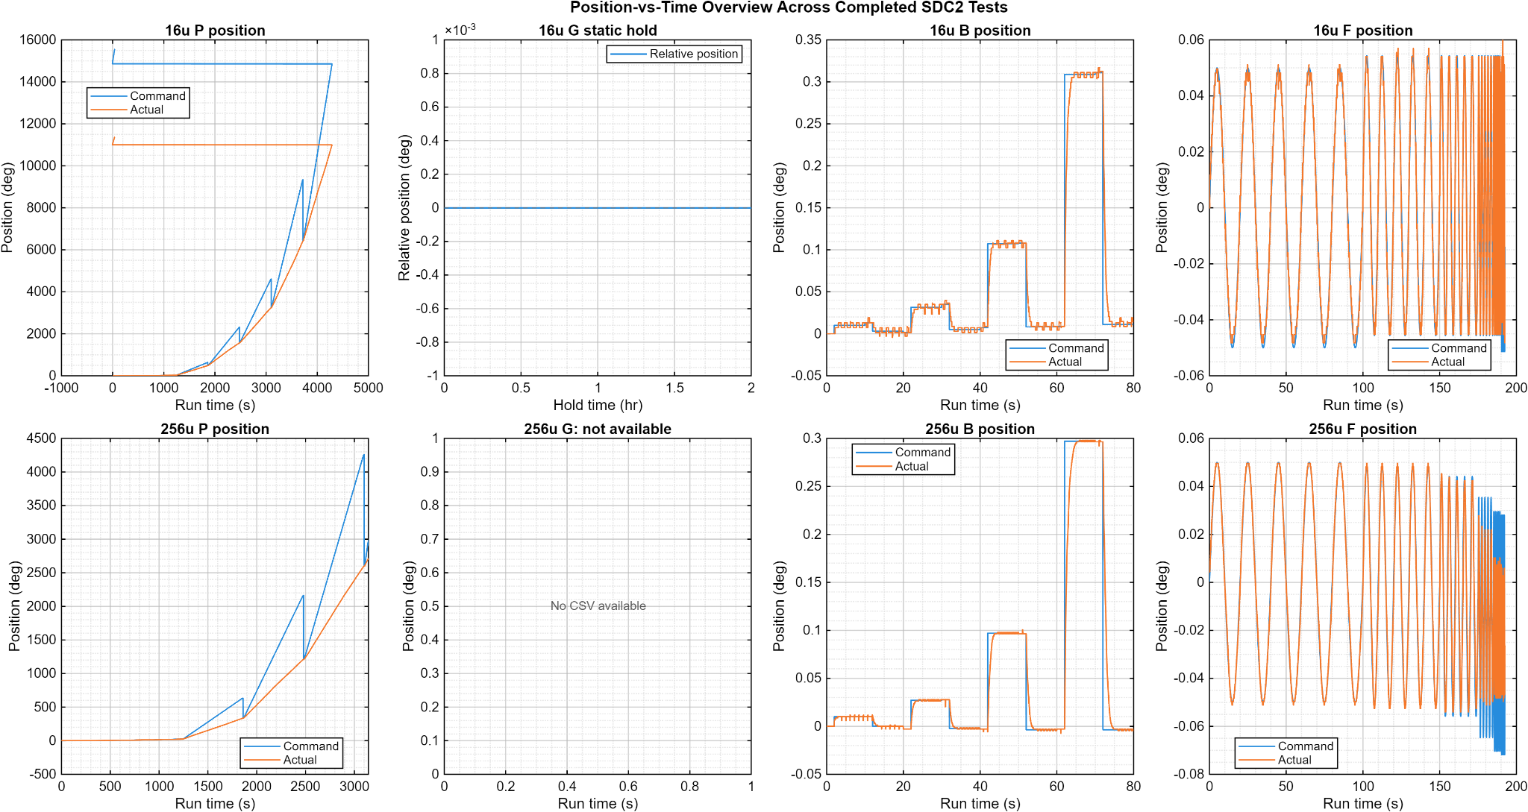
Figure 3. Position-over-time overview for the completed tracking, static-hold, step, and sine-response test families.

7.1 Long-duration tracking and Allan stability
Long-duration tracking results compare command and measured motion across 16 and 256 microstep configurations. The analysis reports tracking ratio, accumulated position error, RMS velocity error, and Allan behavior on error or residual signals. Raw moving position is not treated as a static-noise signal.
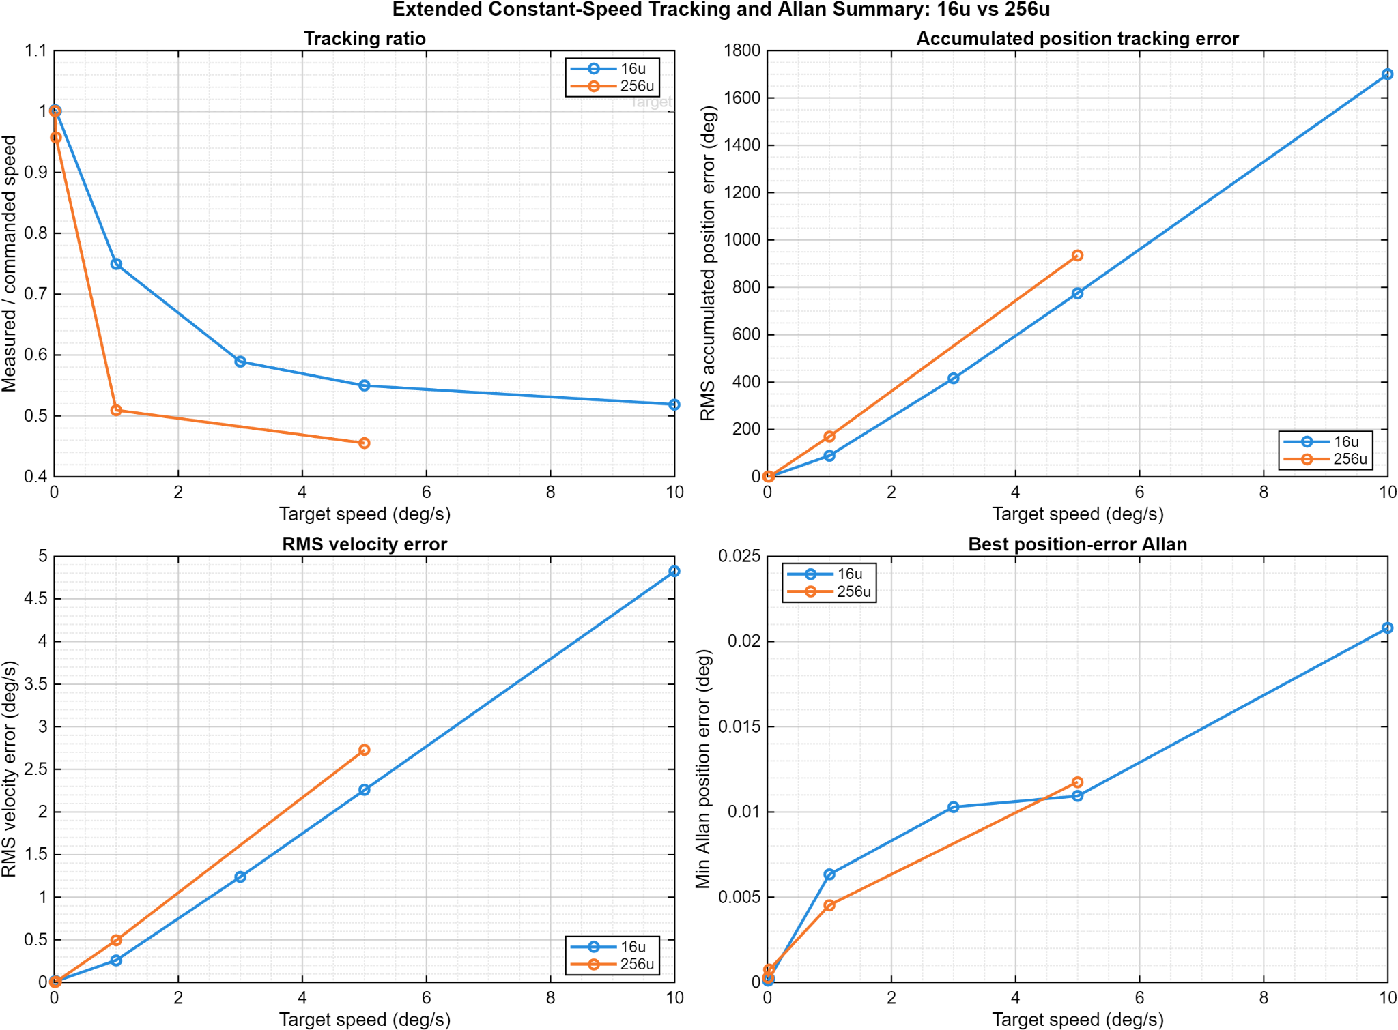
Figure 4. Combined extended tracking and Allan-summary comparison for 16 and 256 microstep configurations.

7.2 256-microstep low-speed characterization
The focused low-speed review uses raw encoder count changes without smoothing, moving averages, or grouped averaging. Average speed is calculated from total count delta over the segment duration. Event-to-event speed and timing-gap flags expose ripple, delayed motion, and catch-up behavior that a segment average alone would hide.
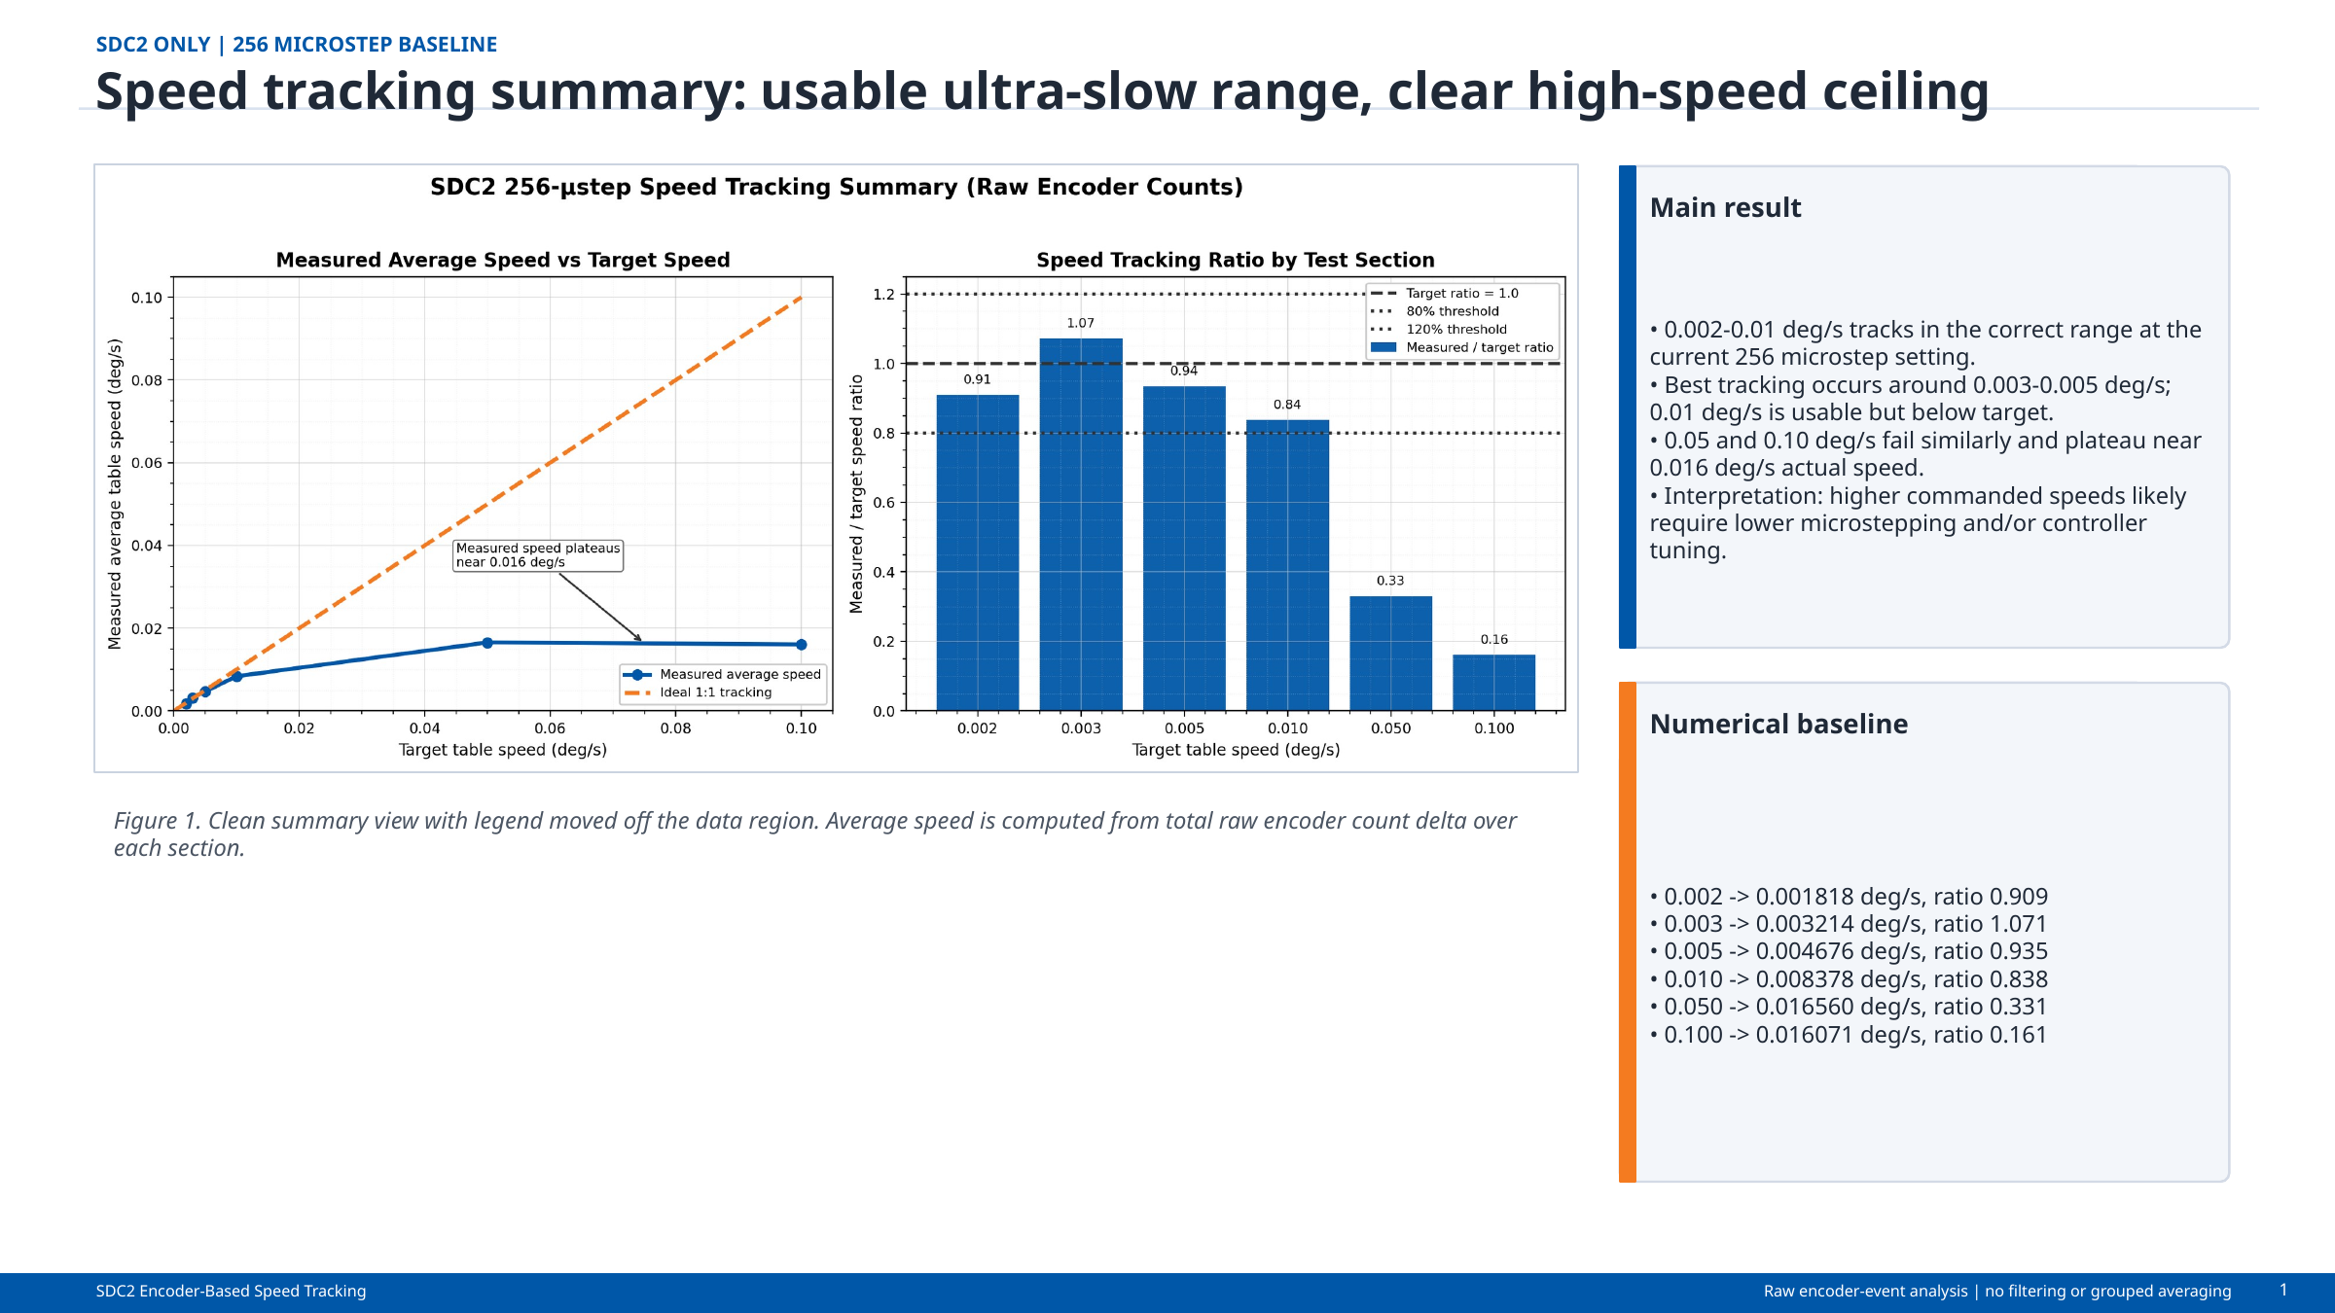
Figure 5. 256-microstep speed-envelope summary. Best tracking occurs at 0.003-0.005 deg/s; 0.050 and 0.100 deg/s commands converge on the same approximately 0.016 deg/s ceiling.
Target | Average speed | Ratio | Assessment
0.002 | 0.001818 | 0.909 | Correct range
0.003 | 0.003214 | 1.071 | Best low-speed case
0.005 | 0.004676 | 0.935 | Best low-speed case
0.010 | 0.008378 | 0.838 | Usable / borderline
0.050 | 0.016560 | 0.331 | Configuration-limited
0.100 | 0.016071 | 0.161 | Configuration-limited
Interpretation: 256 microsteps is the preferred baseline for ultra-slow smoothness, not for the complete command range. The review recommends testing approximately 200 microsteps for improved 0.010 deg/s accuracy and progressively lower settings such as 128, 64, or 32 for faster scans. Those settings remain recommendations until tested with the same raw-event method.
INTERPRETATION BOUNDARY
Allan deviation during motion is calculated on position error, velocity error, or speed residual. It is not used to claim static position noise from a moving trajectory.

7.3 Static hold and noise-equivalent-angle-style assessment
The static-hold test is the appropriate basis for position-hold noise. In the available 16-microstep record, no measurable encoder-count motion was observed over the reported hold, so the result is bounded by encoder and logging resolution rather than proving physically zero noise. A corresponding 256-microstep static-hold record was not present in the reviewed package.
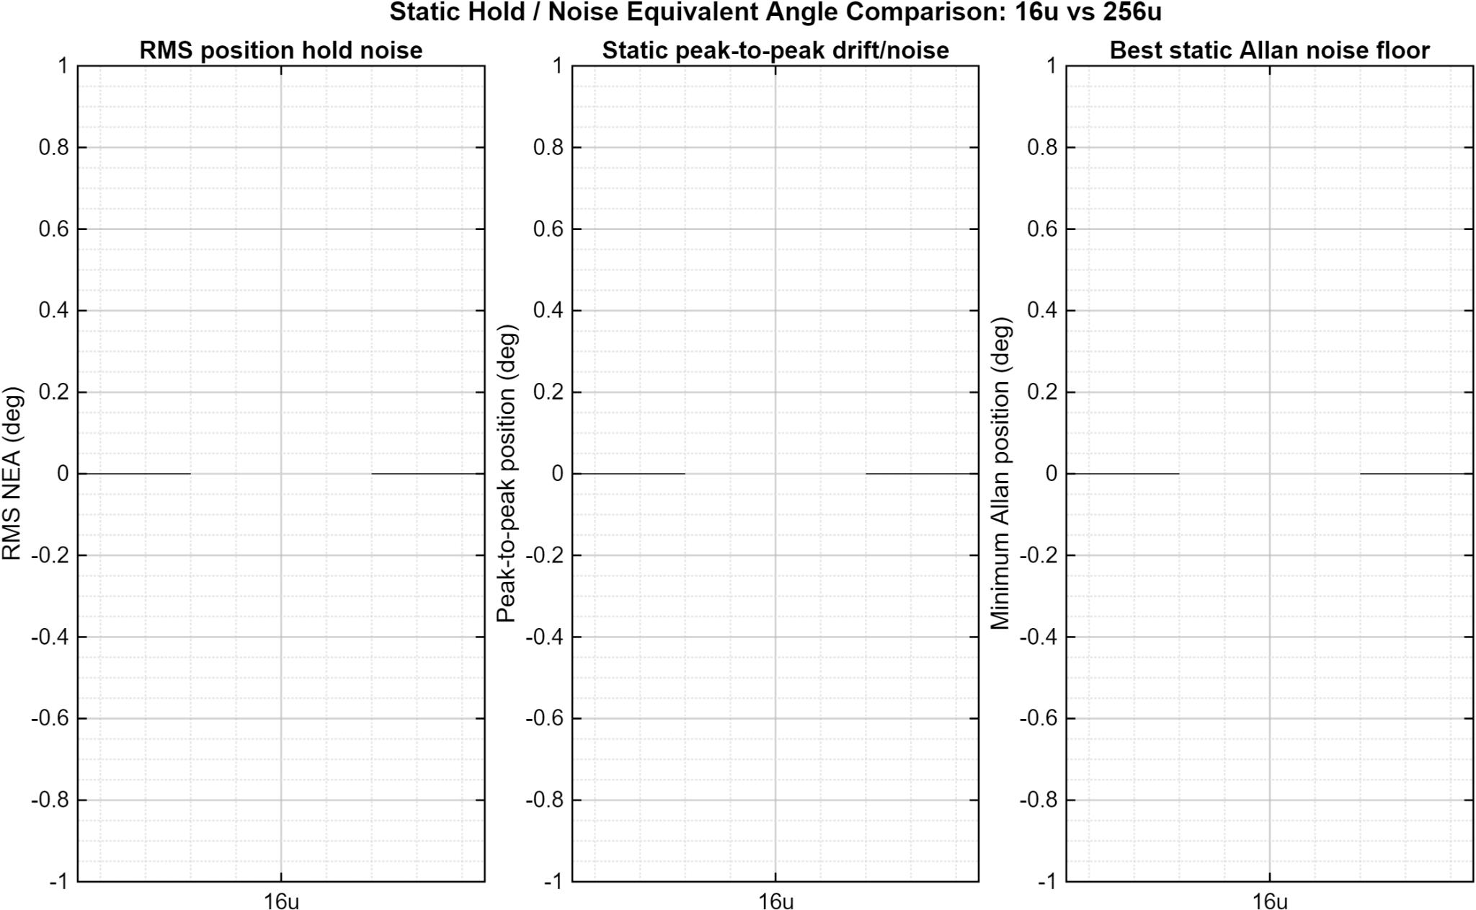
Figure 6. Static-hold comparison. The available 16-microstep trace is resolution-limited; the reviewed package did not contain an equivalent 256-microstep hold.

7.4 Step-response characterization
Step-response analysis reports following error, worst error, settling behavior, and peak speed as step amplitude changes. The reviewed safe-amplitude tests did not show sustained oscillation. The settling-band definition must remain attached to any published settling-time value.
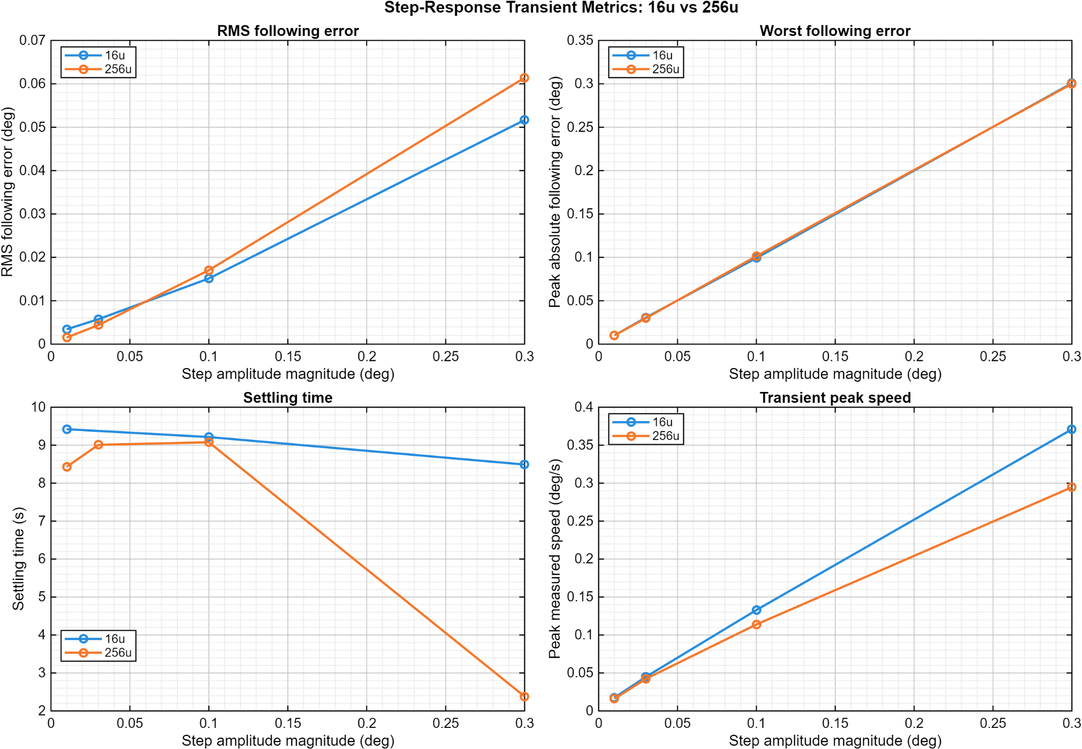
Figure 7. Combined step-response metrics for the tested 16 and 256 microstep configurations.

7.5 Closed-loop sine-response characterization
The sine-response workflow fits the measured response against the commanded trajectory and reports closed-loop gain and phase lag. In the reviewed results, the 256-microstep response rolls off and crosses below approximately −3 dB around 0.5 Hz. The 16-microstep response remains near 0 dB over the tested range, so its −3 dB point is above the tested range or was not resolved.
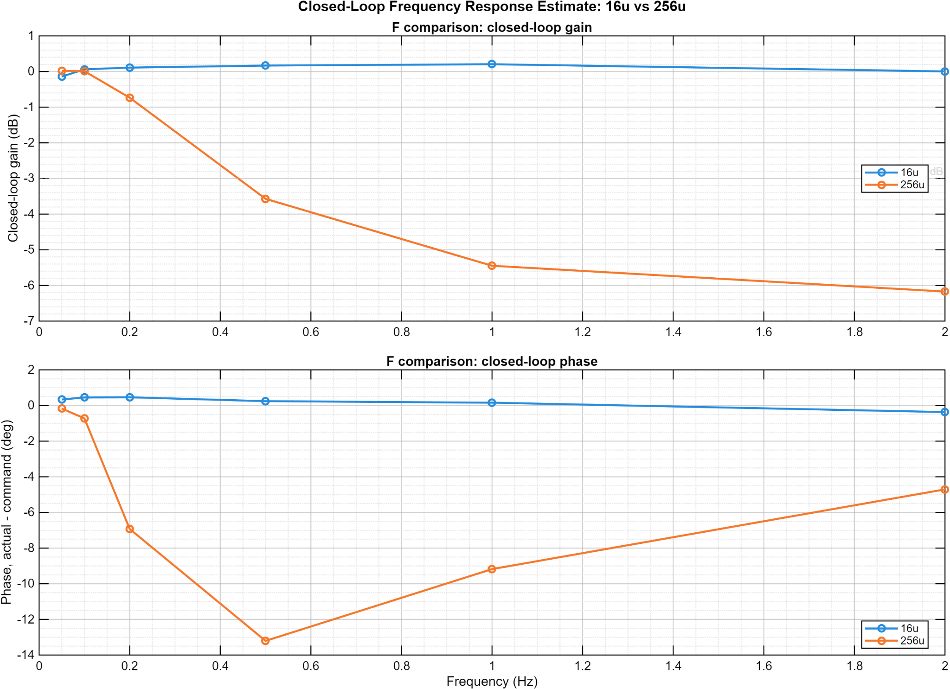
Figure 8. Closed-loop actual/command gain and phase-lag estimates for 16 and 256 microstep configurations.
REQUIRED WORDING
This is a closed-loop tracking response. It is not a formal open-loop phase-margin measurement. True phase margin would require a controlled loop-injection or loop-breaking method.

8. Demonstrated Engineering Outcomes
Outcome | Evidence
Operational instrument | Converted a physical prototype into a host-controlled, timestamped characterization system.
Repeatable testing | Encoded separate long-duration, static, step, and sine-response workflows.
Traceable evidence | Grouped raw data, metadata, summaries, and figures by run.
Defensive logging | Detected missing headers, empty runs, serial interruptions, and incomplete completion states.
Cross-configuration comparison | Separated ultra-slow smoothness from faster-scan capability and quantified the 256-microstep ceiling.
Honest interpretation | Separated static noise, dynamic tracking, transient response, and closed-loop frequency response.

9. Limitations and Open Validation Items
Item | Controlled statement
Firmware archive status | The reviewed handoff contains complete host tooling and reference firmware material, but some patch bundles explicitly require confirmation that the active target firmware includes every intended test handler.
Safety validation | A host heartbeat is implemented, but a customer release must verify target-side timeout behavior and hardware-stop independence on the exact deployed build.
Static data coverage | The reviewed package lacks a matching 256-microstep long static-hold record.
ARW/VRW extraction | Allan curves are present, but formal random-walk coefficients require identified slope regions and fitted coefficients.
Frequency response | Published bandwidth is a closed-loop tracking estimate; open-loop margin is not claimed.
Deployment portability | Development packages contain workstation-specific paths and unfrozen dependencies; these are excluded from the public package.
Production qualification | No formal EMC, environmental, cybersecurity, or long-duration product qualification is claimed.
Speed envelope | The demonstrated 256-microstep envelope is approximately 0.002-0.010 deg/s. Higher-speed settings were proposed but not established by the reviewed low-speed data.
Ripple metric | The review recommends exporting RMS event speed alongside average speed. Until that export is retained for every run, average tracking and raw event plots should be reported together.

10. Customer-Facing Deliverables
- This Software, Firmware & Characterization Report.
- The companion hardware Functional Requirements & Validation Report.
- Host–Target Interface demonstration video.
- Selected GUI screenshots and approved characterization plots.
- Sanitized representative telemetry and summary data.
- Release notes distinguishing demonstrated, bounded, and open capabilities.
Not included: firmware source, Python/MATLAB source, exact serial protocol, editable test definitions, internal patch history, raw customer data, or complete build and manufacturing packages.

11. Attribution and Document Control
The physical Phase 2 platform originated as a multi-person engineering project. Jonathan C. Hernandez served as team lead. The post-handoff dual-core firmware integration, timestamped acquisition, host application, automated test workflows, characterization tooling, and customer-facing report described here were developed and organized under Herder Elektronische Systemen.
This document is a public technical summary. It demonstrates engineering scope and measured outcomes while retaining implementation source and detailed protocols as controlled assets.
Rev | Date | Author | Description
1.1 | 2026-08-03 | HES | Corrected final-page table widths and margins; tightened closing sections for clean customer-facing pagination.
1.2 | 2026-08-03 | HES | Added raw-event 256-microstep low-speed characterization, measured ratios, configuration ceiling, and controlled operating-mode guidance.
RELEASE GATE
Before publication, verify that every figure corresponds to the retained evidence set, remove embedded metadata from media, confirm the deployed target safety timeout, and publish this report alongside the hardware FRD as one coordinated case study.

