FUNCTIONAL REQUIREMENTS & VALIDATION REPORT
TI Piccolo-Based Dual-Motor Dynamometer Testbed
PUBLIC ENGINEERING RELEASE v1.4

Document ID | HES-DYNO-FRD-001
Prepared by | Herder Elektronische Systemen
System basis | TI C2000 Piccolo F28069M dual-PMSM dynamometer testbed
Purpose | Define the public system boundary, functional and quality requirements, verification methods, objective evidence, validation status, and release limitations.
DOCUMENT POSITIONING
Independent engineering documentation for a platform built with Texas Instruments development hardware. This document is not authored, approved, or sponsored by Texas Instruments. Product names and trademarks remain the property of their owners.

1. Executive Summary
The platform is a dual-PMSM dynamometer centered on a TI C2000 Piccolo F28069M real-time controller, two DRV8305 inverter stages, quadrature encoder feedback, and a host-side test and analysis workflow. The inherited platform contained usable hardware and control assets, but the documented motor-phase and encoder connections did not match the physical bench. The electrical interface was corrected, dual-machine control was restored, host-target pacing was stabilized, an efficiency-map workflow was built, and the communications path was extended from SCI-based operation to CAN-controlled real-time testing.
This FRD converts the public evidence set into controlled, testable requirements. Each normative requirement is uniquely identified, written as a single “shall” statement, assigned a verification method, and traced to retained evidence. The structure is aligned with ISO/IEC/IEEE 29148 requirements-engineering principles and NASA requirements/verification guidance; it is not a claim of formal certification to either framework.
Demonstrated capability | Public evidence
Dual-machine operation | Corrected phase and QEP interface; stable commanded drive/load behavior.
Operating envelope represented in data | 0-4000 rpm and 0-0.25 N m processing range.
Measured efficiency characterization | Raw-signal review, validity masks, measured-bin maps, sample counts, and interpolation views.
Real-time communications | CAN receive ID 0x100 and transmit ID 0x101 in retained generated-code evidence; four packed 16-bit command values and telemetry organization.
Drive-cycle workflow | Compressed FTP-style command profile and load-command generation for bench demonstration.

2. Document Scope and Conventions

2.1 Public system boundary
- Included: system architecture, interface definitions, actual editable Simulink target/host models, custom F28069M ADC configuration source, selected MATLAB utilities, sanitized plots, vendor schematic references, public BOM, requirements, and verification evidence.
- Excluded: generated code trees, compiled firmware and binaries, vendor device-support source, private tuning history, raw unpublished data, editable PCB/manufacturing packages, and internal development records.
- Third-party boundary: TI boards and documentation, MathWorks software, Speedgoat interfaces, motors, and inherited fixtures remain third-party or inherited elements.

2.2 Requirement language and status
Term | Meaning
Shall | Mandatory behavior or constraint for the public baseline.
Should | Recommended practice or future enhancement; not mandatory.
Verified | Objective evidence supports the requirement for the reviewed baseline.
Partially verified | Some evidence exists, but an identified condition remains open.
Not verified | No adequate objective evidence is included in the public release.

2.3 Verification methods
Code | Method | Definition
I | Inspection | Review of drawings, files, configuration, labels, or retained source artifacts.
A | Analysis | Evaluation by calculation, data processing, or engineering reasoning.
D | Demonstration | Observed operation without exhaustive quantitative acceptance limits.
T | Test | Controlled execution with defined input, measured output, and acceptance criterion.

3. System Context and Architecture
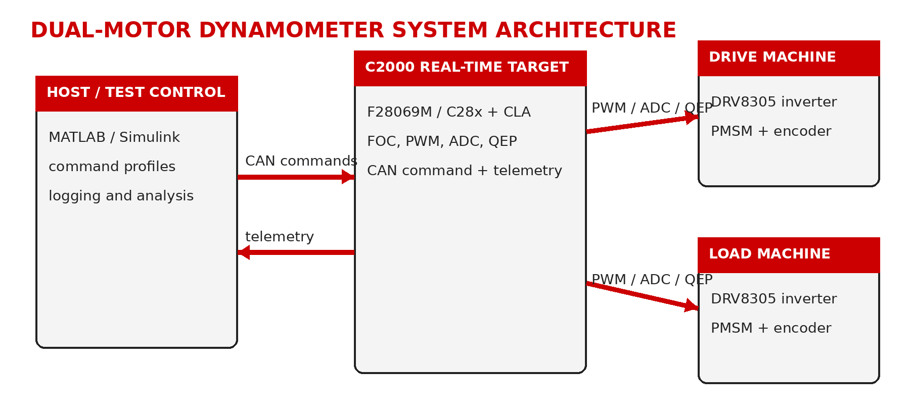
Figure 1. Public system architecture and responsibility boundary.
Time-critical motor control remains on the F28069M target. The host creates command profiles, supervises tests, logs selected channels, and performs analysis. The CAN link replaces dependence on host GUI refresh timing for the command/telemetry transport. Each inverter controls one PMSM; each encoder is assigned to the corresponding QEP input after physical verification.

3.1 Primary interfaces
Interface | Public definition | Boundary
DC power | Nominal 24 V bench supply to both inverter stages. | Exact protection and supply design remain bench-specific.
Motor phases | Three-phase outputs from each DRV8305 inverter to its assigned PMSM. | Phase order verified physically; no universal harness pinout is claimed.
Encoder feedback | Quadrature A/B feedback to F28069M QEP peripherals. | Exact connectorization is platform-specific.
CAN | Differential CANH/CANL with common reference and termination. | Public baseline identifies command 0x100 and response 0x101.
Host data | Selected signals exported for synchronized analysis. | Complete private signal dictionary is excluded.

4. Functional Requirements
ID | Requirement | V-method | Status | Evidence
SYS-001 | The system shall provide independently commanded drive-machine and load-machine control paths. | D/T | Verified | Operational dual-motor bench evidence.
SYS-002 | The system shall maintain an explicit mapping between each inverter, motor, and encoder feedback channel. | I/T | Verified | Corrected phase and QEP assignments.
CTL-001 | The real-time target shall execute motor-control timing independently of host visualization refresh timing. | I/D | Verified | Target FOC/PWM/ADC/QEP architecture.
CTL-002 | The target shall provide closed-loop speed regulation for the commanded drive machine within the demonstrated bench envelope. | T | Verified | Successful speed-command tests and efficiency-map runs.
CTL-003 | The target shall provide a controllable load-machine q-axis current or equivalent torque-producing command. | T | Verified | Fixed-dwell and drive-cycle load profiles.
CTL-004 | The control path shall preserve enable, limit, and command-interpretation logic rather than bypassing the established motor-control state path. | I/D | Verified | Retained host/target model behavior and command routing.
COM-001 | The target shall receive a standard CAN command frame with identifier 0x100. | I/D | Verified | Generated target code mailbox configuration.
COM-002 | The target shall transmit a standard CAN response frame with identifier 0x101. | I/D | Verified | Generated target code mailbox configuration.
COM-003 | A command frame shall transport four packed 16-bit values using a documented scaling convention. | I/D | Verified | Byte pack/unpack and host command evidence.
COM-004 | The public interface description shall distinguish command transport from measurement telemetry. | I | Verified | Interface summary and FRD architecture.
DAQ-001 | The acquisition workflow shall align selected signals to a common analysis interval and time base before derived calculations. | I/A | Verified | Interpolation and crop logic in processing source.
DAQ-002 | The processing workflow shall reject non-finite and physically implausible samples before map generation. | I/A | Verified | Validity masks and filtering plots.
DAQ-003 | The workflow shall retain sample-count evidence for each measured operating bin. | A | Verified | Sample-count map.
CHR-001 | The efficiency workflow shall support an analysis grid spanning 0-4000 rpm and 0-0.25 N m. | I/A | Verified | Processing edges and published figures.
CHR-002 | Electrical input power shall be derived from the selected q-axis voltage/current representation used by the retained workflow. | I/A | Verified | Processing script and report method.
CHR-003 | Mechanical output power shall be derived from measured or estimated torque and angular speed. | I/A | Verified | Processing script and report method.
CHR-004 | Measured-bin results shall remain distinguishable from interpolated visualization products. | I | Verified | Separate measured and interpolated maps.
DRV-001 | The host workflow shall generate a bounded, compressed FTP-style speed command suitable for a short bench demonstration. | I/D | Verified | Public drive-cycle setup script.
SAF-001 | The release shall not characterize the platform as production-safe or safety-certified. | I | Verified | NOTICE and report limitations.
REL-001 | The public package shall exclude complete private control models, generated code, compiled firmware, and editable manufacturing sources. | I | Verified | Final package inspection.
SYS-021 | The target implementation shall configure the additional simultaneous ADC input pairs required by the public instrumentation path using project-specific F28069M SOC configuration source. | I/T | Verified | F28069M_ADC_Custom_Config.c; SOC12/13 and SOC14/15 configuration.

5. Performance and Quality Requirements
ID | Requirement | Method | Status
PER-001 | The public characterization workflow shall represent speed commands from 0 through 4000 rpm. | I/A | Verified
PER-002 | The public characterization workflow shall represent torque values from 0 through 0.25 N m. | I/A | Verified
PER-003 | Efficiency-map acceptance shall require electrical power greater than 10 W, mechanical power greater than 3 W, and torque greater than 0.045 N m. | I/A | Verified
TIM-001 | Host-target execution shall be paced sufficiently to avoid uncontrolled host run-ahead during real-time tests. | D | Verified
USA-001 | Public scripts shall expose configuration parameters and generate labeled plots suitable for engineering review. | I | Verified
MAI-001 | The public repository shall separate firmware evidence, host utilities, hardware references, results, media, and documentation. | I | Verified
TRC-001 | Every FRD requirement shall have a unique identifier, verification method, status, and evidence reference. | I | Verified
SEC-001 | The public release shall contain no credentials, customer data, university-only records, or internal planning notes. | I | Verified
PER-009 | The added ADC pairs shall use PWM-synchronized triggering and explicit end-of-conversion interrupt routing so acquisition remains aligned with target execution. | I | Verified

6. Verification Evidence

6.1 Electrical and control recovery
The working baseline was established by reconciling the physical bench with the inherited connection documentation. Three-phase order and encoder/QEP assignments were corrected, followed by staged single-machine and dual-machine operation. This evidence supports the interface-mapping and closed-loop-control requirements, but it does not establish production wiring compliance or immunity to incorrect reconnection.

6.2 CAN integration evidence
Retained generated-code evidence configures mailbox 0 to receive identifier 0x100 and mailbox 1 to transmit identifier 0x101. The transport packs four 16-bit command values per eight-byte frame. The customer-facing release describes the transport and scaling boundary while while excluding the complete generated-code tree and private target models.

6.3 Efficiency-map evidence
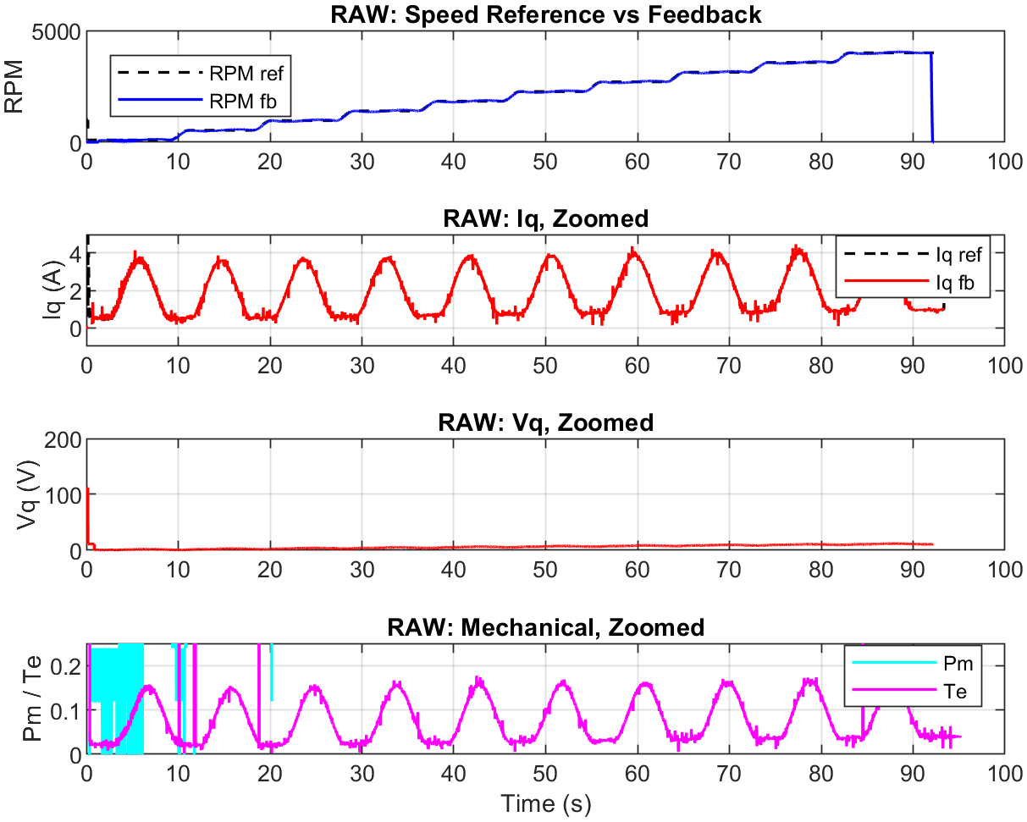
Figure 2. Raw selected signals before validity screening.
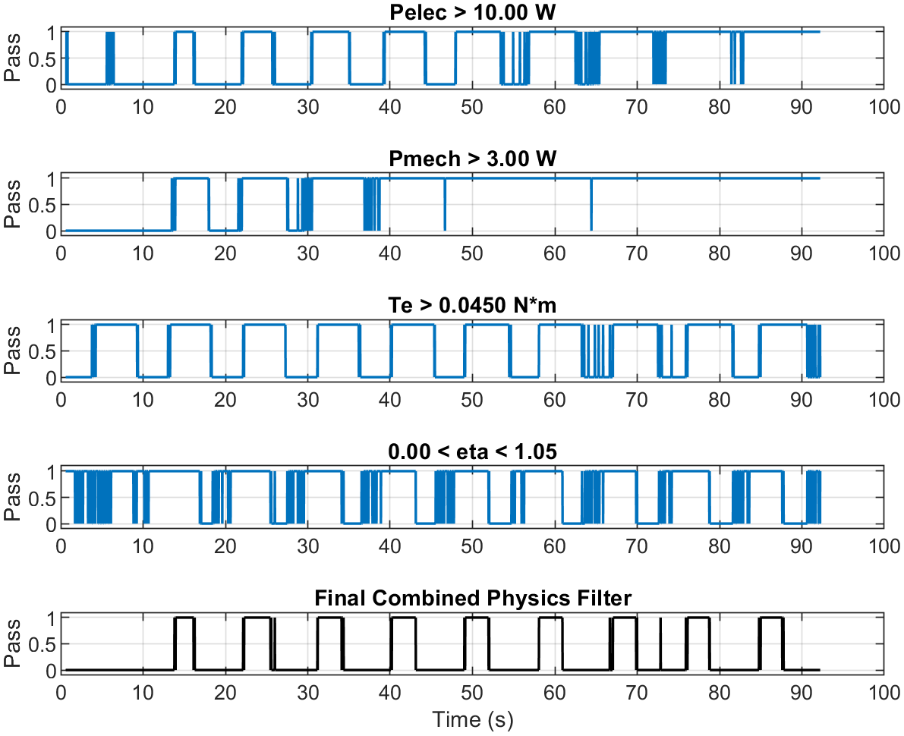
Figure 3. Screening masks used to separate valid operating points.
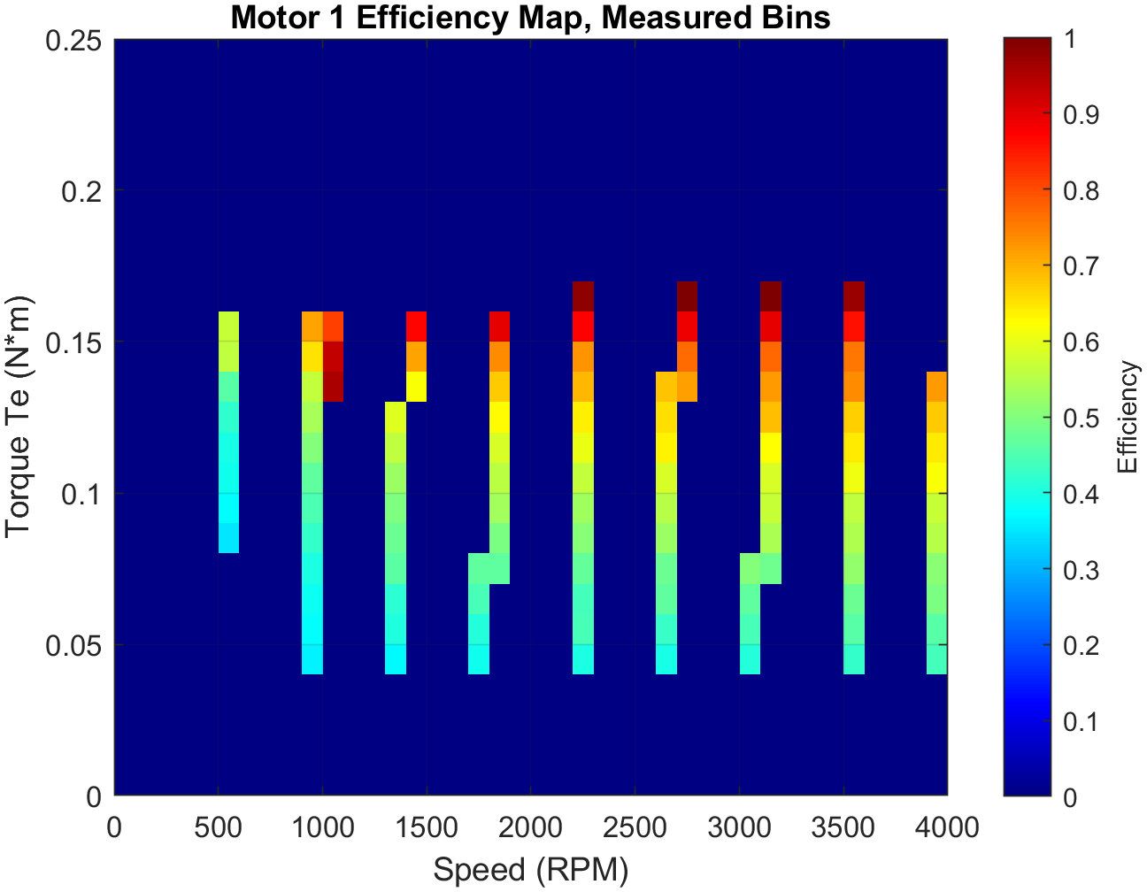
Figure 4. Measured-bin efficiency map; measured evidence is kept separate from interpolation.
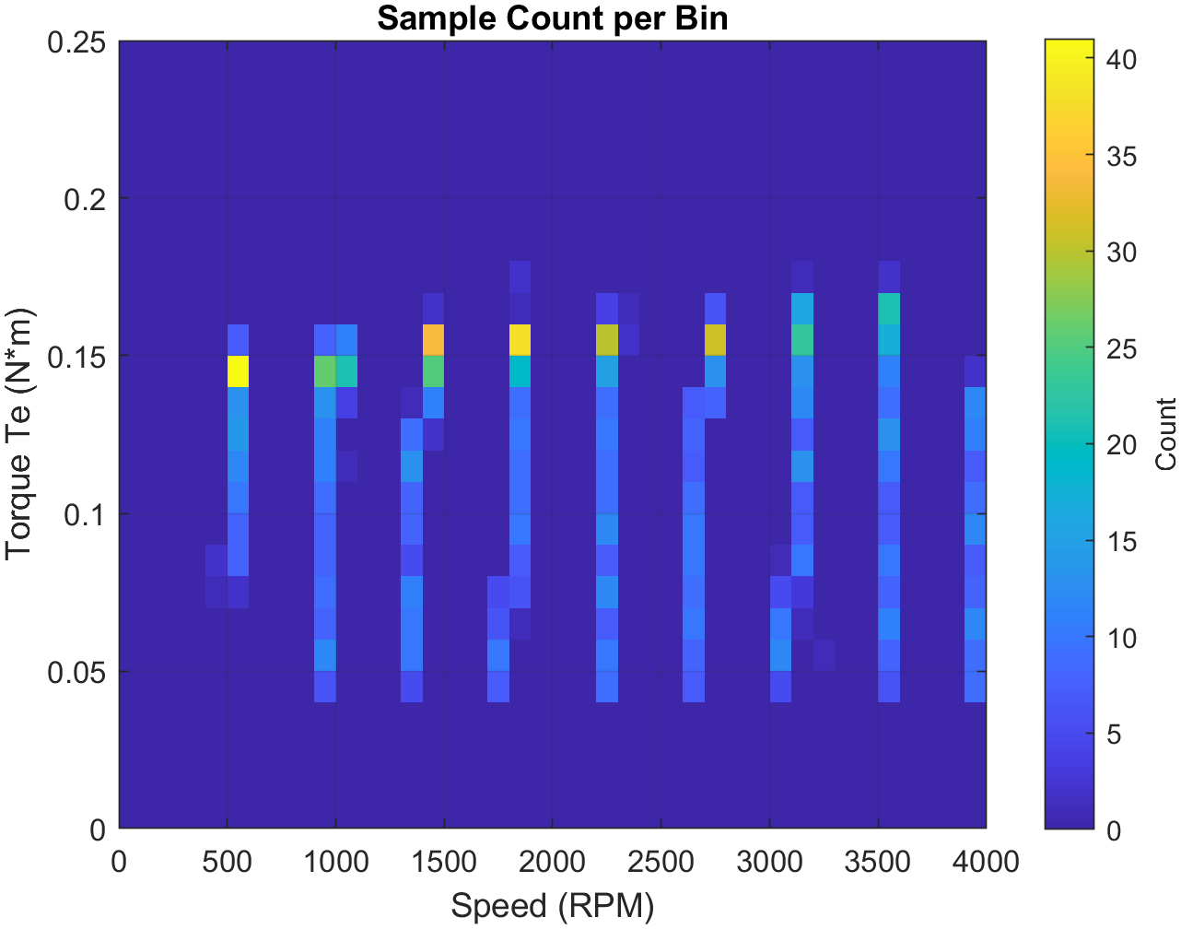
Figure 5. Sample count per operating bin for evidence density review.
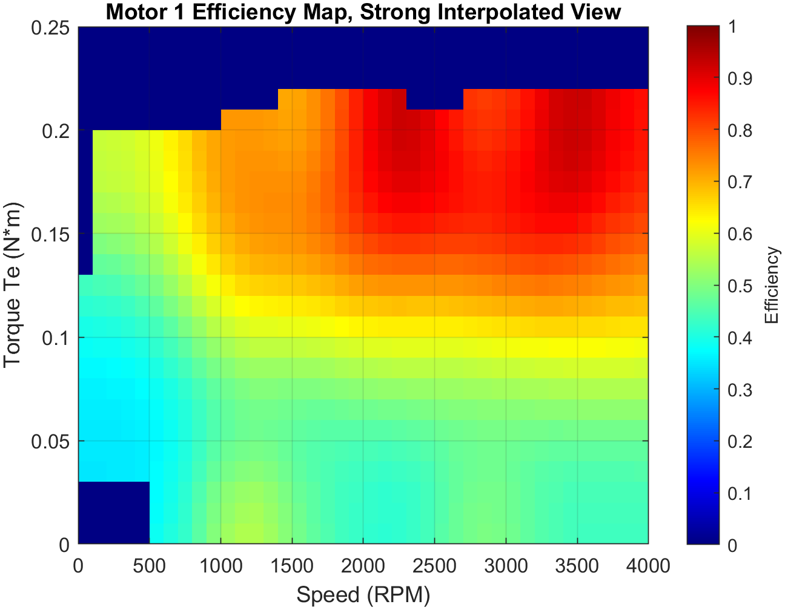
Figure 6. Interpolated efficiency surface for visualization only.

7. Requirements Verification Matrix
Requirement | Method | Result | Objective evidence
SYS-001 | D/T | Verified | Operational dual-motor bench evidence.
SYS-002 | I/T | Verified | Corrected phase and QEP assignments.
CTL-001 | I/D | Verified | Target FOC/PWM/ADC/QEP architecture.
CTL-002 | T | Verified | Successful speed-command tests and efficiency-map runs.
CTL-003 | T | Verified | Fixed-dwell and drive-cycle load profiles.
CTL-004 | I/D | Verified | Retained host/target model behavior and command routing.
COM-001 | I/D | Verified | Generated target code mailbox configuration.
COM-002 | I/D | Verified | Generated target code mailbox configuration.
COM-003 | I/D | Verified | Byte pack/unpack and host command evidence.
COM-004 | I | Verified | Interface summary and FRD architecture.
DAQ-001 | I/A | Verified | Interpolation and crop logic in processing source.
DAQ-002 | I/A | Verified | Validity masks and filtering plots.
DAQ-003 | A | Verified | Sample-count map.
CHR-001 | I/A | Verified | Processing edges and published figures.
CHR-002 | I/A | Verified | Processing script and report method.
CHR-003 | I/A | Verified | Processing script and report method.
CHR-004 | I | Verified | Separate measured and interpolated maps.
DRV-001 | I/D | Verified | Public drive-cycle setup script.
SAF-001 | I | Verified | NOTICE and report limitations.
REL-001 | I | Verified | Final package inspection.
PER-001 | I/A | Verified | Repository or processing evidence.
PER-002 | I/A | Verified | Repository or processing evidence.
PER-003 | I/A | Verified | Repository or processing evidence.
TIM-001 | D | Verified | Repository or processing evidence.
USA-001 | I | Verified | Repository or processing evidence.
MAI-001 | I | Verified | Repository or processing evidence.
TRC-001 | I | Verified | Repository or processing evidence.
SEC-001 | I | Verified | Repository or processing evidence.
SYS-021 | I/T | Verified | Custom source configures SOC12/13 for ADCINA2/B2 with ADCINT5 and SOC14/15 for ADCINA1/B1 with ADCINT9.
PER-009 | I | Verified | Both added pairs use ePWM1 trigger selection, simultaneous sampling, and a seven-clock acquisition window.

8. Validation Against Intended Use
Intended use | Validation statement | Result
Embedded motor-control bring-up | The platform demonstrates correction of physical interfaces and restoration of dual-machine operation. | Demonstrated
Real-time host integration | The platform demonstrates command/response transport between a real-time host and C2000 target over CAN. | Demonstrated
Dynamometer characterization | The platform demonstrates repeatable command generation, data screening, measured-bin mapping, and evidence-density review. | Demonstrated
Production motor-drive qualification | The public evidence does not include EMC, environmental, functional-safety, endurance, or production acceptance testing. | Not claimed
Calibrated metrology system | The release does not provide a complete uncertainty budget or traceable calibration chain. | Not claimed

9. Limitations, Risks, and Open Items
Item | Controlled statement
Safety | No independent safety controller, certified stop chain, or functional-safety assessment is claimed in this release.
Measurement uncertainty | Efficiency results are engineering characterization outputs; a full sensor, torque, timing, and interpolation uncertainty budget is not included.
CAN robustness | The public evidence establishes frame transport, not exhaustive bus-load, fault-injection, timeout, or recovery qualification.
Operating envelope | The analysis grid extends to 4000 rpm and 0.25 N m; this is not a universal continuous-duty rating for every hardware configuration.
Drive cycle | The compressed FTP-style profile is a bench demonstration and is not a regulatory vehicle-emissions test.
Third-party documentation | Vendor schematics are references and do not grant manufacturing or redistribution rights beyond their original terms.

10. Public/Private Release Boundary
Public evidence | Controlled or excluded
Architecture and requirement descriptions | Complete target and host models
Selected MATLAB setup/processing utilities | Generated C/C++ trees and binaries
Sanitized result plots | Raw unpublished datasets and tuning history
Vendor schematic PDFs and interface notes | Editable vendor CAD, Gerbers, pick-and-place, fabrication packages
Public BOM and repository map | Internal minutes, university paths, sponsor records, and design history
Custom F28069M ADC configuration source | TI device-support source and generated ADC build output

11. References and Document Control
- ISO/IEC/IEEE 29148:2018, Systems and software engineering - Life cycle processes - Requirements engineering (confirmed current by ISO in 2024).
- NASA Systems Engineering Handbook, Appendix C (good requirement guidance), Appendix D (requirements verification matrix), and Appendix E (validation matrix).
- Texas Instruments, LAUNCHXL-F28069M overview and TMS320F2806x real-time microcontroller documentation.
- Public repository evidence retained with this release.
Rev | Date | Author | Description
1.4 | 2026-08-04 | HES | Final public release: added custom F28069M ADC SOC/interrupt configuration, actual editable Simulink models, and organized embedded/host source boundaries.

Appendix A - Board Interface Figure
The following retained board-interface figure documents the BoosterPack-to-LaunchPad signal boundary used during electrical-interface review. It is included as supporting public evidence and does not replace the current vendor schematic or board-revision documentation.
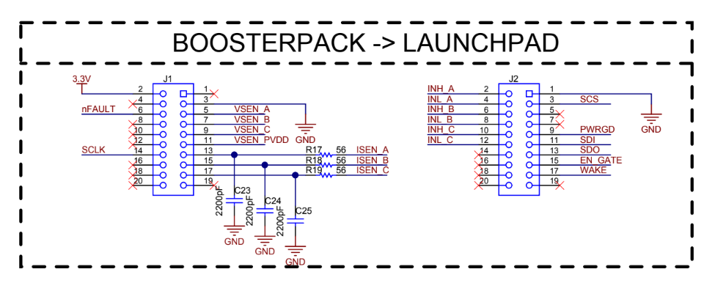
Figure A-1. BoosterPack-to-LaunchPad interface showing voltage-sense, current-sense, fault, SPI, power-good, shutdown, and control signal routing.
Use limitation: verify connector numbering, signal polarity, and board revision against current Texas Instruments documentation before energizing the platform.

Appendix B - Custom F28069M ADC Peripheral Integration
The public source release includes project-specific low-level ADC configuration in addition to the editable Simulink models. The retained file, F28069M_ADC_Custom_Config.c, directly configures F28069M ADC registers and is intentionally distinguished from MathWorks-generated MW_c28xx_adc.c output.

B.1 Functional purpose
The custom source extends the target acquisition path with two additional simultaneous analog-input pairs synchronized to ePWM1. This enables the embedded controller to acquire additional instrumentation channels without moving sample timing into the non-real-time host.
SOC pair | Inputs | Trigger | Completion | Role
SOC0/SOC1 | ADCINA0 / ADCINB0 | ePWM1 | EOC1 -> ADCINT1 | Baseline synchronized pair
SOC2/SOC3 | ADCINA3 / ADCINB3 | ePWM4 | EOC3 -> ADCINT2 | Baseline synchronized pair
SOC4/SOC5 | ADCINA0 / ADCINB0 | Software | Polled / model-controlled | Software-triggered pair
SOC6/SOC7 | ADCINA3 / ADCINB3 | Software | Polled / model-controlled | Software-triggered pair
SOC12/SOC13 | ADCINA2 / ADCINB2 | ePWM1 | EOC13 -> ADCINT5 | Added instrumentation pair
SOC14/SOC15 | ADCINA1 / ADCINB1 | ePWM1 | EOC15 -> ADCINT9 | Added instrumentation pair

B.2 Implementation details
- SOC12/SOC13 select ADCINA2 and ADCINB2 in simultaneous-sampling mode, use ePWM1 as the trigger, and route EOC13 to ADCINT5.
- SOC14/SOC15 select ADCINA1 and ADCINB1 in simultaneous-sampling mode, use ePWM1 as the trigger, and route EOC15 to ADCINT9.
- The acquisition window is configured as ACQPS = 6, corresponding to seven ADC clock cycles.
- Late interrupt pulse positioning is enabled so the ADC result latch is updated before the interrupt is asserted.
- The file retains baseline PWM-triggered and software-triggered ADC pair configuration used by the dual-motor target.

B.3 Verification and ownership boundary
Verification is by source inspection and target integration test. The public repository includes the project-specific configuration file and editable target model, but excludes TI device-support implementation, generated code, object files, and binaries. This demonstrates custom peripheral integration without claiming authorship of vendor libraries or generated support code.

