DUAL-MOTOR PMSM
DYNAMOMETER PLATFORM
FUNCTIONAL REQUIREMENTS &
VALIDATION REPORT
TI C2000 F28069M, dual-inverter control, interfaces, and verification
Customer-facing technical report
Revision 1.6 - 5 August 2026
Prepared by | Herder Elektronische Systemen
Primary subject | System requirements, interfaces, verification status, and public release boundary
Evidence basis | Simulink source models, custom ADC source, CAN interfaces, scripts, figures, and schematics
Distribution | Customer-facing; selected source models, custom firmware, and engineering evidence included
DOCUMENT PURPOSE
This report defines what the public Dual-Motor PMSM Dynamometer Platform is required to do, how each requirement is verified, what evidence is retained, and which capabilities remain outside the release. Implementation details and measured-result interpretation are intentionally assigned to the companion engineering report.

1. Executive Summary
The platform is a coupled two-machine dynamometer built around a TI C2000 F28069M controller, two DRV8305 inverter stages, encoder feedback, supervisory host models, CAN communication, and a structured data-processing workflow. This FRD is deliberately concise: it defines mandatory behavior, interfaces, verification methods, and release limitations without duplicating the implementation narrative.
DOCUMENT BOUNDARY
This FRD answers “what shall the system do and how is compliance shown?” The companion Embedded Control, CAN & Characterization Report answers “how was it implemented and what did testing show?”

2. Scope and System Boundary
- Embedded field-oriented control for two coupled PMSMs.
- Drive-machine speed command and load-machine q-axis current command.
- Independent encoder feedback and target-derived acquisition signals.
- Supervisory CAN command path and diagnostic return path.
- Selected editable Simulink models, custom ADC C source, MATLAB utilities, public figures, and interface documentation.

2.1 Excluded claims and assets
- No production functional-safety certification, calibrated torque traceability, EMC qualification, or environmental qualification.
- No generated C/C++ code, binaries, caches, private raw MAT datasets, or workstation-specific build artifacts.
- No vendor manufacturing packages, editable third-party PCB projects, Gerbers, or licensed software bundles.
- No course instructions, student-facing lab material, answer keys, or internal university records.

3. System Context
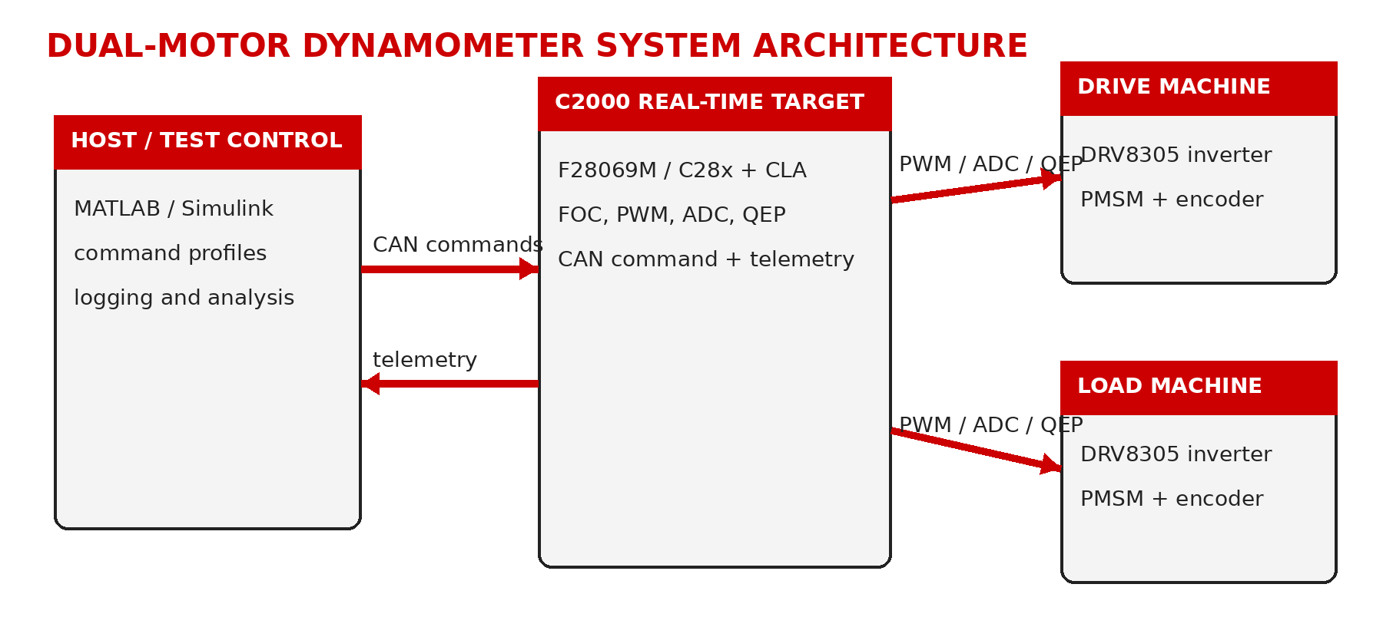
Figure 1. Public system boundary: supervisory host, C2000 real-time target, dual inverter stages, and coupled drive/load machines.

4. Functional Requirements
ID | Area | Requirement | Verification | Status
SYS-001 | Real-time control | The system shall execute fast motor-control loops on the embedded target independently of host display timing. | Inspection + functional test | Demonstrated
SYS-002 | Dual-machine operation | The system shall command one PMSM as the drive machine and the second as a controllable load or assist machine. | Functional test | Demonstrated
SYS-003 | Speed reference | The system shall accept a supervisory speed reference for the drive machine. | Functional test | Demonstrated
SYS-004 | Load reference | The system shall accept a q-axis current or equivalent load reference for the load machine. | Functional test | Demonstrated
SYS-005 | Enable control | The system shall provide explicit enable and disable control for commanded operation. | Inspection + test | Demonstrated
SYS-006 | Feedback | The system shall maintain independent encoder feedback paths for both machines. | Inspection + feedback test | Demonstrated
SYS-007 | Observability | The system shall expose speed, current, voltage, torque-related, power-related, and diagnostic quantities required by the public workflow. | Inspection + analysis | Demonstrated
SYS-008 | Repeatable workflow | The host workflow shall support repeatable setup, capture, export, and postprocessing. | Procedure review | Demonstrated

5. Interface Requirements
ID | Interface | Requirement | Verification | Status
IF-001 | DC input | The inverter stack shall use a verified 24 VDC supply with current limiting during bring-up. | DMM + startup test | Demonstrated
IF-002 | Motor phases | Each PMSM shall be connected consistently to its assigned inverter phase outputs. | Continuity + spin test | Demonstrated
IF-003 | Encoder routing | Motor 1 and Motor 2 encoder channels shall remain electrically and logically distinct. | Pin inspection + feedback test | Demonstrated
IF-004 | CAN physical layer | The CAN bus shall provide CANH, CANL, reference ground, and appropriate termination. | Resistance + bus test | Demonstrated
IF-005 | CAN command | The target shall receive the four-word supervisory command payload on the documented command identifier. | Bus test | Demonstrated
IF-006 | CAN diagnostics | The target shall provide a return identifier for command echo or telemetry diagnostics. | Bus test | Demonstrated
IF-007 | Custom ADC acquisition | The target shall configure two additional simultaneous ADC input pairs using handwritten F28069M peripheral source. | Source inspection + acquisition test | Demonstrated

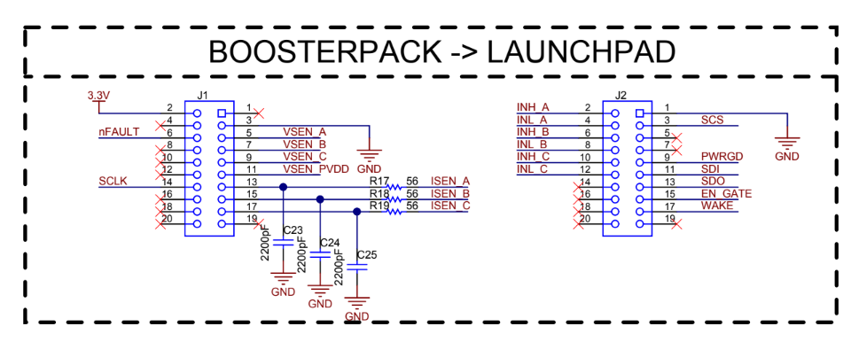
Figure 2. BoosterPack-to-LaunchPad board-interface reference retained with the public release.

6. Data and Processing Requirements
ID | Area | Requirement | Verification | Status
DAT-001 | Mechanical power | The analysis shall compute mechanical power from torque and angular speed. | Equation inspection | Verified
DAT-002 | Electrical power | The dq-frame workflow shall compute electrical power from 1.5 × Vq × Iq for the retained implementation. | Equation inspection | Verified
DAT-003 | Validity filtering | The workflow shall apply explicit minimum-power, minimum-torque, and bounded-efficiency masks before binning. | Script + figure inspection | Demonstrated
DAT-004 | Measured bins | Published efficiency maps shall distinguish populated measured bins from unmeasured regions. | Figure inspection | Demonstrated
DAT-005 | Sample density | The release shall retain a sample-count view for operating-region confidence review. | Figure inspection | Demonstrated
DAT-006 | Traceability | Published figures shall be traceable to retained scripts or approved evidence outputs. | Repository inspection | Verified

7. Safety and Release Constraints
- Verify DC polarity before energizing either inverter stage.
- Begin with low speed, zero load command, conservative limits, and accessible shutdown.
- Confirm encoder direction and phase order before closed-loop sweeps.
- Do not treat software disable as an independent safety function.
- Do not represent the public platform as production-qualified or safety-certified.

8. Requirements Traceability Matrix
Requirement | Verification method | Retained evidence | Status
SYS-001 | Inspection + functional test | C2000_Dual_Motor_CAN_Target.slx | Demonstrated
SYS-002 | Functional test | target and host models | Demonstrated
SYS-003 | Functional test | host setup models | Demonstrated
SYS-004 | Functional test | host setup models | Demonstrated
SYS-005 | Inspection + test | host/target models | Demonstrated
SYS-006 | Inspection + feedback test | board interface + target model | Demonstrated
SYS-007 | Inspection + analysis | target model + processing scripts | Demonstrated
SYS-008 | Procedure review | setup/logging/analysis scripts | Demonstrated
IF-001 | DMM + startup test | interface summary | Demonstrated
IF-002 | Continuity + spin test | interface summary | Demonstrated
IF-003 | Pin inspection + feedback test | board-interface figure | Demonstrated
IF-004 | Resistance + bus test | CAN model set | Demonstrated
IF-005 | Bus test | CAN_Receive.slx | Demonstrated
IF-006 | Bus test | CAN_Transmit.slx | Demonstrated
IF-007 | Source inspection + acquisition test | F28069M_ADC_Custom_Config.c | Demonstrated
DAT-001 | Equation inspection | motor_efficiency_processing.m | Verified
DAT-002 | Equation inspection | motor_efficiency_processing.m | Verified
DAT-003 | Script + figure inspection | 03_filter_masks.png | Demonstrated
DAT-004 | Figure inspection | 05_measured_efficiency_map.png | Demonstrated
DAT-005 | Figure inspection | 06_sample_count_map.png | Demonstrated
DAT-006 | Repository inspection | repository map and checksums | Verified

9. Validation and Release Gate
Validation objective | Acceptance basis | Status
Coupled drive/load operation | Motor 1 establishes shaft speed while Motor 2 applies controlled loading. | Demonstrated
Efficiency workflow | Physics masks, measured bins, sample density, and contour outputs retained. | Demonstrated
CAN supervisory control | Command receipt and motor-spin validation retained in public models and documentation. | Demonstrated
Custom ADC path | Additional PWM-triggered simultaneous input pairs integrated with target application. | Demonstrated
Production qualification | Calibration, endurance, EMC, environmental, and independent safety validation. | Not claimed

RELEASE GATE
Publish only after PDFs are rendered page by page, report links resolve, the ZIP opens at repository root, and public files contain no school-specific lab instructions or private build artifacts.

