DUAL-MOTOR PMSM
DYNAMOMETER PLATFORM
EMBEDDED CONTROL &
CHARACTERIZATION
C2000/Simulink architecture, custom ADC firmware, CAN, host software, and measured results
Customer-facing technical report
Revision 1.6 - 5 August 2026
Prepared by | Herder Elektronische Systemen
Primary subject | Implementation architecture, source inventory, acquisition workflow, and characterization results
Evidence basis | Editable Simulink models, handwritten F28069M C source, MATLAB tooling, plots, and interface references
Distribution | Customer-facing; selected source models, custom firmware, and engineering evidence included
DOCUMENT PURPOSE
This report explains how the platform was implemented and what the retained engineering evidence demonstrates. It intentionally references the FRD for requirement definitions rather than repeating requirement tables, release gates, or system-boundary language.

1. Engineering Overview
The implementation combines model-based embedded control with a small, clearly identified handwritten peripheral layer. Editable Simulink models define the real-time dual-motor application, CAN interfaces, current-control subsystem, and supervisory hosts. A custom C source file extends the F28069M ADC configuration for additional simultaneous measurements. MATLAB utilities configure tests, capture sessions, and process the retained efficiency evidence.
COMPANION RELATIONSHIP
Requirement IDs and verification status are controlled by the FRD. This report supplies implementation detail and evidence interpretation only.

2. Repository Source Inventory
Layer | Public path | Purpose
Target application | models/simulink/target/C2000_Dual_Motor_CAN_Target.slx | Editable real-time application model
Host models | models/simulink/host/*.slx | Efficiency, drive-cycle, and Speedgoat/CAN supervision
Subsystem models | models/simulink/subsystems/*.slx | CAN receive, CAN transmit, and current control
Custom firmware | embedded-control/custom-firmware/F28069M_ADC_Custom_Config.c | Handwritten register-level ADC configuration
MATLAB tooling | host-software/setup, logging, analysis | Configuration, capture, export, plotting, and processing
Evidence | results/*.png | Raw signals, filters, measured bins, density, and contours

3. Embedded Control Architecture
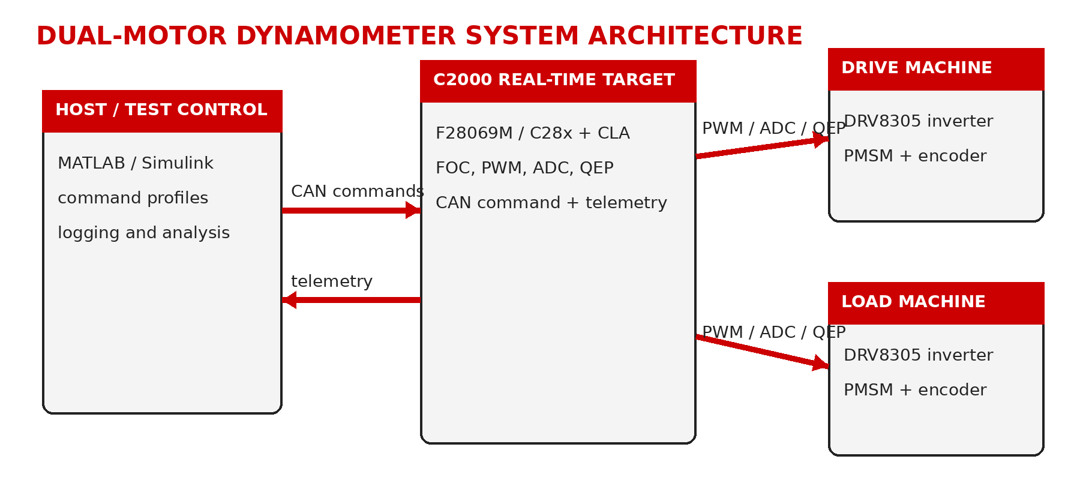
Figure 1. Control and telemetry architecture used by the public implementation.
The C2000 target owns the high-rate field-oriented control loops and machine feedback. The host supplies supervisory references and test sequencing but does not act as the current-loop or speed-loop scheduler. Motor 1 operates as the drive machine. Motor 2 applies opposing or assisting q-axis current to create a controllable load condition.

3.1 Simulink model roles
Model | Engineering role
C2000_Dual_Motor_CAN_Target.slx | Integrated C2000 target model containing dual-machine control, feedback, CAN paths, and deployable target logic.
Current_Control.slx | Reusable current-control implementation supporting the target FOC path.
CAN_Receive.slx | Receives and unpacks the supervisory command payload.
CAN_Transmit.slx | Returns command echo or selected telemetry for diagnostic separation.
Efficiency_Mapping_Host.slx | Commands repeatable speed/load points and supports efficiency acquisition.
Drive_Cycle_Host.slx | Runs time-varying speed and load profiles.
Speedgoat_CAN_Host.slx | Provides the real-time supervisory CAN endpoint.

4. Custom F28069M ADC Integration
The public release includes handwritten source rather than only generated support code. F28069M_ADC_Custom_Config.c configures two additional simultaneous ADC pairs for the measurement path and integrates them with the target application.
SOC pair | Analog inputs | Trigger | Acquisition window | Interrupt routing
SOC12 / SOC13 | ADCINA2 / ADCINB2 | ePWM1 | 7 ADC clocks | EOC13 → ADCINT5
SOC14 / SOC15 | ADCINA1 / ADCINB1 | ePWM1 | 7 ADC clocks | EOC15 → ADCINT9

OWNERSHIP AND ACCURACY
The custom file is presented as register-level peripheral integration. Generated C/C++ support files and TI library internals are excluded; the release does not claim a ground-up ADC driver.

5. CAN Command and Diagnostic Path
The supervisory transport uses a standard CAN command frame containing four 16-bit words. The receive subsystem decodes references and control state into the existing target signal paths. A separate return identifier carries command echo or selected diagnostic telemetry, helping distinguish physical-link faults from target-logic faults.
Item | Public definition | Implementation role
Command ID | 0x100 | Four 16-bit command words in an 8-byte standard frame
Return ID | 0x101 | Command echo or selected diagnostic telemetry
Target integration | CAN receive and unpack | Decoded signals feed reference, enable, selection, and FOC paths
Diagnostic purpose | Return traffic | Separates bus-level failure from model-level interpretation

6. Host Software and Acquisition Workflow
- efficiency_test_setup.m configures repeatable speed/load sweeps and opens the neutral customer-facing host model.
- drive_cycle_setup.m configures time-varying command profiles without school or course references.
- save_debug_session.m exports timeseries, constants, metadata, and a session README.
- post_dyno_export.m and plot_all_dyno_runs.m organize retained datasets and produce reviewable plots.
- motor_efficiency_processing.m performs signal alignment, power calculations, validity filtering, binning, density review, and contour generation.

7. Characterization Method
The processing chain intentionally exposes intermediate decisions. Raw command and feedback signals are aligned, forced or invalid values are identified, physics-based masks are applied, retained operating points are reviewed, measured bins are formed, sample counts are inspected, and interpolation is presented only after measured coverage is visible.
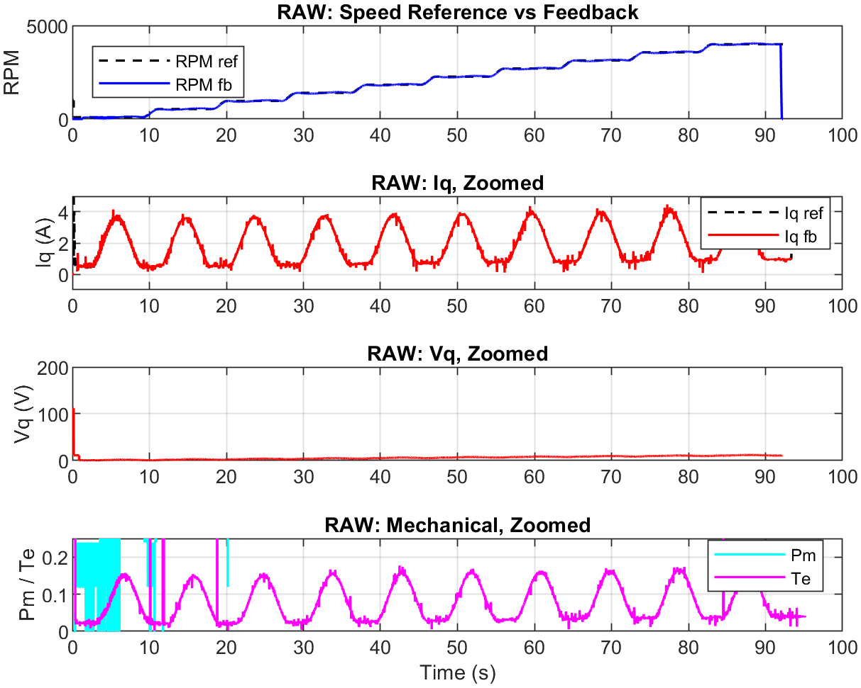
Figure 2. Raw speed, current, voltage, mechanical, and torque-related signals retained before filtering.
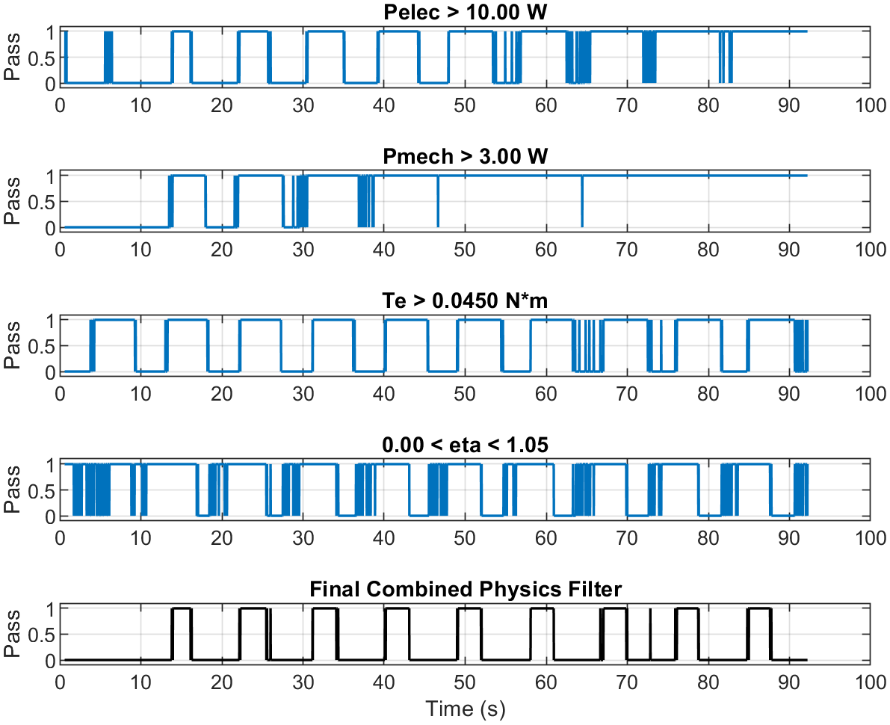
Figure 3. Explicit electrical-power, mechanical-power, torque, and combined validity masks.

8. Measured Evidence
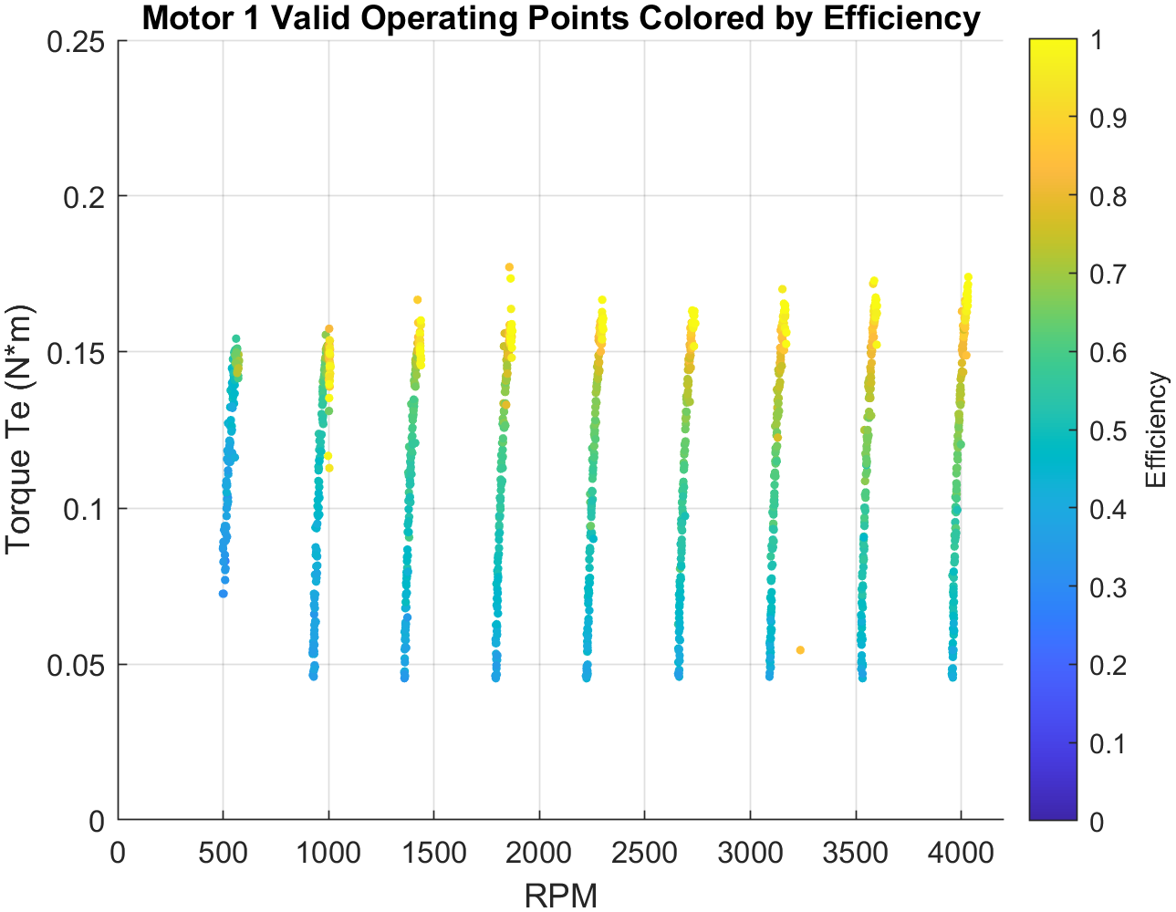
Figure 4. Retained speed-torque operating points colored by calculated efficiency.
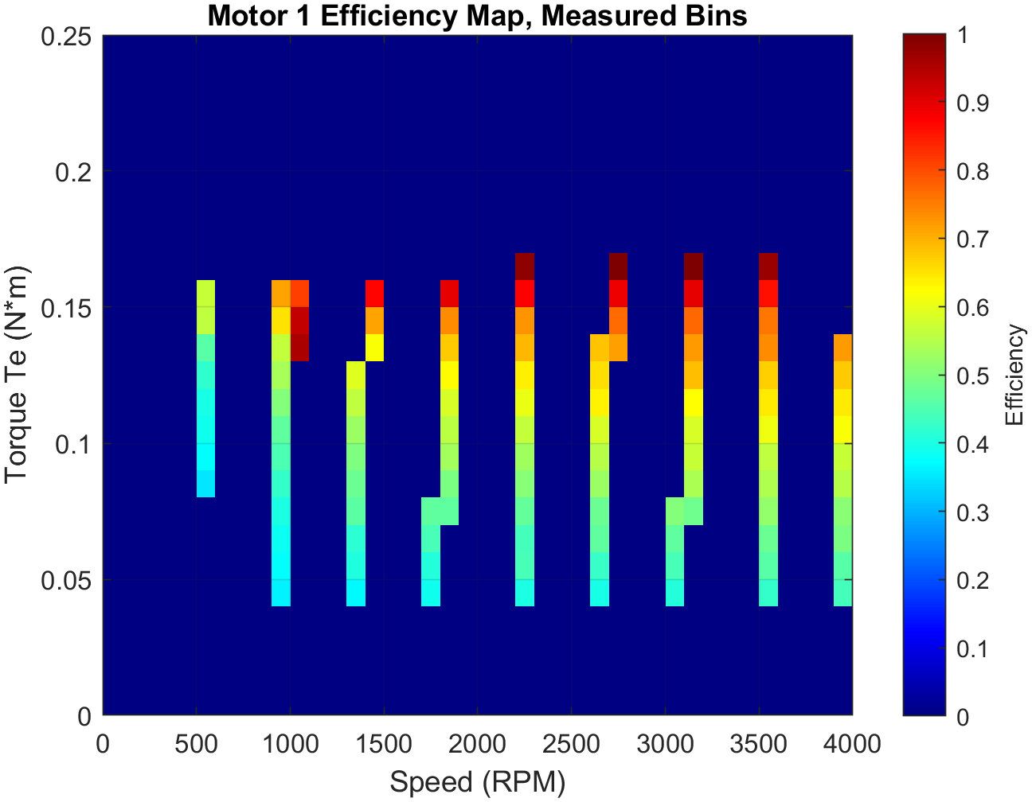
Figure 5. Measured-bin efficiency map; unpopulated regions remain visibly distinct.
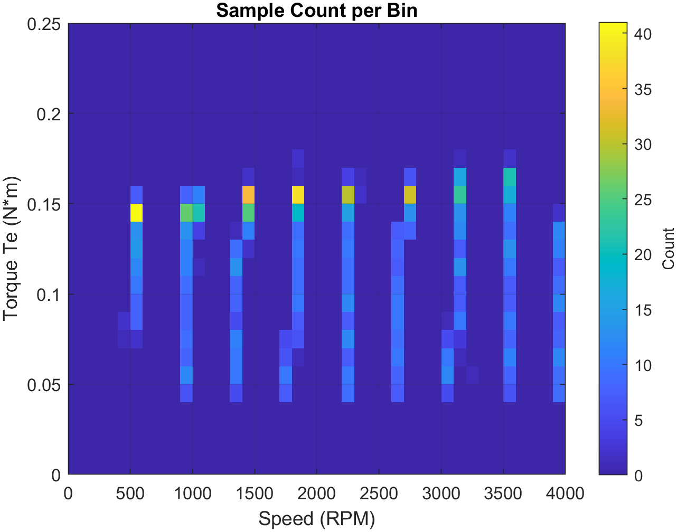
Figure 6. Sample-count map used to judge operating-region density and confidence.
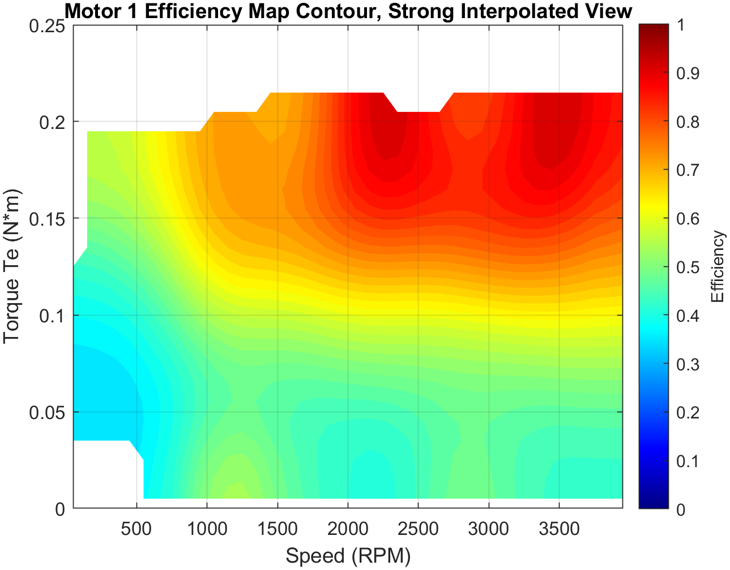
Figure 7. Contour presentation generated after measured-bin and density review.

8.1 Controlled interpretation
- Published speed sweeps approach 4000 RPM in the retained evidence.
- Demonstrated torque-related operating points are concentrated roughly between 0.045 and 0.17 N·m.
- Efficiency values are filtered using explicit power, torque, and bounded-efficiency criteria before binning.
- Measured bins and sample density are the primary evidence; interpolated surfaces are secondary visualization products.
- The results demonstrate bench integration and processing discipline, not calibrated product efficiency or regulatory qualification.

9. Physical Interface Evidence
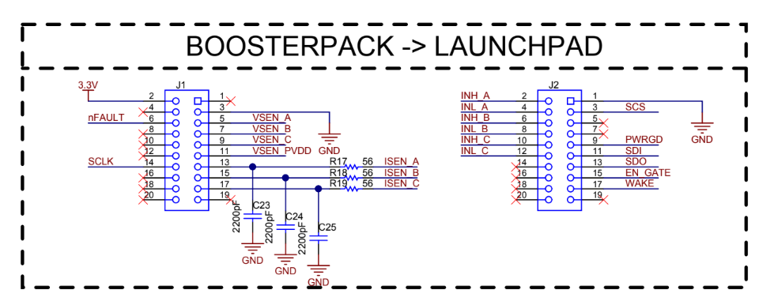
Figure 8. BoosterPack-to-LaunchPad interface reference used during hardware integration.
The release also retains the applicable LaunchPad and BOOSTXL-DRV8305EVM public schematics and a concise interface summary. These references support pinout review and connection traceability without redistributing editable vendor manufacturing sources.

10. Limitations and Next Validation
Area | Controlled statement
Torque and electrical calibration | Independent traceable calibration is outside the retained public evidence.
Thermal endurance | Long-duration thermal and derating qualification is not included.
Fault coverage | A complete independent protection chain and production fault tree are not claimed.
EMC and environment | Formal EMC, vibration, ingress, and environmental testing are not included.
Model dependencies | Opening and deploying the models requires compatible MATLAB/Simulink, C2000 support packages, and relevant licensed hardware blocks.
Physical demonstration media | A dedicated platform video or full-bench photograph should be added when approved and available.

11. Public Engineering Outcome
The public repository demonstrates a complete engineering stack: editable target and host models, handwritten ADC configuration, CAN subsystems, neutral acquisition and analysis scripts, hardware references, and measured outputs. The FRD controls requirements and traceability; this report documents implementation and evidence.

