DUAL-MOTOR PMSM DYNAMOMETER
PLATFORM

FIRMWARE, HOST SOFTWARE & RESULTS
TI C2000 F28069M control models, CAN supervision, acquisition, safeguards, and measured characterization
ENGINEERING REQUIREMENTS DOCUMENT | REVISION 2.4 | 5 AUGUST 2026
Prepared by | Herder Elektronische Systemen
Document scope | Embedded target behavior, editable Simulink models, CAN command/telemetry, host acquisition, custom ADC integration, and verification
Evidence basis | Target/host Simulink models, custom ADC source, MATLAB scripts, CAN evidence, captured signals, and measured maps
Distribution | Customer-facing; selected source models and controlled engineering evidence included
DOCUMENT PURPOSE
Defines the controlled firmware, host-software, interface, safety, verification, and acceptance requirements. Platform wiring, physical interfaces, schematics, and board ownership are controlled by the companion Platform & Electrical FRD.

Functional Requirements Document Framework
WHY THIS IS AN FRD
This document defines what the embedded and host subsystems shall do, the interfaces and constraints under which they shall operate, and the evidence required for acceptance. Model screenshots and result plots support verification; they do not replace the requirements.

Purpose, Scope, and System Boundary
This FRD governs the C2000 target models, host supervisory models, CAN command and return paths, custom ADC integration, logging, and characterization outputs. Mechanical construction, connector ownership, power wiring, and vendor board details are external interfaces controlled by the companion Platform & Electrical FRD.
Boundary element | Included here | Referenced elsewhere
Target control | Drive/load roles, modes, enable, feedback, ADC acquisition | Board power and physical wiring
Host software | Supervisory commands, acquisition, logging, analysis dispatch | Workstation and licensed-tool provisioning
Verification | CAN tests, model inspection, captured signals, measured characterization | EMC, enclosure, thermal and production qualification

Users and Operational Scenarios
Actor | Primary interaction | Expected outcome
Controls engineer | Modify target/host models within defined interfaces | Behavior remains traceable to requirement IDs
Test engineer | Configure runs, acquire signals, execute analysis | Repeatable evidence products
Customer / reviewer | Inspect requirements, source models and results | Clear demonstrated capability and open limits

1. Embedded and Host Operating Concept
Motor 1 establishes shaft speed while Motor 2 applies an opposing or assisting q-axis current. The C2000 target owns the high-rate field-oriented control loops. Host models provide bounded supervisory references, CAN command packing, acquisition, and test orchestration without becoming the real-time control clock.
- Independent feedback paths are retained for both machines.
- CAN command words enter the existing target reference paths rather than bypassing control logic.
- Custom register-level ADC configuration adds two simultaneous analog-input pairs.
- Host logging retains timestamped signals and metadata for post-run review.

1.1 Operating Modes
Mode | Required behavior
Disabled / safe | Torque-producing references are inhibited.
Drive-only | Motor 1 controls speed; Motor 2 remains at a bounded zero-load condition.
Loaded dynamometer | Motor 1 controls speed while Motor 2 applies bounded q-axis load.
CAN-supervised | Four 16-bit command words are received and mapped to the target command interface.
Acquisition | Selected target signals are recorded without altering real-time loop ownership.

1.2 Requirement Conventions
Mandatory behavior is written as a singular “shall” statement. Each requirement identifies a verification method and release status. “Demonstrated” means observed on retained bench evidence; “Verified” means the release package was inspected and accepted.

2. Firmware and Host Functional Requirements
ID | The system shall... | Verification | Status
FW-001 | The embedded target shall execute the fast current and speed loops independently of host refresh, plotting, or logging timing. | Inspection + test | Demonstrated
FW-002 | The target shall command one machine as the drive unit and the second as a controllable load or assist unit. | Functional test | Demonstrated
FW-003 | The target shall maintain independent encoder feedback paths for both machines. | Inspection + feedback test | Demonstrated
FW-004 | The host shall provide bounded speed, load, enable, and motor-selection references. | Model inspection | Demonstrated
FW-005 | The host shall support repeatable configuration, capture, and post-run review. | Procedure review | Verified
FW-006 | The released source shall include editable Simulink models rather than screenshots alone. | Release inspection | Verified
FW-007 | The public release shall exclude generated code, binaries, caches, and proprietary build products. | Release inspection | Verified

2.1 CAN Interface Requirements
ID | The system shall... | Verification | Status
CAN-001 | The target shall receive a standard CAN command frame with four 16-bit command words. | Bus test | Demonstrated
CAN-002 | The decoded command words shall feed the existing reference and enable paths. | Model inspection | Demonstrated
CAN-003 | The target shall provide a return identifier for echo or diagnostic telemetry. | Bus test | Demonstrated
CAN-004 | Loss of CAN traffic shall not transfer real-time loop ownership to the host. | Architecture inspection | Verified

3. Custom ADC Requirements
The handwritten F28069M ADC configuration extends the model-based application with two additional simultaneous channel pairs. This source is retained separately from generated MathWorks support code.
ID | The system shall... | Verification | Status
ADC-001 | The custom source shall configure SOC12/SOC13 for ADCINA2/ADCINB2 simultaneous sampling. | Source inspection | Verified
ADC-002 | The custom source shall configure SOC14/SOC15 for ADCINA1/ADCINB1 simultaneous sampling. | Source inspection | Verified
ADC-003 | The added SOC pairs shall use the ePWM1 trigger and a seven-clock acquisition window. | Source inspection | Verified
ADC-004 | EOC13 and EOC15 shall route completion events to ADCINT5 and ADCINT9 respectively. | Source inspection | Verified
ADC-005 | The public repository shall identify the file as custom register-level integration, not generated firmware. | Document review | Verified

3.1 ADC Acceptance Mapping
SOC pair | Inputs | Trigger | Completion | Evidence
12/13 | A2 / B2 | ePWM1 | EOC13 → ADCINT5 | F28069M_ADC_Custom_Config.c
14/15 | A1 / B1 | ePWM1 | EOC15 → ADCINT9 | F28069M_ADC_Custom_Config.c

4. Acquisition and Characterization Requirements
This FRD controls the required outputs and acceptance logic. Detailed processing equations and engineering interpretation remain in the implementation notes and scripts, while the retained plots below provide objective verification evidence.
ID | The system shall... | Verification | Status
DAT-001 | The workflow shall expose speed, current, voltage, torque-related, and power-related quantities required for review. | Signal inspection | Demonstrated
DAT-002 | The analysis shall retain explicit validity masks before map binning. | Script inspection | Verified
DAT-003 | Published maps shall distinguish measured bins from unmeasured regions. | Figure inspection | Verified
DAT-004 | The release shall retain a sample-count view so sparse operating regions remain visible. | Figure inspection | Verified
DAT-005 | Published figures shall be traceable to retained scripts and approved evidence outputs. | Repository inspection | Verified
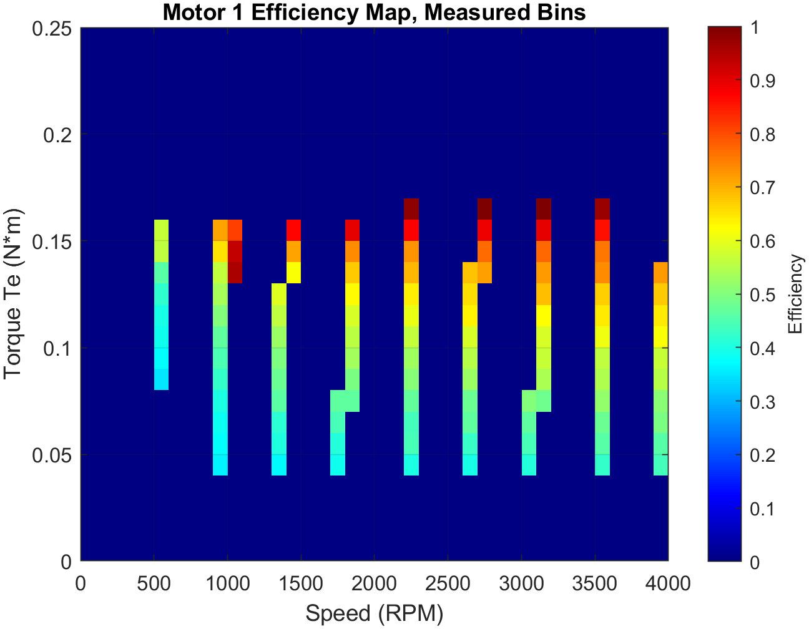
Figure 1. Measured-bin efficiency map retained as verification evidence.
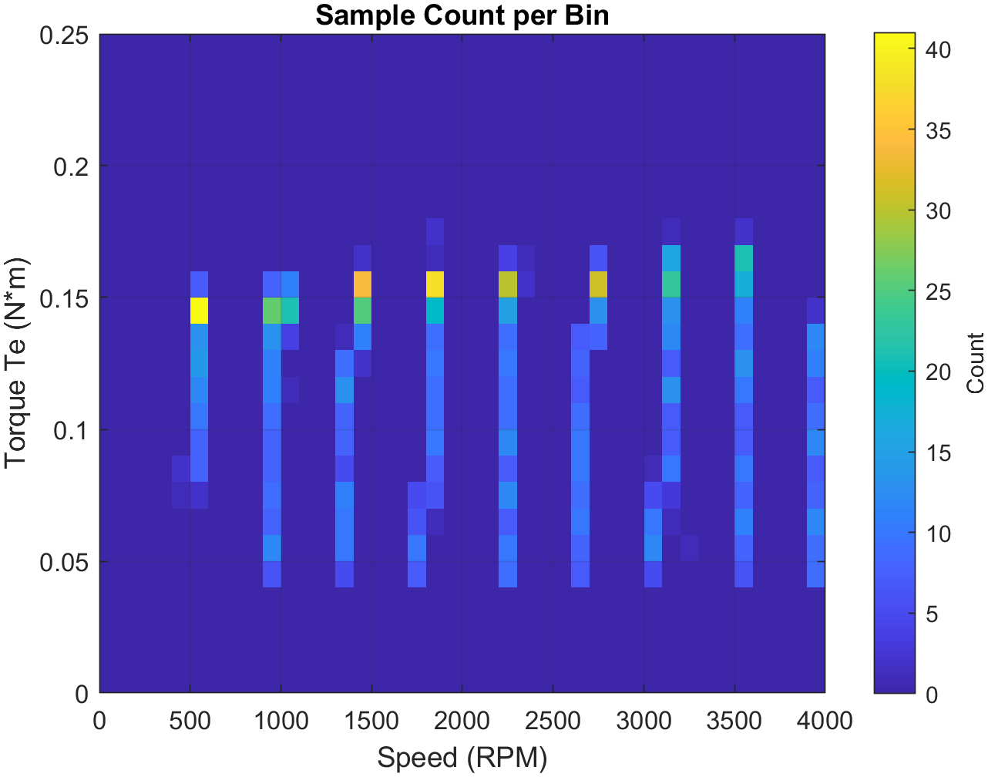
Figure 2. Sample-count map showing evidence density by operating region.

5. Verification and Traceability
Verification uses inspection, analysis, demonstration, and bench test. Acceptance requires a retained evidence path for each mandatory requirement and explicit identification of open qualification items.
Requirement group | Primary method | Retained evidence | Acceptance basis
FW | Model inspection + bench test | Editable .slx models and captured signals | Required control roles and host separation visible
CAN | Model inspection + bus test | Host/target CAN models and diagnostic path | Command receipt and return path demonstrated
ADC | Source inspection | Custom C file | SOC, channel, trigger and interrupt mapping match
DAT | Script + figure inspection | MATLAB source and measured plots | Masks, measured bins and density retained

5.1 Release Limitations
- No calibrated torque traceability is claimed.
- No production functional-safety, EMC, environmental, or endurance qualification is claimed.
- Generated target code and licensed vendor packages are intentionally excluded.
- Efficiency results are bench characterization, not certified machine performance.

5.2 Release Gate
ACCEPTANCE
Release is accepted when every mandatory requirement has a stated method and evidence reference, the editable source models and custom ADC file are present, the public/private boundary is explicit, and both FRDs have been rendered and visually reviewed.

