DUAL-MOTOR PMSM DYNAMOMETER
PLATFORM

PLATFORM, ELECTRICAL & INTERFACES
TI LAUNCHXL-F28069M, dual BOOSTXL-DRV8305EVM stages, encoders, CAN, power, and physical verification
ENGINEERING REQUIREMENTS DOCUMENT | REVISION 2.4 | 5 AUGUST 2026
Prepared by | Herder Elektronische Systemen
Document scope | Physical platform, power distribution, motor phases, encoder routing, board stacking, CAN wiring, connectors, and release limitations
Evidence basis | Vendor schematics, connector maps, public BOM, board-interface figures, and setup verification records
Distribution | Customer-facing; selected source models and controlled engineering evidence included
DOCUMENT PURPOSE
Defines the controlled platform, electrical, interface, safety, verification, and acceptance requirements. Embedded algorithms, host software, CAN message handling, custom ADC code, and efficiency results are controlled by the companion Firmware & Host FRD.

Functional Requirements Document Framework
WHY THIS IS AN FRD
This document defines the physical and electrical behavior the platform shall provide, the interfaces and constraints under which it shall operate, and the objective evidence required for acceptance. Vendor diagrams and photographs support verification; they do not transfer ownership of third-party board designs.

Purpose, Scope, and System Boundary
This FRD governs the institution-independent public description of the dynamometer platform: DC input, board stacking, motor phases, encoder separation, CAN physical layer, deployment connection, mechanical restraint, and safe bench operation. Control algorithms and measured efficiency results are intentionally absent.
Boundary element | Included here | Excluded / referenced
Controller stack | LaunchPad and two inverter stages; connector compatibility | Vendor PCB manufacturing ownership
Machines | Two coupled encoder-equipped PMSMs and phase/feedback routing | Motor internal design and certified ratings
Bench interfaces | 24 V input, USB/deployment, CANH/CANL/GND, termination | Host algorithms and message decoding

1. Platform Architecture
The platform uses one TI LAUNCHXL-F28069M controller board and two BOOSTXL-DRV8305EVM three-phase inverter stages. Two encoder-equipped PMSMs are mechanically coupled so one machine can drive while the second applies a controlled load. A current-limited 24 V bench supply powers the inverter stack; USB supports deployment and diagnostics; CAN supports supervisory communication.
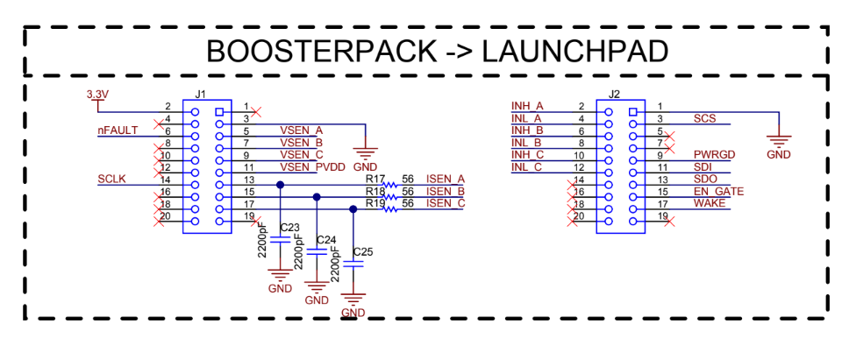
Figure 1. BoosterPack-to-LaunchPad board-interface arrangement.

1.1 Primary Elements
Element | Quantity | Public role
LAUNCHXL-F28069M | 1 | Embedded controller, encoder interfaces, PWM/ADC and CAN endpoint
BOOSTXL-DRV8305EVM | 2 | Three-phase inverter stages for drive and load machines
Encoder-equipped PMSM | 2 | Mechanically coupled drive and load machines
24 V DC supply | 1 | Current-limited bench power source
CAN interface | 1 | Supervisory physical-layer connection

2. Platform and Electrical Requirements
ID | The system shall... | Verification | Status
PLT-001 | The platform shall provide two mechanically coupled encoder-equipped PMSMs. | Inspection | Demonstrated
PLT-002 | The controller stack shall support two independent three-phase inverter stages. | Inspection | Demonstrated
PLT-003 | The platform shall retain physical access for deployment, diagnostics, and emergency shutdown. | Inspection | Demonstrated
PLT-004 | Rotating components shall be restrained and kept clear of hands during operation. | Procedure review | Required
PLT-005 | The public release shall distinguish institution-owned or third-party hardware from authored models and source. | Document review | Verified

2.1 Power and Motor Interface Requirements
ID | The system shall... | Verification | Status
PWR-001 | The inverter stack shall be supplied from 24 V DC with verified polarity and current limiting before operation. | DMM + startup test | Demonstrated
PWR-002 | Each motor shall be connected consistently to its designated three-phase output. | Continuity inspection | Demonstrated
PWR-003 | Initial power-up shall use conservative speed, current, and load limits. | Procedure review | Required
PWR-004 | Software disable shall not be represented as an independent certified safety function. | Document review | Verified

3. Encoder, CAN, and Deployment Interfaces
ID | The system shall... | Verification | Status
IF-001 | Motor 1 and Motor 2 encoder channels shall remain electrically and logically distinct. | Pin inspection + feedback test | Demonstrated
IF-002 | CANH, CANL, and reference ground shall be connected consistently across the bus. | Inspection + bus test | Demonstrated
IF-003 | The CAN bus shall provide two 120-ohm terminations at its physical ends. | Resistance inspection | Required
IF-004 | The target shall retain the debug/deployment connection required for configuration and diagnostics. | Connection inspection | Demonstrated
IF-005 | Board-revision pin assignments shall be checked against current vendor documentation before energizing hardware. | Document review | Required
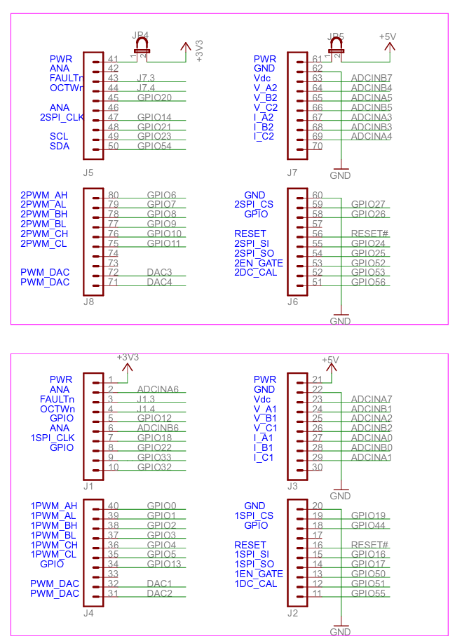
Figure 2. Public connector map used to verify board stacking and interface routing.

3.1 Interface Caution
BEFORE ENERGIZING
Verify supply polarity, board orientation, motor phase order, encoder routing, CAN termination, and mechanical restraint. Stop immediately if the shaft vibrates, loses tracking, overheats, or behaves unexpectedly.

4. Schematics, BOM, and Ownership Boundary
The public package includes vendor schematics and a high-level BOM for interface verification. These materials identify the equipment used; they do not claim authorship of TI board designs or transfer manufacturing rights.
Artifact | Public purpose | Boundary
LAUNCHXL schematic | Controller pin and peripheral reference | TI-owned reference material
BOOSTXL schematic | Gate-driver, phase-output and sensing reference | TI-owned reference material
Public BOM | Platform component identification | Not a manufacturing package
Connector maps | Wiring and board-stacking verification | Verify against current board revision
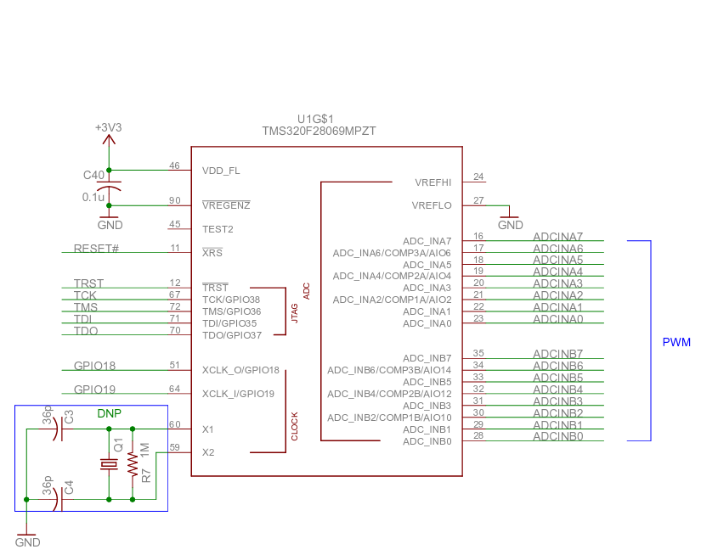
Figure 3. LaunchPad reference view retained for connector orientation.

5. Verification and Acceptance
Platform verification uses inspection, continuity checks, DMM polarity checks, current-limited startup, encoder feedback observation, and CAN communication tests. Passing document or CI checks does not replace physical verification.
Requirement group | Method | Evidence | Acceptance basis
PLT | Visual inspection | Board-interface figures and setup records | Required elements and physical access present
PWR | DMM + current-limited startup | Power-up procedure | Correct polarity and stable low-risk startup
IF | Continuity, pin inspection and bus test | Connector maps and communication evidence | Distinct encoder paths and working interfaces
Release | Archive inspection | NOTICE, BOM and schematics | Ownership and exclusions are explicit

5.1 Open Qualification Items
- Independent torque and electrical-power calibration are outside this release.
- Formal EMC, vibration, ingress, environmental, and long-duration thermal qualification are not included.
- A complete independent protection chain and certified stop architecture are not claimed.
- No vendor PCB manufacturing sources, Gerbers, pick-and-place files, or fabrication packages are redistributed.

5.2 Release Gate
ACCEPTANCE
Release is accepted when the interface requirements have defined verification methods, the schematics and connector maps correspond to the retained platform, the hardware ownership boundary is explicit, and the rendered FRD contains no firmware or efficiency-result duplication.

