Replacing SCI with CAN in the PMSM Motor-Dyno Lab
Reusable Implementation Guide: Speedgoat IO691 CAN Host to TI C2000 F28069M LaunchPad Target
Prepared after successful CAN-based RPM command and motor spin validation
Environment used during bring-up: MATLAB/Simulink R2023b, Simulink Real-Time, Speedgoat IO691, C2000 Microcontroller Blockset, TI LAUNCHXL-F28069M, BOOSTXL-DRV8305 motor-dyno example
Date: 2026-06-03
Safety note: This guide involves spinning motors and motor-drive hardware. Start with low RPM, zero load torque, verified wiring, correct current limits, and emergency-stop access. Do not apply high load or high speed until the CAN command path, enable logic, and feedback path are verified.

Table of Contents
1. Purpose and final result
2. Final system architecture
3. Official documentation and reference links
4. Hardware, software, and files required
5. Clean project setup
6. Speedgoat host setup
7. C2000 target setup
8. Physical CAN wiring
9. CAN message protocol
10. Replacing the SCI receive layer on the target
11. Echo-back diagnostic path
12. Build, deploy, and run sequence
13. Verification tests
14. Troubleshooting and lessons learned
15. Appendix: MATLAB commands and block settings

1. Purpose and final result
The objective of this work was to replace the original serial communication (SCI) command path in the MathWorks PMSM Motor-Dyno model with a CAN-based command path. The Speedgoat real-time target acts as the host/controller side, and the TI F28069M LaunchPad acts as the embedded motor-control target. The final result was successful: the Speedgoat host sent an RPM command over CAN, the C2000 target received and decoded the command, and the motor spun from the CAN command path.
The final implementation does not simply inject raw RPM directly into the FOC controller. Instead, it keeps the original target-side command decoding structure where possible. CAN replaces the lower-level SCI receive/transmit transport layer, while the existing Reference Signal and motor-control logic remain in charge of interpreting commands and enabling motor operation.
Core outcome: The project proved that the command transport can be changed from SCI to CAN while preserving the motor-dyno control structure. A loose/incomplete CAN physical connection was ultimately the main reason the command path appeared broken even after the Simulink logic was mostly correct.

2. Final system architecture
The final architecture separates the two hardware targets cleanly:
HOST_CAN on Speedgoat/Simulink Real-Time
Existing host command logic: RPM, Iq, Enable, Motor select, Debug select
Detect Change/Parse command formatting
Byte Pack: 4 x uint16 -> uint8(8)
CAN Pack: Standard ID 256
Speedgoat IO691 CAN Write, Module ID 2, Channel 1
Physical CAN bus
CANH <-> CANH
CANL <-> CANL
GND <-> GND
Proper termination and secure connection
TARGET_CAN on TI F28069M LaunchPad
C28x CAN Receive: Standard ID 256
Byte Unpack: uint8(8) -> 4 x uint16
First command words -> Reference Signal
Reserved words -> diagnostics/echo
Byte Pack -> C28x CAN Transmit echo, Standard ID 257
Reference Signal -> Enable / SpeedRef / IqRef -> PMSM FOC model

2.1 Final target-side structure
The target-side subsystem contains the C28x CAN Receive block, Byte Unpack, CAN echo transmit path, and the preserved Reference Signal block. The important design choice is that CAN replaces the original SCI receive layer; it does not bypass the entire command interpretation path.
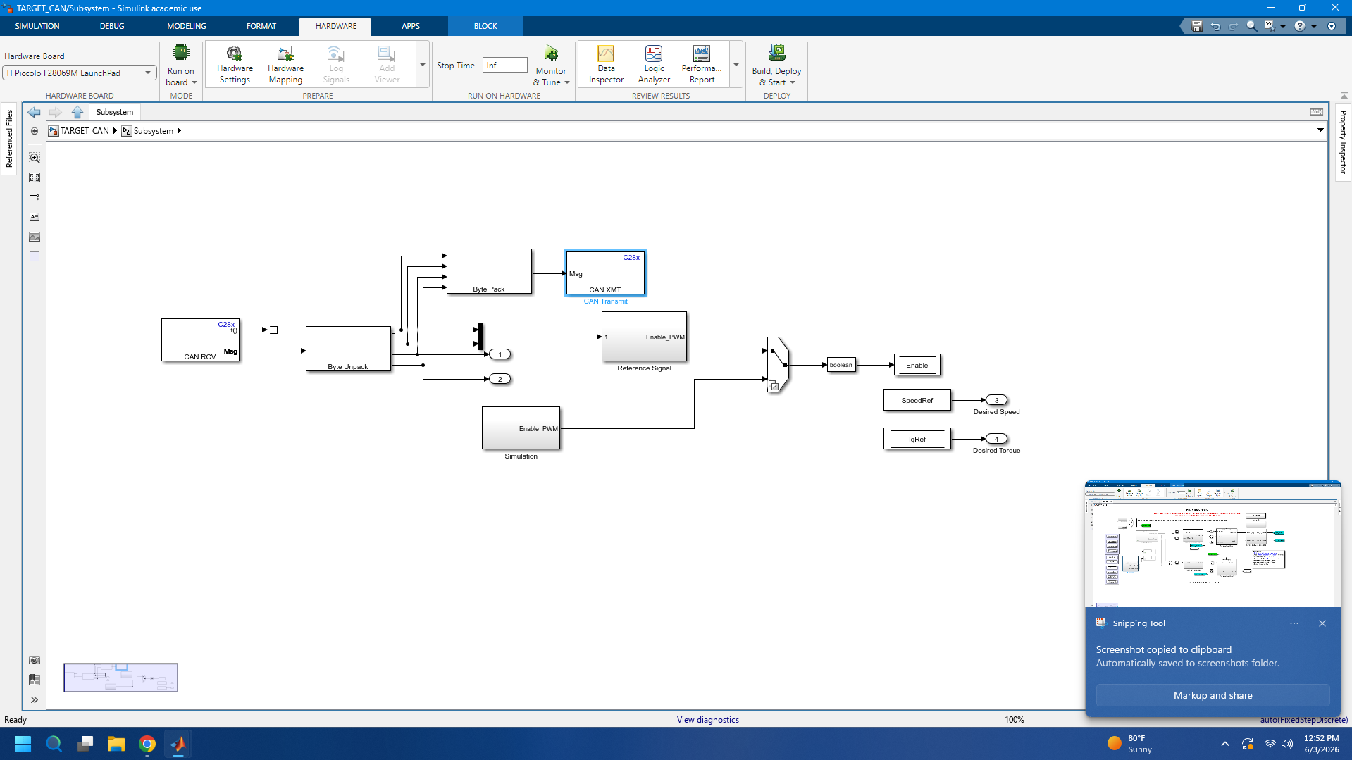
Figure 1. Final TARGET_CAN subsystem: C28x CAN Receive, Byte Unpack, echo transmit, and Reference Signal path.

2.2 Final target integration into the motor-dyno model
At the top level, the new CAN subsystem feeds the same downstream SpeedRef, IqRef, and Enable-related paths that the original Serial Receive block used. This preserves the existing FOC, speed control, motor coupling, and dyno structure.
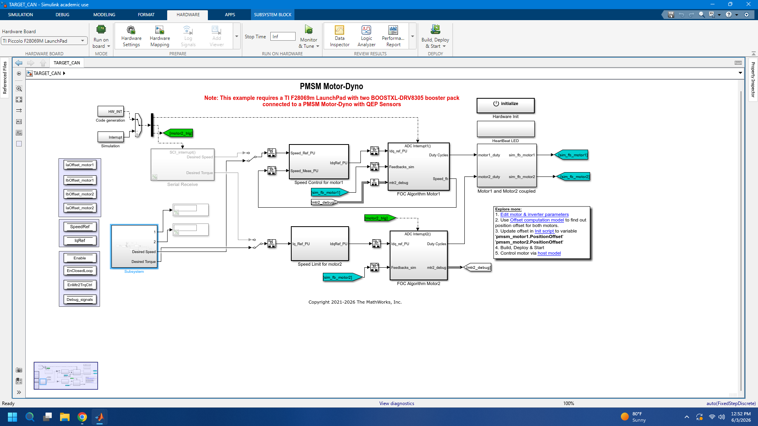
Figure 2. TARGET_CAN top-level integration: the CAN subsystem feeds the motor-dyno command path.

2.3 Final host command generation and CAN transmit path
The host keeps the original command-generation logic and routes the formatted command words into the CAN TX subsystem instead of the old SCI transmit block. The CAN TX subsystem packs command words and reserved diagnostic words into one 8-byte CAN frame.
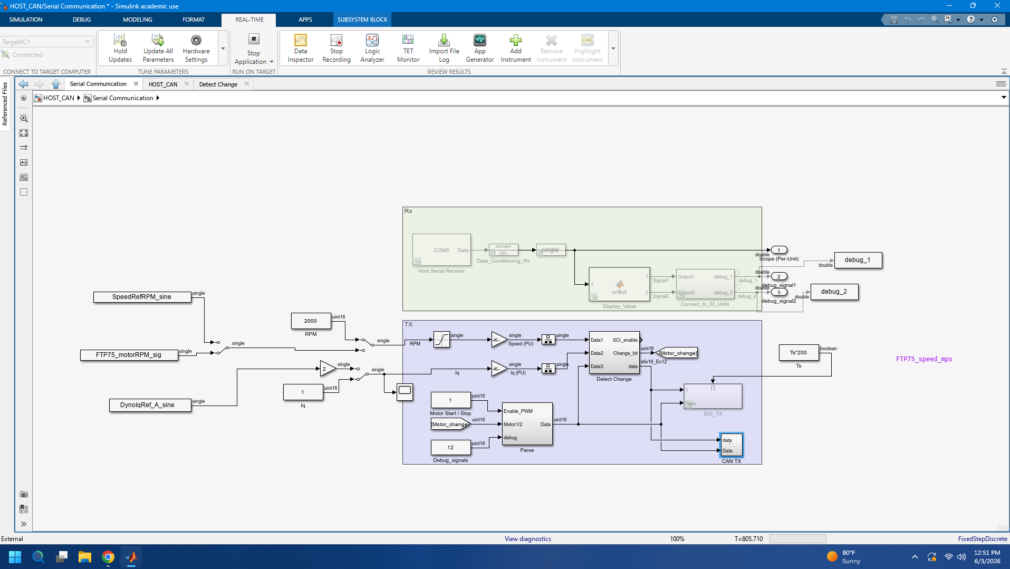
Figure 3. HOST_CAN model: existing command logic feeding the CAN TX subsystem.

2.4 CAN echo diagnostic
An echo diagnostic was added to prove that the C2000 target actually received the CAN frame. The C2000 target echoes the unpacked words back on Standard ID 257. The Speedgoat host reads ID 257 and displays the returned bytes or decoded words.
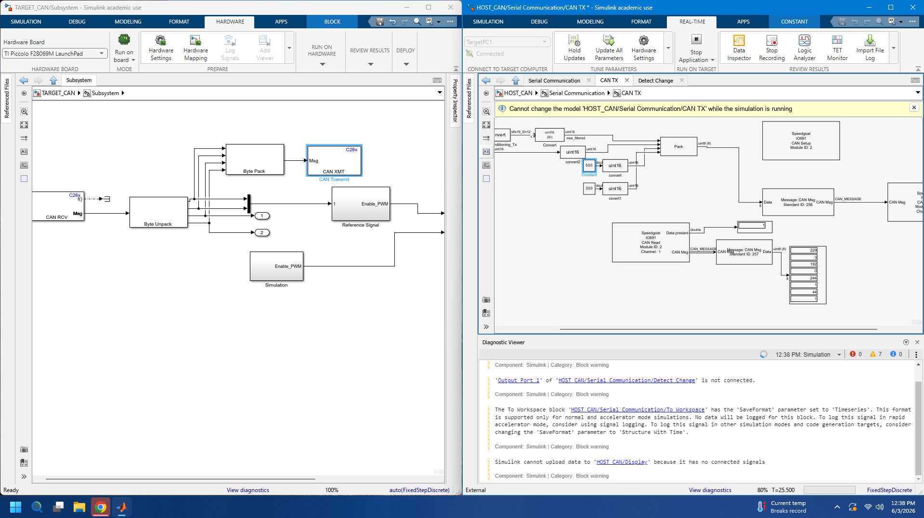
Figure 4. Echo-back diagnostic: C2000 receives ID 256 and echoes on ID 257; Speedgoat reads the echo.

3. Official documentation and reference links
The following sources are the most useful references for repeating or extending this work. Use official MathWorks, Speedgoat, and TI documentation first. Community pages are useful for troubleshooting, but the final configuration should be checked against official documentation.
Source | Link | Why it matters
Simulink Real-Time documentation | https://www.mathworks.com/help/slrealtime/index.html | Overall Speedgoat/Simulink Real-Time workflow and concepts.
Set Up and Configure Simulink Real-Time | https://www.mathworks.com/help/slrealtime/gs/set-up-and-configure-simulink-real-time.html | Target computer setup and configuration.
Set Up Target Computer Ethernet Connection | https://www.mathworks.com/help/slrealtime/ug/set-up-target-computer-ethernet-connection.html | Network connection to the Speedgoat target.
Speedgoat Target Computer Support | https://www.mathworks.com/help/slrealtime/io_ref/speedgoat-target-computer-support.html | Speedgoat I/O Blockset and target support installation.
Speedgoat IO691 CAN I/O Module | https://www.speedgoat.com/products/communication-protocols-can-fd-io691 | IO691 hardware capabilities and CAN channels.
Speedgoat I/O and Communication Protocols Support | https://www.mathworks.com/hardware-support/speedgoat-io-communication-protocols-support-simulink-real-time.html | Speedgoat I/O support from Simulink Real-Time.
C2000 Microcontroller Blockset documentation | https://www.mathworks.com/help/ti-c2000/index.html | C2000 peripheral blocks, code generation, and hardware support.
Getting Started with C2000 Microcontroller Blockset | https://www.mathworks.com/help/ti-c2000/ug/getting-started-with-C2000-example.html | Basic C2000 model build/deploy workflow.
Supported TI C2000 Processors | https://www.mathworks.com/help/ti-c2000/gs/Supported-TI-C2000-Processors.html | Processor and LaunchPad support list including F28069M.
Configure Interrupts and Events for C2000 | https://www.mathworks.com/help/ti-c2000/ug/configure-interrupts-events.html | Hardware Mapping for ADCINT1/ADCINT2 and interrupt tasks.
C2000 External Mode settings | https://www.mathworks.com/help/ti-c2000/ref/sect-hw-imp-pane-external-mode.html | XCP on Serial / XCP on CAN external mode settings.
Serial Configuration for External Mode and PIL | https://www.mathworks.com/help/ti-c2000/ref/serial-configuraton-externalmode-pil.html | COM port and serial settings for C2000 external mode.
Signal Monitoring and Parameter Tuning over XCP on Serial | https://www.mathworks.com/help/ti-c2000/ug/signal-monitoring-paramter-tune-xcp-on-serial.html | Monitor & Tune workflow over XCP serial.
CAN Pack block documentation | https://www.mathworks.com/help/vnt/ug/canpack.html | Packing signal data into CAN messages.
CAN Unpack block documentation | https://www.mathworks.com/help/vnt/ug/canunpack.html | Unpacking CAN messages into signals.
Byte Pack block documentation | https://www.mathworks.com/help/ecoder/ref/bytepack.html | Packing typed signals into a uint8 vector.
Byte Unpack block documentation | https://www.mathworks.com/help/ecoder/ref/byteunpack.html | Unpacking uint8 vectors into typed outputs.
Simulink Real-Time Byte Packing | https://www.mathworks.com/help/slrealtime/io_ref/bytepacking.html | Byte packing support for Speedgoat target applications.
Simulink Real-Time Byte Unpacking | https://www.mathworks.com/help/slrealtime/io_ref/byteunpacking.html | Byte unpacking support for Speedgoat target applications.
TI LAUNCHXL-F28069M Overview | https://www.ti.com/lit/pdf/sprui11 | LaunchPad COM port, XDS100, switches, and board overview.
TI TMS320F2806x Real-Time Microcontrollers Datasheet | https://www.ti.com/lit/ds/symlink/tms320f28062.pdf | F2806x device family reference information.

4. Hardware, software, and files required

4.1 Hardware
Item | Purpose
Speedgoat target computer | Runs HOST_CAN under Simulink Real-Time.
Speedgoat IO691 CAN module | Used for CAN Write/Read. In this setup, Module ID 2 and Channel 1 were used.
TI LAUNCHXL-F28069M LaunchPad | Runs TARGET_CAN and the PMSM FOC target model.
BOOSTXL-DRV8305 booster packs | Motor inverter hardware used by the MathWorks motor-dyno example.
PMSM motor-dyno hardware with QEP sensors | Motor plant and feedback hardware.
CAN wiring | CANH, CANL, and common ground. Use proper termination and secure connections.
USB cable to LaunchPad | For programming and optional External Mode/XCP on Serial.

4.2 Software
Software | Role
MATLAB/Simulink | R2023b was used in this bring-up.
Simulink Real-Time | Builds/runs Speedgoat host application.
Speedgoat I/O Blockset | Required for IO691 driver blocks and sg.* target support.
C2000 Microcontroller Blockset | Required for C28x CAN, SCI, ADC, ePWM, hardware mapping, and F28069M deployment.
Embedded Coder / Simulink Coder | Required for code generation.
TI Code Composer Studio / C2000 compiler support | Used by C2000 build/deploy flow.
Vehicle Network Toolbox or available CAN Pack/Unpack support | Used for CAN Pack/Unpack message handling on the host side where applicable.

5. Clean project setup
A clean folder layout was important because old generated artifacts and mixed Speedgoat/C2000 build settings caused hidden build hooks, stale .slxc cache files, and target configuration confusion. Use a simple path with no spaces and no parentheses.
mkdir('C:\MTU_DMD_CAN')
mkdir('C:\MTU_DMD_CAN\C2000_TARGET')
mkdir('C:\MTU_DMD_CAN\SPEEDGOAT_HOST')
mkdir('C:\MTU_DMD_CAN\COMMON_DATA')
mkdir('C:\MTU_DMD_CAN\CACHE')
mkdir('C:\MTU_DMD_CAN\CODEGEN')
Simulink.fileGenControl('set', ...
'CacheFolder','C:\MTU_DMD_CAN\CACHE', ...
'CodeGenFolder','C:\MTU_DMD_CAN\CODEGEN', ...
'createDir',true);
Copy only real source files into the new folder. Do not copy slprj, *_ert_rtw, .slxc, or CCS generated folders from the old project. Those are generated artifacts and can carry bad state forward.
Folder | Content
C:\MTU_DMD_CAN\C2000_TARGET | TARGET_CAN.slx and C2000-only source files.
C:\MTU_DMD_CAN\SPEEDGOAT_HOST | HOST_CAN.slx and Speedgoat-only source files.
C:\MTU_DMD_CAN\COMMON_DATA | mcb_pmsm_foc_qep_dyno_f28069m_data.m, .mat files, and reusable input data files.

6. C2000 target setup
Open TARGET_CAN alone first. Do not open the Speedgoat host model until the C2000 target builds cleanly. This avoids confusing target-specific settings.
cd('C:\MTU_DMD_CAN\C2000_TARGET')
open_system('TARGET_CAN')
get_param('TARGET_CAN','SystemTargetFile')
get_param('TARGET_CAN','HardwareBoard')
Expected values:
SystemTargetFile = 'ert.tlc'
HardwareBoard = 'TI Piccolo F28069M LaunchPad'

6.1 InitFcn and support data
The original dyno model depends on an initialization script that defines motor, inverter, LaunchPad, and per-unit base quantities. Keep that script available from COMMON_DATA and make the model load it automatically.
addpath('C:\MTU_DMD_CAN\COMMON_DATA')
set_param('TARGET_CAN','InitFcn', ...
"addpath('C:\MTU_DMD_CAN\COMMON_DATA'); mcb_pmsm_foc_qep_dyno_f28069m_data;")
save_system('TARGET_CAN')

6.2 Hardware Mapping for interrupts
The motor-dyno model uses ADC interrupt tasks. After moving or copying the model, Hardware Mapping may reset to Unspecified. Set the interrupts as follows.
Task name | Interrupt group | Interrupt name | Event name | Event order
HWI_ADCINT1 | PIE Group 1 / INT1 | INT1.1 | ADCINT1 | 1
HWI_ADCINT2 | PIE Group 1 / INT1 | INT1.2 | ADCINT2 | 1
Do not keep the old SCI receive interrupt active if SCI_A is being used for External Mode. The old HWI_SCIRXINTA path should be removed/commented unless intentionally used.

6.3 Required diagnostic and memory settings
The clean model needed two additional fixes during bring-up: one for multitask data-store diagnostics and one to restore the C2000 demo memory section package used by the FOC subsystems.
set_param('TARGET_CAN','MultiTaskDSMMsg','none')
set_param('TARGET_CAN','MemSecPackage','tic2000demospkg')
save_system('TARGET_CAN')

6.4 External Mode notes
External Mode/Monitor & Tune is useful but not required to prove CAN control. In this project, External Mode intermittently failed with XCP SYNCH and SHORT_UPLOAD errors. The final proof of CAN communication was done with CAN echo-back, which is more reliable for this task.
Setting / issue | Guidance
Serial port | Use the actual LaunchPad COM port. It changed from COM9 to COM6 during bring-up. Verify with serialportlist("all").
Interface | XCP on Serial if using Monitor & Tune.
SCI module | SCI_A, unless deliberately moved. Ensure no old SCI blocks also use SCI_A.
Baud | Use a stable baud rate such as 115200 or 921600 for External Mode. The data script may print 5625000 for the original SCI baud; do not confuse that with CAN bus speed.
Monitoring | Avoid many Displays/Scopes on the C2000 target. Prefer CAN echo-back for communication proof.

7. Speedgoat host setup
Open HOST_CAN only after TARGET_CAN builds cleanly. The host model must be configured for Simulink Real-Time/Speedgoat, not for the C2000 embedded target.
cd('C:\MTU_DMD_CAN\SPEEDGOAT_HOST')
open_system('HOST_CAN')
get_param('HOST_CAN','SystemTargetFile')
get_param('HOST_CAN','HardwareBoard')
The host should use the Simulink Real-Time target configuration. If MATLAB cannot resolve sg.mw.TargetImplQnx or Speedgoat classes, install/repair the Speedgoat I/O Blockset and restore the MATLAB path.

7.1 Host input signals
The host model expects workspace signals for speed and dyno Iq/load references. For first-spin tests, create conservative safe signals and load them automatically.
cd('C:\MTU_DMD_CAN\COMMON_DATA')
Ts = 0.03;
Tend = 300;
t = (0:Ts:Tend)';
FTP75_motorRPM_sig = timeseries(single(200*ones(size(t))), t);
DynoIqRef_A_sine = timeseries(single(zeros(size(t))), t);
SpeedRefRPM_sine = timeseries(single(200*ones(size(t))), t);
save('host_can_inputs.mat', ...
'FTP75_motorRPM_sig', ...
'DynoIqRef_A_sine', ...
'SpeedRefRPM_sine');
open_system('HOST_CAN')
set_param('HOST_CAN','InitFcn', ...
"addpath('C:\MTU_DMD_CAN\COMMON_DATA'); load('C:\MTU_DMD_CAN\COMMON_DATA\host_can_inputs.mat');")
save_system('HOST_CAN')

7.2 Host CAN TX block path
The old SCI_TX block is bypassed/commented for transmission. The existing command-generation and Detect Change/Parse logic should feed the CAN TX subsystem.
RPM command / FTP75 profile
Iq/load command
Enable
Motor select
Debug signal select
↓
Existing Parse / Detect Change command formatting
↓
CAN_TX subsystem
↓
Byte Pack: 4 x uint16 -> uint8(8)
↓
CAN Pack: Standard ID 256
↓
Speedgoat IO691 CAN Write

8. Physical CAN wiring
The final breakthrough was hardware-level: the CAN connection was not fully intact. Before spending hours on Simulink, verify the physical layer carefully.
Signal / check | Guidance
CANH | Speedgoat IO691 CANH to C2000/transceiver CANH.
CANL | Speedgoat IO691 CANL to C2000/transceiver CANL.
GND | Connect grounds between systems.
Termination | Use correct 120 ohm termination at the bus ends. Avoid double-terminating if built-in termination is already enabled.
Cable integrity | Tug gently, reseat connectors, and check continuity. A loose connection caused the main failure in this bring-up.
Polarity | Swapped CANH/CANL may show no data or inconsistent behavior.

Bring-up rule: When software appears correct but the receive side remains zero, check the physical CAN connection before changing the model again.

9. CAN message protocol
Two CAN IDs were used in the final bring-up.
CAN ID | Direction | Purpose
256 decimal / 0x100 hex | Speedgoat -> C2000 command frame | Main command transport replacing SCI.
257 decimal / 0x101 hex | C2000 -> Speedgoat echo frame | Diagnostic confirmation that C2000 received and unpacked the frame.

9.1 Command frame payload
The CAN payload uses four uint16 words packed into eight bytes. This matches the working testbench and provides a simple, deterministic payload.
Payload word | Type | Meaning
Word 1 | uint16 | Existing command/change/enable word from Detect Change / command formatting.
Word 2 | uint16 | Existing command data word. For speed updates, this carries the encoded speed command from the original host logic.
Word 3 | uint16 | Reserved / diagnostic value, for example 500. Used to prove byte order and echo.
Word 4 | uint16 | Reserved / diagnostic value, for example 300. Used to prove byte order and echo.
Final host Byte Pack configuration:
Input port data types: {'uint16','uint16','uint16','uint16'}
Output packed data type: uint8
Byte alignment: 2
Output width: 8 bytes

Final target Byte Unpack configuration:
Output port dimensions: {[1],[1],[1],[1]}
Output port data types: {'uint16','uint16','uint16','uint16'}
Byte alignment: 2
Decimal vs hex: Standard ID 256 decimal is 0x100 hex. Do not accidentally configure 0x256 if you mean decimal 256; 0x256 is decimal 598.

10. Replacing the SCI receive layer on the target
The correct replacement is not to bypass the whole Serial Receive subsystem. The target model originally used an SCI receive block inside a Code Generation section to provide a Data signal to the Reference Signal block. The Reference Signal block then produced Enable_PWM, SpeedRef, and IqRef. Therefore, CAN should replace only the transport layer and continue feeding the Reference Signal block.
Original path:
SCI RCV / Code Generation
↓ Data
Reference Signal
↓
Enable_PWM, SpeedRef, IqRef
Final CAN path:
C28x CAN Receive ID 256
↓ Msg
Byte Unpack
↓ raw uint16 command words
Mux / Concatenate first command words
↓ Data
Reference Signal
↓
Enable_PWM, SpeedRef, IqRef

10.1 Important signal distinction: f() vs Msg
The C28x CAN Receive block exposes two important outputs. The f() output is a function-call trigger that indicates a received frame event. The Msg output carries the actual CAN message. Use Msg for Byte Unpack. Do not treat f() as payload data.
CAN RCV output | Use
f() | Function-call trigger only. Optional for a receive counter or event-driven subsystem.
Msg | Actual CAN message. Connect this to Byte Unpack.

10.2 Do not pre-scale before Reference Signal
During earlier tests, a 1/4096 gain was used when raw fixed-point values were fed directly into Speed_Ref_PU and Iq_Ref_PU. That is not the final architecture. In the final architecture, raw command words should feed Reference Signal, which preserves the original command decoding behavior. Do not add the 1/4096 gain before Reference Signal.

11. Echo-back diagnostic path
Because External Mode on the C2000 target became unreliable under the full motor-control workload, CAN echo-back became the best diagnostic. It proves receive without depending on C2000 Display blocks or XCP SHORT_UPLOAD.
C2000 target echo path:
CAN RCV ID 256
↓
Byte Unpack -> Word1, Word2, Word3, Word4
↓
Byte Pack -> CAN XMT ID 257
Speedgoat host echo read path:
CAN Read ID 257
↓
CAN Unpack / Byte Unpack
↓
Display returned words or bytes
If Speedgoat sees Data present = 1 on ID 257, the C2000 transmitted an echo. If the echoed reserved words match the host constants, the physical bus, CAN IDs, byte order, and Byte Pack/Unpack formatting are correct.

12. Build, deploy, and run sequence

12.1 Save and back up working models
save_system('TARGET_CAN')
save_system('HOST_CAN')
copyfile('C:\MTU_DMD_CAN\C2000_TARGET\TARGET_CAN.slx', ...
'C:\MTU_DMD_CAN\C2000_TARGET\TARGET_CAN_MOTOR_SPIN_WORKING.slx')
copyfile('C:\MTU_DMD_CAN\SPEEDGOAT_HOST\HOST_CAN.slx', ...
'C:\MTU_DMD_CAN\SPEEDGOAT_HOST\HOST_CAN_MOTOR_SPIN_WORKING.slx')

12.2 Recommended run order
Step | Action | Reason
1 | Power-cycle the C2000 LaunchPad and check wiring. | Avoid stale COM/CAN state and loose connections.
2 | Build, Deploy & Start TARGET_CAN. | Use standalone deploy if Monitor & Tune/XCP is unstable.
3 | Stop any old Speedgoat app. | Prevents “application already running” errors.
4 | Build/load/start HOST_CAN on Speedgoat. | Sends ID 256 command frames.
5 | Verify echo ID 257 on Speedgoat. | Confirms target receives frames.
6 | Enable motor gently at low RPM. | Start low with Iq/load = 0 A.
tg = slrealtime('TargetPC1');
connect(tg);
stop(tg);
load(tg,'HOST_CAN');
start(tg);

13. Verification tests
Test | Procedure | Pass condition
CAN echo test | Host sends reserved Word3/Word4, target echoes ID 257. | Speedgoat sees Data present = 1 and expected values.
Low RPM test | Send 200 RPM with Iq/load = 0. | Motor spins gently and remains stable.
Step RPM test | Step from 200 to 500 RPM. | Motor follows without fault.
Higher RPM test | Increase to 1000 RPM only after stability. | Motor speed response is stable.
Iq/load test | Start 0.2 A or 0.5 A load command. | Dyno load responds; avoid high current until verified.

14. Troubleshooting and lessons learned
This section captures the practical issues encountered during the full bring-up. It is intentionally detailed because most time was lost on environment state, External Mode, and physical wiring rather than on the final CAN logic.
Symptom | Likely cause | Fix
Motor does not spin even though model builds | CAN physical connection was loose or incomplete. | Check CANH/CANL/GND, termination, connector seating, and continuity. The final breakthrough was fixing the physical CAN connection.
Target receives zeros | No CAN frame received, wrong CAN ID, wrong byte alignment, or loose wiring. | Check Data present/echo, ID 256 decimal, Standard ID, Byte Pack/Unpack alignment = 2, and physical wiring.
Echo ID 257 not received on Speedgoat | C2000 CAN XMT not deployed, wrong ID, wrong channel, or no receive on target. | Deploy TARGET_CAN after adding CAN XMT; confirm Standard ID 257; rebuild HOST_CAN.
External Mode XCP SYNCH timeout | C2000 full motor model is too busy or External Mode signal upload is unstable. | Use Build, Deploy & Start and prove communication through CAN echo instead of C2000 Displays. Reduce logged signals if Monitor & Tune is required.
XCP opens COM9 but board is COM6 | External Mode saved stale COM preference. | Set Hardware Settings -> External Mode -> Serial port to actual COM port; confirm log says COM6.
Missing variable DynoIqRef_A_sine or FTP75_motorRPM_sig | Host workspace input signals not loaded. | Create host_can_inputs.mat and load it in HOST_CAN InitFcn.
Missing mcb_pmsm_foc_qep_dyno_f28069m_data | Support script not on MATLAB path after moving folders. | Copy .m/.mat support files into COMMON_DATA and add path in InitFcn.
sg.model.build.Hooks.entry appears in C2000 build | Stale Speedgoat cache/config mixed into C2000 model. | Move to clean folder, delete .slxc/slprj/_ert_rtw, keep Speedgoat and C2000 models separate.
sg.mw.TargetImplQnx missing | Speedgoat I/O Blockset path/install issue. | Install or repair Speedgoat I/O Blockset and restart MATLAB.
Event source HWI_ADCINT1/2 unspecified | Hardware Mapping reset after moving/copying model. | Set HWI_ADCINT1 -> Group 1 / INT1.1 / ADCINT1, HWI_ADCINT2 -> Group 1 / INT1.2 / ADCINT2.
Multitask data store Enable error | Two tasks access the same Enable Data Store. | For this example, set MultiTaskDSMMsg to none after understanding the risk.
Invalid memory section code_ramfuncs | Memory section package missing after config changes. | Set MemSecPackage to tic2000demospkg or restore original config.
Byte alignment error | Byte Pack/Unpack alignment mismatched for 16-bit words. | Use Byte alignment = 2 for four uint16 words.
Cannot edit HOST_CAN while running | Speedgoat application is running. | Stop target with stop(tg), edit, rebuild, reload, and restart.

14.1 Pitfalls from the actual bring-up
- Do not assume a Simulink display showing zero means the model logic is wrong. It may mean the CAN physical layer is not connected or the frame is not arriving.
- Do not mix C2000 and Speedgoat build artifacts in one messy project folder. Use separate clean folders and separate models.
- Do not confuse CAN sample time with CAN bit rate or External Mode serial baud rate. They are three different things.
- Do not feed raw fixed-point CAN words directly into Speed_Ref_PU unless you deliberately use the direct-bypass test method. The final architecture feeds raw command words into Reference Signal.
- Do not rely only on C2000 Monitor & Tune for debugging the communication link. CAN echo-back is a stronger proof for this lab objective.
- When moving models, verify Hardware Mapping, memory section package, model InitFcn, and file paths. Those settings may not survive copying the same way normal blocks do.
- Make backups after every known-good milestone: standalone CAN loopback, Speedgoat-to-C2000 testbench, clean TARGET_CAN build, echo-back verified, motor spin verified.

15. Appendix: MATLAB commands and block settings

15.1 Serial port checks
serialportlist('all')
serialportlist('available')
s = serialportfind; delete(s); clear s
old = instrfindall; fclose(old); delete(old); clear old

15.2 Clean generated files
cd('C:\MTU_DMD_CAN\C2000_TARGET')
if isfile('TARGET_CAN.slxc'), delete('TARGET_CAN.slxc'); end
if isfolder('TARGET_CAN_ert_rtw'), rmdir('TARGET_CAN_ert_rtw','s'); end
if isfolder('slprj'), rmdir('slprj','s'); end
clear mex
clear classes
rehash toolboxcache

15.3 C2000 model sanity check
get_param('TARGET_CAN','SystemTargetFile')
get_param('TARGET_CAN','HardwareBoard')
% Expected:
% 'ert.tlc'
% 'TI Piccolo F28069M LaunchPad'

15.4 Speedgoat model sanity check
get_param('HOST_CAN','SystemTargetFile')
get_param('HOST_CAN','HardwareBoard')
% Expected: Simulink Real-Time / Speedgoat target configuration, not TI C2000.

15.5 Final block configuration checklist
Block / item | Final setting
HOST_CAN Byte Pack | {'uint16','uint16','uint16','uint16'}, output uint8, alignment 2
HOST_CAN CAN Pack | Standard ID 256, DLC 8
HOST_CAN Speedgoat CAN Write | IO691, Module ID 2, Channel 1, sample time 0.03
TARGET_CAN C28x CAN Receive | Standard ID 256, same CAN bit rate as host
TARGET_CAN Byte Unpack | {'uint16','uint16','uint16','uint16'}, dimensions {[1],[1],[1],[1]}, alignment 2
TARGET_CAN Reference Signal input | First command words from Byte Unpack / Mux
TARGET_CAN CAN echo transmit | Byte Pack -> C28x CAN XMT, Standard ID 257, DLC 8
HOST_CAN echo receive | CAN Read ID 257 -> CAN Unpack / Byte Unpack -> displays

16. Final reusable checklist
- Clean folders created and file generation redirected.
- TARGET_CAN opens alone and builds cleanly.
- Hardware Mapping sets HWI_ADCINT1 and HWI_ADCINT2 correctly.
- Old SCI receive/transmit blocks that conflict with SCI_A are commented or removed.
- HOST_CAN uses Speedgoat/Simulink Real-Time target settings.
- Host Byte Pack and target Byte Unpack both use four uint16 values and alignment 2.
- CAN ID 256 sends command from Speedgoat to C2000.
- CAN ID 257 echoes C2000 receive data back to Speedgoat.
- CANH/CANL/GND wiring is secure and terminated correctly.
- Motor first spins at low RPM with Iq/load = 0 A.
- A backup copy is made immediately after motor spin is verified.
Final note: The final working solution was achieved when the model architecture was cleaned up and the physical CAN connection was fixed. The Simulink logic matters, but the physical CAN layer is unforgiving: one loose or miswired connection can make a correct model look completely broken.

