DUAL-MOTOR PMSM
DYNAMOMETER PLATFORM
FUNCTIONAL REQUIREMENTS &
VALIDATION REPORT
TI C2000 F28069M, dual-inverter control, interfaces, and verification
Customer-facing technical report
Revision 1.9 - 5 August 2026
Prepared by | Herder Elektronische Systemen
Primary subject | System requirements, interfaces, verification status, and public release boundary
Evidence basis | Simulink source models, custom ADC source, CAN interfaces, scripts, figures, and schematics
Distribution | Customer-facing; selected source models, custom firmware, and engineering evidence included
DOCUMENT PURPOSE
This report defines what the public Dual-Motor PMSM Dynamometer Platform is required to do, how each requirement is verified, what evidence is retained, and which capabilities remain outside the release. Implementation details and measured-result interpretation are intentionally assigned to the companion engineering report.

1. Purpose, Scope, and Use of This FRD
This Functional Requirements Document (FRD) defines the required behavior, external interfaces, evidence obligations, constraints, and acceptance basis for the public Dual-Motor PMSM Dynamometer Platform. It is intended to support engineering review, controlled modification, verification planning, and customer understanding of the released system boundary.
Unlike the companion Embedded Control & Characterization Report, this document does not explain every Simulink subsystem or interpret efficiency plots. Instead, it establishes the requirements that the implementation must satisfy and identifies how compliance is demonstrated.
WHAT MAKES THIS AN FRD
Each mandatory capability is expressed as an atomic “shall” statement with a unique identifier, verification method, status, and retained evidence reference. Narrative sections explain system intent and operating behavior so the requirement tables are understandable without becoming an implementation manual.

1.1 Intended audience and decisions supported
- Customers and reviewers evaluating system capability and release maturity.
- Engineers modifying host, target, CAN, ADC, or acquisition functions.
- Test personnel selecting verification methods and acceptance evidence.
- Maintainers determining whether a proposed change affects an approved requirement or interface.

1.2 Public system boundary
The public release includes selected editable Simulink models, handwritten ADC peripheral source, MATLAB setup and analysis utilities, interface references, schematics, and approved evidence figures. Generated code, binaries, private raw data, vendor manufacturing packages, and institution-specific instructional materials remain outside the release.

2. System Overview and Operational Concept
The platform couples two encoder-equipped permanent-magnet synchronous machines on a common shaft. Motor 1 establishes shaft speed. Motor 2 applies opposing or assisting q-axis current so the coupled assembly can be exercised as a compact dynamometer. A TI C2000 F28069M target executes the real-time control loops, while supervisory models provide commands, acquisition, and test orchestration.
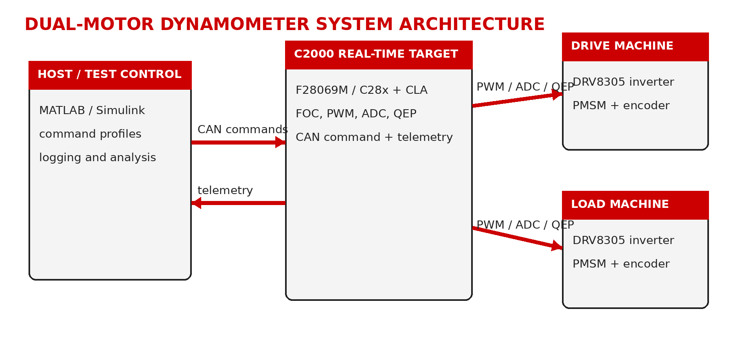
Figure 1. Public functional architecture and system boundary.

2.1 Functional decomposition
Element | Required responsibility | Boundary
Supervisory host | Provide speed, load/current, enable, selection, and test commands; collect observable signals. | Non-real-time supervision
C2000 target | Execute embedded FOC, encoder acquisition, CAN handling, ADC acquisition, and deterministic target logic. | Real-time control
Dual inverter stages | Convert DC bus power into controlled three-phase machine excitation. | TI reference hardware
Coupled PMSMs | Provide drive and load/assist behavior through a shared mechanical shaft. | Physical test article
Analysis workflow | Transform retained signals into reviewable engineering evidence. | Postprocessing

2.2 Normal operating sequence
A typical run begins with wiring and polarity verification, low-risk target deployment, encoder and phase-order confirmation, command enable, controlled speed and load application, data capture, and post-run evidence review. The host coordinates this sequence but does not replace the embedded timing or current-control functions.

3. Requirement Structure and Interpretation
Requirements are grouped by functional behavior, physical and communication interfaces, acquisition/evidence obligations, and release constraints. Every mandatory requirement uses “shall.” Explanatory paragraphs provide intent and context; they are not substitutes for the numbered requirement statements.
Attribute | Meaning
Identifier | Stable reference used in design discussions, verification records, and change review.
Requirement | Atomic mandatory behavior written as a testable “shall” statement.
Rationale | Why the capability is necessary to the system mission or evidence chain.
Verification | Inspection, analysis, demonstration, test, or a controlled combination.
Status | Demonstrated, Verified, Open, or Not Claimed for this public release.
Evidence | Retained model, source file, figure, procedure, or repository artifact supporting closure.

STATUS CONVENTION
“Demonstrated” means operation has been shown on the engineering platform. “Verified” means release content or an analysis obligation has been checked. Neither term implies calibrated metrology, production qualification, functional-safety certification, or regulatory approval.

3.1 Operating modes
Mode | Description | Entry/exit expectation
Disabled / setup | Commands are configured while torque-producing operation remains disabled. | Default safe software state; wiring and feedback checks occur here.
Drive / load operation | Motor 1 regulates shaft speed while Motor 2 applies a commanded load or assist current. | Entered only after enable and feedback checks; exited by disable or fault response.
CAN-supervised operation | Command words arrive over the documented CAN path and are returned or observed diagnostically. | Communication must be validated before relying on remote commands.
Acquisition / review | Signals are captured, exported, and processed after or during a controlled run. | Evidence must remain traceable to source models and scripts.

4. Functional Requirements
The functional requirements define the externally observable behavior of the platform. Implementation details may change, but the required drive/load roles, command paths, feedback separation, and evidence workflow must remain intact unless the FRD is revised.
ID | Area | Requirement | Rationale | Verification | Status
SYS-001 | Real-time control | The system shall execute fast motor-control loops on the embedded target independently of host display timing. | Host timing is unsuitable as the deterministic control clock. | Inspection + functional test | Demonstrated
SYS-002 | Dual-machine operation | The system shall command one PMSM as the drive machine and the second as a controllable load or assist machine. | Defines the dynamometer function. | Functional test | Demonstrated
SYS-003 | Speed reference | The system shall accept a supervisory speed reference for the drive machine. | Provides controlled operating-point selection. | Functional test | Demonstrated
SYS-004 | Load reference | The system shall accept a q-axis current or equivalent load reference for the load machine. | Provides controllable shaft loading. | Functional test | Demonstrated
SYS-005 | Enable control | The system shall provide explicit enable and disable control for commanded operation. | Separates configuration from torque-producing operation. | Inspection + test | Demonstrated
SYS-006 | Feedback | The system shall maintain independent encoder feedback paths for both machines. | Prevents cross-coupled or ambiguous machine state. | Inspection + feedback test | Demonstrated
SYS-007 | Observability | The system shall expose speed, current, voltage, torque-related, power-related, and diagnostic quantities required by the approved workflow. | Supports verification and engineering review. | Inspection + analysis | Demonstrated
SYS-008 | Repeatable workflow | The host workflow shall support repeatable setup, capture, export, and postprocessing. | Reduces ad hoc operator dependence. | Procedure review | Demonstrated

5. Interface Requirements
Interface requirements control the points where errors are most likely to damage hardware, invalidate data, or break compatibility. They cover power, phase and encoder routing, CAN communication, and the custom analog acquisition path.
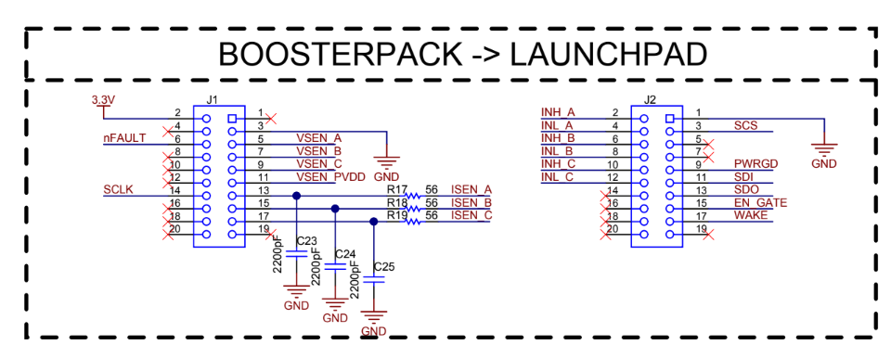
Figure 2. BoosterPack-to-LaunchPad board-interface reference retained with the release.
ID | Interface | Requirement | Verification | Status
IF-001 | DC input | The inverter stack shall use a verified 24 VDC supply with current limiting during bring-up. | DMM + startup test | Demonstrated
IF-002 | Motor phases | Each PMSM shall be connected consistently to its assigned inverter phase outputs. | Continuity + spin test | Demonstrated
IF-003 | Encoder routing | Motor 1 and Motor 2 encoder channels shall remain electrically and logically distinct. | Pin inspection + feedback test | Demonstrated
IF-004 | CAN physical layer | The CAN bus shall provide CANH, CANL, reference ground, and appropriate termination. | Resistance + bus test | Demonstrated
IF-005 | CAN command | The target shall receive the four-word supervisory command payload on the documented command identifier. | Bus test | Demonstrated
IF-006 | CAN diagnostics | The target shall provide a return identifier for command echo or telemetry diagnostics. | Bus test | Demonstrated
IF-007 | Custom ADC acquisition | The target shall configure two additional simultaneous ADC input pairs using handwritten F28069M peripheral source. | Source inspection + acquisition test | Demonstrated

INTERFACE CONTROL NOTE
Exact header positions, polarity, termination, and board-revision pin assignments must be confirmed against the current retained schematics and interface summary before energizing hardware.

6. Data, Evidence, and Verification Requirements
The FRD does not duplicate efficiency plots or their interpretation. It does require that any published result be traceable to retained source artifacts and that verification evidence be sufficient to show whether a requirement is closed.
ID | Area | Requirement | Verification | Status
DAT-001 | Evidence traceability | Published engineering results shall be traceable to retained scripts, source models, or approved evidence outputs. | Repository inspection | Verified
DAT-002 | Source distinction | The release shall distinguish handwritten firmware, editable Simulink source, generated support code, and third-party reference material. | Repository + document inspection | Verified
DAT-003 | Result ownership | Detailed processing methods and measured-result interpretation shall reside in the companion implementation report, not in this FRD. | Document inspection | Verified
DAT-004 | Release integrity | The release shall include checksums and shall open directly at repository root without an unnecessary outer directory. | Archive inspection | Verified

6.1 Verification strategy
Verification answers whether the implementation satisfies a stated requirement. Inspection is used for model structure, source configuration, repository boundaries, and wiring documentation. Functional and bus tests are used where observable behavior must be exercised. Analysis is used only where equations, signal derivations, or retained outputs must be evaluated.
Method | Applied to | Acceptance principle
Inspection | Models, source, schematics, repository structure | Required element exists, is correctly configured, and matches the controlled interface.
Demonstration | Operator workflow and observable behavior | Capability can be shown under controlled conditions without exhaustive measurement.
Functional test | Drive/load operation, enable, feedback, acquisition | Commanded input produces the expected observable system behavior.
Bus test | CAN receive, unpacking, return/diagnostic traffic | Frames are received and interpreted on the documented identifiers and payload layout.
Analysis | Signal availability and retained evidence chain | Calculation or review supports the stated requirement without unsupported extrapolation.

7. Requirements Traceability Matrix
The traceability matrix connects each requirement to its verification method and retained evidence. It is the primary closure record for this public FRD. Detailed implementation discussion remains in the companion report.
Requirement | Verification method | Retained evidence | Status
SYS-001 | Inspection + functional test | C2000_Dual_Motor_CAN_Target.slx | Demonstrated
SYS-002 | Functional test | target and host models | Demonstrated
SYS-003 | Functional test | host setup models | Demonstrated
SYS-004 | Functional test | host setup models | Demonstrated
SYS-005 | Inspection + test | host/target models | Demonstrated
SYS-006 | Inspection + feedback test | board interface + target model | Demonstrated
SYS-007 | Inspection + analysis | target model + processing scripts | Demonstrated
SYS-008 | Procedure review | setup/logging/analysis scripts | Demonstrated
IF-001 | DMM + startup test | INTERFACE_SUMMARY.md | Demonstrated
IF-002 | Continuity + spin test | INTERFACE_SUMMARY.md | Demonstrated
IF-003 | Pin inspection + feedback test | board-interface figure | Demonstrated
IF-004 | Resistance + bus test | CAN model set | Demonstrated
IF-005 | Bus test | CAN_Receive.slx | Demonstrated
IF-006 | Bus test | CAN_Transmit.slx | Demonstrated
IF-007 | Source inspection + acquisition test | F28069M_ADC_Custom_Config.c | Demonstrated
DAT-001 | Repository inspection | models, scripts, reports, checksums | Verified
DAT-002 | Repository + document inspection | embedded-control/README.md + NOTICE.md | Verified
DAT-003 | Document inspection | FRD + companion report | Verified
DAT-004 | Archive inspection | SHA256SUMS.txt + final ZIP | Verified

8. Constraints, Assumptions, and Safety Requirements

8.1 Assumptions and dependencies
- Compatible MATLAB/Simulink, C2000 support packages, and required hardware drivers are available to the user.
- The retained TI schematics and connector references correspond to the board revisions being operated.
- Mechanical coupling, motor mounting, and encoder attachment are secure before commanded rotation.
- Instrumentation and calculated quantities are engineering evidence unless separately calibrated and certified.

8.2 Safety and release constraints
ID | Constraint | Acceptance statement
SAF-001 | Polarity | DC polarity shall be verified before either inverter stage is energized.
SAF-002 | Conservative startup | Initial operation shall use low speed, zero load command, conservative current limits, and accessible shutdown.
SAF-003 | Feedback validation | Encoder direction and phase order shall be confirmed before closed-loop sweeps.
SAF-004 | Independent protection | Software disable shall not be represented as an independent safety function.
REL-001 | Qualification boundary | The release shall not be represented as production-qualified, calibrated, EMC-qualified, or safety-certified.
REL-002 | IP boundary | Generated binaries, private raw data, vendor manufacturing packages, and institution-specific instructional material shall remain excluded.

9. Validation Summary and Release Gate
Validation asks whether the released platform is useful for its intended engineering purpose. The public evidence supports coupled drive/load operation, supervisory CAN command flow, additional ADC acquisition, repeatable host workflows, and traceable characterization. It does not establish product certification or calibrated laboratory metrology.
Validation objective | Acceptance basis | Status
Coupled drive/load operation | Motor 1 establishes shaft speed while Motor 2 applies controlled loading. | Demonstrated
CAN supervisory control | Command receipt and diagnostic return are represented in retained models and evidence. | Demonstrated
Custom ADC path | Additional PWM-triggered simultaneous input pairs are configured and integrated. | Demonstrated
Evidence traceability | Published claims map to retained models, custom source, scripts, figures, and checksums. | Verified
Production qualification | Calibration, endurance, EMC, environmental, cybersecurity, and independent safety validation. | Not claimed

RELEASE GATE
Publish only after both reports are rendered page by page, figure captions and tables are visually checked, links resolve, checksums are regenerated, the ZIP opens at repository root, and no private or institution-specific instructional material remains.

