DUAL-MOTOR PMSM
DYNAMOMETER PLATFORM
EMBEDDED CONTROL, CAN &
CHARACTERIZATION
C2000/Simulink control, custom ADC acquisition, host software, and measured results
Customer-facing embedded-controls technical report
Revision 1.5 - 5 August 2026
Prepared by | Herder Elektronische Systemen
Primary subject | Model-based control, handwritten ADC integration, CAN transport, host workflows, and characterization
Evidence basis | Target and host Simulink models, F28069M custom C source, MATLAB tooling, plots, and interface documentation
Distribution | Customer-facing; selected source models, custom firmware, and engineering evidence included
DOCUMENT PURPOSE
This companion report presents the embedded and host implementation of the Dual-Motor PMSM Dynamometer Platform: real-time Simulink control, custom register-level ADC configuration, CAN command and telemetry paths, acquisition tooling, and measured characterization outputs.

1. Document Relationship
The companion Functional Requirements & Validation Report is the authoritative public baseline for requirements, verification methods, status, and traceability. This report explains how the embedded, communications, host, and characterization evidence supports that baseline.

2. Engineering Outcome
An inherited dual-motor bench with mismatched connection documentation was converted into a repeatable embedded-controls and characterization platform. The work corrected physical phase and encoder interfaces, restored dual-machine FOC operation, stabilized host-target pacing, built fixed-dwell and compressed drive-cycle command generation, implemented a CAN command/response path, and produced reviewable efficiency-map evidence.
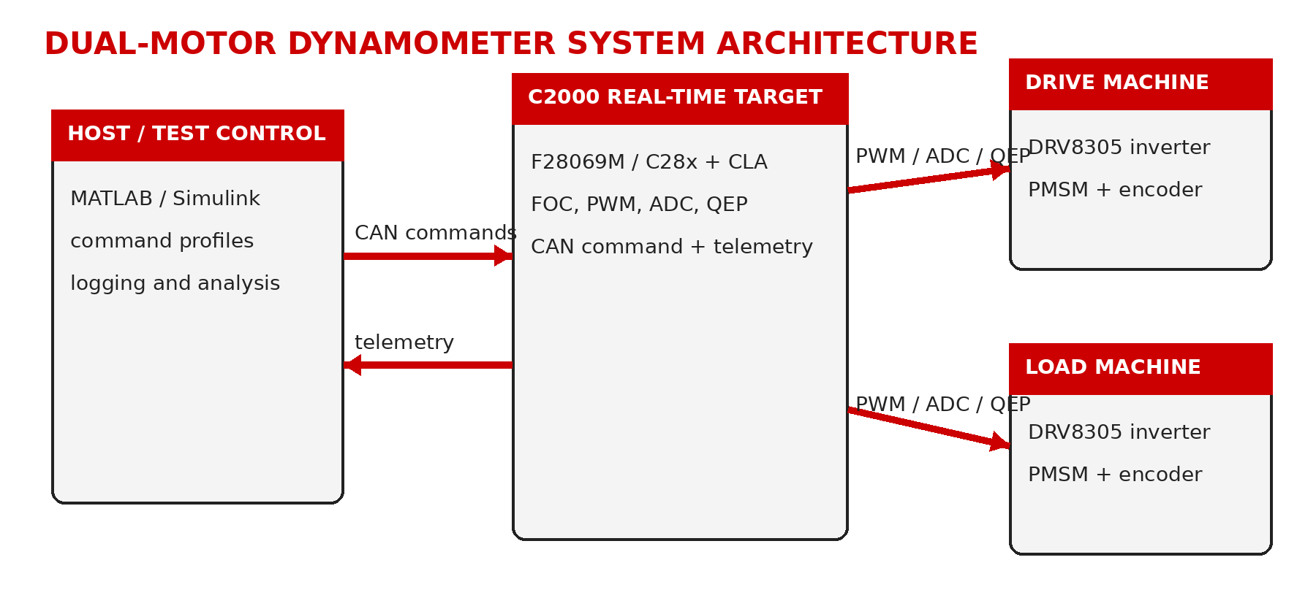
Figure 1. Control and data-flow architecture.

3. Real-Time Target Responsibilities
- Execute the motor-control loop, PWM generation, project-specific ADC-synchronized acquisition, QEP position/speed capture, and command interpretation.
- Maintain separate drive-machine and load-machine control paths.
- Receive packed host commands over CAN and expose response/telemetry values.
- Keep time-critical behavior independent of host plotting and GUI refresh timing.

4. CAN Host-Target Interface
Direction | Identifier | Payload | Public role
Host to target | 0x100 | 4 x 16-bit values | Command transport: speed, load/current, enable/state, and selection/configuration fields.
Target to host | 0x101 | 4 x 16-bit values | Response/echo and selected target values for integration verification.

The retained source evidence shows standard CAN mailbox configuration for these identifiers and byte packing/unpacking for four 16-bit values. Exact private scaling tables and the complete telemetry dictionary are not published.

5. Host Workflows
Workflow | Purpose | Evidence
Fixed-dwell efficiency test | Hold defined speed/load operating points long enough to accumulate valid samples. | efficiency_test_setup.m
Drive-cycle test | Create a bounded, compressed FTP-style speed command and corresponding load command. | drive_cycle_setup.m
Efficiency processing | Crop, align, screen, compute, bin, count, and visualize efficiency data. | motor_efficiency_processing.m
Run export and plotting | Save selected sessions and compare runs. | host-software utilities

6. Characterization Method
Signals captured across selected debug configurations are cropped to a common interval and interpolated onto a common time base. The workflow computes electrical and mechanical power, applies validity masks, bins accepted samples by speed and torque, stores sample counts, and produces measured and interpolated views. Interpolated surfaces are explicitly presentation aids rather than additional measured evidence.
Screening rule | Threshold
Electrical input power | > 10 W
Mechanical output power | > 3 W
Torque | > 0.045 N m
Efficiency | Finite and physically plausible
Speed/torque grid | 0-4000 rpm; 0-0.25 N m

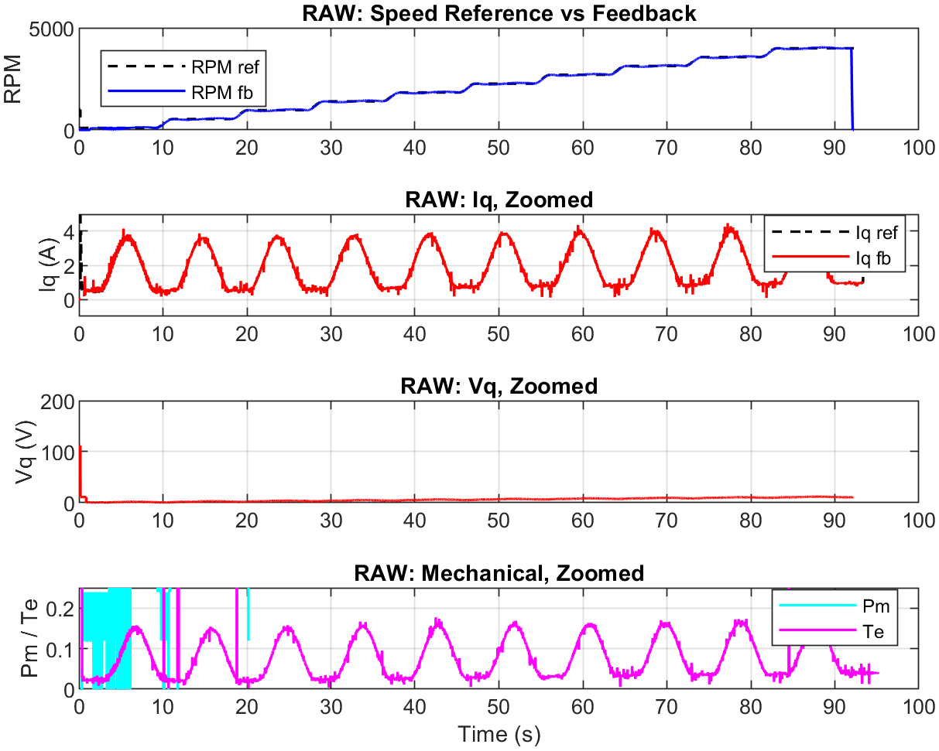
Figure. Raw signal review.
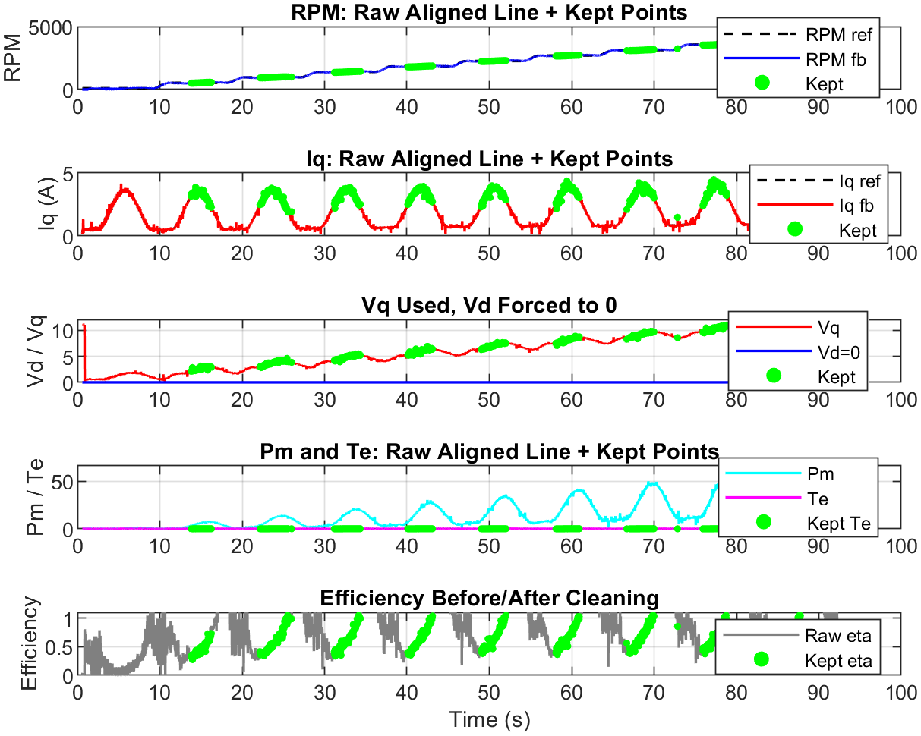
Figure. Cleaning overlay showing retained and rejected regions.
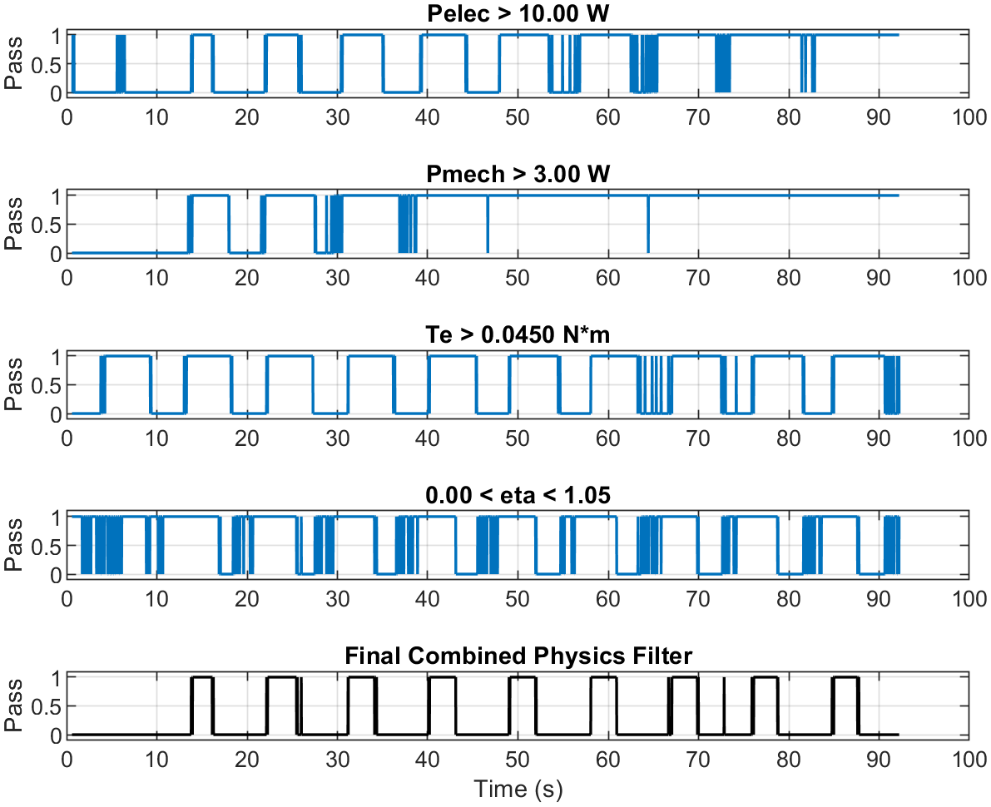
Figure. Validity masks before derived calculations.
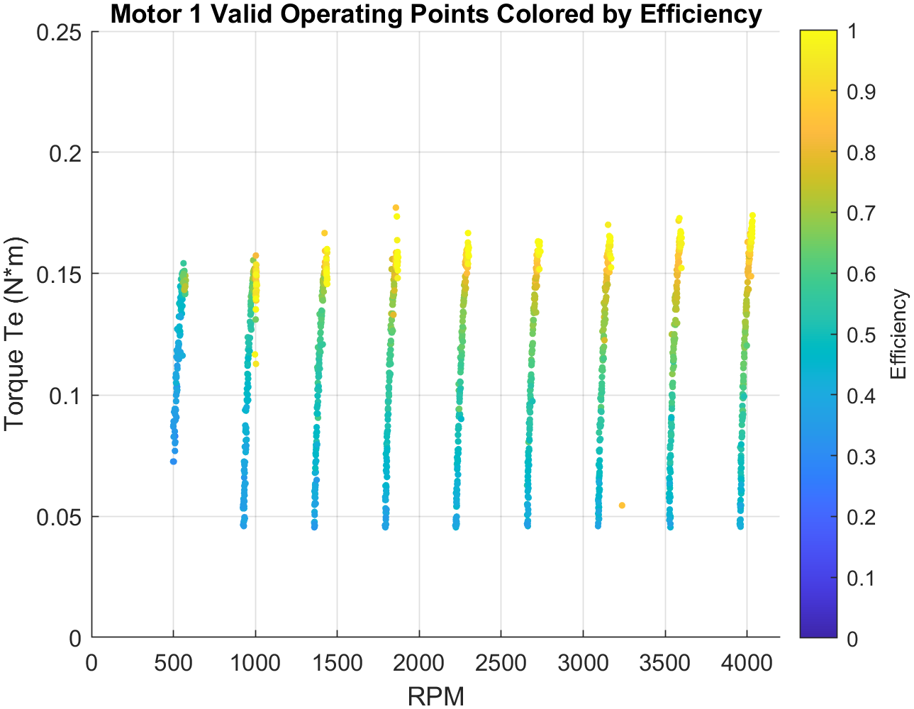
Figure. Accepted measured operating points.
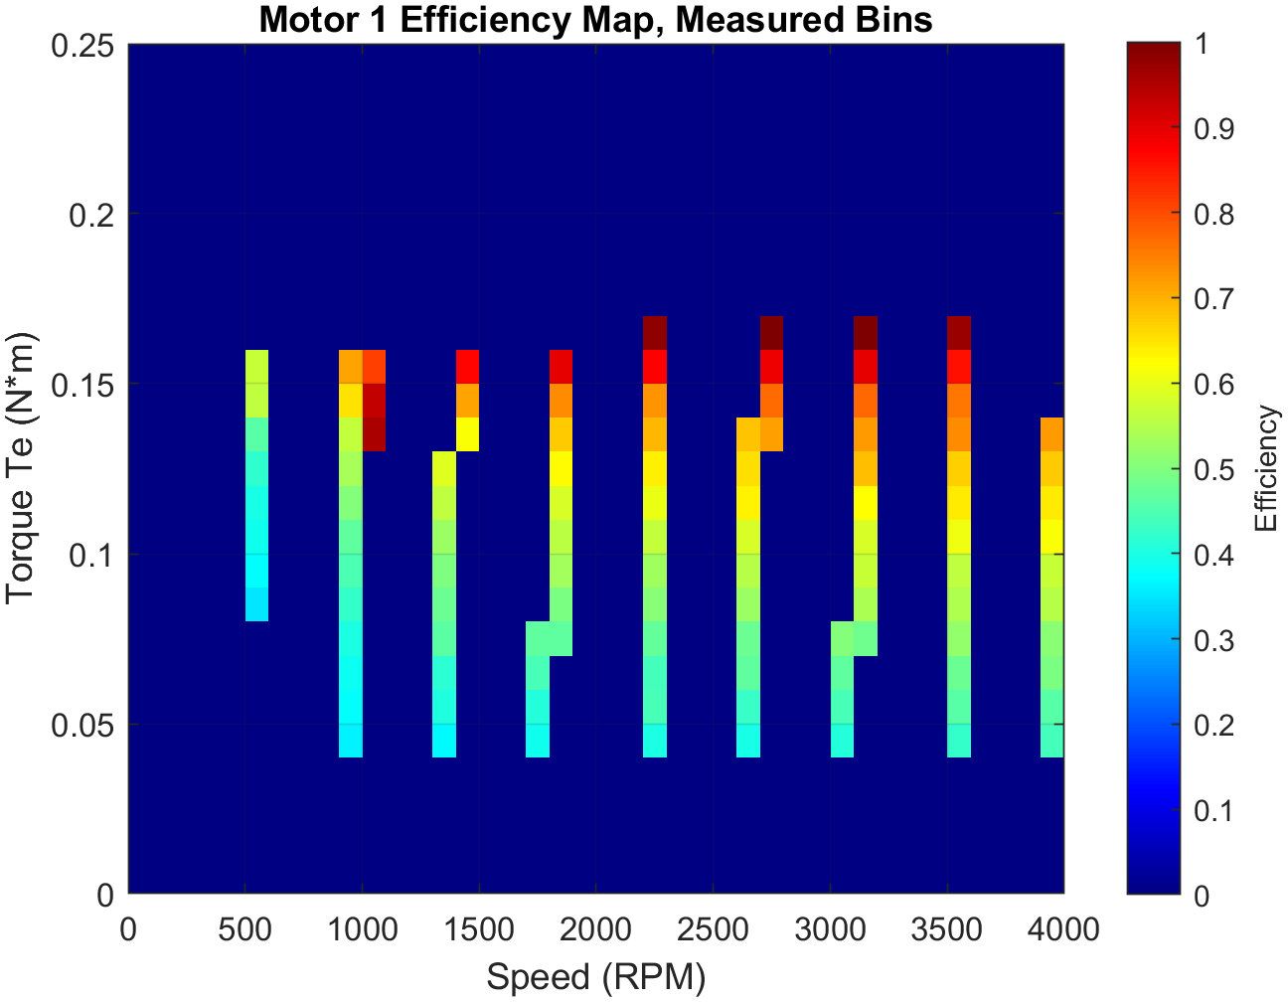
Figure. Measured-bin efficiency map.
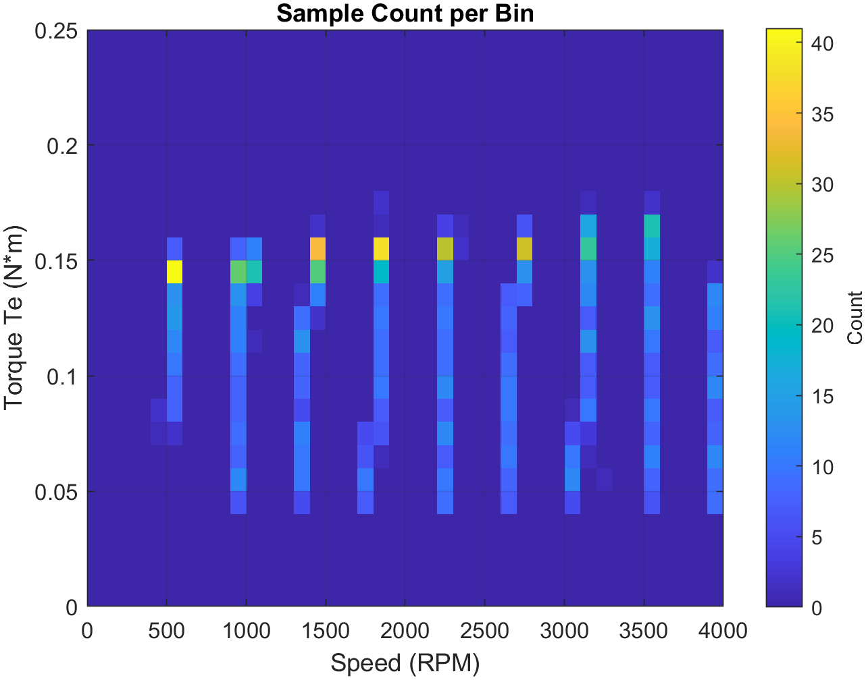
Figure. Evidence density by bin.
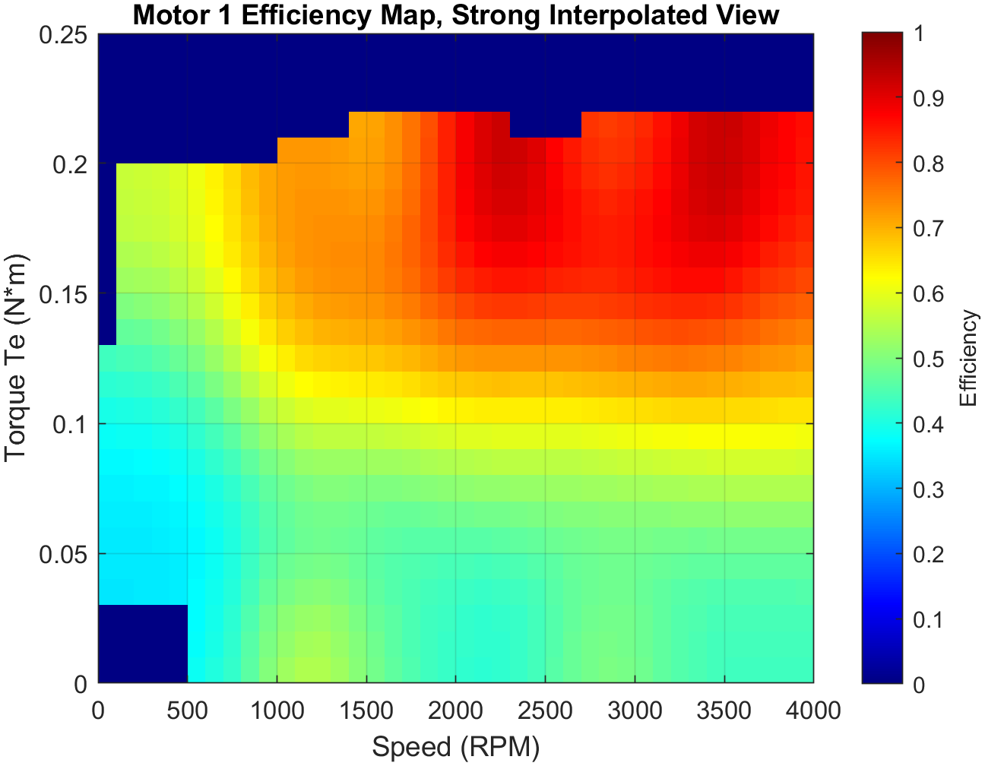
Figure. Interpolated visualization.
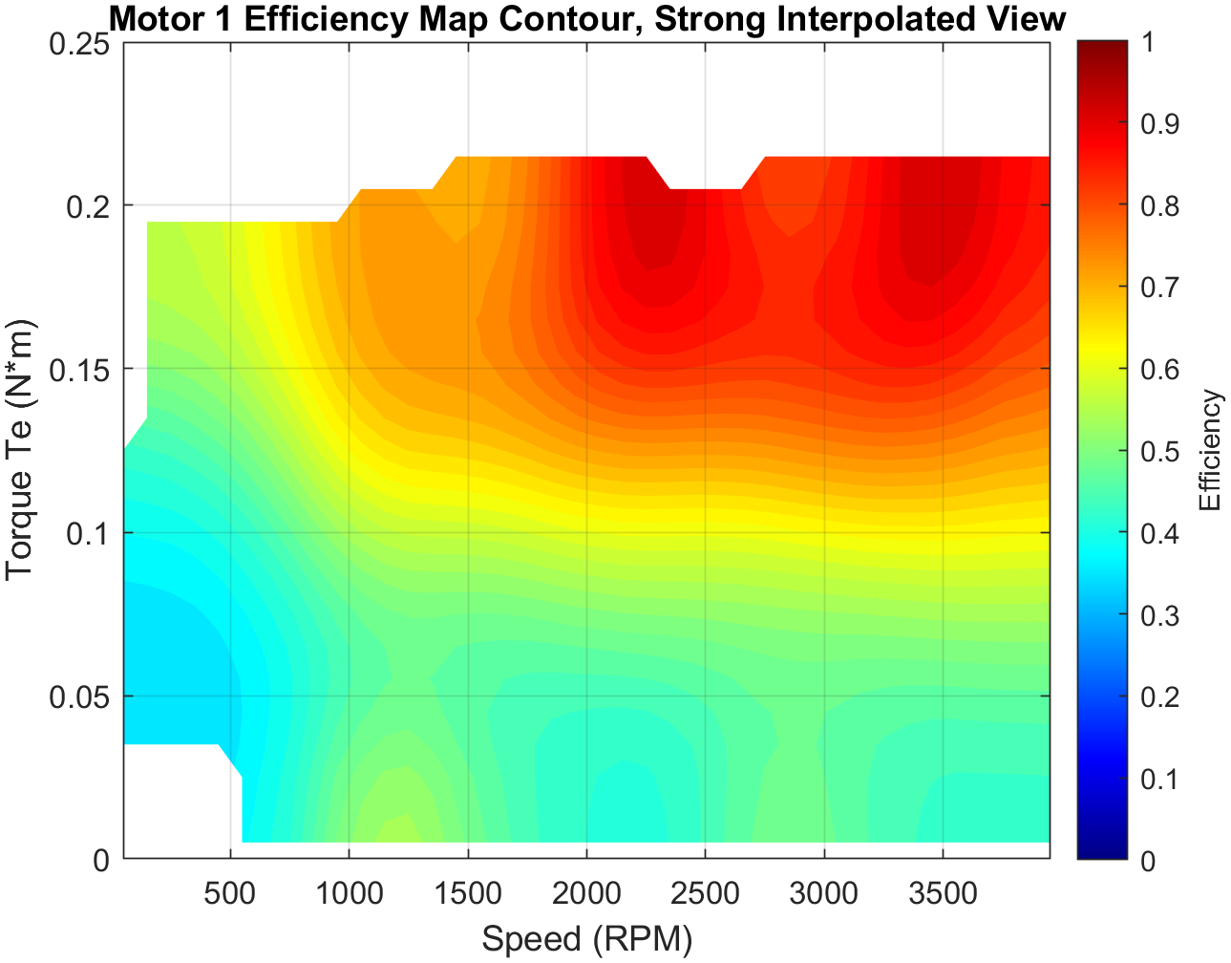
Figure. Contour visualization of the interpolated surface.

7. Demonstrated Outcomes and Interpretation Boundaries
Outcome | Supported statement
Physical recovery | Phase order and encoder/QEP mapping were corrected against the actual platform.
Control bring-up | Dual-machine closed-loop operation was restored on the F28069M target.
Communications | CAN command and response transport was demonstrated with retained mailbox and packing evidence.
Data quality | Non-finite and implausible samples are screened before map generation.
Traceability | Measured bins, sample counts, and interpolated views are retained as distinct evidence products.
Boundary | No production safety, calibrated metrology, EMC, environmental, or functional-safety qualification is claimed.

8. Release Status
This report is released with FRD revision 1.4. The public repository is a capability showcase and engineering evidence package, not a turnkey firmware distribution. Selected sanitized Simulink examples are included; complete target models, binaries, private scaling tables, raw data, and generated implementation trees remain controlled.
Rev | Date | Author | Description
1.1 | 2026-08-03 | HES | Reformatted in TI-inspired application-note style and aligned to the new FRD and traceability model.
1.2 | 2026-08-03 | HES | Added selected sanitized Simulink examples and aligned the companion report to FRD revision 1.4; no substantive technical findings changed.

9. Custom Low-Level ADC Integration
Most application behavior is represented by editable Simulink models, but the target also contains a focused custom C layer for F28069M ADC peripheral configuration. This source is included under embedded-control/custom-firmware/ and is not a renamed generated support file.

9.1 Added acquisition resources
SOC pair | Inputs | Trigger | Completion | Role
SOC0/SOC1 | ADCINA0 / ADCINB0 | ePWM1 | EOC1 -> ADCINT1 | Baseline synchronized pair
SOC2/SOC3 | ADCINA3 / ADCINB3 | ePWM4 | EOC3 -> ADCINT2 | Baseline synchronized pair
SOC4/SOC5 | ADCINA0 / ADCINB0 | Software | Polled / model-controlled | Software-triggered pair
SOC6/SOC7 | ADCINA3 / ADCINB3 | Software | Polled / model-controlled | Software-triggered pair
SOC12/SOC13 | ADCINA2 / ADCINB2 | ePWM1 | EOC13 -> ADCINT5 | Added instrumentation pair
SOC14/SOC15 | ADCINA1 / ADCINB1 | ePWM1 | EOC15 -> ADCINT9 | Added instrumentation pair
The project-specific additions are SOC12/SOC13 and SOC14/SOC15. Both pairs are synchronized to ePWM1 so the additional instrumentation channels are sampled against target-side timing rather than host execution timing.

9.2 Integration boundary
- The Simulink target remains the primary editable application/control source.
- F28069M_ADC_Custom_Config.c provides the project-specific register-level SOC, trigger, acquisition-window, and ADC interrupt configuration.
- MathWorks-generated ADC support files, TI device-support source, object files, and binaries remain excluded.
- A compatible C2000 support package, device headers, and the referenced target model are required to compile and deploy the complete target.

9.3 Controlled engineering claim
The demonstrated contribution is custom C2000 ADC peripheral integration for two additional simultaneous analog-input pairs, including PWM-triggered sampling and end-of-conversion interrupt routing. The release does not claim a from-scratch ADC driver or ownership of TI/MathWorks support libraries.

