# Middle of the Mitt High School Figure Skating Competition Results

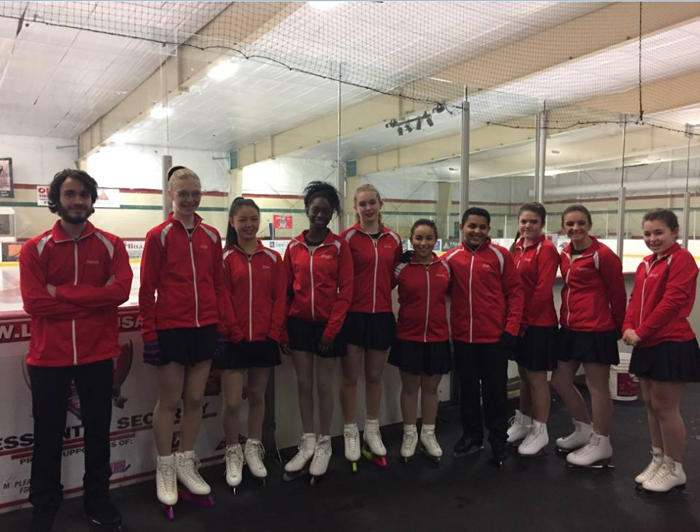

*From the Shepherd High School*

Congratulations to Kayla Morgan and Angelina Myers who represented Shepherd High School and the Middle of the Mitt High School Figure Skating Team on January 21 at their 2nd Competition of the Season in Mt Pleasant. The 3 Teams (A, B & C) came home with 2 bronze and 2 silver medals from the event. The final district competition of the season will take place on Sunday, February 19th in Bay City where the skaters will be trying to qualify for the State Championships in March.