

SQE (Fall-2026)
Teacher: Sir Tamim

Department of Software Engineering

Bahria University, Islamabad

Student : Sher Hassan , Shahaab Ur Rehman
Enrollment : 01-131232-084, 01-131232-080

Assignment: 1
Date: 3/1/2026

- Black-Box Testing

1.1 Binary Search — Control Flow Graph (CFG)
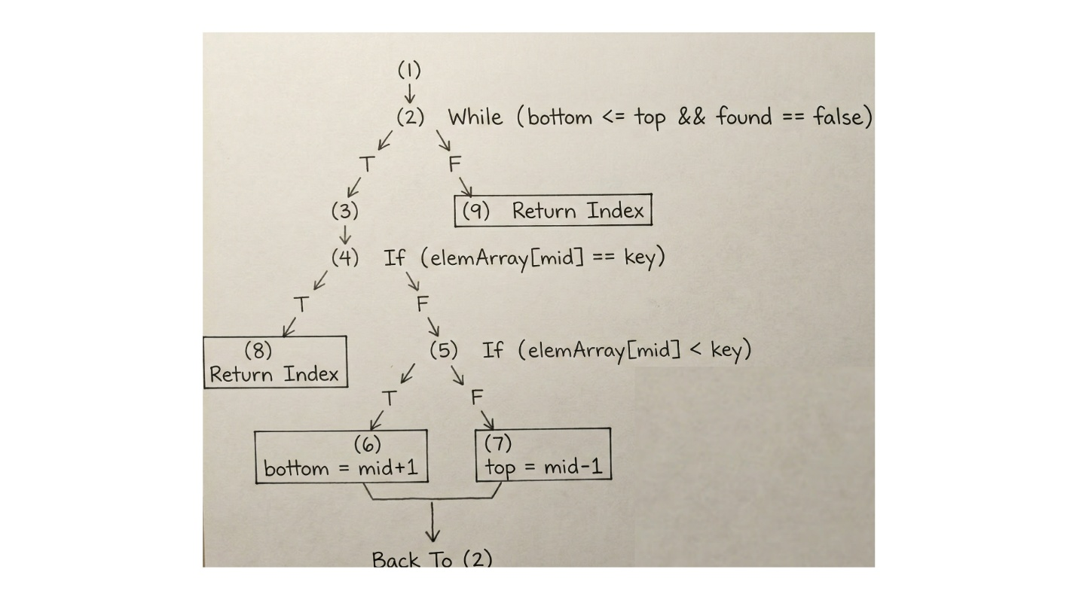

Cyclomatic Complexity
- Number of decision nodes: 3
- V(G) = Decisions + 1 = 3 + 1 = 4
- Independent paths: 4

Independent Paths
- 1 → 2(F) → 9
- 1 → 2(T) → 3 → 4(T) → 8
- 1 → 2(T) → 3 → 4(F) → 5(T) → 6 → 2(T) → 3 → 4(T) → 8
- 1 → 2(T) → 3 → 4(F) → 5(F) → 7 → 2(F) → 9

Test Cases
TC | Input | Expected | Path
TC1 | (5, {}) | -1 | Path 1
TC2 | (5, {5}) | 0 | Path 2
TC3 | (5, {1,2,3,4,5}) | 4 | Path 3
TC4 | (1, {1,2,3,4,5}) | 0 | Path 4
TC5 | (2, {1,3,5}) | -1 | Loop exit path

1.2 Linear Search — Control Flow Graph (CFG)
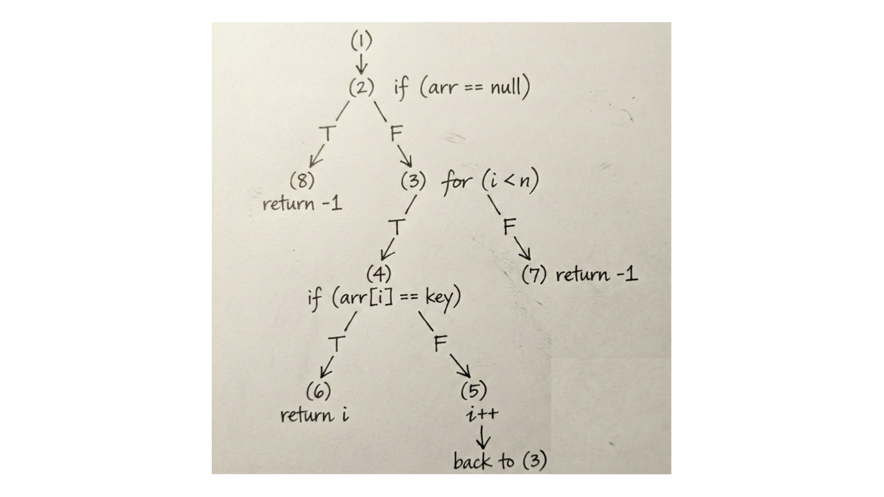

Cyclomatic Complexity
- Decisions: 3 → V(G) = 3 + 1 = 4
- Independent paths: 4

Independent Paths
- 1 → 2(T) → 8
- 1 → 2(F) → 3(T) → 4(T) → 6
- 1 → 2(F) → 3(T) → 4(F) → 5 → 3(T) → 4(T) → 6
- 1 → 2(F) → 3(T) → 4(F) → 5 → 3(F) → 7

Test Cases
TC | Input | Expected | Path
TC1 | (1, null) | -1 | Path 1
TC2 | (7, {7,8,9}) | 0 | Path 2
TC3 | (8, {7,8,9}) | 1 | Path 3
TC4 | (5, {1,2,3}) | -1 | Path 4

1.3 Jump Search — Control Flow Graph (CFG)
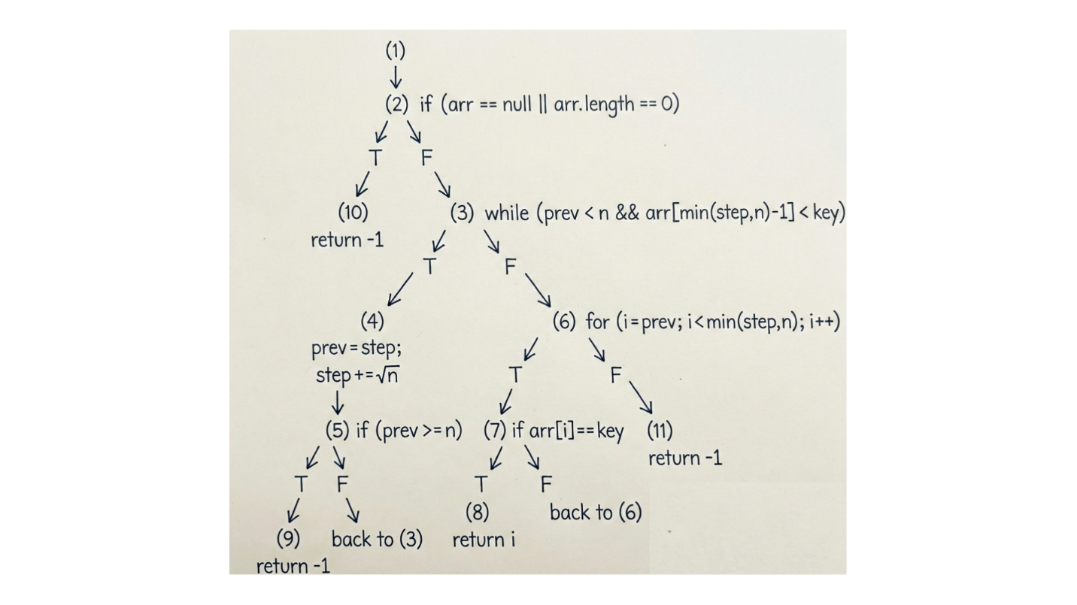

Cyclomatic Complexity
- Decisions: 5 → V(G) = 5 + 1 = 6
- Independent paths: 6

Independent Paths
- 1 → 2(T) → 10
- 1 → 2(F) → 3(F) → 6(T) → 7(T) → 8
- 1 → 2(F) → 3(F) → 6(T) → 7(F) → 6(F) → 11
- 1 → 2(F) → 3(T) → 4 → 5(T) → 9
- 1 → 2(F) → 3(T) → 4 → 5(F) → 3(F) → 6(T) → 7(T) → 8
- 1 → 2(F) → 3(T) → 4 → 5(F) → 3(F) → 6(T) → 7(F) → 6(F) → 11

Test Cases
TC | Input | Expected | Path
TC1 | (1, null) | -1 | Path 1
TC2 | (5, {}) | -1 | Path 1
TC3 | (5, {1,3,5,7,9}) | 2 | Path 2
TC4 | (4, {1,3,5,7}) | -1 | Path 3
TC5 | (1, {1,2,3,4}) | 0 | Path 4
TC6 | (10, {1,2,3,4}) | -1 | Loop exit path

2. White-Box Testing

2.1 GitHub Actions Workflow
The project includes a GitHub Actions workflow (.github/workflows/maven.yml) which runs on every push and pull request.
It executes:
```bash mvn -B clean verify
GitHub Repository: https://github.com/Sher-Hassan/SQE-Assignment-1
GitHub actions run the test cases successfully and generates a functional coverage report.
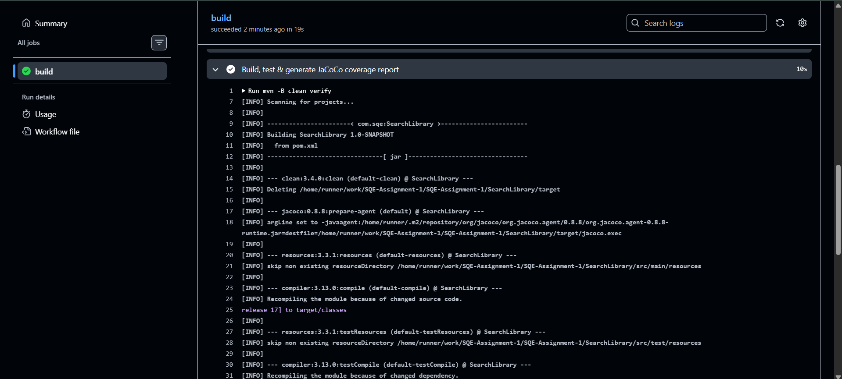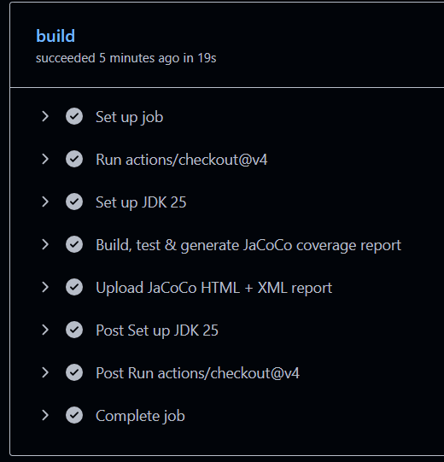

Coverage Report Generated:
