Documentation for SherSmart Infotech

What We Do:
Deliver Success! The core mantra of SherSmart Infotech is to implement profitable business model on time which meets all the requirements of our clients. Unique prototypes for various business services can be created which are acquirable.
(For Three Boxes)
- Client Centric Dedicated Team:
We have a team that sways the best web, mobile, ERP and CRM solutions. Our development team is designed in a way to handle the project while maintaining quality and cost-efficiency. We thrive to give out the final product that meets client’s prospect while sustaining the cost-effectiveness.
- Data Protection and Backups:
To offer the comprehensive results, we follow agile development. To maintain the client confidentiality and data privacy, we sign the NDA. Maintaining regular backups is the ardent solution in the time of crisis. Therefore, by curating periodic backups, help our clients to advert any misfortune.
- Advanced Support at Frequent Intervals:
At every phase of project, we provide support to our clients using the best possible approach. Throughout the Innovation, Creation and Implementation, our tech team is there to assist at each and every step.

(Change How We Work to “Project Execution Methodology” as shown in below image)
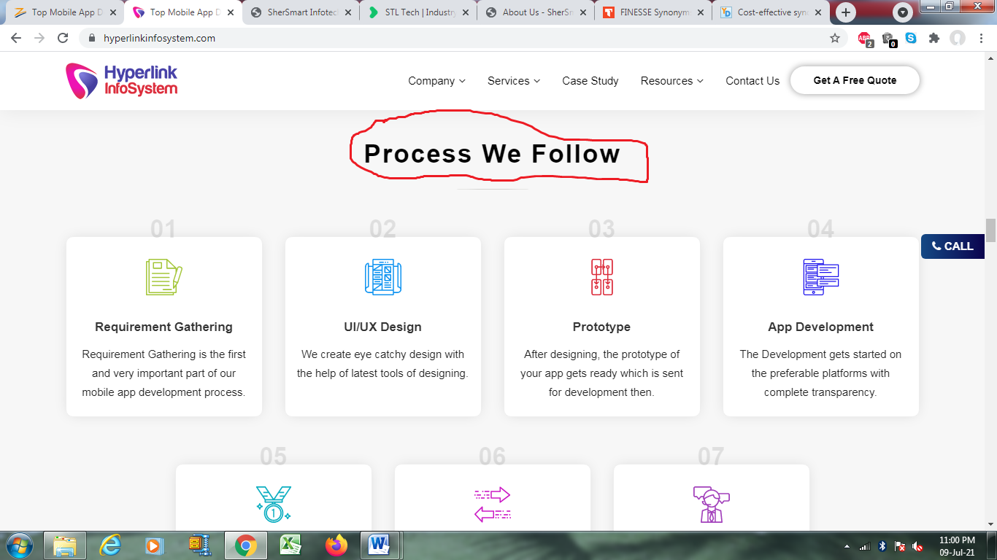
Project Execution Methodology
- Requirements Collection:
The first step to start any development is the collection of requirements from the client’s end.
- UI/UX Proposal:
Using the cutting-edge designing software tools, the prominent UI/UX is proposed.
- Model:
The prototype of the application is created and sent to the development team, once the UI/UX proposal is approved.
- Development:
By considering the suggested platform and technologies, the application enters into the development phase.
- QA/QC verification:
Each and every module of the application is thoroughly checked and verified before handling out for the seamless experience.
- Distribution:
Once the QA/QC certification is completed, the application is ready to go LIVE in the market.
- Support and Maintenance:
Support team is available 24*7 for further assistance in handling the application.

(Change Collections from our customers to “what Our Customers Say”)
What Our Customers Say:

Our customers are front runners of our company. We would not have survived without our dedicated customers. Our customers have pushed us to attain the fierce dedication for our self-evolutionary path. Therefore, we have been able to emerge as the best in the industry to use cognitive technologies in addition to our distinguished IT services.

- Testimonial 1:
SherSmart Infotect is well-versed in their IT technologies. The application has helped us to achieve desired results in the market.
- Testimonial 2:
Development team is very advanced. They developed the perfect application based on our requirements.
- Testimonial 3:
SherSmart is the most amazing IT company I have worked with. They have multi-talented team. They provide extra-ordinary support after the deployment of the application.
- Testimonial 4:
They have created remarkable application as per the given prototype. Their backup process is smooth and frequents updates are on-time.
- Testimonial 5:
This was my first time working with an IT company. We had an idea for the application but wasn’t sure about its execution. We contacted SherSmart and informed about our requirements. Based on those requirement collections, they have deliver tremendous application. I will definitely work again with SherSmart.

