**HangOver**

**Time Limit: 2000/1000 MS (Java/Others)    Memory Limit: 65536/32768 K (Java/Others)  
Total Submission(s): 10132    Accepted Submission(s): 4274**

**Problem Description**

How far can you make a stack of cards overhang a table? If you have one card, you can create a maximum overhang of half a card length. (We're assuming that the cards must be perpendicular to the table.) With two cards you can make the top card overhang the bottom one by half a card length, and the bottom one overhang the table by a third of a card length, for a total maximum overhang of 1/2 + 1/3 = 5/6 card lengths. In general you can make n cards overhang by 1/2 + 1/3 + 1/4 + ... + 1/(n + 1) card lengths, where the top card overhangs the second by 1/2, the second overhangs tha third by 1/3, the third overhangs the fourth by 1/4, etc., and the bottom card overhangs the table by 1/(n + 1). This is illustrated in the figure below.  
  
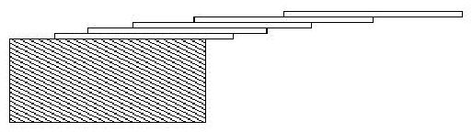   
  
The input consists of one or more test cases, followed by a line containing the number 0.00 that signals the end of the input. Each test case is a single line containing a positive floating-point number c whose value is at least 0.01 and at most 5.20; c will contain exactly three digits.  
  
For each test case, output the minimum number of cards necessary to achieve an overhang of at least c card lengths. Use the exact output format shown in the examples.

**Sample Input**

1.00

3.71

0.04

5.19

0.00

**Sample Output**

3 card(s)

61 card(s)

1 card(s)

273 card(s)

**Source**

[Mid-Central USA 2001](http://acm.hdu.edu.cn/search.php?field=problem&key=Mid-Central+USA+2001&source=1&searchmode=source)

**Recommend**

We have carefully selected several similar problems for you:  [1065](http://acm.hdu.edu.cn/showproblem.php?pid=1065) [1099](http://acm.hdu.edu.cn/showproblem.php?pid=1099) [1077](http://acm.hdu.edu.cn/showproblem.php?pid=1077) [1257](http://acm.hdu.edu.cn/showproblem.php?pid=1257) [1248](http://acm.hdu.edu.cn/showproblem.php?pid=1248)