Task 1
- Create a kind cluster named cte412-<sid> with one control-plane node and two worker nodes. Host port 30090, bound to 127.0.0.1 only, must reach node port 30090 on the cluster.
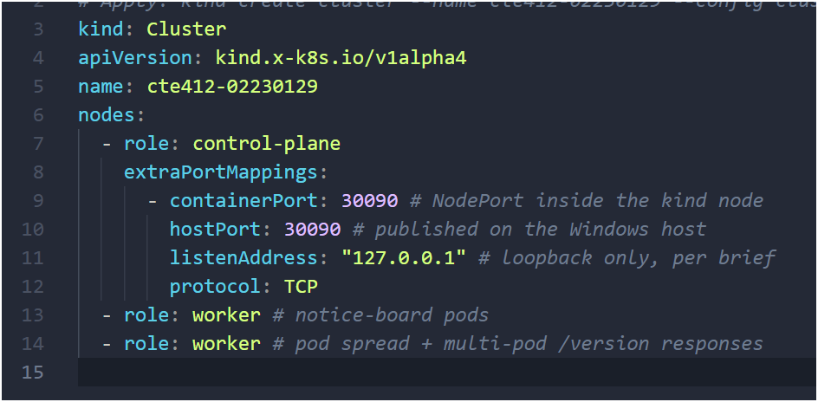
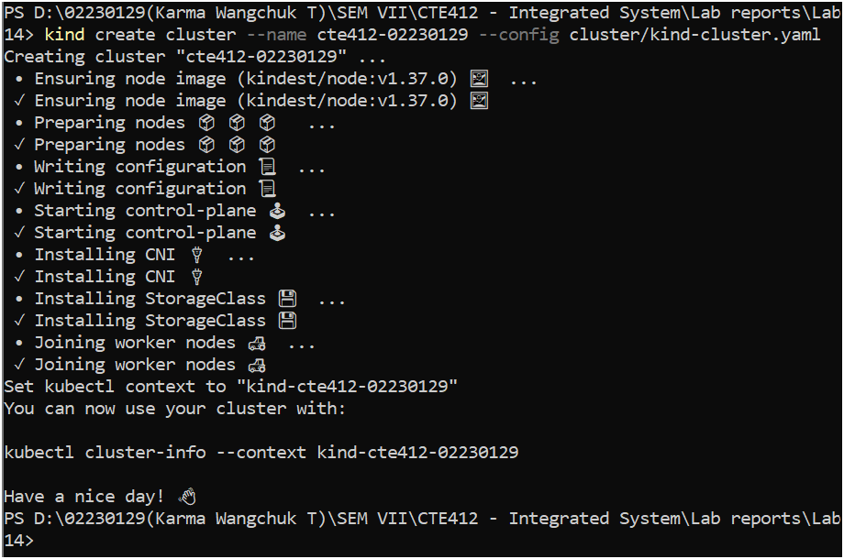
- Create the namespace nb-<sid> with the labels app.kubernetes.io/part-of=campus-noticeboard and cte412/practical="06", and an annotation recording your full name.
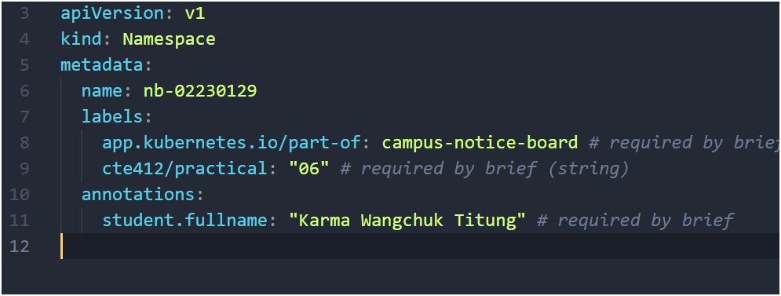
- In that namespace, create a ResourceQuota with these hard limits: requests.cpu 1, requests.memory 1Gi, limits.cpu 2, limits.memory 2Gi, pods 15, count/services 4.
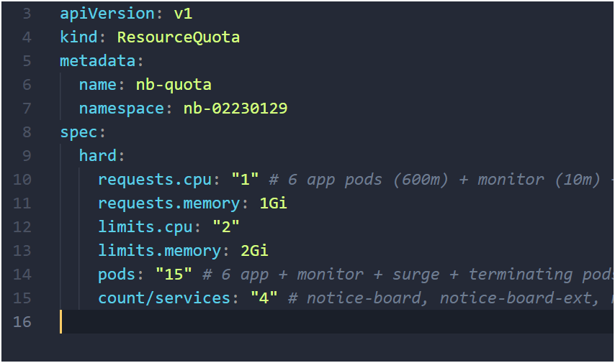
- Create a LimitRange supplying default requests and limits for containers. Choose the values yourself and justify each one in a comment against the quota above.
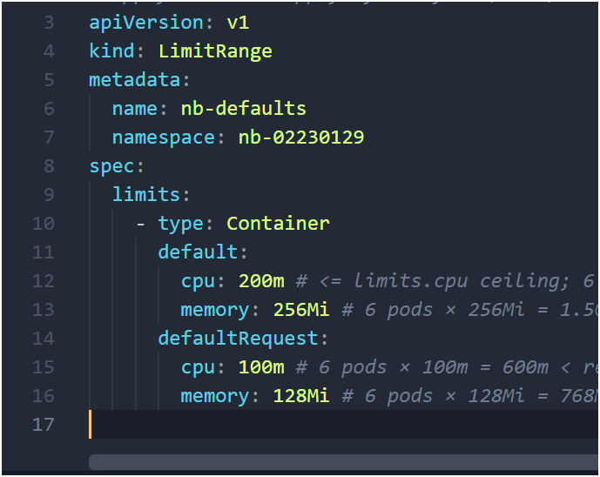
- Make nb-<sid> the default namespace of your kubectl context.
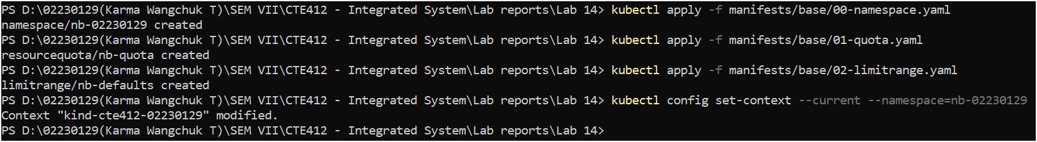
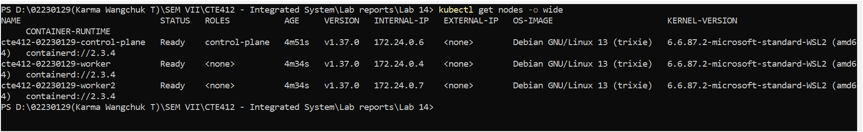
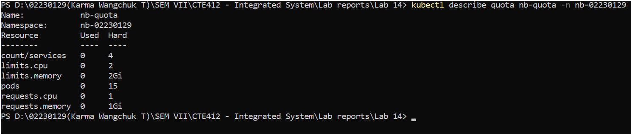
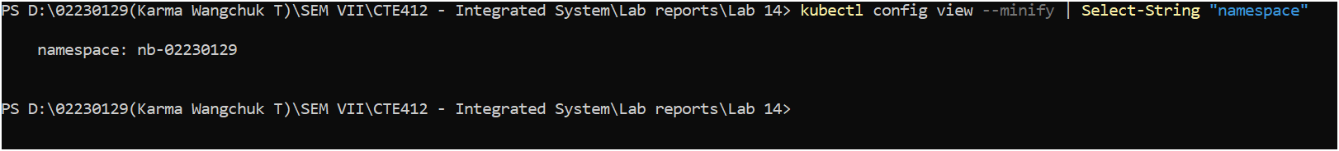
Task 2
- Every version listens on port 8080, runs as a non-root user, and exposes three endpoints. GET /notices returns at least three notices as JSON. GET /version returns JSON containing version, student (your <sid>) and pod (the container hostname). GET /healthz returns HTTP 200 when healthy.
- docker tag noticeboard-app:v1.0.0 notice-board:02230129-1.0.0
- Tag notice-board:<sid>-1.1.0 — adds a category field to every notice and a pinned Boolean to at least one. When the environment variable FEATURE_PINNED equals true, pinned notices are listed first and the response body includes "pinnedFirst": true; otherwise the order is unchanged and the field is false.
- Tag notice-board:<sid>-1.1.0 — adds a category field to every notice and a pinned Boolean to at least one. When the environment variable FEATURE_PINNED equals true, pinned notices are listed first and the response body includes "pinnedFirst": true; otherwise the order is unchanged and the field is false.
- Tag notice-board:<sid>-1.2.0-broken — identical to 1.1.0 except that /healthz never returns 200. /notices and /version still work.
- Place all three images into the cluster without using a registry.
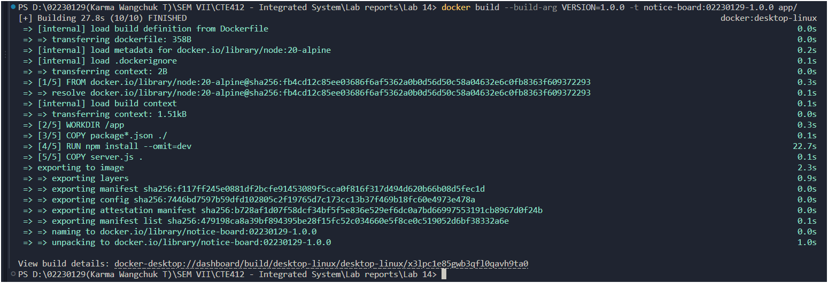
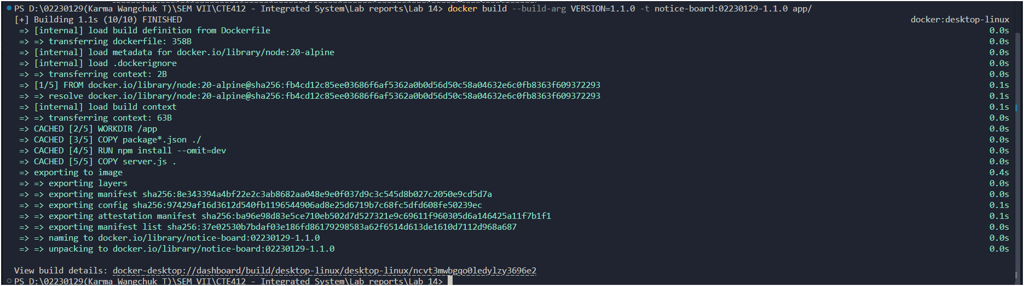
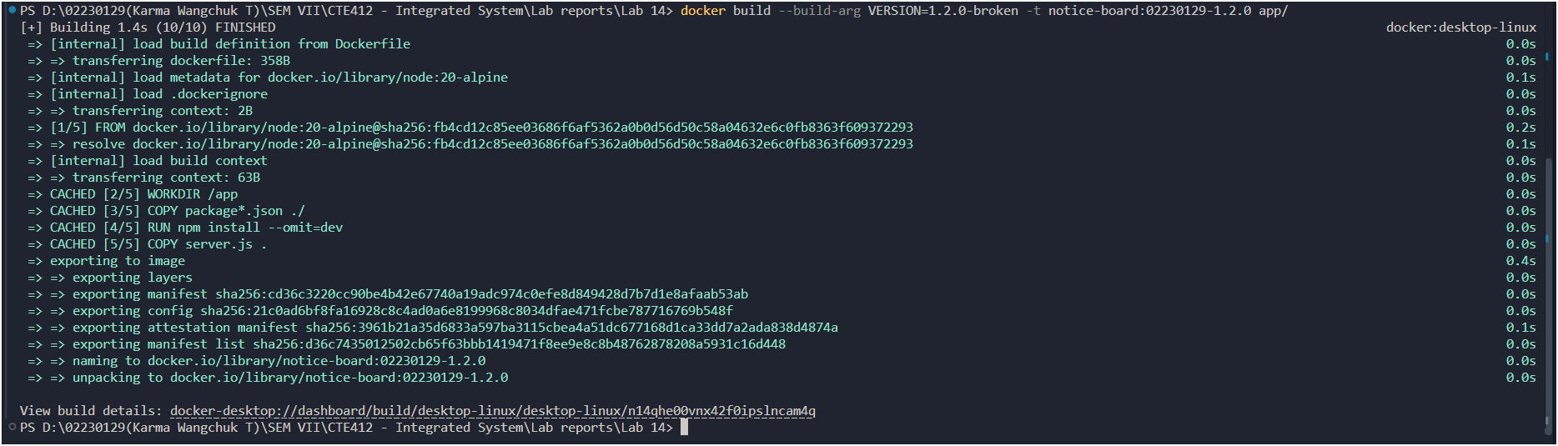

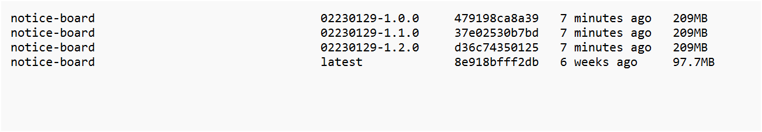
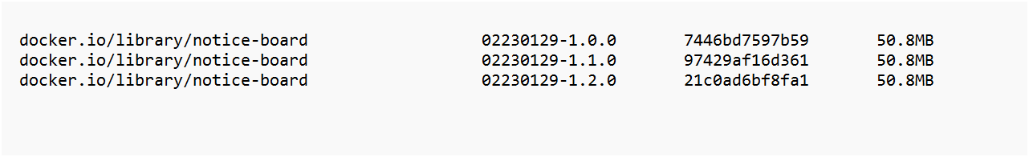

Task 3 — Deploy and Expose Version 1.0.0 (25 minutes)
- Create a Deployment notice-board running 3 replicas of 1.0.0, with labels app=notice-board and version=<image version> on the Pods.
- Declare requests and limits for the container that fit inside your quota with room for Tasks 5 to 8.
- Configure a readiness probe against /healthz. Configure a liveness probe that does not use /healthz; state in a comment why.
- Ensure the kubelet can never attempt a registry pull for this image.
- Create a ClusterIP Service notice-board (port 80 to the named container port) and a NodePort. Service notice-board-ext on node port 30090.
- From the host, show that /version on port 30090 is answered by at least two different Pods.
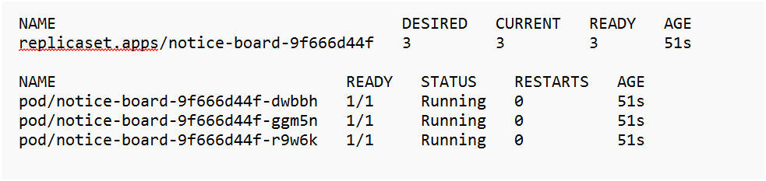
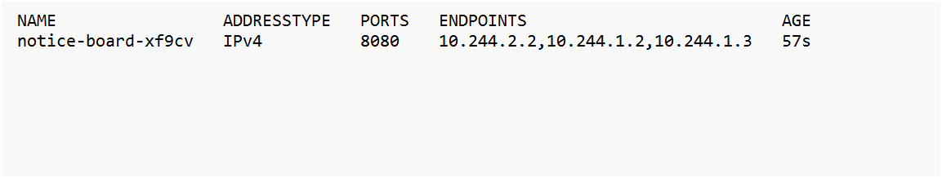
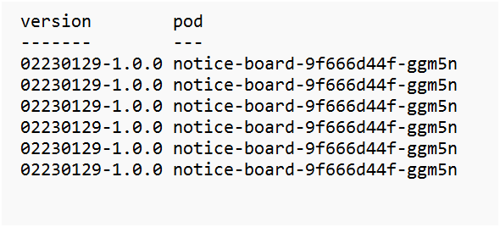

Task 4 — Availability Monitor and Summariser (15 minutes)
The monitor is the measuring instrument for Tasks 5 to 8. It must run continuously and must not be restarted between measurements.
- Create a Pod monitor in manifests/base/ that requests http://notice-board/version every 0.5 seconds, forever, and writes one line per request to standard output in the form <ISO-8601 timestamp> <OK|FAIL> <response body or error>.
2. Write scripts/summarise.sh. Given a saved monitor log as its only argument, it prints: total
requests, failed requests, the first and last timestamp, and the count of responses per distinct
version value.
3. Save one minute of monitor output with the system at rest and summarize it.

