After you start the Calculator you will see:

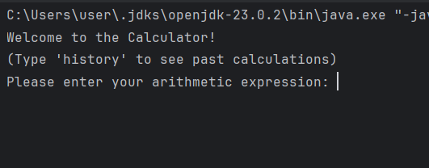

Then after you enter some expression, you will be asked if you would like to continue:

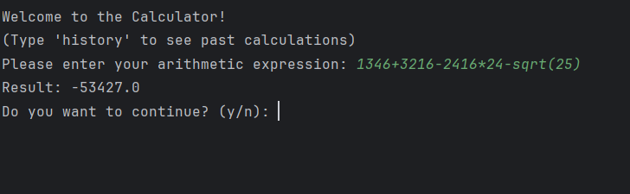

You can’t choose anything, except ‘y’ or ‘n’. If you enter something except given letters, you will get error and will be asked to make another one choice:

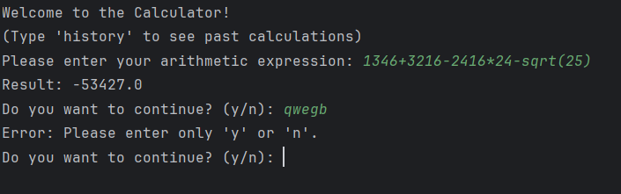

And now when you already have some expressions, you can always check them in history section. To open history, you need to type ‘history’, as it is given in the instruction higher, and all your previous expressions will be given:

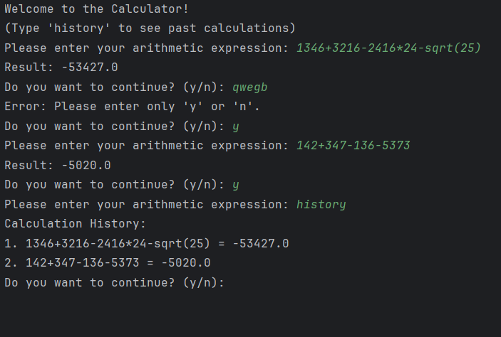

If you want to exit, type choose ‘n’ and close the Calculator.