



[PROGRAMMING LANGUAGE VS. MARKUP LANGUAGE VS. SCRIPTING LANGUAGE: WHO WILL COMES OUT WINNER?](https://www.cirdangroup.com/cirdan-blog/2017/11/29/programming-language-vs-markup-language-vs-scripting-language-who-will-comes-out-winner)

The average programmer will tell you that programming and doing code is like learning another language…which is essentially true. What most people don’t know is that it could be like learning several languages at once. Coding is the terminology used for any type of the computer writing language used. There are three main types of coding that every programmer will know:

1. Programming Language: C++, Visual Basic, Java, C#
2. Markup Language: HTML, XML, CSS
3. Scripting Language: JavaScript, PHP, Python

However, what are the key differences between these three, that distinguishes them from one another…and which one of the three languages is the best to use?

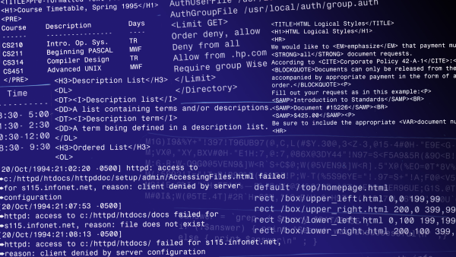

**PROGRAMMING LANGUAGE**

A programming language is the proper and formal language that has been designed to allow programmers to communicate instructions to a computer. Programming language is used to create programs.

Programming language is used to transform data by creating CPU instruction that will rewrite the input data into the desired output. This is a language that encodes programs, meaning that a word in the language can be interpreted as a sequence of actions.

**MARKUP LANGUAGE**

This is debatable, but markup language is not considered to be a programming language simply because the term is not well-defined. A markup language is used to control the presentation of the data, like representing structured data. For example, HTML is used to specify that some part of a document is a title, another part is a list, another part is heading etc. So, based off of that, a markup language is used to describe the data and the formatting in a textual format. There is a general rule, that a markup language will not describe a process or an algorithm (like programming language does) but is just pure data.

**SCRIPTING LANGUAGE**

A scripting language is a subset of programming languages that is used to mediate between programs in order to generate data. The main feature of scripting languages is that it can guide other programs, much like a script that will give an actor/actress their cue to start his/her part. It is a language that is meant to be interpreted, rather than compiled, emphasizing its purpose as a subset of all programming languages. Some may define it as a programming language that support scripts (which is written to control other programs). Therefore, scripting language is written to control another program or programs, and sometimes take a longer time to run, since the script must be interpreted first and then run into a supporting system.

With each of the differences being highlighted for all three languages, it must be understood that not one language is greater than the other, because they are all used interdependently help make the program itself run smoother.

<https://www.cirdangroup.com/cirdan-blog/2017/11/29/programming-language-vs-markup-language-vs-scripting-language-who-will-comes-out-winner>

……………….



