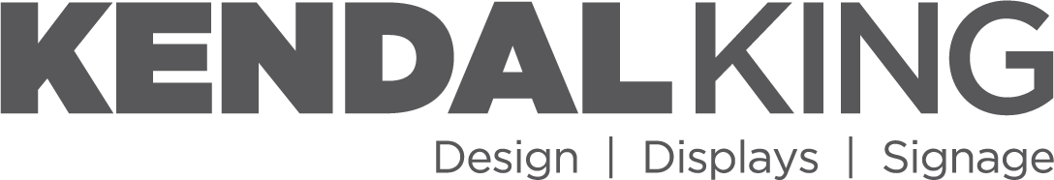  609 SW 8th St • Ste 140 • Bentonville, AR 72712 |  |  |  |  |  |  |  | UNIFORM BILL OF LADING
 |  |  |  |  |  |  |  | BOL # | MBOL-001
 |  |  |  |  |  |  |  | Ship Date | 05/13/2026
 |  |  |  |  |  |  |  | Carrier | Test Carrier
 |  |  |  |  |  |  |  | Carrier Pro #
 |  |  |  |  |  |  |  | PO # | PO-0551
FROM (SHIPPER) |  |  |  |  |  |  |  | Tracker #
COMPANY | Kendal King C/O Productiv |  |  |  |  |  |  | KK PO # | KKPO-001
 |  |  |  |  |  |  |  | KKG Load # | 1
STREET | 4255 Patriot Drive Suite 400  Grapevine, TX |  |  |  |  |  |  | Delivery Appt.
 |  |  |  |  |  |  |  | APPT #
 |  |  |  |  |  |  |  | Comments: Keep dry
ATTN |  |  |  |  |  |  |  | Seal #
TO (CONSIGNEE) |  |  |  |  |  |  |  | FREIGHT CHARGE TERMS:
COMPANY | DC 0551 |  |  |  |  |  |  |  | X FREIGHT PREPAID
 |  |  |  |  |  |  |  |  | FREIGHT COLLECT
STREET | 1 Stop Way |  |  |  |  |  |  |  | FREIGHT THIRD PARTY
CITY/ST/ZIP | Dallas, TX 75001 |  |  |  |  |  |  | BILL TO:
APPOINTMENT # |  |  |  |  |  |  |  | Acme Freight
DC: | 0551 |  |  |  |  |  |  | 505 Riverfront Pkwy
 |  |  |  |  |  |  |  | Chattanooga, TN 37402
SUBJECT TO SECTION 7: Of the conditions if shipment is to be delivered to consignee without recourse on the consignor, the consignor shall sign the following statement: The Carrier shall not make delivery of the shipment without payment of the freight and all other lawful charges. |  |  |  |  |  |  |  | Attn:
(Delivery Appointment is Subject to Change)
The property described below in apparent good order, except as noted (contents and condition of contents of packages unknown), marked, consigned, and destined as indicated below which said carrier (the word carrier being understood throughout this contract as meaning any person or corporation in possession of the property under the contract) agrees to carry to its usual place of delivery at said destination, if on its route otherwise to deliver to another carrier on the route to said destination. It is mutually agreed as to each carrier of all or any of said property over all are any portion of said route to destination, and as to each party at any time interested in all or any said property, that every service to be performed hereunder shall be subject to all the terms and conditions of the Uniform Domestic Straight Bill of Lading set forth (1) in Uniform Freight Classifications in effect on the date hereof, if this is a rail or rail-water shipment, or (2) in the applicable motor carrier classification or tariff if this is a motor carrier shipment. Shipper hereby certifies that he is familiar with all the terms and conditions of the said bill of lading, set forth in the classification or tariff which governs the transportation of this shipment, and the said terms and conditions are hereby agreed to by the shipper and accepted for himself and his assigns.
Pallet Qty | TYPE |  | PO # |  | ITEM DESCRIPTION |  |  |  |  |  | # SKIDS |  |  | WEIGHT
10 | PLT |  | PO-0551 |  | Stop one pallet  Item #: ITEM1 UPC #: 000111222333 |  |  |  |  |  | 2 |  |  | 100
10 |  |  |  |  | TOTALS |  |  |  |  |  | 2 |  |  | 100
 |  |  |  |  |  |  |  |  | AGENT (Driver Signature) Date: # of Pallets
CUSTOMER NOTE: Please check this shipment carefully. No returns accepted without prior approval. If shipment does not agree with this manifest, have carrier note discrepancy on receipt and notify shipper immediately.

