Document Knowledge Assistant
Installation and Operation Manual - Tutorial Sample
Section 3: Install and run the application locally on Windows
This sample shows the format used for every section of the full manual: each actionable step has a purpose, numbered instructions, copyable commands, a real screenshot, the expected result and a verification. All screenshots were captured from a clean installation following exactly these steps; no real secrets appear in them.
Tested environment
Component | Version
Operating system | Windows 11 Pro (build 22621), 64-bit
Python | 3.12.10
FastAPI / Uvicorn | 0.142.2 / 0.54.0
NiceGUI (Python UI) | 3.17.1
fastembed / embedding model | 0.8.1 / BAAI/bge-small-en-v1.5 (384 dimensions)
pytest / Playwright for Python | 9.1.1 / 1.63.0
Full dependency lock | requirements.lock.txt (87 packages)
Date of capture | 6 October 2026

Contents
3 Install and run locally on Windows
Before you start
3.1 Check that Python 3.12 is installed
3.2 Open the project folder
3.3 Allow PowerShell to run the project scripts
3.4 Run the one-time setup script
3.5 Review the configuration without exposing secrets
3.6 Start the application
3.7 Check the health endpoint
3.8 Create demo users and load the sample documents
3.9 Log in and ask a question with sources
3.10 Run the automated tests
3.11 Remove the bootstrap admin password from .env
3.12 Stop the application
3.13 Common errors and fixes
3.14 What the full manual adds

3 Install and run locally on Windows

Before you start
Item | Details
Hardware | Any 64-bit PC with 8 GB RAM and 2 GB free disk; no GPU needed.
Software | Windows 10/11, Python 3.12 (python.org), a modern browser (Edge or Chrome).
Network | Internet on the first install/start only (packages and the 70 MB embedding model).
Accounts | None. No AWS account or API key is needed for this section; the default model provider runs offline at no cost.
Time | About 15 minutes.
Conventions
- Grey boxes contain commands to copy. The blue header says where to run them: Windows PowerShell (this PC) or, in later sections, Server (Amazon Linux, via SSM). Never run a server command on Windows or vice versa.
- PS D:\POC> at the start of a line in a screenshot is the prompt - do not type it.
- <LIKE_THIS> marks a placeholder you must replace, including the angle brackets.
- Window #1 runs the application; window #2 is used for all other commands.

3.1 Check that Python 3.12 is installed
Purpose: The application and all tests are Python. Version 3.12 is the version the pinned dependencies were tested with.
Instructions:
- Click Start, type PowerShell, and open Windows PowerShell (a normal, non-administrator window is correct).
- Type the two commands below and press Enter after each.

Windows PowerShell (any folder)
python --version
python -m pip --version
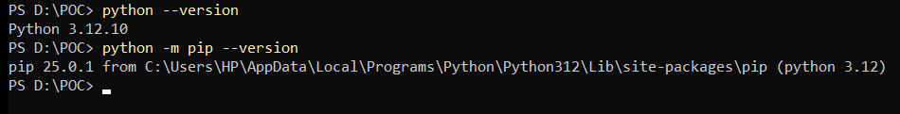
Figure 1 - Python and pip versions
Expected result: Python 3.12.x and a pip version line.
Verification: The first line starts with Python 3.12. If you see "python is not recognized", see error E1 in section 3.13.

3.2 Open the project folder
Purpose: All later commands are run from the project root so the relative paths (.\scripts\...) resolve.
Instructions:
- Extract the delivered project ZIP to a folder without spaces, for example D:\POC. D:\POC is an example used throughout this manual - replace it with your folder.
- In PowerShell, change into that folder and list its contents.

Windows PowerShell
cd D:\POC
Get-ChildItem
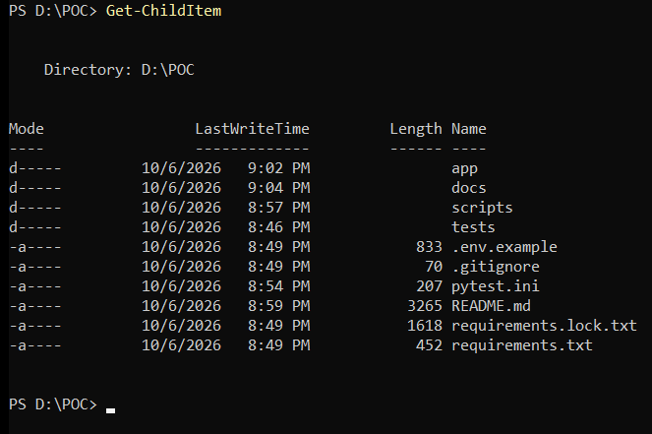
Figure 2 - Project root after extracting the ZIP (before setup)
Expected result: Folders app, docs, scripts, tests and files .env.example, requirements.txt, requirements.lock.txt, README.md.
Verification: requirements.txt and the scripts folder are listed. There is no .env yet - it is created in step 3.4.

3.3 Allow PowerShell to run the project scripts
Purpose: Windows blocks .ps1 scripts by default on some machines. RemoteSigned allows local scripts while still requiring downloaded scripts to be signed.
Instructions:
- Check the current policy with the first command.
- Only if CurrentUser and LocalMachine are both Undefined or Restricted, run the second command (affects only your user account, no administrator rights needed).

Windows PowerShell
Get-ExecutionPolicy -List
Set-ExecutionPolicy -Scope CurrentUser RemoteSigned
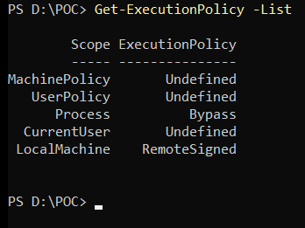
Figure 3 - Execution policy - LocalMachine is already RemoteSigned on this PC
Expected result: RemoteSigned (or Unrestricted) for CurrentUser or LocalMachine.
Verification: Re-run Get-ExecutionPolicy -List. The Process row may show Undefined or Bypass depending on how the window was opened - it does not matter.

3.4 Run the one-time setup script
Purpose: Creates an isolated Python environment, installs the exact pinned packages, creates the secret-free-by-default configuration and the first admin password.
Instructions:
- Run .\scripts\setup.ps1. The first run downloads and installs packages (3-5 minutes; internet required).
- At Choose the first admin password, type a password of at least 10 characters and press Enter. Nothing is echoed except * - this is expected.
- At Type it again to confirm, type the same password. If it is too short or does not match, the script asks again.
- Do not click inside the black console area while it runs (see error E3). Record the password in your password manager.

Windows PowerShell (in D:\POC)
.\scripts\setup.ps1
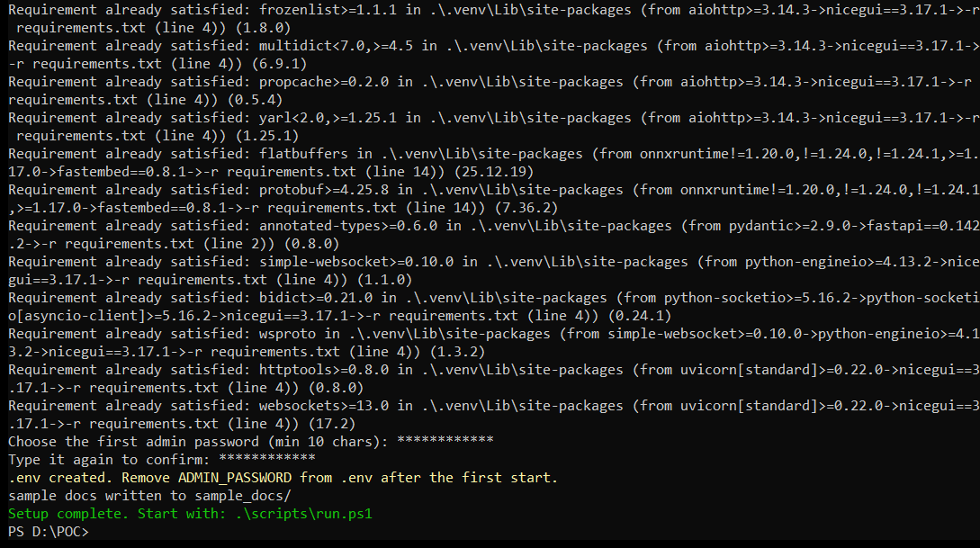
Figure 4 - End of setup: password entered twice, .env created, sample documents generated
Expected result: .env created..., sample docs written to sample_docs/ and the green line Setup complete. Start with: .\scripts\run.ps1.
Verification: Test-Path .env, .venv, sample_docs returns True three times.
Note: This screenshot is from a second run on the same folder, so pip prints "Requirement already satisfied". On a first run you see "Downloading ..." and "Successfully installed ..." instead. What the script does: (1) creates .venv; (2) installs requirements.txt; (3) copies .env.example to .env and writes a random 48-character STORAGE_SECRET; (4) stores the admin password for the first start only; (5) restricts .env and data so only your Windows account can read them; (6) generates the demo documents.

3.5 Review the configuration without exposing secrets
Purpose: Shows which settings exist (model provider, address, limits) while masking the two secret values, so the output is safe for screenshots and support tickets.
Instructions:
- Run the command below. It prints .env with STORAGE_SECRET and ADMIN_PASSWORD replaced by ********.
- Optionally edit .env in Notepad (notepad .env) - for example LLM_PROVIDER - and save. Restart the app after any change.

Windows PowerShell (in D:\POC)
Get-Content .env | ForEach-Object { $_ -replace '^(STORAGE_SECRET|ADMIN_PASSWORD)=.+', '$1=********' }
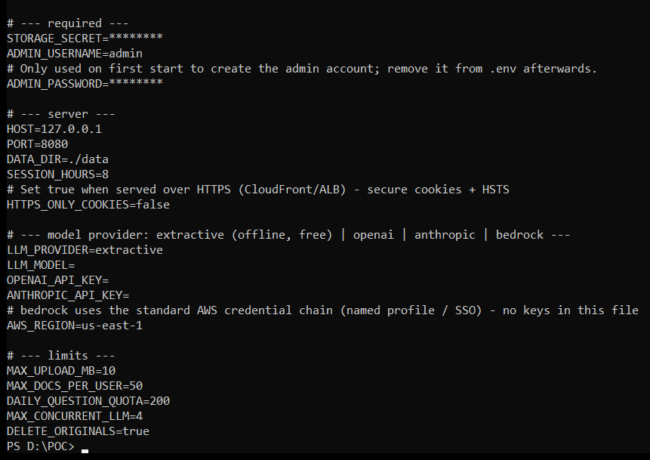
Figure 5 - Masked view of .env
Expected result: Both secrets show ********; HOST=127.0.0.1, PORT=8080, LLM_PROVIDER=extractive (offline, no API key, no cost).
Verification: STORAGE_SECRET is not change-me (the app refuses to start with the placeholder value).
Note: Placeholders in this manual are written in angle brackets, e.g. <ADMIN_PASSWORD>, <OPENAI_API_KEY>. Replace the whole placeholder including the brackets. Never paste real keys into documents, screenshots or chat.

3.6 Start the application
Purpose: Runs the FastAPI backend and the Python (NiceGUI) frontend in one process, bound to 127.0.0.1 so only this PC can reach it (remote access is added later through AWS).
Instructions:
- Run .\scripts\run.ps1 and keep this window open - closing it stops the application.
- On the very first start the local embedding model (about 70 MB) is downloaded once; wait until the last line appears.

Windows PowerShell window #1 (in D:\POC) - keep open
.\scripts\run.ps1
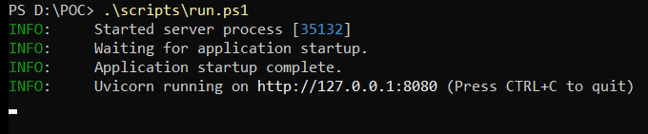
Figure 6 - Application running
Expected result: Uvicorn running on http://127.0.0.1:8080 (Press CTRL+C to quit).
Verification: Next step (3.7) returns status ok.

3.7 Check the health endpoint
Purpose: Confirms the web server, the database and the search index are working before you open the browser.
Instructions:
- Open a second PowerShell window (window #1 keeps running the app).
- Run the command below.

Windows PowerShell window #2
Invoke-RestMethod http://127.0.0.1:8080/healthz
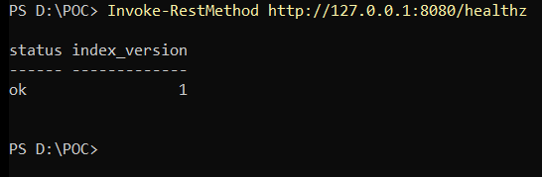
Figure 7 - Health check
Expected result: status ok and index_version 1.
Verification: Any error such as "Unable to connect" means the app is not running - check window #1 and section 3.13.

3.8 Create demo users and load the sample documents
Purpose: Creates the standard user accounts alice and bob and uploads the four shared sample documents through the same API the application uses.
Instructions:
- In window #2, change into the project folder (cd D:\POC) and run the command below.
- At Admin password, type the password from step 3.4. At Password for the demo users, choose a password (10+ characters) for alice and bob. Typing is invisible.
- Wait until all four documents show ready.

Windows PowerShell window #2 (in D:\POC)
.\.venv\Scripts\python scripts\seed_demo.py --users alice,bob
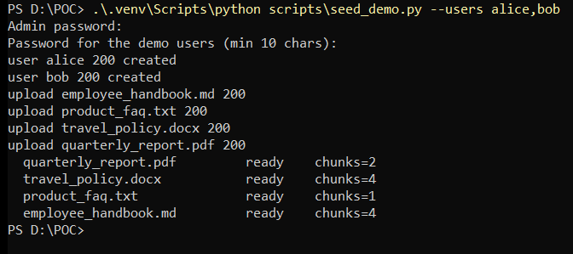
Figure 8 - Demo users created and documents indexed
Expected result: user alice 200 created, user bob 200 created, four upload ... 200 lines and every document ready with chunks > 0.
Verification: Status ready for .md, .txt, .docx and .pdf. 401 Unauthorized means the admin password was wrong (error E6).

3.9 Log in and ask a question with sources
Purpose: End-to-end check of the real user interface: login, chat, hybrid retrieval and source references.
Instructions:
- Open a browser at http://127.0.0.1:8080 - you are redirected to the sign-in page.
- Sign in as alice with the demo user password from step 3.8.
- Click NEW CHAT, type What warranty does the SolarBox 3000 include? and click the send button.
- Click Sources under the answer to expand the references.
- Click Documents in the top bar to see the shared documents and their status.
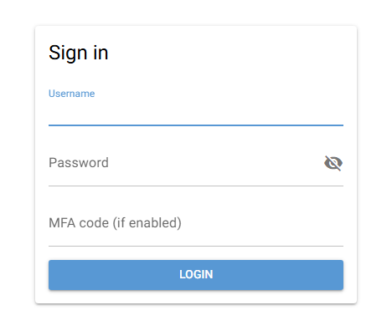
Figure 9 - Sign-in page
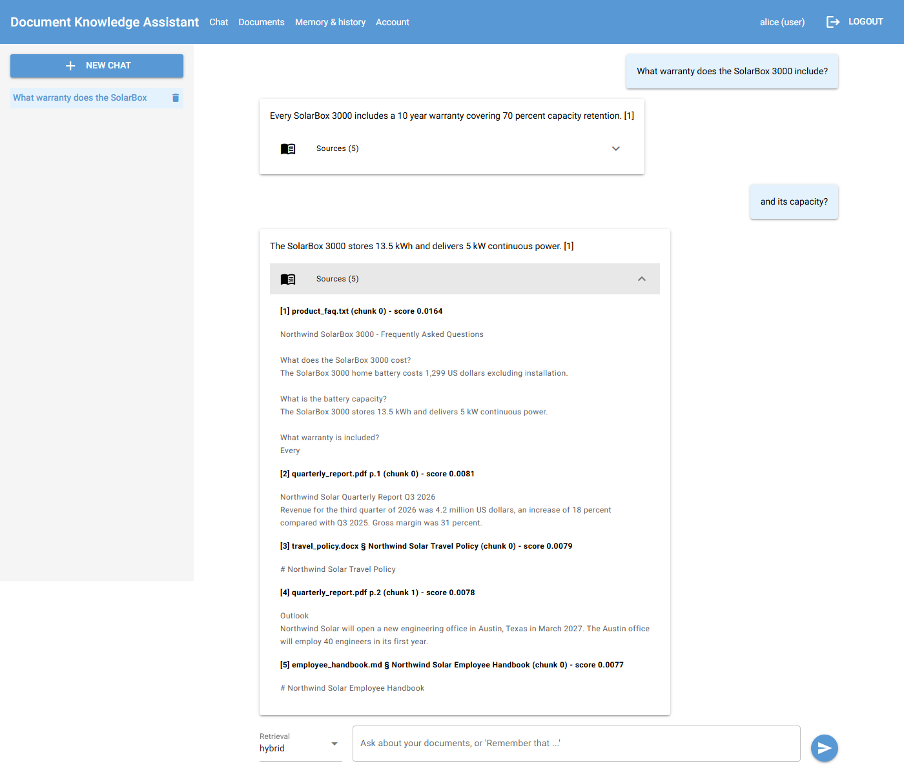
Figure 10 - Answer with numbered citations and expanded sources
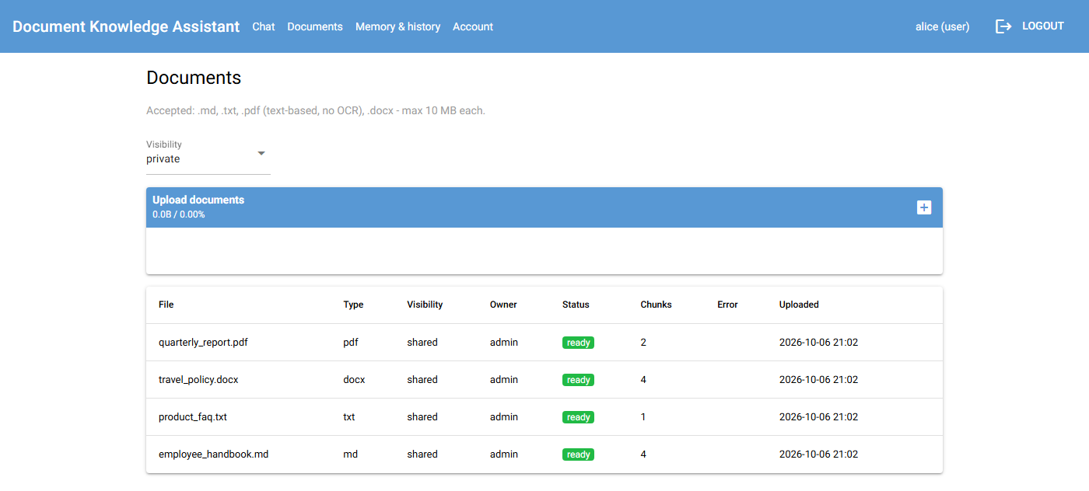
Figure 11 - Documents page: all four file types indexed (ready)
Expected result: An answer containing 10 year warranty with [1], and source [1] product_faq.txt (chunk 0) with its score and text.
Verification: Ask What is the capital city of Mongolia? - the assistant refuses ("I could not find this...") and shows no sources, proving it does not invent answers.

3.10 Run the automated tests
Purpose: Repeatable proof that retrieval, memory, permissions and security controls work. The tests use their own temporary database, so the running app and your data are not touched.
Instructions:
- In window #2 run the command below (about 10 seconds).
- Optional: .\scripts\test.ps1 -RealEmbeddings runs the same suite with the real embedding model, including the 4 dense-only checks.

Windows PowerShell window #2 (in D:\POC)
.\scripts\test.ps1
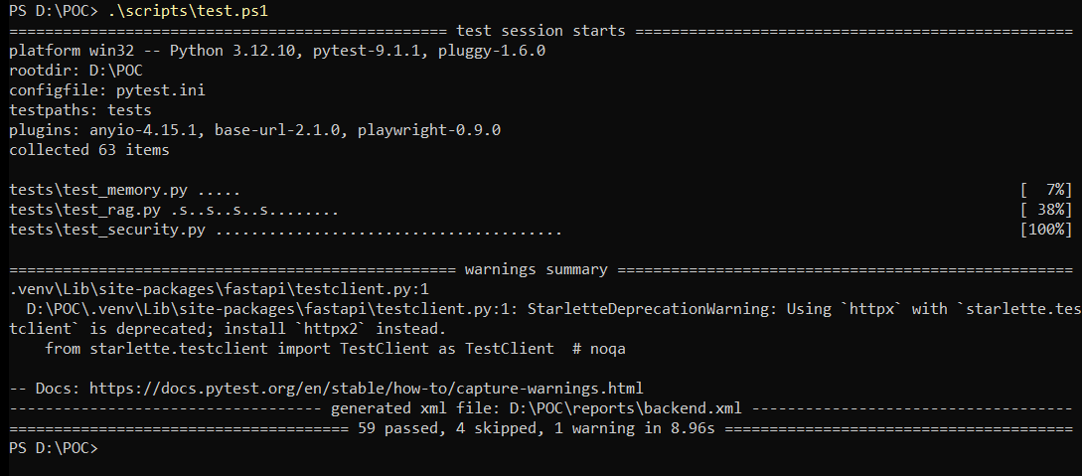
Figure 12 - Backend and security test results
Expected result: 59 passed, 4 skipped (the 4 skips are dense-only checks that need the real model; with -RealEmbeddings: 63 passed).
Verification: reports\backend.xml exists (JUnit format, can be attached as evidence).

3.11 Remove the bootstrap admin password from .env
Purpose: ADMIN_PASSWORD is only needed to create the admin on the first start. The password is stored hashed (scrypt) in the database, so the plain copy in .env should be deleted.
Instructions:
- Run the two commands below in window #2.
- Restart the app: in window #1 press Ctrl+C, then run .\scripts\run.ps1 again, and repeat the health check from step 3.7.

Windows PowerShell window #2 (in D:\POC)
(Get-Content .env) | Where-Object { $_ -notmatch '^ADMIN_PASSWORD=' } | Set-Content .env -Encoding utf8
Select-String -Path .env -Pattern '^ADMIN_PASSWORD=' -Quiet
Figure 13 - ADMIN_PASSWORD line removed (search returns False)
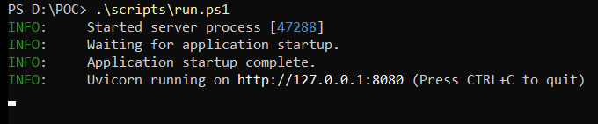
Figure 14 - Application restarted successfully without ADMIN_PASSWORD
Expected result: The search prints False; after the restart the app starts normally and you can still log in as admin.
Verification: Health check returns status ok and the admin login works.

3.12 Stop the application
Purpose: Clean shutdown; the database, documents, chats and memories remain in the data folder for the next start.
Instructions:
- Click the title bar of window #1 and press Ctrl+C (as shown in its last line, Figure 6).
- Verify from window #2 that nothing is listening on port 8080 any more.

Windows PowerShell window #2
Test-NetConnection 127.0.0.1 -Port 8080 -InformationLevel Quiet -WarningAction SilentlyContinue
Figure 15 - Port 8080 closed after shutdown
Expected result: Window #1 returns to the PS D:\POC> prompt; the check prints False.
Verification: Start again with .\scripts\run.ps1 - your chats, memories and documents are still there (they are stored in data\app.db).

3.13 Common errors and fixes
# | Message / symptom | Cause | Fix
E1 | python is not recognized as the name of a cmdlet | Python not installed or not on PATH. | Install Python 3.12 from python.org with Add python.exe to PATH ticked, then open a new PowerShell window.
E2 | running scripts is disabled on this system | Execution policy blocks .ps1 files. | Run the second command of step 3.3.
E3 | Console output stops and the window title starts with Select | A click inside the console started text selection (QuickEdit), which pauses the program. | Press Esc or right-click inside the window; the program continues.
E4 | STARTUP ERROR: No users exist yet: set ADMIN_PASSWORD in .env (Figure below) | First start (or data was deleted) and .env has no admin password. | Add ADMIN_PASSWORD=<ADMIN_PASSWORD> (10+ chars) to .env, start once, then repeat step 3.11.
E5 | STARTUP ERROR: ADMIN_PASSWORD / ADMIN_USERNAME in .env is not valid | Password shorter than 10 characters or invalid username. | Fix the value in .env, or delete .env and run .\scripts\setup.ps1 again.
E6 | 401 Unauthorized when running seed_demo.py | Wrong admin password typed. | Run the command again and type the password from step 3.4. Five wrong attempts lock the account for 15 minutes (429) by design.
E7 | error while attempting to bind on address ('127.0.0.1', 8080) | Another instance already uses port 8080. | Close the other window (Ctrl+C), or set PORT=8081 in .env and use that port in the browser.
E8 | First start fails while downloading the embedding model | No internet on the first start. | Connect once; the model is cached locally afterwards.
E9 | user alice 400 Username already exists | seed_demo.py was run before. | Harmless - existing users and documents are kept.
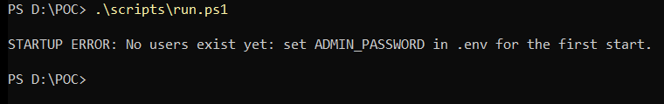
Figure 16 - Error E4 as it appears in window #1

3.14 What the full manual adds
The complete manual follows this same format for every section, with matching numbered MP4 videos:
- Code structure and how to modify the Python application and the Python tests.
- Agent, memory and hybrid RAG explained, with settings experiments (chunking profiles, retrieval modes, reindexing).
- PostgreSQL + pgvector on a small AWS instance: installation, secure access, migrations, backups and restore.
- AWS network path (CloudFront + WAF to EC2, SSH over SSM to Windows), Windows service account, automatic recovery after reboot, crash and network loss.
- Authentication and security assessment, including the pinned patchright-enhanced revision, Python Playwright and direct HTTP tests.
- Parallel-user tests (5, 10, 25, 50 users), monitoring with CloudWatch, updates, costs and complete cleanup.

