

Software Engineering Department
Braude College of Engineering

IQ PLUS
A Smart Learning Management System for Personalized Academic Support

Project code: 26-1-D-27

Capstone Project Phase B – 61998
June 2026

Sherbel Abdalla
Roni Shifrin

Git repository link:

Supervisor:
Dr. Natali Levi

Table of Contents
Contents
1. Introduction 3
2. Background and Related Work 4
2.1 Learning Management Systems 5
2.2 Learning Analytics and Progress Monitoring 5
2.3 AI and Rule-Based Decision Support 6
2.4 Summary 6
3.General Description 6
3.1 System Objectives 7
3.2 Target User Identification 7
3.3 Academic Intelligence and Progress Monitoring 8
4.Development Process 8
5.System Architecture 11
5.1 System Package Diagram 12
5.1.1 Frontend 13
5.1.2 Backend 13
5.1.3 Database 14
5.2 System Flow 14
6.Challenges and Obstacles 15
6.1 Managing Role-Based Access Control 15
6.2 Designing Interfaces for Multiple User Roles 16
6.3 Managing Academic Data and Progress Tracking 16
6.4 Integrating Academic Intelligence and AI Services 16
6.5 System Performance and Data Consistency 16
6.6 Lessons Learned 17
7.Project Metrics 18
8.Conclusions and Future Work 20
9.References 21
Appendices 22
Appendix A – User Guide 22
A.1 Introduction 22
A.2 Operating Instructions 22
A.2.1 Sign-Up Page 23
A.2.2 Login Page 24
A.2.3 Admin Dashboard 25
A.2.4 Teacher Dashboard 26
A.2.5 Student Dashboard 27
A.2.6 Parent Dashboard 29
A.2.7 Course Management 30
A.2.8 Lesson Records and Feedback 31
A.2.9 Progress Page 33
A.2.10 Chat Page 34
A.2.11 Materials Page 35
A.2.12 Academic Planner 36
A.3 Navigation and Settings 38
A.3.1 Navigation Bar 38
A.3.2 Language Selection 38
A.3.3 Dark Mode 39
A.3.4 Role-Based Access 39
A.3.5 Logging Out 39
Appendix B – Maintenance Guide 39
B.1 System Requirements 39
B.2 Installation Instructions 40
B.2.1 Database Setup 41
B.2.2 Backend Setup 41
B.2.3 Frontend Setup 42
B.3 Deployment Guide 43
B.4 Configuration Files 43
B.5 Demo Data and Seed Scripts 44
B.6 Project Structure 45
B.7 Maintenance Recommendations 46

Abstract
The IQ PLUS project addresses the need for a centralized digital platform for managing learning center operations and academic follow-up. In many tutoring environments, administrative tasks, course scheduling, student progress tracking, and parent communication are handled through fragmented tools such as spreadsheets, messaging applications, and informal documentation. This fragmentation makes it difficult to maintain consistent academic records, identify student difficulties early, and provide clear communication between teachers, students, parents, and administrators. This project presents a web-based learning center management system that integrates user management, course management, enrollment workflows, attendance, grades, feedback, reports, notifications, and academic progress monitoring in one platform. The system supports four main user roles: Admin, Teacher, Student, and Parent, each with role-based permissions and dedicated interfaces. IQ PLUS also includes an academic intelligence layer that provides progress summaries, alerts, and recommendations based on student data. By centralizing operational and academic processes, the system improves organization, transparency, and data-supported decision-making in modern learning centers.
Abbreviations
LMS - Learning Management System
AI - Artificial Intelligence
API - Application Programming Interface
RBAC - Role-Based Access Control
REST - Representational State Transfer
UI - User Interface
UX - User Experience
DB - Database
ODM - Object Document Mapper
CRUD - Create, Read, Update, Delete

1. Introduction
Learning centers and tutoring environments play an important role in supporting students who require additional academic assistance, personalized guidance, and continuous follow-up. These environments usually involve several stakeholders, including administrators, teachers, students, and parents. Each stakeholder needs access to different information and tools: administrators need operational control, teachers need academic documentation tools, students need access to their progress, and parents need clear visibility into their children’s learning development.
In many learning centers, daily processes are still managed through fragmented tools such as spreadsheets, messaging applications, paper notes, and informal communication. Although these tools may support basic coordination, they do not provide a centralized and reliable way to manage users, courses, schedules, enrollment requests, attendance, grades, feedback, reports, and long-term academic progress. As the number of students, teachers, and courses grows, this fragmentation increases administrative workload and makes it harder to identify academic difficulties at an early stage.
The objective of this project is to develop IQ PLUS, a web-based learning center management system that centralizes the main operational and academic workflows of a learning center. The system supports four main user roles: Admin, Teacher, Student, and Parent. Each role has a dedicated interface and role-based permissions according to its responsibilities. Administrators can manage users, approve registrations, manage courses, monitor activity, and handle enrollment workflows. Teachers can manage courses, record attendance, grades, and lesson feedback, and monitor student progress. Students and parents can view schedules, course information, feedback, progress reports, notifications, and academic insights according to their permissions.
The implemented system combines administrative management with academic follow-up and decision-support capabilities. In addition to user and course management, IQ PLUS includes progress tracking, performance scores, academic alerts, notifications, reports, messaging, course materials, syllabus management, and academic planner. These features are designed to improve organization, transparency, and communication between the learning center and its users.
From a technical perspective, IQ PLUS is implemented as a client-server web application. The frontend is developed using React, TypeScript, Vite, and Tailwind CSS. The backend is implemented using Python and FastAPI. MongoDB is used as the main database, with Beanie ODM for asynchronous data access. The system also includes authentication, role-based access control, audit logs, reporting services, analytics services, and deployment support through Docker.
The project follows the goals defined in Phase A, which focused on building a smart learning management platform for personalized academic support. In Phase B, the planned concept was transformed into a working software system that demonstrates the complete flow of a learning center: account creation, administrative approval, course creation, enrollment, schedule validation, lesson documentation, academic analysis, communication, and report generation.
The structure of this document is as follows. Chapter 2 presents the background and related work relevant to learning management systems and learning analytics. Chapter 3 describes the developed system, its objectives, target users, and implemented features. Chapter 4 describes the development process. Chapter 5 presents the system architecture and main workflows. Chapter 6 discusses the challenges and obstacles encountered during development. Chapter 7 presents the project metrics. Chapter 8 presents conclusions and future work. The appendices include the User Guide and the Maintenance Guide.

2. Background and Related Work
Learning centers and tutoring environments provide academic support for students who need additional practice, personal guidance, and continuous follow-up outside the regular classroom. These environments usually involve several stakeholders: administrators, teachers, students, and parents. Each of them needs access to different information. Administrators need to manage courses, teachers, schedules, and enrollment. Teachers need to document attendance, grades, and feedback. Students need to follow their learning progress, and parents need clear updates about their children’s academic situation.
In many learning centers, these processes are still handled through fragmented tools such as spreadsheets, paper notes, phone calls, and messaging applications. Although these tools may be sufficient for basic coordination, they do not provide a centralized and reliable way to track student progress over time. As a result, academic information may be incomplete, communication may become unclear, and teachers may find it difficult to identify learning difficulties early.
This gap motivated the development of IQ PLUS as an integrated system for both operational management and academic follow-up.

2.1 Learning Management Systems
Learning Management Systems (LMS) are digital platforms that support educational processes such as course organization, content management, grading, communication, and student tracking. Systems such as Moodle, Google Classroom, and Canvas are widely used in schools, colleges, and universities. These platforms improve the organization of learning materials and provide a structured environment for teachers and students.
However, many existing LMS platforms are designed mainly for formal educational institutions rather than small or medium-sized learning centers. Learning centers often require more flexible workflows, such as direct parent involvement, course enrollment approval, lesson-level feedback, flexible scheduling, and continuous monitoring of individual student progress. General LMS platforms may support content delivery and grades, but they do not always match the daily operational needs of tutoring environments.
IQ PLUS addresses this gap by focusing on the specific workflow of a learning center. The system combines user management, course management, enrollment, scheduling, lesson documentation, parent visibility, communication, and progress monitoring in a single web-based platform.

2.2 Learning Analytics and Progress Monitoring
Learning analytics refers to the collection and analysis of educational data in order to understand and improve learning processes. In IQ PLUS, the relevant data includes grades, attendance, lesson feedback, engagement level, difficulty level, and progress history. By storing this information in a structured way, the system can provide a clearer picture of each student’s academic development over time.
Progress monitoring is important because learning centers often support students who are trying to close academic gaps or prepare for important exams. Early identification of decline, repeated absences, low grades, or negative feedback trends can help teachers respond more quickly and provide additional support. Instead of relying only on informal impressions, IQ PLUS allows teachers and parents to view organized academic records and progress indicators.
A key requirement in educational analytics is explainability. Teachers and parents need to understand why a system generates an alert or recommendation. Therefore, IQ PLUS focuses on clear indicators such as attendance rate, grade trends, feedback history, and engagement level. The system supports educational decision-making, but the final pedagogical decisions remain under human responsibility.

2.3 AI and Rule-Based Decision Support

Artificial Intelligence can support educational systems by analyzing student data, identifying patterns, and generating recommendations. However, in education, AI should be used carefully because student performance may be influenced by personal, emotional, social, and contextual factors. For this reason, AI should support teachers and administrators rather than replace their professional judgment.
The implemented IQ PLUS system follows a hybrid approach. It includes a rule-based analytics layer that calculates performance indicators and detects academic risk situations based on predefined conditions. In addition, the system includes optional Claude AI integration for generating richer academic explanations and recommendations when an Anthropic API key is configured. If the external AI service is unavailable, the system falls back to rule-based analysis.
This design keeps the system reliable and explainable. Academic monitoring can continue even without external AI access, while AI-based explanations can improve the clarity of insights when available.

2.4 Summary
The reviewed background shows that learning centers need a system that combines operational management with academic follow-up. Existing tools often solve only part of the problem, which leads to fragmented data and inefficient communication. IQ PLUS was developed as an integrated platform that supports learning center administration, structured lesson documentation, communication, reporting, and explainable academic decision support.

3.General Description
IQ PLUS is a web-based learning center management system designed to centralize the daily operation of learning centers and improve academic follow-up for students. The system manages users, courses, schedules, enrollment requests, attendance, grades, feedback, reports, notifications, and communication in one platform.
The system supports four main user roles: Admin, Teacher, Student, and Parent. Each role has a dedicated dashboard and role-based permissions that allow users to access only the information and actions relevant to them.
At the operational level, IQ PLUS supports user management, course management, enrollment workflows, course materials, syllabi, notifications, and communication. At the academic level, teachers can record lesson-level data such as attendance, grades, feedback, difficulty level, and engagement rating. This data is later used to generate progress views, performance scores, alerts, recommendations, and reports.

3.1 System Objectives
The primary objective of IQ PLUS is to provide learning centers with a centralized digital system that supports both administrative management and academic follow-up. The system helps administrators manage users, courses, schedules, and enrollments, while enabling teachers to document student progress in a structured way.
Another objective is to improve transparency between the learning center, students, and parents. Students and parents can view course information, schedules, feedback, reports, notifications, and academic insights according to their permissions.
The system also supports data-based decision-making by generating progress summaries, performance indicators, alerts, and recommendations. These outputs help teachers and administrators identify academic risks earlier, while final pedagogical decisions remain under human responsibility.

3.2 Target User Identification
IQ PLUS is designed for four main user groups within the learning center environment:
- Admin: Manages users, roles, courses, enrollment requests, system activity, and administrative dashboards.
- Teacher: Manages academic activity in assigned courses, records attendance, grades, and feedback, manages course materials, and follows student progress indicators.
- Student: Views personal courses, schedules, grades, feedback, progress reports, notifications, messages, and academic planner recommendations.
- Parent: Follows the academic progress of linked children, including schedules, course information, feedback, reports, notifications, alerts, and recommendations.
The system is designed to provide each user group with a clear and focused interface according to its needs.

3.3 Academic Intelligence and Progress Monitoring
A central component of IQ PLUS is the academic intelligence layer. The system analyzes student-related data such as grades, attendance, feedback, engagement level, difficulty level, and progress history. Based on this data, it generates performance scores, progress summaries, alerts, predictions, and recommendations.
The implemented intelligence layer combines rule-based analytics with optional Claude AI integration through the Anthropic API. The rule-based component detects academic risk situations using predefined conditions, such as low grades, repeated absences, declining performance, or negative feedback trends. When the Claude AI service is configured, the system can generate richer academic explanations and recommended actions.
If the external AI service is unavailable, the system falls back to rule-based analysis. This keeps the system reliable and explainable. The purpose of this component is not to replace teachers, but to support them in understanding student progress and responding earlier to academic difficulties.

4.Development Process
The development of IQ PLUS followed an iterative and systematic approach, divided into several key phases:
- Research and Requirement Refinement: We began by reviewing the requirements defined in Phase A and adapting them to the actual implementation scope. The main goal was to identify the essential workflows required for a functional learning center platform. These workflows included user registration and approval, role-based access, course management, enrollment requests, lesson documentation, academic progress tracking, communication, and reporting. In parallel, we refined the four main system roles: Admin, Teacher, Student, and Parent, and defined the permissions and main actions for each role.
- Architecture Design: We designed a client-server architecture that separates the frontend, backend, and database layers. Key decisions included:
• Choosing React with TypeScript and Vite for the frontend to provide a responsive, component-based user interface.
• Selecting FastAPI for the backend due to its performance, clear REST API structure, and support for asynchronous operations.
• Implementing MongoDB as the main database because it provides flexible document storage suitable for users, courses, lesson records, messages, notifications, and academic analytics.
• Using Beanie ODM to simplify asynchronous database interaction with MongoDB.
- Development Phase: The development process was conducted incrementally, building and testing features in stages.
Backend Development:
• Implemented RESTful API endpoints using FastAPI.
• Developed authentication using email/password login, password hashing, session tokens, and role-based access control.
• Implemented user management, admin approval, course management, enrollment workflows, lesson records, grades, attendance, feedback, reports, notifications, messages, and chat services.
• Built academic analytics services for performance scores, progress predictions, risk detection, and recommendations.
• Integrated optional Claude AI analysis through the Anthropic API, with rule-based fallback when the external AI service is unavailable.
Frontend Development:
• Created responsive UI components using React, TypeScript, and Tailwind CSS.
• Implemented login, signup, protected routes, and role-based dashboards.
• Developed pages for admin, teacher, student, and parent workflows.
• Built interfaces for courses, enrollments, lesson records, progress tracking, reports, notifications, messages, chat, course materials, syllabus management, and academic planning.
• Added user feedback mechanisms such as alerts, status messages, forms, tables, dashboards, and progress views.
Database Integration:
• Configured MongoDB connection and data models using Beanie ODM.
• Created collections for users, courses, enrollments, lesson records, grades, attendance, feedback, notifications, messages, chats, course materials, syllabi, reports, audit logs, and usability feedback.
• Designed the data structure to support both operational management and academic progress analysis.
- Integration and Testing: We connected the frontend and backend through REST API calls and tested the main end-to-end workflows. Testing included user registration, admin approval, login, course creation, enrollment request handling, lesson record submission, progress tracking, report generation, notifications, and communication between users. Special attention was given to role-based permissions and the protection of student-related data.
- Refinement and Finalization: Based on testing and practical use, we improved the user interface, fixed bugs, organized the codebase, and prepared the system for demonstration. We also added Docker and docker-compose support to simplify execution and deployment, and created seed scripts to populate the system with demo data. Throughout the process, the system evolved from the initial Phase A concept into a functional web-based platform that demonstrates the main workflows of a modern learning center

5.System Architecture

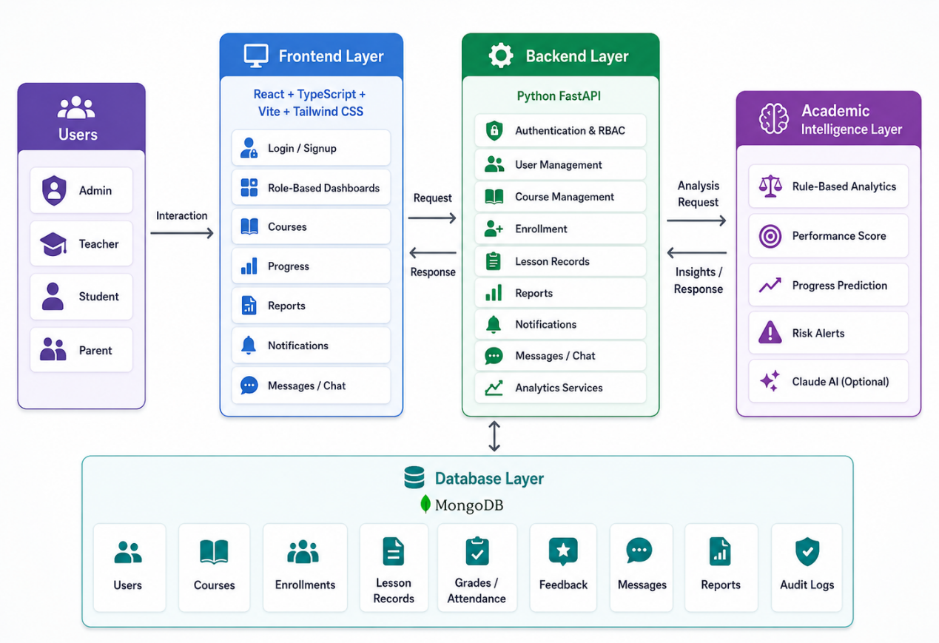

Figure 1: Architecture Diagram
The System Architecture Diagram presents the overall structure of the IQ PLUS system. The system is built on four main layers: Frontend, Backend, Database, and Academic Intelligence. The frontend layer provides the user interface for the four system roles: Admin, Teacher, Student, and Parent. It is responsible for login, signup, role-based dashboards, course views, progress pages, reports, notifications, and communication features.
The backend layer is implemented using Python FastAPI and serves as the central logic layer of the system. It handles authentication, role-based access control, user management, course management, enrollment workflows, lesson records, reports, notifications, messages, chat, and analytics services. The backend receives requests from the frontend, validates the user session and permissions, performs the required business logic, and returns the appropriate response.
The database layer is based on MongoDB and stores the system’s persistent data, including users, courses, enrollments, lesson records, grades, attendance, feedback, messages, reports, and audit logs. The academic intelligence layer processes student-related academic data and generates progress summaries, performance scores, progress predictions, risk alerts, and recommendations. This layer combines rule-based analytics with optional Claude AI integration, allowing the system to remain functional even when the external AI service is unavailable.
5.1 System Package Diagram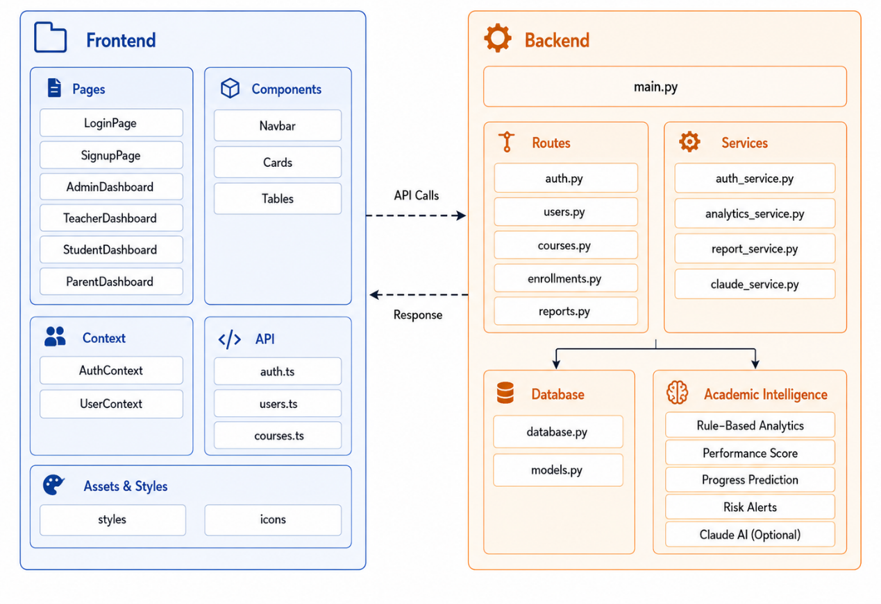

Figure 2: System Package Diagram

The Package Diagram illustrates the internal structure of the IQ PLUS system. The system is divided into two main implementation components: Frontend and Backend. The Frontend, built with React, TypeScript, Vite, and Tailwind CSS, includes the application pages, reusable components, context management, API communication layer, and assets and styles.
The Backend, built with FastAPI, includes the main application entry point, API routes, service modules, database access, and the academic intelligence component. The routes handle HTTP requests such as authentication, users, courses, enrollments, and reports. The services implement the main business logic, including authentication, analytics, report generation, and Claude AI integration.
The diagram also shows the communication flow between the Frontend and Backend. The Frontend sends API calls to the Backend and receives structured responses. Inside the Backend, the system communicates with the database package for data storage and with the academic intelligence package for progress analysis, performance scores, risk alerts, and recommendations.

5.1.1 Frontend
The frontend of IQ PLUS is built using React, TypeScript, Vite, and Tailwind CSS. It provides the user interface of the system and allows users to interact with the platform according to their roles. The frontend follows a component-based structure, where pages, components, context, API services, and styling files are separated for better maintainability.
The main frontend pages include login, signup, admin dashboard, teacher dashboard, student dashboard, parent dashboard, courses, progress, reports, notifications, messages, and user profile pages. Each dashboard presents information and actions relevant to the current user role. For example, the admin dashboard focuses on users, courses, approvals, and system activity, while the teacher dashboard focuses on courses, students, feedback, and progress indicators.
Reusable components such as navigation bars, cards, tables, forms, and modals are used across different pages to keep the interface consistent. The frontend communicates with the backend through API service files that send HTTP requests and receive structured responses. Protected routes and authentication context are used to control access to pages according to the logged-in user and role.

5.1.2 Backend
The backend of IQ PLUS is implemented using Python and FastAPI. It serves as the central logic layer of the system and handles the main workflows of the platform. The backend exposes REST API endpoints that allow the frontend to perform actions such as login, user management, course management, enrollment handling, lesson record submission, report generation, notifications, messages, and academic analysis.
The backend is organized into routes, services, models, and database configuration. Routes receive HTTP requests and direct them to the relevant logic. Services contain the main business logic, such as authentication, analytics, report creation, notifications, and Claude AI integration. Models define the structure of the data stored in the system.
Security is an important part of the backend. The system uses password hashing, session tokens, and role-based access control to protect sensitive data. Before executing protected actions, the backend verifies the current user and checks whether the user has the required permission.

5.1.3 Database
IQ PLUS uses MongoDB as its main database. The database stores the persistent data of the system, including users, courses, enrollments, lesson records, grades, attendance, feedback, messages, notifications, reports, and audit logs.
MongoDB was selected because it provides flexible document storage that fits the different types of information managed by the system. The backend accesses the database through Beanie ODM, which simplifies asynchronous interaction with MongoDB.
The database supports both operational and academic workflows. For example, course and enrollment data are used for scheduling and registration management, while lesson records, grades, attendance, and feedback are used for progress tracking, reports, and academic insights.

5.2 System Flow
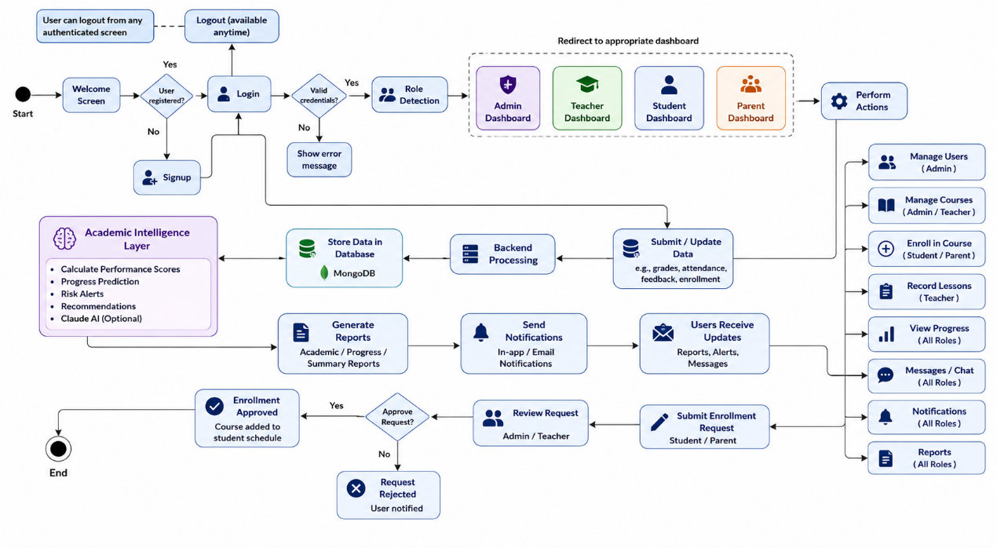

Figure 3: System Flow Diagram
The System Flow Diagram presents the main operational flow of the IQ PLUS system. The flow begins when a user accesses the platform and either logs in or creates a new account. If the user is new, the account requires administrator approval before full access is granted. After successful authentication, the system checks the user status, identifies the user role, and redirects the user to the appropriate dashboard: Admin, Teacher, Student, or Parent.
Each role receives access to different actions according to its permissions. Admin users can manage users, courses, enrollments, reports, and system activity. Teachers can manage their courses, record lesson data, submit grades and feedback, and review student progress. Students can view their courses, schedules, grades, feedback, reports, and notifications. Parents can view information related to their linked children, including schedules, grades, feedback, reports, and academic alerts.
When a user performs an action, the frontend sends a request to the backend. The backend validates the request, checks role permissions, processes the required business logic, and updates the database when needed. Academic data such as attendance, grades, feedback, difficulty level, and engagement is stored in MongoDB and then used by the academic intelligence layer to generate performance scores, progress predictions, risk alerts, recommendations, and insights.
The diagram also shows important workflows such as enrollment requests, report generation, and general system updates. Enrollment requests are checked for course availability and schedule conflicts before approval or rejection. Report requests generate PDF, CSV, or Excel outputs. After each successful action, the system updates the relevant dashboards and sends notifications or messages to authorized users.

6.Challenges and Obstacles
Throughout the development of IQ PLUS, we encountered several technical and design challenges related to role-based access, academic data management, system usability, analytics, and integration between frontend and backend components. This section describes the main challenges, the solutions implemented, and the lessons learned during the project.

6.1 Managing Role-Based Access Control
One of the central challenges in IQ PLUS was supporting four different user roles: Admin, Teacher, Student, and Parent. Each role requires access to different data and actions. For example, an admin can manage users and courses, a teacher can manage academic data for assigned students, a student can view personal academic information, and a parent can view information related only to linked children.
To address this challenge, we implemented role-based access control in both the frontend and backend. The frontend uses protected routes and role-based dashboards, while the backend validates the current user and checks permissions before executing protected actions. This approach improves security and ensures that sensitive student information is exposed only to authorized users.

6.2 Designing Interfaces for Multiple User Roles
Another challenge was designing an interface that serves different types of users without making the system confusing. Admins, teachers, students, and parents use the system for different purposes and require different screens, actions, and information.
To solve this, each role was given a dedicated dashboard and a focused set of pages. The interface was designed using reusable components such as cards, tables, forms, navigation bars, and modals. This allowed us to maintain a consistent design while adapting the content to each role. The goal was to keep the system clear for non-technical users while still providing rich functionality.

6.3 Managing Academic Data and Progress Tracking
IQ PLUS stores different types of academic data, including attendance, grades, lesson feedback, difficulty level, engagement rating, course information, and progress history. A major challenge was organizing this information in a way that supports both daily use and long-term academic analysis.
The solution was to store lesson-level records in a structured format and connect them to the relevant student, teacher, course, and date. This structure allows the system to build a historical academic profile for each student. The stored data is later used to generate progress views, reports, performance scores, alerts, and recommendations.

6.4 Integrating Academic Intelligence and AI Services
A significant challenge was integrating academic intelligence into the system without making the system fully dependent on an external AI provider. Educational insights need to be reliable, explainable, and available even when external services are not configured or temporarily unavailable.
To handle this challenge, we implemented a hybrid intelligence approach. The system includes rule-based analytics that calculates performance indicators and detects risk situations using predefined conditions. In addition, optional Claude AI integration was added through the Anthropic API. When the Claude AI service is configured, the system can generate richer explanations and recommendations. If the service is unavailable, the system falls back to rule-based analysis. This design improves reliability and keeps the system explainable.

6.5 System Performance and Data Consistency
Because IQ PLUS includes many connected workflows, such as enrollments, lesson records, reports, notifications, and progress calculations, maintaining data consistency was an important challenge. For example, when a lesson record is submitted, the system must store the record, update progress information, and make the data available to authorized users.
To address this issue, the backend was organized into clear routes and services. Each service is responsible for a specific area, such as reports, notifications, predictions, or academic analysis. This separation helps reduce errors and makes the system easier to test and maintain. MongoDB was used to store flexible educational data, while Beanie ODM simplified asynchronous database access.

6.6 Lessons Learned
During the project, we learned that developing a multi-role educational system requires careful planning of permissions, data structure, and user workflows. It is not enough to build separate screens; the system must also ensure that each user receives accurate and relevant information while protecting sensitive data.
We also learned the importance of building the system incrementally. Developing authentication, roles, courses, academic records, reports, and analytics in separate stages helped us test each part before integrating the full workflow. The hybrid approach to academic intelligence was also an important lesson, because it allowed us to combine AI-based explanations with reliable rule-based fallback.
If we were to continue developing the system, we would improve automated testing, expand the analytics evaluation, add more advanced parent-teacher communication tools, and conduct broader usability testing with real learning center users. Overall, the main lesson is that educational systems must balance functionality, simplicity, security, and explainability.

7.Project Metrics
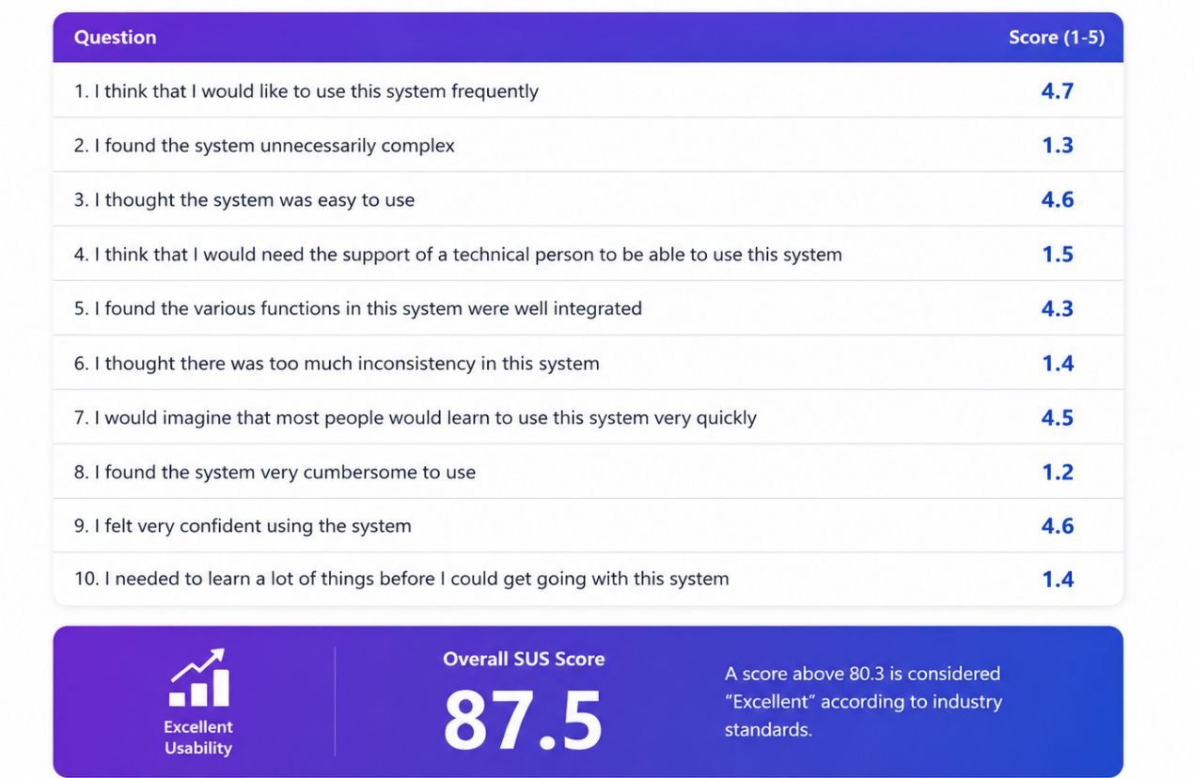

Figure 4: SUS Results
At the outset of the project, we defined several success criteria in order to evaluate the effectiveness, usability, and reliability of the IQ PLUS system. The evaluation focused on three main aspects: user experience, functional completeness, and system reliability.
Figure 4 presents the SUS-based usability evaluation results.
User Experience and Satisfaction: To evaluate the usability of the system, we conducted an informal System Usability Scale (SUS)-based evaluation with users who tested the main system workflows. These workflows included logging in, navigating between dashboards, viewing courses, submitting or viewing academic data, checking progress information, and using reports and notifications.
The system achieved an overall SUS score of 87.5, which indicates excellent usability. The results show that users found the system easy to use, well organized, and not unnecessarily complex. Positive scores were received for ease of use, confidence while using the system, and the ability to learn the system quickly. Low scores for negative statements, such as system complexity and the need for technical support, indicate that the interface is accessible for non-technical users.
Functional Completeness: Another important metric was the ability of the system to support the main workflows of a learning center. The implemented system includes user registration and login, administrator approval, role-based dashboards, user management, course management, enrollment requests, lesson records, attendance, grades, feedback, notifications, messages, reports, and academic progress monitoring. These features demonstrate that the system covers both the administrative and academic needs defined for the project.
Role-Based Access and Data Protection: The system was tested using Admin, Teacher, Student, and Parent accounts. Each role was redirected to its dedicated dashboard and could access only the actions and information relevant to it. This confirms that the role-based access mechanism works as expected and helps protect sensitive student-related data.
Academic Tracking and Insights: IQ PLUS stores structured lesson-level data, including attendance, grades, feedback, difficulty level, and engagement rating. Based on this information, the system generates performance scores, progress predictions, risk alerts, recommendations, and academic insights. This confirms that the system supports continuous academic follow-up rather than isolated data entry.
Reporting and Export: The system supports academic report generation and export in formats such as PDF, CSV, and XLSX. This is important because learning centers often need to share organized progress information with students, parents, teachers, and administrators.
System Reliability and Fallback Behavior: The academic intelligence layer was designed to remain reliable even when external AI services are not available. When the Claude AI service is configured, the system can generate richer academic explanations and recommendations. If the service is unavailable, the system falls back to rule-based analysis. This ensures that academic monitoring remains available.
Overall, the project metrics show that IQ PLUS successfully achieved its main goals. The system provides a working multi-role platform that centralizes learning center management, academic documentation, communication, reporting, and explainable academic insights.

8.Conclusions and Future Work
The IQ PLUS project successfully achieved its main objective: developing a working web-based platform that centralizes learning center management and academic follow-up. The system supports the main roles required in a learning center environment: Admin, Teacher, Student, and Parent. Each role has a dedicated interface and role-based permissions that allow users to access the information and actions relevant to them.
The implemented system provides a wide range of functionality, including user management, course management, enrollment requests, lesson records, attendance, grades, feedback, reports, notifications, messages, chat, course materials, syllabus management, and academic progress monitoring. These features show that IQ PLUS addresses both the administrative and academic needs of a modern learning center.
A significant contribution of the project is the academic intelligence layer. By analyzing grades, attendance, feedback, and progress history, the system generates performance scores, progress predictions, risk alerts, recommendations, and academic insights. The combination of rule-based analytics and optional Claude AI integration allows the system to provide explainable support while keeping final pedagogical decisions under human responsibility.
The project also demonstrated the importance of modular design. Separating the frontend, backend, database, and intelligence components made the system easier to develop, test, and maintain. The use of React, TypeScript, FastAPI, MongoDB, and Docker created a modern and extensible technical foundation.
In future work, the system can be extended in several directions. First, the academic analytics layer can be improved using larger real datasets and more advanced evaluation methods. Second, communication features can be expanded to support richer parent-teacher interaction and automated meeting scheduling. Third, the system can include more advanced dashboards for administrators, including trend analysis across courses and teachers. Finally, broader usability testing with real learning center users can help improve the user experience and validate the system in a real operational environment.
Overall, IQ PLUS provides a practical, organized, and data-supported solution for learning centers. It improves transparency, reduces fragmented workflows, and supports continuous academic follow-up for students.

9.References
[1] Bloom, B. S. (1984). The 2 sigma problem: The search for methods of group instruction as effective as one-to-one tutoring. Educational Researcher, 13(6), 4–16.
[2] Dahlstrom, E., Brooks, D. C., & Bichsel, J. (2014). The current ecosystem of learning management systems in higher education. EDUCAUSE Center for Analysis and Research.
[3] Dawson, S., Jovanovic, J., & Gašević, D. (2019). Learning analytics in higher education: Towards a future research agenda. British Journal of Educational Technology, 50(6), 3131–3140.
[4] Ferguson, R. (2012). Learning analytics: Drivers, developments and challenges. International Journal of Technology Enhanced Learning, 4(5–6), 304–317.
[5] Hattie, J. (2009). Visible learning: A synthesis of over 800 meta-analyses relating to achievement. Routledge.
[6] Holmes, W., Bialik, M., & Fadel, C. (2019). Artificial intelligence in education: Promises and implications for teaching and learning. Center for Curriculum Redesign.
[7] Luckin, R., Holmes, W., Griffiths, M., & Forcier, L. B. (2016). Intelligence unleashed: An argument for AI in education. Pearson.
[8] Means, B., Bakia, M., & Murphy, R. (2014). Learning online: What research tells us about whether, when and how. Routledge.
[9] Siemens, G., & Baker, R. S. J. d. (2012). Learning analytics and educational data mining: Towards communication and collaboration. Proceedings of the 2nd International Conference on Learning Analytics & Knowledge, 252–254.
[10] Siemens, G., & Long, P. (2011). Penetrating the fog: Analytics in learning and education. EDUCAUSE Review, 46(5), 30–40.
[11] Tomlinson, C. A. (2014). The differentiated classroom: Responding to the needs of all learners. ASCD.

Appendices

Appendix A – User Guide

A.1 Introduction
IQ PLUS is a web-based learning center management system designed to support administrators, teachers, students, and parents in managing academic and operational activities in one centralized platform. The system allows users to access information and perform actions according to their role and permissions.
This user guide explains the main operating instructions for the system. It focuses on the normal and successful usage flow, including account creation, login, dashboard navigation, course management, enrollment, lesson documentation, progress tracking, reports, notifications, messages, and academic planning.
The system supports four main roles:
Admin: manages users, roles, courses, enrollment requests, system activity, and administrative data.
Teacher: manages assigned courses, records lesson data, submits attendance, grades, and feedback, and follows student progress.
Student: views courses, schedule, grades, feedback, reports, notifications, messages, and academic planner recommendations.
Parent: follows the academic progress of linked children, including schedules, courses, feedback, reports, alerts, and notifications.

A.2 Operating Instructions

A.2.1 Sign-Up Page
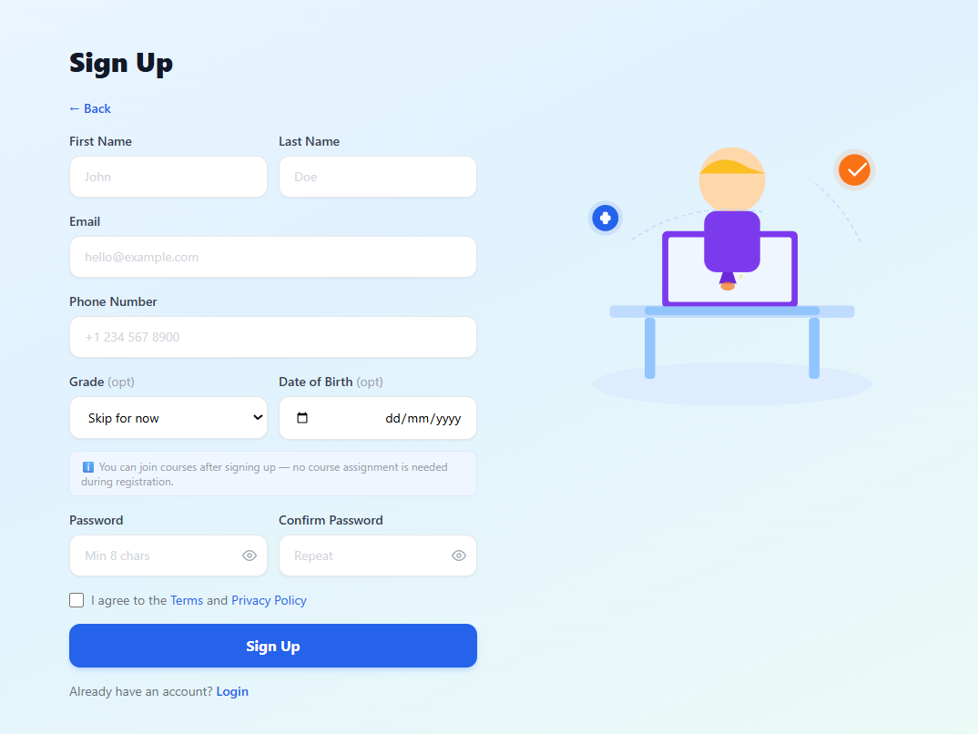
Figure 5: Sign-Up Page
To use IQ PLUS, a new user must first create an account.
Steps to Sign Up:
- Click the Sign Up option in the navigation bar.
- Select the relevant user role: Teacher, Student, or Parent.
- You will be directed to the registration form.
- Fill in the registration form with the following information:
• First Name: Enter your first name.
• Last Name: Enter your last name.
• Email: Provide a valid email address. This email will be used for login.
• Phone Number: Enter your phone number.
• Grade: Select the grade if relevant. This field can be skipped when not required.
• Date of Birth: Enter your date of birth if relevant.
• Password: Create a secure password with at least 8 characters.
• Confirm Password: Re-enter your password to confirm it.
- Use the eye icon next to the password fields to show or hide the password if needed.
- Read and accept the Terms and Privacy Policy.
- Click the Sign Up button to submit the registration form.
After submitting the form, the account may require administrator approval before full access is granted. Once the account is approved, the user can log in and access the system according to the assigned role.

A.2.2 Login Page
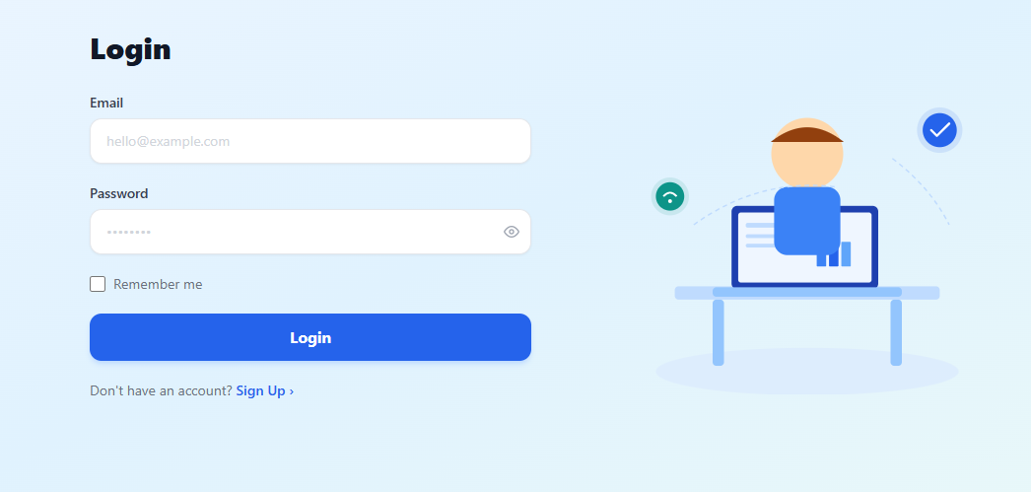
Figure 6: Login Page
After creating an account and receiving approval when required, the user can access the system through the Login page.
Steps to Log In:
- Open the IQ PLUS platform.
- Click the Login option in the navigation bar.
- Enter your registered email address in the Email field.
- Enter your password in the Password field.
- Use the eye icon next to the password field to show or hide the password if needed.
- Select Remember me if you want the system to keep your login session active.
- Click the Login button.
After successful authentication, the system identifies the user role and redirects the user to the appropriate dashboard: Admin, Teacher, Student, or Parent. If the email or password is incorrect, or if the account has not yet been approved, the system displays an appropriate message.

A.2.3 Admin Dashboard

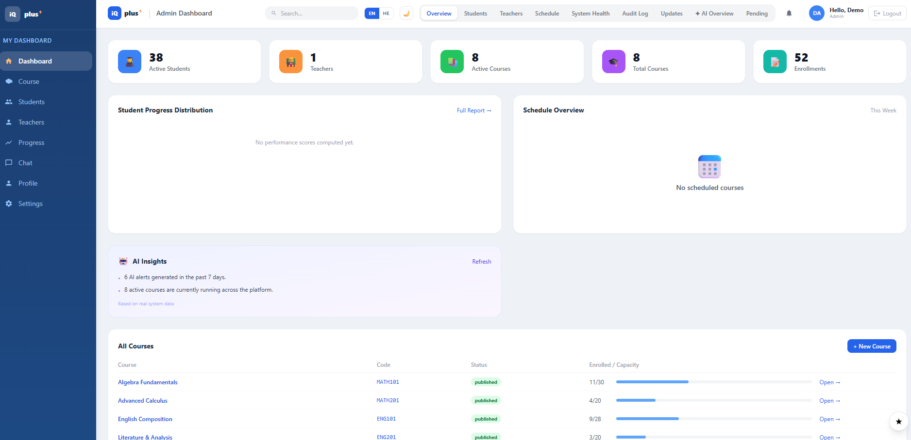
Figure 7: Admin Dashboard
The Admin Dashboard provides an overview of the learning center and allows the administrator to manage the main operational areas of the system.
The dashboard displays summary cards such as the number of active students, teachers, active courses, total courses, and enrollments. It also includes sections for student progress distribution, schedule overview, AI insights, and a list of all courses. The navigation menu allows the admin to access different parts of the system, such as courses, students, teachers, progress, chat, profile, and settings.
Steps to Use the Admin Dashboard:
- Log in with an Admin account.
- The system redirects you to the Admin Dashboard.
- Review the summary cards at the top of the page to see the current status of the learning center.
- Use the top navigation tabs to access sections such as Overview, Students, Teachers, Schedule, System Health, Audit Log, Updates, AI Overview, and Pending approvals.
- Use the side navigation menu to move between Dashboard, Course, Students, Teachers, Progress, Chat, Profile, and Settings.
- Review the All Courses table to see course names, course codes, status, and enrollment capacity.
- Click New Course to create a new course, or click Open next to an existing course to view its details.
- Review AI Insights to see system-level academic alerts and active courses.
The Admin Dashboard helps the administrator monitor system activity, manage learning center resources, and access important operational and academic information from one place.

A.2.4 Teacher Dashboard
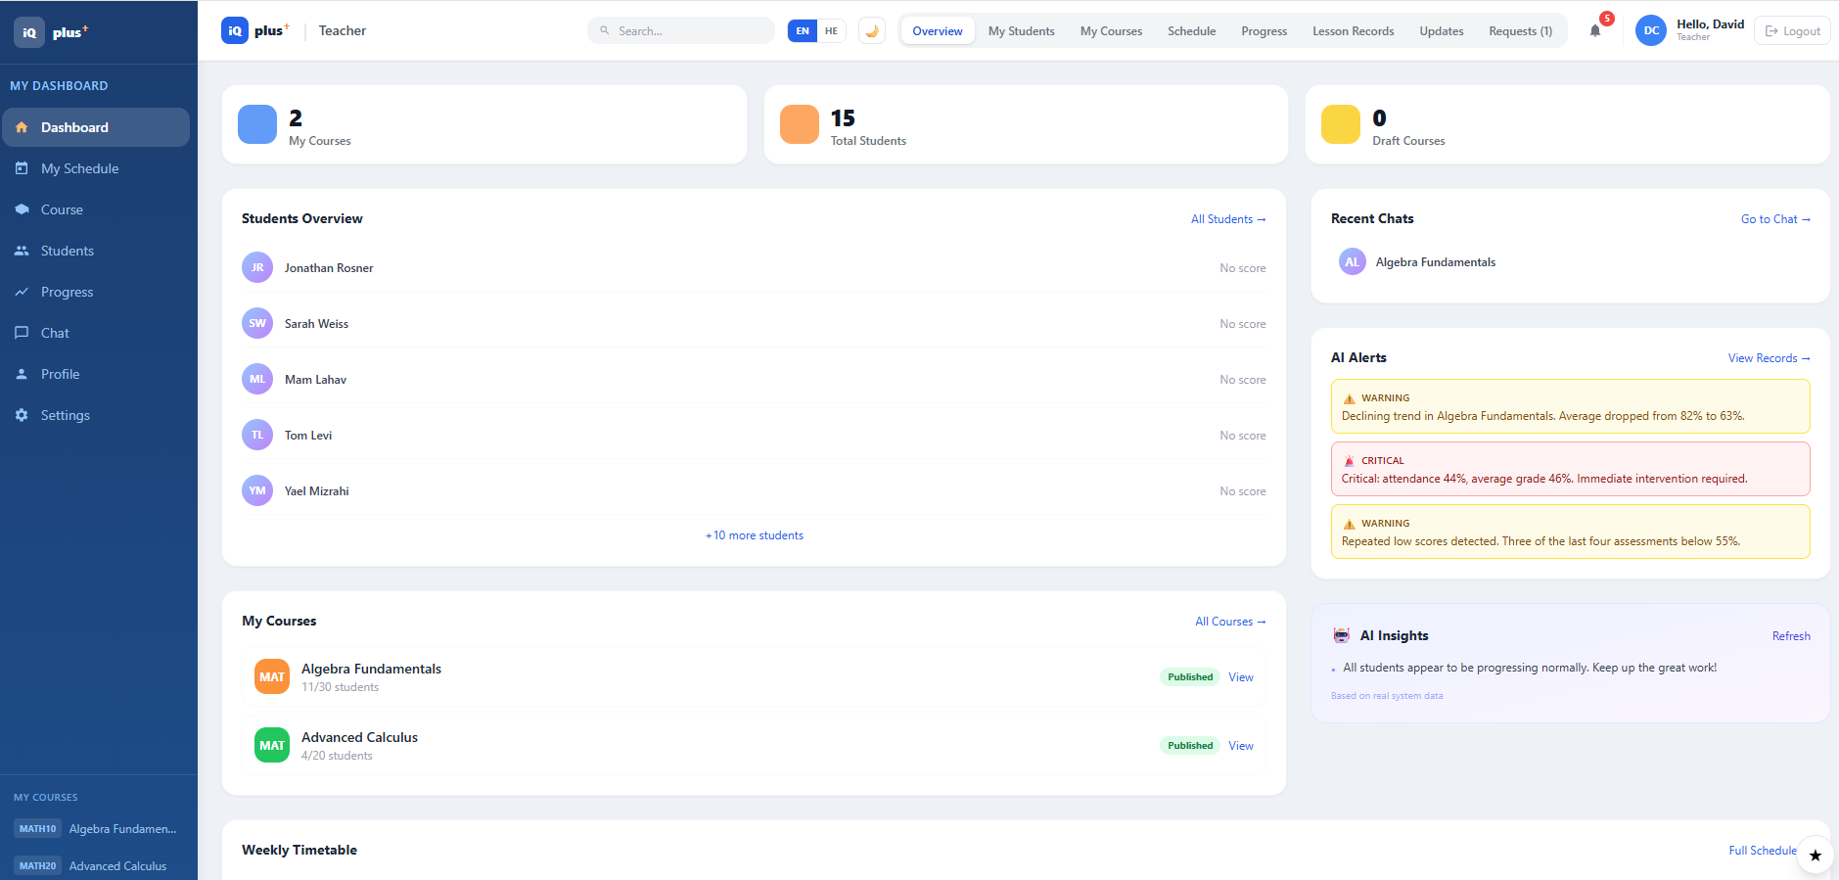
Figure 8: Teacher Dashboard
The Teacher Dashboard provides teachers with an overview of their assigned courses, students, recent academic activity, chats, alerts, and progress information.
The top summary cards display the number of courses, total students, and draft courses. The main dashboard area includes a students overview, a list of the teacher’s courses, recent chats, AI alerts, AI insights, and a weekly timetable. The teacher can use the navigation menu to access schedule, courses, students, progress, chat, profile, and settings.
Steps to Use the Teacher Dashboard:
- Log in with a Teacher account.
- The system redirects you to the Teacher Dashboard.
- Review the summary cards to see the number of assigned courses, students, and draft courses.
- Use the Students Overview section to view students related to the teacher’s courses.
- Open the My Courses section to view assigned courses and their publication status.
- Use the top navigation tabs to access My Students, My Courses, Schedule, Progress, Lesson Records, Updates, and Requests.
- Review the AI Alerts section to identify students or courses that may require attention.
- Use Recent Chats or the Chat page to communicate about course-related issues.
- Open the weekly timetable to view scheduled course sessions.
The Teacher Dashboard helps teachers manage academic activity, follow student progress, communicate with users, and respond to academic alerts from one central interface.

A.2.5 Student Dashboard

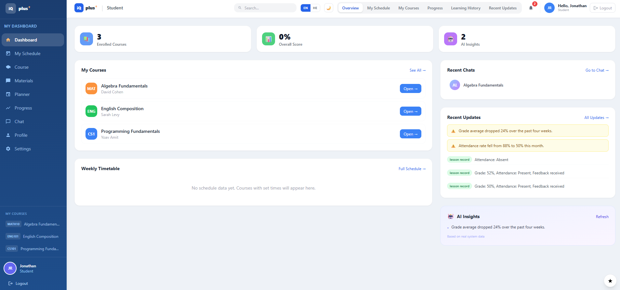
Figure 9: Student Dashboard
The Student Dashboard provides students with a personal overview of their courses, academic progress, schedule, updates, chats, and AI insights.
The top summary cards display the number of enrolled courses, the overall score, and the number of AI insights. The main area shows the student’s courses, weekly timetable, recent chats, recent updates, and academic insights. The student can use the side navigation menu to access the schedule, courses, materials, planner, progress, chat, profile, and settings.
Steps to Use the Student Dashboard:
- Log in with a Student account.
- The system redirects you to the Student Dashboard.
- Review the summary cards to see the number of enrolled courses, overall score, and available AI insights.
- Use the My Courses section to view enrolled courses and open course details.
- Open the Weekly Timetable section to view scheduled lessons.
- Use Recent Updates to review new grades, attendance updates, feedback, or alerts.
- Review AI Insights to understand important academic changes or recommendations.
- Use the top navigation tabs to access My Schedule, My Courses, Progress, Learning History, and Recent Updates.
- Use the side menu to access materials, academic planner, progress, chat, profile, and settings.
The Student Dashboard helps students follow their academic status, access course information, and stay updated about grades, feedback, attendance, and progress.

A.2.6 Parent Dashboard
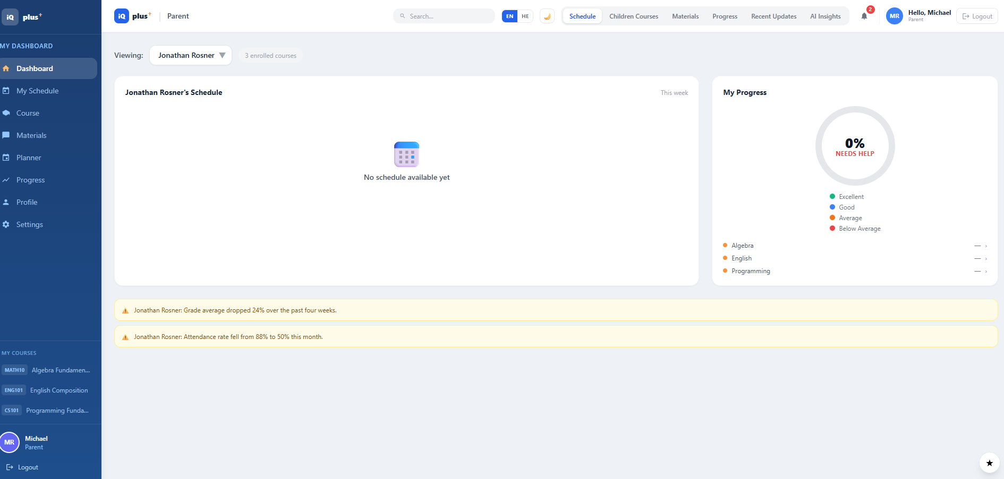
Figure 10: Parent Dashboard
A.2.6 Parent Dashboard
The Parent Dashboard allows parents to follow the academic progress and schedule of their linked children. The parent can select a child from the dropdown list and view information related only to that child.
The dashboard displays the child’s schedule, enrolled courses, progress status, and academic alerts. Parents can also access course materials, progress information, recent updates, and AI insights through the top navigation tabs. The side navigation menu provides access to schedule, courses, materials, planner, progress, profile, and settings.
Steps to Use the Parent Dashboard:
- Log in with a Parent account.
- The system redirects you to the Parent Dashboard.
- Select the relevant child from the dropdown list.
- Review the child’s schedule and enrolled courses.
- Check the progress section to view the child’s current academic status.
- Review alerts and recent updates related to grades, attendance, feedback, or academic changes.
- Use the top navigation tabs to access Children Courses, Materials, Progress, Recent Updates, and AI Insights.
- Use the side menu to access schedule, courses, materials, planner, progress, profile, and settings.
The Parent Dashboard helps parents stay informed about their child’s learning process, follow academic changes, and receive important updates from the learning center.

A.2.7 Course Management
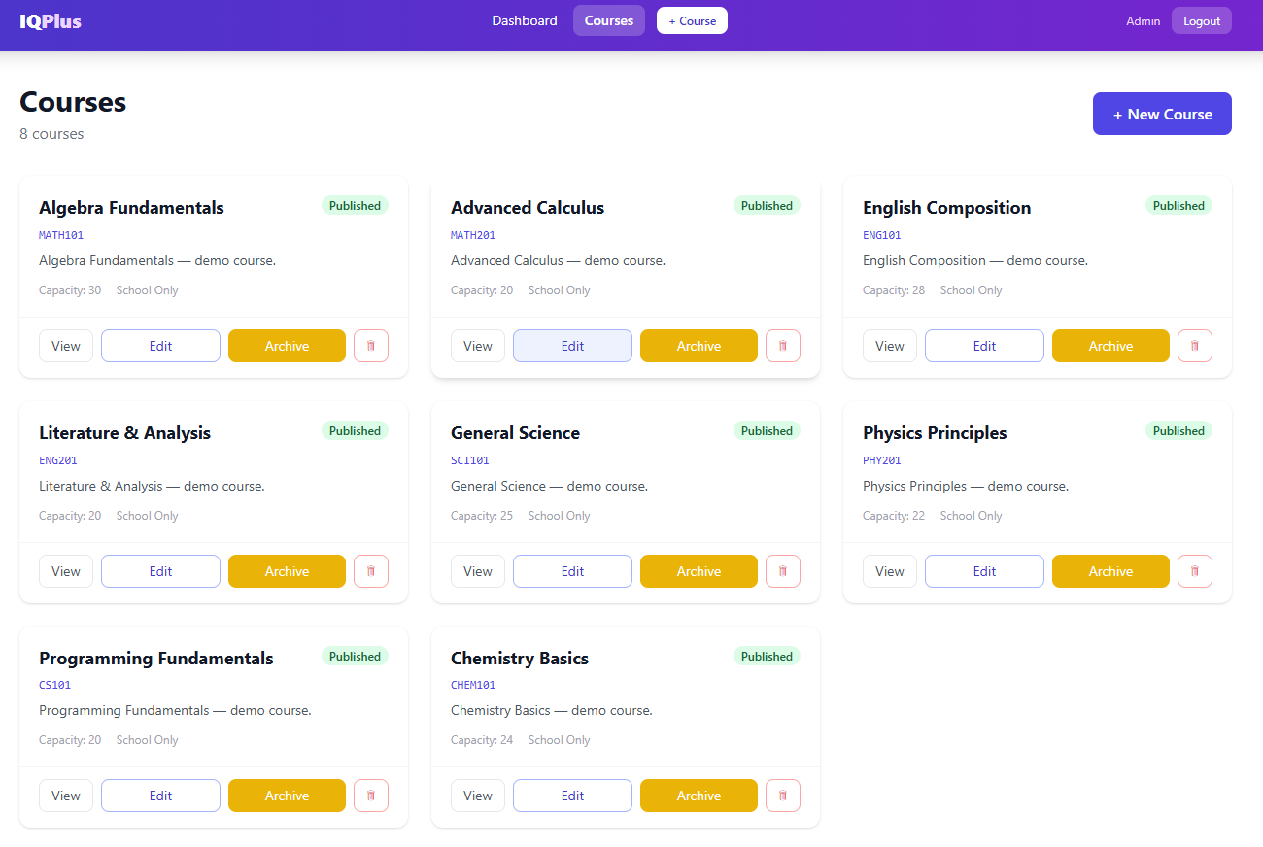
Figure 11: Course Management Page
The Course Management page allows the administrator to view, create, edit, archive, and delete courses in the IQ PLUS system.
The page displays all available courses as course cards. Each course card includes the course name, course code, publication status, short description, capacity, and action buttons. The administrator can use the provided actions to manage each course directly from the page.
Steps to Use the Course Management Page:
- Log in with an Admin account.
- Open the Courses page from the navigation bar or dashboard.
- Review the list of available courses displayed on the page.
- Click View to open the selected course and view its details.
- Click Edit to update course information such as the course name, description, capacity, or other settings.
- Click Archive to move the course to an archived state when it is no longer active.
- Click the delete icon to remove a course from the system if needed.
- Click the New Course button to create a new course.
The Course Management page helps the administrator organize the available courses, manage their status, and maintain an updated course catalog for the learning center.

A.2.8 Lesson Records and Feedback
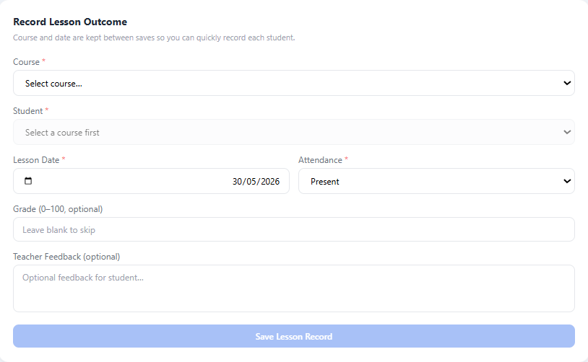
Figure 12: Record Lesson Outcome Page
The Record Lesson Outcome page allows a teacher to document the outcome of a lesson for a specific student. This includes attendance, lesson date, grade, and optional teacher feedback.
This page helps teachers maintain structured academic records for each lesson. The saved information is later used by the system for progress tracking, reporting, alerts, and academic insights.
Steps to Record a Lesson Outcome:
- Log in with a Teacher account.
- Open the Lesson Records page from the top navigation menu.
- Select the relevant course from the Course dropdown list.
- Select the student from the Student dropdown list.
- Choose the lesson date in the Lesson Date field.
- Select the attendance status, such as Present or Absent.
- Enter the student’s grade if available. This field is optional.
- Enter teacher feedback in the Teacher Feedback field if needed. This field is also optional.
- Click the Save Lesson Record button to store the lesson outcome in the system.
After saving the record, the information becomes part of the student’s academic history. It can later appear in progress views, reports, updates, and academic analysis results. This page supports continuous and detailed academic follow-up for each student.

A.2.9 Progress Page
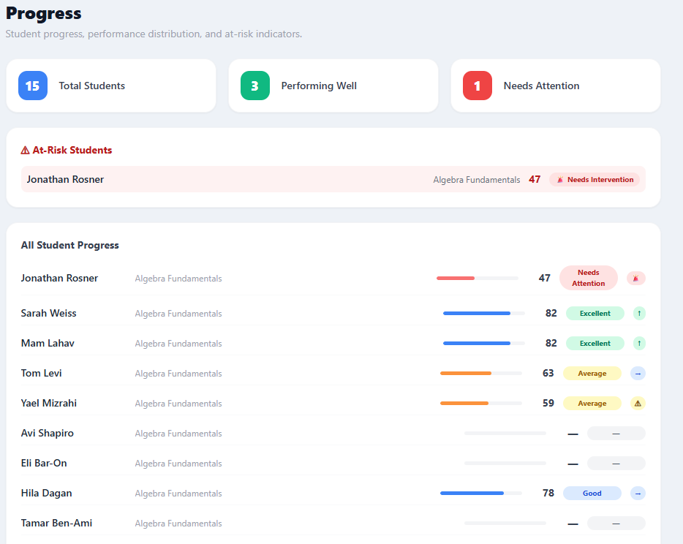
Figure 13: Progress Page
The Progress page allows teachers to monitor student performance and identify students who may need academic attention. It presents a summary of the overall class status and a detailed view of individual student progress.
At the top of the page, the system displays summary indicators such as the total number of students, the number of students performing well, and the number of students who need attention. The page also highlights at-risk students and provides a detailed list of student progress records, including course name, score, and performance status.
Steps to Use the Progress Page:
- Log in with a Teacher account.
- Open the Progress page from the side navigation menu or the top navigation bar.
- Review the summary cards at the top of the page to understand the general performance distribution of students.
- Check the At-Risk Students section to identify students who require intervention.
- Review the All Student Progress table to view each student’s progress information.
- Examine the displayed score and status labels, such as Excellent, Good, Average, or Needs Attention.
- Use this information to identify students who may need additional support, follow-up, or academic intervention.
The Progress page helps teachers track academic performance in a structured way and supports early identification of students who may be at risk.

A.2.10 Chat Page
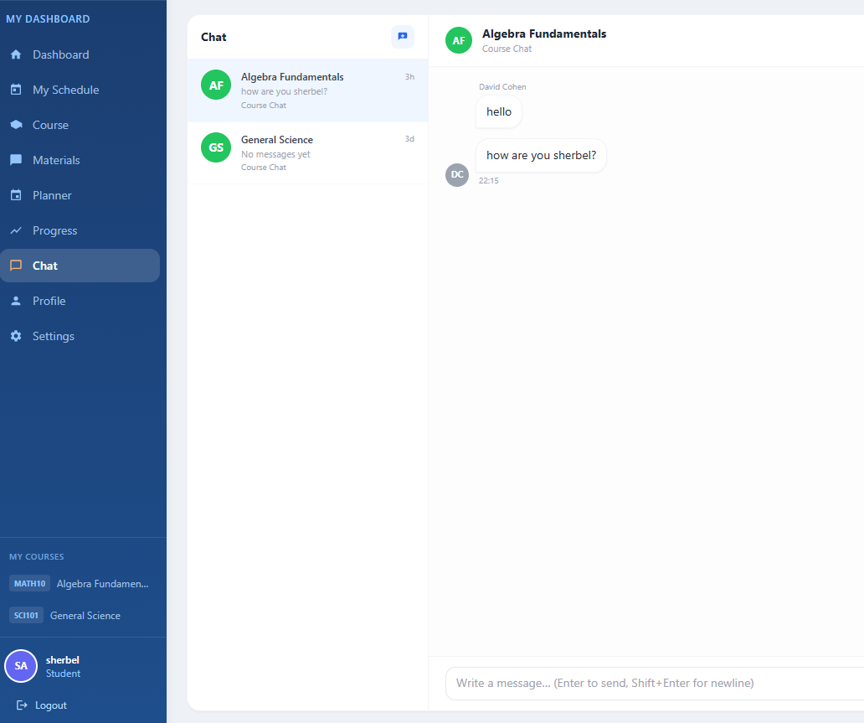
Figure 14: Chat Page
The Chat page allows users to communicate within the IQ PLUS platform regarding courses and academic matters. It supports direct communication inside the system and reduces the need for external messaging tools.
The page is divided into two main areas. On the left side, the user can see the list of available course chats and recent conversations. On the right side, the selected conversation is displayed, including previous messages and the message input area. The user can write and send a new message directly from this page.
Steps to Use the Chat Page:
- Log in to the system.
- Open the Chat page from the side navigation menu.
- Review the list of available chats on the left side of the screen.
- Click on a course chat or conversation to open it.
- Read previous messages displayed in the conversation area.
- Type a new message in the message input field at the bottom of the page.
- Press Enter or use the send option to send the message.
- Continue the conversation as needed.
The Chat page helps students, teachers, and other users communicate efficiently inside the platform, ask questions, follow course-related discussions, and receive quick responses in an organized way.

A.2.11 Materials Page
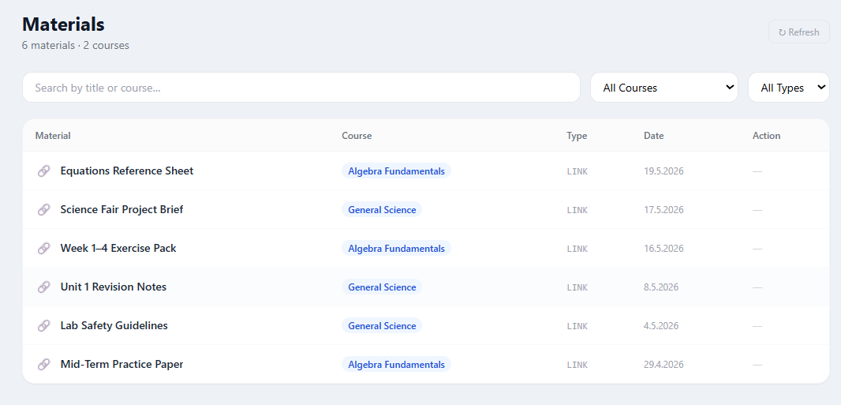
Figure 15: Materials Page
The Materials page allows students and parents to view learning materials related to enrolled courses. Materials may include reference sheets, exercise packs, revision notes, practice papers, project briefs, or external links.
The page displays a list of available materials with the material title, related course, material type, date, and available action. Users can search for a material by title or course name and can filter the list by course or material type.
Steps to Use the Materials Page:
- Log in to the system as a Student or Parent.
- Open the Materials page from the side navigation menu.
- Review the list of available learning materials.
- Use the search bar to search for a specific material by title or course.
- Use the course filter to display materials for a specific course.
- Use the type filter to display materials of a specific type.
- Open or use the available action for the relevant material when needed.
The Materials page helps students and parents access course-related resources in one organized location.

A.2.12 Academic Planner
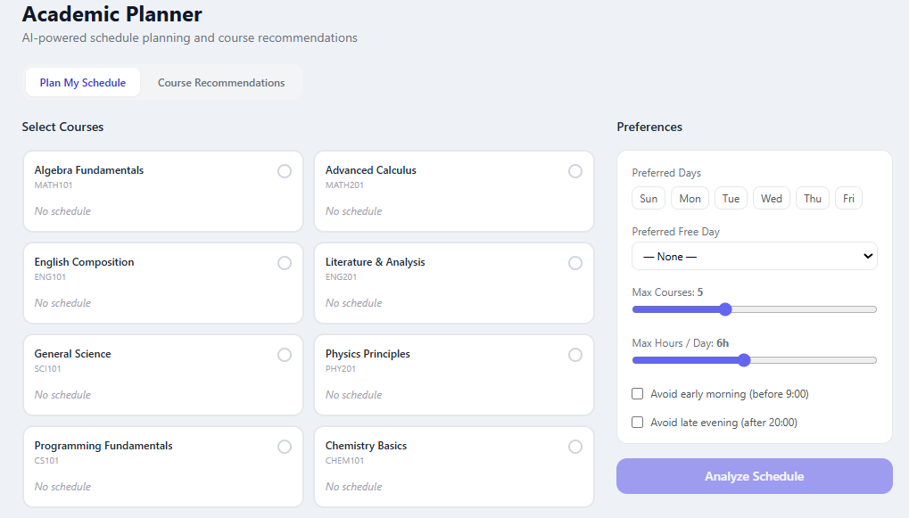
Figure 16: Academic Planner – Course Selection

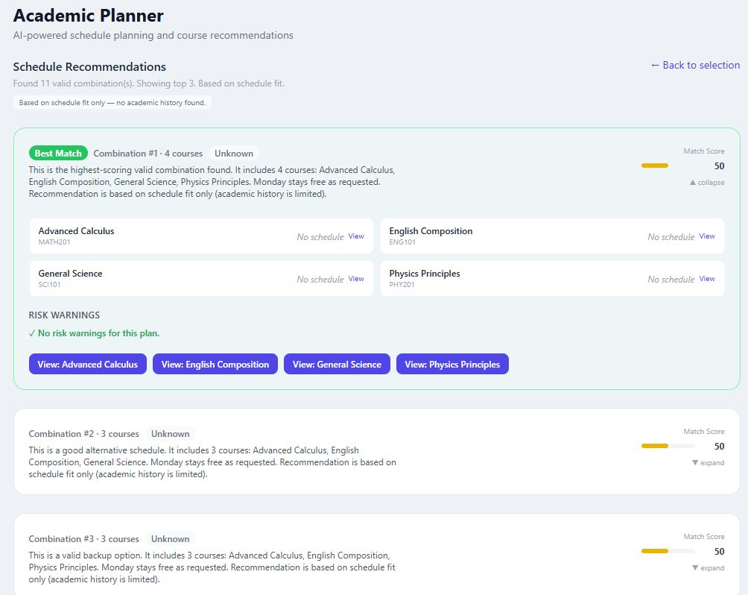
Figure 17: Academic Planner – Schedule Recommendations
The Academic Planner page helps students and parents plan a possible learning schedule and receive course recommendations according to selected preferences.
The first screen allows the user to select courses and define planning preferences. The user can choose preferred learning days, select a preferred free day, define the maximum number of courses, set the maximum number of learning hours per day, and choose whether to avoid early morning or late evening lessons.
Steps to Use the Academic Planner:
- Log in to the system as a Student or Parent.
- Open the Planner page from the side navigation menu.
- Select the courses you want to include in the schedule planning.
- Choose preferred learning days if relevant.
- Select a preferred free day if needed.
- Adjust the maximum number of courses and maximum hours per day.
- Select additional preferences, such as avoiding early morning or late evening lessons.
- Click the Analyze Schedule button.
After the schedule is analyzed, the system displays schedule recommendations based on the selected courses and preferences. The recommendation screen shows valid course combinations, a match score, the selected courses in each combination, and possible risk warnings.
The user can review the best matching combination, expand or collapse additional options, and open the details of specific courses. This helps students and parents compare different course combinations and choose a schedule that better fits their preferences.

A.3 Navigation and Settings

A.3.1 Navigation Bar
The navigation bar and side menu allow users to move between the main areas of the system. The available options depend on the user role. For example, administrators can access user and course management sections, teachers can access students and lesson records, and students or parents can access schedules, materials, progress, and planner pages.
Common navigation options include Dashboard, Schedule, Courses, Materials, Planner, Progress, Chat, Profile, and Settings. The top navigation area may also include role-specific tabs, language selection, dark mode toggle, notifications, and logout.

A.3.2 Language Selection
IQ PLUS supports switching between English and Hebrew. The user can change the interface language using the language toggle in the top navigation bar. When the user selects a language, the interface labels and navigation items are displayed in the selected language.
This feature improves accessibility for users who prefer to work in Hebrew or English and supports a wider range of users in the learning center environment.

A.3.3 Dark Mode
IQ PLUS includes a dark mode option that allows users to change the visual appearance of the system. The user can activate or deactivate dark mode using the moon/sun icon in the top navigation bar.
Dark mode provides a darker color theme that may reduce eye strain and improve comfort during extended use. The user can switch between light mode and dark mode according to personal preference.

A.3.4 Role-Based Access
IQ PLUS uses role-based access to display only the information and actions relevant to each user. After login, the system identifies the user role and redirects the user to the appropriate dashboard.
Admin users can manage users, courses, enrollments, and system activity. Teacher users can manage academic data and courses related to their students. Student users can view their personal academic information. Parent users can view information related to their linked children.

A.3.5 Logging Out
When the user finishes working with the system, they can click the Logout button. The system ends the current session and redirects the user to the login page. Logging out helps protect the user account and prevents unauthorized access to personal or academic information.

Appendix B – Maintenance Guide

B.1 System Requirements
The purpose of this maintenance guide is to allow future developers or maintainers to install, run, configure, and continue developing the IQ PLUS system after the project submission.
IQ PLUS is implemented as a full-stack web application composed of a React-based frontend, a FastAPI backend, and a MongoDB database. The system can be executed locally for development and demonstration, and it also includes Docker support for easier deployment.
B.1.1 Hardware Requirements
The system can run on a standard development computer. The recommended hardware requirements are:
• Processor: Intel i5 / AMD Ryzen 5 or higher.
• Memory: At least 8 GB RAM. 16 GB RAM is recommended for smoother development.
• Storage: At least 2 GB of free disk space for the source code, dependencies, virtual environment, and frontend packages.
• Internet Connection: Required for installing dependencies, connecting to MongoDB Atlas, and using optional external AI services.
B.1.2 Software Requirements
The following software should be installed before running the system:
• Python 3.11 or higher.
• Node.js 18 or higher.
• npm 9 or higher.
• MongoDB Atlas account or accessible MongoDB connection.
• Git for cloning and managing the repository.
• Visual Studio Code or another development environment.
• Docker and Docker Compose, if using the Docker-based execution option.
The backend dependencies are listed in the requirements.txt file under the BACK directory. The frontend dependencies are listed in the package.json file under the FRONT directory.

B.2 Installation Instructions
The project repository is organized into three main directories:
• FRONT: contains the React, TypeScript, Vite, and Tailwind CSS frontend.
• BACK: contains the Python FastAPI backend.
• INFRA: contains infrastructure files such as docker-compose configuration and environment examples.

B.2.1 Database Setup
IQ PLUS uses MongoDB as its main database. The database can be hosted using MongoDB Atlas or another accessible MongoDB instance.
Steps to configure the database:
- Create or use an existing MongoDB database.
- Copy the backend environment example file:
BACK/.env.example
- Create a new environment file named:
BACK/.env
- Set the MongoDB connection string in the environment file.
- Make sure the backend can access the database using the configured connection string.
The MongoDB database stores users, courses, enrollments, lesson records, grades, attendance, feedback, notifications, messages, reports, audit logs, and usability feedback.

B.2.2 Backend Setup
The backend is implemented using Python and FastAPI.
Steps to run the backend locally:
- Open a terminal.
- Navigate to the backend directory:
cd BACK
- Create a virtual environment:
python -m venv venv
- Activate the virtual environment.
On Windows:
venv\Scripts\activate
On Linux or macOS:
source venv/bin/activate
- Install backend dependencies:
pip install -r requirements.txt
- If required, install development dependencies:
pip install -r requirements-dev.txt
- Run the backend server:
uvicorn app.main:app --reload --host 0.0.0.0 --port 8000
After running successfully, the backend API is available at:
http://localhost:8000
The automatic API documentation is available at:
http://localhost:8000/docs

B.2.3 Frontend Setup
The frontend is implemented using React, TypeScript, Vite, and Tailwind CSS.
Steps to run the frontend locally:
- Open a new terminal.
- Navigate to the frontend directory:
cd FRONT
- Install frontend dependencies:
npm install
- Configure the frontend API URL.
The frontend environment file should include:
VITE_API_URL=http://127.0.0.1:8000
- Run the frontend development server:
npm run dev
After running successfully, the frontend application is available at:
http://localhost:5173
If port 5173 is already in use, Vite may automatically use another port. The actual URL will appear in the terminal output.

B.3 Deployment Guide
The IQ PLUS system includes Docker support in order to simplify execution and deployment. Docker allows the system components to run in isolated containers and reduces dependency issues between different development environments.
General deployment steps:
- Make sure Docker and Docker Compose are installed.
- Clone the project repository.
- Configure the required environment variables in the backend and frontend environment files.
- From the project root or infrastructure directory, run the Docker Compose command according to the repository configuration.
- Verify that the backend server, frontend application, and database connection are running correctly.
- Open the frontend URL in the browser and test the login flow.
The Docker configuration is mainly intended to simplify development, testing, and demonstration. For production deployment, additional security configurations should be applied, such as HTTPS, secure environment variable management, database backup policies, and access restrictions.

B.4 Configuration Files
The system uses environment configuration files to separate sensitive data and environment-specific settings from the source code.
Main configuration values include:
• MongoDB connection string.
• Backend API URL.
• Secret key or session configuration.
• Allowed frontend origins.
• Optional Anthropic API key for Claude AI integration.
• Email or notification-related settings, if enabled.
The backend configuration is managed through the .env file in the BACK directory. The frontend configuration is managed through a Vite environment file in the FRONT directory.
Important configuration examples:
Backend:
MONGODB_URI=
SECRET_KEY=
ANTHROPIC_API_KEY=
Frontend:
VITE_API_URL=http://127.0.0.1:8000
Sensitive configuration values should not be committed to the Git repository. Instead, example configuration files should be provided, and each developer should create a local .env file.

B.5 Demo Data and Seed Scripts
The project includes seed scripts that can populate the system with demo data. Demo data is useful for testing, presentation, and development because it allows the system to show realistic users, courses, enrollments, lesson records, feedback, alerts, and progress information.
General steps for using seed scripts:
- Make sure the backend environment file is configured correctly.
- Make sure the backend can connect to MongoDB.
- Run the relevant seed script from the backend or scripts directory according to the repository structure.
- After the script finishes, open the frontend and log in using one of the demo accounts.
- Verify that dashboards, courses, progress data, reports, messages, and notifications are displayed correctly.
Seed scripts should be used carefully. In a real production environment, demo data should not be inserted into the live database unless it is clearly separated from real user data.

B.6 Project Structure
The project is organized into frontend, backend, and infrastructure parts.
FRONT directory:
Contains the React application. It includes pages, reusable components, hooks, contexts, API services, assets, and styling files. This directory is responsible for the user interface and communication with the backend.
BACK directory:
Contains the FastAPI backend. It includes routes, models, schemas, services, authentication logic, database configuration, analytics services, reporting services, and AI integration logic.
INFRA directory:
Contains infrastructure and deployment-related files, such as Docker and Docker Compose configuration. These files help run the system in a more consistent environment.
The separation between these directories helps future developers understand the system more easily and maintain each layer independently.

B.7 Maintenance Recommendations
Future maintainers should follow these recommendations:
- Keep frontend and backend dependencies updated carefully and test the system after each update.
- Do not commit sensitive environment files or API keys to the repository.
- Use role-based access checks for every new feature that exposes student or academic data.
- Add tests for new backend routes and important frontend workflows.
- Keep the database structure documented when adding new collections or fields.
- Monitor external AI service usage and keep rule-based fallback available.
- Back up the database regularly when the system is used with real data.
- Keep the user guide updated whenever new screens or workflows are added.
These recommendations help ensure that IQ PLUS remains secure, maintainable, and usable after the project submission.

