UniCin Report

Software Design and development | CFS2160

testing of software “unicin”

S.C.Edgar U1257802

2019

Contents

**Login Page Testing** 2

Login Button 2

Bibliography 4

# **Modelling**

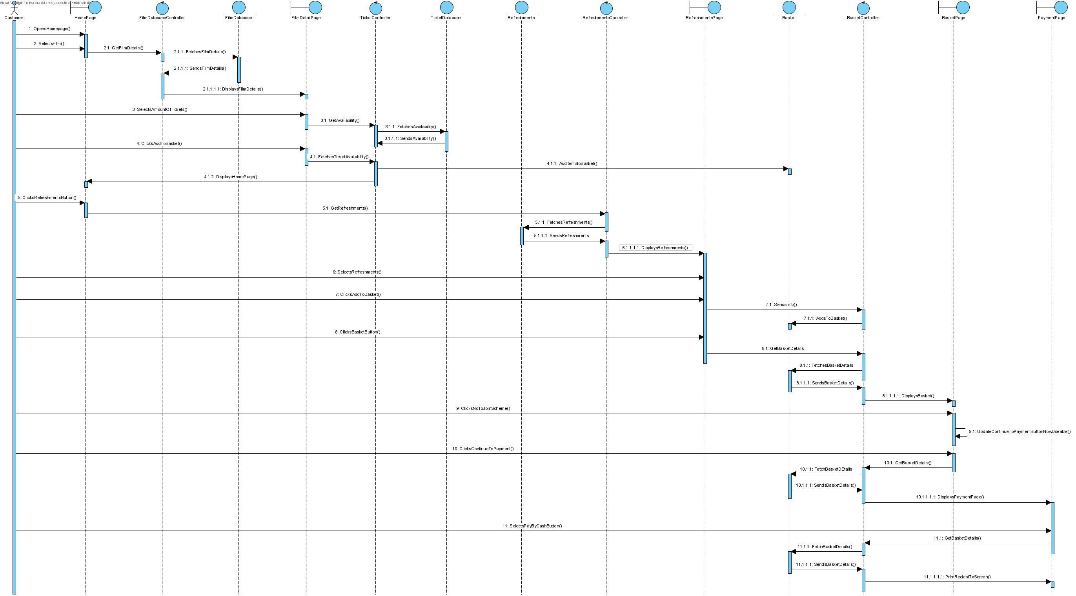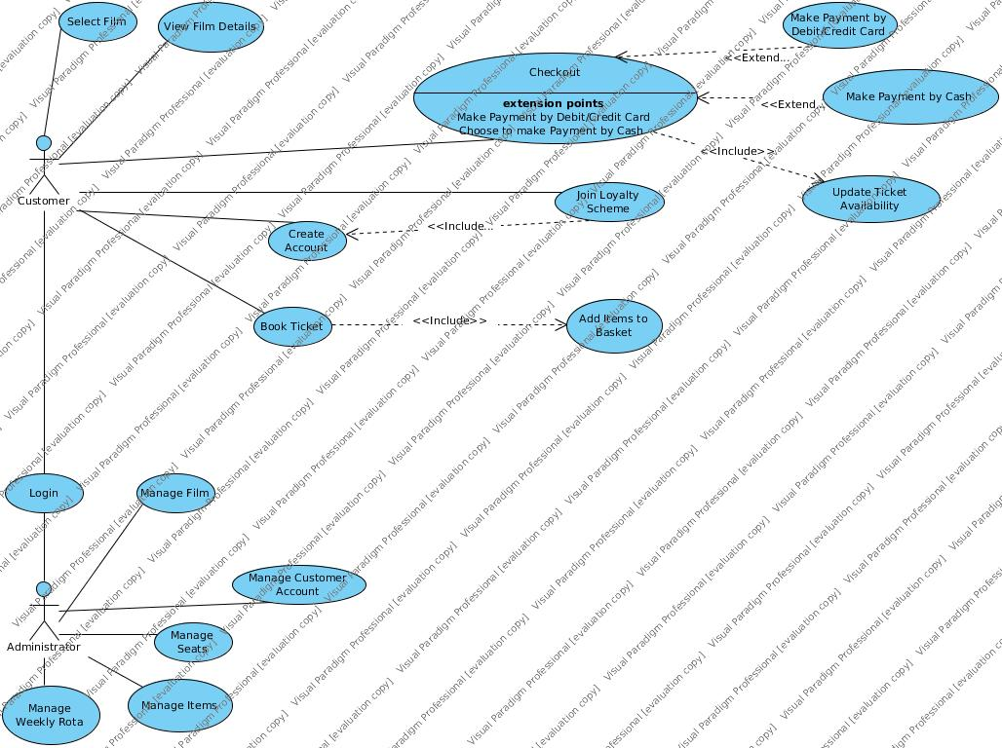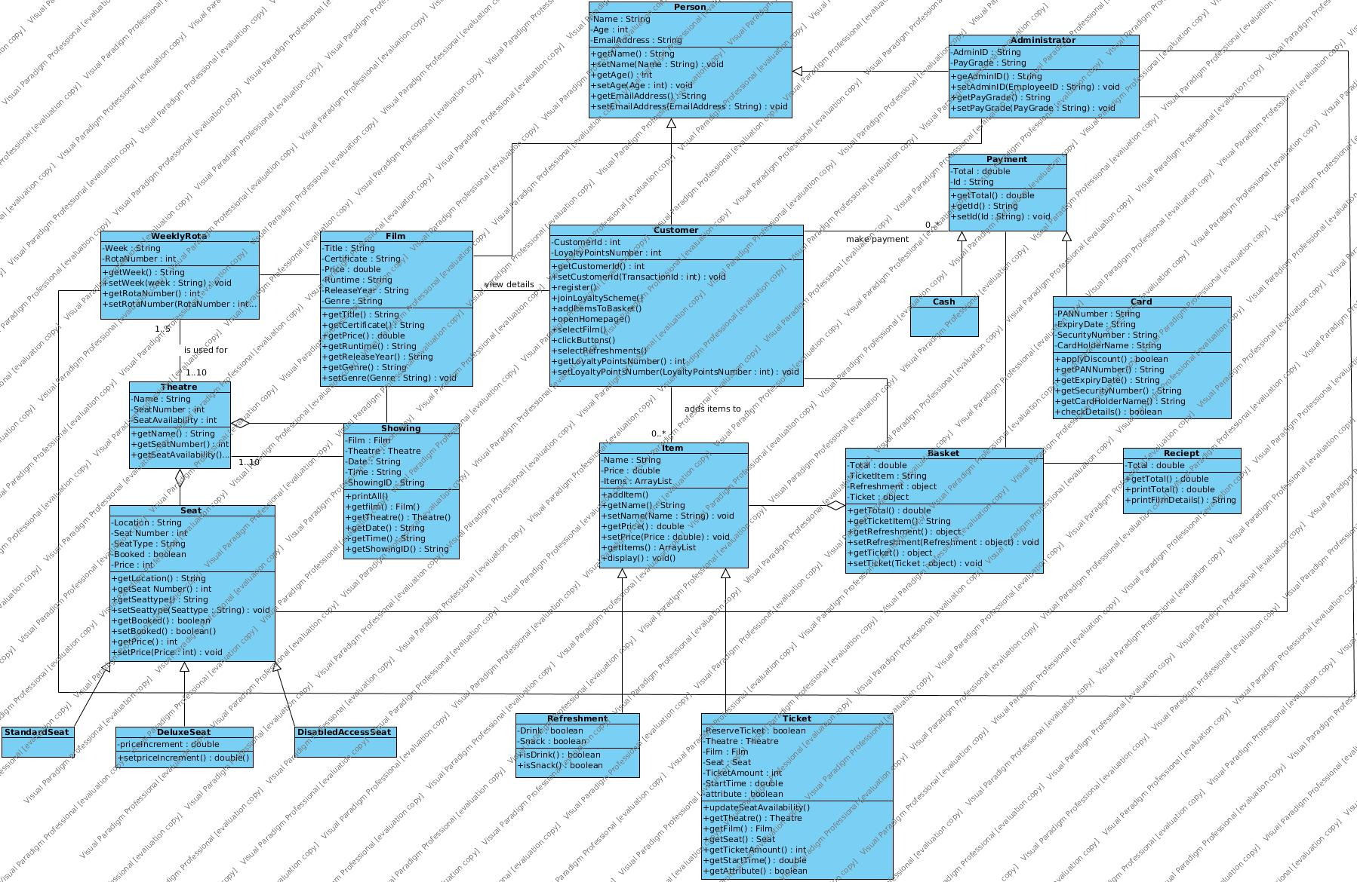

# **Login Page Testing**

## Login Button

|  |  |  |  |
| --- | --- | --- | --- |
| Test Number | Test Input | Result | Comments |
| Test 1 Login Button  (Testing without any input)  The program should first check if there is a string in the username field and if not it will display an error message explaining what the problem is |  |  | The error message appears successfully. |
| Test 2  (Testing with only a username)  The program will be happy that there is a string in username however it will now pop up another alert to now enter a password |  |  | The error message appears successfully. |
| Test 3  (Testing with only a password)  The program should show the error message for the username because that’s what the if statement checks for first |  |  | The User Name error message appears as expected. |
| Test 4  (Testing with two random strings)  The program should display a different error message explaining that the information does not match a record |  |  | The error message appears successfully. |
| Test 5  (Testing with pre hardcoded customer data)  The program should take the input from the user and reference that against the pre-set data in the CustomerData Class to see if it exists if it does they will be able to continue to the next page through the login button if not they will again see an error message explaining that the information does not match a record (see figure 1) |  |  |  |

## Continue as a Guest Button

|  |  |  |  |
| --- | --- | --- | --- |
| Test Number | Test Input | Result | Comments |
| Test 1  (Testing confirmation message)  When you click on the okay button you should be taken to the film selection page. |  |  | When clicking on the OK button it successfully takes the user to the film selection page. |
| Test 2  (Testing confirmation message)  When you click the cancel button it should leave you on the current page. |  |  | When selecting the cancel option on the alert it successfully keeps the user on the Login Page. |

# **Film Page Testing**

## Film Image Buttons

|  |  |  |  |
| --- | --- | --- | --- |
| Test Number | Test Input | Result | Comments |
| Test 1 (clicking the film image button)  When an image of the film is selected it will take the user to the Film Detail page which will populate all of the information for the selected film |  |  | The film image takes you to the new page where it has populated the information from the selected film from the film selection page.  The user interface on this screen is very simple however some other features could be added in future |
|  |  |  |  |

# Bibliography

<https://www.youtube.com/watch?v=7LxWQIDOzyE> switching between scenes – this guy’s git hub <https://github.com/buckyroberts/Source-Code-from-Tutorials/blob/master/JavaFX/004_switchingScenes/Main.java>

<https://github.com/TonyJenkins/cfs2160-2018-java-public/blob/master/src/cfs2160/lectures/week15/social/network/v6/Post.java> tony polymorhism

<https://docs.oracle.com/javafx/2/ui_controls/button.htm> button set image to button

<https://www.youtube.com/watch?v=0aZy81etURE> tutorial helped with Spinner

<https://www.lynda.com/Java-tutorials/Lay-out-user-interface/466182/498141-4.html?autoplay=true> different pane uses

<https://github.com/TonyJenkins/cfs2160-2018-java-public/blob/master/src/cfs2160/lectures/week11/fund/raising/FundRaiser.java> formatting gb

<https://examples.javacodegeeks.com/desktop-java/javafx/listview-javafx/javafx-listview-example/> listview

<https://code.makery.ch/blog/javafx-dialogs-official/?fbclid=IwAR1F89XzcUhHShDieeWzkJeKepbrTC0n8QF9vnW47xVBiXwBVhRxMZAQ03U> alert type examples