

SYST53364 Site Reliability and Observability

Lab 4
Researching and Implementing Application Architectures

Submitted To: Submitted By:

Pro. Rahul Bahl Sweta Rajput (991818161)

Part 1: Research and Document Application Architectures

1. Research Traditional Architectures:

a) Single-Machine Webserver Architecture
Key Components and Their Responsibilities:
- Web Server Software (Apache/Nginx): Handles HTTP/HTTPS requests and serves static content
- Application Runtime (PHP/Python/Node.js): Executes business logic and dynamic content generation
- Database (MySQL/PostgreSQL): Stores and retrieves application data
- Operating System (Linux/Windows): Provides the foundation for all software to run
- File System: Stores application code, uploads, and configuration files
Benefits:
- Simplicity: Easiest to set up - just install everything on one machine
- Low Cost: Requires only one server (physical or virtual)
- Easy Maintenance: Only one system to update, monitor, and backup
- Low Latency: All components communicate locally via localhost (no network delays)
- Quick Deployment: Can be running in minutes with pre-configured stacks like XAMPP/WAMP
Limitations:
- Single Point of Failure: If the server crashes, everything goes down
- Limited Scalability: Can only scale vertically (bigger machine), not horizontally
- Resource Contention: CPU, memory, and disk I/O competition between components
- Security Risks: Database exposed on same machine as web server
- Maintenance Downtime: Updates require taking entire application offline
Real-World Examples:
This pattern is commonly found in small business websites, such as local restaurants or retail shops that use platforms like WordPress on shared hosting. It is also typical for personal blogs and portfolios. Historically, many successful companies started this way; for instance, Facebook initially ran on a single server at Harvard University before scaling. University student projects and internal tools for small teams often use this architecture due to its simplicity.
Typical Use Cases Where This Architecture Excels:
The Single-Machine Webserver excels in scenarios with low traffic and minimal complexity. It is ideal for personal projects, prototypes, and proof-of-concept applications where rapid deployment is needed. Development and testing environments benefit from this setup because it mirrors a production-like environment without the overhead. Small business brochure websites with predictable, low visitor counts (under 1,000 daily users) are well-suited. Educational purposes, such as teaching web development fundamentals, also commonly use this architecture.
Scenarios Where This Architecture Would Be a Poor Choice:
This architecture is unsuitable for high-traffic or mission-critical applications. E-commerce sites during holiday sales or promotional events would likely crash under load. Applications expecting viral growth or unpredictable traffic spikes cannot rely on a single server. Systems requiring high availability (99.9% uptime or more), such as online banking or financial services, need redundancy that this architecture lacks. Environments where frequent updates or maintenance must occur without downtime are also poorly served, as taking the single server offline affects the entire application.

b) Three-Tier Web Service Architecture

Key Components and Their Responsibilities:
Presentation Tier (Tier 1):
- Load Balancer: Distributes incoming traffic across multiple web servers
- Web Servers: Handle HTTP requests, serve static files, forward dynamic requests to application tier
- SSL Terminator: Manages HTTPS encryption/decryption
Application Tier (Tier 2):
- Application Servers: Execute business logic (Node.js, Java, Python apps)
- Business Logic: Core application functionality
- API Endpoints: Interface for presentation tier communication
Data Tier (Tier 3):
- Database Server: Primary data storage (SQL or NoSQL)
- Database Management System: MySQL, PostgreSQL, MongoDB, etc.
- Backup System: Regular database backups
Benefits:
- Scalability: Each tier can scale independently
- Better Fault Isolation: Failure in one tier doesn't necessarily bring down others
- Specialization: Each tier can be optimized for its specific purpose
- Security: Database isolated in private network
- Team Separation: Different teams can work on different tiers
- Flexible Technology Choices: Different technologies per tier
Limitations:
- Increased Complexity: More components to configure and maintain
- Network Latency: Communication between tiers adds overhead
- Higher Cost: Requires multiple servers/instances
- Deployment Complexity: Coordinating updates across tiers
- More Points of Failure: More components that can fail
- Harder to Debug: Issues can occur in any tier
Real-World Examples:
This architecture is widely used in medium to large-scale web applications. E-commerce platforms like Shopify often employ a three-tier structure to handle product catalogs, shopping carts, and user accounts. University learning management systems (e.g., Canvas or Blackboard) use it to separate frontend interfaces, application logic, and student databases. Many SaaS products (Software as a Service), such as project management tools or CRM systems, adopt this pattern. Online banking applications for regional banks frequently implement three-tier architectures to ensure security and scalability.
Typical Use Cases Where This Architecture Excels:
The Three-Tier architecture excels in business applications with moderate to high user concurrency. It is well-suited for enterprise web applications like customer relationship management (CRM) systems, enterprise resource planning (ERP) software, and content management systems (CMS). Online marketplaces and e-commerce sites benefit from the ability to scale the web tier during sales events and the application tier for order processing. Educational platforms and online learning tools that need to serve thousands of simultaneous users also find this architecture effective. Applications requiring clear separation between user interface, business logic, and data storage for maintainability and team workflow are ideal candidates.
Scenarios Where This Architecture Would Be a Poor Choice:
For simple static websites or blogs with very low traffic, a three-tier setup is overkill and unnecessarily complex and costly. Real-time applications requiring ultra-low latency, such as multiplayer online games or financial trading platforms, may suffer from the network hops between tiers. Internet of Things (IoT) applications that process millions of small messages from devices might find the tiered structure inefficient. Projects with extremely tight budgets or timelines, like hackathon prototypes or MVP (Minimum Viable Product) versions that need to be built in hours, would be better served by simpler architectures. Serverless or Platform-as-a-Service (PaaS) scenarios, where the goal is to minimize infrastructure management, also do not align well with the operational overhead of a three-tier system.

c) Reverse Proxy Architecture

Key Components and Their Responsibilities:
Reverse Proxy Layer:
- Reverse Proxy Server: Nginx, HAProxy, or Apache with mod_proxy
- Load Balancer: Distributes requests to backend servers
- SSL Terminator: Handles HTTPS encryption
- Caching Layer: Caches static content and API responses
Backend Layer:
- Application Servers: Multiple servers running the actual application
- Web Servers: Apache, Nginx serving the application
- Session Stores: Redis/Memcached for shared session storage
Benefits:
- Improved Security: Hides backend servers, provides DDoS protection
- Load Distribution: Evenly spreads traffic across multiple servers
- SSL Termination: Offloads CPU-intensive encryption/decryption
- Caching: Reduces load on backend servers
- Compression: Reduces bandwidth usage
- Single Point of Entry: Simplified DNS and certificate management
- A/B Testing Support: Can route traffic to different backends
Limitations:
- Additional Latency: Extra hop adds 5-50ms depending on setup
- Single Point of Failure: If proxy fails, entire system is down (unless clustered)
- Configuration Complexity: Need to configure proxy rules properly
- Potential Bottleneck: Proxy can become overloaded
- Debugging Complexity: Harder to trace requests through proxy
Real-World Examples:
This pattern is fundamental to many high-traffic websites and services. GitHub uses Nginx as a reverse proxy to manage traffic to its backend services. Netflix employs the Zuul gateway as a reverse proxy and API gateway for its microservices architecture. WordPress.com utilizes Nginx reverse proxies in front of pools of PHP-FPM application servers to handle millions of blogs. Reddit relies on HAProxy for load balancing across its application servers. Content Delivery Networks (CDNs) like Cloudflare essentially act as globally distributed reverse proxies, caching content close to users and protecting origin servers.
Typical Use Cases Where This Architecture Excels:
Reverse Proxy Architecture excels in high-traffic websites and web applications that require reliable load distribution and DDoS mitigation. It is ideal for modern web applications using microservices, where an API gateway (a form of reverse proxy) routes requests to appropriate backend services. Legacy application modernization projects often place a reverse proxy in front of an old monolithic application to add security, caching, and load balancing without rewriting the entire codebase. Global applications that integrate with a CDN benefit from the proxy managing origin shielding and cache control headers. Systems requiring flexible deployment strategies (like blue-green or canary deployments) use the proxy's routing capabilities to direct user traffic.
Scenarios Where This Architecture Would Be a Poor Choice:
For a simple, low-traffic personal blog or project website, introducing a reverse proxy adds unnecessary complexity and cost. Local development environments where simplicity and fast iteration are key typically do not need a reverse proxy layer. Applications where every millisecond of latency is critical, such as high-frequency trading platforms or real-time competitive gaming servers, might avoid the extra hop. Small teams with limited operations or DevOps expertise might struggle with the configuration and maintenance overhead. Projects with extremely constrained budgets that cannot afford the additional compute instance for the proxy would find this architecture impractical.

2. Research Modern Cloud Architectures:

1. Microservices Architecture
Key Components and Their Responsibilities:
Service Layer:
- Independent Services: Each service handles specific business capability
- Container Runtime: Docker containers for each service
- Orchestration: Kubernetes/ECS for managing containers
Communication Layer:
- API Gateway: Single entry point for all client requests
- Service Discovery: Consul/Eureka for finding services
- Message Queue: RabbitMQ/Kafka for async communication
- Event Bus: For event-driven communication
Data Layer:
- Database per Service: Each service has its own database
- Polyglot Persistence: Different databases for different needs
- Data Replication: For data sharing between services
Operational Layer:
- Centralized Logging: ELK stack or CloudWatch Logs
- Distributed Tracing: Jaeger or AWS X-Ray
- Monitoring: Prometheus or Datadog
- CI/CD Pipeline: Automated deployment per service
Benefits:
- Independent Deployment: Update one service without affecting others
- Technology Flexibility: Each service can use different technologies
- Scalability: Scale only the services that need it
- Fault Isolation: One service failure doesn't bring down entire system
- Team Autonomy: Small teams own entire services
- Faster Development: Teams can work in parallel
Limitations:
- Distributed System Complexity: Network issues, latency, partial failures
- Data Consistency: Hard to maintain ACID transactions
- Operational Overhead: Many more components to monitor and maintain
- Testing Complexity: Need to test interactions between services
- Network Overhead: Many network calls between services
- Skill Requirements: Need expertise in distributed systems
Real-World Examples:
- Netflix: Pioneer in microservices, thousands of services
- Uber: Each functionality (payment, dispatch, etc.) is separate service
- Spotify: Hundreds of services for music streaming
- Amazon: Even their "Add to Cart" is a separate service
- Twitter: Migrated from monolith to microservices
AWS Services for Implementation:
- Compute & Orchestration: Amazon ECS (Elastic Container Service), Amazon EKS (Elastic Kubernetes Service), AWS Fargate (serverless containers).
- API Management: Amazon API Gateway for routing and API management.
- Service Discovery & Networking: AWS Cloud Map, Elastic Load Balancing, Amazon VPC.
- Messaging & Events: Amazon SQS (queues), Amazon SNS (pub/sub), Amazon EventBridge (event bus).
- Databases: Amazon RDS (for SQL), Amazon DynamoDB (for NoSQL), Amazon ElastiCache (for caching).
- Monitoring & Operations: Amazon CloudWatch (metrics & logs), AWS X-Ray (tracing), AWS Systems Manager.
- Security: AWS IAM (identity), AWS Secrets Manager, AWS WAF (web firewall).
- CI/CD: AWS CodePipeline, AWS CodeBuild, AWS CodeDeploy.

Cost Considerations vs Traditional:
- Higher Infrastructure Costs: More smaller instances vs fewer larger ones
- Increased Data Transfer Costs: More inter-service communication
- Management Tools Cost: Need additional monitoring/tracing tools
- Development Cost: More complex development environment
- Potential Savings: Can save by scaling only what's needed
- TCO (Total Cost of Ownership): Often higher due to operational complexity

2. Serverless Architecture
Key Components and Their Responsibilities:
Compute Layer:
- Function-as-a-Service: AWS Lambda, Azure Functions
- Event Sources: API Gateway, S3 events, DynamoDB streams
- Runtime Environments: Node.js, Python, Java, etc.
API Layer:
- API Gateway: Routes requests to functions
- Authentication: Cognito for user management
- Rate Limiting: Built into API Gateway
Data Layer:
- Serverless Databases: DynamoDB, Aurora Serverless
- Object Storage: S3 for files and static content
- Caching: DAX for DynamoDB, ElastiCache Serverless
Integration Layer:
- Event Bridge: For event-driven architectures
- Step Functions: For workflow orchestration
- SQS/SNS: For messaging between functions
Benefits:
- No Server Management: AWS manages infrastructure
- Auto-scaling: Scales from zero to thousands instantly
- Pay-per-use: Only pay for actual execution time
- High Availability: Built-in redundancy and failover
- Fast Deployment: Deploy code without provisioning infrastructure
- Reduced Operational Burden: Less patching, monitoring, capacity planning

Limitations:
- Cold Starts: Delay when function hasn't been used recently
- Execution Limits: 15-minute max execution time (AWS Lambda)
- Vendor Lock-in: Heavy dependency on cloud provider
- Debugging Complexity: Harder to debug distributed functions
- Local Testing: Different from production environment
- Cost Unpredictability: Can get expensive with high volume
Real-World Examples:
- Airbnb: Uses Lambda for image processing
- Nordstrom: Serverless for inventory management
- Coca-Cola: Vending machine data processing
- FINRA: Processes 75 billion events daily with serverless
- iRobot: Roomba data processing with AWS Lambda
AWS Services for Implementation:
- Compute: AWS Lambda
- API Management: API Gateway
- Database: DynamoDB, Aurora Serverless
- Storage: S3
- Authentication: Cognito
- Events: EventBridge
- Orchestration: Step Functions
- Monitoring: CloudWatch Logs and Metrics
Cost Considerations vs Traditional:
- No Idle Cost: Don't pay for servers when not in use
- Granular Billing: Pay per 100ms of execution
- Potential Savings: For sporadic or unpredictable workloads
- Potential Higher Costs: For constant high-volume workloads
- Data Transfer Costs: Same as traditional
- API Gateway Costs: Additional cost per request
- Development Cost: May be lower due to less infrastructure code

- Architecture Diagrams
Traditional Architecture Diagram: Three-Tier Web Service
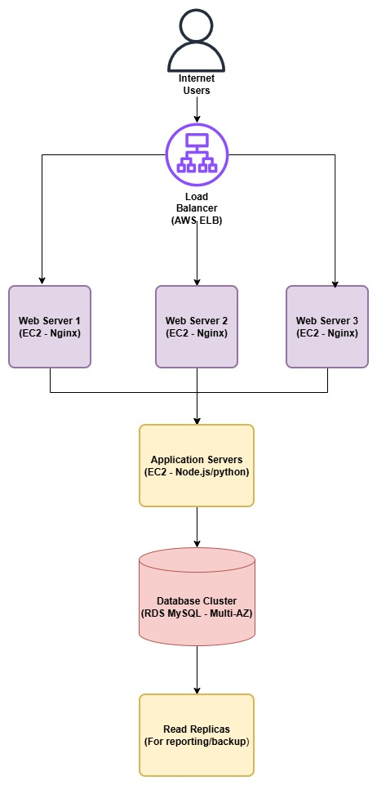
Key Interactions:
- Users → Load Balancer: HTTPS requests
- Load Balancer → Web Servers: HTTP (internal)
- Web Servers → App Servers: API calls (HTTP/RPC)
- App Servers → Database: SQL queries
- Database → Read Replicas: Asynchronous replication
- Modern Architecture Diagram: Microservices on AWS
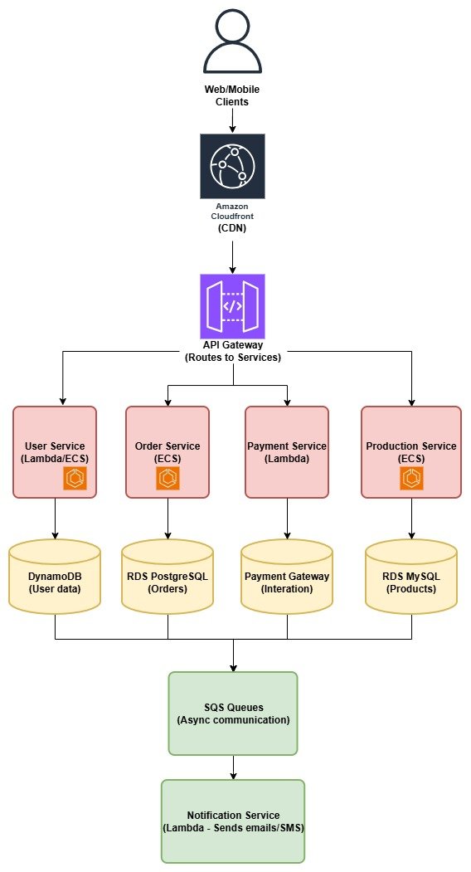
Key Interactions:
- Clients → CloudFront: Static content caching
- CloudFront → API Gateway: Dynamic requests
- API Gateway → Services: Route-based routing
- Services → Databases: Each service has own DB
- Services → SQS: Async messages for decoupling
- SQS → Notification Service: Event-driven processing
Comparison Table
Feature | Single-Machine | Three-Tier | Reverse Proxy | Microservices | Serverless
Complexity | Very Low | Medium | Medium-High | Very High | Medium
Scalability | Very Poor | Good | Excellent | Excellent | Excellent
Cost Driver | Cost of a single server. | Cost of multiple servers + load balancer + database. | Cost of proxy servers + backend servers. | Cost of many services, orchestration, and inter-service communication. | Number of requests and compute duration (GB-seconds).
Deployment Speed | Very Fast | Slow | Medium | Very Slow (per service) | Very Fast
Team Size Required | 1 developer | 2-3 engineers | 3-5 engineers | 5+ engineers with ops | 2-3 developers
Best For | Prototypes, small sites | Business applications | High-traffic websites | Large enterprises | Event-driven apps
Worst For | High-growth startups | Real-time systems | Low-budget projects | Small companies | Long-running processes
Typical AWS Services | EC2, RDS (on same instance not recommended). | EC2, ELB/ALB, RDS, Auto Scaling. | EC2 (for proxy/backends), ALB/NLB, ElastiCache. | ECS/EKS, API Gateway, SQS/SNS, various databases, X-Ray. | Lambda, API Gateway, DynamoDB, S3, EventBridge.
Failure Recovery | Manual restart | Tier-by-tier recovery | Proxy cluster needed | Service-by-service | Automatic
Learning Curve | Beginner | Intermediate | Intermediate | Expert | Intermediate
Vendor Lock-in | None | Low | Low | Medium | High
Time to Market | Hours | Days-Weeks | Weeks | Months | Days

Part 2: Hands-On Implementation of a Simple Three-Tier Architecture
  - Implement a Basic Three-Tier Architecture:
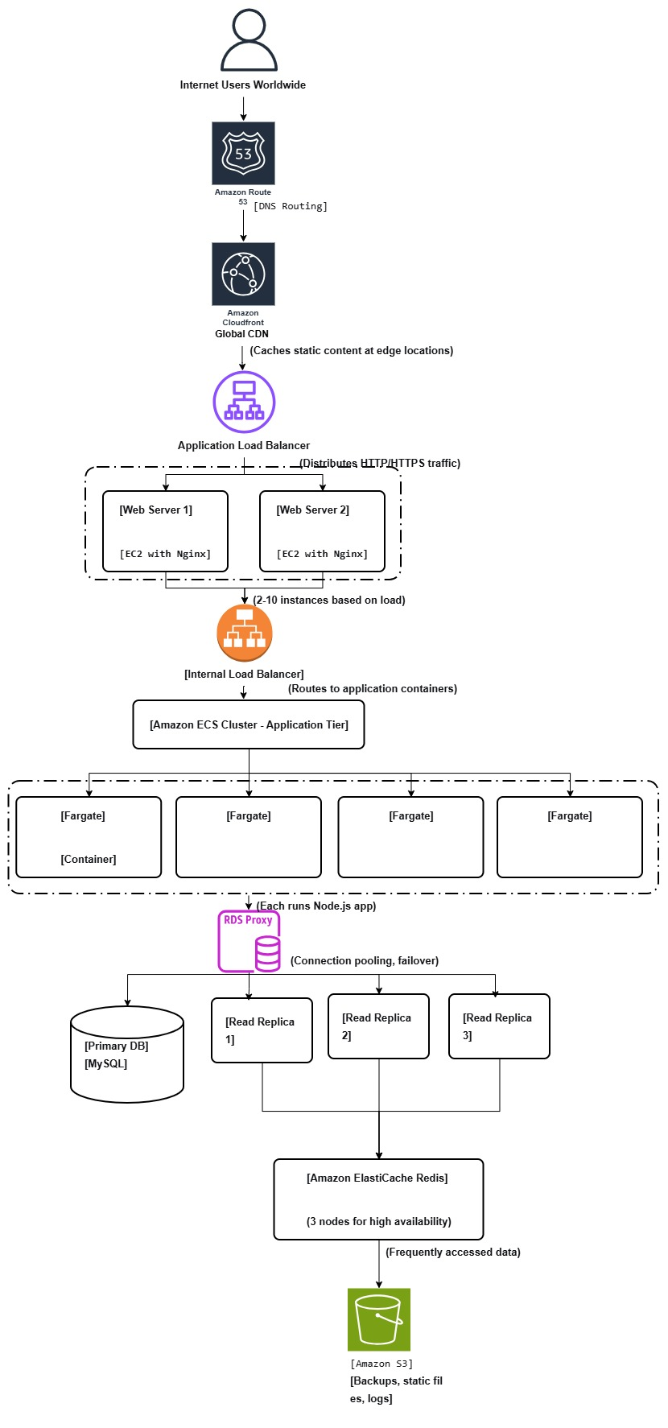
- Data Flow Explanation:
- User request → CloudFront (cache check) → ALB → Web Server
- Web Server → Internal ALB → ECS Container
- ECS Container → Check ElastiCache → If miss → RDS Proxy → Database
- Write: Primary RDS → Async replication → Read Replicas
- Background: Automated backups to S3, monitoring via CloudWatch

- Key Features of This Scaled Architecture:
- Global reach via CloudFront
- Automatic scaling at every tier
- High availability across multiple AZs
- Performance optimization via caching
- Disaster recovery via backups
- Monitoring via CloudWatch

- First, Create a VPC (Virtual Private Cloud):
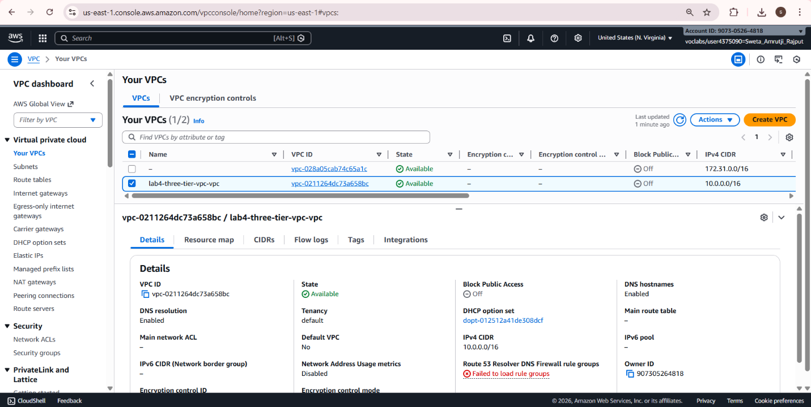

- Create Security Groups (Firewalls): We need three security groups
a) Web Server Security Group
b) Application Security Group
c) Database Security Group
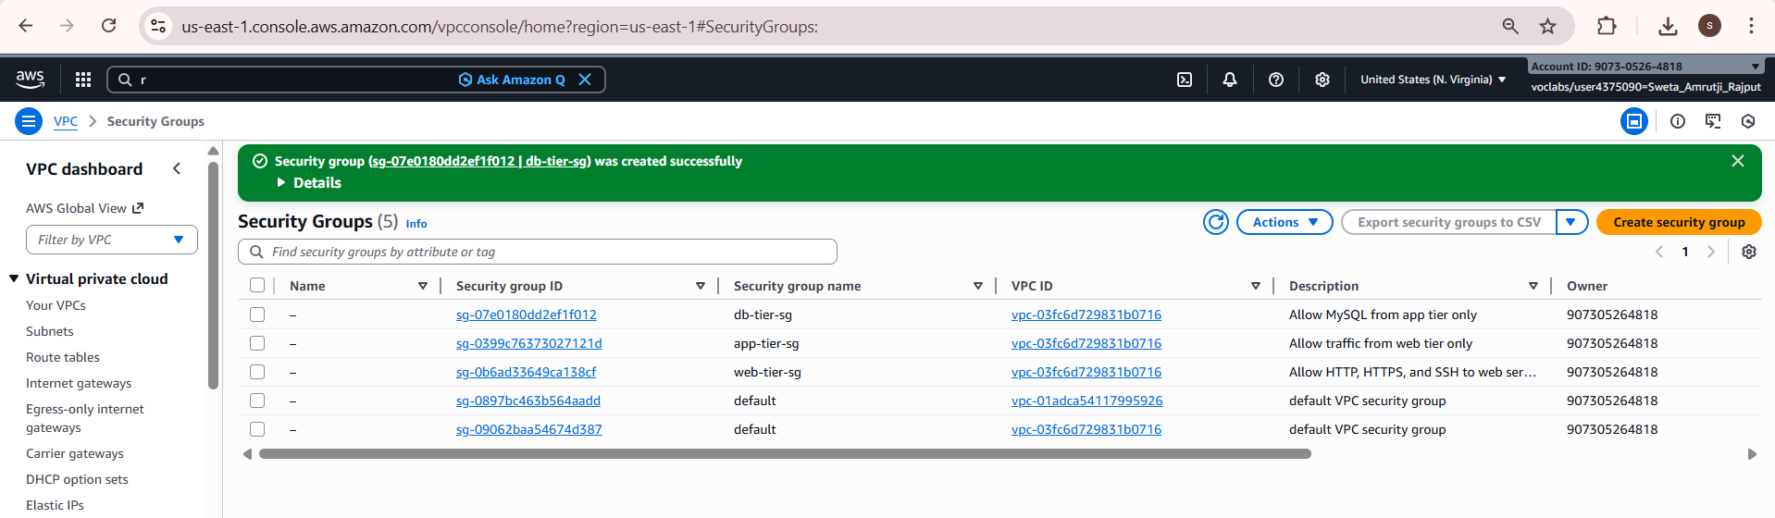

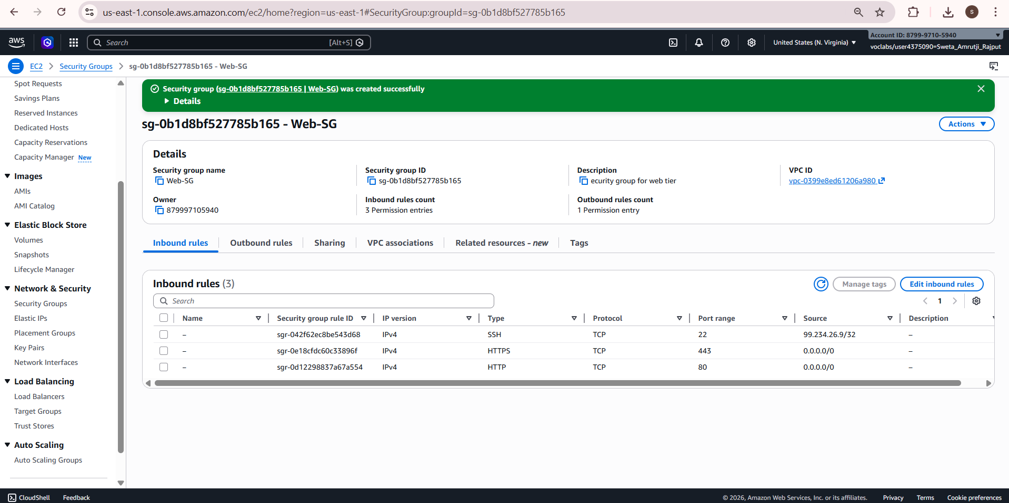

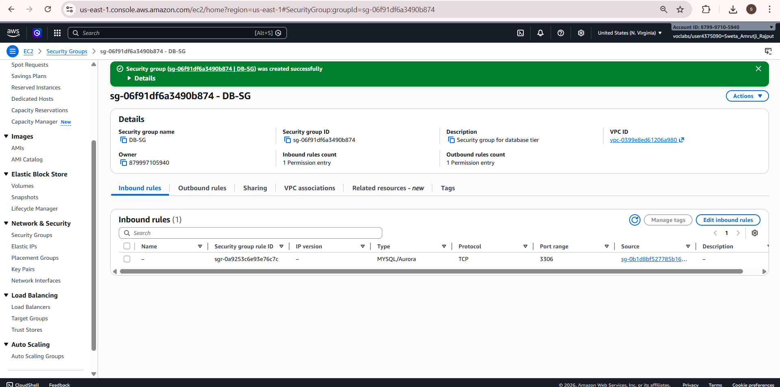
- Create EC2 Instance (Web/Presentation Tier):
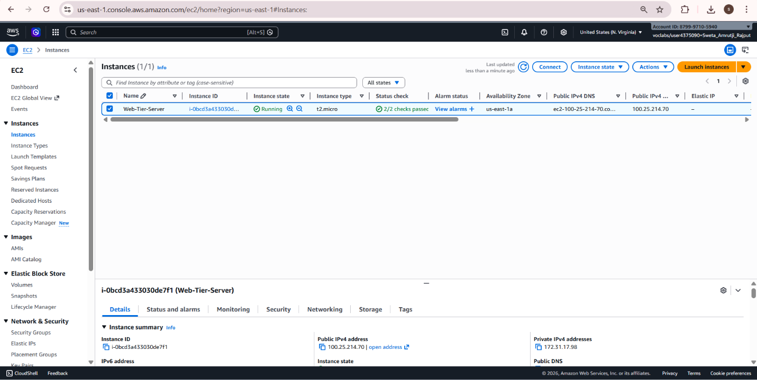

4. Create RDS Instance (Database Tier):
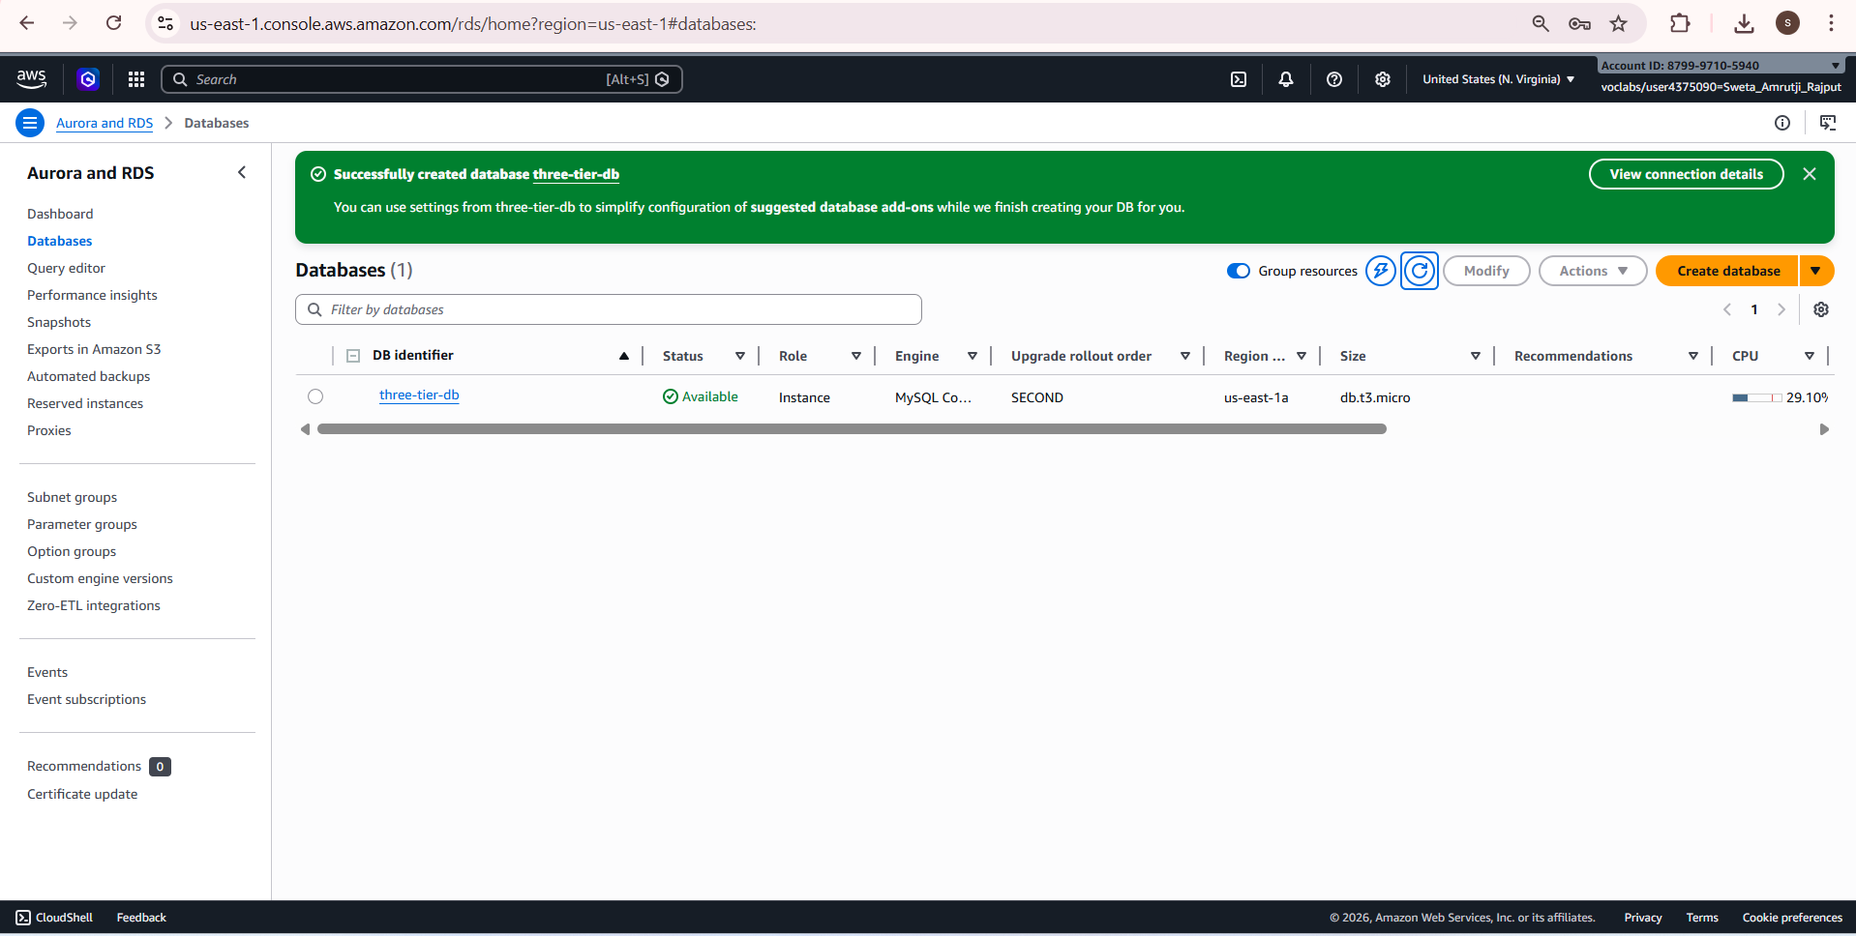
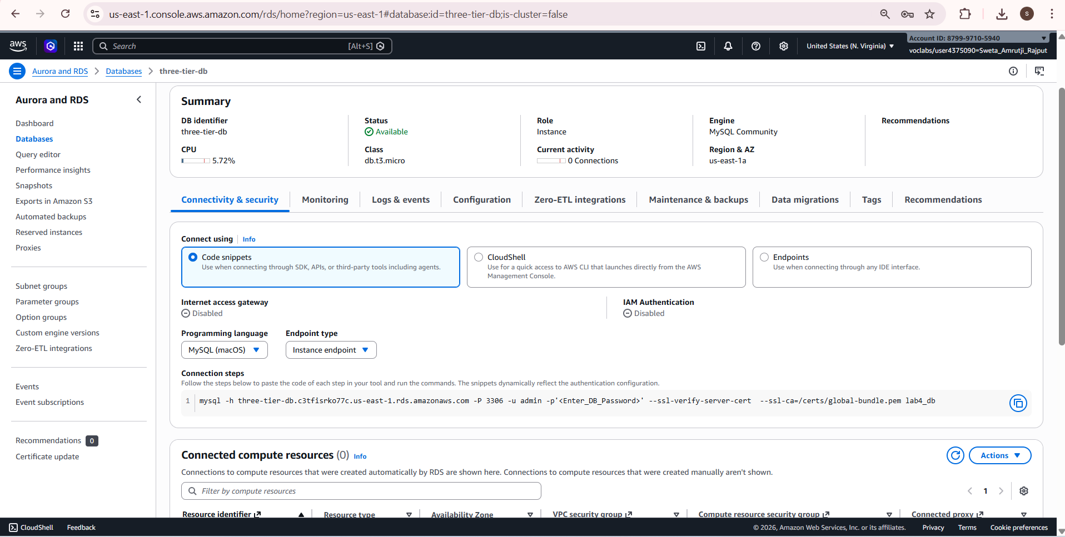

5. Create EC2 Instance (Application Tier):
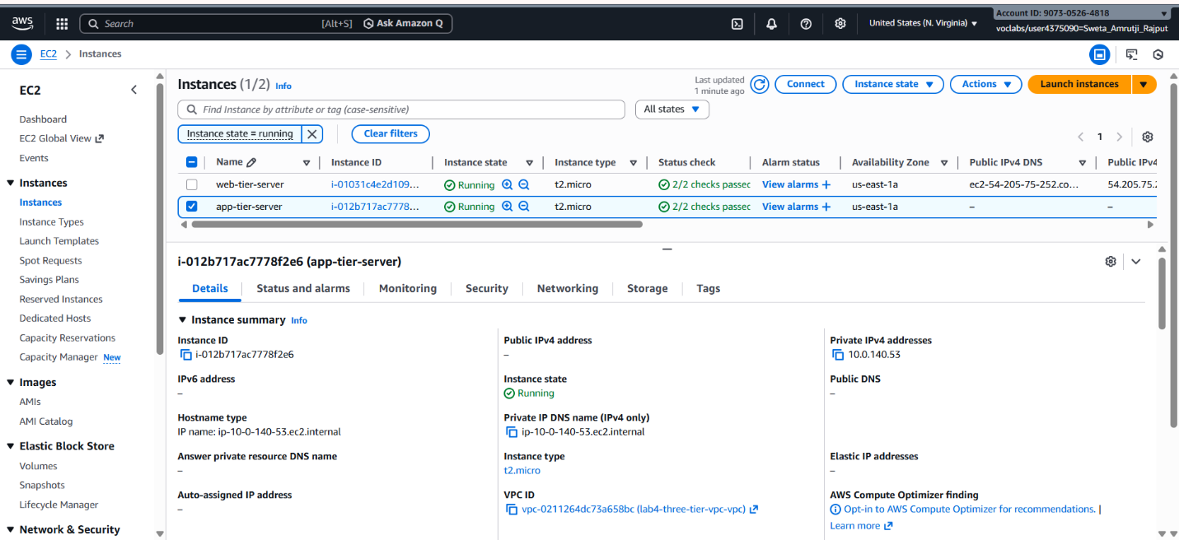

6. Test the Complete Setup:


My Three-Tier Architecture Implementation
How I Set Up My Three-Tier System
I built a basic three-tier web application on AWS using what I learned in class. Here's how I did it step by step:
First, I created a VPC (Virtual Private Cloud) which is like my private network in AWS. I made it with both public and private subnets. The public subnet is for servers that need internet access, and the private subnet is for servers that should be protected from direct internet access.
For the web tier (presentation tier), I launched an EC2 instance with Amazon Linux 2. I chose t2.micro because it's free tier eligible. I installed Nginx web server on it and configured it to serve web pages. This server gets a public IP address so users can access it from the internet.
For the application tier, I launched another EC2 instance but placed it in a private subnet. This means it has no public IP address and is more secure. On this server, I installed Node.js and created a simple web application that handles business logic.
For the database tier, I created an RDS MySQL instance. I placed this in the private subnet too. I configured it with a master password and made sure it was accessible only from the application tier.
The tricky part was connecting everything together. I had to create security groups (which are like firewalls) to control traffic:
- Web tier allows HTTP/HTTPS from the internet
- Application tier only accepts traffic from the web tier
- Database tier only accepts MySQL connections from the application tier
I tested everything by creating a simple web page on the web tier and making sure it could talk to the application tier, which could then talk to the database. Everything worked! I took screenshots of each step as proof.

  - Research and Document Scaling Strategies:

- How would you scale the web tier? (EC2 Auto Scaling, Load Balancers)
Right now, I have just one web server. If my website becomes popular and thousands of people try to visit at once, this single server will crash. To prevent this, I need to scale the web tier.
The solution is to use an Application Load Balancer (ALB) with Auto Scaling Groups. Here's how it works:
- Add a Load Balancer: Instead of users connecting directly to my web server, they connect to a load balancer. The load balancer then forwards requests to one of many web servers.
- Create Multiple Identical Web Servers: I need to make copies of my web server. In AWS, I create a "Launch Template" which is like a recipe for making web servers. It specifies the AMI, instance type, security groups, and startup scripts.
- Set Up Auto Scaling: This is the cool part. I create an Auto Scaling Group that:
  - Always keeps at least 2 web servers running (for redundancy)
  - Can automatically add more servers when traffic increases
  - Removes extra servers when traffic decreases
  - Replaces servers if they fail
- Configure Scaling Rules: I tell AWS when to add or remove servers:
  - Add 1 server if CPU usage goes above 70% for 5 minutes
  - Remove 1 server if CPU usage stays below 30% for 10 minutes
AWS Services I Would Use:
- Application Load Balancer (ALB) - distributes traffic
- Auto Scaling Groups - manages server count
- CloudWatch - monitors performance
- Launch Templates - server configuration
Real Example: If my school website gets mentioned in the news and traffic spikes from 100 to 10,000 visitors, auto scaling would automatically add more web servers to handle the load. When traffic returns to normal, it removes the extra servers to save money.

- How would you scale the application tier? (Horizontal scaling, containerization)
The application tier runs my business logic. If it becomes slow, the whole website becomes slow, even if the web tier is working fine.
The best solution is containerization with Amazon ECS. Here's why:
Traditional scaling would mean launching more EC2 instances with my application, but this has problems:
- Each instance needs its own operating system (wastes resources)
- Difficult to ensure all instances are identical
- Slow to deploy updates
Containerization solves these problems. A container packages my application with all its dependencies into a single unit that runs the same everywhere.
Here's my scaling strategy:
- Create Docker Container: I package my Node.js application into a Docker container. This includes the code, Node.js runtime, and all libraries.
- Store Container in ECR: Amazon Elastic Container Registry (ECR) is where I store my Docker images, like a library for containers.
- Use Amazon ECS with Fargate: ECS is a service that runs containers. Fargate means AWS manages the servers - I just pay for the containers running. This is easier than managing servers myself.
- Set Up Auto Scaling for Containers: Just like with web servers, I can auto-scale containers:
  - Run 2 containers minimum for redundancy
  - Add more containers when CPU or memory usage is high
  - Scale down when not needed
- Load Balance Between Containers: An internal load balancer distributes requests from the web tier to all the application containers.
Benefits of This Approach:
- Consistency: Containers run exactly the same in development and production
- Efficiency: Multiple containers can run on one server (better resource use)
- Fast Deployment: Deploy new version by just updating the container image
- Easy Scaling: Add or remove containers in seconds
AWS Services I Would Use:
- Amazon ECR - stores Docker images
- Amazon ECS - runs containers
- AWS Fargate - serverless containers (no server management)
- Application Load Balancer - distributes traffic to containers
Real Example: My application handles user logins and processes orders. During peak hours (like lunchtime for a food app), more containers automatically start to handle increased login and order processing. During quiet hours, fewer containers run to save costs.

- How would you scale the database tier? (Read replicas, sharding)
The database is often the hardest part to scale. If the database is slow, everything is slow, no matter how many web or application servers I have.
I need a multi-step approach to scale the database:
Step 1: Add Read Replicas
Right now, I have one database that handles both read operations (SELECT queries) and write operations (INSERT, UPDATE, DELETE). When traffic increases, reads and writes compete for resources.
Solution: Create read replicas - these are copies of the main database that handle only read operations.
How it works:
- Primary database handles all writes
- Read replicas are synchronized copies that handle reads
- Application is modified to send read queries to replicas, write queries to primary
Benefits:
- Read performance improves significantly
- Primary database focuses on writes
- If a replica fails, others can still handle reads
Step 2: Add Caching Layer
Many database queries are repetitive. For example, on an e-commerce site, product information doesn't change often but is viewed frequently.
Solution: Add Amazon ElastiCache (Redis or Memcached) to cache frequently accessed data.
How it works:
- Application checks cache first for data
- If found in cache, return immediately (fast!)
- If not in cache, query database, then store result in cache
- Next time, data comes from cache
Benefits:
- Reduces database load by 70-90%
- Much faster response times (milliseconds vs seconds)
- Database can handle more important queries
Step 3: Implement Connection Pooling
Each time my application connects to the database, there's overhead. With many application containers, this creates many connections.
Solution: Use RDS Proxy, which manages database connections efficiently.
Benefits:
- Reduces database load from connection management
- Improves application performance
- Handles failover better
Step 4: Advanced Options (For Very Large Scale)
If my application grows really large, I might need:
- Sharding: Split database into multiple smaller databases
- Amazon Aurora: More scalable database engine
- Global Database: For worldwide applications
AWS Services I Would Use:
- RDS Read Replicas - for scaling reads
- Amazon ElastiCache - for caching
- RDS Proxy - for connection pooling
- Amazon Aurora - for advanced scaling needs
Real Example: A social media app's database. The primary handles posts and comments (writes). 3 read replicas handle profile views and news feeds (reads). ElastiCache stores user sessions and trending topics. During viral events, add temporary read replicas.

  - Cost Analysis

- Basic Three-Tier Implementation Monthly Cost
For my simple implementation with 1 web server, 1 app server, and 1 database:
Assumptions:
- Region: US East (N. Virginia) - us-east-1
- 30-day month = 730 hours
- Free tier eligible where possible
- Estimated data transfer: 100GB out
Cost Breakdown:
1. Web Tier (EC2 Instance):
- EC2 t2.micro: 730 hours × $0.0116 = $8.47
- EBS Storage (8GB gp2): 8 × $0.10 = $0.80
- Subtotal: $9.27
2. Application Tier (EC2 Instance):
- EC2 t2.micro: 730 hours × $0.0116 = $8.47
- EBS Storage (8GB gp2): 8 × $0.10 = $0.80
- Subtotal: $9.27
3. Database Tier (RDS):
- RDS db.t3.micro: 730 hours × $0.017 = $12.41
- Storage (20GB gp2): 20 × $0.115 = $2.30
- Backup Storage (20GB): 20 × $0.095 = $1.90
- Subtotal: $16.61
4. Networking:
- VPC: Free
- Data Transfer Out (100GB): 100 × $0.09 = $9.00
- NAT Gateway (needed for private subnets): 730 × $0.045 = $32.85
- Subtotal: $41.85
Total Monthly Cost: $77.00
Note: This is reasonable for a small website or school project. It can handle maybe 100-500 daily users.

- Scaled Architecture Monthly Cost Estimate
If I implement all the scaling strategies, the cost increases:
Scaled Cost Breakdown:
1. Web Tier (Scaled):
- Application Load Balancer: 730 × $0.0225 = $16.43
- ALB LCUs (10/day): 10 × $0.008 × 30 = $2.40
- EC2 t3.medium (2 always on): 2 × 730 × $0.0416 = $60.74
- Additional EC2 during peak (4 at 50%): 4 × 730 × $0.0416 × 0.5 = $30.37
- Subtotal: $109.94
2. Application Tier (Scaled with ECS Fargate):
- ECS Fargate (2 tasks always on):
  - vCPU: 2 × 0.5 × 730 × $0.04048 = $29.55
  - Memory: 2 × 1GB × 730 × $0.004445 = $6.49
  - Total: $36.04
- Additional tasks during peak (4 at 50%): $18.02
- ECR Storage (1GB): 1 × $0.10 = $0.10
- Subtotal: $54.16
3. Database Tier (Scaled):
- RDS Primary db.t3.medium: 730 × $0.068 = $49.64
- Read Replicas (2): 2 × $49.64 = $99.28
- ElastiCache Redis cache.t3.micro (3 nodes): 3 × 730 × $0.068 = $148.92
- RDS Proxy (2 vCPU): 2 × 730 × $0.015 = $21.90
- Storage (100GB): 100 × $0.115 = $11.50
- Subtotal: $331.24
4. Additional Services:
- CloudFront (1TB data): 1000 × $0.085 = $85.00
- CloudWatch (50 metrics): 50 × $0.30 = $15.00
- S3 Storage (100GB): 100 × $0.023 = $2.30
- Route 53 (1 hosted zone): $0.50
- Subtotal: $102.80
Total Scaled Monthly Cost: $598.14
That's almost 8 times more expensive! But it can handle 10,000+ daily users instead of just 500.

- Cost Comparison Summary:
- Basic Implementation: $77.00/month
- Scaled Implementation: $598.14/month
- Increase: 7.77× higher cost
- Capacity Increase: Can handle 10-20× more traffic
Important: This scaled cost assumes:
- Traffic increase from 1,000 to 10,000+ daily users
- 24/7 operation at higher capacity
- All premium features enabled

- How to Reduce Costs with Optimization
$598 per month is a lot for a student project! Here's how I could reduce costs:
Web Tier Optimization:
- Use Spot Instances: These are discounted servers (70-90% off) that AWS sells when they have extra capacity. Perfect for web servers since if they get interrupted, the load balancer sends traffic to other servers.
- Implement Better Caching: Use CloudFront more aggressively to cache content. This reduces load on web servers, so I need fewer of them.
- Right-Size Instances: Monitor actual usage. If servers are only using 30% of CPU on average, I might use smaller, cheaper instances.
Expected Savings: Could reduce $110 to around $65 (40% savings)
Application Tier Optimization:
- Use Fargate Spot: Same concept as EC2 Spot, but for containers. 50-70% savings.
- Optimize Container Size: If my container only needs 0.25 vCPU but I'm giving it 0.5 vCPU, I'm wasting money. Monitor and adjust.
- Use Graviton Processors: ARM-based processors that offer 20% better price/performance.
Expected Savings: Could reduce $54 to around $27 (50% savings)
Database Tier Optimization:
- Use Aurora Serverless: Instead of fixed-size database, use one that scales automatically and charges per second of use. Good for variable workloads.
- Optimize Queries: Slow queries waste database resources. Use Performance Insights to find and fix them.
- Archive Old Data: Move old data (like logs from last year) to cheap storage like S3 Glacier. Keep only recent data in the expensive database.
- Delete Unused Snapshots: Old backups take up space and cost money. Set up automatic cleanup.
Expected Savings: Could reduce $331 to around $215 (35% savings)
General Cost-Saving Tips:
- Set Budget Alerts: Use AWS Budgets to get alerts if I'm spending too much.
- Clean Up Regularly: Delete test resources, unused storage volumes, and old snapshots.
- Use AWS Free Tier: Some services have free tiers for 12 months.
- Monitor with Cost Explorer: Regularly check where money is being spent.
Optimized Total Cost:
With all optimizations:
- Original Scaled Cost: $598
- After Optimization: Around $350-400
- Savings: $200-250 per month (33-42% savings)
That's much more reasonable! I could handle high traffic without breaking my budget.

- My Implementation Plan
If I were actually going to implement this scaling, here's my step-by-step plan:
Phase 1 (First Week):
- Add Application Load Balancer in front of web server
- Create second web server manually
- Set up CloudFront for static files
- Add ElastiCache Redis for basic caching
Phase 2 (Second Week):
- Set up Auto Scaling Group for web tier
- Create Docker container of my application
- Set up ECS Fargate with 2 containers
- Add one read replica to database
Phase 3 (Ongoing):
- Implement Spot Instances for cost savings
- Optimize database queries
- Set up monitoring and alerts
- Regularly review and adjust based on usage
Part 3: Case Study Analysis

1. Research Case Studies:
- Case Study 1: How Netflix Moved to the Cloud

- What I Learned About Netflix's Journey
Netflix is a company I use almost every day, so I was really interested to learn how they built their technology. Back in the early 2000s, Netflix had a problem. They were running everything from their own data centers, and when they had a database failure in 2008, it stopped their DVD shipments for three whole days. Can you imagine? Three days where no one could get their movies in the mail!
This was their wake-up call. They realized their system wasn't reliable enough, especially as they were planning to move from mailing DVDs to streaming movies online. They needed a system that wouldn't crash, could handle millions of people watching at once, and could grow as they expanded to other countries.

- What They Did Differently
Netflix decided to completely change how they built software. Instead of having one giant application that did everything (what's called a "monolith"), they broke it into hundreds of smaller pieces called "microservices." Each microservice does just one thing really well. For example:
- One service just handles movie recommendations
- Another service just manages user profiles
- Another just streams the video to your device
This was smart because if one service has a problem (like the recommendation engine), it doesn't crash the whole Netflix app. You might not get good movie suggestions, but you can still watch what you want.
They also moved everything to Amazon Web Services (AWS). Instead of buying and maintaining their own servers, they rent computing power from AWS. This means they can easily add more servers when lots of people are watching (like on Friday nights) and use fewer servers during quiet times (like Tuesday mornings).
- The Challenges They Faced
This wasn't easy. When Netflix started this transition, they were basically inventing this approach as they went along. Some of their biggest challenges were:
- Learning new skills: Their engineers had to learn completely new ways of building software
- Managing complexity: With hundreds of services, it's harder to understand how everything connects
- Testing problems: How do you test that all these services work together correctly?

- What They Built
Netflix created some really cool tools to make this work:
- Chaos Monkey: This tool randomly breaks things in their system on purpose! Sounds crazy, right? But it forces them to build systems that can handle failures gracefully
- Spinnaker: Their own deployment system that lets them update services without interrupting viewers
- Eureka: A service that helps all the microservices find each other

- The Results
The move paid off big time. Today, Netflix can:
- Handle over 200 million subscribers worldwide
- Deploy new features hundreds of times a day
- Survive when individual services fail
- Scale up instantly when there's a new popular show

- What I Would Have Done Differently
Looking back, I think I might have started with containers (like Docker) earlier than Netflix did. They started with virtual machines, which work but are heavier than containers. Today, I'd also look at using more "serverless" services from AWS for things that don't run constantly, like sending notifications or processing thumbnails.

- Case Study 2: Airbnb's Architecture Evolution

- Airbnb's Growing Pains
Airbnb started as a simple website to rent air mattresses in someone's living room. By 2015, they had grown into this massive global platform with millions of listings, but their technology was struggling to keep up.
Their main application was built with Ruby on Rails, and it had become what they call a "monolithic" application - everything was in one giant codebase. This caused all sorts of problems:
- Slow deployments: They could only update their website once a day, and even then, things often broke
- Performance issues: The homepage took 3 seconds to load
- Team conflicts: With 40 engineers all working on the same code, they kept stepping on each other's work

- Why They Had to Change
Airbnb was growing internationally and adding new features like "Experiences" and "Luxury Stays." Their old system just couldn't handle this complexity. They needed to be able to:
- Move faster and add features more quickly
- Handle traffic from all over the world
- Support mobile apps better
- Let different teams work independently

- Their Solution: Service-Oriented Architecture
Airbnb didn't go straight to microservices like Netflix. Instead, they took a more gradual approach called "service-oriented architecture." They broke their application into services organized around business areas:
- Listings Service: Handles all the property information
- Reservations Service: Manages bookings
- Payments Service: Handles money transactions
- Search Service: Helps users find places to stay
Each service is like a mini-application with its own database and code. Teams of 5-10 engineers own entire services and can work independently.

- How They Made the Switch
The clever part was how they migrated. They used something called the "Strangler Fig" pattern. Just like a strangler fig tree slowly grows around an old tree until the old tree dies, they slowly built new services around their old monolith until they could turn the old system off.
They also moved to AWS, which gave them:
- Better ability to scale up and down
- Global infrastructure for their global users
- Managed services so they could focus on their business logic

- The Results
The migration took about three years, but it was worth it. Today, Airbnb can:
- Deploy changes over 1,000 times a day (up from once a day!)
- Load pages in half the time
- Handle traffic from 190+ countries
- Have teams work independently without blocking each other

- Lessons Learned
Airbnb shared some important lessons:
- API design is super important: If you design bad APIs between services, you create a mess
- You need good monitoring tools: When you have many services, you need better ways to see what's happening
- Data consistency is hard: Keeping data synchronized across services is challenging
- It's not just technical: You need to change how teams work and communicate

- What I Might Have Done
If I were leading this project, I think I would have invested more in creating standard ways for teams to build services. I'd also look at using more message queues to reduce dependencies between services. And I'd probably start the data migration planning even earlier - that seems to be where most companies struggle.

2. My Own Case Study: StudyHub Online Learning Platform

- Background: The Company and Its Problems
I'm creating a fictional company called StudyHub for this case study. StudyHub is an online learning platform that helps university students study better. Professors upload course materials, videos, and practice exams, and students can access everything in one place.
StudyHub started in 2018 as a final year project by computer science students. It got really popular on their campus, then at nearby universities, and now they have 50,000 students and 500 professors using it. That's the good news.
The bad news is that their technology is struggling. StudyHub was built by students who just wanted something that worked. They put everything on one AWS server:
- The website
- The application logic
- The database
- Video files
- Everything else
This worked fine with 100 users. But with 50,000 users? It's a disaster waiting to happen.

- The Specific Problems:
- Exam week crashes: Every semester during finals, when thousands of students try to access past exams at once, the website crashes
- Slow video loading: Professors complain that uploading lecture videos takes forever
- Limited features: They want to add mobile apps, discussion forums, and live classes, but their current system can't handle it
- Development nightmares: The development team (now 10 people) fights constantly because everyone's working in the same code and breaking each other's work
The founders know they need to fix this, or they'll lose users to bigger platforms like Coursera or edX.

Current Architecture (The Messy System)
Here's what StudyHub looks like right now:
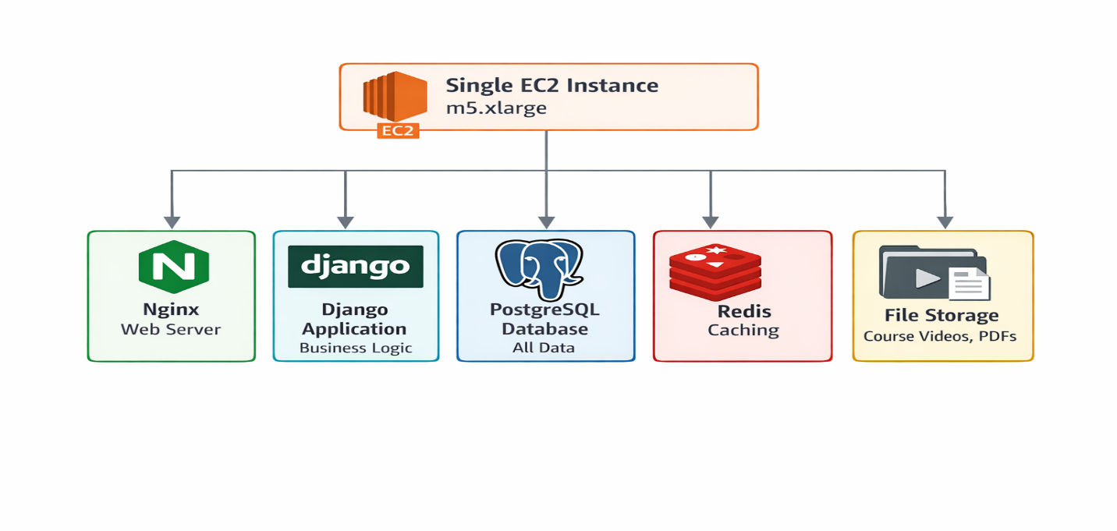
- Why This Doesn't Work Anymore:
- It Can't Handle Crowds: During peak times (like 8 PM when students study), the CPU hits 95% and everything slows down
- Single Point of Failure: If this server has problems, the whole StudyHub goes offline
- Scaling is Painful: To handle more users, they have to buy a bigger server, which takes the site down for 30 minutes
- Backup Problems: They sometimes forget to backup, and when they do, it takes hours
- Development Headaches: Testing takes forever because you have to test the whole application every time

- Real User Complaints:
- "I couldn't access my study materials the night before the final!"
- "Uploading my 2-hour lecture video failed three times!"
- "Searching for 'calculus practice problems' takes 10 seconds!"
- "The mobile app is useless because it's so slow!"

- My Proposed Solution: A Modern Three-Tier Architecture
After learning from Netflix and Airbnb, here's what I think StudyHub should build:
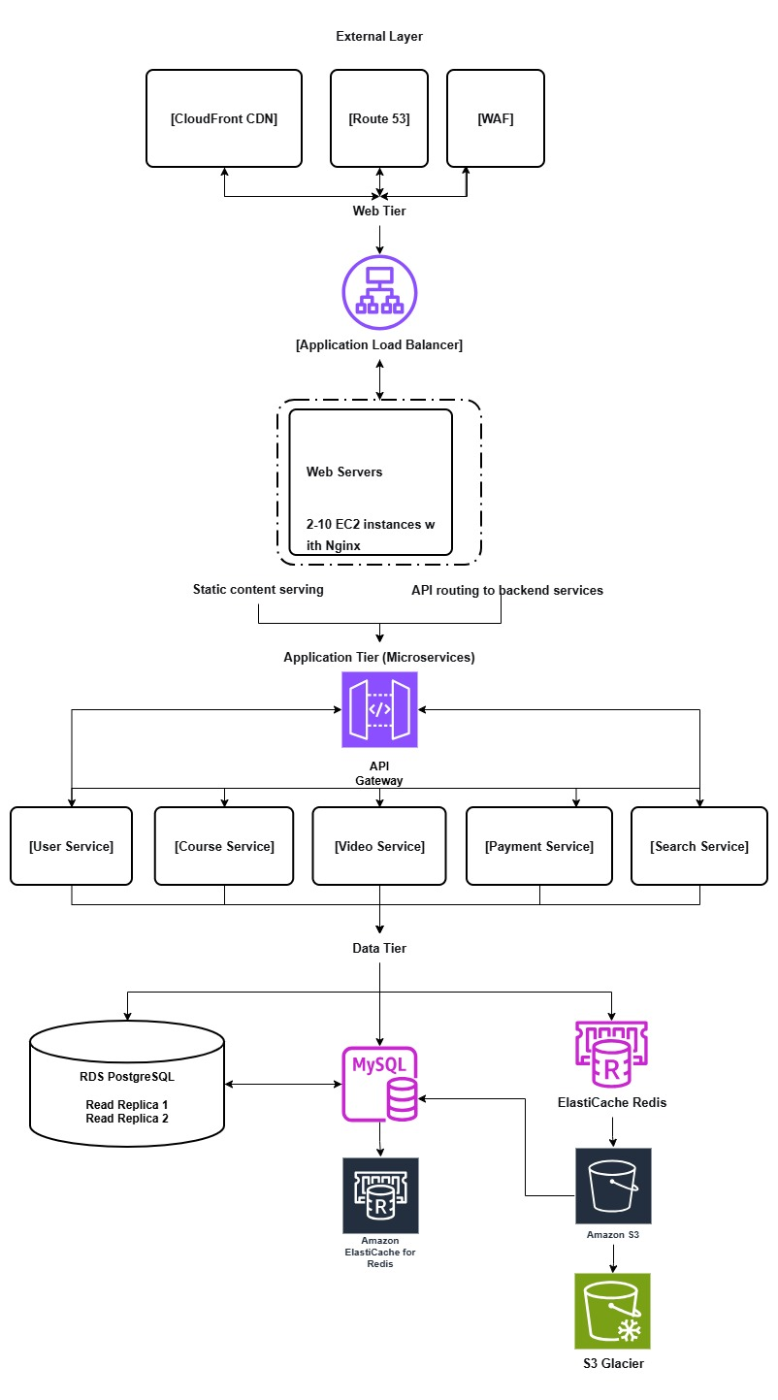

- Why This Design is Better:
- Handles Traffic Spikes: When exam week hits, the system automatically adds more web servers
- Better Performance: Videos stream from CloudFront edge locations near users
- No Single Point of Failure: If one component fails, others keep working
- Easier Development: Teams can work on different services independently
- Cost Effective: They only pay for what they use, scaling down during summer break

- Justification for Each Piece
Let me explain why I chose each component:
CloudFront: StudyHub has users all over the country. CloudFront stores copies of study materials at locations near users, so a student in California doesn't have to wait for files from servers in Virginia.
Load Balancer + Auto Scaling: This solves their exam week problem. Normally, they run 2 web servers. During busy times, it automatically adds more (up to 10). When it's quiet (like during summer), it removes extra servers to save money.
Microservices: Instead of one giant application, we break it into services. The "Video Service" team can work on video features without affecting the "Payment Service" team. If the Video Service has a bug, students can still access PDFs and take quizzes.
Multiple Databases: The main database handles important transactions (like recording quiz scores). Read replicas handle all the reading (like loading course materials). This separation makes everything faster.
S3 for Storage: Instead of storing videos on a server, use S3. It's designed for storing files, it's cheaper, and it automatically makes backups.

- How to Migrate Without Breaking Everything
The biggest challenge is how to move from the old system to the new one without disrupting 50,000 students.
Phase 1: The Foundation
First, build the basic infrastructure without changing the main application:
- Move the database to AWS RDS (managed database service)
- Set up the load balancer in front of the current server
- Move static files (images, PDFs) to CloudFront
This phase doesn't change how StudyHub works for users, but it makes the system more reliable.
Phase 2: Extract First Service
Start with the easiest service: User Management. Create a separate User Service that handles:
- Student and professor logins
- User profiles
- Permissions
Run this alongside the old system. When users login, some go to the new service, some to the old. We can fix problems without affecting everyone.
Phase 3: Extract Core Services
Now tackle the bigger pieces:
- Course Service (courses, materials, enrollment)
- Video Service (uploading, processing, streaming videos)
Phase 4: Finish and Cleanup
- Move the remaining pieces
- Turn off the old system
- Optimize and tune the new system

- Key Strategy: The Strangler Fig Approach
Like Airbnb, we'll use the "strangler fig" method. We'll build the new system around the old one. First redirect a small percentage of traffic (maybe 10%) to the new system. If it works, redirect more. Eventually, all traffic goes to the new system, and we can turn off the old one.

- Expected Results
If StudyHub follows this plan, here's what should happen:
For Students and Professors:
- No more crashes during exam week
- Videos that load quickly without buffering
- Faster search for course materials
- New features like mobile apps and discussion forums
For the Company:
- Ability to grow to 200,000+ users
- 25% more revenue (from fewer crashes and better features)
- Happier customers who don't leave for competitors
For the Development Team:
- Ability to deploy new features daily instead of weekly
- Teams that don't block each other
- Easier to hire new developers (they can work on one service)

- Cost Changes:
Right now, StudyHub pays about $300/month for their big server (running 24/7). The new system might cost $400-500/month normally, but could scale to $1,000/month during peak times. However, they'll make more money from not losing users during crashes, so it's worth it.

- Potential Problems and Solutions
I know this won't be easy. Here are problems they might face:
Problem 1: Data Migration Headaches
Moving data from one database to multiple services is tricky. What if some data gets lost or corrupted?
My Solution: Use AWS Database Migration Service, which is designed for this. Test extensively with fake data first. Have a rollback plan.
Problem 2: Team Learning Curve
The current team knows how to build monolithic applications, not microservices.
My Solution: Train them gradually. Start with simple services. Hire one person with microservices experience to guide them.
Problem 3: Increased Complexity
More services means more things that can go wrong and more things to monitor.
My Solution: Invest in monitoring tools from day one. Use AWS CloudWatch and X-Ray to see what's happening.
Problem 4: Cost Overruns
AWS costs can surprise you if you're not careful.
My Solution: Set up billing alerts. Monitor costs daily at first. Use reserved instances for services that run 24/7.
Problem 5: Cultural Resistance
People don't like change. The team might resist new ways of working.
My Solution: Involve the team in planning. Show them how this will make their jobs easier. Celebrate small wins.

- What Success Looks Like
Here's how we'll know if this migration worked:
Technical Success:
- Website loads in under 2 seconds (currently 8+ seconds)
- Can handle 10,000 simultaneous users (currently 1,000)
- 99.9% uptime (currently about 95%)
- Deploy new features daily (currently weekly)
Business Success:
- Grow to 200,000 users in 12 months
- Increase revenue by 25%
- Reduce user complaints by 75%
- Launch mobile apps successfully
Team Success:
- Developers can deploy without fear of breaking everything
- Teams work independently without conflicts
- New hires get productive quickly

- My Final Thoughts
Looking at Netflix and Airbnb showed me that moving from a simple system to a complex one is challenging but necessary for growth. StudyHub is at that point where their success is threatening to break their technology.
The key lessons I'm applying from the real case studies are:
- Start small and move gradually
- Automate everything you can
- Design for failure (assume things will break)
- Invest in monitoring
- Change team culture along with technology
This migration will take time and money, but if StudyHub doesn't do it, they'll keep losing users every exam period. By building a scalable, modern architecture, they can turn their student project into a real business that helps students learn better.
The most important thing I learned from this research is that architecture isn't just about technology it's about enabling the business to grow and serve users better. StudyHub's mission is to help students succeed. Their technology should support that mission, not get in the way.

