Repository: https://github.com/Sheridan-College-FAST-CloudSecurity/sweta_final_exam

Question 1 — Persistent Storage and Batch Workloads

- kubectl get nodes – it should show a Ready node.
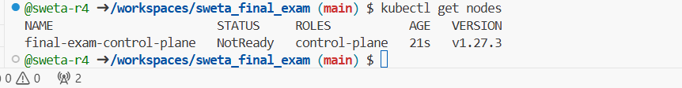

- Create my namespace
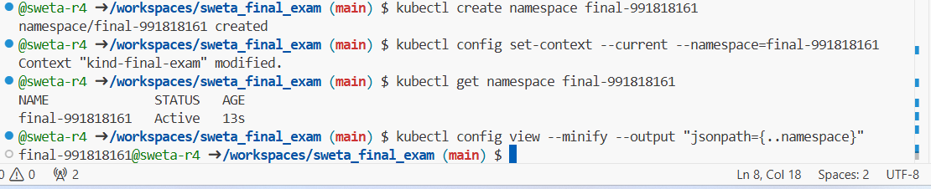

Task A – PV and PVC
- Verify both were created and bound
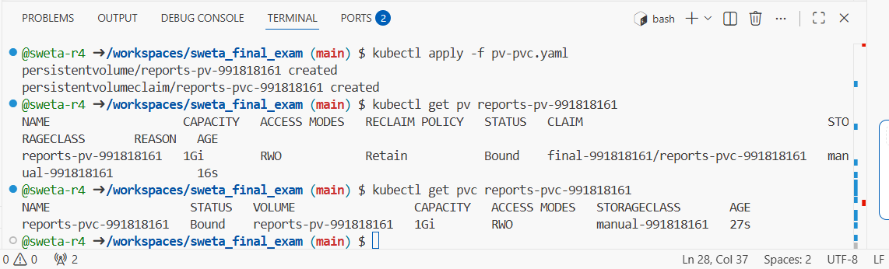

Task B – Job writing the report
- The job created successfully and the logs showing the report output.
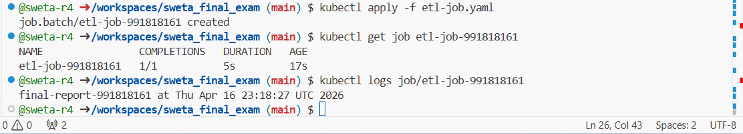

Task C – CronJob heartbeat and persistence proof
- Then delete all CronJob Pods (to prove persistence).
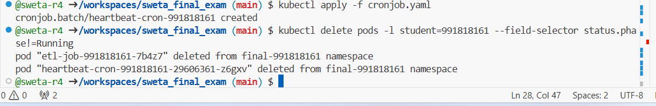
- Now create reader-pod.yaml
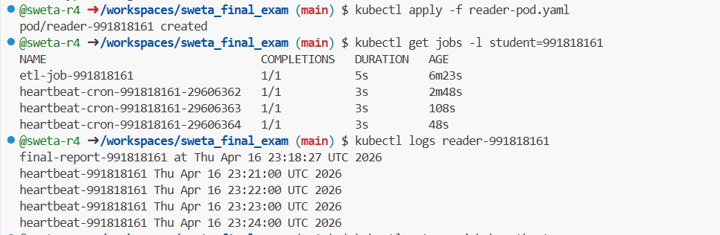

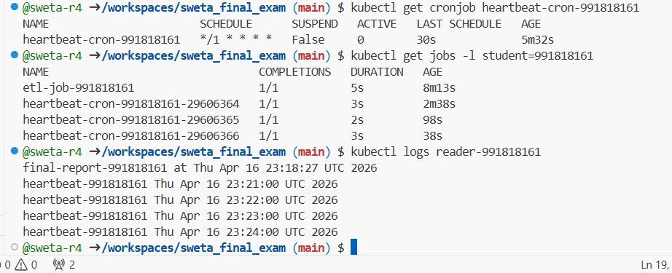

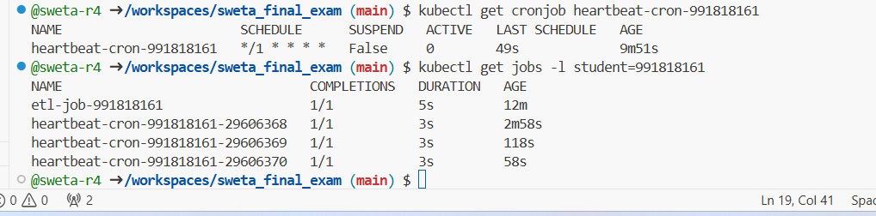

I created a PersistentVolume and PersistentVolumeClaim to provide persistent storage, then used a Job to write a report and a CronJob to append heartbeats every minute. After deleting all CronJob Pods, a reader Pod mounted the same PVC and successfully displayed both the original report and heartbeat lines, proving data survives Pod deletion. This demonstrates PV/PVC persistence, Jobs for one-off tasks, and CronJobs for scheduled workloads.

YAML Manifests Used
