Cairo University  
Faculty of Computers and Information



**CS251**

**Software Engineering I**

GameSpot

Software Requirements Specifications

*Nada Ibrahim*

*Marwa Ehab*

*Sahar Ahmed*

*Sheren Doma*

November - 2016

Contents

Instructions [To be removed] 3

Team 3

Document Purpose and Audience 3

Introduction 3

Software Purpose 3

Software Scope 4

Definitions, acronyms, and abbreviations 4

Requirements 4

Functional Requirements 4

Non Functional Requirements 4

System Models 5

Use Case Model 5

Use Case Tables 5

Ownership Report 6

Policy Regarding Plagiarism: 6

# Team

|  |  |  |  |
| --- | --- | --- | --- |
| **ID** | **Name** | **Email** | **Mobile** |
| 20140347 | Marwa Ehab | marwah.ehab@gmail.com | 01158491324 |
| 20140288 | Nada Ibrahim | nadaibrahim112@gmail.com | 01147814364 |
| 20140321 | Sheren Doma | sherien_21_@hotmail.com | 01014441157 |
| 20140345 | Sahar Ahmed | Sahar_Ahmed1996@hotmail.co.uk | 01110219885 |

# Document Purpose and Audience

**This document describes the system in terms of functional and nonfunctional requirements, it contains the results of the requirements elicitation activities in addition to the information the client needs to know about the system as its purpose and scope.**

**It also contains information about our team members.**

**Targeted audience:**

* **Client**
* **Customers**
* **Developers**

# 

# Introduction

## Software Purpose

**The purpose of the website is to provide a website having a collection of educational games for students to learn and improve their knowledge while playing.**

## Software Scope

* **The software is a web application, it's considered as an educational online platform for students**
* **This application supports 2D games**

## Definitions, acronyms, and abbreviations

**No abbreviations.**

# Requirements

## Functional Requirements

**The system shall:**

* **Allow users to sign up for an account using name, username, password, Email, phone number, age and gender.**
* **Allow students and teachers to log in using their username and password.**
* **Allow students and teachers select a game to play it.**
* **Allow students to rate any game after playing it either with interesting - normal- boring.**
* **Allow students to write comments for each game.**
* **Adds student’s achievements to their profile.**
* **Allow users to search for any game by its name.**
* **Allow users to end the game they are playing.**
* **Allow Teachers to create any new game, each game should belong to one category.**
* **Allow Teachers to edit or remove the game they created.**
* **Allow Teachers to respond to student’s comments on the game they created.**
* **Allow Users to edit or view their profiles.**

## Non Functional Requirements

|  |  |
| --- | --- |
|  | **Details** |
| **Performance** | * **The website has short response time as it takes 15 seconds to load and 10 seconds to refresh screen** |
| **Scalability** | * **The website can handle up to 500 players playing the same game simultaneously** |
| **Security** | * **The website is accessible and usable only by authorized students and teachers having an account on the website** |
| **Usability** | * **All users can play games on the website by only signing up for an account** |
| **Portability** | * **The website can work on different platforms as desktop, mobile phones and tablets** |
| **Maintainability** | * **Any failure occurs in the system will be fixed within 10 min** |
| **Interface** | * **The website is user friendly as the user interface is understandable by the users from the very first view** |
| **Reliability** | * **If the user enter wrong password more than 3 times the system will discover a problem and stop the program for 1 min** |

# 

# System Models

## Use Case Model

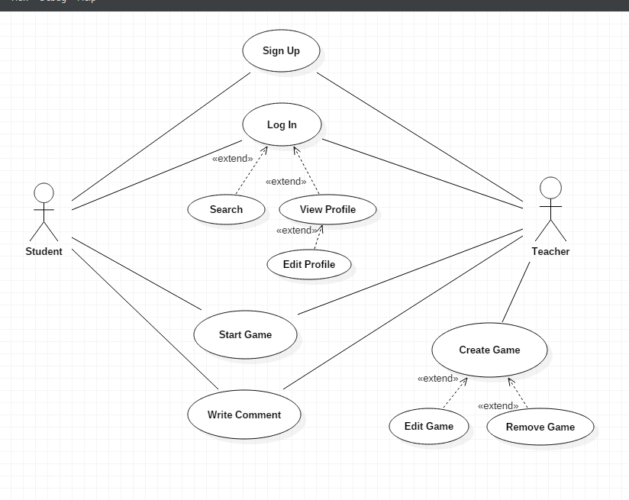

## 

## Use Case Tables

|  |  |  |
| --- | --- | --- |
| Use Case ID: | 1 | |
| Use Case Name: | Sign Up | |
| Actors: | Students and Teachers | |
| Pre-conditions: | User must have a valid email , and chooses to sign up for an account | |
| Post-conditions: | An account is successfully created for the user | |
| Flow of events: | **User Action** | **System Action** |
| 1- Enter needed information |  |
|  | 2- Verify user data |
| 3- Press Sign up button |  |
|  | 4- System creates an account |
|  | 5-Send verification email for the user |
| Exceptions: | **User Action** | **System Action** |
| 1- User entered needed information |  |
|  | 2- Information is invalid  3- An error message appears for the user requesting valid information |
| Includes: |  | |
| Notes and Issues: |  | |

|  |  |  |
| --- | --- | --- |
| Use Case ID: | 2 | |
| Use Case Name: | Start Game | |
| Actors: | Students and Teachers | |
| Pre-conditions: | 1-User is already logged in  2-The page having the requested game is displayed for the user | |
| Post-conditions: | The user wins or loses the game | |
| Flow of events: | **User Action** | **System Action** |
| 1- Select game |  |
|  | 2- Open game |
| 3- Play Game |  |
|  | 4- Calculate Score |
| 5-End game | 6-Display score  7-Display suggestions for other games |
| Exceptions: | **User Action** | **System Action** |
| 1- Select game |  |
|  | 2- Error in loading  3- Display RELOAD button for the user |
| Includes: |  | |
| Notes and Issues: |  | |

# 

|  |  |  |
| --- | --- | --- |
| Use Case ID: | 3 | |
| Use Case Name: | Write comment | |
| Actors: | Students /Teacher | |
| Pre-conditions: | User is already logged in | |
| Post-conditions: | Commented is posted by the user. | |
| Flow of events: | **User Action** | **System Action** |
| 1-Select game |  |
| 2-Scroll down for comments section |  |
| 3-Write comment |  |
|  | 4-Display comment |
| Exceptions: | **User Action** | **System Action** |
| 1-Write comment. |  |
|  | 2-Error in posting comment |
|  |  | 3-Display "Try Again " error message for the user |

|  |  |  |
| --- | --- | --- |
| Use Case ID: | 4 | |
| Use Case Name: | Create game | |
| Actors: | Teacher | |
| Pre-conditions: | 1-User is logged in as a teacher.  2-User chooses to create game. ( Clicks on Create game button ) | |
| Post-conditions: | Game is saved to the system. | |
| Flow of events: | **User Action** | **System Action** |
| 1-Select category for the game. |  |
|  | 2-Display interface for creating the game. |
| 3-Select display picture for the game. |  |
| 4-Select name for the game. |  |
| 5- Click "Save Game" button. |  |
| Exceptions:   1. Name | **User Action** | **System Action** |
| 1-Write name of game. |  |
|  | 1-Display error message " Name already exists" |
| 2-Writes another name |  |
| 1. Category | 1-No category selected. |  |
|  |  | 2-Display error message "No category selected , please select a category" |
|  | 3-Select a category for the game |  |
| Includes: | 5,6 | |
|  |  | |

|  |  |  |
| --- | --- | --- |
| Use Case ID: | 5 | |
| Use Case Name: | Edit game | |
| Actors: | Teacher | |
| Pre-conditions: | User is logged in as a teacher | |
| Post-conditions: | Game is updated successfully. | |
| Flow of events: | **User Action** | **System Action** |
| 1- Select game |  |
|  | 2- Open game |
| 3- Press " Edit Game" |  |
|  | 4- Display options for editing |
|  | 5- Edits the game and submit changes |  |
|  | 6-Display edited game for the teacher |
| **User Action** | **System Action** |
| Exceptions: | 1-Select game |  |
|  |  | 2- Game is not created by the teacher  3- Display error message appears for the user that this game is created by another teacher |

|  |  |  |
| --- | --- | --- |
| Use Case ID: | 6 | |
| Use Case Name: | Remove game | |
| Actors: | Teachers | |
| Pre-conditions: | 1-User is logged in as a teacher  2-Game is already created | |
| Post-conditions: | Game is removed by the system | |
| Flow of events: | **User Action** | **System Action** |
| 1- Select game |  |
|  | 2- Display confirmation message to remove the game |
| 3- User chooses to remove the game |  |
|  | 4- System removes the game |
| **User Action** | **System Action** |
| Exceptions: | 1-Select game |  |
|  | 2- Game is not created by the teacher |
|  | 3- Display error message appears for the user that this game is created by another teacher |
| Includes: |  | |
| Notes and Issues: | If the user chooses not to remove the game, the system take no action. | |

|  |  |  |
| --- | --- | --- |
| Use Case ID: | 7 | |
| Use Case Name: | Login | |
| Actors: | Students / Teachers | |
| Pre-conditions: | User already has account. | |
| Post-conditions: | Account verified / Home page is opened. | |
| Flow of events: | **User Action** | **System Action** |
| 1-Enter information. |  |
|  | 2-Verify password and username. |
| 3-Press login. |  |
| Exceptions: | **User Action** | **System Action** |
| 1-Enter information. |  |
|  | 2-Display error message " Wrong username or password ". |
| Includes: | 8,9 | |

|  |  |  |
| --- | --- | --- |
| Use Case ID: | 8 | |
| Use Case Name: | Search | |
| Actors: | Student /Teacher | |
| Pre-conditions: | User already logged in | |
| Post-conditions: | Display game and any related games. | |
| Flow of events: | **User Action** | **System Action** |
| 1-Enter game name in search bar. |  |
|  | 2-Look up for game. |
| Exceptions: | **User Action** | **System Action** |
| 1-Enter name of the game |  |
|  | 2-Display message "No results for this game". |

|  |  |  |
| --- | --- | --- |
| Use Case ID: | 9 | |
| Use Case Name: | View profile | |
| Actors: | Students and Teachers | |
| Pre-conditions: | User is already logged in | |
| Post-conditions: | User closes the profile | |
| Flow of events: | **User Action** | **System Action** |
| 1-Press view profile |  |
|  | 2- System will display the profile |
| Includes | 10 |  |

|  |  |  |
| --- | --- | --- |
| Use Case ID: | 10 | |
| Use Case Name: | Edit profile | |
| Actors: | Students and Teachers | |
| Pre-conditions: | * User is already logged * User views his/her profile | |
| Post-conditions: | Profile is edited | |
| Flow of events: | **User Action** | **System Action** |
| 1-Press edit profile |  |
|  | 2- System will provide a page for the user to edit and change his/her information |
| 3- Change information |  |
| 4 – Click save |  |
|  | 5-System will save the edited information to the profile |

# 

|  |  |  |
| --- | --- | --- |
| Use Case ID: |  | |
| Use Case Name: | Test game | |
| Actors: | Teacher | |
| Pre-conditions: | The game is created . | |
| Post-conditions: | The teacher will submit the game. | |
| Flow of events: | **User Action** | **System Action** |
|  | 1- display message for test it before submit |
| 2- The teacher click on continue. |  |
|  | 3-display this message ” you choose this category”. |
| 4-press continue |  |
|  |  | 5-display this message” you choose this interface “and display the interface with the component of the game. |
| 6-check the components and press submit. |  |
| **User Action** | **System Action** |
| Exceptions: |  | 1- display message for test it before submit. |
|  | 2-user click cancel then click submit. |  |

# 

# 

# Ownership Report

|  |  |
| --- | --- |
| **Item** | **Owners** |
| * Document purpose and audience * Functional Requirements * Non Functional requirements: * Maintainability | *Sahar Ahmed* |
| * Use case model * Software scope * Non Functional requirements: * Security * Performance * Usability * Interface * Scalability * Use case tables: * Sign Up (1) * Start Game (2) * Remove Game (6) | *Nada Ibrahim* |
| * Software purpose * Non Functional requirements: * Portability * Use case tables * Edit game(5) * View profile (9) * Edit profile (10) | *Marwa Ehab* |
| * Definitions and abbreviations * Non Functional requirements: * Reliability * Use case tables * Write comment (3) * Create game (4) * Login (7) * Search (8) | *Sheren Doma* |

# Policy Regarding Plagiarism:

**Students have collective ownership and responsibility of their project. Any violation of academic honesty will have severe consequences and punishment for ALL team members.**

1. تشجع الكلية على مناقشة الأفكار و تبادل المعلومات و مناقشات الطلاب حيث يعتبر هذا جوهريا لعملية تعليمية سليمة
2. ساعد زملاءك على قدر ما تستطيع و حل لهم مشاكلهم فى الكود و لكن تبادل الحلول غير مقبول و يعتبر غشا.
3. أى حل يتشابه مع أى حل آخر بدرجة تقطع بأنهما منقولان من نفس المصدر سيعتبر أن صاحبيهما قد قاما بالغش.
4. قد توجد على النت برامج مشابهة لما نكتبه هنا أى نسخ من على النت يعتبر غشا يحاسب عليه صاحبه.
5. إذا لم تكن متأكدا أن فعلا ما يعد غشا فلتسأل المعيد أو أستاذ المادة.
6. فى حالة ثبوت الغش سيأخذ الطالب سالب درجة المسألة ، و فى حالة تكرار الغش سيرسب الطالب فى المقرر.