Software Requirements Specification (IEEE 830)

Smart Inventory Management System – Java Console Application (In-Memory Storage)
Version: 1.0
Course: SCS253 – Software Process & Quality Management
Instructor: Dr. Shaimaa Galal
Name | ID
Omar Mohamed Elsayed Ibrahim | 20246076
Mahmoud Ayman AboBakr | 20246100
Aly Adel Maamoun | 20246072
Sheriff Mohamed | 20246062
Aly Ahmed | 20246069
Mahmoud Hassanein | 20246153
Seif Sobhy | 20246144

Table of Contents
- Introduction
  - 1.1 Purpose
  - 1.2 Scope
  - 1.3 Definitions, Acronyms, and Abbreviations
  - 1.4 References
  - 1.5 Overview
- Overall Description
  - 2.1 Product Perspective
  - 2.2 User Characteristics
  - 2.3 Assumptions and Dependencies
- Specific Requirements
  - 3.1 Functional Requirements
  - 3.2 Non-Functional Requirements
- External Interface Requirements
  - 4.1 User Interfaces (Console)
  - 4.2 Hardware Interfaces
  - 4.3 Software Interfaces
  - 4.4 Communication Interfaces
- Appendices
  - Appendix A: Java-Specific Implementation Notes
  - Appendix B: Sample Data
  - Appendix C: Test Case Mapping

1. Introduction

1.1 Purpose
The purpose of this document is to specify all functional and non-functional requirements for the Smart Inventory Management System – Java Console Application with in-memory storage. This system operates entirely from the command line with no external database – all data is stored in Java collections (ArrayList, HashMap) in RAM and is lost when the JVM terminates.
Intended audience:
- Java development team (for implementation guidance)
- QA team (for test case creation)
- Course instructor/TA (for grading verification)

1.2 Scope
The Smart Inventory Management System is a Java-based console application that enables warehouse staff to manage product inventory using text menus and keyboard input. The system uses in-memory Java collections with no persistent storage.
Will be implemented:
- Complete product lifecycle management (CRUD) using Java ArrayList or HashMap
- Real-time inventory quantity tracking
- Automatic low-stock detection and alerts
- Text-based console reports (formatted tables)
Out of scope (for this prototype):
- Graphical user interface (GUI) – use System.out and Scanner only
- Any external database (JDBC, JPA, Hibernate, SQLite, etc.)
- File-based persistence (FileInputStream, FileOutputStream, NIO, Serialization, etc.)
- Barcode/RFID scanning integration
- Multi-warehouse support
- User authentication/roles
- Email/SMS notifications
- Web or mobile access
- Network/socket programming
- Data saving between program sessions

1.3 Definitions, Acronyms, and Abbreviations
Term | Definition
SKU | Stock Keeping Unit – a unique identifier for each product
Threshold | Minimum quantity that triggers a low-stock alert
Low-Stock | Status when product quantity ≤ threshold
JVM | Java Virtual Machine
JDK | Java Development Kit
ArrayList | Java collection class for dynamic arrays
HashMap | Java collection class for key-value pairs
FR | Functional Requirement
NFR | Non-Functional Requirement
CRUD | Create, Read, Update, Delete operations
SRS | Software Requirements Specification
CLI | Command-Line Interface

1.4 References
Reference | Description
IEEE Std 830-1998 | IEEE Recommended Practice for Software Requirements Specifications
SCS253 Project Rubric | Term project grading criteria (Waterfall track)
Java JDK 11+ Documentation | https://docs.oracle.com/en/java/javase/11/

1.5 Overview
Section 2 describes the system's context and users. Section 3 contains all numbered, testable requirements. Section 4 specifies external interfaces. Section 5 provides Java-specific implementation guidance.

2. Overall Description

2.1 Product Perspective
The Smart Inventory Management System is a standalone Java console application. All data is stored in Java memory objects only – no files, no databases. When the JVM exits, all data is lost.
System context diagram:

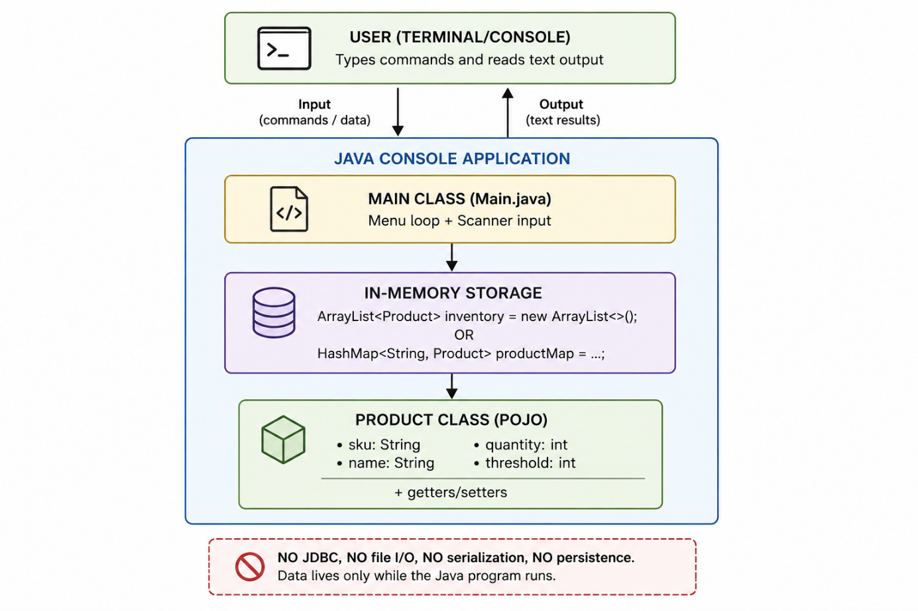
Package structure recommendation:

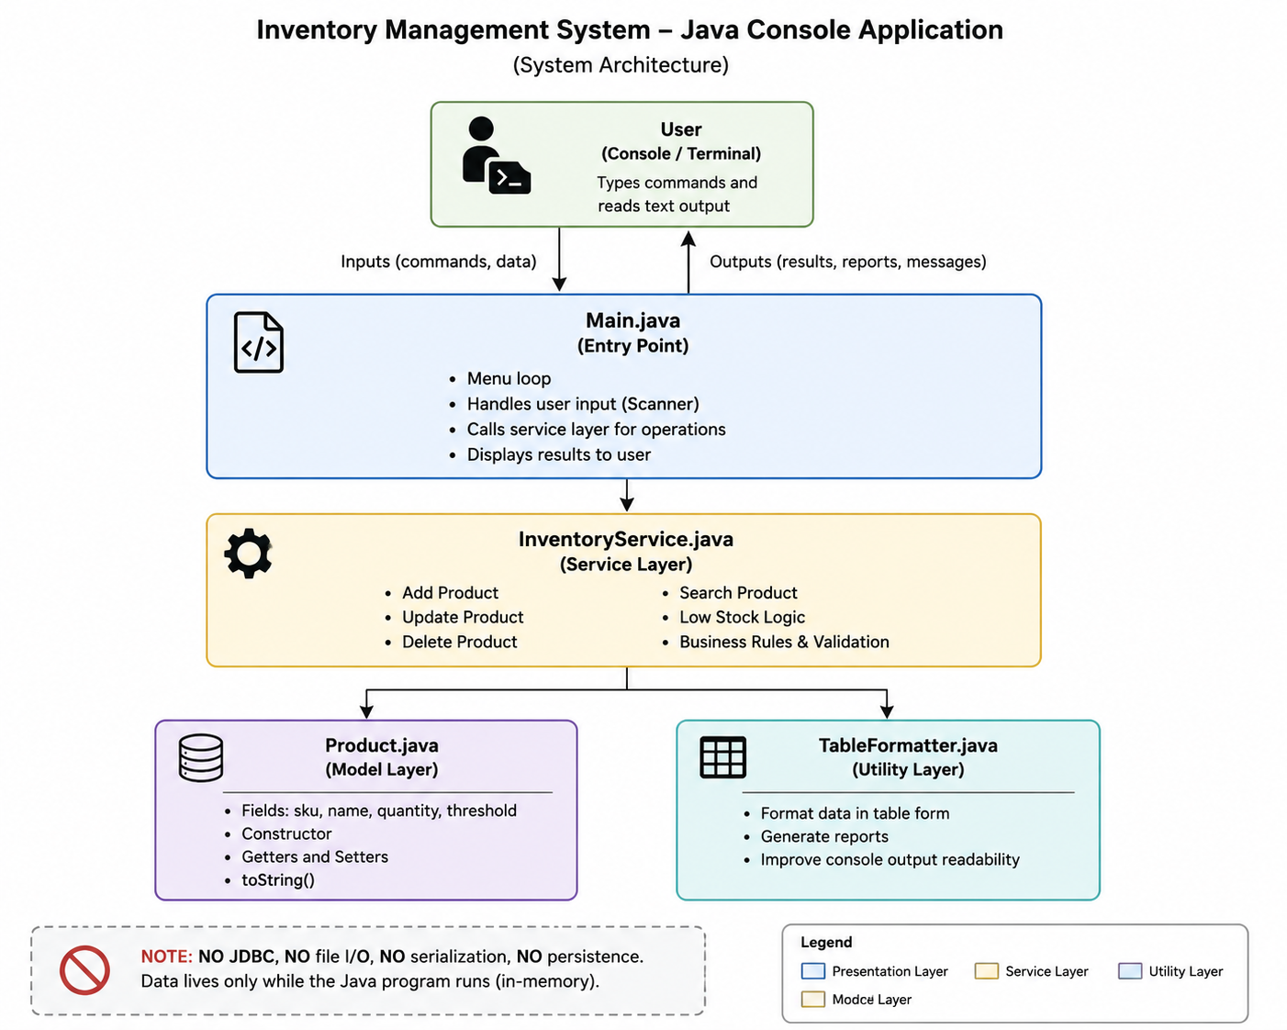
Updated package structure (reflecting new service and util layers):
com.inventory
Main.java ← entry point, UI loop (thin)
com.inventory.model
Product.java ← data class (A.1)
com.inventory.service
InventoryManager.java ← CRUD operations (A.4)
ReportGenerator.java ← console report formatting (A.6)
com.inventory.util
InputValidator.java ← input validation rules (A.5)

2.2 User Characteristics
User Type | Technical Skill | Frequency of Use | Primary Goals
Warehouse Staff | Basic | During single JVM session | Add/update products, check stock levels
Manager | Basic | During single JVM session | Generate inventory reports
TA/Grader | High | Once | Verify requirements, test all functions

2.3 Assumptions and Dependencies
Assumptions:
- Users have Java Runtime Environment (JRE) 11 or higher installed
- Users can run java -jar InventoryApp.jar or java main from terminal
- Users understand that all data is lost when the program exits
- Maximum of 100 products in memory (practical limit for console display)
- Single user at a time – no threading/concurrency required
- Console supports 80+ character width for proper table formatting
Dependencies:
- Java JDK 11+ for development, JRE 11+ for execution
- No external libraries – Java Standard Edition only (java.util., java.io. ONLY for console I/O, NOT for persistence)
- No Maven/Gradle dependencies required
- No database drivers
- No ORM frameworks (Hibernate, JPA)
- No Spring Framework
Restrictions (explicitly prohibited):
- No java.sql.* (JDBC)
- No javax.persistence.*
- No java.io.File, FileWriter, FileReader, ObjectOutputStream
- No java.nio.file.*
- No java.util.prefs.Preferences
- No external JSON/XML libraries
- Only system.out for output, scanner for input

3. Specific Requirements

3.1 Functional Requirements
All functional requirements are numbered, testable, and unambiguous.

3.1.1 Application Startup and Main Menu
ID | Requirement | Testability Criteria
FR-01 | Upon startup, the main()method shall display a welcome message and a numbered main menu using system.out.println() | Run java main ->  welcome message and menu appear.
FR-02 | The main menu shall provide exactly 7 options: (1) Add Product, (2) View All Products, (3) Update Product, (4) Delete Product, (5) View Low-Stock Products, (6) Generate Report, (7) Exit. | Menu displays all 7 options clearly.
FR-03 | The system shall return to the main menu after completing any operation (except Exit) using a while loop. | After any operation, menu reappears.
FR-04 | The system shall use Scanner.nextInt() or Scanner.nextLine() to read user menu choices. | Type "2" -> view products screen appears.
FR-05 | The system shall handle InputMismatchException and display "Invalid input, please enter a number" when non-numeric input is entered. | Type "abc" ->error message, re-prompt.
FR-06 | The system shall display an error message and re-prompt if user enters a number outside 1-7. | Type "9" → error "Invalid option, please enter 1-7".

3.1.2 Add Product (Create)
ID | Requirement | Testability Criteria
FR-07 | The system shall prompt for SKU (String), Product Name (String), Quantity (int), Threshold (int) using Scanner.extLine() and Scanner.nextInt(). | Select option 1 -> prompts appear in sequence.
FR-08 | SKU shall be stored as a String and used as unique identifier. Cannot be empty or null. | Empty SKU -> error "SKU cannot be empty".
FR-09 | The system shall prevent adding a product with duplicate SKU by checking all existing Porduct objects in the ArrayList. | Add SKU "A001". Try to add another "A001" -> error "SKU already exists".
FR-10 | The system shall prevent adding a product with negative quantity (quantity<0). | Enter quantity = -5 -> error "Quantity cannot be negative".
FR-11 | The system shall prevent adding a product with threshold less than 1 (threshold<1). | Enter threshold = 0 -> error "Threshold must be at least 1".
FR-12 | After successful addition, the system shall create a new Product object using theProduct class constructor and add it to the ArrayList<Product>.. | Add product -> product stored in ArrayList.
FR-13 | The system shall display confirmation: " Product added successfully!" followed by product details. | Add product -> confirmation prints with SKU, Name, Quantity, Threshold.

3.1.3 View All Products (Read)
ID | Requirement | Testability Criteria
FR-14 | The system shall iterate through ArrayList<product> and display all products in a formatted table using System.out.printf(). | Select option 2 -> formatted table prints.
FR-15 | The table shall have columns: #, SKU, Name, Quantity, Threshold, Status. | Headers appear correctly.
FR-16 | Status column logic: if product.getQuantity()<=product.getThreshold() -> "LOW STOCK", else "OK". | Test with both conditions.
FR-17 | The table shall include a sequential row number (starting at 1). | First product shows #1.
FR-18 | The system shall display " No products in inventory." When ArrayList.isEmpty() is true. | No products -> message appears.
FR-19 | Products shall be displayed in the order they were added (insertion order – ArrayList preserves order). | Add A001, then B002 -> A001 first.

3.1.4 Update Product
ID | Requirement | Testability Criteria
FR-20 | The system shall prompt for SKU and search the ArrayListusing a loop or HashMap lookup. | "Enter SKU of product to update:"
FR-21 | If SKU not found, display " Product not found" and return to menu. | Non-existent SKU -> error message.
FR-22 | After finding the product, display sub-menu: (1) Update Quantity, (2) Update Threshold, (3) Update Both, (4) Cancel. | Sub-menu appears.
FR-23 | Updating quantity shall validate that new quantity ≥ 0. | Try negative -> error.
FR-24 | Updating threshold shall validate that new threshold ≥ 1. | Try 0 -> error.
FR-25 | After update, display " Product updated!" with old and new values. | "Quantity updated: 5 -> 10".
FR-26 | The Product object in the ArrayList shall be modified directly (no need to re-add). | View products -> new values appear.

3.1.5 Delete Product
ID | Requirement | Testability Criteria
FR-27 | The system shall prompt for SKU and search for the product in ArrayList. | "Enter SKU of product to delete:"
FR-28 | If SKU not found, display " Product not found". | Non-existent SKU -> error.
FR-29 | Before deletion, display product details and ask "Are you sure? (Y/N)" using Scanner.nextLine(). | Product info prints, then prompt.
FR-30 | If user enters 'Y' or 'y', remove product using ArrayList.remove(index) or removeIf(). | Confirm -> product removed.
FR-31 | If user enters 'N' or 'n', display "Deletion cancelled" and return to menu. | Cancel -> product remains.
FR-32 | Display " Product deleted successfully" after removal. | Confirmation message appears.

3.1.6 View Low-Stock Products
ID | Requirement | Testability Criteria
FR-33 | The system shall filter ArrayList<Product> where quantity<=threshold using a loop or Java Streams (filter()). | Select option 5 ->filtered list.
FR-34 | Display low-stock products in the same table format as View All Products. | Same column headers.
FR-35 | If no low-stock products, display " No low-stock products found." | All products OK ->message.
FR-36 | Status column for low-stock view shall always show "LOW STOCK". | Status column consistent.

3.1.7 Generate Report (Console Text)
ID | Requirement | Testability Criteria
FR-37 | Sub-menu: (1) Full Inventory Report, (2) Low-Stock Only Report. | Two options appear.
FR-38 | Report header: system name, current date/time (using java.time.LocalDateTime), total product count. | Header shows all three.
FR-39 | Report table: same format as View All Products. | Table prints correctly.
FR-40 | Report footer: total products, sum of all quantities (using loop), count of low-stock products. | Footer calculations correct.
FR-41 | After report displays, prompt "Press Enter to continue..." using Scanner.nextLine. | Press Enter -> returns to menu.

3.1.8 Exit Application
ID | Requirement | Testability Criteria
FR-42 | When user selects Exit, display " Goodbye!" and call System.exit(0) or break the main loop. | Select 7 -> goodbye message, program ends.
FR-43 | No data shall be saved to any file or database upon exit (verify no file I/O code exists). | Exit, restart -> inventory empty.
FR-44 | Optional confirmation: "Are you sure you want to exit? (Y/N)" before exiting. | Confirm Y -> exits. N → returns.

3.2 Non-Functional Requirements
ID | Requirement | Category | Testability
NFR-01 | The main method loop shall respond within 500ms for all operations with ≤100 products. | Performance | Time operations with System.currentTimeMillis()
NFR-02 | The application shall compile with javac without warnings using Java 11+. | Compilation | Run javac *.java -> no errors.
NFR-03 | No try-catch blocks shall swallow exceptions without logging. | Robustness | Code review: all catch blocks print error message.
NFR-04 | The Scanner object shall be closed properly or a single shared instance used. | Resource Mgmt | No resource leak warnings.
NFR-05 | All class fields shall be private with public getters/setters (encapsulation). | Maintainability | Code review: Product class follows JavaBeans pattern.
NFR-06 | Each class shall be in its own .java file (Main, Product, InventoryManager, ReportGenerator, InputValidator). | Modularity | Separate files exist for Main, Product, InventoryManager, ReportGenerator, and InputValidator.
NFR-07 | The code shall contain Javadoc comments for all public methods. | Documentation | /***/comments present.
NFR-08 | No usage of java.sql.* , java.io.* (except for console I/O), java.nio.*. | Constraint | Code review: no forbidden imports.
NFR-09 | The product list shall be stored as ArrayList<Product> (or HashMap<String, Product> for O(1) lookup). | Data Structure | Type declaration matches.
NFR-10 | Table columns shall be aligned using String.format() or System.out.printf() with fixed widths (e.g., %-10s, %5d). | Usability | Columns align properly.

4. External Interface Requirements

4.1 User Interfaces (Console)
Main menu display:
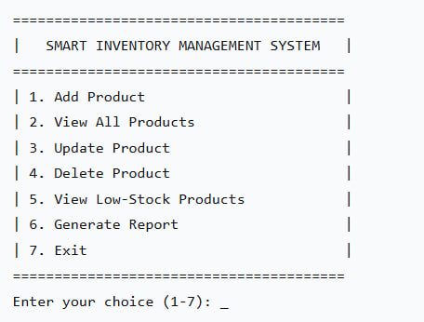
View All Products table:

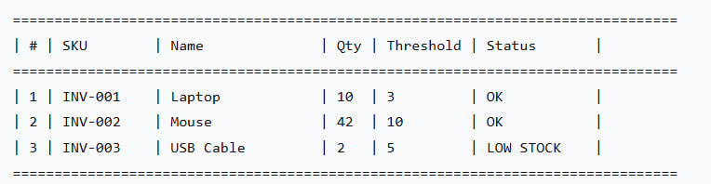
4.2 Hardware Interfaces
- Minimum: Any computer capable of running Java JRE
- Input: Keyboard only
- Output: Console/Terminal (80+ character width recommended)

4.3 Software Interfaces
Interface | Specification
Java Version | JDK 11 or higher (LTS recommended)
Build Tool | None required (compile with javac) or optional Gradle/Maven
External Libraries | ❌ None allowed. Java Standard Edition only
Allowed packages | java.util.*, java.time.*, java.lang.*
Forbidden packages | java.sql.*, java.io.File*, java.nio.*, java.awt.*, javax.swing.*
Operating System | Any (Windows, macOS, Linux)

4.4 Communication Interfaces
- None. Offline only. No network, no sockets, no HTTP.

5. Appendices

Appendix A: Java-Specific Implementation Notes

A.1 Product Class (model/Product.java)
package com.inventory.model;

public class Product {
private String sku;
private String name;
private int quantity;
private int threshold;

// Constructor
public Product(String sku, String name, int quantity, int threshold) {
this.sku = sku;
this.name = name;
this.quantity = quantity;
this.threshold = threshold;
}

// Getters
public String getSku() { return sku; }
public String getName() { return name; }
public int getQuantity() { return quantity; }
public int getThreshold() { return threshold; }

// Setters
public void setSku(String sku) { this.sku = sku; }
public void setName(String name) { this.name = name; }
public void setQuantity(int quantity) { this.quantity = quantity; }
public void setThreshold(int threshold) { this.threshold = threshold; }

// Business logic method
public boolean isLowStock() {
return quantity <= threshold;
}

@Override
public String toString() {
return String.format("%-10s | %-20s | %5d | %5d | %s",
sku, name, quantity, threshold, isLowStock() ? "LOW STOCK" : "OK");
}
}

A.2 Main Class Structure (Main.java)
package com.inventory;

import com.inventory.model.Product;
import com.inventory.service.InventoryManager;
import com.inventory.service.ReportGenerator;
import com.inventory.util.InputValidator;
import java.util.Scanner;

public class Main {
private static final InventoryManager manager = new InventoryManager();
private static final Scanner scanner = new Scanner(System.in);
private static final ReportGenerator reporter = new ReportGenerator();

public static void main(String[] args) {
boolean running = true;
while (running) {
displayMenu();
int choice = getIntInput();
switch (choice) {
case 1: addProduct(); break;
case 2: viewAllProducts(); break;
case 3: updateProduct(); break;
case 4: deleteProduct(); break;
case 5: viewLowStock(); break;
case 6: generateReport(); break;
case 7: running = confirmExit(); break;
default: System.out.println("Invalid option. Please enter 1-7.");
}
}
System.out.println("goodbye!");
scanner.close();
}

private static void displayMenu() { /* print menu */ }
private static int getIntInput() { /* handle InputMismatchException; use InputValidator.isValidMenuChoice() */ }
private static void addProduct() { /* FR-07 to FR-13: read input, validate with InputValidator, call manager.addProduct() */ }
private static void viewAllProducts() { /* FR-14 to FR-19: call manager.getAllProducts(), format and print table */ }
private static void updateProduct() { /* FR-20 to FR-26: call manager.findBySku(), validate with InputValidator, mutate Product */ }
private static void deleteProduct() { /* FR-27 to FR-32: call manager.findBySku(), confirm, call manager.deleteBySku() */ }
private static void viewLowStock() { /* FR-33 to FR-36: call manager.getLowStockProducts(), print table */ }
private static void generateReport() { /* FR-37 to FR-41: call reporter.printReport() with manager.getAllProducts() or getLowStockProducts() */ }
private static boolean confirmExit() { /* FR-42 to FR-44 */ }
}

A.3 Alternative: Using HashMap for O(1) Lookup
// Instead of ArrayList, use HashMap for faster SKU lookup
private static HashMap<String, Product> inventoryMap = new HashMap<>();

// Add product
inventoryMap.put(sku, new Product(sku, name, quantity, threshold));

// Find product
Product p = inventoryMap.get(sku); // O(1) instead of O(n)

// Delete product
inventoryMap.remove(sku);

// View all products (iterate over values)
for (Product p : inventoryMap.values()) { ... }

A.4 InventoryManager Class (service/InventoryManager.java)
package com.inventory.service;

import com.inventory.model.Product;
import java.util.ArrayList;
import java.util.List;

/**
* Encapsulates all CRUD operations on the in-memory product list.
* Main.java delegates business logic here to keep the UI layer thin.
*/
public class InventoryManager {

private final ArrayList<Product> inventory = new ArrayList<>();

// Adds a new product. Returns false if SKU already exists.
public boolean addProduct(Product p) {
if (findBySku(p.getSku()) != null) return false;
inventory.add(p);
return true;
}

// Returns unmodifiable view of all products (insertion order preserved).
public List<Product> getAllProducts() {
return java.util.Collections.unmodifiableList(inventory);
}

// Linear search by SKU (case-insensitive). Returns null if not found.
public Product findBySku(String sku) {
for (Product p : inventory) {
if (p.getSku().equalsIgnoreCase(sku)) return p;
}
return null;
}

// Removes product by SKU. Returns true if removed, false if not found.
public boolean deleteBySku(String sku) {
return inventory.removeIf(p -> p.getSku().equalsIgnoreCase(sku));
}

// Returns products whose quantity <= threshold.
public List<Product> getLowStockProducts() {
List<Product> result = new ArrayList<>();
for (Product p : inventory) {
if (p.isLowStock()) result.add(p);
}
return result;
}

// Returns total quantity across all products.
public int getTotalQuantity() {
int total = 0;
for (Product p : inventory) total += p.getQuantity();
return total;
}
}

A.5 InputValidator Class (util/InputValidator.java)
package com.inventory.util;

/**
* Static helper methods for validating all user inputs.
* Centralises rules from FR-08 to FR-11 and FR-23 to FR-24.
*/
public class InputValidator {

// FR-08: SKU must not be null or blank.
public static boolean isValidSku(String sku) {
return sku != null && !sku.trim().isEmpty();
}

// FR-10: Quantity must be >= 0.
public static boolean isValidQuantity(int quantity) {
return quantity >= 0;
}

// FR-11: Threshold must be >= 1.
public static boolean isValidThreshold(int threshold) {
return threshold >= 1;
}

// FR-02 / FR-06: Menu choice must be in [1..max].
public static boolean isValidMenuChoice(int choice, int max) {
return choice >= 1 && choice <= max;
}

// Returns a trimmed, non-null string or throws IllegalArgumentException.
public static String requireNonBlank(String value, String fieldName) {
if (value == null || value.trim().isEmpty()) {
throw new IllegalArgumentException(fieldName + " cannot be empty.");
}
return value.trim();
}
}

A.6 ReportGenerator Class (service/ReportGenerator.java)
package com.inventory.service;

import com.inventory.model.Product;
import java.time.LocalDateTime;
import java.time.format.DateTimeFormatter;
import java.util.List;

/**
* Generates formatted console reports (FR-37 to FR-41).
* Accepts a pre-filtered list so it can serve both Full and Low-Stock reports.
*/
public class ReportGenerator {

private static final String DATE_FMT = "yyyy-MM-dd HH:mm:ss";
private static final String DIVIDER =
"=".repeat(70);

/**
* Prints a full report for the given product list.
* @param products pre-filtered list (all products or low-stock only)
* @param title report title shown in the header
* @param totalItems total count across ALL products (for footer)
*/
public void printReport(List<Product> products, String title, int totalItems) {
String now = LocalDateTime.now()
.format(DateTimeFormatter.ofPattern(DATE_FMT));

// FR-38: Header
System.out.println(DIVIDER);
System.out.println(" Smart Inventory Management System");
System.out.println(" " + title);
System.out.println(" Generated: " + now);
System.out.printf(" Total products in system: %d%n", totalItems);
System.out.println(DIVIDER);

// FR-39: Table
System.out.printf("%-4s %-10s %-20s %8s %9s %-10s%n",
"#", "SKU", "Name", "Qty", "Threshold", "Status");
System.out.println("-".repeat(70));
int row = 1;
int sumQty = 0;
int lowCount = 0;
for (Product p : products) {
String status = p.isLowStock() ? "LOW STOCK" : "OK";
System.out.printf("%-4d %-10s %-20s %8d %9d %-10s%n",
row++, p.getSku(), p.getName(),
p.getQuantity(), p.getThreshold(), status);
sumQty += p.getQuantity();
if (p.isLowStock()) lowCount++;
}

// FR-40: Footer
System.out.println(DIVIDER);
System.out.printf(" Products shown: %d | Total qty: %d | Low-stock: %d%n",
products.size(), sumQty, lowCount);
System.out.println(DIVIDER);
}
}

Appendix B: Sample Test Data
SKU | Name | Quantity | Threshold | Expected Status
PRD-001 | Office Chair | 25 | 5 | OK
PRD-002 | Desk Lamp | 3 | 5 | LOW STOCK
PRD-003 | Monitor | 8 | 4 | OK
PRD-004 | Keyboard | 2 | 3 | LOW STOCK
PRD-005 | Mouse Pad | 0 | 5 | LOW STOCK

Appendix C: Test Case Mapping Summary
Requirement IDs | Test Case Prefix
FR-01 to FR-06 | TC-MENU-01 to TC-MENU-06
FR-07 to FR-13 | TC-ADD-01 to TC-ADD-07
FR-14 to FR-19 | TC-VIEW-01 to TC-VIEW-06
FR-20 to FR-26 | TC-UPDATE-01 to TC-UPDATE-07
FR-27 to FR-32 | TC-DELETE-01 to TC-DELETE-06
FR-33 to FR-36 | TC-LOW-01 to TC-LOW-04
FR-37 to FR-41 | TC-REPORT-01 to TC-REPORT-05
FR-42 to FR-44 | TC-EXIT-01 to TC-EXIT-03
NFR-06 (InventoryManager, ReportGenerator, InputValidator) | TC-MODULAR-01 to TC-MODULAR-03

