Contents
General Information 3
Database Credentials 3
FMW Credentials 3
APEX WORKSPACE 3
Applications URLs 3
SMAT Database Export 4
Create Directory 4
Export Database 4
Note: - 4
Import the Smart Materials Dump 5
Note: - 5
Apex 23.2 Installation 7
Drop Previous Apex versions 7
Install Apex 23.2 7
Install Apex 23.2 Patch 7
Change Admin Password 7
Smart Materials Upgrade to 10.5 9
Note: - 9
ACL Creation for License Server and Email Setup 10
License Server 10
Email Setup 10
Oracle Client Patch Installation and GAC Dlls Registration 11
ORDS Configuration and SMAT BIR Installation 12
Database Credential Error 12
Fusion Middleware Installation 13
Installation and Configuration 13
SSL Configuration in FMW 17
Command Prompts 17
Generating Wallet 17
Importing Wallet 20
OHS SSL Configuration 21
SMAT WPF Installation 25
SSL Configuration 25
Service Pack Installation 27
DB Backup 27
SMAT DB 27
SMAT BIR 27
SSL Configuration in IIS Server 28
SSL Configuration in Apache Tomcat Server 29
General Issues 30
Steps for resolving password expiry issue for system user 30
Steps for retrieving the database to previous day backup 30

General Information

Database Credentials
User: - sys, Password: - SaPDAdministrator
User: - m_sys/bir_spmat, Password: - manager1

FMW Credentials
Console Url:- http://smat-fmw-01:7001/console/
Enterprise Manager Url: - http://smat-fmw-01:7001/em/
Username: - weblogic
Password: - manager1
Password for all REPO related Schemas - manager1

APEX WORKSPACE
Workspace: - INTERNAL/BIR_SPMAT
User: - ADMIN
Password: - Manager1!
Password changed on 16-Feb-25 to be: Manager2!
Password changed on 27-July-25 to be: Manager3!
Password changed on 25-Aug-25 to be: $aPDAdministr@tor
Password changed on 19-Oct-25 to be: Manager3!
Password changed on 19-Oct-25 to be: Manager1!

Applications URLs
Classic: - https://SMAT-FMW-01.enppi.com/forms/frmservlet?config=webstart_smatprd
Reports Jobs: -
https://SMAT-FMW-01.enppi.com/reports/rwservlet/showjobs?server=xyzAs1601Rep
SMAT Web: - https://smat-apx-01.enppi.com:8443/apex/f?p=101
SMAT Portal: - https://smat-prtl-01.enppi.com:8443/apex/f?p=1000
SMAT WPF: - https://smat-wpf-01.enppi.com/SmartMaterials/Launcher/index.htm
SRD Plus:- https://smat-srd-01.enppi.com/SmartReferenceData/SrdClient/Deploy.html
Login Parameters for SRD Plus
Address: - https://SMAT-SRD-01.enppi.com/SmartReferenceData/SrdService/Service.asmx
Token: - ABC123

SAM Credentials
URL:- https://sam-auth-01.enppi.com/Sam/#/apis
User: - sysadmin
Password: - Manager1!

SQL Server Credentials
ServerName:- SAM-AUTH-01\SAMSQLSERVER
User:- SA
Password:- $aPDAdministr@tor

SMAT Database Export

Create Directory
create or replace directory dpump as 'F:\DB_Backup';
Grant read,write on directory dpump to system;
grant exp_full_database to system;

Export Database
set ORACLE_HOME=C:\ORACLE\19c_Sta\db
set PATH=C:\ORACLE\19c_Sta\db\bin;%PATH%
set NLS_LANG=AMERICAN_AMERICA.AL32UTF8
cd /d C:\ORACLE\19c_Sta\db\bin
expdp system/manager1@SMAT full=Y directory=DPUMP dumpfile=SMATPRD.dmp logfile=SMATPRD.log

Note: -
- Ensure to remove the dot (.) at the end of NLS_LANG parameter.
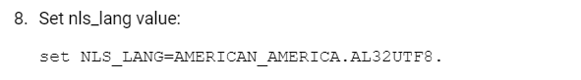

Import the Smart Materials Dump
set oracle_home=E:\Oracle\19c_Sta\db
sqlplus/nolog
conn sys/SaPDAdministrator@SMATPRD as sysdba
grant imp_full_database to system;
Create smallfile tablespace "APEX_BIR SPMAT" datafile size 4096M autoextend on next 100m;
create or replace directory dpump as 'I:\10_2_Backup';
grant read, write on directory dpump to system;

set oracle_home=E:\Oracle\19c_Sta\db
set NLS_LANG=AMERICAN_AMERICA.AL32UTF8
impdp system/SaPDAdministrator@SMATPRD full=y directory=dpump dumpfile=SMATPRD.DMP logfile=impSMATPRD.log parfile=I:\10_2_Backup\28-12-24\exclude.par

cd /d E:\INTERGRAPH\Smart Materials DB 10.5\samples\post_import\import_general sqlplus/nolog
@post_import.sql

Note: -
- The user creating the Database must be added in ORA_DBA group to avoid the process getting stuck at 36% or 53%.
- Steps mentioned for Modify init.ora of CDB instance step after Database creation needs to be altered as shown below
7. shutdown immediate
8. conn sys/<sys_password> as sysdba
9. create spfile from pfile;
10. Startup

https://docs.hexagonppm.com/r/en-US/Intergraph-Smart-Materials-Installation-10.5/Version-10.5/1125521

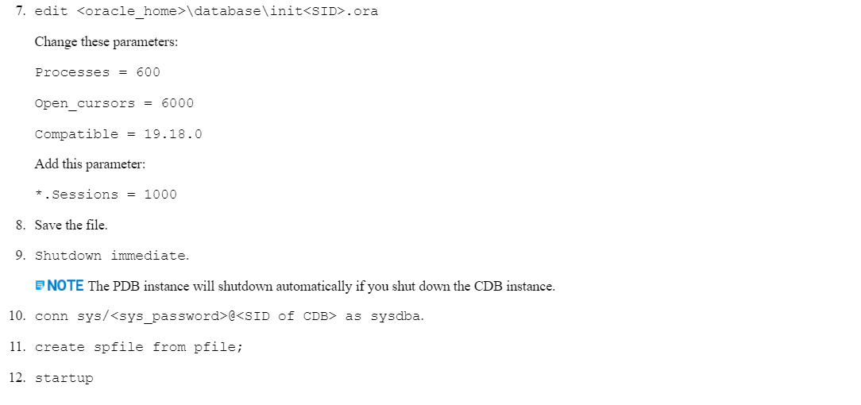

Apex 23.2 Installation

Drop Previous Apex versions
cd /d E:\INTERGRAPH\Smart Materials DB 10.5\samples\SMat
set oracle_home=E:\Oracle\19c_Sta\db
Sqlplus /nolog
connect sys/SaPDAdministrator@CDB as sysdba
Alter session set container = SMATPRD;
show con_name
@drop_WWV_DBMS_SQL_APEX-version.sql

Install Apex 23.2
cd /d E:\Oracle\apex_23.2\apex
set oracle_home=E:\Oracle\19c_Sta\db
Sqlplus /nolog
connect sys/SaPDAdministrator@CDB as sysdba
Alter session set container = SMATPRD;
show con_name
@apexins.sql SYSAUX SYSAUX TEMP /i/

select comp_name, status from dba_registry where comp_name like '%APEX%';

Install Apex 23.2 Patch
cd /d E:\Oracle\apex_23.2\35895964
set oracle_home=E:\Oracle\19c_Sta\db
Sqlplus /nolog
connect sys/SaPDAdministrator@CDB as sysdba
Alter session set container = SMATPRD;
show con_name
@catpatch.sql;

Change Admin Password
cd /d E:\Oracle\apex_23.2\apex
set oracle_home=E:\Oracle\19c_Sta\db
Sqlplus /nolog
connect sys/SaPDAdministrator@SMATPRD as sysdba
@apxchpwd.sql
--ADMIN
--Manager1!

alter user apex_public_user account unlock;
alter user apex_public_user identified by APEX_PUSER;

cd /d E:\Oracle\apex_23.2\apex
set oracle_home=E:\Oracle\19c_Sta\db
Sqlplus /nolog
connect sys/SaPDAdministrator@SMATPRD as sysdba
@apex_rest_config.sql

Smart Materials Upgrade to 10.5
set oracle_home=E:\Oracle\19c_Sta\db
set oracle_sid=SMATPRD
cd /d E:\INTERGRAPH\Smart Materials DB 10.5\samples\SMat
sqlplus/nolog
connect sys/SaPDAdministrator@SMATPRD as sysdba
@create_smat_web_workspace.sql F:\ORADATA\CDB\A8DC020264894E04A51E4E198C61D26C\DATAFILE\O1_MF_APEX_BIR_MPZB1BBO_.DBF manager1

set oracle_home=E:\Oracle\19c_Sta\db
set oracle_sid=SMATPRD
cd /d E:\INTERGRAPH\Smart Materials DB 10.5
sqlplus/nolog
@install_upgrade.sql

exec dbms_java.grant_permission('M_SYS', 'java.io.FilePermission', '<UTL Path>', 'read, write, delete');

exec dbms_stats.gather_schema_stats('M_SYS', 'COMPUTE');

-----------------------------------Post Upgrade Steps-----------------------------------
exec dbms_java.grant_permission('M_SYS', 'java.util.PropertyPermission', '*', 'read, write');
exec dbms_java.grant_permission('M_SYS', 'java.net.SocketPermission', '*', 'connect, resolve');
exec dbms_java.grant_permission('M_SYS', 'java.io.FilePermission', '', 'read, write, delete');

grant read, write on directory LOGFILEDEST to bir_spmat;
grant read, write on directory LOGFILEDEST to m_sys;

Note: -
- Run Post Import script again to validate the objects using the below script

cd /d E:\INTERGRAPH\Smart Materials DB 10.5\samples\post_import\import_general sqlplus/nolog
@post_import.sql

ACL Creation for License Server and Email Setup

License Server
Exec DBMS_NETWORK_ACL_ADMIN.create_acl ('LicenseWebservice.xml','Access control list for the session-based-check-SmartLicensing','M_SYS',TRUE,'connect',NULL,NULL);
exec DBMS_NETWORK_ACL_ADMIN.assign_acl ('LicenseWebservice.xml','SMAT-LIC-01.ENPPI.COM',NULL,NULL);

Email Setup
BEGIN
DBMS_NETWORK_ACL_ADMIN.APPEND_HOST_ACE (
HOST => 'smtp.enppi.com',
LOWER_PORT => 25,
UPPER_PORT => 25,
ACE => XS$ACE_TYPE(PRIVILEGE_LIST => xs$name_list('smtp'),
PRINCIPAL_NAME => 'M_SYS',
PRINCIPAL_TYPE => xs_acl.ptype_db)
);
END;
/

Oracle Client Patch Installation and GAC Dlls Registration

cd /d C:\temp\p35962832_Patch\35962832
set oracle_home=E:\client19c\base\client_1
net stop msdtc
set PATH=%ORACLE_HOME%\Opatch;%ORACLE_HOME%\perl\bin;%PATH%
opatch apply

cd E:\client19c\base\client_1\ODP.NET\bin\4
oraprovcfg /action:gac /providerpath:E:\client19c\base\client_1\ODP.NET\bin\4\Oracle.DataAccess.dll

oraprovcfg /action:gac /providerpath:E:\client19c\base\client_1\ODP.NET\bin\4\EF6\Oracle.DataAccess.EntityFramework.dll

ORDS Configuration and SMAT BIR Installation
_JAVA_OPTIONS = -Dconfig.url=E:\apache\ords_config

cd /d E:\apache\webapps
ords --config E:\apache\ords_config install -i

alter user apex_rest_public_user identified by APEX_RPUSER;
alter user ords_public_user identified by ORDS_PUSER;
alter user apex_public_user identified by APEX_PUSER;
alter user apex_listener identified by APEX_LIST;
alter user apex_rest_public_user account unlock;
alter user ords_public_user account unlock;
alter user apex_public_user account unlock;
alter user apex_listener account unlock;

Database Credential Error
Below error appears when browsing SMAT WEB/PORTAL URL
“HTTP Status Code: 574
Request ID: 9qu_gaWPoTDX7UdHz8XNVw
Request Timestamp: 2024-12-23T13:12:31.202812Z
ORDS was unable to make a connection to the database.
The username or password of the database user specified by db.username configuration setting is invalid.
The connection pool named: |default|lo| had the following error(s): ORA-01017: invalid username/password; logon denied https://docs.oracle.com/error-help/db/ora-01017/”

Run below commands to resolve the above issue
- ords --config E:\apache\ords_config config secret db.password
Provide ORDS_PUBLIC_USER password when prompted
- ords --config E:\apache\ords_config serve
It should show the ORDS in valid state
- Restart tomcat error

cd /d E:\INTERGRAPH
set oracle_home=E:\client19c\base\client_1
sqlplus/nolog
@Install_SMAT_BIR.sql

Fusion Middleware Installation

Installation and Configuration
----------Install Oracle Weblogic Server Patch (34519923) Version 12.2.1.4.0
cd /d C:\Program Files\Java\jdk-1.8\bin
java -jar "D:\Misc\fmw_12.2.1.4.0_infrastructure.jar" -prereqConfigLoc "D:\Misc\p34519923\34500720\prereq"

----------Install Oracle WLS Patch (28186730)
cd /d C:\Program Files\Java\jdk-1.8\bin
java -jar D:\Share\p28186730_1394217_Generic\6880880\opatch_generic.jar -silent oracle_home=E:\iAS_12c

----------Install Oracle Virtual Directory Generic (34065178) Version 12.2.1.4.0
cd /d D:\Share\p34065178_122140_Generic\34065178
set ORACLE_HOME=E:\iAS_12c
set PATH=%ORACLE_HOME%\Opatch;%ORACLE_HOME%\perl\bin;%PATH%
opatch apply

----------Install Oracle WLS Generic Bundle Patch (36178496) Version 12.2.1.4.240111
cd /d D:\Misc\p36178496\WLS\binary_patches
set ORACLE_HOME=E:\iAS_12c
set PATH=%ORACLE_HOME%\Opatch;%ORACLE_HOME%\perl\bin;%PATH%
E:\iAS_12c\OPatch\opatch napply -report -oh E:\iAS_12c -phBaseFile windows64_patchlist.txt

----------Prepare for Patch (35943354) installation
cd /d D:\Misc\p35943354\35943354
set ORACLE_HOME=E:\iAS_12c
set PATH=%ORACLE_HOME%\Opatch;%ORACLE_HOME%\perl\bin;%PATH%
opatch rollback -id 35005177
opatch rollback -id 35522383

----------Install Oracle Virtual Directory Generic (35943354) Version 12.2.1.4.0
cd /d D:\Misc\p35943354\35943354
set ORACLE_HOME=E:\iAS_12c
set PATH=%ORACLE_HOME%\Opatch;%ORACLE_HOME%\perl\bin;%PATH%
opatch apply
----------Install Oracle Forms 12.2.1.19.0 Interim Patch for Bug (36009429)
cd /d D:\Misc\p36009429\36009429
set ORACLE_HOME=E:\iAS_12c
set PATH=%ORACLE_HOME%\Opatch;%ORACLE_HOME%\perl\bin;%PATH%
opatch apply

----------Configure Fusion Middleware
cd /d E:\iAS_12c\oracle_common\common\bin
config.cmd

----------Initialize Admin Server
cd /d E:\iAS_12c\user_projects\domains\base_domain\bin
startWebLogic.cmd

cd /d E:\iAS_12c\user_projects\domains\base_domain\servers\AdminServer
md security

cd /d E:\iAS_12c\user_projects\domains\base_domain\servers\AdminServer\security
echo username=weblogic>>boot.properties
echo password=manager1>>boot.properties

cd /d E:\iAS_12c\user_projects\domains\base_domain\bin
stopWebLogic.cmd

----------Start NodeManager
cd /d E:\iAS_12c\user_projects\domains\base_domain\bin
startNodeManager

----------Start AdminServer
cd /d E:\iAS_12c\oracle_common\common\bin
wlst.cmd
--nmConnect("nodemanager","manager1" ,"localhost","5556","base_domain","E:/iAS_12c/user_projects/domains/base_domain")
nmConnect("nodemanager","manager1" ,"10.14.27.11","5556","base_domain","E:/iAS_12c/user_projects/domains/base_domain")
nmStart('AdminServer')

http://SMAT-FMW-01:7001/console/

----------Install Node Manager Service
cd /d E:\iAS_12c\user_projects\domains\base_domain\bin
installNodeMgrSvc.cmd

----------Reports Server Configuration
----------Create Reports Tools and Server Instance
cd /d E:\iAS_12c\oracle_common\common\bin
wlst.cmd
connect("weblogic","manager1", "t3://SMAT-FMW-01:7001")
createReportsToolsInstance(instanceName='RepTools1',machine='AdminServerMachine')

----------Enable Reports Web Access
E:\iAS_12c\user_projects\domains\base_domain\config\fmwconfig\servers\WLS_REPORTS\applications\reports_12.2.1\configuration
E:\iAS_12c\user_projects\domains\base_domain\config\fmwconfig\components\ReportsServerComponent\xyzAs1601Rep\

----------Grant Access on Non-Default Directories
E:\iAS_12c\user_projects\domains\base_domain\config\fmwconfig\components\ReportsServerComponent\xyzAs1601Rep

----------Start Report Tools
cd /d E:\iAS_12c\user_projects\domains\base_domain\bin
startComponent.cmd RepTools1 storeUserConfig

----------Start Report Instance
cd /d E:\iAS_12c\user_projects\domains\base_domain\bin
startComponent.cmd xyzAs1601Rep storeUserConfig

http://SMAT-FMW-01:9002/reports/rwservlet/showenv?server=xyzAs1601Rep
http://SMAT-FMW-01.enppi.com/reports/rwservlet/showenv?server=xyzAs1601Rep

----------OHS Configuration
----------Start OHS
cd /d E:\iAS_12c\oracle_common\common\bin
wlst.cmd
nmConnect('nodemanager','manager1','SMAT-FMW-01','5556','base_domain','E:/iAS_12c/user_projects/domains/base_domain')
nmStart(serverName='ohs1', serverType='OHS')

----------OHS Listing Port Configuration
----------Configure OHS

----------Module Configuration
----------Configure sqlnet.ora and tnsnames.ora
----------Configure Formsweb.cfg
E:\iAS_12c\user_projects\domains\base_domain\config\fmwconfig\servers\WLS_FORMS\applications\formsapp_12.2.1\config
----------Configure Default.env
E:\iAS_12c\user_projects\domains\base_domain\config\fmwconfig\servers\WLS_FORMS\applications\formsapp_12.2.1\config

https://smat-fmw-01.enppi.com/forms/
https://smat-fmw-01.enppi.com/reports/
https://SMAT-FMW-01.enppi.com/forms/frmservlet?config=webstart_smat

https://SMAT-FMW-01.enppi.com/forms/frmservlet?config=webstart_smatprd

https://SMAT-FMW-01.enppi.com:8443/forms/frmservlet?config=webstart_smat
http://SMAT-FMW-01.ENPPI.COM/forms/frmservlet?config=webstart_smat
http://SMAT-FMW-01:9001/forms
http://SMAT-FMW-01:9002/reports

https://SMAT-FMW-01.enppi.com/forms/frmservlet?config=webstart_smat

----------Install WebUtil
cd /d E:\iAS_12c\forms
sqlplus/nolog
conn sys/SaPDAdministrator@SMATPRD as sysdba
@create_webutil_db.sql
create or replace public synonym webutil_db for webutil_db;
grant execute on webutil_db to m_sys,m_project_role,m_approve;

SSL Configuration in FMW

Command Prompts
set JAVA_HOME=C:\Program Files\Java\jdk-1.8
cd /d D:\INTERGRAPH\SSL_CERTS
orapki wallet create -wallet ./ -auto_login
cd /d D:\INTERGRAPH\SSL_CERTS\wallet
orapki wallet create -wallet ./ -auto_login
Wallet Password:- Enppi_1357

orapki wallet import_pkcs12 -wallet ./ -pkcs12file ewallet.p12.orig -pkcs12pwd Enppi_1357

cd /d E:\iAS_12c\oracle_common\bin
orapki wallet display -wallet D:\INTERGRAPH\SSL_CERTS

cd /d E:\iAS_12c\oracle_common/common/bin
wlst.cmd
connect("weblogic","manager1", "t3://SMAT-FMW-01:7001")
svc = getOpssService(name='KeyStoreService')
svc.importKeyStore(appStripe='OHS', name='ohs1_keystore', password='Enppi_1357', type='OracleWallet', permission=true, filepath='D:\INTERGRAPH\SSL_CERTS\wallet')

svc.importKeyStore(appStripe='OHS', name='ohs1_keystore', password='Enppi_1357', aliases='te-copyofsccmiiscertificate_test-f91c72db-6808-437d-b1df-932d68e1bbaa', keypasswords='Enppi_1357', type='JKS', permission=true, filepath='D:\Misc\SMAT-FMW.jks')

cd /d C:\Program Files\Java\jdk-1.8\bin
keytool -importkeystore -srckeystore D:\Misc\SMAT-FMW.pfx -srcstoretype PKCS12 -destkeystore D:\INTERGRAPH\SSL\wallet\SMAT-FMW-01.jks -deststoretype JKS

Generating Wallet
- Rename the <file>.pfx file to ewallet.p12

- Copy ewallet.P12 into new directory.
For example: D:\INTERGRAPH\SSL_CERTS

- Open command prompt as administrator, navigate to the folder in the step 2 and run below command.
Set JAVA_HOME=” C:\Program Files\Java\jdk-1.8”
orapki wallet create -wallet ./ -auto_login

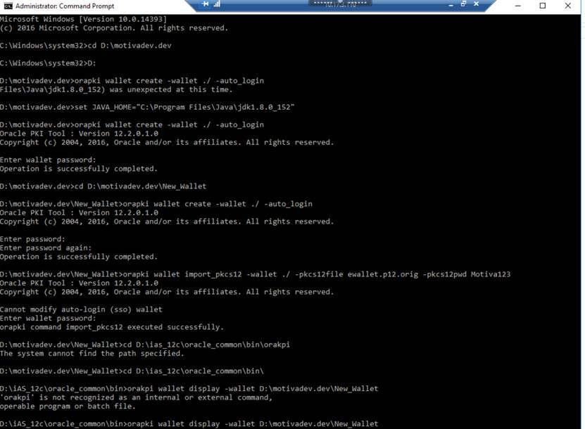

- Rename ewallet.p12 to ewallet.p12.orig
- Create new directory wallet, copy ewallet.p12.orig to this directory and open command prompt as administrator and navigate to this folder.

orapki wallet create -wallet ./ -auto_login

Enter Password of the pfx file (that is obtained from server team).
Reenter same password again.

- Execute below command

orapki wallet import_pkcs12 -wallet ./ -pkcs12file ewallet.p12.orig -pkcs12pwd <password>

- Dump the Wallet out with orapki to make sure it looks correct:

Navigate to the path D:\iAS_12c\oracle_common\bin and execute below command.
orapki wallet display -wallet <newallet_path>

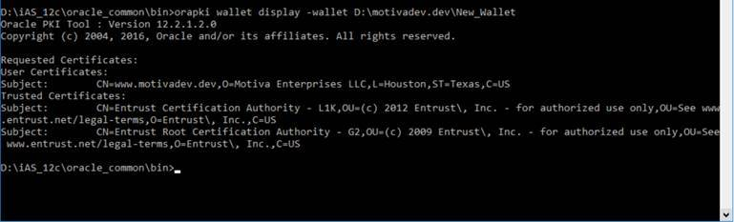

Your folder should look like below.

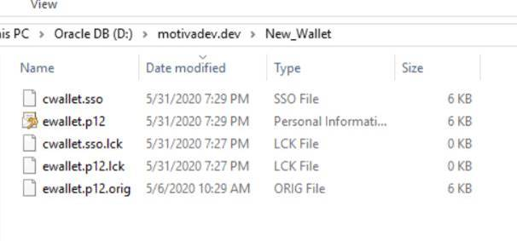

Importing Wallet
- Launch Weblogic Scripting Tool:
D:\iAS_12c\oracle_common/common/bin/wlst.sh

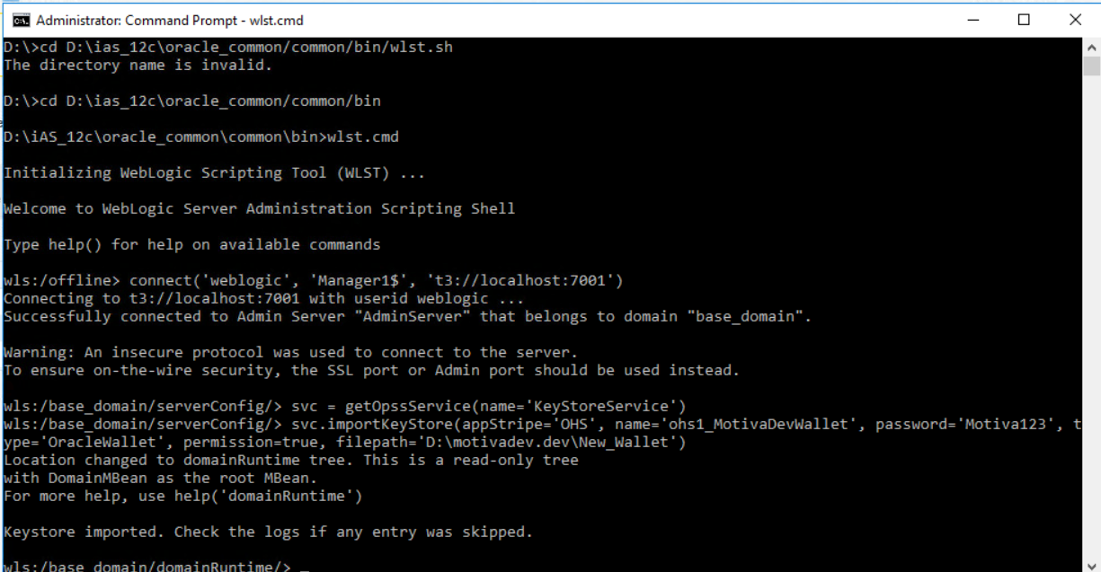

- Once launched connect wlst to the running domain adminserver:
wls:/offline> connect('username', 'password', 't3://hostname.domain:port')

- Get the OPSS service command object and set it to svc for use later.
wls:/domain_name/serverConfig/> svc = getOpssService(name='KeyStoreService')

- Import the wallet or keystore. This wallet or keystore must include the private key and supporting public key along with full certificate chain as trusted certificates. Typically this will be your Identity Keystore for a Java Keystore.

wls:/domain_name/serverConfig/> svc.importKeyStore(appStripe='<Stripe Name>', name='<component_name>_<keystore_name>', password='<wallet_password>', type='OracleWallet', permission=true, filepath='<dir_path_to_wallet>')

svc.importKeyStore(appStripe='OHS', name='ohs1_keystore', password='manager1', type='OracleWallet', permission=true, filepath='<dir_path_to_wallet>')

OHS SSL Configuration
- You can login to enterprise manager and go to OHS1, Lock and Edit and go to Keystores you can find the wallet that we imported.

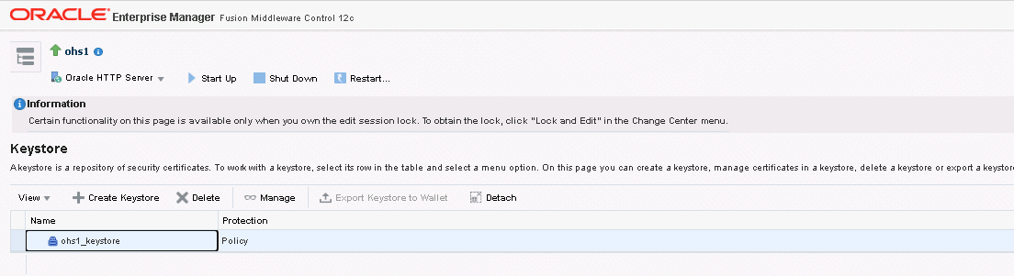

- Click Manage and press “Export Keystore to Wallet”

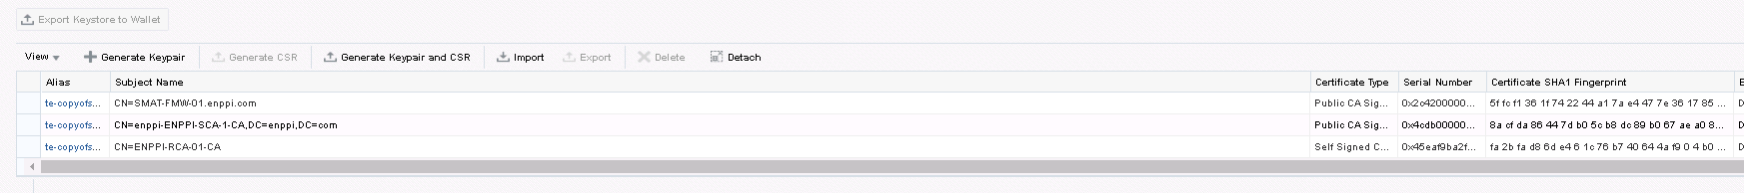

- Activate changes.
- Lock and Edit and go to Ports Configuration.
- Create port 443.

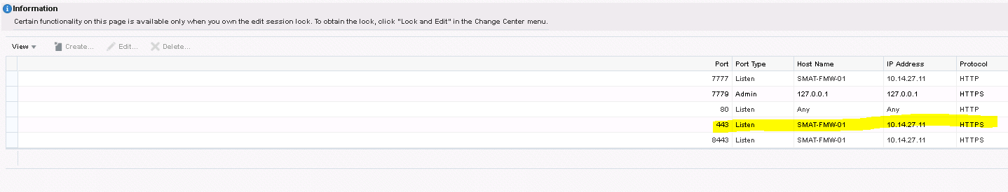

- Create Virtual Host for port 443
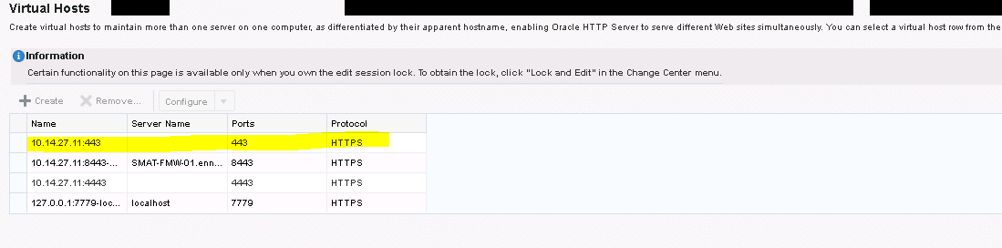

- Select SSL Configuration.

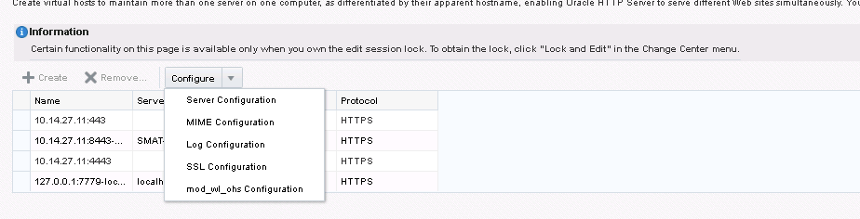

- Select the keystore and enable SSL click Ok.

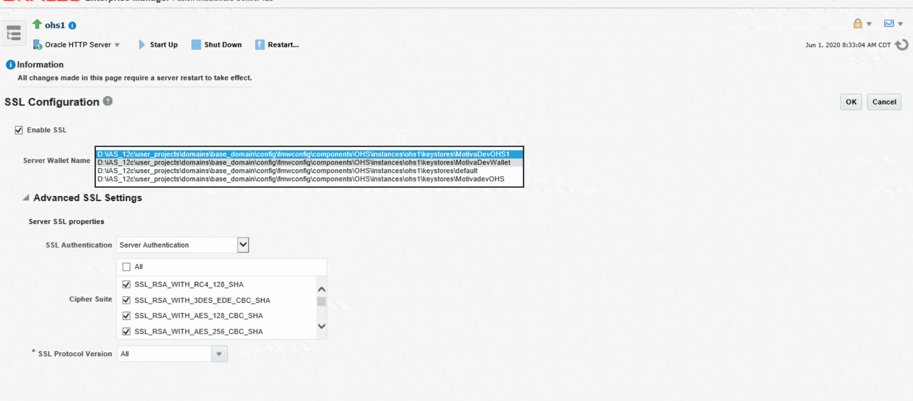

- Activate the changes and Restart OHS.

- Forms and Reports should start with HTTPS.

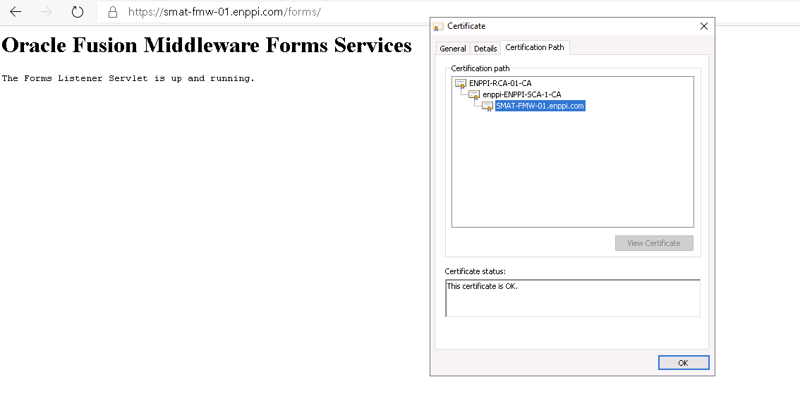

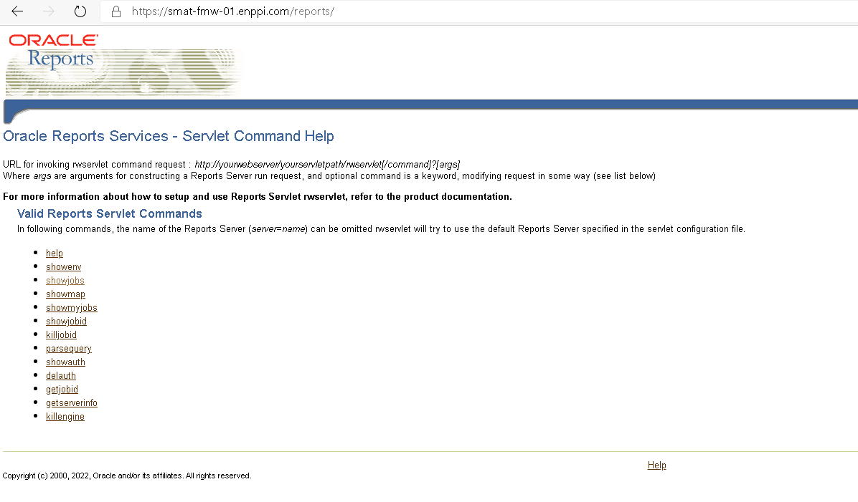

- Add the webstart_codebase parameter in formsweb.cfg file as shown below in Web Start configuration.

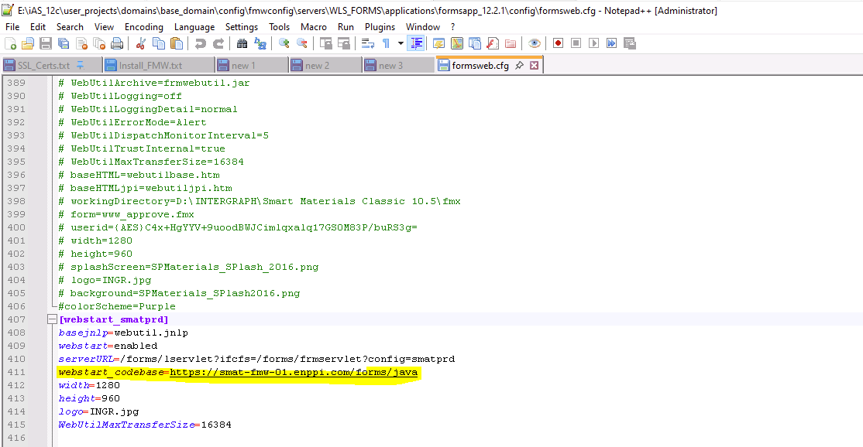

SMAT WPF Installation

SSL Configuration
- Ensure to change the update_map_uri.sql located under <Product Root Location>\tools folder as shown below to support https.
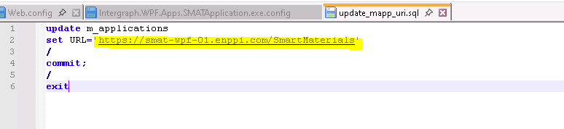

- Ensure that httpsGetEnabled="true", by default the config file contains httpGetEnabled =”true”
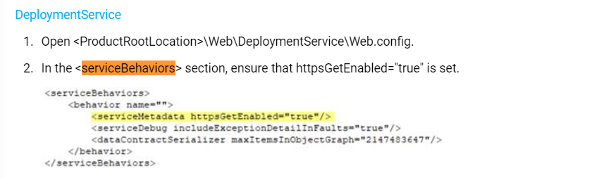
- Ensure to change the Uri in the below locations as per the IIS web service in <ProductRooLocationt>\SPMAT\Intergraph.WPF.Apps.SPMatApplication.exe.config file

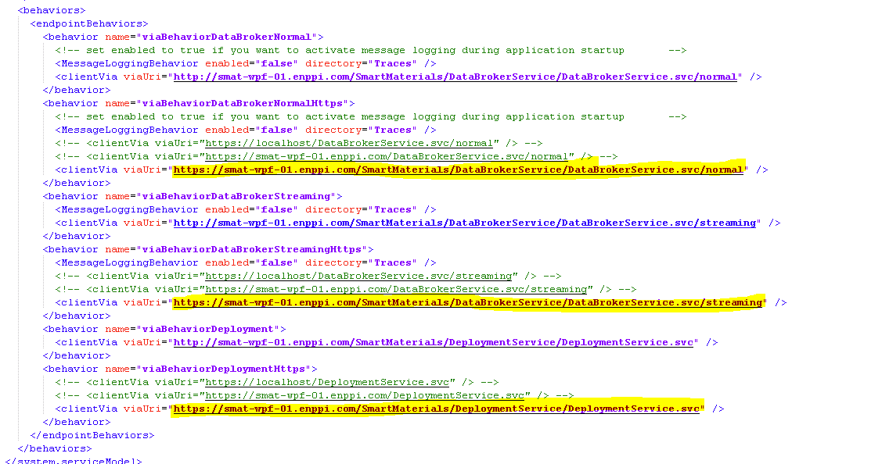

Service Pack Installation
https://docs.hexagonppm.com/r/en-US/Intergraph-Smart-Materials-Installation-10.5/Version-10.5/773462

DB Backup
Follow the steps mentioned in SMAT Database Export.
Alternatively, run the customized scheduler job (DB_BACKUP_JOB) from sys account available for taking daily DB backup as shown below.

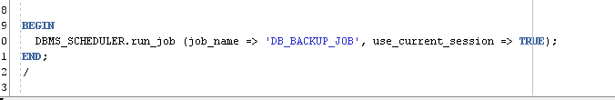

SMAT DB
cd /d E:\INTERGRAPH\Smart Materials DB 10.5 SP01
set oracle_home=E:\Oracle\19c_Sta\db
set oracle_sid=SMATPRD
sqlplus/nolog
@install_upgrade.sql

SMAT BIR
cd /d E:\INTERGRAPH\Smart Materials WEB 10.5 SP01
set oracle_home=E:\client19c\base\client_1
set oracle_sid=SMATPRD
sqlplus/nolog
@Install_SMAT_BIR.sql

SSL Configuration in IIS Server
https://docs.hexagonppm.com/r/en-US/Intergraph-Smart-Materials-Installation-10.5/Version-10.5/1077665
- Start the Internet Information Services (IIS) Manager
- Select Server Certificates and click import to import the certificate
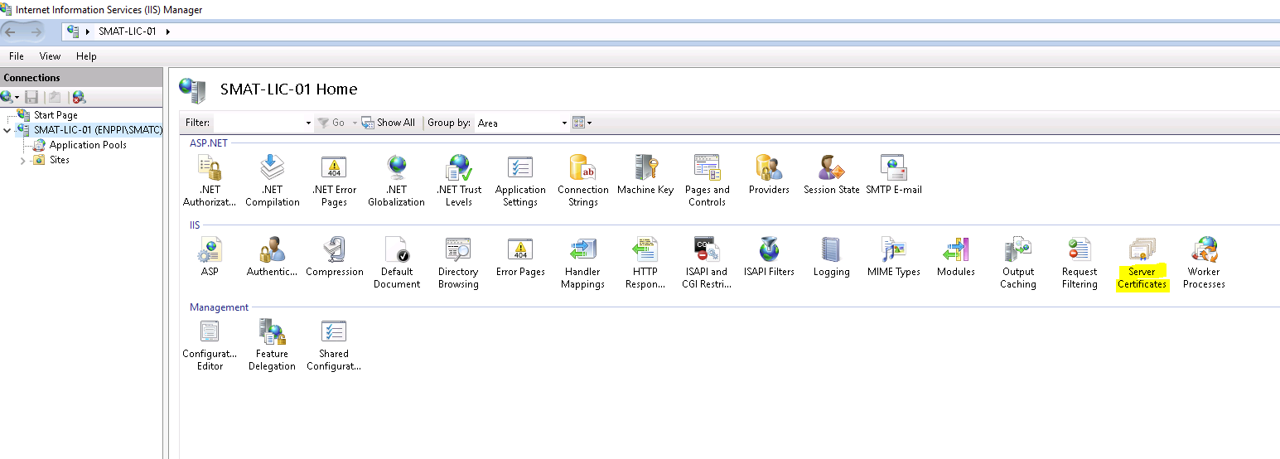
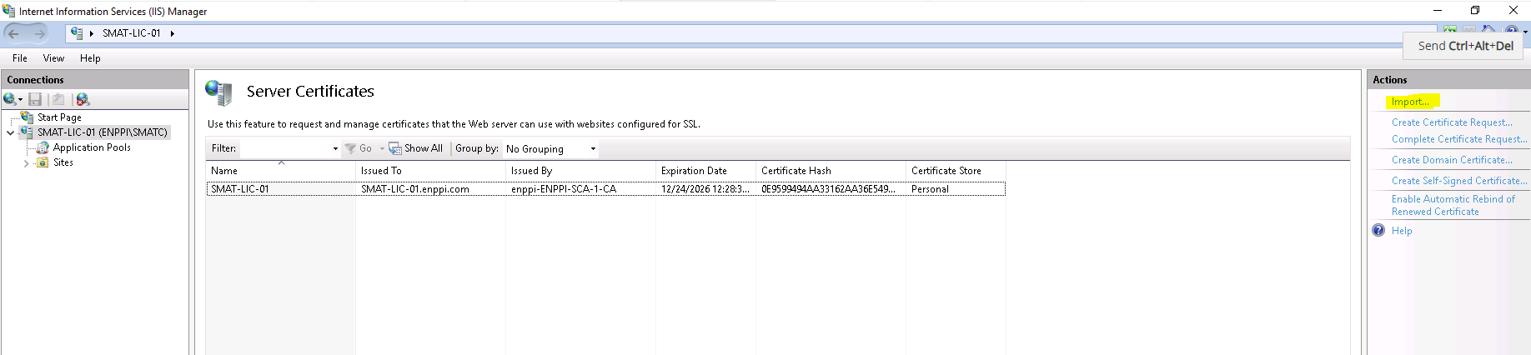
- Select Default Web Site > Edit Site Bindings and add the new binding with the certificate as shown below
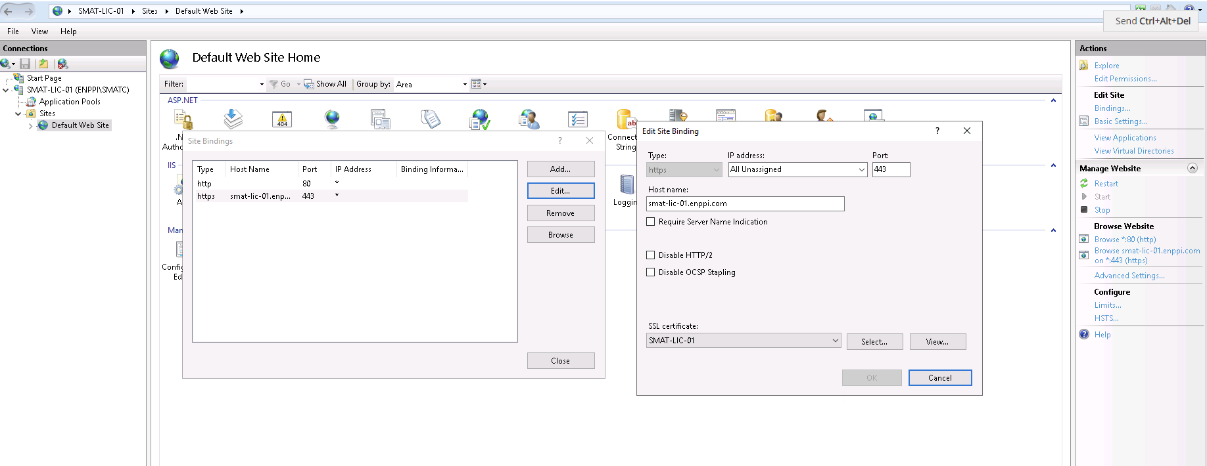

SSL Configuration in Apache Tomcat Server
https://docs.hexagonppm.com/r/en-US/Intergraph-Smart-Materials-Installation-10.5/Version-10.5/1049962
- Locate your Tomcat’s server configuration file at $Tomcat\conf\server.xml
- Add a connector element to support for https connection (replace ##PathToYourKeystoreCertificateFile## with the certificate file path and ##YourKeystorePassword## with the password) as shown below
<Connector port="8443" scheme="https" secure="true" SSLEnabled="true" clientAuth="false" sslProtocol="TLS" keystoreFile="##PathToYourKeystoreCertificateFile##" keystorePass="##YourKeystorePassword##" />

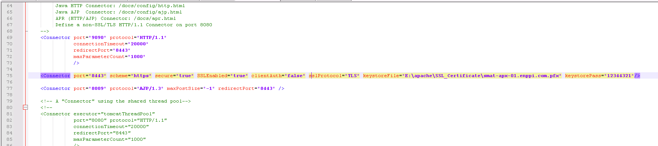

General Issues

Steps for resolving password expiry issue for system user
This issue was observed when backup for the DB scripts was prepared and since it uses system user, it needs to be available.
Please run the below SQL commands using sys as sysdba account;

- ALTER USER system IDENTIFIED BY system;
- ALTER USER system ACCOUNT UNLOCK;
- ALTER PROFILE DEFAULT LIMIT PASSWORD_LIFE_TIME UNLIMITED;

Steps for retrieving the database to previous day backup

