Denormalization Report
and Analytical Model for the OULAD Project
Team reference for the SQL Server denormalization stage
Report date 13 October 2026

1- Purpose and Design Scope
The ODS tables were transformed into an analytical model comprising 9 tables: 3 Facts and 6 Dimensions.
The model consists of three stars with shared dimensions, known as a Fact Constellation (Galaxy Schema).

2- Business Case
How do learning-platform engagement and assessment performance relate to success, failure and withdrawal, and where can student support be improved? We use historical data to identify groups and course offerings with weaker outcomes and their associated engagement patterns, guiding further work on academic support and early intervention.
The analysis identifies associations; it does not establish that more clicks cause success. The final outcome is available after the enrollment ends.

Key Analytical Questions
- How do success and withdrawal rates vary across modules, presentations and years?
- How do outcomes vary by gender, region, education, deprivation band, disability and age band?
- Are click intensity and active days in the first weeks associated with the final outcome?
- How does weekly engagement evolve among successful, withdrawn and failed enrollments?
- Do assessment scores and submission delays differ across outcome groups?
- Which resource types are used most, and how does their use differ across final outcomes?
- How are previous attempts and studied credits associated with success and withdrawal?

3- Tables in the Denormalization Stage
Target | Source and Transformation
DimStudent | Copy stable student attributes from ods.Student, excluding age band and outcome.
DimCourseOffering | Copy the course offering; derive the year from the first 4 characters and the term from the last character.
DimFinalResult | Create 5 fixed outcome categories with success and withdrawal flags.
DimAssessment and DimLearningResource | Copy assessment and resource attributes; course offering relates directly to the Facts.
DimRelativeDay | Generate a continuous day range covering all ODS day columns, including day zero.
FactEnrollment | Copy enrollment records, replace the outcome text with a key, and retain AgeBand as a Fact attribute.
FactStudentAssessment | Assessment identifies the offering; the matching student-and-offering Enrollment supplies the outcome.
FactDailyInteraction | LearningResource identifies the offering; the matching Enrollment supplies the outcome. Clicks are not reaggregated.
Click aggregation preceded this stage: it occurred during ODS loading for each student, resource and day. The confirmed Clean View and ODS comparison returned 38,343,063 clicks in each. This reconciles cleaned data; it does not test the effect of removing identical raw rows.

4- Table and Row Summary
Table | Columns | Rows | After a Successful Load
DimStudent | 6 | 28,785 | Equals the row count in ods.Student
DimCourseOffering | 6 | 22 | Equals the row count in ods.CourseOffering
DimFinalResult | 4 | 5 | Fixed rows
DimAssessment | 4 | 206 | Equals the row count in ods.Assessment
DimLearningResource | 4 | 6,364 | Equals the row count in ods.LearningResource
DimRelativeDay | 4 | 974 | EndDay - StartDay + 1
FactEnrollment | 10 | 32,593 | Equals the row count in ods.Enrollment
FactStudentAssessment | 9 | 173,912 | Equals the row count in ods.StudentAssessment
FactDailyInteraction | 7 | 8,459,320 | Equals the row count in ods.StudentDailyInteraction

Total columns across the tables: 54. The ODS interaction row count was reported as approximately 8 million; this is an estimate.

5- Entity Relationship Diagram
The diagram shows the three stars and their primary keys. Shared dimensions are repeated for clarity only; the database contains one instance of each dimension. Arrows show the proposed filter direction from Dimension to Fact. All relationships are one-to-many.
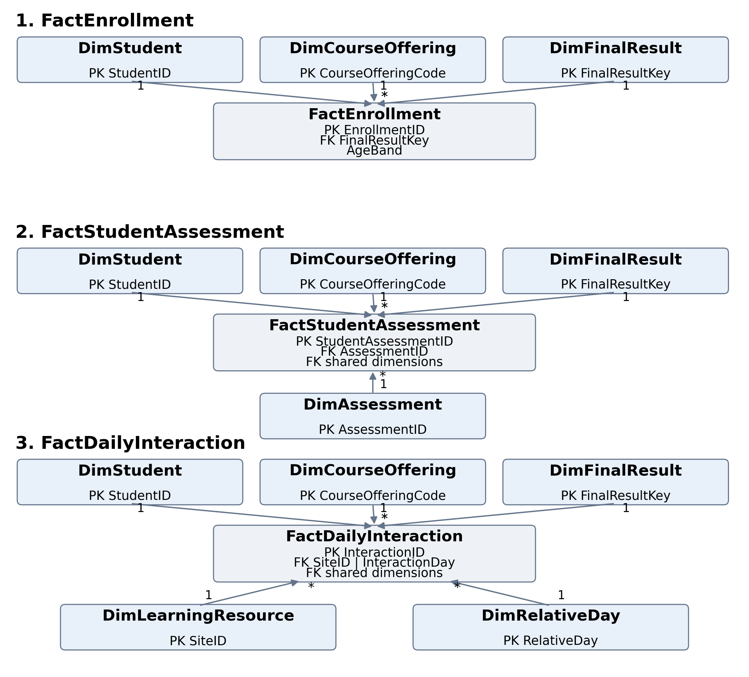

6- Dimension Table Dictionary

DimStudent
Grain: one row per student | Columns: 6 | PK: StudentID
Row count: equals ods.Student after a successful load; the exact count is obtained from the appendix.
Column | Type and Nullability | Meaning and Use
StudentID | INT  NOT NULL | Original student identifier and primary key; one row per student.
Gender | NVARCHAR(1)  NULL allowed | Gender as stored in ODS: M or F.
Region | NVARCHAR(50)  NULL allowed | Recorded student residence region.
HighestEducation | NVARCHAR(50)  NULL allowed | Highest recorded education level.
IMDBand | NVARCHAR(50)  NULL allowed | Recorded deprivation band; a descriptive category, not an amount or calculated score.
Disability | NVARCHAR(1)  NULL allowed | Disability indicator from the source: Y or N.

DimCourseOffering
Grain: one row per module and presentation | Columns: 6 | PK: CourseOfferingCode | UQ: ModuleCode + PresentationCode
Row count: equals ods.CourseOffering after a successful load; the exact count is obtained from the appendix.
Column | Type and Nullability | Meaning and Use
CourseOfferingCode | NVARCHAR(8)  NOT NULL | PK: the first character of ModuleCode combined with PresentationCode, for example A2014J.
ModuleCode | NVARCHAR(3)  NOT NULL | Full module code, for example AAA.
PresentationCode | NVARCHAR(5)  NOT NULL | Presentation code, for example 2014J.
PresentationLengthDays | INT  NOT NULL | Presentation length in days; greater than zero.
PresentationYear | INT  NULL allowed | Year extracted from the first four characters; invalid conversion returns NULL.
PresentationTerm | NVARCHAR(1)  NOT NULL | Last character of the presentation code, such as B or J, distinguishing presentation terms.

Dimension Dictionary Continued

DimFinalResult
Grain: one row per outcome category | Columns: 4 | PK: FinalResultKey | UQ: FinalResult
Row count: 5 fixed rows
Column | Type and Nullability | Meaning and Use
FinalResultKey | INT  NOT NULL | Fixed numeric PK from 0 to 4, referenced by each Fact.
FinalResult | NVARCHAR(20)  NOT NULL | UNKNOWN, PASS, DISTINCTION, FAIL or WITHDRAWN.
IsSuccess | BIT  NOT NULL | 1 for PASS and DISTINCTION; 0 for other outcomes.
IsWithdrawn | BIT  NOT NULL | 1 for WITHDRAWN; 0 for other outcomes.

DimAssessment
Grain: one row per assessment | Columns: 4 | PK: AssessmentID
Row count: equals ods.Assessment after a successful load; the exact count is obtained from the appendix.
Column | Type and Nullability | Meaning and Use
AssessmentID | INT  NOT NULL | PK: original assessment identifier.
AssessmentType | NVARCHAR(10)  NULL allowed | Assessment type, such as TMA, CMA or EXAM.
AssessmentDay | INT  NULL allowed | Scheduled assessment day relative to presentation start; may be missing.
Weight | DECIMAL(6,2)  NULL allowed | Assessment weight as a percentage from 0 to 100; not the student score.

IsSuccess and IsWithdrawn are classification flags, not counts or percentages. Assessment weight describes the assessment and must not be summed across student rows to obtain the module weight.

Dimension Dictionary Continued

DimLearningResource
Grain: one row per resource | Columns: 4 | PK: SiteID
Row count: equals ods.LearningResource after a successful load; the exact count is obtained from the appendix.
Column | Type and Nullability | Meaning and Use
SiteID | INT  NOT NULL | PK: original resource identifier, unique in the adopted ODS model.
ActivityType | NVARCHAR(255)  NULL allowed | Activity or resource type, such as a forum or content.
WeekFrom | INT  NULL allowed | Resource start week in the source; may be missing.
WeekTo | INT  NULL allowed | Resource end week in the source; may be missing.

DimRelativeDay
Grain: one row per relative day | Columns: 4 | PK: RelativeDay
Row count: EndDay - StartDay + 1
Column | Type and Nullability | Meaning and Use
RelativeDay | INT  NOT NULL | PK: day offset from presentation start, including negative values and zero.
StudyWeekNumber | INT  NULL allowed | For nonnegative days: integer division by 7, plus 1. Negative days return NULL.
DayPhase | NVARCHAR(20)  NOT NULL | Before start, Start day or After start, based on the day offset.
IsBeforeStart | BIT  NOT NULL | 1 before the start; 0 on or after it.

WeekFrom and WeekTo come from the resource data, whereas StudyWeekNumber is derived from the interaction day. Their week definitions should not be assumed to match without checking the original source documentation.

7- Enrollment Table Dictionary

FactEnrollment
Grain: one row per student and presentation | Columns: 10 | UQ: StudentID + CourseOfferingCode
Row count: equals ods.Enrollment after a successful load; the exact count is obtained from the appendix.
Column | Type and Nullability | Meaning and Use
EnrollmentID | INT  NOT NULL | PK: enrollment ID copied from ODS; no new DW IDENTITY is generated.
StudentID | INT  NOT NULL | FK to DimStudent.
CourseOfferingCode | NVARCHAR(8)  NOT NULL | FK to DimCourseOffering.
FinalResultKey | INT  NOT NULL | FK to DimFinalResult: the outcome of this enrollment.
AgeBand | NVARCHAR(255)  NULL allowed | Enrollment-specific age band; a descriptive column, not an FK.
PreviousAttempts | INT  NULL allowed | Recorded previous-attempt count; nonnegative when known.
StudiedCredits | INT  NULL allowed | Studied credits recorded for this enrollment; not necessarily earned credits or credits for this module alone.
RegistrationDay | INT  NULL allowed | Relative registration day; may be negative or NULL.
UnregistrationDay | INT  NULL allowed | Relative withdrawal day; NULL means no day is recorded.
EnrollmentCount | INT  NOT NULL | Constant 1 with a default and constraint; SUM gives the enrollment count.

The primary key identifies the enrollment row. The Unique constraint protects the grain by preventing the same enrollment from being inserted under a different ID. A student may have different age bands across enrollments, so AgeBand is not stored in DimStudent.
Removing EnrollmentID from the activity Facts does not prevent identification of the enrollment: the student and course offering uniquely identify it. The code retains the join to ods.Enrollment to obtain the outcome and validate the enrollment.
Key measures: SUM(EnrollmentCount) for enrollments; distinct StudentID for students within the selected enrollments; counts and rates for the selected outcome. Summing StudiedCredits across enrollments does not automatically produce unique credits per student.

8- Assessment Table Dictionary

FactStudentAssessment
Grain: one row per student and assessment | Columns: 9 | Uniqueness: StudentID + AssessmentID
Row count: equals ods.StudentAssessment after a successful load; the exact count is obtained from the appendix.
Column | Type and Nullability | Meaning and Use
StudentAssessmentID | INT  NOT NULL | PK: student assessment record ID copied from ODS.
StudentID | INT  NOT NULL | FK to DimStudent.
CourseOfferingCode | NVARCHAR(8)  NOT NULL | FK to DimCourseOffering, obtained from the assessment.
FinalResultKey | INT  NOT NULL | FK to DimFinalResult, obtained from the matching enrollment.
AssessmentID | INT  NOT NULL | FK to DimAssessment.
SubmittedDay | INT  NULL allowed | Submission day relative to presentation start.
IsBanked | BIT  NULL allowed | 1 for a result banked from an earlier presentation; 0 otherwise; NULL means unknown.
Score | DECIMAL(6,2)  NULL allowed | Student score from 0 to 100, or NULL if missing.
AssessmentRecordCount | INT  NOT NULL | Constant 1; counts assessment records, not necessarily new submissions.

The table retains IsBanked records. New-submission measures require a policy for excluding or separating these records. Missing scores are not converted to zero. The average Score covers records with known scores unless a different policy is defined.
Submission delay = SubmittedDay - AssessmentDay, calculated only when both values are available and the record is eligible for this analysis. Positive values indicate submission after the scheduled day. NULL means the delay cannot be calculated from the record.
Non-submitted assessments cannot be counted from existing rows alone. A list of expected assessments for each enrollment is required, with rules for banked assessments and withdrawal.

9- Interaction Table Dictionary

FactDailyInteraction
Grain: one row per student, resource and day | Columns: 7 | Uniqueness: StudentID + SiteID + InteractionDay
Row count: equals ods.StudentDailyInteraction after a successful load; the exact count is obtained from the appendix.
Column | Type and Nullability | Meaning and Use
InteractionID | BIGINT  NOT NULL | BIGINT PK: interaction row ID copied from ODS.
StudentID | INT  NOT NULL | FK to DimStudent.
CourseOfferingCode | NVARCHAR(8)  NOT NULL | FK to DimCourseOffering, obtained from the resource.
FinalResultKey | INT  NOT NULL | FK to DimFinalResult, obtained from the matching enrollment.
SiteID | INT  NOT NULL | FK to DimLearningResource.
InteractionDay | INT  NOT NULL | FK to DimRelativeDay.RelativeDay.
SumClicks | BIGINT  NOT NULL | Total clicks after ODS aggregation; a nonnegative BIGINT.

Total clicks = SUM(SumClicks). The Fact row count is neither the click count nor the active-day count. Active days require distinct days per student and presentation, with a positive-click condition if that is the agreed definition of activity.
The approximate ODS count is 8 million rows. The load transfers the same rows to DW with additional context, without reaggregation or row loss. The confirmed reference total is 38,343,063 clicks in both the Clean View and ODS; DW reconciliation is checked after execution.
Interaction rows represent enrollments with resource-and-day records. An enrollment with no interaction does not appear in FactDailyInteraction but remains in FactEnrollment. Average clicks across all enrollments must include zero-interaction enrollments in the denominator.

10- Relationships and Filter Directions
One Side | Many Side
DimStudent.StudentID | FactEnrollment.StudentID
DimStudent.StudentID | FactStudentAssessment.StudentID
DimStudent.StudentID | FactDailyInteraction.StudentID
DimCourseOffering.CourseOfferingCode | FactEnrollment.CourseOfferingCode
DimCourseOffering.CourseOfferingCode | FactStudentAssessment.CourseOfferingCode
DimCourseOffering.CourseOfferingCode | FactDailyInteraction.CourseOfferingCode
DimFinalResult.FinalResultKey | FactEnrollment.FinalResultKey
DimFinalResult.FinalResultKey | FactStudentAssessment.FinalResultKey
DimFinalResult.FinalResultKey | FactDailyInteraction.FinalResultKey
DimAssessment.AssessmentID | FactStudentAssessment.AssessmentID
DimLearningResource.SiteID | FactDailyInteraction.SiteID
DimRelativeDay.RelativeDay | FactDailyInteraction.InteractionDay

SQL defines 12 FK relationships. In Power BI, create active 1:* relationships with Single filter direction from Dimension to Fact. SQL constraints protect referential integrity; Power BI relationships control filter propagation and must be configured and checked when building the model.
The three shared dimensions filter all Facts. Assessment type filters assessments only; resource type and relative day filter interactions only. AgeBand filters enrollments only and does not automatically filter assessments or interactions. Do not enable Both merely to propagate a filter through Facts.
Do not directly relate the Facts or add relationships from DimAssessment or DimLearningResource to DimCourseOffering in this model. Course offering is stored in the Facts to avoid multiple filter paths.
To compare assessment scores with engagement for the same enrollment, first aggregate each Fact to StudentID + CourseOfferingCode, then join the summaries. Joining detailed rows directly multiplies clicks and scores because the grains differ.

11- DimRelativeDay and Its Importance
A relative-time dimension aligns the study timeline: day zero is the start, negative days precede it, and positive days follow it. It allows comparisons at the same study stage across presentations without assuming a calendar start date that is absent from the code.

How the Code Builds It
Take the minimum and maximum day from InteractionDay, SubmittedDay, AssessmentDay, RegistrationDay and UnregistrationDay in ODS. Extend the bounds to include zero where needed. A recursive CTE generates every integer from StartDay through EndDay, inclusive. Row count = EndDay - StartDay + 1, with at least one row for day zero.
For nonnegative days, StudyWeekNumber = integer division of RelativeDay by 7, plus 1. Negative days have NULL study weeks. OPTION (MAXRECURSION 0) removes the default recursion limit; the condition of reaching EndDay stops the sequence.
Day | Week | Phase | Before Start
-10 | NULL | Before start | 1
0 | 1 | Start day | 0
6 | 1 | After start | 0
7 | 2 | After start | 0
20 | 3 | After start | 0

Analytical Benefits
- Show daily or weekly click trends and compare final-outcome groups.
- Distinguish engagement before the presentation starts from engagement during it.
- Provide a continuous axis that includes days with no records. Showing items with no data and displaying zero require visual and measure configuration.
- Provide one time filter for engagement instead of repeating week derivations across millions of rows.
- The current version relates RelativeDay only to InteractionDay. Covering registration and submission days in its range does not create relationships to those columns. It is not a Calendar dimension and is not used for calendar dates, weekdays or holidays. Days beyond the presentation length remain classified as After start; the code has no separate after-course-end category.
- Suggested chart: StudyWeekNumber on the axis, total clicks as values, and FinalResult as separate lines. For fair comparisons between groups of different sizes, also show clicks per enrollment, with a defined observation period and eligible-enrollment denominator.

12- DimFinalResult and Its Importance
This dimension contains 5 rows and 4 columns. It separates outcome categories from activity rows and provides one outcome slicer that filters all three Facts by the final result of the enrollment to which each activity belongs.
Key | FinalResult | IsSuccess | IsWithdrawn
0 | UNKNOWN | 0 | 0
1 | PASS | 1 | 0
2 | DISTINCTION | 1 | 0
3 | FAIL | 0 | 0
4 | WITHDRAWN | 0 | 1

IsSuccess groups PASS and DISTINCTION under one condition. IsWithdrawn simplifies selecting WITHDRAWN. Both flags simplify measures without adding information beyond FinalResult. IsSuccess = 0 does not mean failure alone: it also includes withdrawal and unknown outcomes.
UNKNOWN is a permanent dimension member, even when no enrollment uses it. NULL ODS outcomes map to Key = 0 through COALESCE. An unrecognized category fails to match and is caught by the row-count checks.
The outcome belongs to the enrollment, not permanently to the student. If a student passes one presentation and fails another, activities are classified by the result of each enrollment. Selecting success filters successful enrollments and their activities, not all activities across that student’s presentations.

13- Loading and Quality Validation
- Check that the ODS tables exist and that no transaction is open or target DW tables already exist.
- Create dimensions and Facts in one transaction; load dimensions before Facts.
- Validate that each assessment or interaction record matches exactly one valid student-and-presentation enrollment.
- Load enrollments, assessments and then interactions, preserving the original row identifiers.
- Match each Fact row count to its ODS source, and match copied dimensions to their sources.
- Compare total clicks between ODS and DW before COMMIT; on failure, execute ROLLBACK and then THROW.
- This is an initial-build script, not an incremental update. It stops when the target DW tables already exist. Loading roughly 8 million interactions in one transaction requires sufficient Transaction Log capacity. Retain actual validation results and the execution date before approving the dashboard.

14- Measures for the Analytics Team
Measure | Calculation Rule
Enrollment count | SUM(EnrollmentCount) from FactEnrollment.
Student count | Distinct StudentID in FactEnrollment within the filter context.
Success rate | PASS and DISTINCTION enrollments divided by enrollments in the agreed denominator.
Withdrawal rate | WITHDRAWN enrollments divided by enrollments in the agreed denominator.
Total clicks | SUM(SumClicks); do not use interaction row counts.
Average score | Average of known Score values; specify assessment scope and the IsBanked policy.
Late-submission rate | Late records divided by records with calculable delays after applying the policy.
Average clicks per enrollment | Clicks divided by eligible enrollments, including zero-interaction enrollments when in scope.

Before calculating rates, agree whether UNKNOWN is included in or excluded from the denominator and document that decision in the measure description. Measures with different denominators are not directly comparable. IsSuccess is stored in a Dimension; summing it there does not give the number of successful enrollments.

Design Limitations
- A missing withdrawal day does not prove success; FinalResult is the authoritative outcome classification.
- Distinct student counts may not equal the sum of student counts across outcomes or presentations; a student can belong to more than one group.
- Engagement and scores are different measures. Summing student scores or assessment weights is not a meaningful overall-performance total.
- StudentID is the source key. The current model does not preserve attribute-change history as a Slowly Changing Dimension.
- Classifying engagement by AgeBand or PreviousAttempts requires enrichment or measures that transfer enrollment keys; the current relationships do not do this automatically.
- Do not use the final outcome as a feature available in week one of an early-warning model; this causes data leakage.

