C[able News Network](https://www.britannica.com/topic/Cable-News-Network)



Among the world's leaders in online news and information delivery.

Staffed 24 hours, seven days a week by a dedicated staff in CNN's world headquarters in Atlanta, Georgia, and in bureaus worldwide, Relies heavily on CNN's global team of almost 4,000 news professionals.

Features the latest multimedia technologies, from live video streaming to audio packages to searchable archives of news features and background information

Mission

"Our mission is to create the finest possible news product and to present hard-breaking, national, and international news, as it unfolds. We deliver unparalleled perspectives across multiple categories, including political, medical, financial, technology, entertainment, and more.

Vision

At CNN, we know our news and want to share it. Our vision is for the network to be broadcasted to countries all over the world in English and the various regional languages. The journalists at CNN work around the clock, providing the latest news 24 hours a day, seven days a week. We provide live coverage and analysis of news across numerous categories. At CNN, our goal is to deliver accurate information to our viewers with speed so that they are well informed at all times."

Challenges

I’m not informed enough to tell you what CNN’s leadership sees as our challenges so I don’t want to comment too much on this. I will say that as a media company in the internet age, CNN faces the same challenges that many in our field do as well - we are constantly looking for ways to use the internet to share and spread content without giving it away. We try and stay competitive against not only other legacy media companies (NYTimes, WaPost, ABC, CBS, et. al., etc) but newer upstarts (Buzz Feed, Vox, etc). We are always looking for better, more compelling, and innovative ways of telling our stories.

Mergers - CNN’s parent company, Turner Broadcasting, merged with Time Warner in 1996. In 2000 Time Warner merged with AOL but the deal was a bad one and AOL was spun off an independent company in 2009. And obviously now there is the acquisition of Time Warner by AT&T…though that has yet to be finalized.

Information Architecture:

The nature of our information are media (videos – images - Radio) and text (reports).

The following steps define a process for creating an effective information architectures.

* Understand the business/contextual requirements and the proposed content for the system. Read all existing documentation, interview stakeholders and conduct a content inventory.
* Conduct cards sorting exercises with a number of representative users.
* Evaluate the output of the card sorting exercises. Look for trends in grouping and labelling.
* Develop a draft information architecture (i.e. information groupings and hierarchy).
* Evaluate the draft information architecture using the card-based classification evaluation technique.
* Don’t expect to get the information architecture right first time. Capturing the right terminology and hierarchy may take several iterations.
* Document the information architecture in a site map. This is not the final site map, the site map will only be finalized after page layouts have been defined.
* Define a number of common user tasks, such as finding out about how to request holiday leave. On paper sketch page layouts to define how the user will step through the site. This technique is known as storyboarding.
* Walk other members of the project team through the storyboards and leave them in shared workspaces for comments.

Best / Most suitable storage solution

 How do you decide what's best for you?

First, you'll want to consider your storage needs in terms of both capacity and physical location.

Then you should look at the storage options that best fit those needs.

Lastly, you need to develop a plan for implementing your chosen storage solutions.

What are Your Storage Needs?  
Small businesses should first assess the storage needs associated with their applications, their data, and how and where they need to access that data.

Some of Options:

**Flash memory thumb drives.** These type of drives are particularly appealing to mobile professionals because they consume little power, are small enough to fit on a keychain and have no moving parts.

**External hard drives.** A simple and relatively inexpensive way to add more storage is to connect an external hard disk drive to your computer.

**Online storage.** Services that provide remote storage and backup over the internet offer businesses a number of compelling benefits.

How information architecture will affect our future capabilities?

Information Architecture, according to Wikipedia, is nothing but “the art and science of organizing and labeling websites to support usability” whereas “the way a person feels about using a system, product or service is known as User experience that includes a person’s capability of perceiving practical aspects like utility, efficiency and easiness in using that system.

An information architect organizes your content to make it easy to access and navigate.

It’s not until your home structure is complete that you can begin to fill your home with furniture, appliances, decorations, and clothes.

Information growth rate

Growth rates refer to the percentage change of a specific variable within a specific time period, given a certain context.

For investors, growth rates typically represent the compounded [annualized rate](http://www.investopedia.com/terms/a/annualized-rate.asp) of growth of a company's revenues, earnings, [dividends](http://www.investopedia.com/terms/d/dividend.asp) and even macro concepts such as GDP and the economy as a whole.

Expected forward-looking or [trailing](http://www.investopedia.com/terms/t/trailing.asp) growth rates are two common kinds of growth rates used for analysis.

CNN does not provide cloud computing - our cloud-based needs are handled by a third party

Information Technology Architecture:

The vision of infrastructure optimization is to build an efficient, secure, and optimized information technology (IT) infrastructure and services in a logical sequence. An optimized IT infrastructure is built upon IT standards and ensures conformation to those standards. With each level of optimization, the IT infrastructure also brings about significant cost reduction, increased security, and improved availability and manageability.

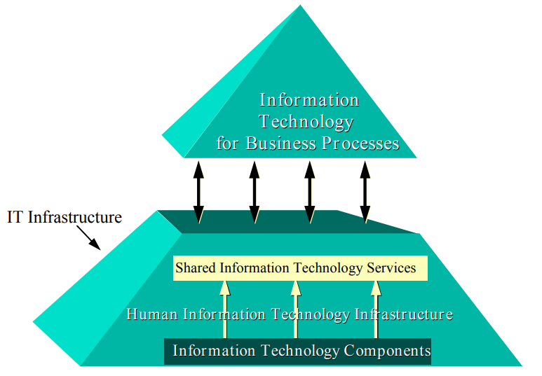

And there are capabilities necessary to enable the infrastructure:

* Services Integration
* Execution Handling
* Services
* Security
* Data Management

Services Integration:

Component communication technologies

* CORBA
* RPC (Remote Procedure Call) & XDS (External Data Representation) Execution Handling:

Execution control technologies

* Globus
* Legion

Services

The components that do the work...

* Core Services - General services to which all applications MUST access in order to "play" within the common distributed computing infrastructure (eg: Resource Broker)
* System Services - Services which any distributed application COULD use to add or improve functionality (eg: Data Service)
* Application Services - Services which are useful for a single class of application (eg: The scientists own custom services!)

Security

Security system requirements

* Registration - persistent storage of identification information
* Identification - a claim of identification credentials
* Authentication - verification of the identification claim
* Authorization - access rights to a resource
* Cryptography - encrypted data transactions

Security technologies

* GSS (Generic Security Service)
* SSL (Secure Socket Layer)
* X.509 (Public Key Certificates)

Data management

Data management technologies

* HPSS (High Performance Storage System)
* SRB (Storage Resource Broker)

Does it fit our needs?

Of course because it covers all news using a regulated system depends on steps of security, storage and services for make it easy for the user.

Does it fit our future needs?

Of course because there is a review and updates every period of time

Software Architecture:

What is the best software architecture for the enterprise/organization based on what we studied?

MVC