 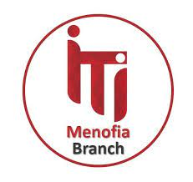

**Marketplace System**

A project submitted in partial fulfillment of the requirements for the course of Python

At ITI.

**“Power BI Developer” Track,**

**2023/2024**

**Project Team**

Abdellatif Nagy Abdellatif

Andrew Ashraf Kamal

Fathi Elsayed Fathi

Sherif Rizk Ismail Abdel

Alaa Ahmed Eraky

**Under Supervision of**

ENG. Mohamed Elgendy.

Table of Contents

Abstract 1

Chapter 1: Project Planning 2

**1.1** **Problem Definition** 3

**1.2** **Project Objectives** 4

**1.3 Literature Review** 5

**1.4** **System Development Requirements** 6

**1.5** **Requirements** 7

**1.6** **SDLC Model** 8

Chapter 2: Analysis 8

**2.1** **Use Case Diagram** 9

**2.2** **Class Diagram** 10

Chapter 3*:* Implementations and Testing 11

**3.1 Run** 12

**3.2** **Implementation** 13

4.1 Conclusion 14

# 

# Abstract

A marketplace is an e-commerce platform that brings together several sellers. In exchange for a commission/subscription on the sales it has generated, the merchants benefit from the audience acquired by the online marketplaces. The particularity of marketplaces is that they only offer for sale products from third-party sellers.

Contrary to popular belief, marketplaces are not only for professionals. In fact, individuals can also sell on some of them. For example, Le Bon Coin is a marketplace that allows anyone to sell any type of product (dishes, cars, ready-to-wear clothes, toys, high-tech objects, etc.).

To put it simply, we can easily compare a marketplace to a digital shopping mall, the latter grouping together several merchants in the same space. Customers can buy products from their favorite brands but also discover new ones.

Just like a physical shop, merchants are responsible for their e-shop and must ensure that they offer an attractive digital shop. They are also responsible for processing customer orders, making sure that customers are satisfied, and collecting positive reviews that will increase their sales and visibility on the online marketplaces where they are present. On the other hand, customers place their orders directly on the marketplace, which acts as a relay between the consumers and the shop(s) concerned.

**Chapter 1: Project Planning**

* 1. **Problem Definition**

an online marketplace is a virtual place where sellers and buyers meet to exchange goods or services. The exchange usually takes the form of transactions managed by the marketplace operator.

The operator measures the overall success rate of the marketplace by the number of deals between buyers and sellers. This is because they typically get a commission out of every transaction. So, to generate revenue it is the operator’s role to build a friendly environment that encourages:

* Sellers to exhibit.
* Buyers to buy.
  1. **Literature Review**

There are many niches you can target with an online marketplace.

On top of this, there are many types of marketplaces. So far, the market has come up with B2B, B2C, service, or C2C types. Yet the core mechanics of any marketplace platform are pretty much the same.

A marketplace should provide these features:

* a promise of ever-growing traffic — to attract new sellers,
* a product catalog which stands out — and generates the traffic,
* a buyer-seller-operator communication and sales tooling — to spark confidence in buying
* a legal framework and transparent payment system — to finally close the sale, guarantee the quality, make buyers come back, and start the cycle again.

As you can imagine, these essentials have a huge impact on the design

of the software the platform works on.

What’s more, they often change over time. As much as we’d like to, we cannot cover all the cases upfront. Without further ado, we’re going to build a marketplace that matches the hardware designers with the hardware manufacturer.

* 1. **Project Objectives**

Marketplaces are complex beasts. There are plenty of things you have to think of.

We’ve discerned the following pillars :

Users Base: how to handle registration and login process for all users types (Customer – Seller).

Product Base : Handling both of Display product information and update quantity.

Online Marketplace Base: Gather all available products to be accessible for buyers.

Order management — how to handle orders through the platform in a simple way

Shopping Cart : How to handle Adding item, removing item, viewing cart, calculating total cost.

Payment Class : Handling both of Process payment and update payment status.

**1.4 System Development Requirements**

* Platform infrastructure & monitoring & recovery — deploying monitoring and alerting measures, error handling guidelines, manual and automatic recovery
* Email & SMS marketing — the use of email and SMS APIs in marketing channels
* Payments & invoices — different payment options and gateways, recurring payments, billing and invoice operations
* Customer service — creating email campaigns for customer onboarding, organizing support and case management
* Customer tracking — how to track marketing channels and users online, A/B testing
* Reporting — collecting and visualizing data
* Promotions — how to generate more traffic and re-engage existing customers
* Shipping — automating shipping
  1. **Requirements**

Design a system for an online marketplace with classes for products, sellers, and customers. A marketplace System should provide these features:

|  |  |
| --- | --- |
| **Functional Requirements** | **Nonfunctional Requirements** |
| * handling registration and login process for all users types (Customer – Seller). * Handling both Display product information and update quantity. * Gathering all available products to be accessible for buyers. * handling orders through the platform in a simple way * Adding item, removing item, viewing cart, calculating total cost. * Handling both of Process payment and update payment status. | * There are many niches you can target with an online marketplace. On top of this, there are many types of marketplace. So far, the market has come up with B2B, B2C, service, or C2C type. Yet the core mechanics of any marketplace platform are pretty much the same. * an online marketplace is a virtual place where sellers and buyers meet to exchange goods or services. |

### 1.13 SDLC Model

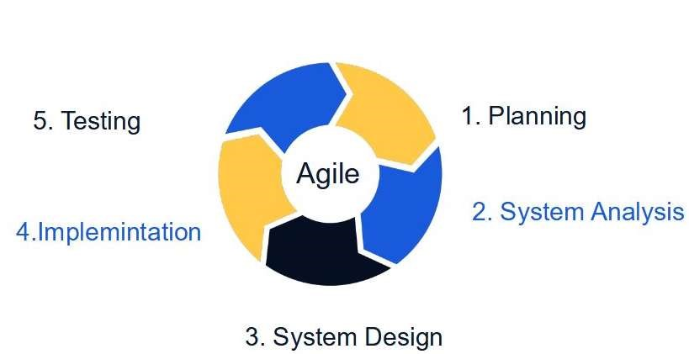

# Chapter 2: Analysis

**2.1 Use Case Diagram**

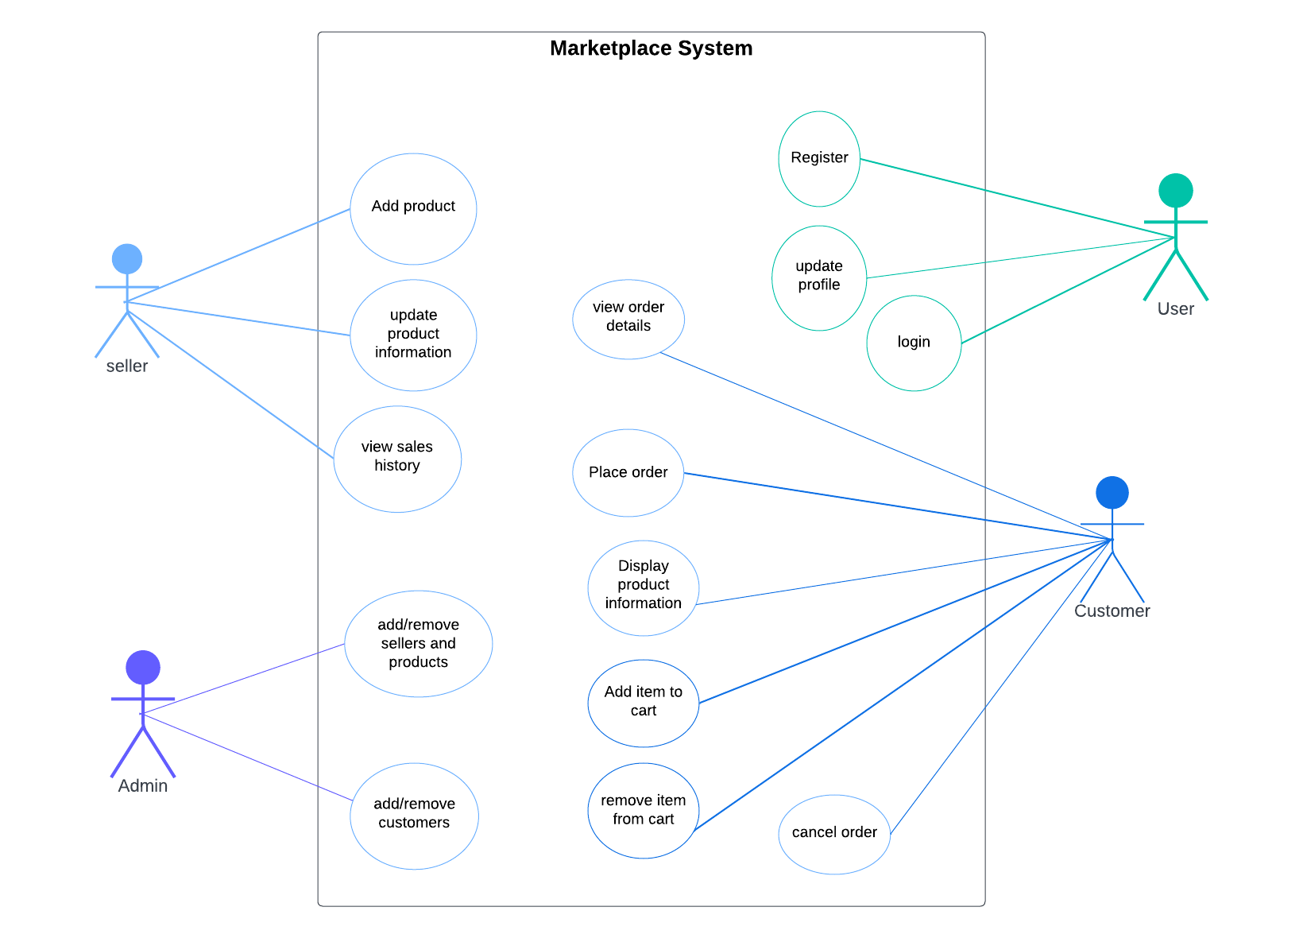

### 2.4 Class Diagram

### 