**system description:**

Traffic lights are signaling devices positioned at road intersections, pedestrian crossings, and other locations to control the flow of traffic.

This system provides cross-walkers availability to cross the road any time they want as it contains a crosswalk button where let the signal operations know that someone is planning to cross the street, so the light adjusts, giving the pedestrian enough time to get across.

It can detect if the button is pressed and hence according to state on cars’leds, system will take the action to change appropriate leds for both cars and pedestrians to make a smooth road for cross walkers to cross the road.

**system design:**

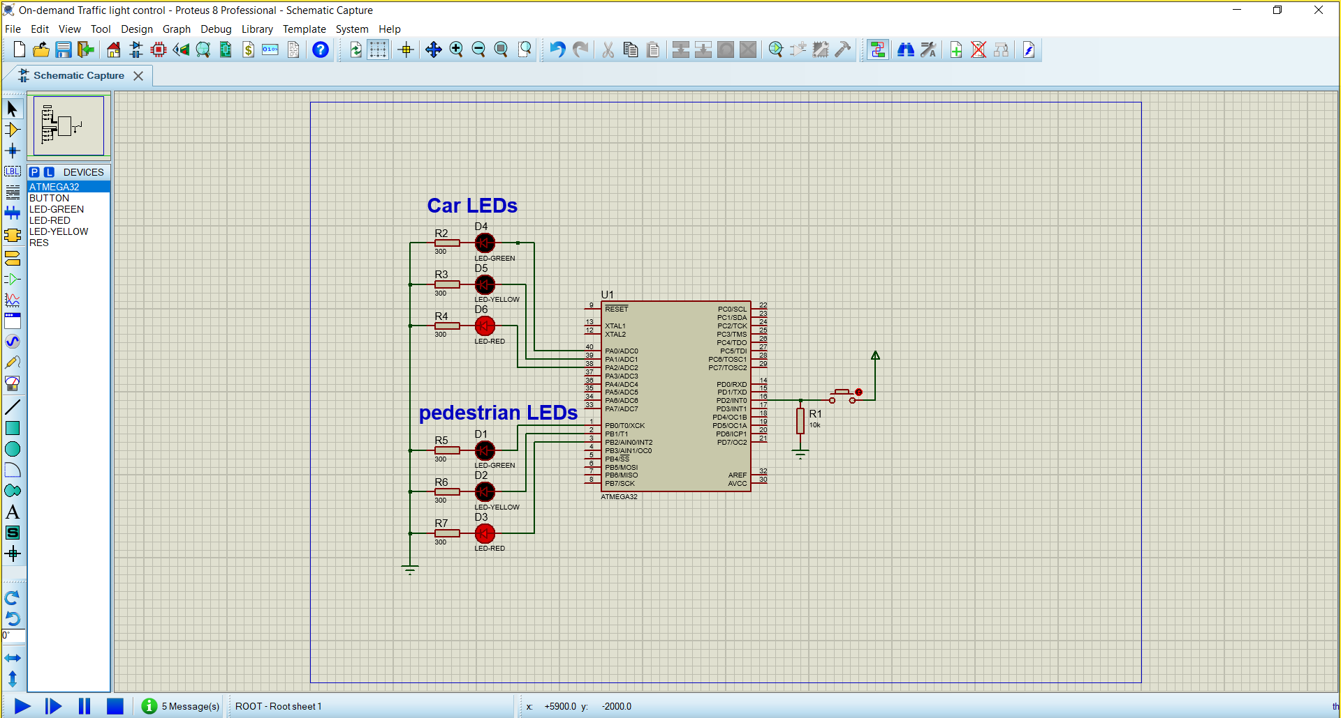

**System Constraints**

* Double press on the push button will only read the first press.
* A long press on the push button will only read one only.
* Pressing the button while the Car Signal is RED or YELLOW does nothing.

**system flow chart:**

