Restaurant Suite Scenarios And Images
This guide combines the live dashboard captures, generated Flutter workspace screenshots, and the operational flow cards already produced from the API walkthrough.
Flutter images in this document come from widget goldens generated on April 1, 2026 from the current code in `factory_app`. Dashboard images come from the live owner dashboard capture set already in the repository.

Scenario 1: Returning Customer Dines In And Earns Loyalty

Step 1. Customer opens the app and checks order memory, restaurants, and points
The customer app is designed like a warm marketplace homepage: registered restaurants, previous orders, and loyalty points are visible immediately.
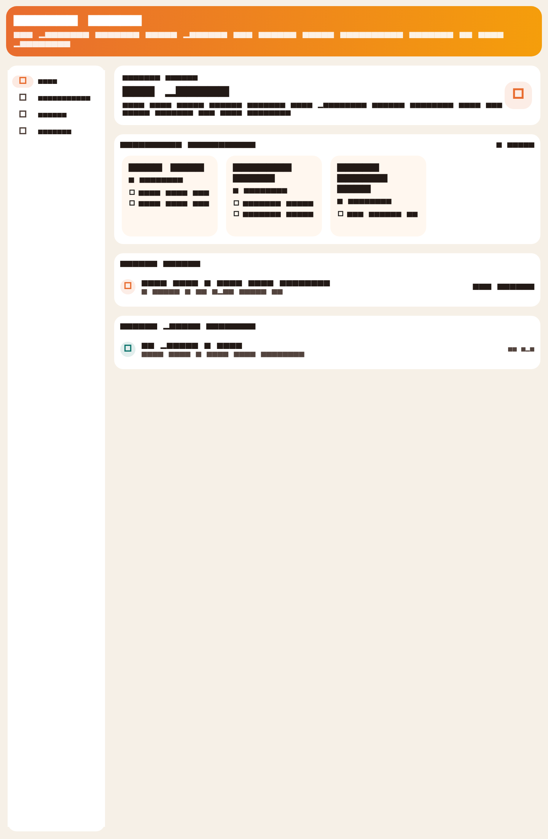
Customer app home with restaurants, order history, and rewards visibility.

Step 2. Waiter sees the floor in a table-first layout
The waiter app prioritizes table occupancy, table value, and guest context, which is the fastest mental model for dine-in operations.
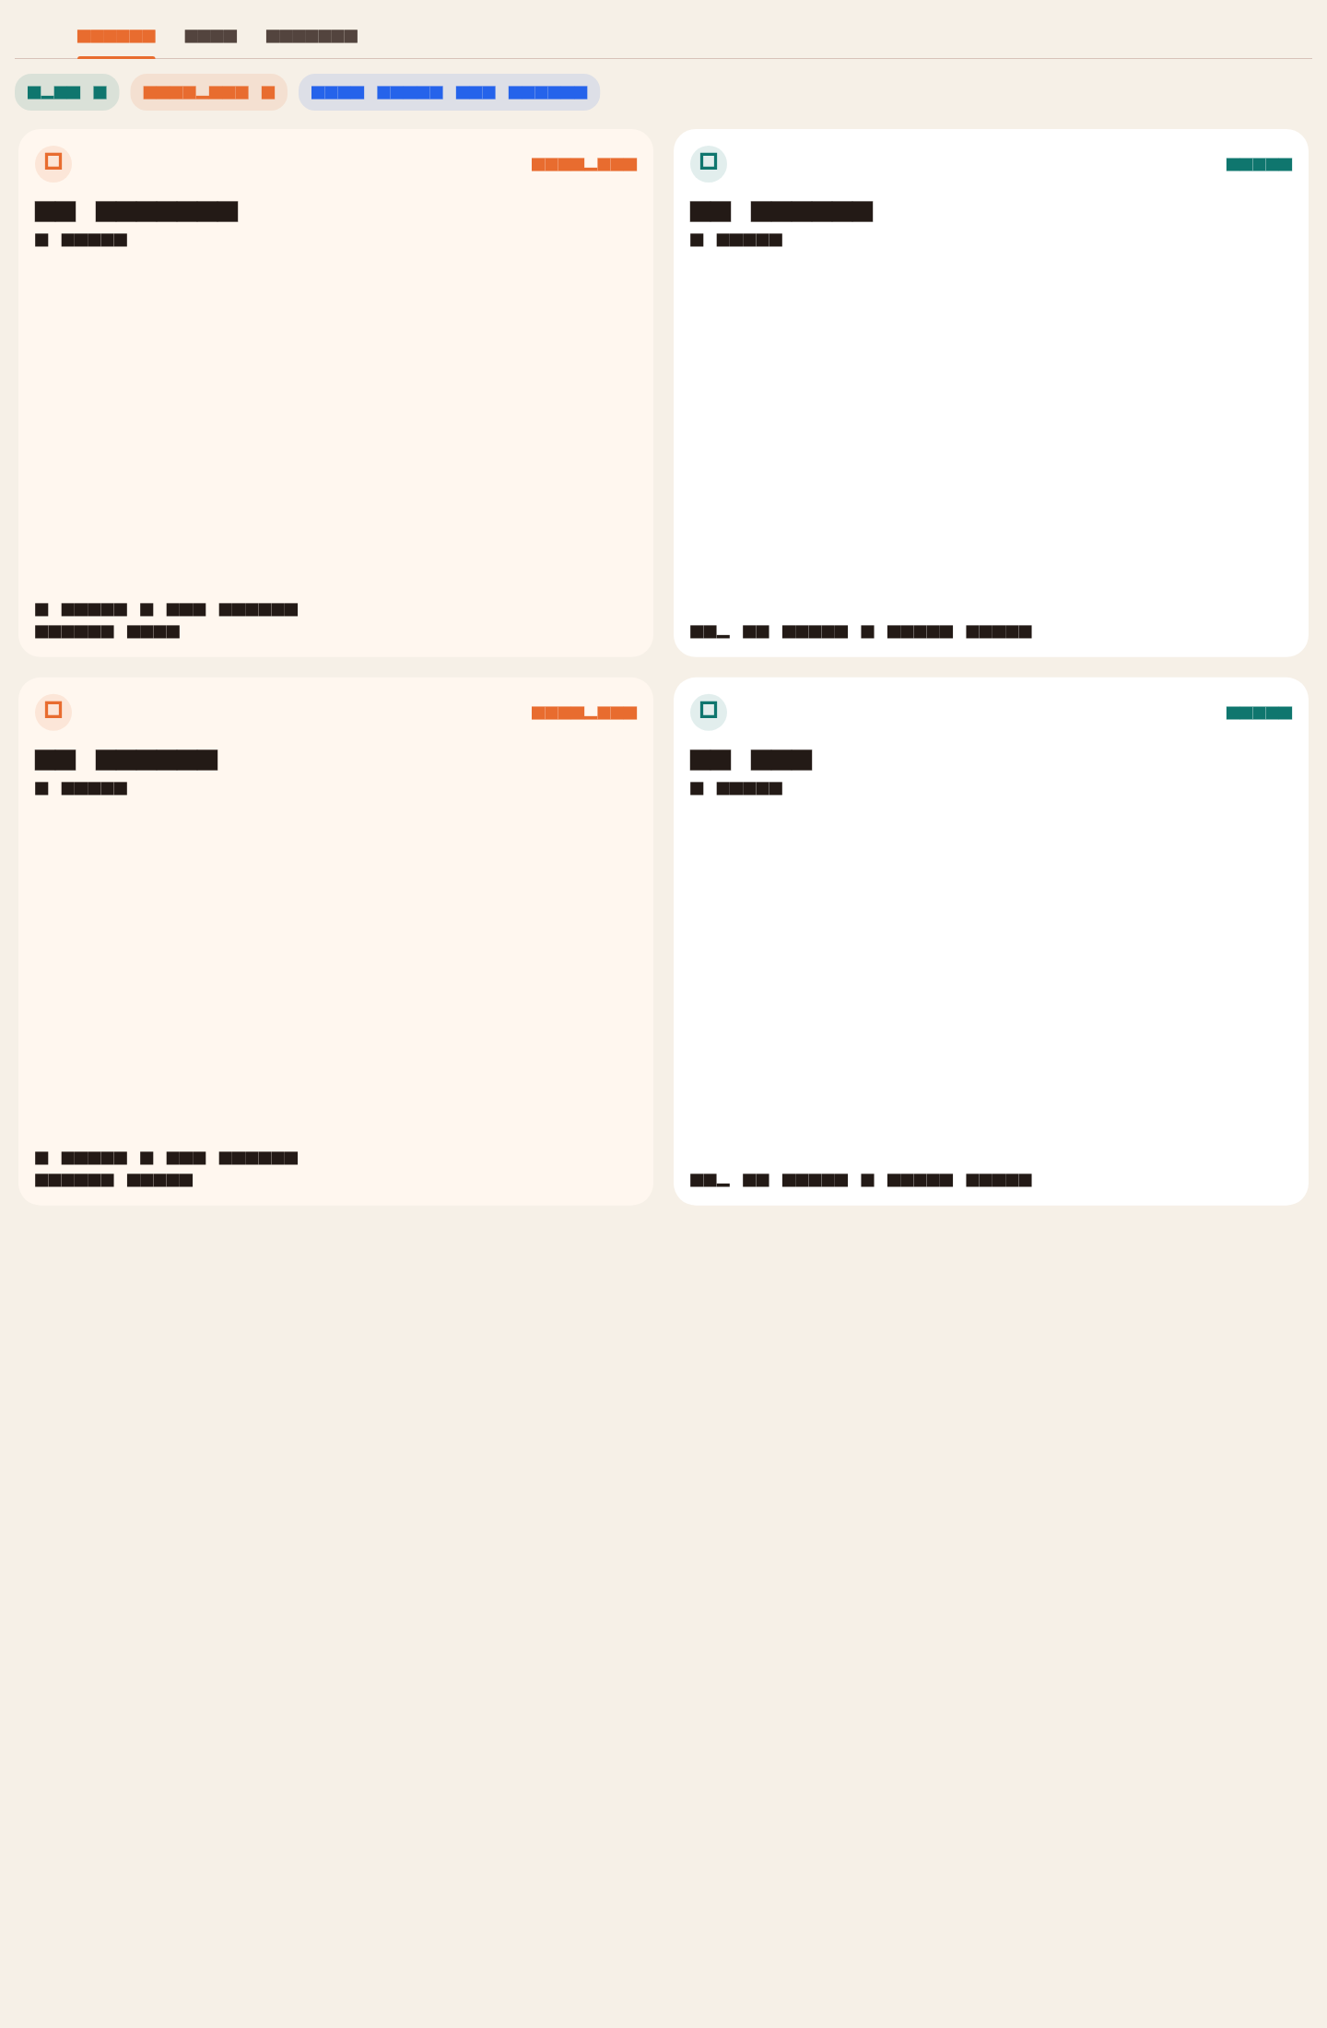
Waiter workspace with live open and occupied tables.

Step 3. Waiter opens the active table, attaches customer phone, adds notes, answers, and modifiers
This closes a meaningful gap in the old repo state because dine-in orders can now be tied to a real customer profile for history and loyalty visibility.

Waiter order detail with customer phone, current items, and menu composer.

Step 4. Kitchen receives the ticket and advances item states
Queued, preparing, and ready states are visible per item. Kitchen can advance each line item without waiting on a full-order status change.
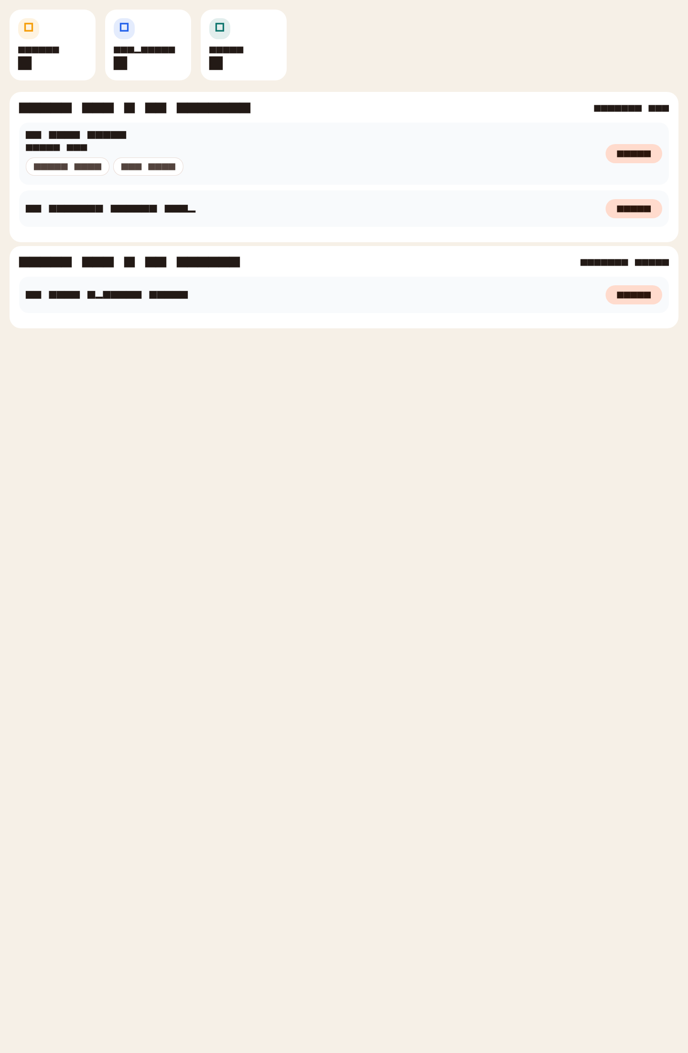
Kitchen board with live queued, preparing, and ready tickets.

Step 5. Cashier settles the order with one or multiple tenders
The cashier workspace supports multiple tenders in one settlement flow, which directly addresses a visible gap against Foodics-style dine-in bundles.
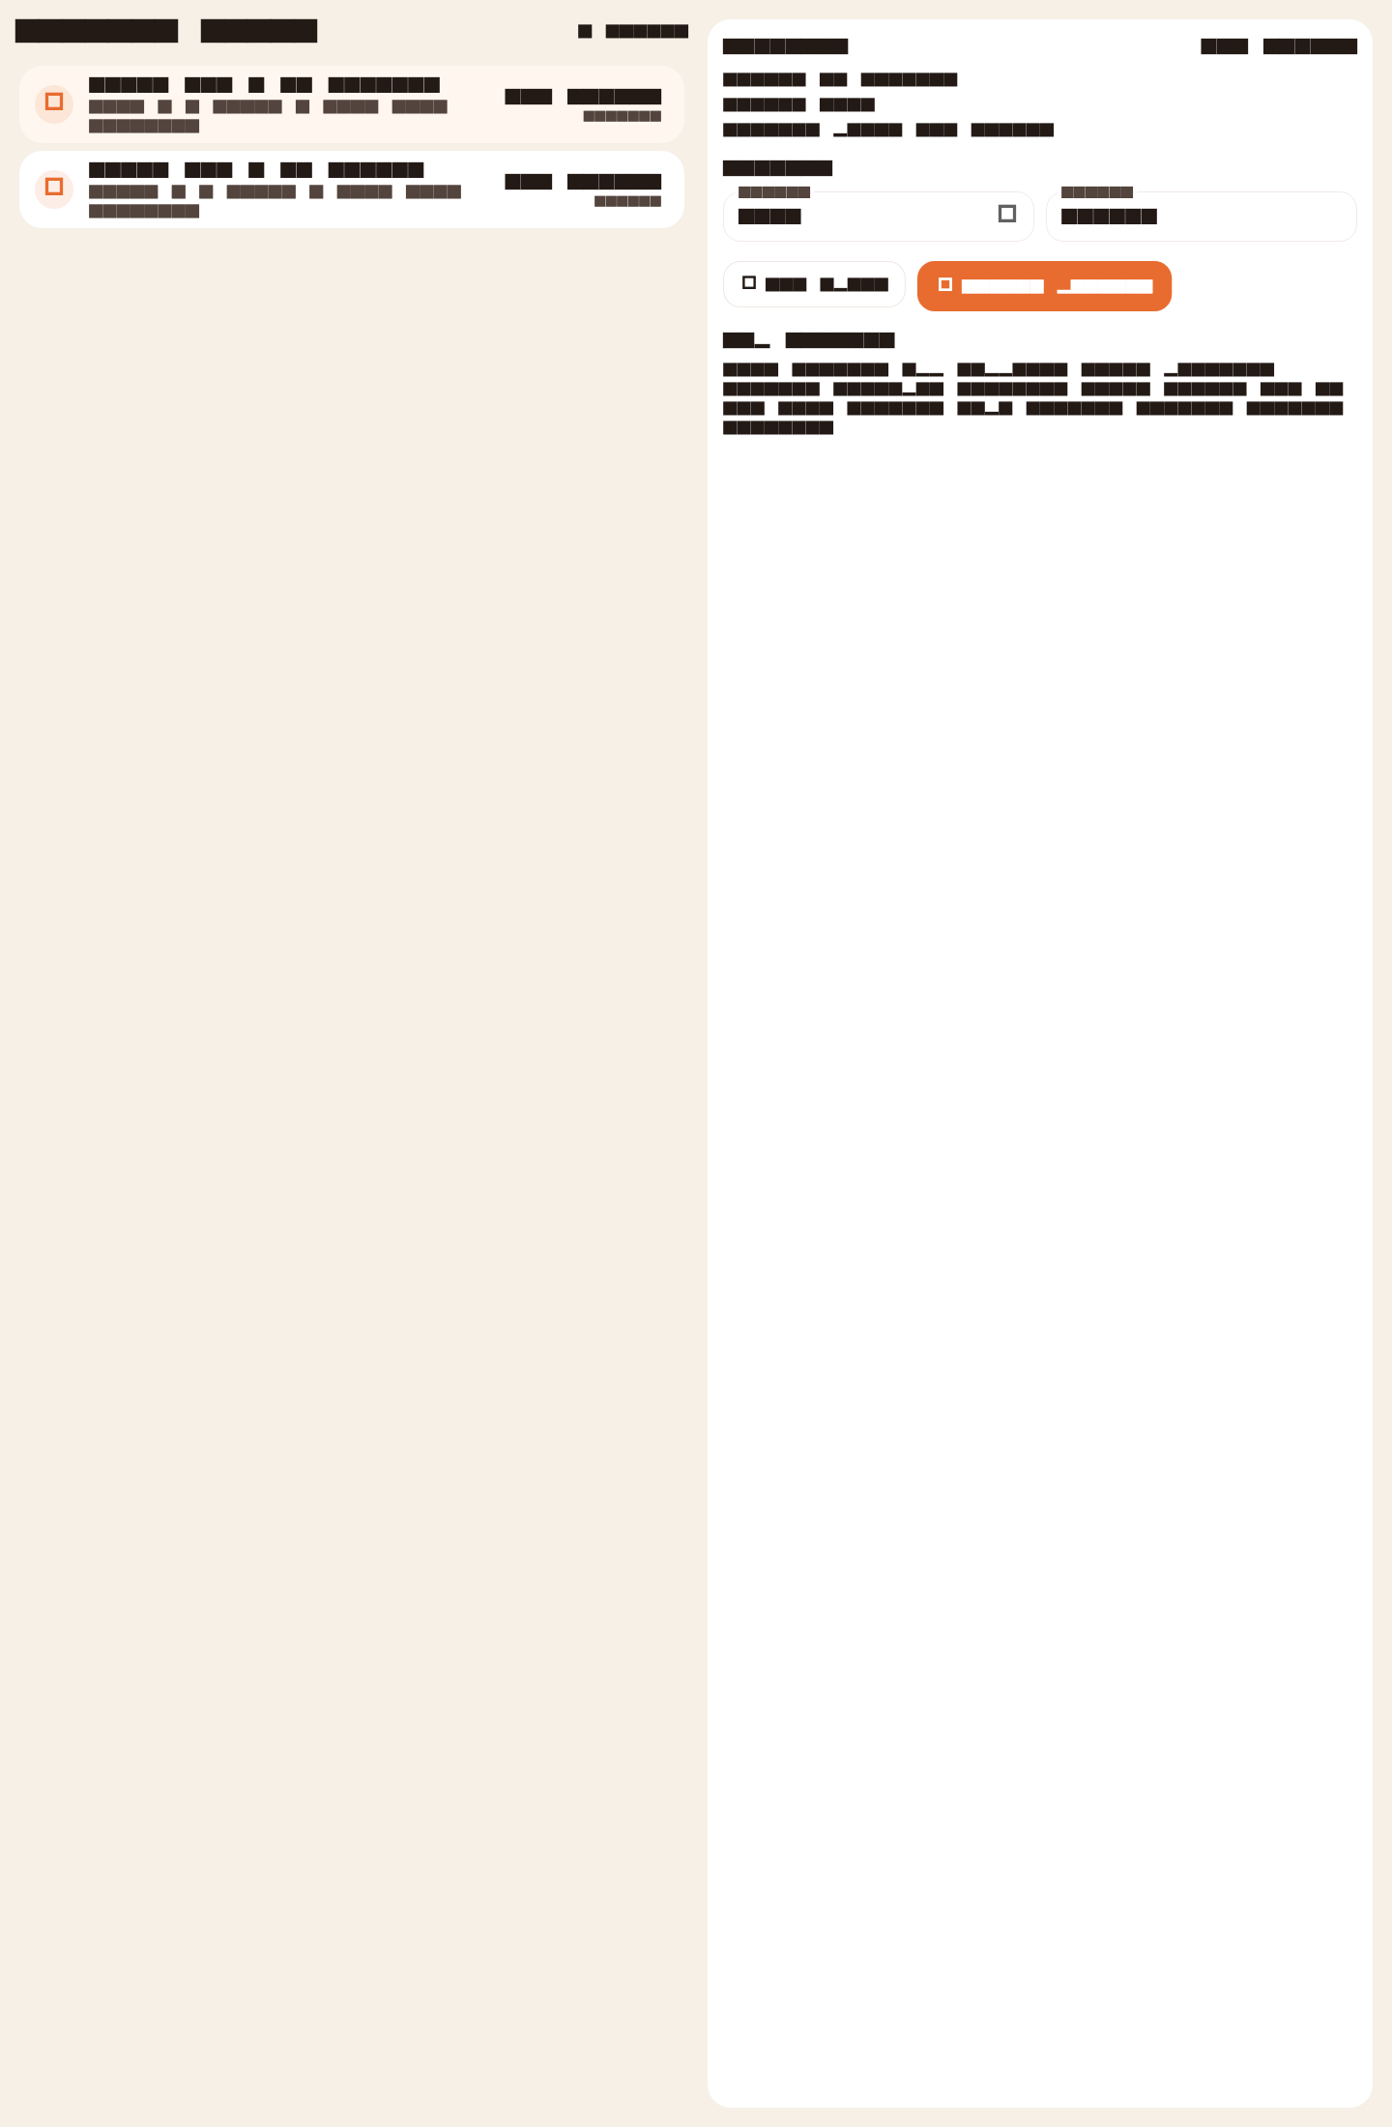
Cashier queue and split-payment settlement workspace.

Step 6. Owner and shareholders see the result in branch-level analytics
The owner workspace surfaces revenue, cashier queue, KDS backlog, branch ranking, and loyalty member count. The live dashboard capture below shows the web side of the same operational flow.
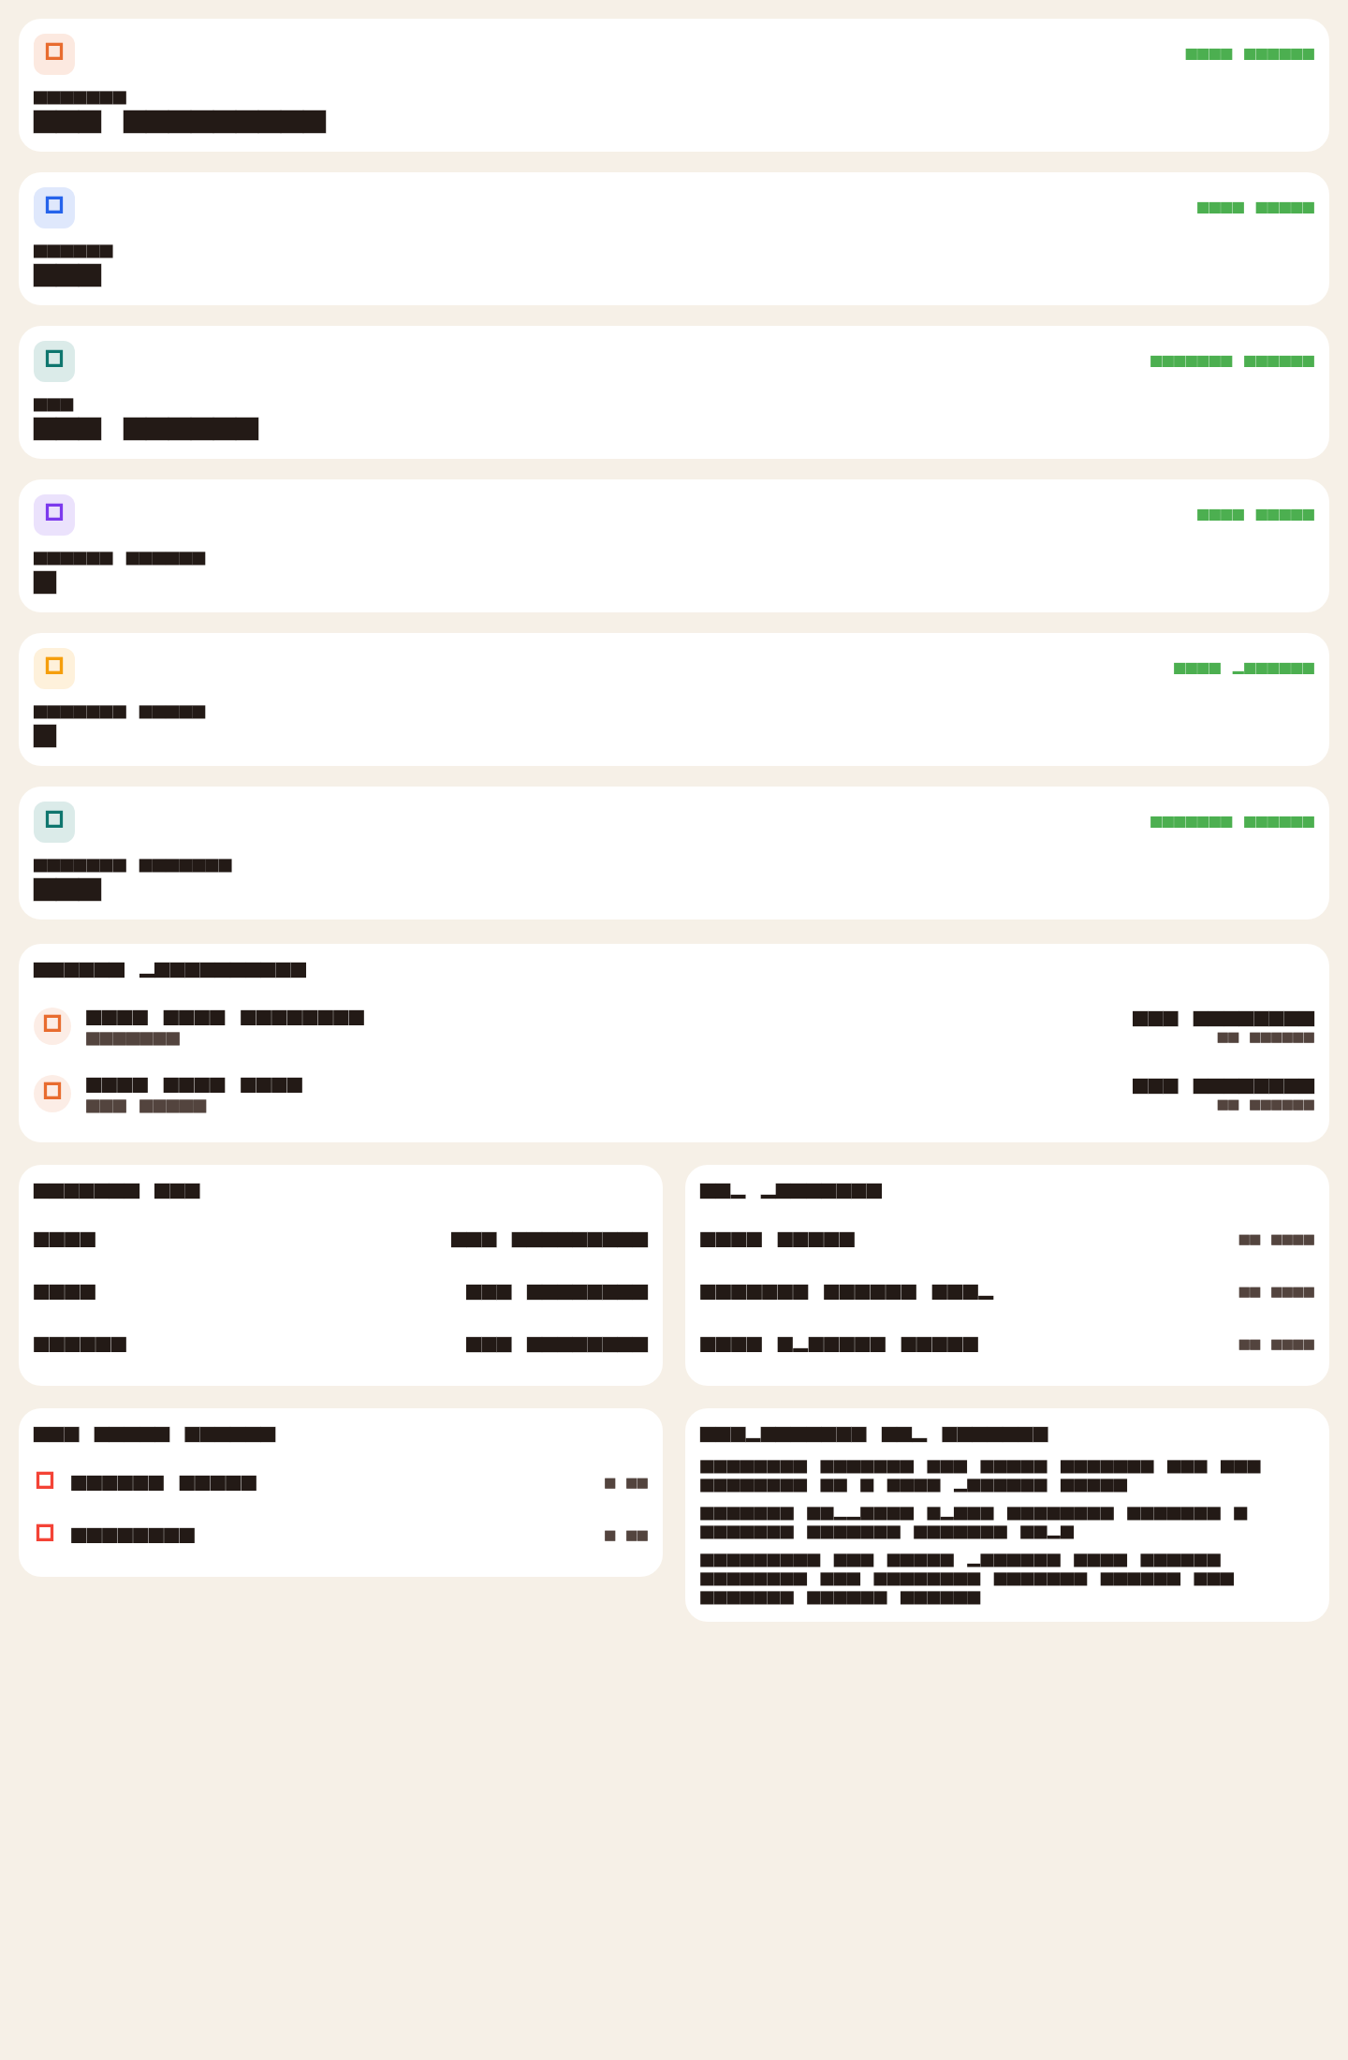
Flutter owner control center.
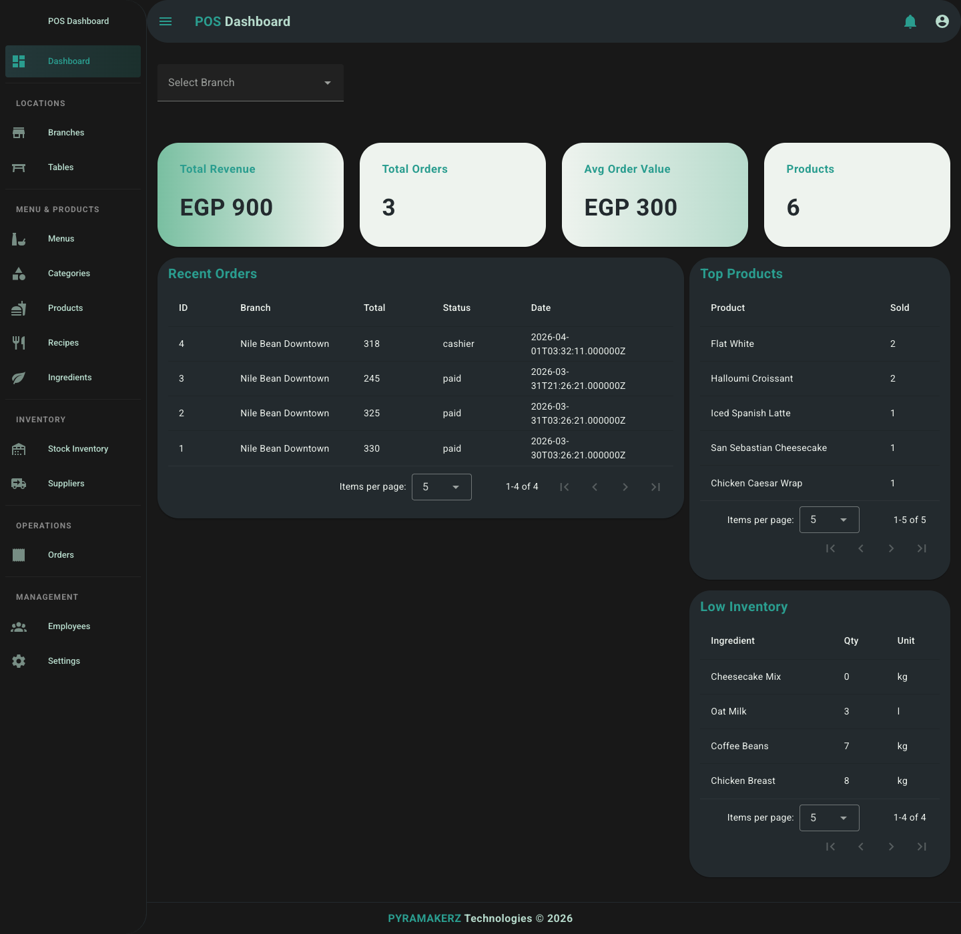
Live web dashboard after the walkthrough payment step.

Scenario 2: Real Dine-In Exception Handling

Quantity Change
The waiter can reduce an item quantity after submission. The API keeps history and recalculates totals.
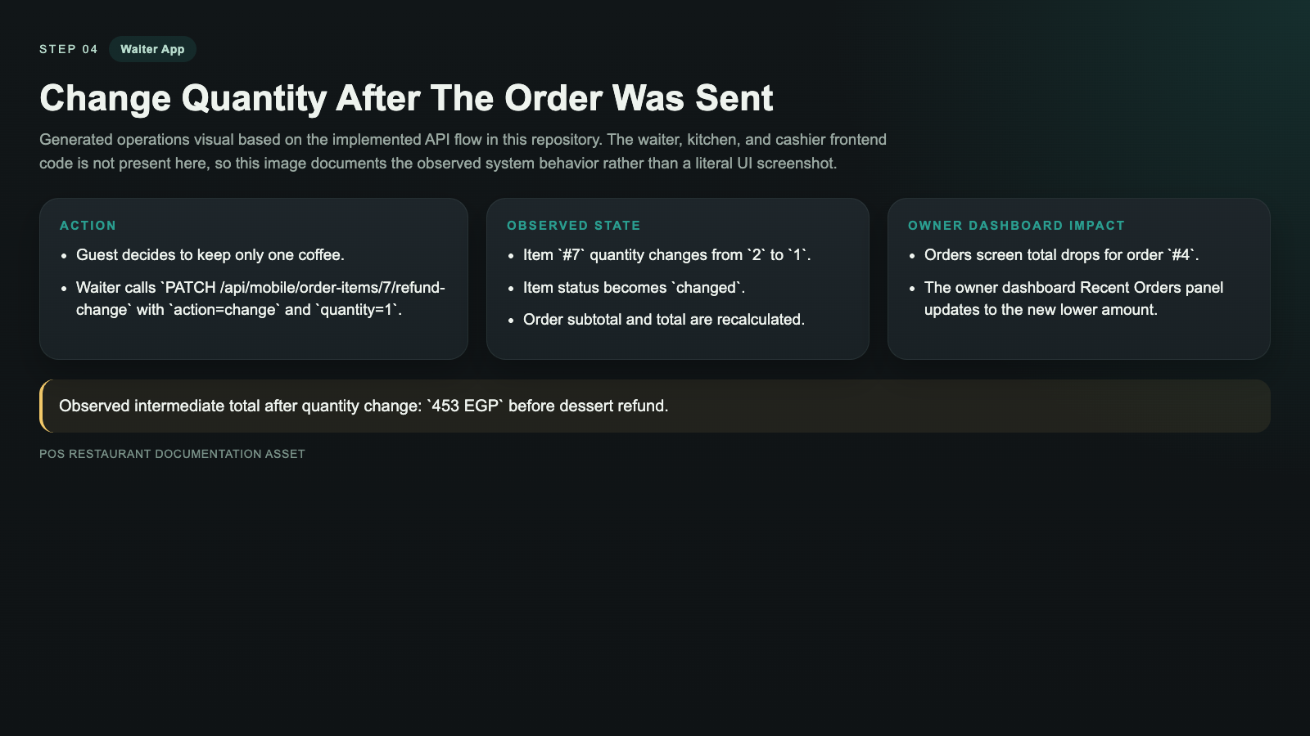

Refund One Item
The waiter can refund an item and preserve auditability instead of silently editing the order line.
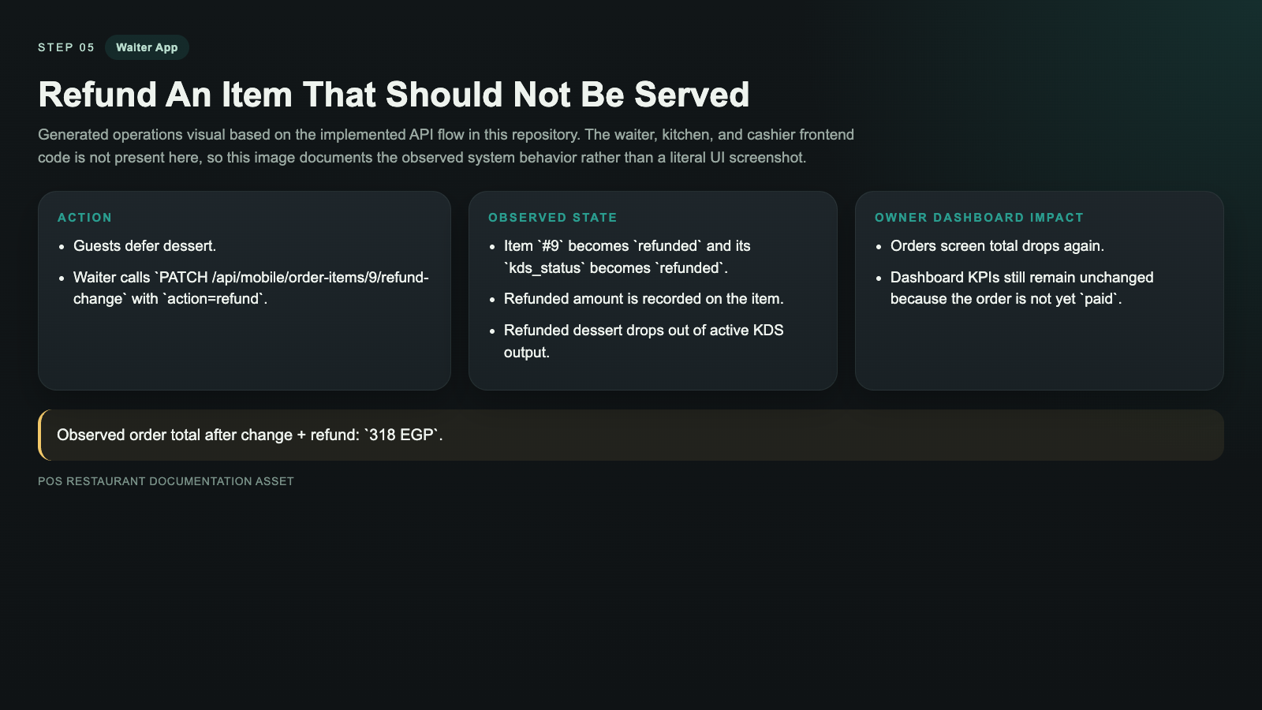

Reopen After Settlement
Paid orders can be reopened, which is important for late add-ons and floor corrections.

Move Table
The system supports audit-safe table moves by closing the source order and cloning active items into the target table order.
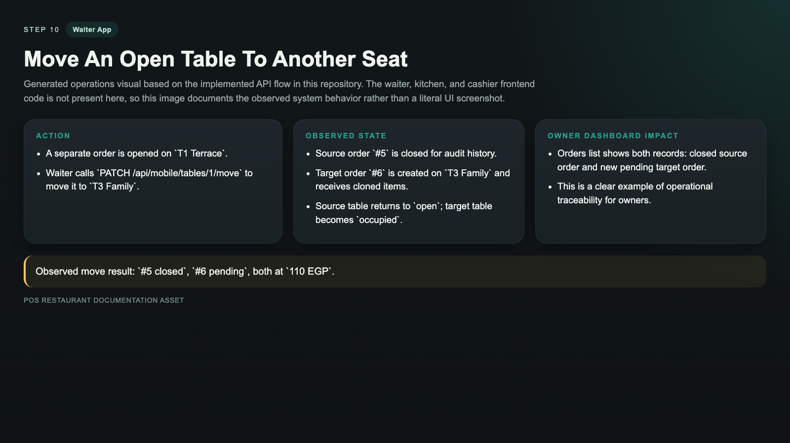

Scenario 3: Dashboard Effects During The Same Service Window

Before Service
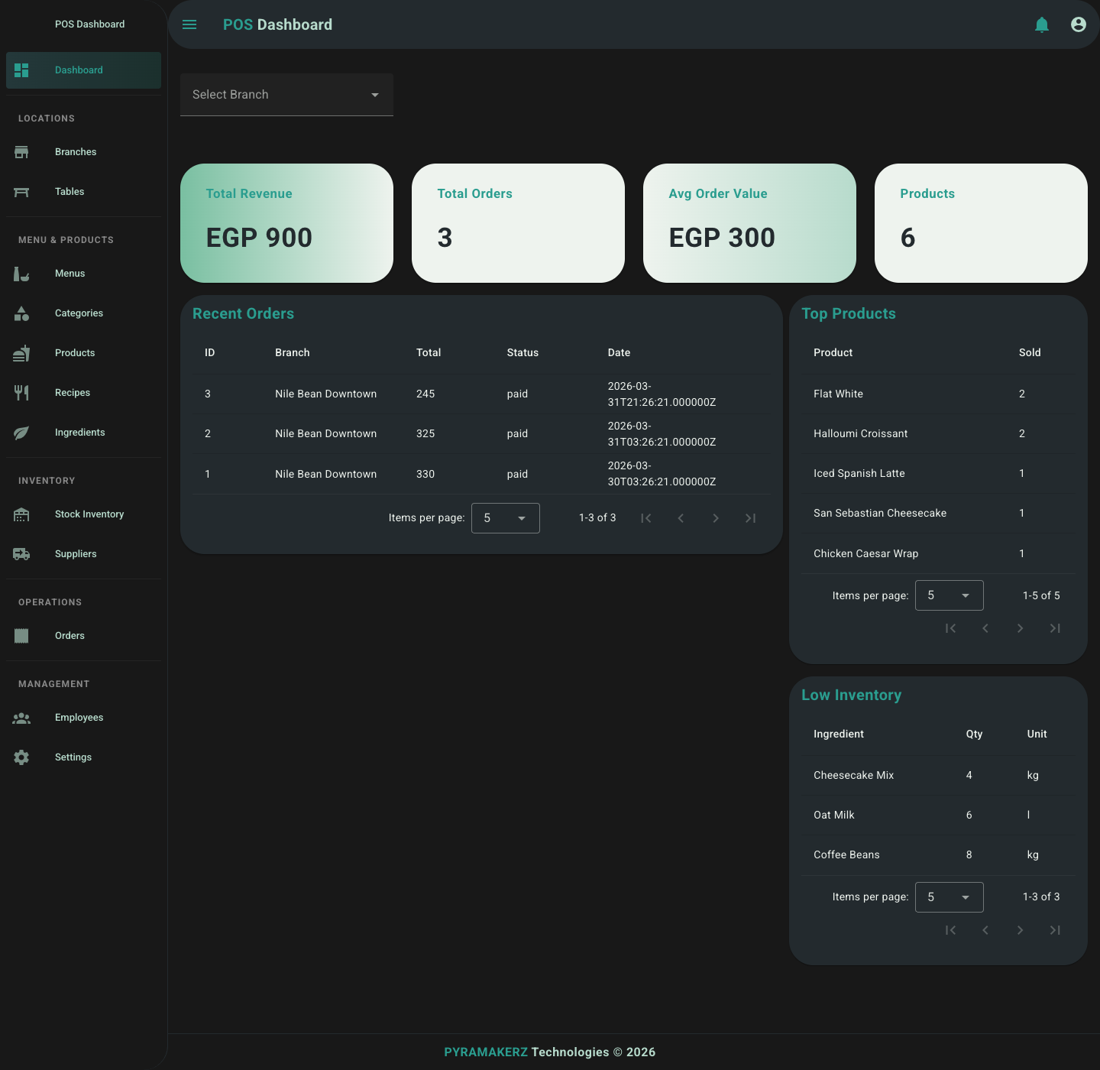
Baseline owner KPIs before the walkthrough flow started.

After Order And Adjustments
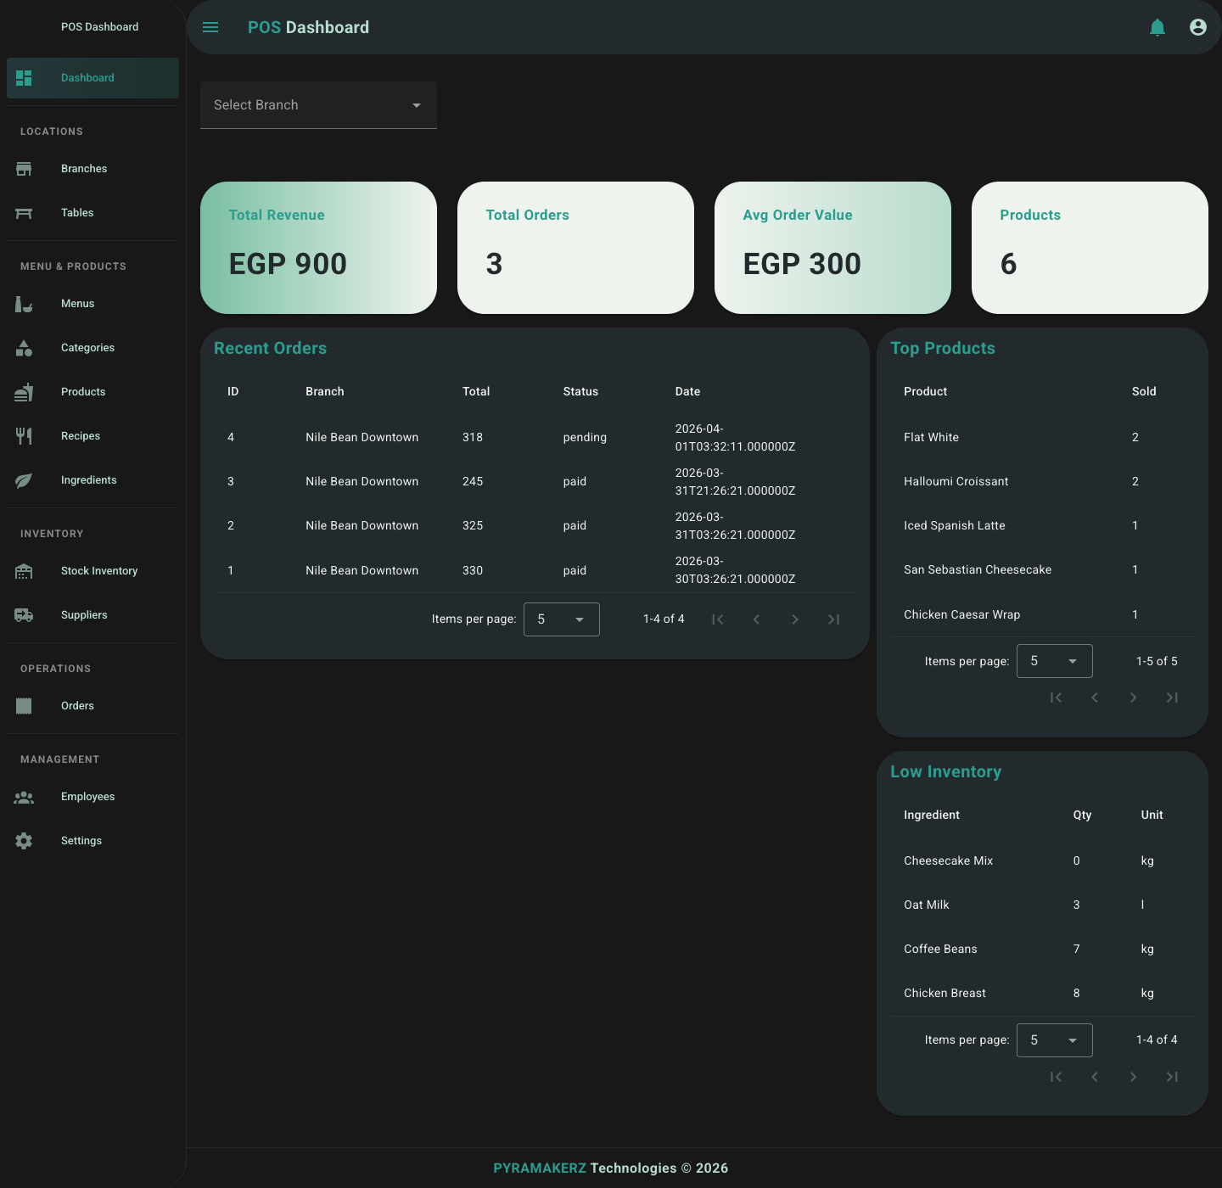
Revenue pipeline and recent orders reflect order creation and item adjustments.

After Payment

Payment data and recent activity update after settlement.

After Table Move
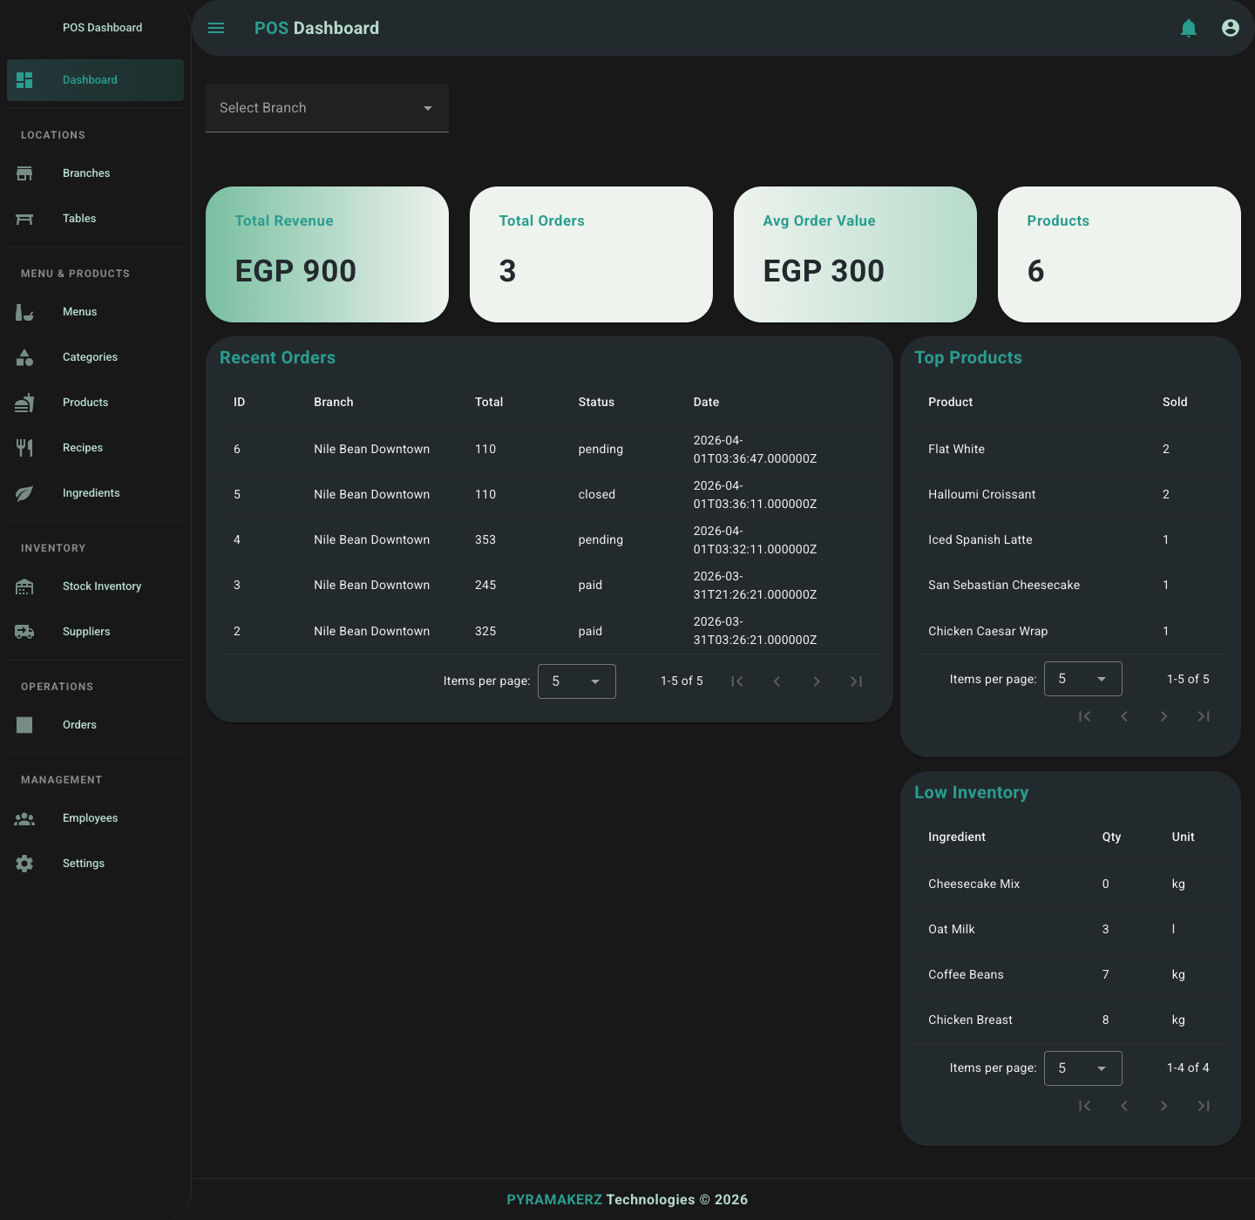
Order history preserves the source and target table timeline.

Recommended Next Scenario Packs
- Large family table splits the bill across cash plus card plus wallet.
- Busy brunch service with one kitchen bottleneck and one cashier bottleneck.
- VIP repeat guest arrives, waiter recognizes phone, and owner dashboard later measures loyalty lift.
- Multi-branch operator compares lunch shift performance between branches and drills into payment mix.

