Golden First Day Scenario
Real first-day sanity run for a newly signed restaurant using the full Restaurant Suite flow from platform admin setup through end-of-day owner review.
Harbor Ember Kitchen Generated 2026-04-03 03:34 UTC sqlite scenario database
The operational scenario itself was executed against the live Laravel API and scenario database. Web dashboard screenshots are live captures from that run. Flutter screenshots are scenario-matched captures from the current app UI so the step-by-step report shows the exact surfaces used by customer, waiter, cashier, kitchen, and owner roles.

Scenario Setup

Restaurant Created
Harbor Ember Kitchen was created as a restaurant and launched with three operating branches.
Branch ID | Branch | Location
28 | Downtown Flagship | Downtown Cairo
29 | New Cairo Studio | New Cairo
30 | Maadi Terrace | Maadi

Primary Accounts
Role | Name | Email
Owner | Rana Soliman | `owner.harbor-ember-kitchen@example.com`
Stakeholder | Hossam Gaber | `stakeholder.harbor-ember-kitchen@example.com`
Admin | Restaurant Suite Admin | `admin@restaurant-suite.com`

Operational Staff By Branch
Branch | Employee | Role / Type | Login
Downtown Flagship | Dina Farouk | supervisor | `dina.farouk.downtown-flagship@example.com`
Downtown Flagship | Karim Adel | waiter | `karim.adel.downtown-flagship@example.com`
Downtown Flagship | Salma Nasser | cashier | `salma.nasser.downtown-flagship@example.com`
Downtown Flagship | Tamer Wael | kitchen | `tamer.wael.downtown-flagship@example.com`
New Cairo Studio | Nour Hassan | waiter | `nour.hassan.new-cairo-studio@example.com`
New Cairo Studio | Ahmed Samy | cashier | `ahmed.samy.new-cairo-studio@example.com`
New Cairo Studio | Mina Wagdy | kitchen | `mina.wagdy.new-cairo-studio@example.com`
Maadi Terrace | Mariam Fares | waiter | `mariam.fares.maadi-terrace@example.com`
Maadi Terrace | Omar Lotfy | cashier | `omar.lotfy.maadi-terrace@example.com`
Maadi Terrace | Lina Atef | kitchen | `lina.atef.maadi-terrace@example.com`

Launch Catalog Snapshot
The owner seeded the first-day menu, floor map, and stock thresholds before service opened. The table below shows the first nine sellable items created across the three branches.
Branch | Category | Product | Price | Stock | Min stock
Downtown Flagship | Breakfast & Brunch | Cedar Chicken Bowl | EGP 198 | 16 | 8
Downtown Flagship | Breakfast & Brunch | Harissa Penne | EGP 214 | 12 | 6
Downtown Flagship | Signature Drinks | Spanish Latte | EGP 92 | 30 | 12
Downtown Flagship | Signature Drinks | Citrus Sparkling Cooler | EGP 84 | 24 | 10
Downtown Flagship | Desserts | Sea Salt Brownie | EGP 74 | 6 | 8
New Cairo Studio | Breakfast & Brunch | Cedar Chicken Bowl | EGP 198 | 16 | 8
New Cairo Studio | Breakfast & Brunch | Harissa Penne | EGP 214 | 12 | 6
New Cairo Studio | Signature Drinks | Spanish Latte | EGP 92 | 30 | 12
New Cairo Studio | Signature Drinks | Citrus Sparkling Cooler | EGP 84 | 24 | 10

Step-By-Step Timeline

Step 1. Web Dashboard - Login
Platform Admin Restaurant Suite Admin
Action: Signed into the platform dashboard with the seeded admin account.
Outcome: Admin session token was issued successfully and cross-restaurant control is available.
Clicks and operator actions
- Open the platform dashboard login page.
- Enter `admin@restaurant-suite.com` and `password`.
- Click `Sign in`.
API POST /api/login HTTP 200
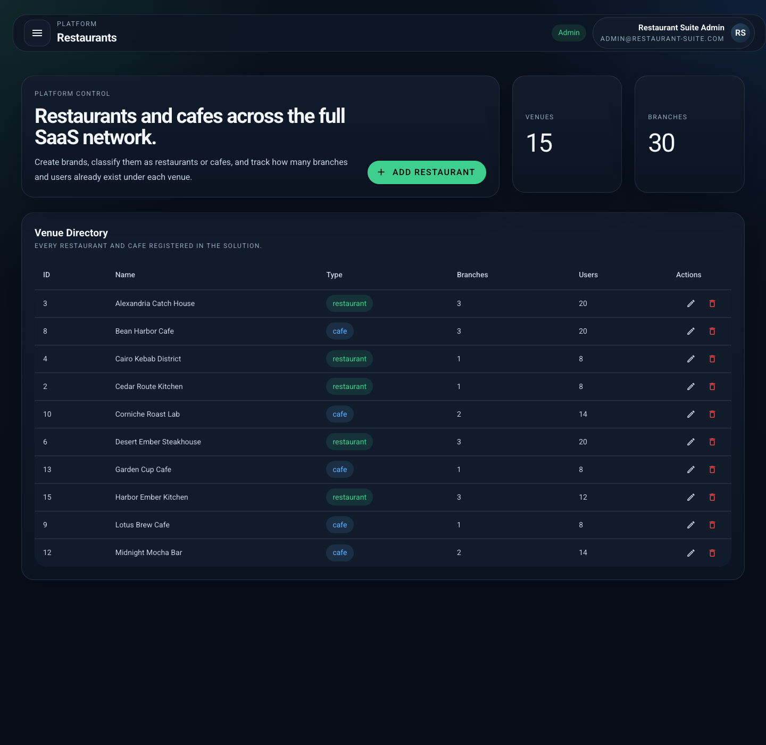
Platform admin session after login with restaurant management available.

Step 2. Web Dashboard - Restaurants
Platform Admin Restaurant Suite Admin
Action: Opened Restaurants, clicked Add Restaurant, entered `Harbor Ember Kitchen`, selected `restaurant`, and clicked Save.
Outcome: The new restaurant was created and became available for branch, owner, menu, and employee setup.
Clicks and operator actions
- Open the left navigation and click `Restaurants`.
- Click `Add Restaurant`.
- Enter `Harbor Ember Kitchen`.
- Set venue type to `restaurant`.
- Click `Save`.
API POST /api/restaurants HTTP 201

Restaurants page after Harbor Ember Kitchen was added.

Step 3. Web Dashboard - Branches
Platform Admin Restaurant Suite Admin
Action: Opened Branches, clicked Add Branch three times, and created Downtown Flagship, New Cairo Studio, and Maadi Terrace for the new restaurant.
Outcome: All three operational branches were created and linked to Harbor Ember Kitchen.
Clicks and operator actions
- Click `Branches` in the platform navigation.
- Click `Add Branch` three times.
- Save `Downtown Flagship`, `New Cairo Studio`, and `Maadi Terrace`.
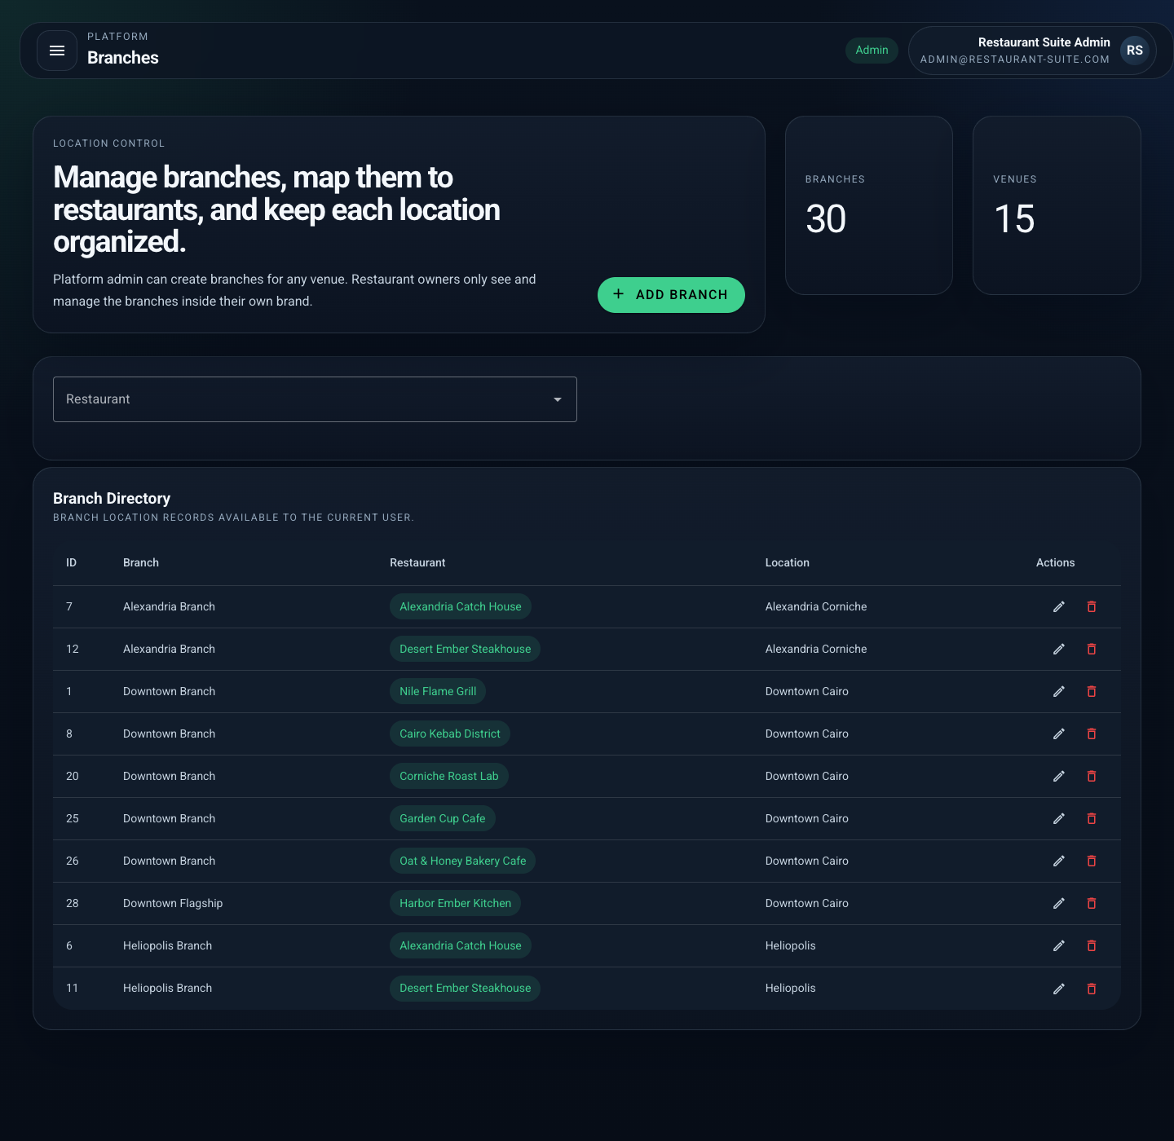
Branches page showing the three newly created operating branches.

Step 4. Web Dashboard - Users
Platform Admin Restaurant Suite Admin
Action: Opened Users and provisioned the owner, stakeholder, supervisor, waiter, cashier, and kitchen users for the new restaurant.
Outcome: The restaurant now has authenticated accounts for admin control, owner oversight, and branch operations on the waiter, cashier, kitchen, and owner apps.
Clicks and operator actions
- Click `Users` and choose `Add User`.
- Create the owner and stakeholder accounts.
- Create the supervisor, waiter, cashier, and kitchen accounts for each branch.
- Open `Roles & Permissions` to verify access boundaries.
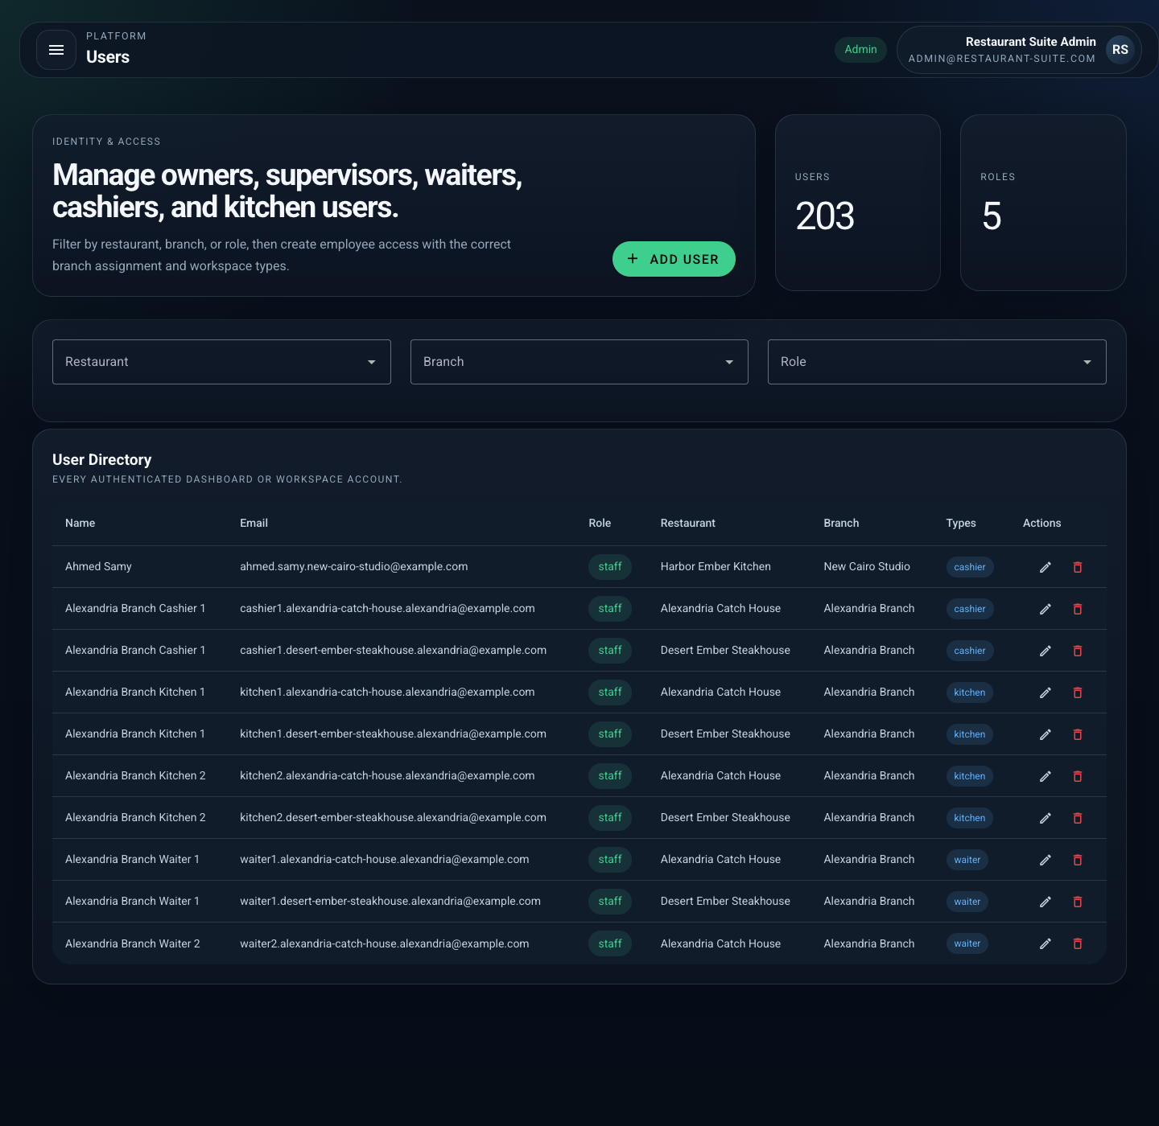
Users page after provisioning owner, stakeholder, and branch staff.
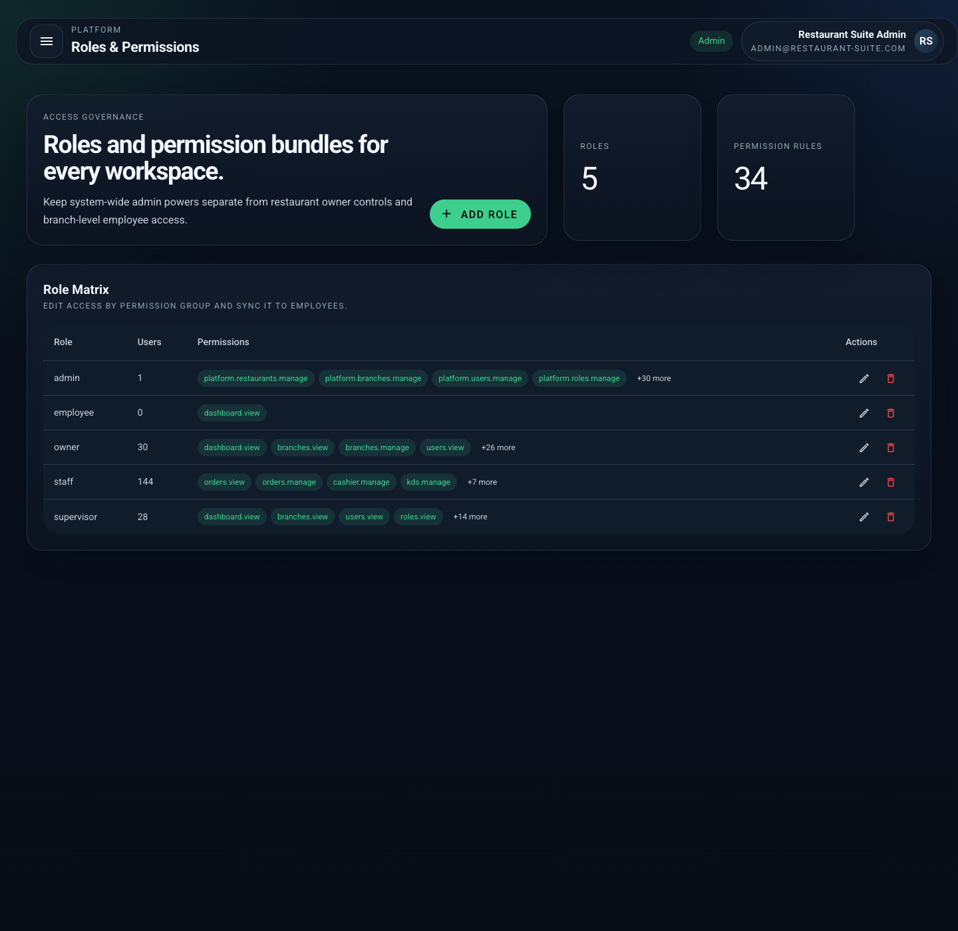
Roles and permissions page used to control access across the platform.

Step 5. Web Dashboard - Login
Owner Rana Soliman
Action: Signed into the owner dashboard for Harbor Ember Kitchen.
Outcome: Owner-scoped session is active and restricted to the new restaurant.
Clicks and operator actions
- Sign out of the platform admin session.
- Enter owner credentials for `Rana Soliman`.
- Click `Sign in` to switch to restaurant-scoped ownership.
API POST /api/login HTTP 200
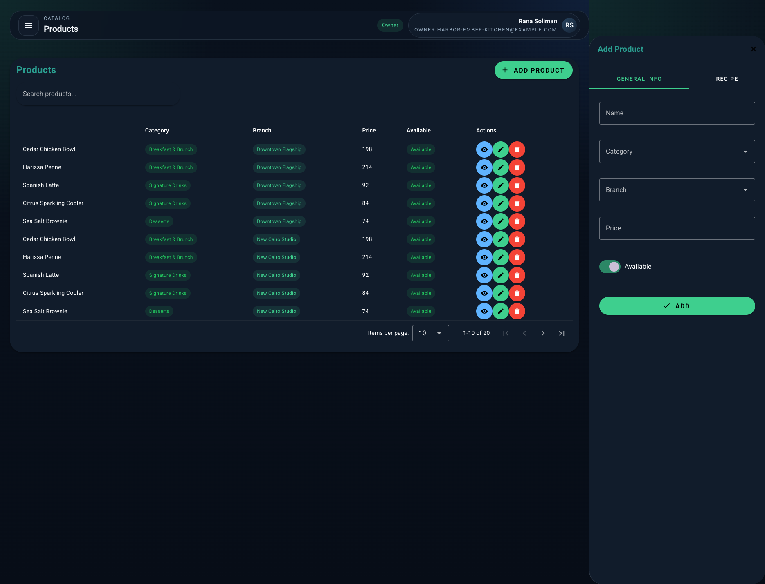
Owner-scoped dashboard session restricted to Harbor Ember Kitchen.

Step 6. Web Dashboard - Catalog & Tables
Owner Rana Soliman
Action: Opened Categories, Products, Menus, Tables, Inventory, and Employees to create the launch catalog, dining room map, team records, and low-stock monitoring for each branch.
Outcome: Each branch now has a working menu, sellable products, dine-in tables, employee records, and inventory thresholds for the first trading day.
Clicks and operator actions
- Open `Categories` and create the launch sections.
- Open `Products` and save the sellable meals, drinks, and dessert items.
- Open `Menus` and attach products to the correct branches.
- Open `Tables` and define the dine-in floor map.
- Open `Inventory` and save stock thresholds.
- Open `Employees` and confirm team records are attached to branches.

Products page with the launch catalog ready to sell.
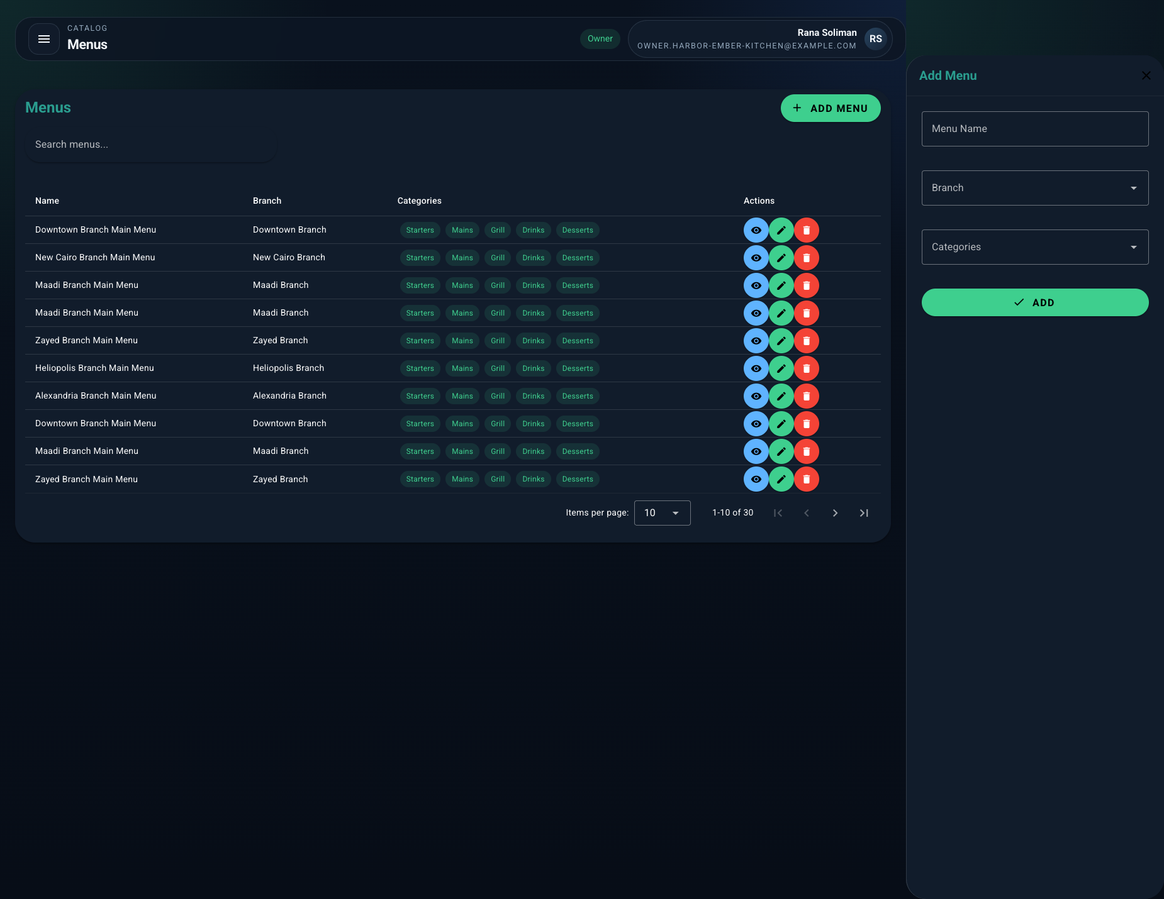
Menus page with branch-ready menu structure.
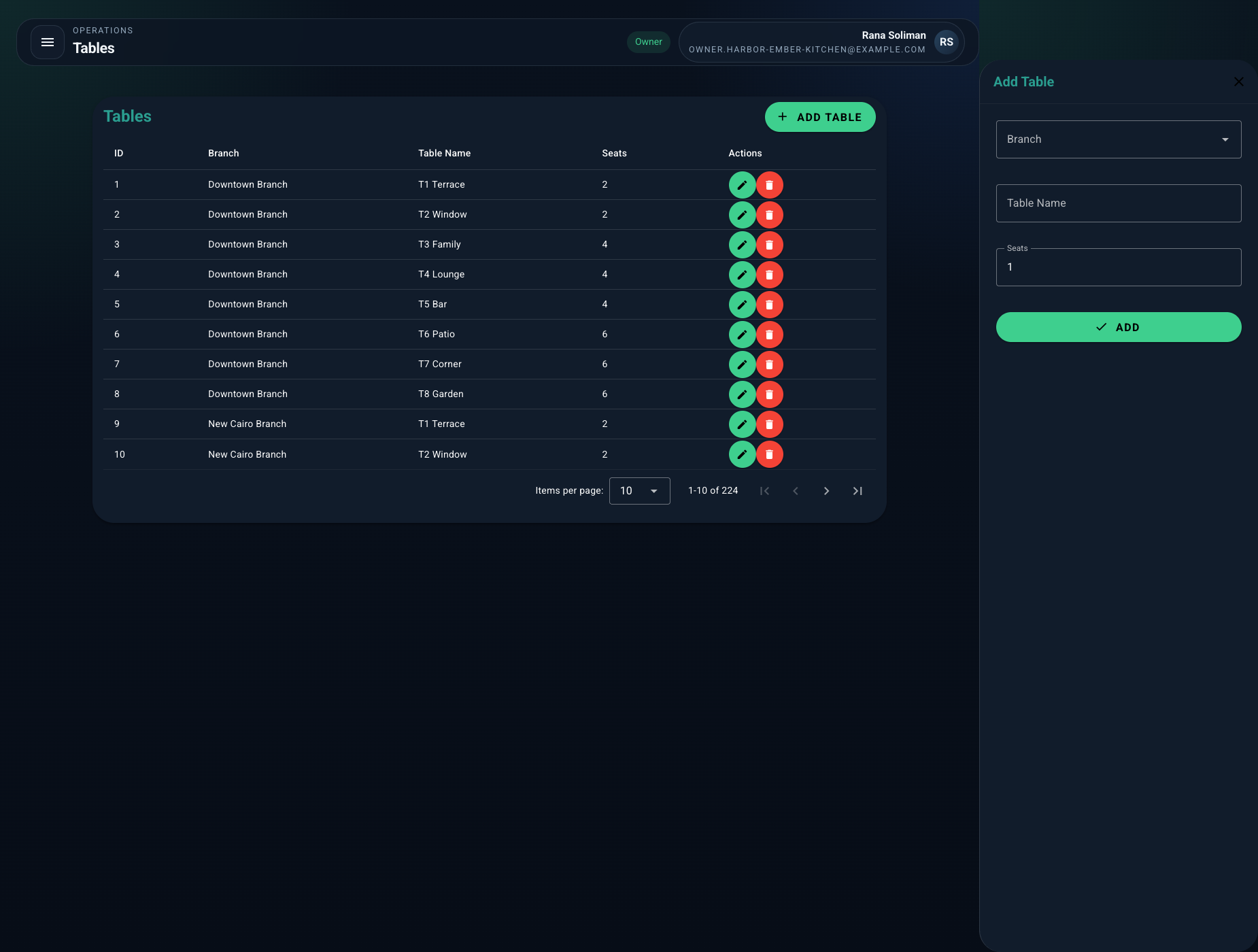
Tables page with the dine-in floor map and table inventory.
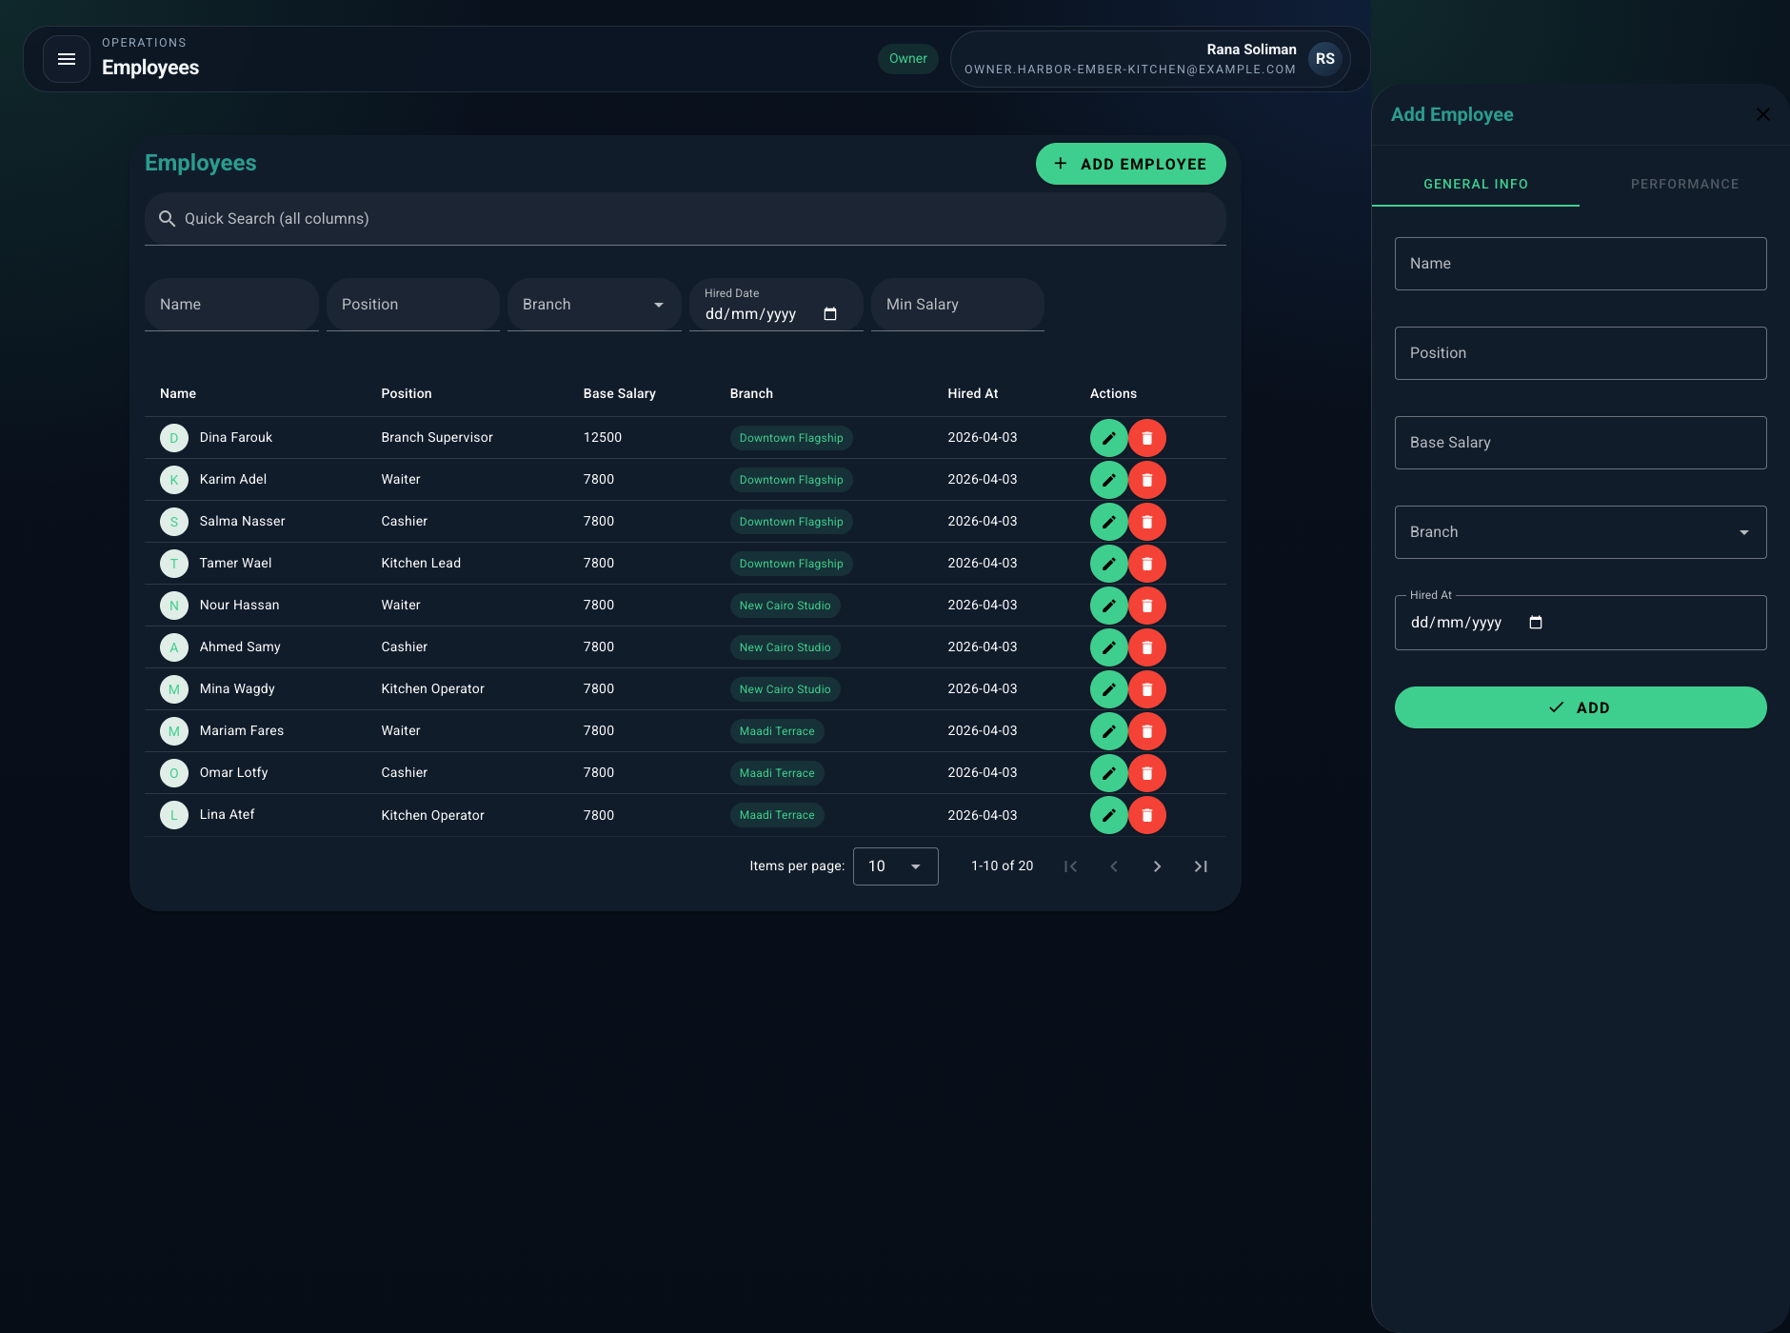
Employees page with operational team records linked to branches.

Step 7. Customer App - Home
Customer Mona Sami
Action: Logged into the customer app with a new phone number and opened the home screen.
Outcome: The new restaurant appears in the marketplace listing, ready for discovery before the first dine-in order is placed.
Clicks and operator actions
- Open the customer app.
- Enter a new phone number for Mona Sami.
- Finish login and land on the home marketplace.
API GET /api/customer/home HTTP 200
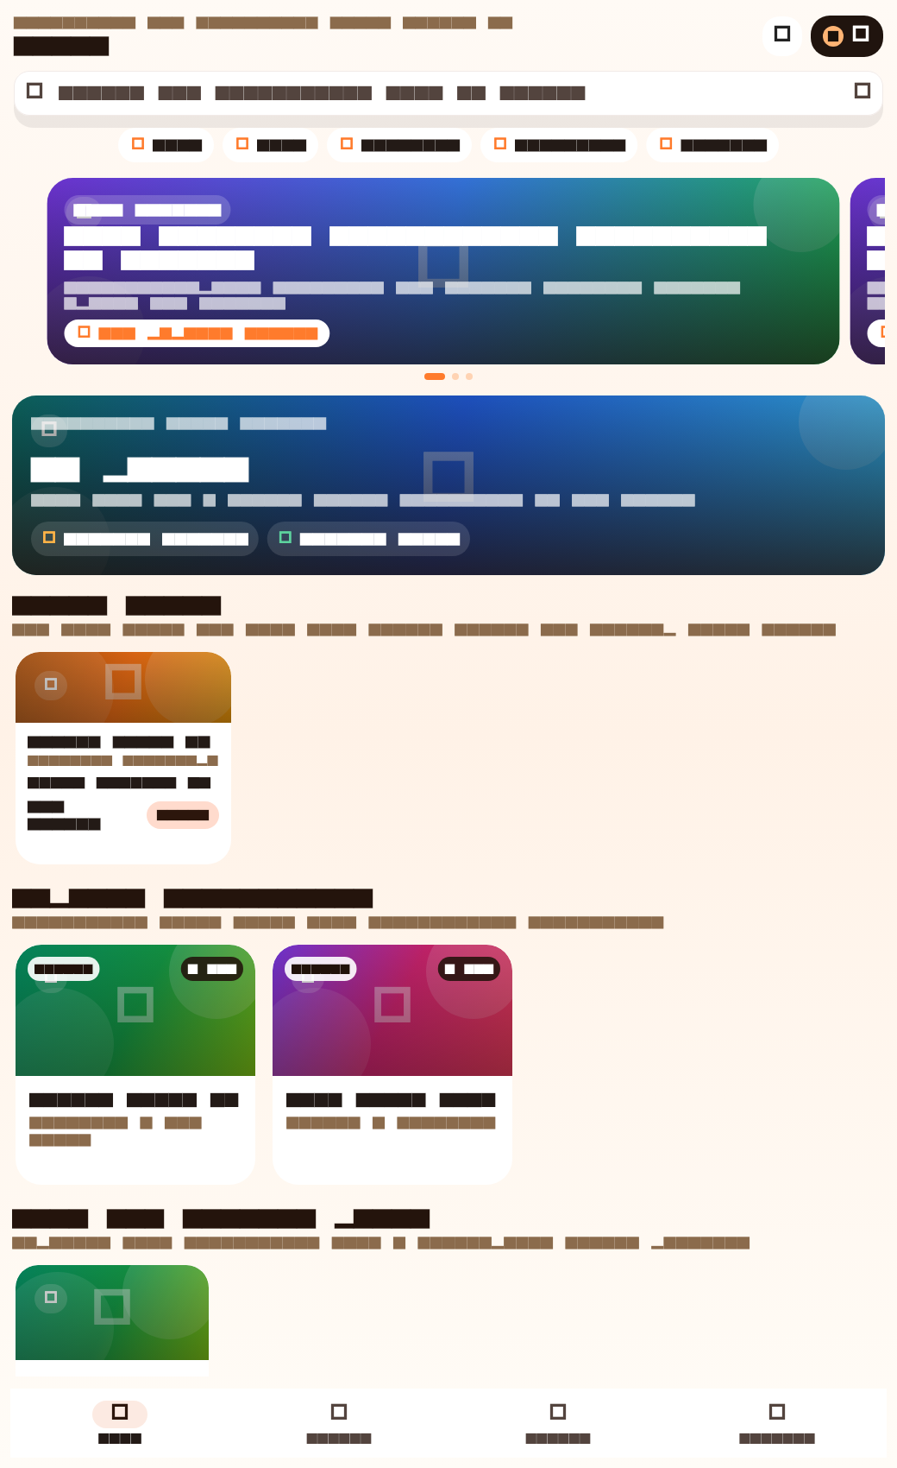
Customer home showing the new restaurant, remembered orders, and rewards.

Step 8. Waiter App - Table T1 Garden
Waiter Karim Adel
Action: Opened T1 Garden, attached Mona Sami to the table, added full meals and drinks with modifiers, then saved the dine-in order.
Outcome: Order #244 was created on Downtown Flagship and the table became occupied.
Clicks and operator actions
- Open the waiter app and tap `T1 Garden`.
- Attach Mona Sami to the table using name and phone.
- Add two Cedar Chicken Bowls, two Spanish Lattes, and one Citrus Sparkling Cooler.
- Apply modifiers and notes for taste and service changes.
- Tap to save the dine-in order.
API POST /api/mobile/orders HTTP 201
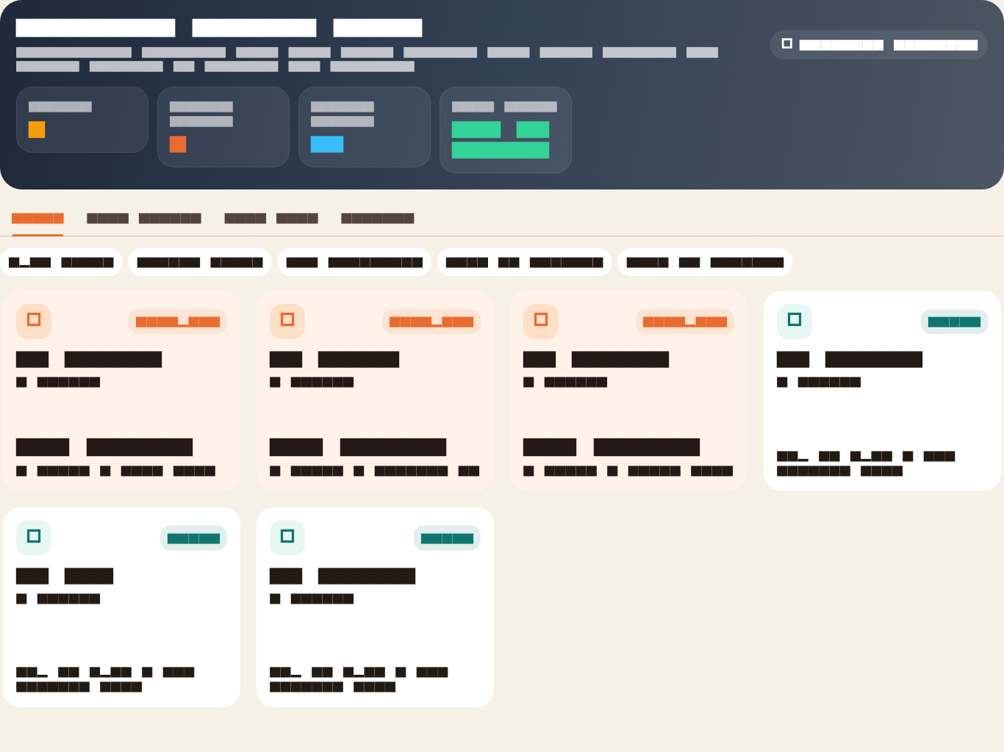
Waiter floor board before and during table service.
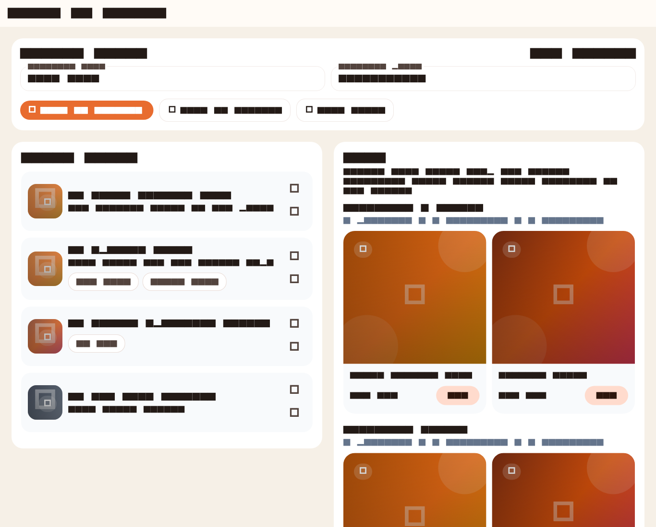
Waiter order composer for T1 Garden with images, notes, and modifiers.

Step 9. Waiter App - Order Composer
Waiter Karim Adel
Action: Added dessert to the same open table and sent the full ticket to the kitchen display.
Outcome: Kitchen now has a queued dine-in ticket with mains, drinks, and dessert for Mona Sami.
Clicks and operator actions
- Stay on the same waiter order screen.
- Add one Sea Salt Brownie.
- Click `Send to kitchen`.
Order Id: 244

Open order composer used to add dessert and send the ticket to KDS.

Step 10. Waiter App - Order Adjustments
Waiter Karim Adel
Action: Reduced the latte quantity after the guests changed their mind, then refunded the brownie that the table no longer wanted.
Outcome: The live order total was recalculated and the refunded dessert dropped out of active service.
Clicks and operator actions
- Use the order adjustment controls on the active ticket.
- Reduce the latte quantity to one.
- Refund the brownie with the return note.
Changed Item Id: 569 | Refunded Item Id: 571

Same waiter order surface used for quantity reduction and refund handling.

Step 11. Kitchen App - Downtown KDS
Kitchen Tamer Wael
Action: Opened the KDS board, advanced the active items from queued to preparing, then to ready.
Outcome: All non-refunded lines for Mona’s order became ready for cashier handoff.
Clicks and operator actions
- Open the kitchen KDS.
- Tap the full ticket to move queued items into preparing.
- Tap the ticket again to move items into ready.
API GET /api/mobile/kds/orders HTTP 200
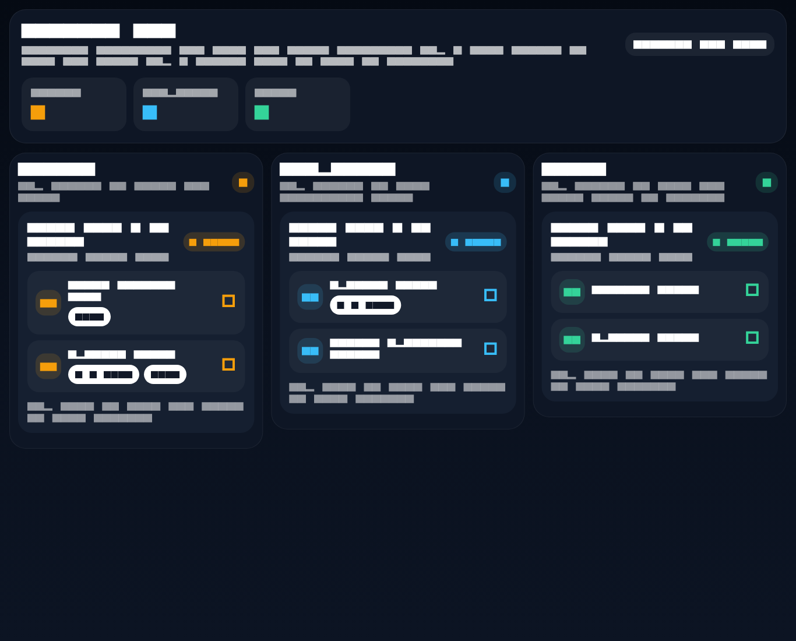
Kitchen display with minimal, high-speed lane progression.

Step 12. Cashier App - Settlement Queue
Cashier Salma Nasser
Action: Pulled Mona’s ready order into cashier, confirmed the final total, and completed payment by card.
Outcome: The order closed as paid, the table reopened, and Mona earned loyalty points for the completed visit.
Clicks and operator actions
- Open the cashier queue.
- Select Mona Sami's ready order.
- Confirm the total and submit one card payment.
API POST /api/mobile/orders/244/pay HTTP 200
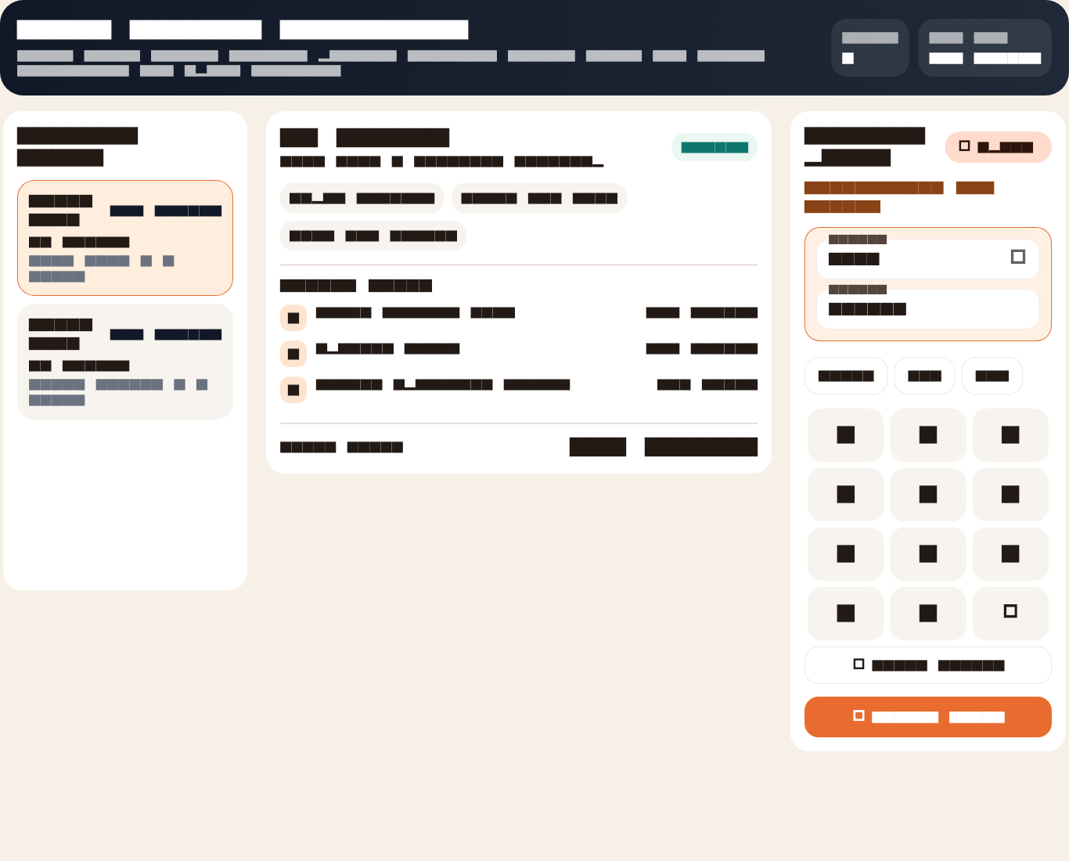
Cashier settlement workspace for final payment collection.

Step 13. Waiter + Kitchen + Cashier - T2 Window
Service Team Karim Adel / Tamer Wael / Salma Nasser
Action: Processed a drinks-only dine-in visit from order creation through kitchen readiness and cash settlement.
Outcome: The first branch now has both card and cash sales on the same trading day.
Clicks and operator actions
- Create a second dine-in drinks-only order in T2 Window.
- Send it through kitchen readiness.
- Collect payment in cash at cashier.
Order Id: 245

Cashier view reused for the drinks-only visit that closed in cash.

Step 14. Waiter + Kitchen + Cashier - T3 Family to T4 Lounge
Service Team Karim Adel / Tamer Wael / Salma Nasser
Action: Moved a family table mid-service from T3 Family to T4 Lounge, reduced a drink line, completed kitchen production, and settled the final bill with split payment.
Outcome: The system preserved the audit trail of the table move while still allowing the visit to finish and pay successfully.
Clicks and operator actions
- Move the family table from `T3 Family` to `T4 Lounge`.
- Adjust one drink line after the guests changed seats.
- Finish kitchen production and settle with split payment.
Source Order Id: 246 | Target Order Id: 247

Floor board supporting table movement from T3 Family to T4 Lounge.

Kitchen continued service after the table move without losing ticket continuity.

Step 15. Multi-Branch Operations - New Cairo Studio + Maadi Terrace
Branch Teams Parallel service crews
Action: Processed light paid service in the second and third branches so the owner can review branch comparison, payment mix, and cross-branch performance on the first day.
Outcome: The restaurant now has paid activity across all branches for the end-of-day owner review.
Clicks and operator actions
- Run one paid order in New Cairo Studio.
- Run one paid order in Maadi Terrace.
- Leave both orders completed so branch comparison becomes visible to the owner.
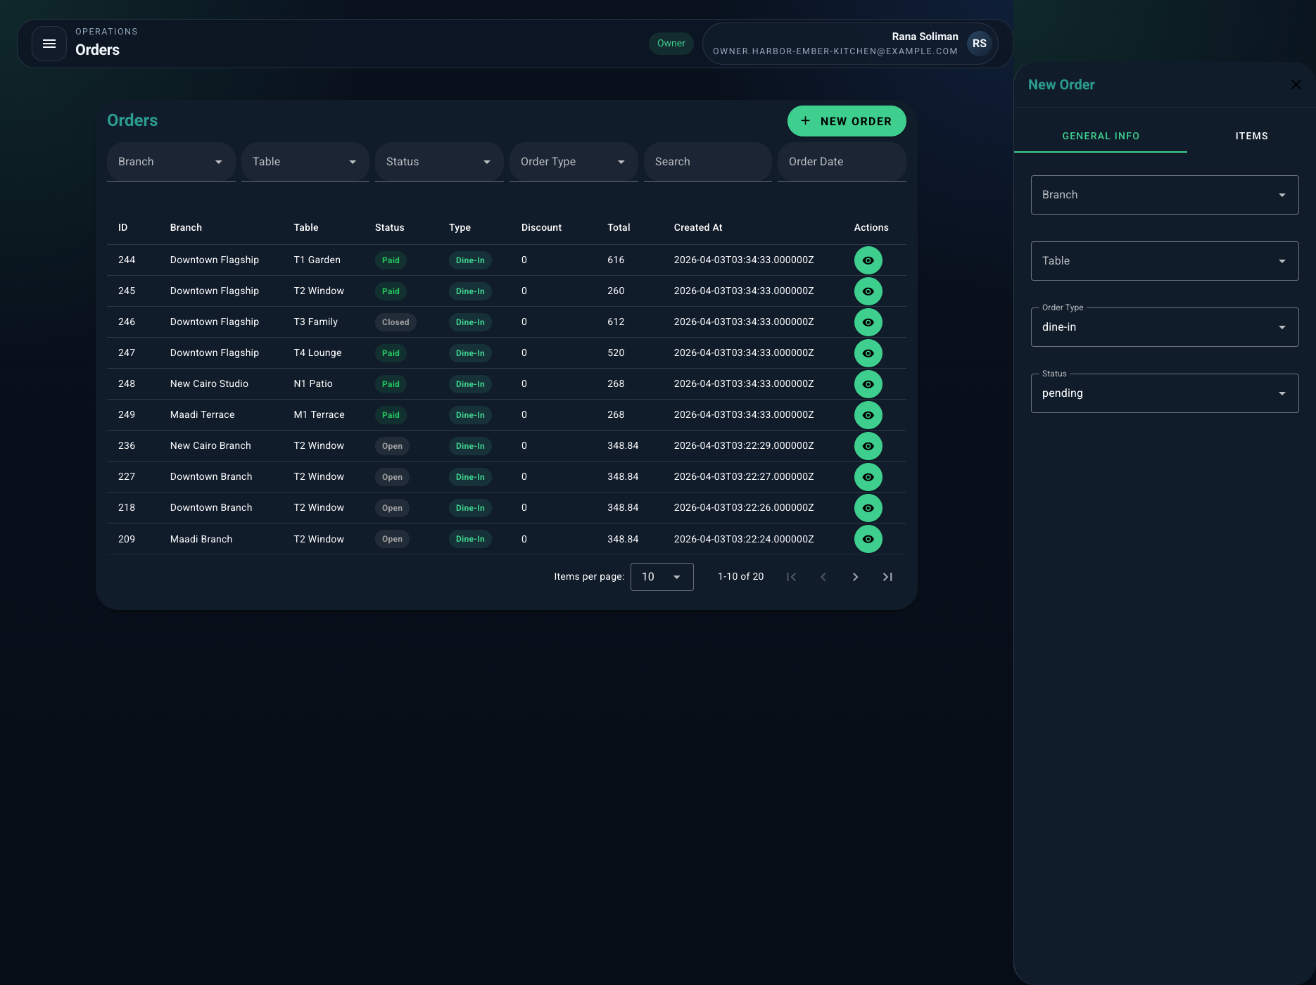
Owner orders view showing paid activity across more than one branch.

Step 16. Customer App - Orders & Rewards
Customer Mona Sami
Action: Reopened the customer app after payment to check visit history and loyalty.
Outcome: The first dine-in visit now appears in order history with updated loyalty points and the correct restaurant and branch names.
Clicks and operator actions
- Open the customer app again after payment.
- Review remembered visits, restaurant name, branch name, and rewards.

Customer home after payment with loyalty and visit memory visible.
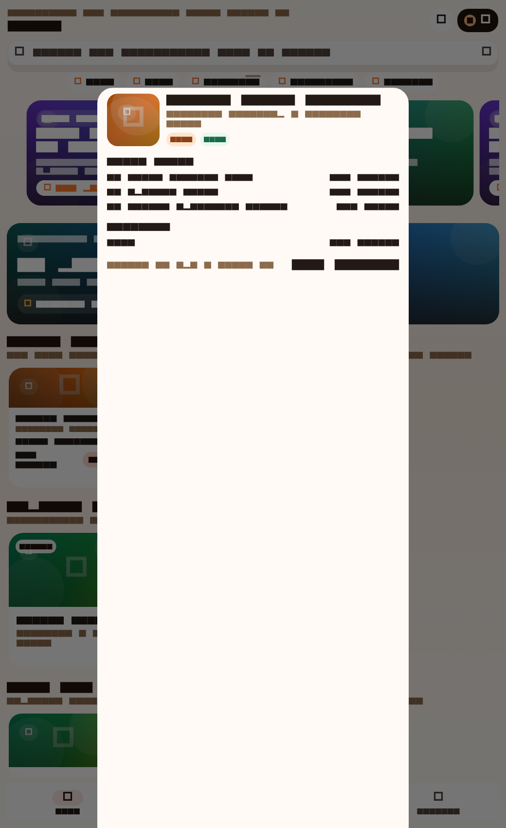
Restaurant detail still linked to the same branches and menu visibility.

Step 17. Web Dashboard - Owner Dashboard
Owner Rana Soliman
Action: Opened the live dashboard at close of day to review revenue, orders, payment mix, branch performance, low stock, and recent orders.
Outcome: The dashboard reflects the completed first day across three branches, including paid revenue, mixed tenders, loyalty activity, and low-stock warnings.
Clicks and operator actions
- Open the owner dashboard at close of day.
- Review revenue, order volume, payment mix, branch ranking, recent orders, and low-stock alerts.
- Open the detailed order modal for the flagship paid visit.
API GET /api/dashboard/summary HTTP 200
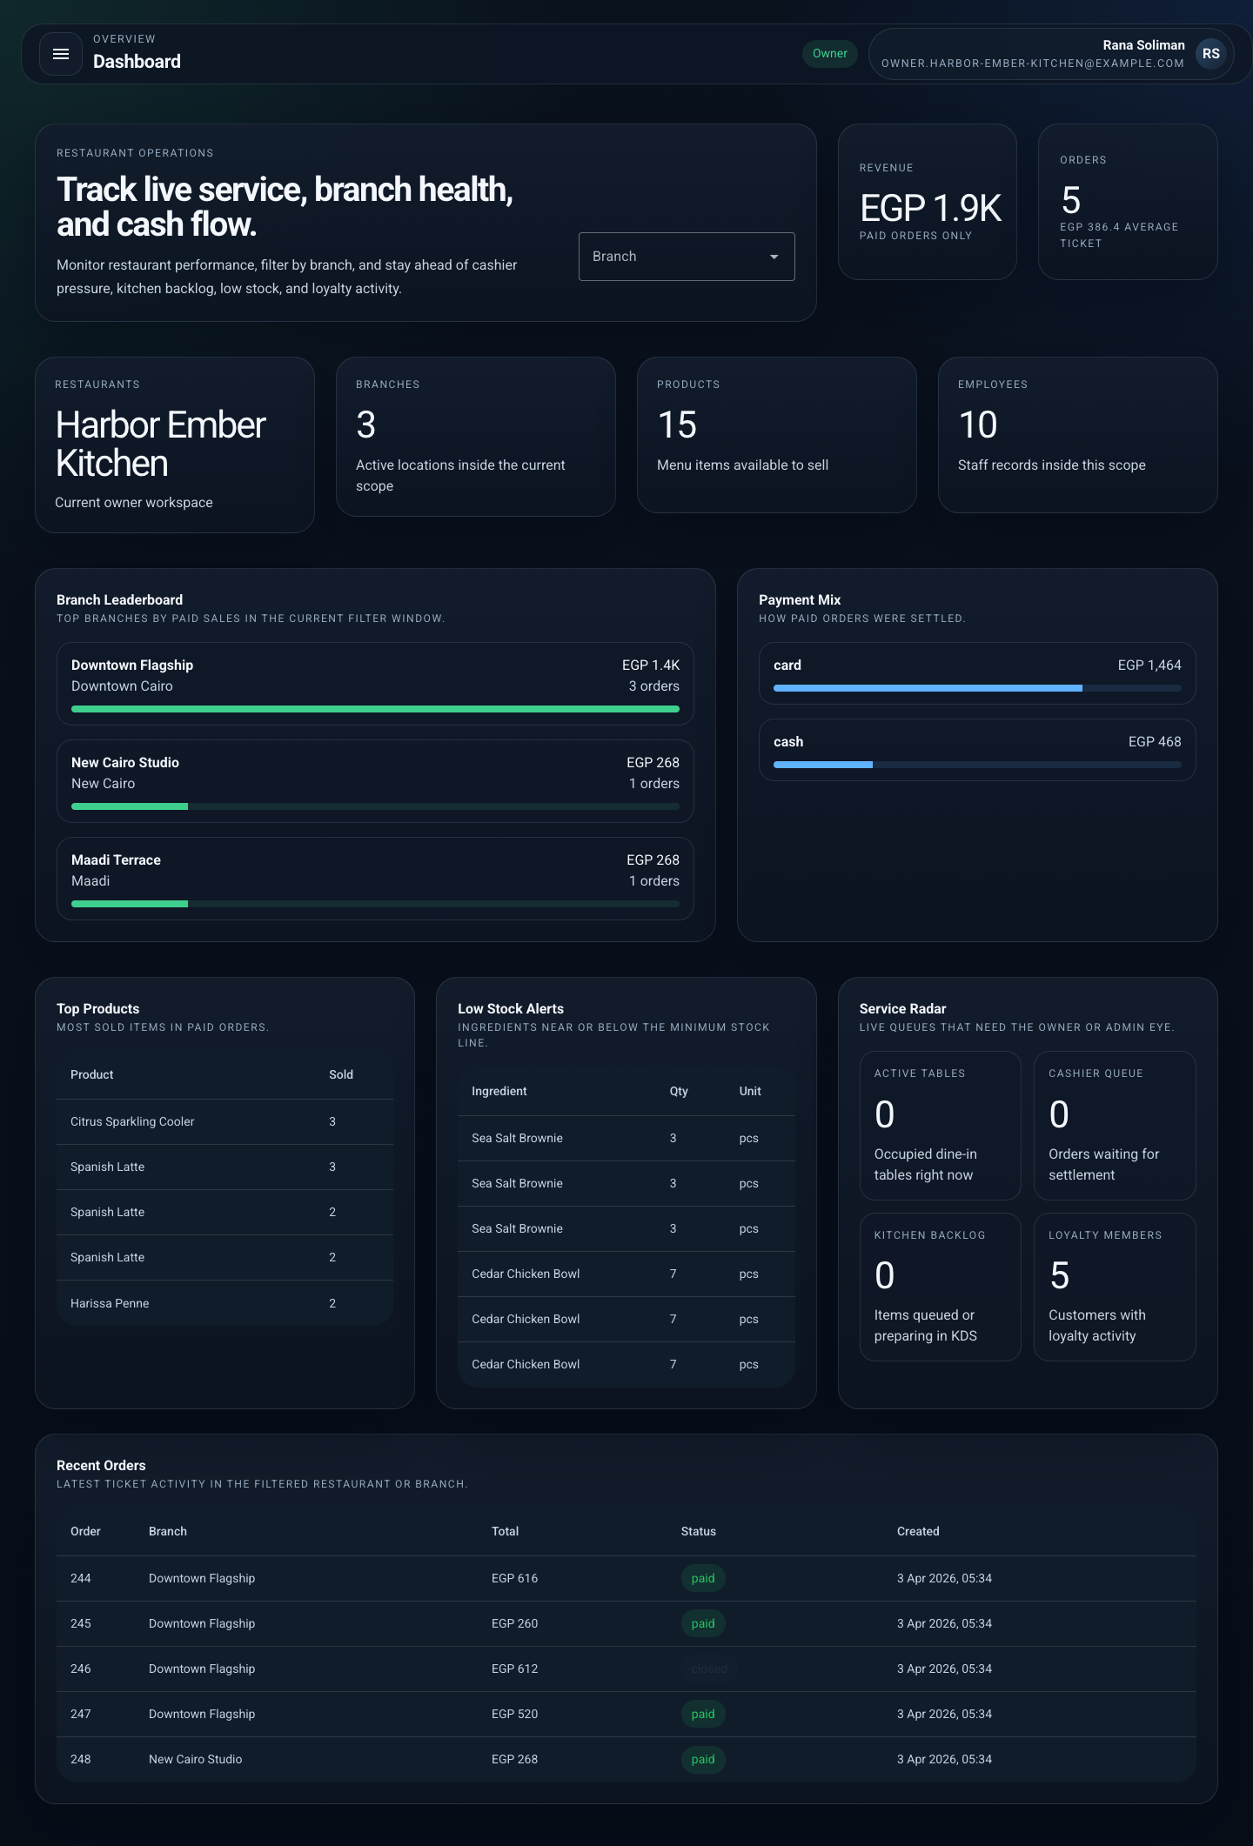
End-of-day owner dashboard with revenue, branch ranking, payment mix, and stock alerts.
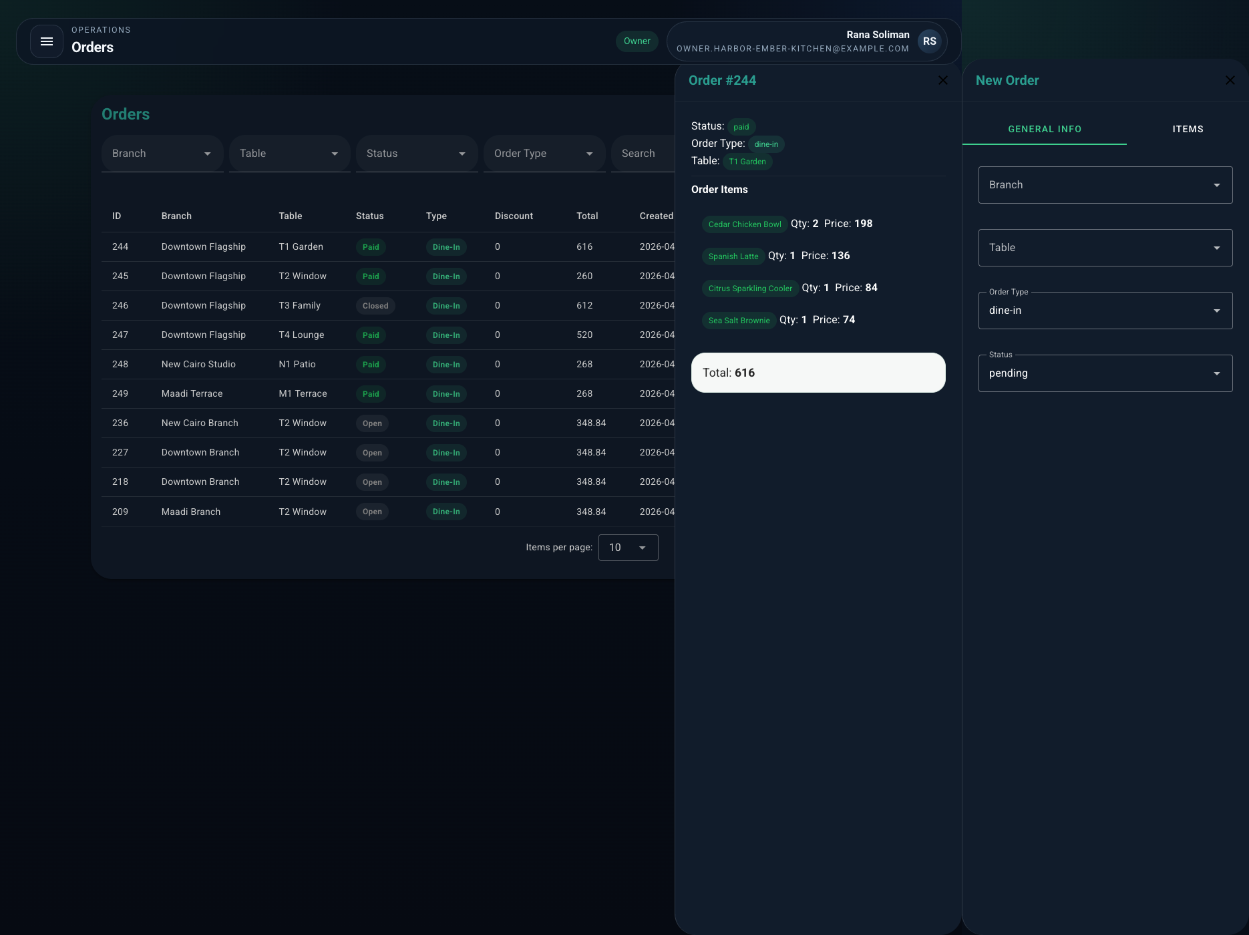
Detailed web dashboard order evidence for Mona Sami's paid visit.

End Of Day Outcome

Headline KPIs
Metric | Value
Revenue | EGP 1,932
Paid orders | 5
Average ticket | EGP 386.4
Branches live | 3
Products live | 15
Employees active | 10
Loyalty members | 5

Payment Mix
Method | Total
Card | EGP 1,464
Cash | EGP 468

Branch Performance
Branch | Location | Sales | Orders
Downtown Flagship | Downtown Cairo | EGP 1,396 | 3
New Cairo Studio | New Cairo | EGP 268 | 1
Maadi Terrace | Maadi | EGP 268 | 1

Top Products
Product | Quantity
Citrus Sparkling Cooler | 3
Spanish Latte | 3
Spanish Latte | 2
Spanish Latte | 2
Harissa Penne | 2

Low Stock Alerts
Item | Stock | Unit
Sea Salt Brownie | 3 | pcs
Sea Salt Brownie | 3 | pcs
Sea Salt Brownie | 3 | pcs
Cedar Chicken Bowl | 7 | pcs
Cedar Chicken Bowl | 7 | pcs
Cedar Chicken Bowl | 7 | pcs

Key Validation Points
- Platform admin successfully created a new restaurant, three branches, and all staff accounts.
- Owner completed catalog, menu, table, inventory, and employee setup before service.
- Waiter handled dine-in ordering, add-ons, quantity changes, refund handling, and table movement.
- Kitchen processed KDS state changes from queued to ready.
- Cashier completed both single-tender and mixed-tender payment flows.
- Customer history and loyalty were updated after payment.
- Owner dashboard reflected same-day revenue, branch comparison, payment mix, and stock alerts.

