# CaptialOneChallenge
This is Sheriff Agboola's submission for the Capital One Challenge for the Software engineering summit in the summer of 2016.
Summarizer Application
by Sheriff Agboola( University of Texas, Austin)

Application Description
This Application summarizes any length article to just three sentences. The user inputs the article URL into the textbox(it will only accept urls for articles) and using their text analysis API from http://aylien.com/ it parses the URL and gives back a three sentence summary along with the articles author and the date the article was published. There is also an option for the user to view the full article.

Installation Instructions.

1) Follow the github link to the repository titled CapitalOneChallenge, the repository contains 3 different files.
a) The capital One summarizer(2).zip files, which contains the source code of the application if you would like to view it.
b) The ReadMe file
c) The APK file for the application itself.
2) Select the Apk file named SummarizerApp.apk
3) Click on open binary file, this should initialize the download of the file.
4) Click on the downloaded apk file, telling you that the installation was blocked.

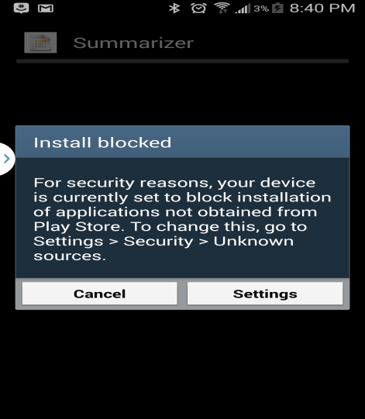

6) Click on settings and select enable installation from unknown sources as shown below.
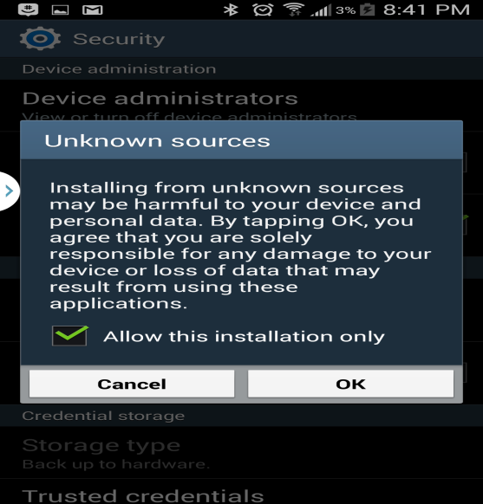

7) Enable "Unknown Sources"
8) Then click on install
9) The App will be installed and you will be able to summarize any article you want.

