**Consumption of Natural Gas in Fertilizer Industry**



**BTech/II Year CSE/III Semester**

**19CSE202/Database Management Systems**

**Case Study Review -1**

**Name of the Team: JAVADERS**

|  |  |
| --- | --- |
| **Rollno** | **Name** |
| **CB.EN.U4CSE21257** | **Shreenithi**  **S** |
| **CB.EN.U4CSE21207** | **Ashiq Sheriff** |
| **CB.EN.U4CSE21220** | **Naveen Raaghavendran** |
| **CB.EN.U4CSE21238** | **Mathamgi Nair** |

**Department of Computer Science and Engineering**

**Amrita School of Computing, Coimbatore**

**Amrita Vishwa Vidyapeetham**

**2022 -2023 Odd Semester**

**CONSUMPTION OF NATURAL GAS IN THE FERTILIZER INDUSTRY**

**Introduction**:

The ammonia and urea industries represent significant and vital components of the chemical economy. They serve as important sources of revenues and employment, within countries with large availability of feedstocks such as natural gas and coal.

India’s gas industry is in a state of transition. The country faces a broadening gap between indigenous supply and demand. The initiative for exploiting the commercial potential of natural gas as feedstock and fuel by planning NGFF for producing urea fertilizer in the mid-1950s was based on a single gas field in what is now Bangladesh. The use of natural gas as a fuel in Chhatak Cement Factory in 1960 replaced imported coal and thus began the era of cleaner fuel for industries in Bangladesh. It is only from 1984 that the power sector's natural gas consumption exceeded that of the fertilizer sector. Urea fertilizer together with natural gas-based electricity is today recognized as the cornerstone of the country's food security and political stability.

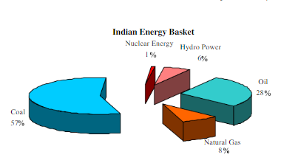 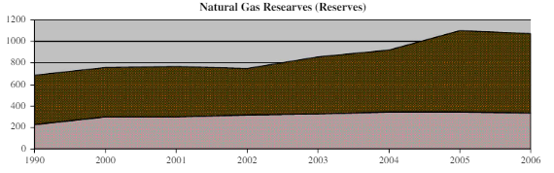

**Modularity:**

For the Consumption of Natural Gas in Fertilizer Industry, there are different modules to look upon while collected and distributing the data:

* **Interface Creation:** The main interface should be created externally for displaying and viewing the dataset and for feedback purposes on how reducing the impact of high amount of natural gas usage.
* **Count of Industries:** The total count of number of industries and the percentage of natural gases used in different number of cities across India.
* **Yearly Report:** The natural gases used in different cities with different amount will be clubbed together and shown in a yearly report with percentage of increment or decrement.
* **Uses of Natural Gas:** The usage of the natural gas in different products of the fertilizer industry would be collected and a report of what impact it causes, show in the growth rate of the industry.
* **Report Generation:** The data collected from various sources would be put down as a whole single report and details about the amount and consumption of natural gas in different places will be shown.

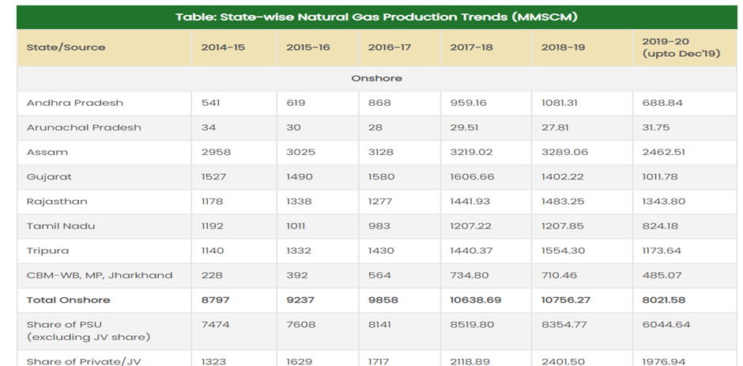

**Software Description:**

* MongoDB is the software that we're planning to use as our database management system. It is basically a source-available cross-platform document-oriented database program which is classified as a NoSQL database program.

**Why MongoDB?**

1. It has enhanced features like ad-hoc queries, indexing, file storing, aggregation, server-side java execution, capped collections and transactions; various editions like community server, enterprise server and atlas

2. Full cloud-based developer data platform: It’s a complete developer data platform. With MongoDB Atlas, there's access to a collection of services that all integrate nicely with a database

3. Flexible Document Schemas: MongoDB’s document model allows virtually any data structure to be modelled and manipulated easily. It supports creating explicit schemas and validating data and the flexibility is also very much of an asset

4. Widely supported and code native access: MongoDB stores and represents data in a document format so that it can be accessed from any language, in data structures that are native to that language

5. High performance: Due to the document model used in MongoDB, information can be embedded inside a single document rather than relying on expensive join operations from traditional relational databases which makes queries much faster, and returns all the necessary information in a single call to the database.

6. Simple Installation and Cost Effectiveness

**Hardware Description:**

Windows 8 and above versions are the hardware specifications that is used in this project. Those are the versions desired since they are the mostly used versions and since they qualify the basic necessities needed for the database management system to function properly, with their corresponding features.

**Functionalities of the system:**

Fertilizer industry would be divided as government and private industries, so there will be a set of government and private industries. The following are the functionalities of the database management system that we're developing: -

1. **Source of natural gas**: the data about the source of natural gas produced in the fertilizer industries involved will be present in the DBMS

2. **Storage capacity**: volumes of natural gas as fertilizers that is stored in the industries will be listed out

3. **Security**: the security of the credentials that the user might enter while accessing the data is guaranteed and nobody would have access to the credentials other than the user themself

4. **Accuracy in data providence**: it is ensured that the data provided to the user is accurate according the real world scenarios and no manipulation in data is carried out, so the accuracy and validity of the data provided in the database is ensured

5. **Benefits for the client**: benefits that the user can expect is in terms of security, accessibility and credibility of the data.

**Non Functionalities of the System:**

1. cost of maintenance of fertilizer industries that consume/utilize natural gas; profit made by such industries; marketing value- that is, basic data on import or export details of commodities produced by such industries

2. data on to which crop the fertilizer produced by the industry is benefitted and on when it is to be supplied

3. data on density level of natural gas consumption

4. Not only natural gas, basic consumption data even on other types of gases used as intermediate products to make mineral fertilizers

5. graphs which represents the trade balance of the natural gas will be displayed

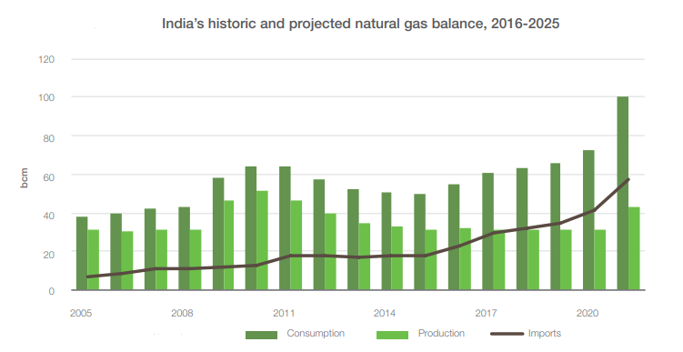

**Benefits of the system:**

This system supports and generates reports about the natural gas database, representing them in a statistical way to show the liters of gases consumed, exported, imported and used within our country using MongoDB and UI website.

**ER Diagram:**

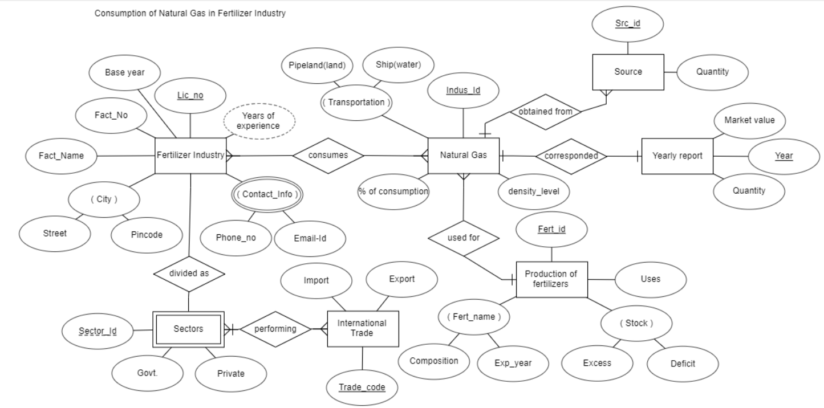

**ER TO SCHEMA:**

There are a total of 7 Entities in which 2 many-to-many relations and a multivalued attribute. So, a total of 10 Schema’s (7+2+1).

1. Fertilizer Industry (\**Lic_no*, Fact_no,Fact_Name,Base Year,Street,Pincode)
2. Natural Gas (\**Indus_Id*,Pipeland,Ship,% of consumption,density level)
3. Consumes (Lic_no,Indus_Id) - **Composite Primary Key**
4. Contact_info (Lic_no,Phone_no,Email_id)
5. Sectors (Lic_no,Sector_id,Govt,Private)
6. International Trade (Trade_Code,Import,Export)
7. Performing ( Lic_no,Sector_id,Trade_code) - **Composite Primary Key .**
8. Source ( Src_id , Quantity )
9. Yearly Report ( Year,Market Value,Quantity)
10. Production of Fertilizers ( \**Fert_id* , Composotion,Exp_Year,Excess,Deficit,Uses)

**Note:**

**\*Indus_Id is FK(Foreign Key) for the table Source , Fert_Id for Production of Fertilizers , Lic_no for Sectors .**

**EER MODEL:**

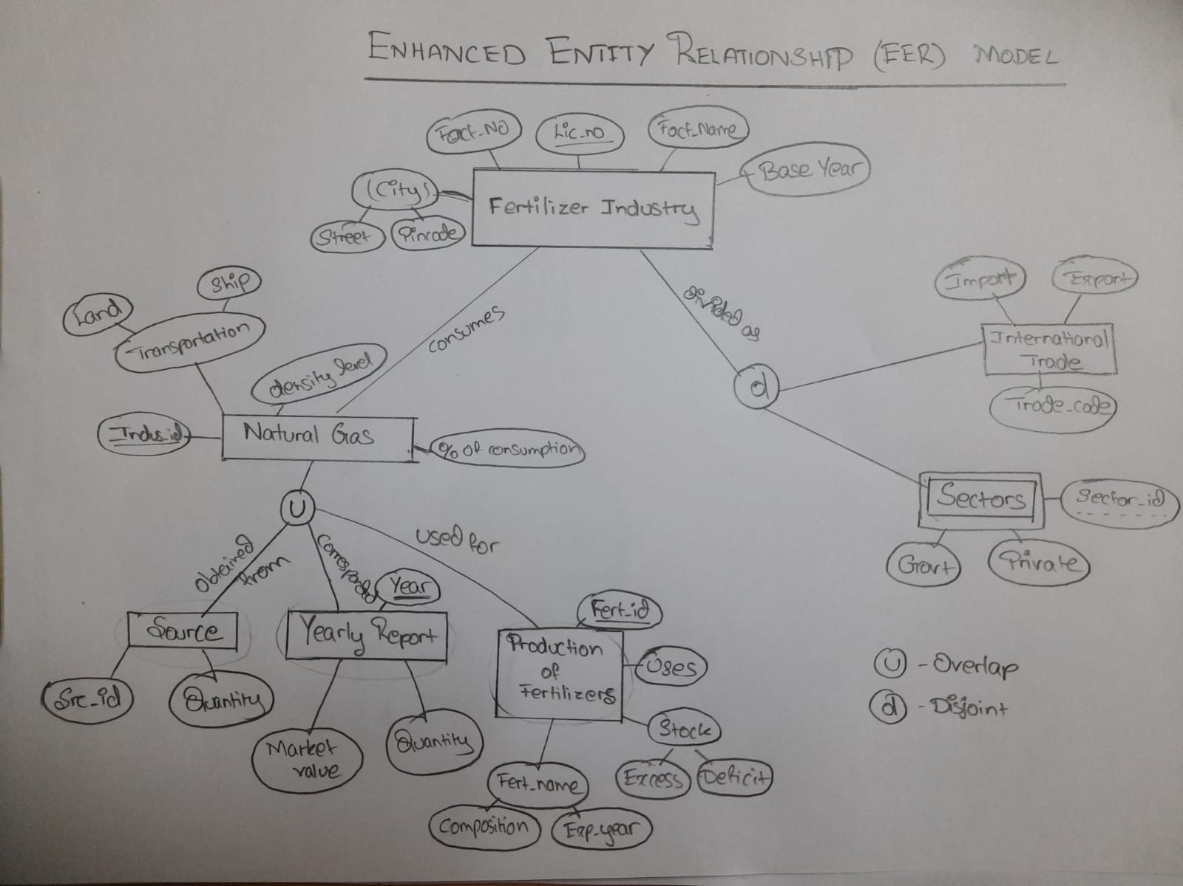

**Development Platform:**

* For Database - MongoDB
* For User Interface - Java