**CONSUMPTION OF NATURAL GAS IN FERTILIZER INDUSTRIES**



**BTech/II Year CSE/III Semester**

**19CSE202/Database Management Systems**

**Project Review -2**

|  |  |
| --- | --- |
| **ROLLNO** | **NAME** |
| **CB.EN.U4CSE07** | **ASHIQ SHERIFF** |
| **CB.EN.U4CSE**20 | **NAVEEN RAAGHAVENDRAN** |
| **CB.EN.U4CSE38** | **MATHAMGI NAIR** |
| **CB.EN.U4CSE57** | **SHREENITHI S** |

**Amrita School of Engineering, Coimbatore**

**Department of Computer Science and Engineering**

**2022 -2023 Odd Semester**

**Table of Contents**

|  |  |
| --- | --- |
| **Sl.no:** | **Title:** |
| **1** | **Normalization** |
| **2** | **Creation Of Tables** |
| **3** | **User Interface Design** |
| **4** | **References** |

**Normalization:**

1. **Write out the relation including all attribute names. Write down all Functional Dependencies.**

**a. Find FD closure and attribute closure**

**b. Determine Canonical Cover**

**c. Determine candidate keys**

**Relations with all the attribute names:**

**R(lic_no,fact_no,base_year,fact_name,pincode,f_name,street,indus_id,percent_of_consumption,min_threshold,density_level,pipeland,shipland,contact_no,sector_id,govt,private,trade_code,import,export,src_id,quantity,year,market_value,fert_id,composition,exp_year,excess,deficit,uses)**

**FUNCTIONAL DEPENDENCIES**

**Fertilizer:**

**•** **Lic_no, -> Fact_no ,Fact_name,Base Year , Street , Pincode**

**•** **Fact_no,Fact_name->Base Year,Street,Pincode (AS there would be same**  **factory names )**

**•** **Base Year -> Fact_name,Street**

**Natural Gas:**

**•** **Indus_Id -> Pipeland,Ship,% of consumption,density level, Min_Threshold,**  **Density level**

**•** **% of consumption -> density level**

**•** **Min_Threshold Density level -> Pipeland,Ship**

**Consumes:**

**•** **Lic_no->Indus_Id**

**•** **Indus_id->Lic_no**

**Contact_info:**

**•** **Lic_no -> Contact_No ( 1NF and check in ER )**

**Sector_Info:**

**•** **Sector_id -> Govt,Private**

**International Trade:**

**•** **Trade_Code -> Import**

**•** **Trade_Code -> Export**

**Performing:**

**•** **Sector_id -> Trade_Code**

**Source:**

**•** **Src_id -> Quantity**

**CLOSURES:**

**Table 1:**

**•** **(Lic_No)+ = { Lic_No ,Fact_no ,Fact_name,Base Year , Street , Pincode}**

**•** **(Fact_no,Fact_name)+ = { Fact_no,Fact_name, Base Year,Street,Pincode }**

**•** **(Base Year)+ = { Base Year ,Fact_name,Street}**

**Table 2 :**

**•** **(Indus_Id)+ = { Indus_Id , Pipeland , Ship,% of consumption ,density level**  **}**

**•** **(% of consumption)+ = {% of consumption , density level }**

**•** **(Min_Threshold Density level)+= { Min_Threshold Density level ,Pipeland**  **,Ship }**

**Table 3:**

**•** **(Lic_no)+ = { Lic_no,Indus_id}**

**•** **(Indus_id)+ = { Indus_id , Lic_no, }**

**Table 4:**

**•** **(Lic_no)+ = { Lic_no ,Contact_No }**

**Table 5:**

**•** **(Sector_id)+ = { Sector_id,Govt,Private }**

**Table 6:**

**•** **(Trade_Code)+ = { Trade_Code,Import,Export }**

**Table 7:**

**•** **(Sector_id)+ = { Sector_id,Trade_code) }**

**Table 8:**

**•** **(Src_id)+= { Src_id ,Quantity }**

**Table 9:**

**•** **(Year)+ = { Year,Market Value,Quantity }**

**Table 10:**

**•** **(Fert_id)+ = { Fert_id , Composotion , Exp_Year , Excess , Deficit ,Uses }**

**Yearly Report:**

**•** **Year -> Market Value ,Quantity**

**Production of Fertilizers :**

**•** **Fert_id -> Composition , Exp year , Excess , Deficit**

**•** **Exp_Year -> Excess , deficit .**

**•** **Compostion , Exp_Year -> Uses**

**CANDIDATE KEY:**

**The candidate Key for the whole table is**

**(Lic_no , Indus_id , Sector_id , Src_id , Year , Fert_id )**

**MINIMAL COVER:**

**Minimal Cover for each tables :**

**Table 1 :**

**•** **Lic_no -> Fact_no**

**•** **Lic_no -> Base Year**

**•** **Fact_no , Fact_name -> Base Year**

**•** **Fact_no , Fact_name -> Pincode**

**•** **Base Year -> F_name**

**•** **Base Year -> Street**

**Table 2:**

**•** **Indus_id -> % of consumption**

**•** **Indus_id -> Min_Threshold Density Level**

**•** **% of consumption -> density level**

**•** **Min_Threshold Density Level -> Pipeland**

**•** **Min_Threshold Density Level -> Shipland**

**Table 3:**

**•** **Lic_no->Indus_Id**

**•** **Indus_id->Lic_no**

**Table 4:**

**•** **Lic_no -> Contact_No**

**Table 5:**

**•** **Sector_id -> Govt**

**•** **Sector_id -> Private**

**Table 6:**

**•** **Trade_code -> import**

**•** **Trade_code -> export**

**Table 7:**

**•** **Sector_id -> trade_code**

**Table 8:**

**•** **Src_id -> quantity**

**Table 9:**

**•** **Year -> market_value**

**•** **Year -> quantity**

**Table 10:**

**•** **Fert_id -> composition**

**•** **Fert_id -> exp_year**

**•** **Exp_year -> excess**

**•** **Exp_year -> deficit**

**•** **Composition, exp_year -> uses**

1. **Check if it is in First normal form**
2. **Identify the Partial dependencies and decompose the table and check if it is 2NF**
3. **Check Transitive dependencies and decompose the table and check if it is 3NF**
4. **If possible, normalize to BCNF.**

**Normalization:**

**First normal form, Second normal form**

**Table 1: 2NF**

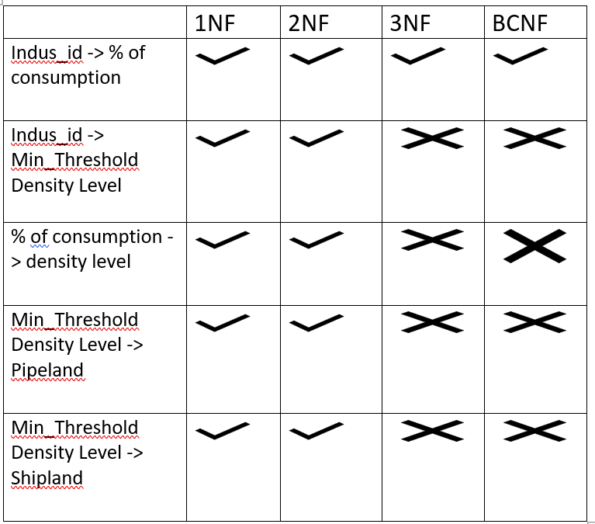

**Table 2: 2NF**

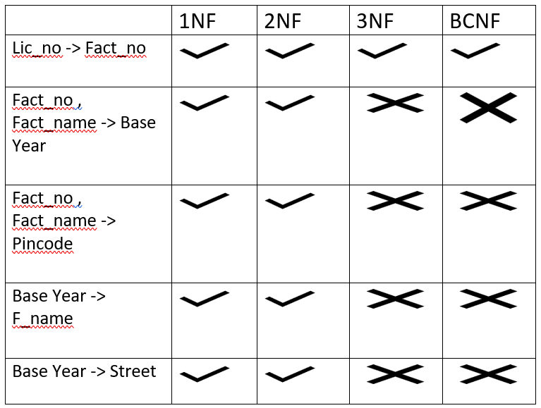

**Table 3: BCNF**

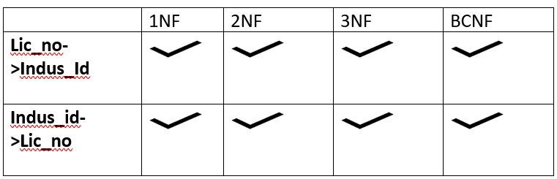

**Table 4: BCNF**

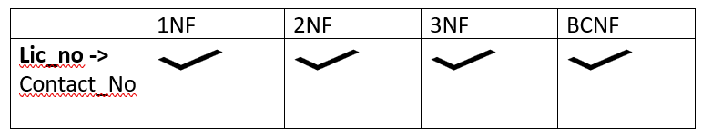

**Table 5: BCNF**

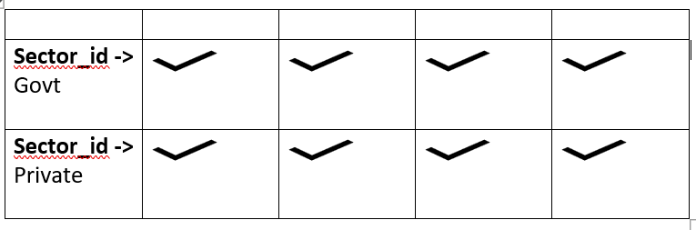

**Table 6: BCNF**

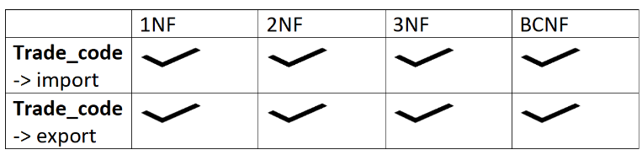

**Table 7: BCNF**

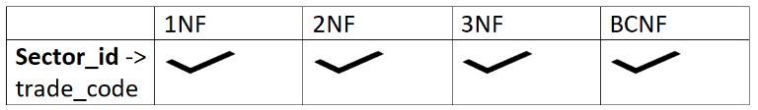

**Table 8: BCNF**

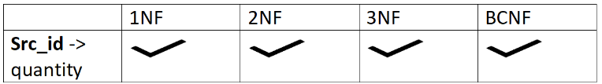

**Table 9: BCNF**

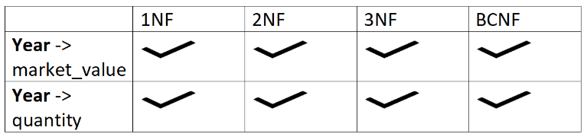

**Table 10: 2NF**

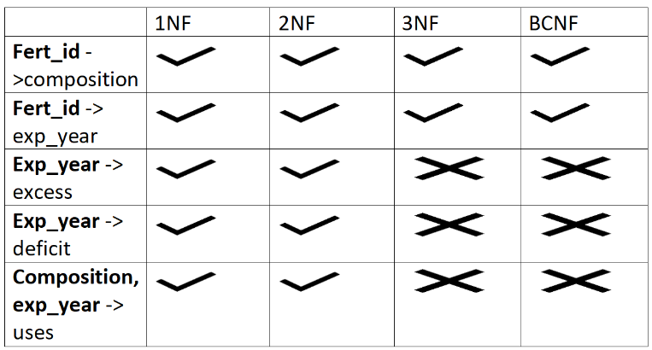

**The table, considered one as a whole is in 2NF, now we have to convert it into 3NF and then to BCNF**

**FUNCTIONAL DEPENDENCIES in 3NF:**

**lic_no -> fact_no,base_year,contact_no**

**fact_name,fact_no -> base_year,pincode**

**base_year -> street,fact_name**

**indus_id -> percent_of_consumption,min_threshold**

**percent_of_consumption -> density_level**

**min_threshold -> shipland,pipeland**

**sector_id -> trade_code,private,govt**

**trade_code -> export,import**

**src_id -> quantity**

**year -> quantity,market_value**

**fert_id -> composition,exp_year**

**exp_year -> deficit,excess**

**composition,exp_year -> uses**

**lic_no -> indus_id**

**indus_id -> lic_no**

**3NF RELATIONS:**

**R1 (Lic_no,contact_no,base_year,fact_no)**

**R2 (fact_no,fact_name,pincode,base_year)**

**R3 (base_year,street,fact_name)**

**R4 (indus_id,percent_of_consumption,min_threshold)**

**R5 (percent_of_consumption,density_level)**

**R6 (min_threshold,shipland,pipeland)**

**R7 (sector_id,trade_code,private,govt)**

**R8 (trade_code,export,import)**

**R9 (src_id,quantity)**

**R10 (year,quantity,market_value)**

**R11 (fert_id,composition,exp_year)**

**R12 (exp_year,deficit,excess)**

**R13 (composition,exp_year,uses)**

**R14 (lic_no,indus_id)**

**Candidate Key:**

**{fact_name, sector_id, src_id, year, fert_id, lic_no}**

**{fact_name, sector_id, src_id, year, fert_id, indus_id}**

**CONVERSION TO BCNF:**

**lic_no -> fact_no,base_year,contact_no**

|  |  |
| --- | --- |
| **Lic_no, fact_no, base_year, contact_no** | **Lic_no, fact_name, pincode, f_name, street, indus_id, percent_of_consumption, min_threshold, density_level, pipeland, shipland, sector_id, govt, private, trade_code, import, export, src_id, quantity, year, market_value, fert_id, composition, exp_year, excess, deficit, uses** |

**indus_id -> percent_of_consumption,min_threshold**

|  |  |
| --- | --- |
| **Indus_id, percent_of_consumption, min_threshold** | **Lic_no, fact_name, pincode, f_name, street, indus_id, density_level, pipeland, shipland, sector_id, govt, private, trade_code, import, export, src_id, quantity, year, market_value, fert_id, composition, exp_year, excess, deficit, uses** |

**sector_id -> trade_code,private,govt**

|  |  |
| --- | --- |
| **Sector_id, trade_code, private, govt** | **Lic_no, fact_name, pincode, f_name, street, indus_id, density_level, pipeland, shipland, sector_id, import, export, src_id, quantity, year, market_value, fert_id, composition, exp_year, excess, deficit, uses** |

**src_id -> quantity**

|  |  |
| --- | --- |
| **Src_id, quantity** | **Lic_no, fact_name, pincode, f_name, street, indus_id, density_level, pipeland, shipland, sector_id, import, export, src_id, year, market_value, fert_id, composition, exp_year, excess, deficit, uses** |

**fert_id -> composition,exp_year**

|  |  |
| --- | --- |
| **Fert_id, composition, exp_year** | **Lic_no, fact_name, pincode, f_name, street, indus_id, density_level, pipeland, shipland, sector_id, import, export, src_id, year, market_value, fert_id, excess, deficit, uses** |

**lic_no -> indus_id**

|  |  |
| --- | --- |
| **Lic_no, indus_id** | **Lic_no, fact_name, pincode, f_name, street, density_level, pipeland, shipland, sector_id, import, export, src_id, year, market_value, fert_id, excess, deficit, uses** |

**Therefore, at the end of the BCNF conversion, we’re left with 6 tables, and their relations are like:**

**R1( Lic_no, fact_no, base_year, contact_no )**

**R2( Indus_id, percent_of_consumption, min_threshold )**

**R3( Sector_id, trade_code, private, govt )**

**R4( Src_id, quantity )**

**R5( Fert_id, composition, exp_year )**

**R6( Lic_no, indus_id )**

# **CREATION OF TABLES**

# **USER INTERFACE DESIGN**

# 