[www.mongodb.com](http://www.mongodb.com)

create and account with your email

verify the confirmation email sent to you

using the email ,log into the mongo site

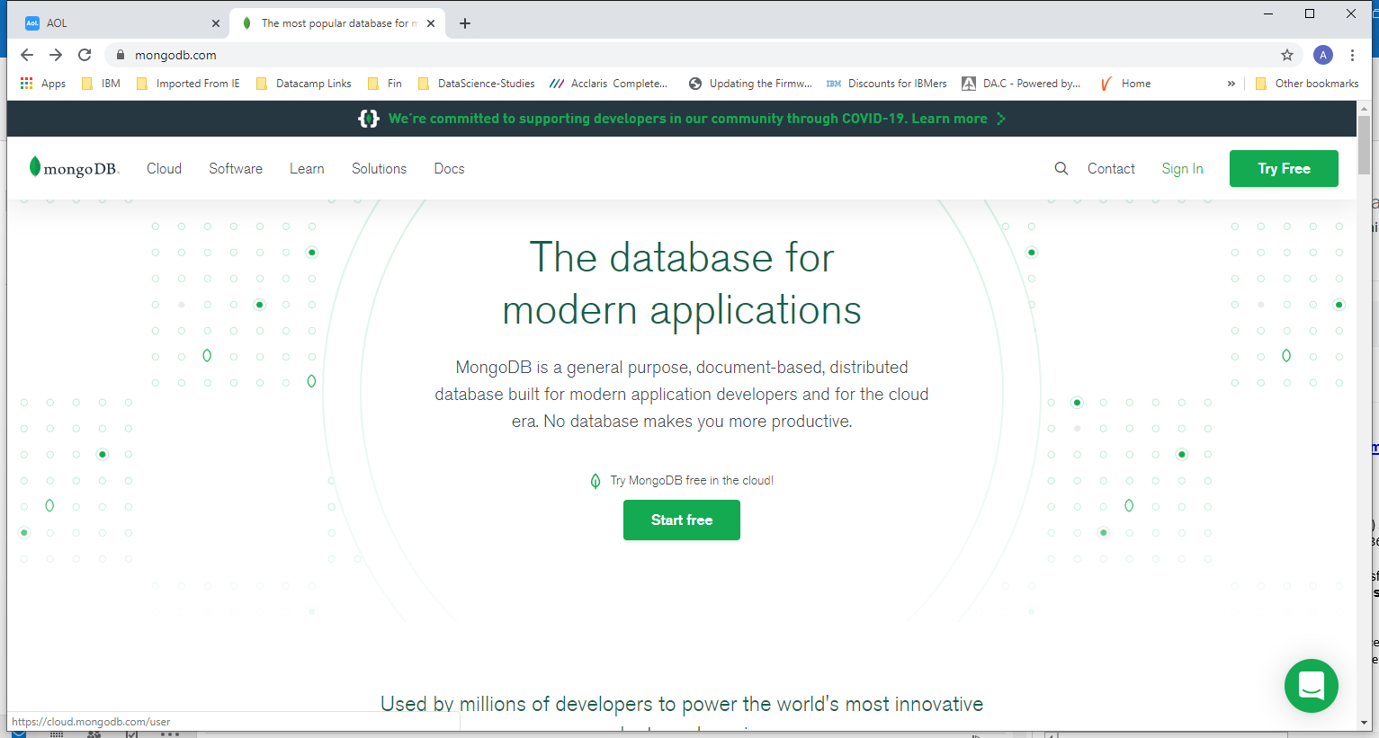

Any one of the buttons will allow you to get started for account creation. Once again verify the email mongo sent and log in to the account. The choose the free tier as marked below

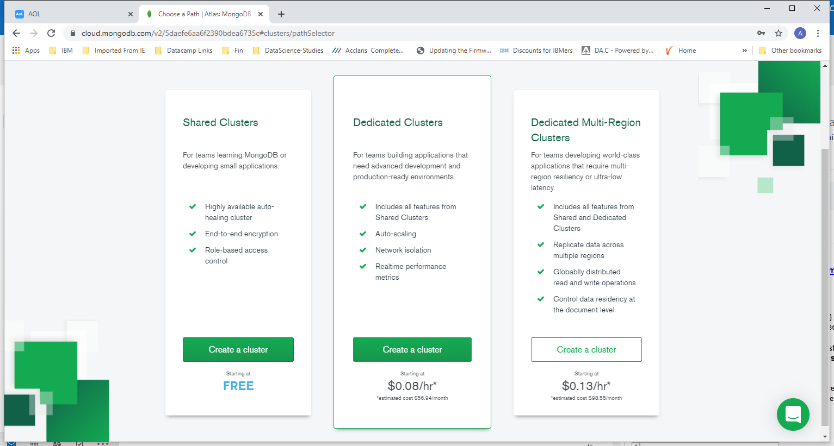

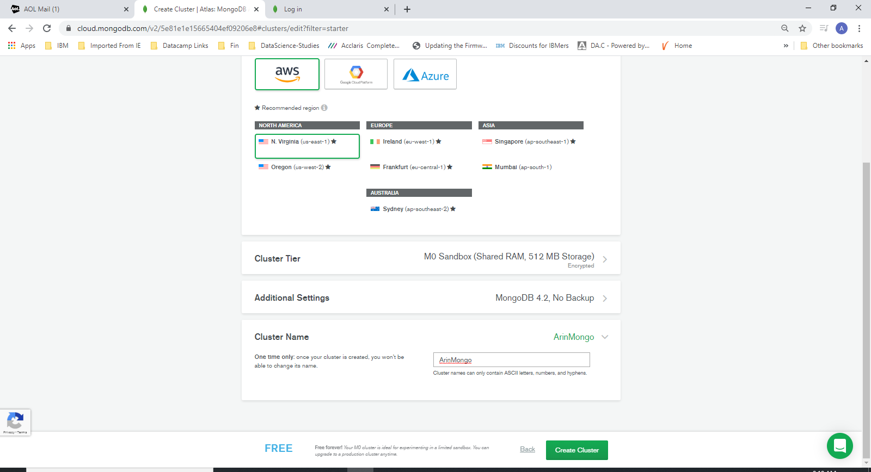

Type in the cluster name at the bottom and ensure that the other arrows match to your settings

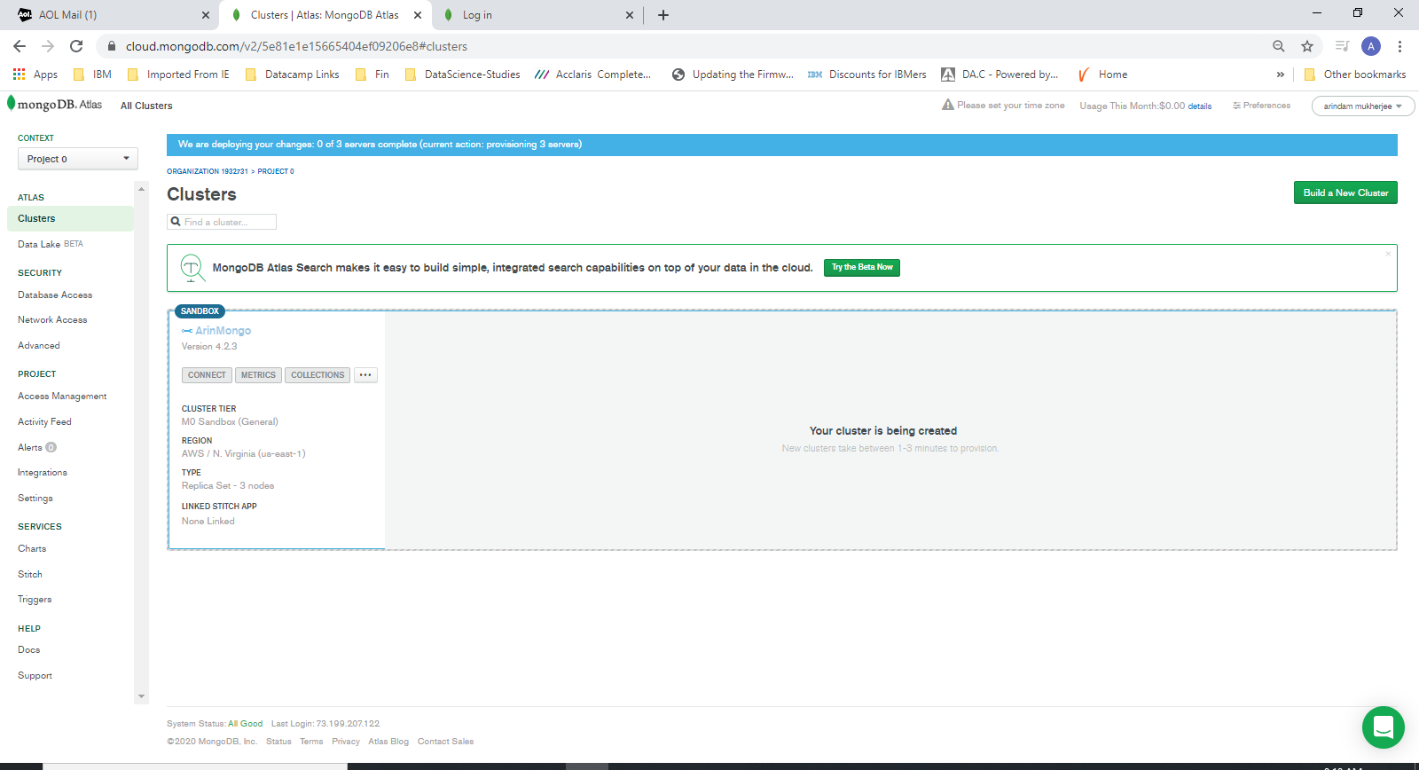

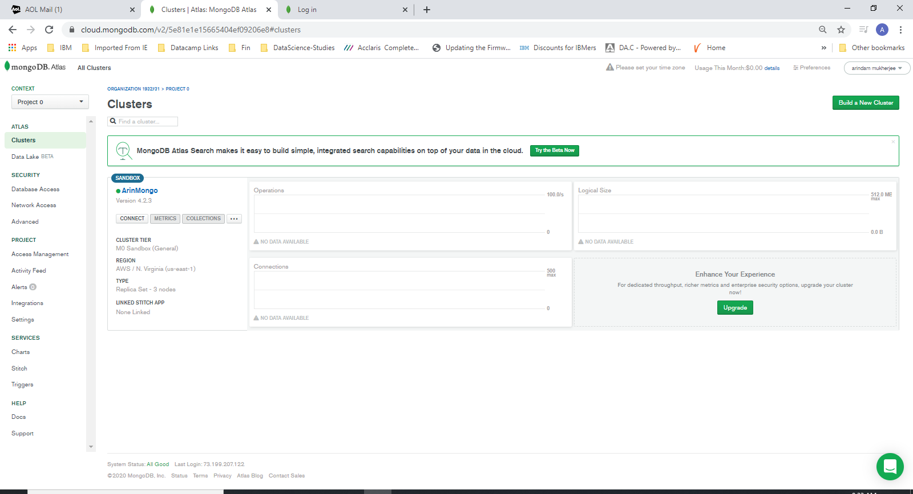

Click on “connect”

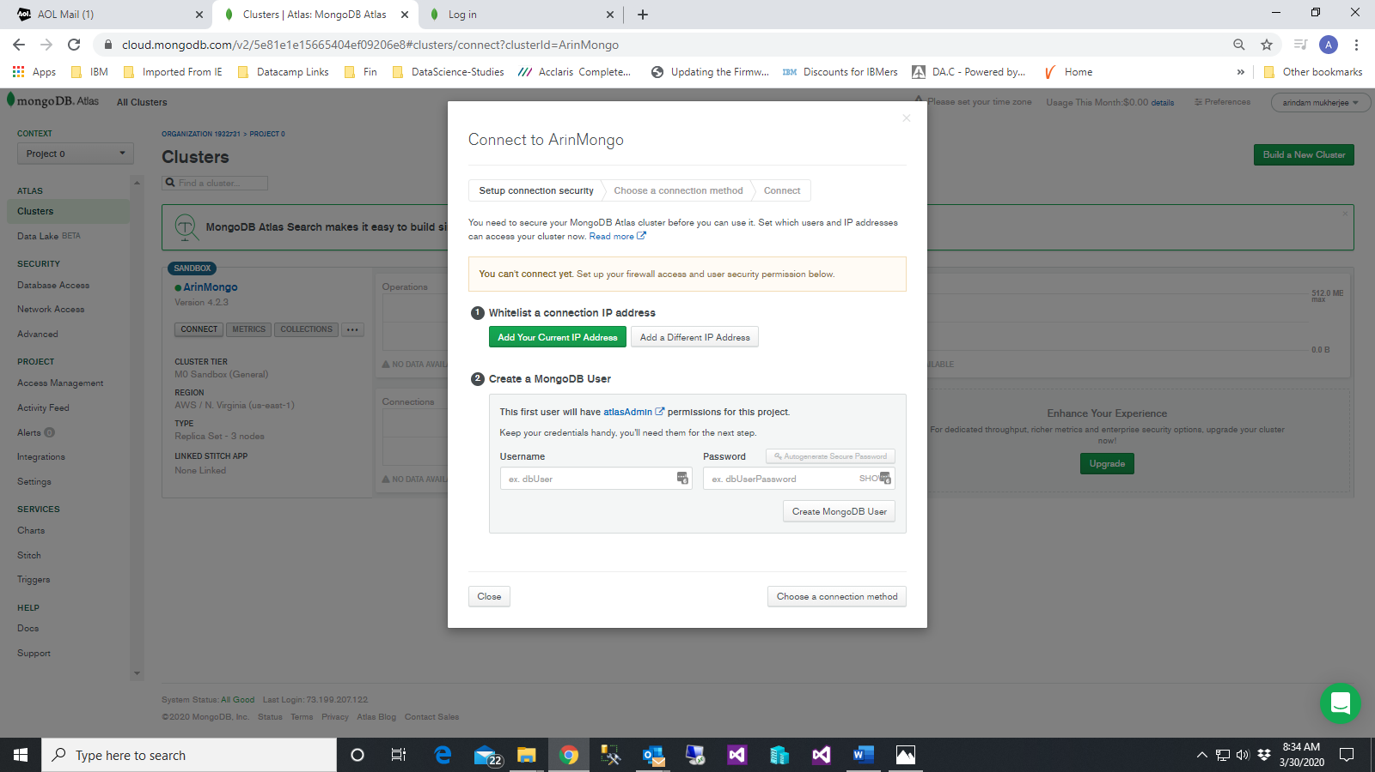

Add your current IP Whitelist ( click on the option)

And

Plugin a userid and password where the second arrow shows up

**Very Important- donot forget this user id and password**