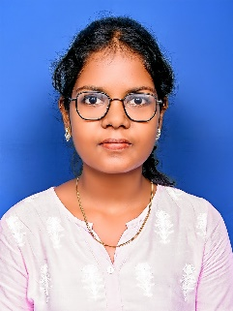
SHERIN X K
Frontend Engineer (React + TypeScript)
Marthandam, Kanyakumari | 9487845908 | sherinxavier004@gmail.com
linkedin.com/in/sherin-xavier | github.com/Sherin721/portfolio
Portfolio: sherin-portfolio-nine.vercel.app
Career Objective
To start my career as a Frontend / Full Stack Developer (MERN Stack) in a growth-oriented organization where I can apply modern web technologies like React and Node.js, learn continuously, and contribute to building efficient, user-friendly digital solutions.
Professional Summary
Enthusiastic Full Stack Developer skilled in React.js, TypeScript, Node.js, and Express.js with strong debugging and database management skills. Experienced in building responsive web apps, integrating APIs, and applying CI/CD concepts for smoother development workflows in Agile teams.
Technical Skills
Languages: JavaScript, TypeScript, Python, C, C++
Frontend: React.js, HTML, Tailwind CSS | Backend: Node.js, Express.js,REST APIs,CI/CD pipeline
Database: MySQL, PostgreSQL | Tools: Git, Bitbucket, Jira, Power BI, MS Office Tools.
Projects
Portfolio Web App (React, Tailwind CSS) – Developed and deployed a responsive portfolio.
User Dashboard System (React, Express, PostgreSQL) – Created a CRUD-based dashboard with authentication and modular components.
Internship/Experience
Software Engineer Intern (React & Express) :
• Developed full-stack web apps and integrated REST APIs.
• Reduced bugs by 15% through efficient debugging and clean code.
• Participated in Agile sprints and code reviews.
Data Analyst Trainee – JHF IT Services :
• Delivered accurate datasets and client-ready reports by cross checking senior’s reports.
• Improved data accuracy and workflow efficiency by performing beyond trainee level.
Education
B.Sc. Computer Science – Nesamony Memorial Christian College (2021–2024) | CGPA: 8.5
HSC: 88.5% | SSLC: 90.6%
Achievements
• Certified Python Developer
• Recognized for debugging and documentation during internship
• Conducted coding and Git training sessions in college
Reached top 10 finalists in CodeFest 2024, organized by college.

Strengths
Quick Learner | Problem Solver | Adaptable | Team Player | Clean Code Practices
Languages
English | Tamil | Hindi | Malayalam

