Sherin Soman  
Aug 24, 2021  
Assignment 07

GitHub Webpage: <https://sherinjoel.github.io/IntroToProg-Python-Mod07/>

GitHub Repository : <https://github.com/SherinJoel/IntroToProg-Python-Mod07>

# Create a script using Exception Handling and Pickling

## Introduction

This Assignment gives a basic overview of Exception Handling and Pickling in python. In this Assignment, I explained the steps I have done to create a script using custom functions and binary files. I start my program by loading the data in a binary file called ToDoFile.dat into a python list of dictionaries rows. The script continues to display a menu of choices to the user until the user ask to exit the program. I used a printed "menu" to guide the user through this process.

## Python Exception Handling

Try and except statements are used to catch and handle exceptions in Python. Statements that can raise exceptions are kept inside the try clause and the statements that handle the exception are written inside except clause.

**Catching Specific Exception**

A try clause can have any number of except clauses to handle different exceptions, however, only one will be executed in case an exception occurs. ValueError, TypeError, ZeroDivisionError, FileNotFoundError are some examples.

**Try with Else Clause**

In python, we can also use the else clause on the try-except block which must be present after all the except clauses. The code enters the else block only if the try clause does not raise an exception.

**finally Keyword in Python**

Python provides a keyword finally, which is always executed after the try and except blocks.

**Raising Exceptions in Python**

In Python programming, exceptions are raised when errors occur at runtime. We can also manually raise exceptions using the raise keyword.

**Researching Exception Handling in Python**

I searched the web for examples of how to use Python’s exception handing features and found the following links good at explaining it.

How to Handle Exceptions in Python: <https://www.freecodecamp.org/news/exception-handling-python/>

The above link clearly introduces Exceptions, the purpose of exception handling and how to handle exceptions with simple examples.

# Python Exceptions Handling (With Examples): [*https://pythonguides.com/python-exceptions-handling/*](https://pythonguides.com/python-exceptions-handling/)

The above link gives a basic overview of exception handling by explaining each type of errors with simple examples of how to handle it. As a beginner to Python, I found this link very useful.

**Python Pickling**

The process to converts any kind of python objects (list, dict, etc.) into byte streams (0s and 1s) is called pickling or serialization or flattening or marshalling. We can converts the byte stream (generated through pickling) back into python objects by a process called as unpickling.  
Pickling and unpickling can be done only after importing pickle module using the command − import pickle.  
Once the file is opened for writing(wb-write binary mode), you can use pickle.dump(), which takes two arguments: the object you want to pickle and the file to which the object has to be saved. To read data from pickle file(rb-read binary mode),we can use the pickle.load()which takes one argument: the file from which binary data is read.

**Researching Pickling in Python**

Pickling and Unplickling**:** <https://www.codesansar.com/python-programming/what-is-pickling-and-unpickling.htm>

Explains what Pickling is and Unpickling with an example of each.

Python Pickling: <https://www.tutorialspoint.com/python-pickling>

Clearly explains about how to pickle and unpickle from a list and dictionary with simple programs.

## Create a new project in Pycharm

To create a new Project in PyCharm, I created a sub-folder called Assignment 07 inside of the _PythonClass folder and used _PythonClass\Assignment07 as its location to create the new project. Within the project, I added the python file, "Assignment07.py.

**Code Explanation**

I started my script by adding the script's header.

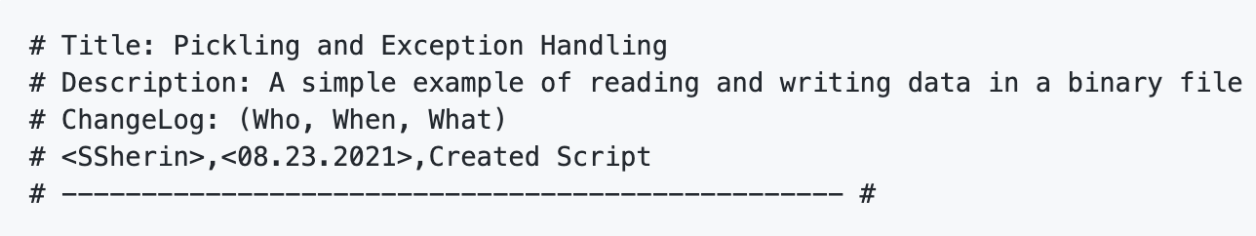Listing 1: Script Header

### Reading data from a binary file into a list of dictionary rows

This task is defined by a function which returns the list of dictionary rows. To read data from a binary file, the file is opened in “rb” mode. Using the pickle load(), the data from the pickle file is read and loaded into the list. Two exceptions are handled while reading data from file. Specific exception if the file to read is not found and generic exception if the file to read is corrupted.

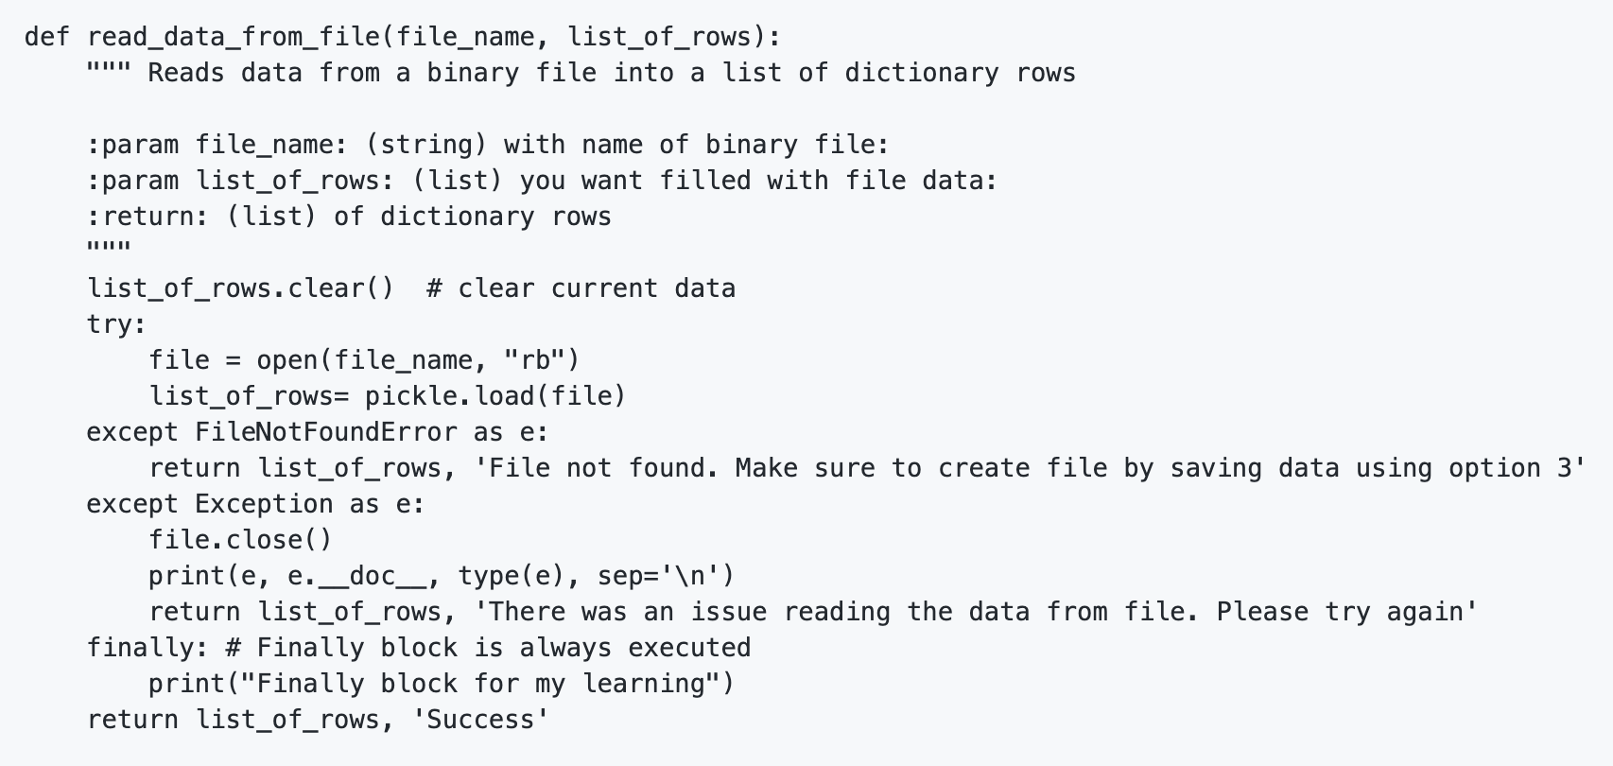Listing 2: Function reading data from file and returning the list of dictionary rows

### Writing List data to binary file

This function accepts two parameters, file_name(binary file to which the list data is written) and list_of_rows(list from which data is read). The file is opened in the "wb" mode and using the pickle dump(), the data from the list is written to the binary file.

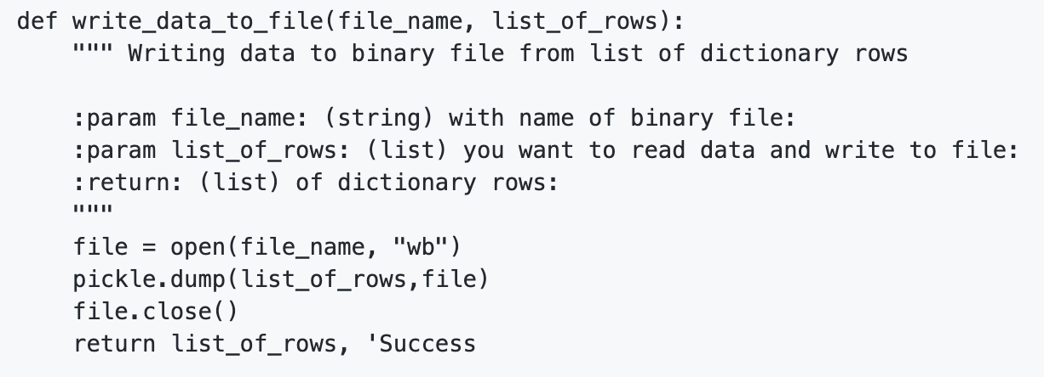Listing 3: Function writing List data to a binary file

## Execution

With the script created in its proper location, I run the script in both PyCharm (Figure 1) and an OS command/shell window (Figure 2).

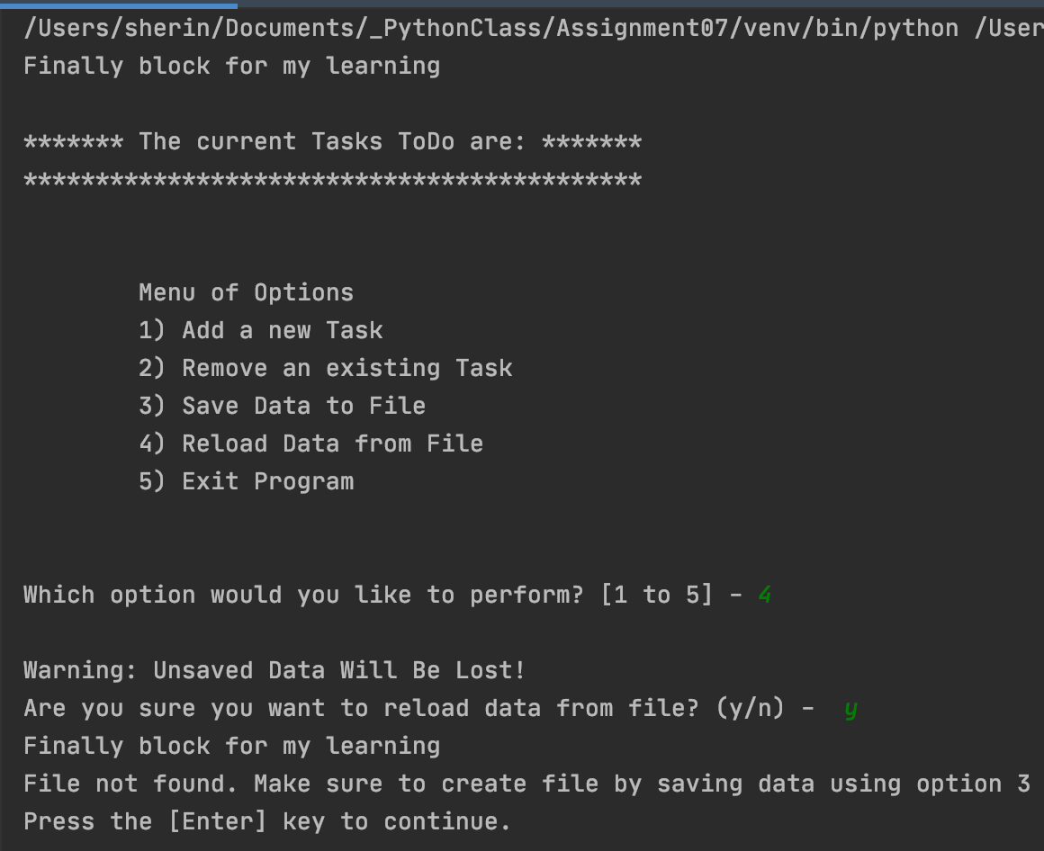Figure 1.1: The results of Listing 2

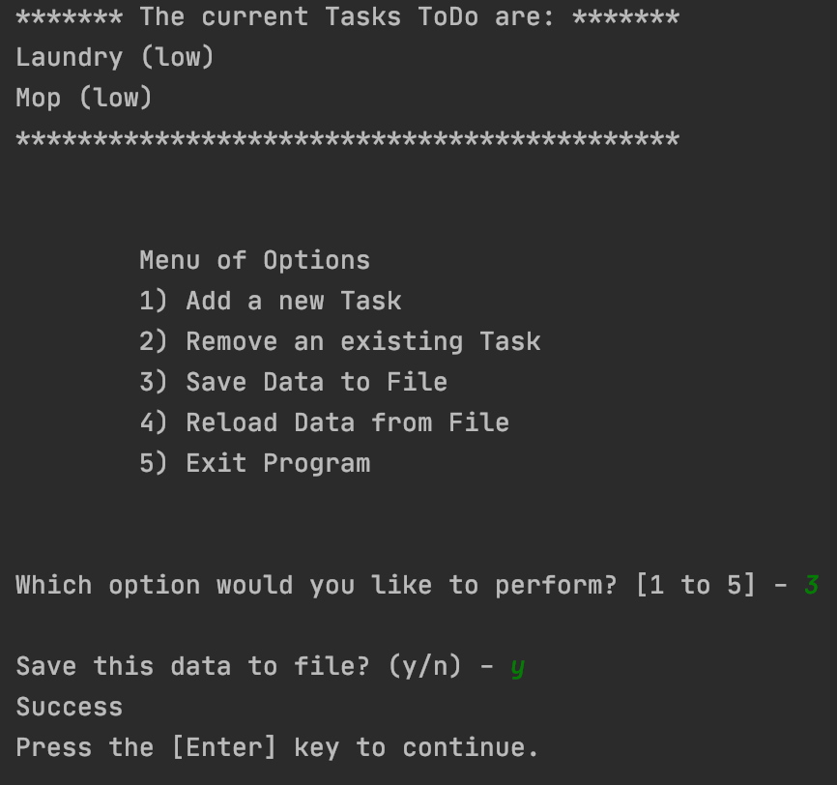

Figure 1.2: The results of Listing 3

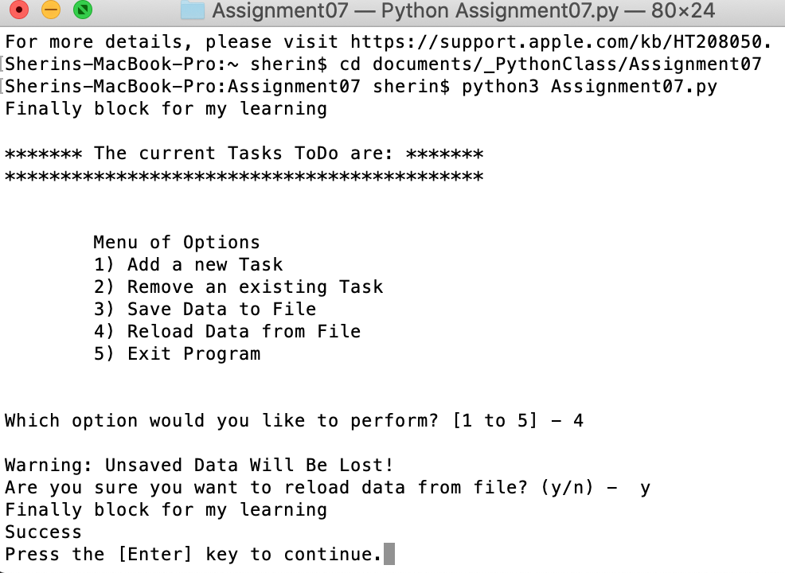Figure 2: The Script running in Command Window

## Verifying the result

Locate the file and open it in a text editor.

  
*Figure 3:* Verifying that the file contains binary data

## Summary

In this assignment, I was able to write a python script which uses Exceptions and Pickling. The script is executed both in PyCharm and in command window to verify the results and the script ran as expected. I also post the files on a public GitHub repository to review.