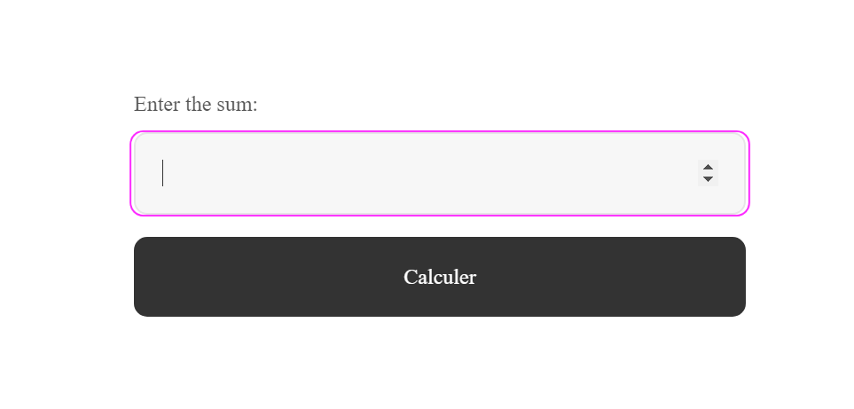

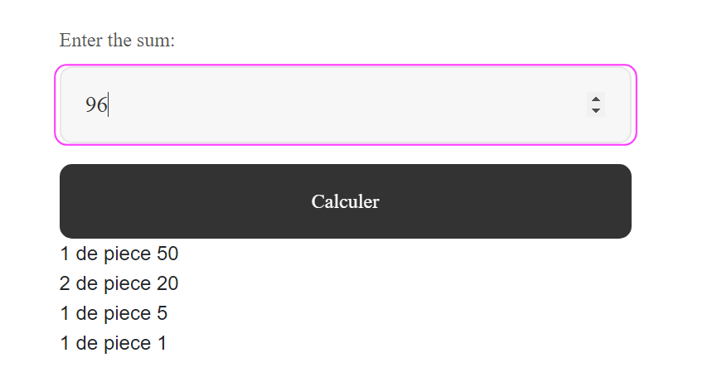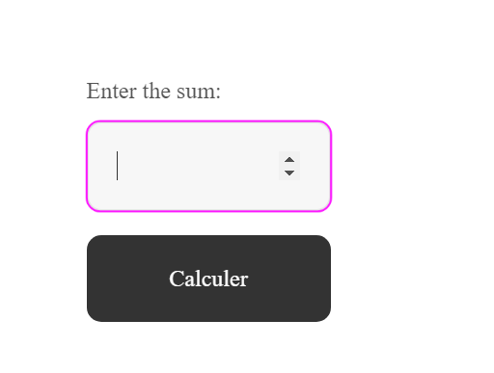

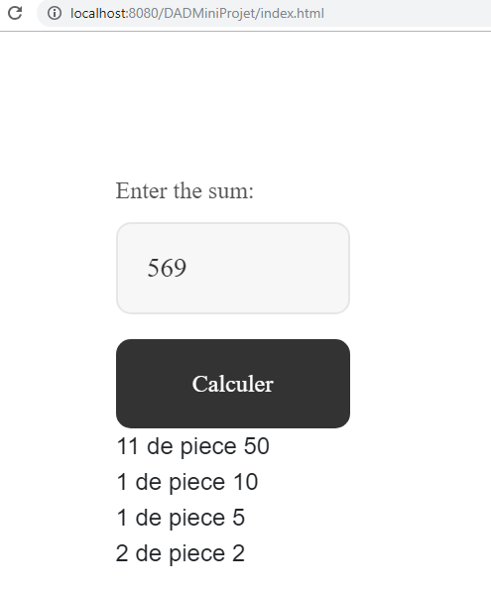

|  |
| --- |
| C:\Users\charik2\Documents\NetBeansProjects\DADMiniProjet\src\java\Calcule.java |

import java.io.IOException;

import java.io.PrintWriter;

import javax.servlet.ServletException;

import javax.servlet.http.HttpServlet;

import javax.servlet.http.HttpServletRequest;

import javax.servlet.http.HttpServletResponse;

/**

*

* **@author** charik2

*/

public class **Calcule** extends HttpServlet {

/**

* **Processes** **requests** **for** **both** **HTTP** **<code>GET</code>** **and** **<code>POST</code>**

* **methods.**

*

* **@param** request servlet request

* **@param** response servlet response

* **@throws** ServletException if a servlet-specific error occurs

* **@throws** IOException if an I/O error occurs

*/

protected void **processRequest**(HttpServletRequest req, HttpServletResponse response)

throws ServletException, IOException {

response.setContentType("text/html;charset=UTF-8");

try (PrintWriter out = response.getWriter()) {

int s = Integer.*parseInt*(req.getParameter("s"));

//piece 50 20 10 5 2 1

int[] piece = {

50, 20, 10, 5, 2, 1

};

int[] reslt = new int[piece.length];

for (int i = 0; i < piece.length; i++) {

if (s >= piece[i]) {

reslt[i] = s / piece[i];

s = s % piece[i];

}

}

for (int i = 0; i < reslt.length; i++) {

if (reslt[i] != 0) {

out.print(" " + reslt[i] + " de piece " + piece[i] + "**\n**");

}

}

}

}