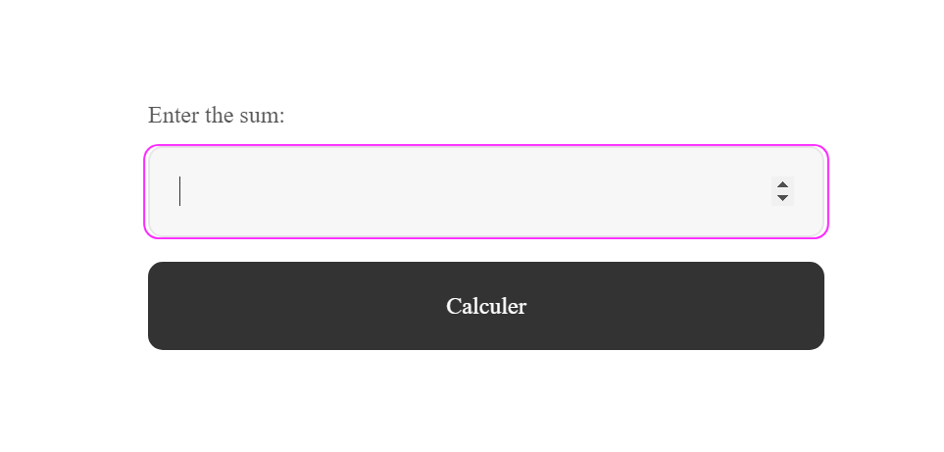
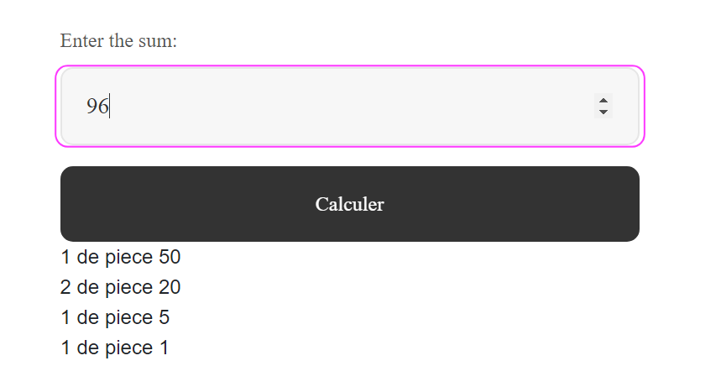
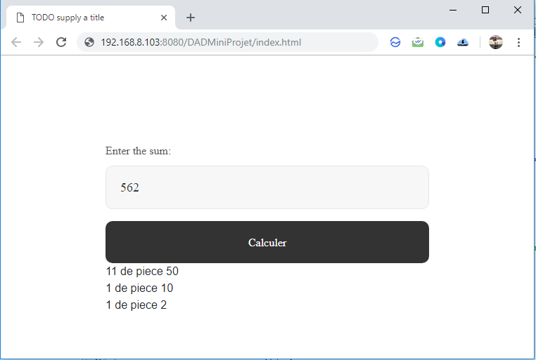

C:\Users\charik2\Documents\NetBeansProjects\DADMiniProjet\src\java\Calcule.java

import java.io.IOException;
import java.io.PrintWriter;
import javax.servlet.ServletException;
import javax.servlet.http.HttpServlet;
import javax.servlet.http.HttpServletRequest;
import javax.servlet.http.HttpServletResponse;

/**
*
* @author charik2
*/
public class Calcule extends HttpServlet {

/**
* Processes requests for both HTTP <code>GET</code> and <code>POST</code>
* methods.
*
* @param request servlet request
* @param response servlet response
* @throws ServletException if a servlet-specific error occurs
* @throws IOException if an I/O error occurs
*/
protected void processRequest(HttpServletRequest req, HttpServletResponse response)
throws ServletException, IOException {
response.setContentType("text/html;charset=UTF-8");
try (PrintWriter out = response.getWriter()) {
int s = Integer.parseInt(req.getParameter("s"));
//piece 50 20 10 5 2 1
int[] piece = {
50, 20, 10, 5, 2, 1
};
int[] reslt = new int[piece.length];
for (int i = 0; i < piece.length; i++) {
if (s >= piece[i]) {
reslt[i] = s / piece[i];
s = s % piece[i];
}
}
for (int i = 0; i < reslt.length; i++) {
if (reslt[i] != 0) {
out.print(" " + reslt[i] + " de piece " + piece[i] + "\n");
}
}

}
}

