–

Document ID: ASP-CMS-SRS-02.doc

Author(s): SHERJEEL AMIN

Version: 1.0

Date: March 7, 2023

1. Objective and Scope 3

2. Project End Users 3

3. Features 3

3.1 Login to the system 3

3.2 Registration 3

3.3 Book List . 4

3.4 Rent a book 4

3.5 Account information 4

3.7 Return a book 4

**4.** **Diagrams ……………………………………………………………………………………………………….. 5**

4.1 Use Diagram…………………………………………………………………………………………………………………….5

4.2 Class Diagram………………………………………………………………………………………………………………….6

4.3 Flow Diagram…………………………………………………………………………………………………………………..7

4.4 ER Diagram……………………………………………………………………………………………………………………..8

4.5 Sequence Diagram………………………………………………………………………………………………………….8

**5. Functional Requirements …………………………………………………………………………………..9**

5.1 User Registration and Authentication……………………………………………………………………………..9

5.2 Borrowing and returning………………………………………………………………………………………………….9

5.3 Reservation system………………………………………………………………………………………………………….9

5.4 User profile……………………………………………………………………………………………………………………….9

**6. Non-Functional requirements …………………………………………………………………………….10**

6.1 Security

6.2 Reliability

6.3 Availability

# Objective and Scope

The objective and the scope of the project is to build a efficient automated solution that helps us in book listing and borrowing.

The scope of the product includes the following basic features:

* User will be able to login and view their profiles.
* A user should be able to select books from the catalogue.
* A user should be able to reserve and return the books.

# Project End Users

Library admin and students

# Features

## Login to the system

Each and every user should be authenticated with a User Name and Password to login into the system.

Validations for User Name and Password.

User Name: It can be anything of the users’ choice.

Password: It can be anything of the users’ choice.

## Registration

**Add User:**

A user should be able to register himself in the system.

The student has two options to register : Normal registration and Special registration.

The registration requires user to enter Name, ID and Password

## Book List

Booklist can be viewed by the user and can accordingly rent the book using a JSON file.

## Rent a book

A user can rent a book for 10 days with normal credit and 20 days with Special credit. The user exceeding the limits will be blocked from renting more books after resolving the fine with the book store.

## Account information

A user will be able to view his Name, ID number and the number of books a user has rented.

## Return a book

A user will be able to return the book and the book will be available for other users to rent.

1. **DIAGRAMS**

4.1 Use Diagram

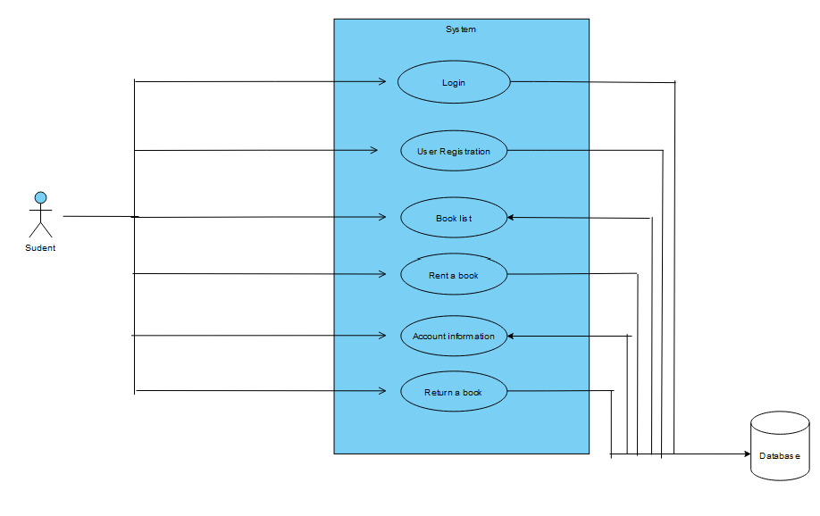

4.2 Class Diagram

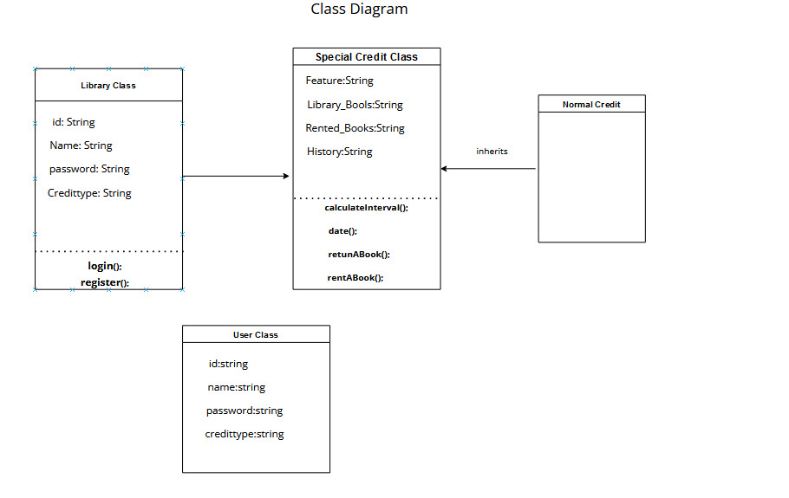

4.3 Flow Diagram

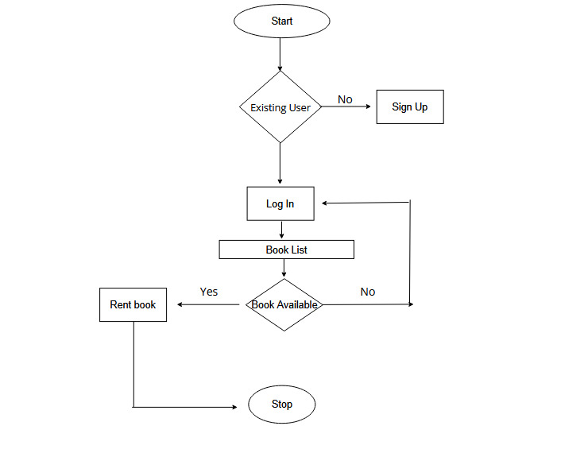

4.4 ER Diagram

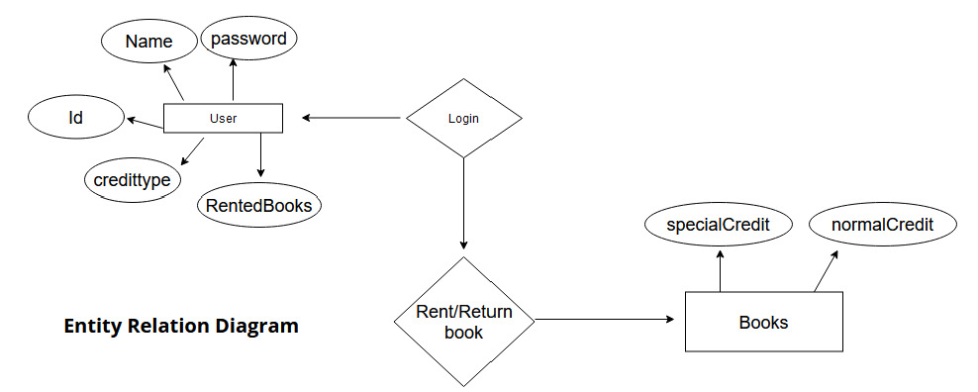

4.5 Sequence Diagram

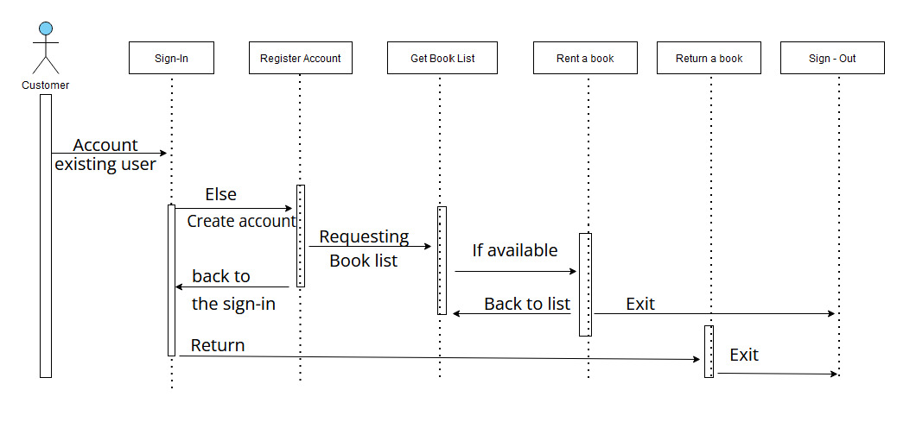

FUNCTIONAL REQUIREMENTS:

**5.1 User Registration and Authentication:**

* Users can create accounts with usernames, emails, and passwords.
* System validates information and guides users through the process.
* Registered users log in with credentials, supported by 2FA for security.

**5.2 Borrowing and Returning:**

* Users find and view available items for borrowing.
* Borrowed items have due dates assigned.
* Users return items, updating availability and records.

**5.3 Reservation System:**

* Users check item availability and make reservations.
* System manages reservations to prevent conflicts.
* Users receive notifications about reservations.

**5.4 User Profile:**

* Users manage profile info and preferences.
* System tracks activity history (borrowed, returned, reserved items).
* Users control privacy settings for data visibility.

Non-Functional requirements:

**6.1 Security:**

Security refers to safeguarding the system and its data from unauthorized access, data breaches, and malicious activities. It involves implementing measures such as encryption, authentication, authorization, and secure coding practices to ensure that user information and sensitive data remain confidential and protected.

**6.2 Reliability:**

Reliability focuses on the system's ability to perform consistently and predictably over time. A reliable system ensures that users can depend on it to function without unexpected crashes, errors, or failures. Achieving reliability involves rigorous testing, robust error handling, and monitoring to promptly identify and address any issues that might arise.

**6.3 Availability:**

Availability pertains to the system's uptime and accessibility. A highly available system ensures that users can access its features and services whenever they need to, without significant downtime. This can involve redundant server setups, load balancing, failover mechanisms, and strategies to handle high traffic periods without compromising performance.