Implementation of LBS (Lottery-Based Scheduling)
Traditional Implementation:
- To implement Lottery-Based Scheduling, we count the number of runnable processes by checking the RUNNABLE state of all processes.For which a basic function is written that performs a count operation when it detects a RUNNABLE process. A lottery is drawn from this pool of processes. For this pick_lottery function has been implemented.
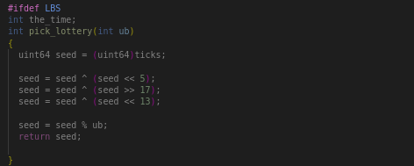
- The struct has been modified to include tickets, and during process creation (in the fork(), the child's ticket count is set to match that of the parent.
- Once the lottery selects a random process, a context switch is performed to that process.
Added Functionality:
- After the lottery selects the winner, the ticket count of the selected process is compared with all other processes. If another process has an earlier start time, further checks are performed.
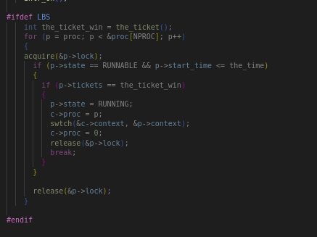
- This additional logic is implemented within the scheduler().. In this scheduler(), we call the pick_lottery and the_ticket() and check with all the NPRO processes. If a suitable process is found (based on the ticket count and start time), the context switch is performed for that process instead.
- All of this functionality is executed when the relevant macro LBS is defined before running the program.
- We have used two variables: tickets and strating time in struct of process to implement the above

Implementation Report: Queue System for Process Scheduling

Overview
This report outlines the implementation of a queue system to manage process scheduling based on a multi-level feedback queue (MLFQ) mechanism. The design ensures efficient management of runnable processes, the relinquishment of resources, and adherence to Round Robin Scheduling (RRS) principles.
- Changes in process: struct :
//MLFQ
int inq;
int qid;
int proc_no;
- Implemented functions and structures:
- struct priority_queues
{
int ptr1;
int ptr2;
int size;
int time_slice_for_level;
struct proc *Process[2*NPROC];
};
- void priorityboost();
void mlfq_remove(struct proc *p, int queue_no);
void enque_top(struct proc *p, int qid);
struct proc *dequeue(int qid);
void init_que();
void enque_back(struct proc *p, int qid);
extern struct priority_queues priority_queues[4];

Queue Management
To facilitate process management, we implemented a queuing system where runnable processes are pushed into a queue at every tick. The scheduler iterates over all processes, identifying those in the RUNNABLE state. These processes are enqueued and scheduled for execution.
IDEA:
To maintain a queue system, that for every tick, enqueues procs in the right level(based on p->qid), and selects one proc from it based on priority and dequeues that proc does push (based on p→qid =/!= 3)
- Push Runnable Processes:
  - At every tick, the scheduler checks the state of each process.
  - All processes that are in the RUNNABLE state are pushed into the appropriate queue. This guarantees that all eligible processes are considered for execution.
- Execution of Processes:
  - The system runs the processes based on their position in the queue. It uses a trap mechanism, defined in trap.c, to manage transitions between different queue states.
  - Funtionality in trap.c
  - Every time it reaches its max. ticks, it is dequeued from that level!
  - Or its execution time is updated!

Relinquishing Processes
- Exclusion of I/O Processes:
  - Processes in the relinquishment are intentionally excluded from being pushed to the queue. This prevents unnecessary context switching and allows the CPU to focus on active processes.
  - Ensured as no relinquished process will be queued, only RUNNABLE processes are at every tick.
  - By ensuring that only runnable processes are queued, we minimize CPU idle time and optimize throughput.
- Implementation of Round Robin Scheduling (RRS):
  - To maintain fairness among processes, we ensure that processes executed in queue3 (the lowest priority queue) are pushed to the end of the queue after their time slice expires. This ensures once a process is run the next process in its queue will be given the chance:
if (sel_p_to_run->state == RUNNABLE)
{
if(sel_p_to_run->qid ==3)
enque_back(sel_p_to_run, sel_p_to_run->qid);
else
enque_top(sel_p_to_run, sel_p_to_run->qid); // Enable RRS in Q3
break;
}

Priority Adjustment
To further enhance the performance of the scheduling system, we have implemented a periodic priority adjustment mechanism.
- Priority Boost Every 48 Ticks:
  - Every 48 ticks, all processes are assigned the highest priority. This adjustment is crucial for preventing starvation, particularly for processes that may be waiting in lower priority queues.
  - Ensured as for every 48 ticks (ticks % 48 == 0) the priority boost func.() is called, that enqueues all processes to lowest priority queue.

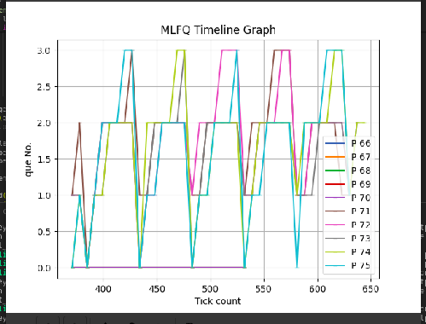
At 48, qid = 0

Performance Analysis
The table below summarizes the performance of the three scheduling policies in terms of average running time and waiting time:
Scheduling Policy | Average Running Time (rtime) | Average Waiting Time (wtime)
MLFQ | 31 | 216
LBS | 29 | 158
RRS | 29 | 218

Insights:
- Average Running Time: The running times for LBS and RRS are slightly better than MLFQ, as they both give more uniform access to CPU resources across all processes. The minimal difference in running time suggests that the policies are fairly efficient in process execution.
- Average Waiting Time:
  - LBS has the lowest waiting time (158), thanks to the random selection mechanism, which ensures that processes with more tickets (typically higher-priority or more resource-hungry) are given better chances to run. And here it runs like FCFS as all are set to 1.
  - MLFQ has a relatively high waiting time (216), as processes that fall to lower-priority queues may experience significant delays in execution, especially if the system is overloaded with tasks.
  - RRS has the highest waiting time (218), primarily because all processes are given equal CPU time, leading to delays for processes at the back of the queue.

Conclusion:
- LBS provides the most balanced performance overall, with the lowest waiting time while maintaining a competitive average running time.
- RRS ensures fairness but results in longer waiting times due to its cyclic nature.
- MLFQ is effective for prioritizing short jobs but can lead to longer waiting times for lower-priority processes, although it offers decent running time averages.
In this context,
This performance comparison shows that LBS may be the most efficient in terms of reducing process waiting time, while MLFQ remains a good choice for systems where process priority needs to be dynamically managed.
Q)
Incorporating arrival time into the lottery-based scheduling policy can prioritize processes that have been waiting longer, ensuring fairness by giving older processes a better chance of running. However, a pitfall to watch out for is potential starvation of processes with fewer tickets, as newer processes with equal tickets could be continuously favored due to randomness. If all processes have the same number of tickets, the scheduler effectively becomes a randomized round-robin system,(if traditional) where each process has an equal probability of being chosen, and no clear priority emerges. But as we incorporate another check of start_time, the earliest process gets the chance so it becomes an FCFS.

