Project Run and GitHub Handoff
Medicine Stock and Expiry Tracking System with DevOps Automation
This hand-in records the running local app, the fictional batches currently loaded, and verification commands. The project is committed locally on branch main; publishing will need the GitHub owner and repository details.

Live website
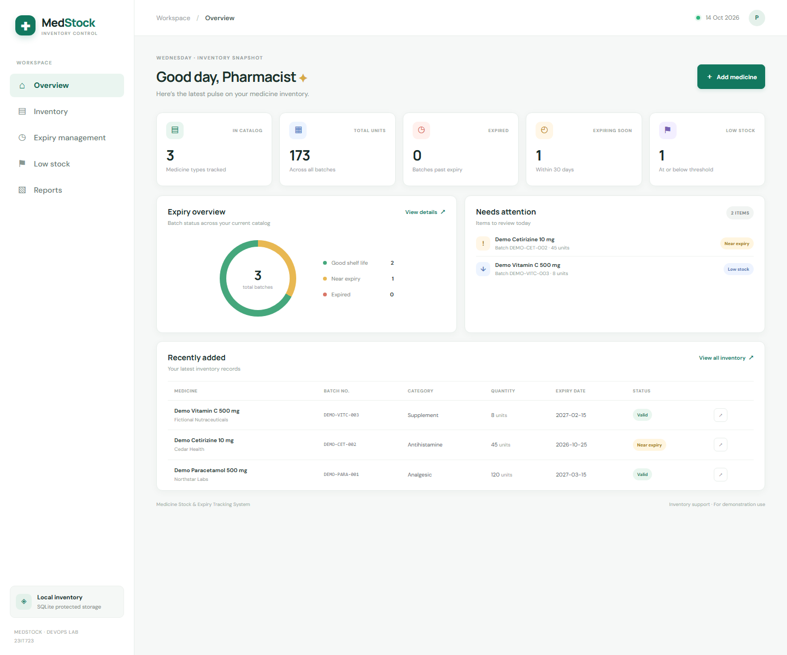
Dashboard captured on 14 October 2026 from the local application.

Fictional demo records
Medicine and batch | Quantity / threshold | Expiry | Calculated status
Demo Paracetamol 500 mg  DEMO-PARA-001 | 120 / 20 | 15 Mar 2027 | In stock
Demo Cetirizine 10 mg  DEMO-CET-002 | 45 / 12 | 25 Oct 2026 | Near expiry
Demo Vitamin C 500 mg  DEMO-VITC-003 | 8 / 15 | 15 Feb 2027 | Low stock

Run the application
From PowerShell, start the existing project with the commands below. Open http://localhost:5000 after the server starts.
cd D:\Devops
py -m venv .venv
.\.venv\Scripts\Activate.ps1
python -m pip install -r requirements.txt
$env:SECRET_KEY = "replace-with-a-random-local-secret"
python app.py
The database is created automatically. Add your own records with Add medicine; demo records remain available as examples.

Terminal verification transcript
This formatted transcript reproduces command output from the local checks. The dashboard above is a browser screenshot.
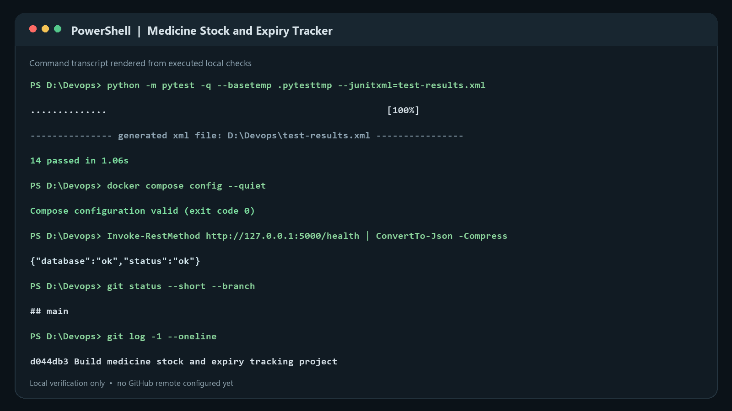
Checks shown: pytest, Compose configuration, health endpoint, and local Git status.

GitHub publishing status
A local Git repository is ready on branch main with commit d044db3 (Build medicine stock and expiry tracking project). The working tree is clean. No remote repository has been created or pushed.
To publish, provide the GitHub username or organization, repository name, and whether it should be public or private. Do not send a password or access token in chat; authenticate through GitHub's normal sign-in or an approved connector when publishing.

