**NAME: Dongxu Xia**

**ID: 202283890007**

**Project #1: Using Agile with Raspberry Pi**

**The Quick Reaction Game**

**DATE: 21/4/7**

**GitHub URL:**

**[Sherlock0129/NUIST3-Pi-Physical](https://github.com/Sherlock0129/NUIST3-Pi-Physical)**

**Part 1 The Agile Process**

*SCRUM(Plan the Quick Reaction Pi Game) Duration:5 Days*

*|*

*|__________>SPRINT 1 - Duration = 2 Days*

*Task 1 : Plan Steps*

*Task 2 : Write User Stories*

*Task 3 : Create Burndown Chart*

*Task 4 : Write Agile section of the report*

· **As a developer**, I want to **break down the project into smaller tasks**, so I can manage the work more effectively.

· **As a team member**, I want to **write clear user stories**, so our development goals are user-focused and trackable.

· **As a Scrum Master**, I want to **create a burndown chart**, so I can visually monitor our team’s progress during the sprint.

· **As a documentation lead**, I want to **write the Agile section of the final report**, so that our development process is well-documented.

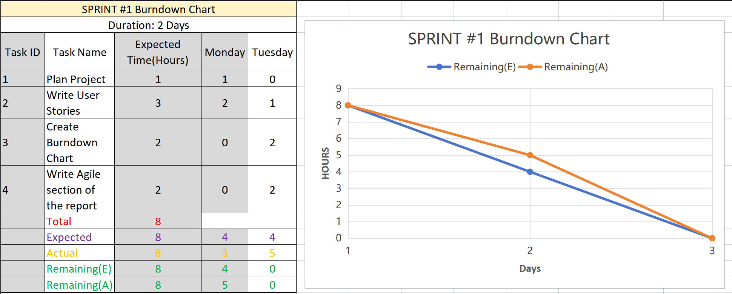

*|*

*|__________>SPRINT 2 - Duration = 3 Days*

*Task 1 : Setup GitHub remote Repository*

*Task 2 : Connect hardware components (LED, buttons)*

*Task 3 : Implement code to detect the first button press*

*Task 4 :Prompt players to enter names and Display winner`s name*

*Task 5 : Submit to GitHub remote Repository*

**·As a developer,** I want to setup a GitHub remote repository, so that the team can collaborate on the project code efficiently and have a centralized version control.

**· As a hardware engineer,** I want to connect hardware components (LED, buttons), so that the system can interact with the physical environment and provide tangible user experiences.

**· As a software coder,** I want to implement code to detect the first button press, so that the game can start and respond to user actions accurately.

**·As a UI/UX designer,** I want to prompt players to enter names and display the winner's name, so that the game has a personalized and engaging user interface.

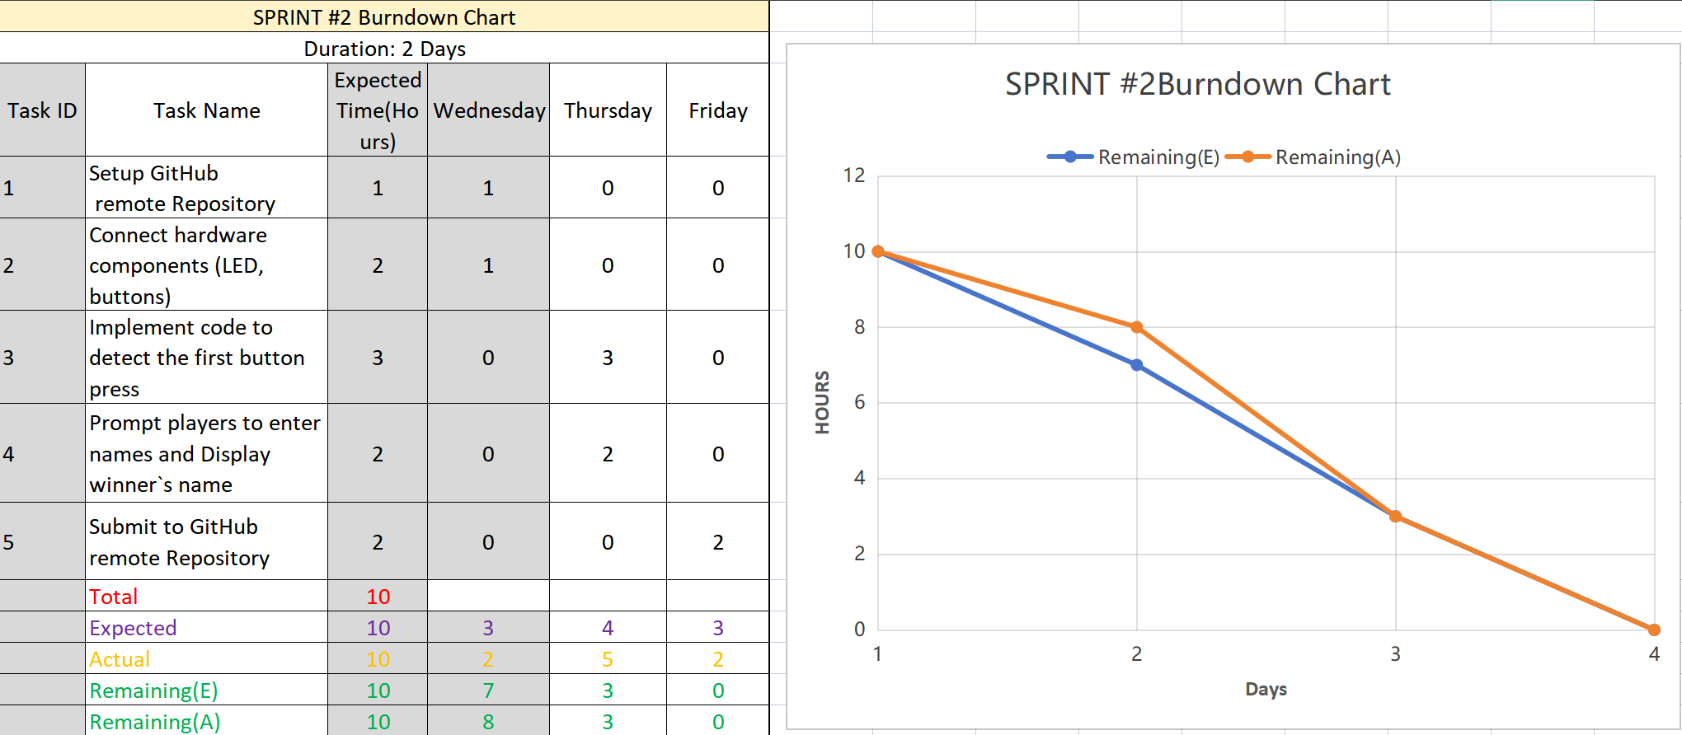

**Part 2 The Agile Process**