Customer Logo: {CUSTOMER_Logo}

Rackspace Logo: {Rax_logo}



Version Date: {Date}

Generated for: QTSC by {SA_EMAIL} (VN TEAM) with Partner {PARTNER_NAME}

# Cloud Readiness Assessment (CRA) - QTSC

Customer Introduction

Customer Name: QTSC

City: TP.HCM

Country: Vietnam

### 3.1 Architecture Diagrams

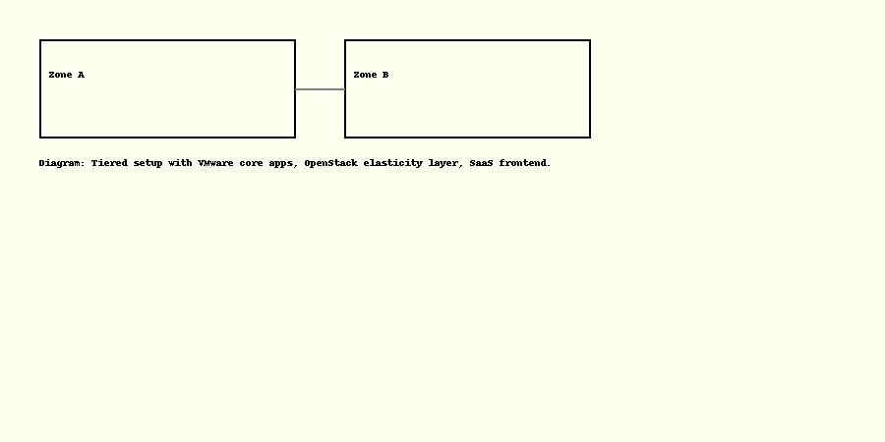

### 3.2 Current IT Environment

Hardware Requirements: {Hardware_Requirements}

Network Requirements: {Network_Requirements}

Software Requirements: {Software_Requirements}

|  |  |  |  |
| --- | --- | --- | --- |
| Application | RTO (hrs) | RPO (hrs) | DR Method |
| App1 | 1 | 1 | VMware SRM |
| App2 | 2 | 2 | OpenStack Snap |
| App3 | 4 | 2 | SRM |
| App4 | 8 | 6 | Tape |
| App5 | 12 | 8 | Cold Standby |
| App6 | 6 | 4 | VMware SRM |
| App7 | 24 | 12 | Cloud Rep |
| App8 | 12 | 8 | Cloud Rep |
| App9 | 16 | 6 | Warm Standby |
| App10 | 8 | 2 | VM Snap |

Migration Table: {mig_table}

### 4.2 Disaster Recovery

Disaster Recovery Strategy: {DISASTER_RECOVERY}

Disaster Recovery Method: {DR_METHOD}

### 4.3 Network Design

Network Allocation Table:

|  |  |  |  |  |
| --- | --- | --- | --- | --- |
| Year | VMware Cost (USD) | OpenStack Cost (USD) | SaaS Cost (USD) | Total Cost (USD) |
| Year 1 | 50000 | 20000 | 10000 | 80000 |
| Year 2 | 48000 | 22000 | 12000 | 82000 |
| Year 3 | 46000 | 25000 | 14000 | 85000 |
| Year 4 | 44000 | 27000 | 16000 | 87000 |
| Year 5 | 42000 | 30000 | 18000 | 90000 |

Data Center Naming Convention: {DC_NB}

## 5. Security & Compliance

### 5.1 SSL Certificates

SSL Certificates: {SSL_Certificates}

### 5.2 Governance

Governance Diagram:

{Gov_Diagram}

### 6.3 Service Level Agreements

SLA for Applications: {SLA_APPS}

## Executive Summary

This section provides a high-level overview of the assessment findings and recommendations.

This Cloud Readiness Assessment (CRA) is conducted for CUSTOMER, a leading utility provider in Vietnam, in partnership with Rackspace and CMC.  
The goal is to assess the current IT infrastructure landscape, identify gaps, and provide a roadmap toward a cost-effective, resilient hybrid cloud model.  
The assessment was conducted through stakeholder interviews, infrastructure discovery tools, and TCO modeling.  
Findings show fragmented infrastructure management, limited disaster recovery (DR) capabilities, and significant cost inefficiencies in licensing and compute scaling.  
To address these, a hybrid strategy is proposed: maintain VMware for mission-critical systems (OMS, IAM), and migrate elastic workloads (BI, CRM, Dev/Test) to OpenStack.  
This phased approach enables agility, cost reduction, and compliance with data residency requirements.  
The roadmap includes automation (IaC, pipelines), centralized observability, and CCoE governance.  
Cost optimization through Flexera indicates 30–40% potential OPEX savings over 5 years.  
Migration risks are manageable with a 3-wave migration plan and controlled DR design.  
A joint governance model will ensure alignment across partners: CMC, Rackspace, and CUSTOMER leadership.  
This CRA serves as the foundation for execution and aligns with MoIT and EVN digital transformation guidelines.