QTSC – ITIL – CRA Response – Statement of Work

Prepared for: QTSC

Date: 05/27/2025

Version: v2.0

# 1. Executive Summary

This executive summary provides an overview of the project’s purpose, its key objectives, and the major phases including discovery, architecture, DevOps, and ITSM evaluation.

|  |  |  |  |
| --- | --- | --- | --- |
| Deliverable | Format | Owner | Due Date |
| Current State Assessment | PDF | Solution Architect | 2025-06-01 |
| Cloud Architecture Design | PPTX | Cloud Architect | 2025-06-05 |
| DevOps Gap Report | DOCX | DevOps Lead | 2025-06-10 |

|  |  |
| --- | --- |
| **Team** | **Tasks Covered** |
| **Audit / Assessment Team** | - Automated discovery of infrastructure and applications |
|  | - Initial system baselining |
| **Audit / Licensing Team** | - Software license compliance audit |
| **FinOps / Audit Team** | - TCO modeling & cloud suitability |
| **Security Audit Team** | - Risk and vulnerability assessment (e.g., CVEs, EOL systems) |
| **Solution Architects** | - Review business & technical environment- Infra/app dependency inventory- Network & connectivity review- Performance, storage, and security analysis- Use case and emerging tech analysis- Cloud architecture & network design- DevOps and observability policies- Cost analysis- App-component mapping- Infrastructure remediation recommendations- Scalability planning |
| **FinOps** | - Joint cost analysis with Solution Architects |
| **DevOps Consultants** | - SDLC and CI/CD tooling review- Deployment architecture evaluation- DevOps maturity assessment and gap analysis |
| **ITIL Team** | - ITSM maturity and operations baseline review- ITSM tools comparison- RACI mapping- Design of Target Operating Model- Service architecture blueprinting |
| **Business Consultants** | - Review customer profile & business strategy |
| **Product Team** | - Cloud product portfolio evaluation |
| **HR / Org Analysts** | - Skills gap and certification analysis |
| **TBD / Cross-Team** | - Infrastructure EOL evaluation- Sovereign cloud roadmap alignment- Service management automation tools (e.g., ServiceNow, SIEM) |

# 2. Scope

**In Scope**: Phases 0–5  
**Out of Scope**: Phases 6–7 (not priced in this SoW)

# 3. Objectives

{TEXT_OBJECTIVES}

# 4. Deliverables

📊 {EXCEL_DELIVERABLE_TRACKER}

# 5. Project Phases & Tasks

# Phase 0 – Task Breakdown

Establish a baseline understanding of current infrastructure, applications, software licensing, and risk posture through automated discovery and analysis.

|  |  |  |  |  |
| --- | --- | --- | --- | --- |
| Task | Goal | Tools | Duration | Deliverable |
| Automated Discovery of Infra/Apps | Baseline all systems & dependencies | Flexera / Live Optics / RVTools | 2 days | Inventory & usage heatmaps |
| Software License & Compliance Audit | Identify over-/under-licensing | Flexera FNMS / Snow / SCCM | 2 days | Compliance report |
| TCO Modeling & Cloud Suitability | Compare on-prem vs. cloud costs | Flexera CloudScape / AWS Migration Evaluator | 2 days | 3- and 5-year TCO charts |
| Risk & Vulnerability Assessment | Surface security gaps & EOL issues | Qualys / Nessus / Flexera Secunia | 2 days | Risk matrix & remediation list |

|  |  |  |  |  |
| --- | --- | --- | --- | --- |
| Task | Goal | Tools | Duration | Deliverable |
| Automated Discovery of Infra/Apps | Baseline all systems & dependencies | Flexera / Live Optics / RVTools | 2 days | Inventory & usage heatmaps |
| Software License & Compliance Audit | Identify over-/under-licensing | Flexera FNMS / Snow / SCCM | 2 days | Compliance report |
| TCO Modeling & Cloud Suitability | Compare on-prem vs. cloud costs | Flexera CloudScape / AWS Migration Evaluator | 2 days | 3- and 5-year TCO charts |
| Risk & Vulnerability Assessment | Surface security gaps & EOL issues | Qualys / Nessus / Flexera Secunia | 2 days | Risk matrix & remediation list |

# Phase 1 – Task Breakdown

📄 {TEXT_PHASE_1_OBJECTIVE}

📊 {TABLE_PHASE_1_TASKS}

|  |  |  |  |  |
| --- | --- | --- | --- | --- |
| Task | Goal | Tools | Duration | Deliverable |
| Review biz ops & tech environment | Understand current environment | Workshops, Interviews, Excel | 2 days | Current state analysis doc |
| Build infra/app inventory | Document assets & deps | Flexera/Live Optics/RVTools | 3 days | Asset & dependency matrix |
| Networking & connectivity review | Assess readiness | Nmap, NetFlow, Visio | 2 days | Connectivity assessment report |
| Performance, security, storage review | Evaluate NFRs | Zabbix, SolarWinds | 2 days | NFR evaluation checklist |
| Review emerging-tech use cases | Understand future needs | Workshops, Gartner reports | 1 day | Emerging tech matrix |
| Design cloud architecture & networking | Blueprint target state | Lucidchart, Terraform | 3 days | Cloud target architecture |
| Define DevOps, monitoring & logging policies | Standardize ops best practices | Grafana, Prometheus, ELK | 2 days | DevOps & Observability policies |
| Cost analysis & comparison | Support budget planning | Flexera CloudScape, Excel | 2 days | TCO comparison report |

# Phase 2 – Task Breakdown

📄 {TEXT_PHASE_2_OBJECTIVE}

📊 {TABLE_PHASE_2_TASKS}

|  |  |  |  |  |
| --- | --- | --- | --- | --- |
| Task | Goal | Tools | Duration | Deliverable |
| Asset & server utilization assessment | Optimize usage | Flexera/Live Optics/RVTools | 2 days | Utilization optimization plan |
| Evaluate network, security, backup arch. | Ensure compliance & reliability | Nessus, Veeam, firewall configs | 3 days | Reliability & compliance report |
| Application & component evaluation | Align infra to app needs | Dependency mapping tools | 2 days | App-to-host matrix |
| Security posture evaluation | Strengthen controls | IAM tools, CIS benchmarks | 2 days | Security controls assessment |
| Connectivity & scaling optimization | Enable cloud scalability | CloudWatch, auto-scaling | 2 days | Scalability roadmap |
| Provide remediation recommendations | Guide implementation | Jira, risk register | 1 day | Remediation playbook |

# Phase 3 – Task Breakdown

📄 {TEXT_PHASE_3_OBJECTIVE}

📊 {TABLE_PHASE_3_TASKS}

|  |  |  |  |  |
| --- | --- | --- | --- | --- |
| Task | Goal | Tools | Duration | Deliverable |
| Review SDLC & CI/CD tooling | Identify pipeline gaps | GitLab, Jenkins, Azure DevOps | 2 days | CI/CD tooling gap report |
| Evaluate deployment architecture | Improve repeatability | Helm, Terraform, Kubernetes | 2 days | Deployment architecture report |
| DevOps gap analysis & remediation plan | Raise maturity | Jira, Confluence, maturity models | 2 days | DevOps maturity roadmap |

# Phase 4 – Task Breakdown

📄 {TEXT_PHASE_4_OBJECTIVE}

📊 {TABLE_PHASE_4_TASKS}

|  |  |  |  |  |
| --- | --- | --- | --- | --- |
| Task | Goal | Team | Duration | Deliverable |
| Review customer business profile & future plans | Align roadmap to strategy | Business Consultants / SA | 2 days | Strategic roadmap |
| Product portfolio evaluation | Define cloud product strategy | Solution Architects / Product Team | 2 days | Product strategy doc |
| Service Mgmt tooling review | Recommend automation & RPA/SRE | ITIL Team | 2 days | Tooling recommendations |
| Team structure, skills & certifications review | Assess readiness | ITIL Team / HR | 2 days | Skills gap & training plan |
| Evaluate current & future infra incl. EOL gear | Plan upgrades or reuse | Solution Architects | 2 days | Infrastructure rationalization report |

# Phase 5 – Task Breakdown

📄 {TEXT_PHASE_5_OBJECTIVE}

📊 {TABLE_PHASE_5_TASKS}

|  |  |  |  |  |
| --- | --- | --- | --- | --- |
| Task | Goal | Tools | Duration | Deliverable |
| ITIL maturity & operations baseline assessment | Measure ITSM effectiveness | ITIL self-assessment tools | 2 days | ITIL maturity scorecard |
| Compare current ITSM tools & modules | Select best-fit platform | Tool demos, scoring matrix | 2 days | ITSM tool evaluation report |
| Role/responsibility mapping vs. ITIL | Align to ITSM best practices | Excel, process mapping | 1 day | RACI matrix |
| Design Target Operating Model | Build future-ready service model | PowerPoint, BPMN | 2 days | Target Operating Model |
| Design service architecture (people, tools, suppliers) | Enable integrated ITSM strategy | Lucidchart, CMDB inputs | 2 days | Integrated service blueprint |

Refer to Phases 0–5 task breakdown as previously detailed.

# 6. Team Roles & RACI

|  |  |  |  |  |
| --- | --- | --- | --- | --- |
| Task | Responsible | Accountable | Consulted | Informed |
| Cloud Design | Cloud Architect | Project Manager | Security Team | Finance |
| DevOps Review | DevOps Lead | CTO | QA | Legal |
| ITSM Strategy | ITIL Lead | CIO | HR | PMO |

# 7. Timeline & Milestones

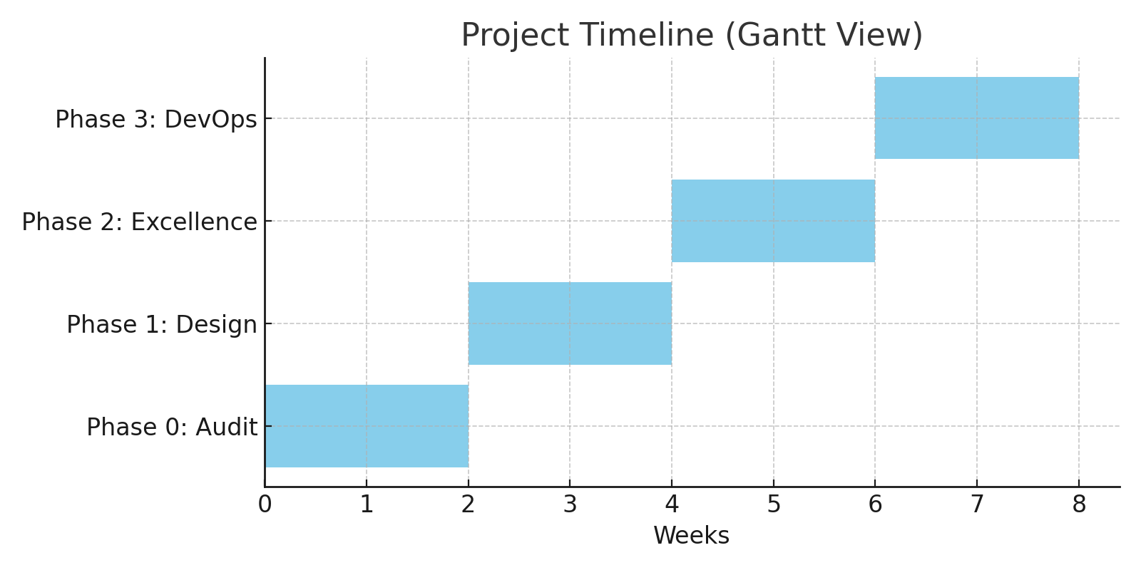

# 8. Assumptions & Dependencies

📄 {TEXT_ASSUMPTIONS}  
📄 {TEXT_DEPENDENCIES}

# 9. Acceptance Criteria

Deliverables are considered accepted upon approval from the customer’s project lead and documentation of acceptance via formal sign-off.

# 10. Change Control

📄 {TEXT_CHANGE_MANAGEMENT}

# 11. Commercial Summary

|  |  |
| --- | --- |
| Component | Estimated Cost (USD) |
| Assessment | 5000 |
| Design | 7000 |
| DevOps Audit | 4000 |

# 12. Appendix

A. Glossary  
B. Tool Reference  
C. Full Task Matrix (Excel)  
D. Sample Deliverables