# ☁️ S Cloud Readiness Assessment

Author : [Dzoan,nguyen@rackspace.com](mailto:Dzoan,nguyen@rackspace.com)

Status : draft base on my current assumptions

Next steps : need feeback from about their core business apps and validation from Matt

Date 03 april 2025

CONTENT

☁️ S Cloud Readiness Assessment 1

1. Executive Summary 4

**Company Overview** 4

💼 S Service Portfolio 4

🏛️ Existing IT Infrastructure 4

⚠️Challenges with the Current Landscape 5

🚀 Future Strategic IT Automation Transformation 5

**✨ Benefits of Hybrid Transformation:** 6

2. Objectives of the Assessment 6

3. Current IT Landscape Overview 8

Current Infrastructure Summary 8

**Key Challenges** 9

Application Portfolio Classification 10

Applications Dependencies 11

**Application Dependencies Overview** 11

3. Target Architecture Strategy 13

**🏗🏛️ Architecture View (Logical Diagram – with DR overlay)** 13

Disaster Recovery Strategies 14

**✅ For Best performances Disaster Recovery Strategy** 14

**💡 Cost-Effective Disaster Recovery Matrix for S** 15

**Cost Effectiveness Ratings:** 15

**🏗️ Target Architecture Strategy – With Current Hosting and DR Plan** 17

4. S Migration Strategy 18

Cloud Fit Analysis 18

Proposed Migration Strategy 20

Migration Table Summary 21

Migration Waves Details 24

**🌊 Wave 1: Core Systems on VMWare and metal servers** 24

**🌊 Wave 2: Customer-Facing** 25

**🌊 Wave 3: BI & Reporting** 28

**🌊 Wave 4: Peripheral Services** 28

5. TCO s 30

💰 Total Cost of Ownership (TCO) Breakdown – S CRA 30

**📌 Observations:** 31

**1. TCO Analysis (Private vs. Public Cloud)** 31

**2. TCO – Steady-State (Current)** 31

**3. TCO – Steady-State (Private Cloud)** 31

**4. TCO Comparison Summary** 31

**5. One-Time Migration Cost** 32

**6. 📊 Financial Summary Table** 32

6 -✅ SUM UP Key Takeaways & Strategic Outcomes 33

**🧩 1. Infrastructure Modernization Strategy** 33

**💸 2. Cost Optimization** 33

**🔁 3. Phased Migration Plan** 33

**🔒 4. DR & Resilience Strategy** 34

**📊 5. Strategic Outputs Delivered** 34

🎯 7. Next Steps 36

8. ☎️ Contact & Support 37

# 1. Executive Summary

## Company Overview

**Vietcombank Securities ( S)** is a leading securities firm and a subsidiary of offering a wide spectrum of investment banking, brokerage, and advisory services to institutional and retail clients. S plays a key role in Vietnam’s financial ecosystem, delivering:

## 💼 S Service Portfolio

S provides a comprehensive suite of financial services tailored to meet the needs of a wide client base, including:

|  |  |
| --- | --- |
| **Service** | **Description** |
| **Securities Brokerage** | Execution of buy/sell orders for listed and OTC securities on behalf of clients. |
| **Investment Advisory** | Expert consultation on market trends, portfolio structuring, and investment strategies. |
| **Securities Management** | Custody services including shareholder list management, rights exercise, depository, and reporting. |
| **Market Research & Analytics** | In-depth macroeconomic, industry, company, and bond market research to support informed decisions. |
| **Transaction Support** | Client onboarding, account setup, cash transfers, and related transactional services. |
| **Corporate Finance** | Bond issuance, listing consultancy, and corporate restructuring advisory for enterprises. |

Through these services, S plays a central role in supporting Vietnam’s financial markets with transparency, agility, and integrity.

## 🚀 Future Strategic IT Automation Transformation

In the context of cost optimization, regulatory expectations, and increasing demand for digital experiences, S seeks to modernize its IT infrastructure.

This CRA identifies opportunities to:CBS is evolving into a **data- and AI-driven digital financial platform**, requiring:

* 📉 Lower TCO
* 🌐 Enhanced HA via cost effective solid disaster recovery solutions
* ⚡ Faster DevOps environments to Increase agility for AI, analytics, and in house digital product rollout
* 🧠 AI-driven analytics & Business intelligence Services

To overcome these challenges and support its future digital ambitions, S exploring a transition to a **hybrid infrastructure model**, strategically balancing its existing VMware estate with a modern **OpenStack platform**.

* 🏛 **VMware** will continue to host **mission-critical systems** (core trading, compliance, regulatory apps).
* **High Availability** by choosing the best cost effect Disaster recovery solution within VBCS budget and SLA , SLO for their core business systems . DR can be on VMWARE , Openstack or Cloud )
* ☁️ **OpenStack** will absorb **secondary systems** (BI, HR, CRM, test/dev, analytics), offering agility and cost efficiency.

### ✨ Benefits of Hybrid Transformation:

* **Cost Optimization**: OpenStack can cut infrastructure spend by ~50% for suitable workloads.
* **Platform Flexibility**: Enables rapid provisioning of staging, QA, and analytics environments.
* **Improved DR and Resilience**: Applications can be split across zones or replicated for HA.
* **Innovation Enablement**: Frees VMware resources for high-priority apps, while OpenStack to supports new Services and Business system AI/ML expansion , Business Analytics, Expansion to new Markets and networks ( Defi , Blockchain for examples )

# 2. Objectives of the Assessment

Our Cloud Readiness Assessment will cover

* Evaluate the **current IT environment**
* Identify **cloud-compatible workloads**
* Recommend a **target architecture** (Hybrid: VMware + OpenStack)
* Outline **migration strategies** based on the **7 R’s model**
* Provide a **TCO comparison** between current and hybrid setups
* Recommend **phased migration waves** aligned with business goals

# 3. Current IT Landscape Overview

## 🏛️ Existing IT Infrastructure

Over the last decade, S has invested in a centralized, enterprise-grade infrastructure built on **VMware technologies**. Their core platforms — including the **Order Management System (OMS)**, **Trading Gateway**, **Market Data Services**, and **Risk & Compliance tools** — run on a high-availability VMware cluster, utilizing **Oracle RAC**, **Windows Server**, **vSphere**, and **NSX** for compute, network, and storage orchestration.

This infrastructure is complemented by centralized logging via **Splunk**, identity and access management using **Active Directory**, and a secure Contact Center environment.

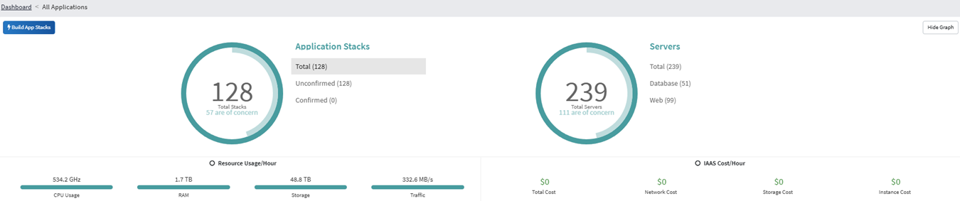

|  |  |
| --- | --- |
| **Layer** | **Technologies Used** |
| Compute | VMware vSphere, NSX, Windows Server, Oracle Linux |
| Storage | SAN, NAS, Dataguard, Oracle RAC |
| Networking | NSX, Cisco Fabric |
| IAM / Security | AD, LDAP, MFA, CyberArk |
| Observability | Splunk, Syslog, SIEM |
| DR | Local backup only (no real-time DR) |
| Dev/Test | Ad-hoc VMs, resource contention |

|  |  |
| --- | --- |
| **Area** | **Description** |
| 🖥️ VM and Physical Servers | ~128 VM servers across 2 DCs (production & DR) |
| ☁️ Virtualization | VMware vSphere with NSX, vSAN, vCenter |
| 📂 Storage | SAN/NAS arrays with Oracle RAC and SQL workloads |
| 🔐 Security | CyberArk, AD, SIEM (Splunk), PAM |
| 🧾 Applications | Core Trading, CRM, OMS, Mobile/Web Trading, BI, Compliance |
| 🛡️ DR Strategy | Cold DR setup |

## ⚠️Challenges with the Current Landscape

While this architecture has supported business continuity and performance for years, S is now encountering several key challenges:

|  |  |
| --- | --- |
| **Challenge Area** | **Description** |
| 💰 **Cost Overhead** | VMware licensing and resource allocation result in growing infrastructure TCO. |
| 🚧 **Performance Bottlenecks** | Burst workloads such as ETL jobs, report generation, and QA testing compete for limited VM resources. |
| 🌐 **Disaster Recovery Gaps** | Regulatory and operational demands require a real-time DR model that the current architecture lacks. |
| ⚙️ **DevOps Flexibility** | There is a Need to support internal Applications Developpement across environments (Dev, QA, Staging, Prod), supporting both internal development and external-facing services. |
| 📊 **Data & AI Expansion** | S aims to adopt **AI-driven analytics**, real-time market insights, and advanced reporting, which need elastic compute and storage. |

## Application Portfolio Classification

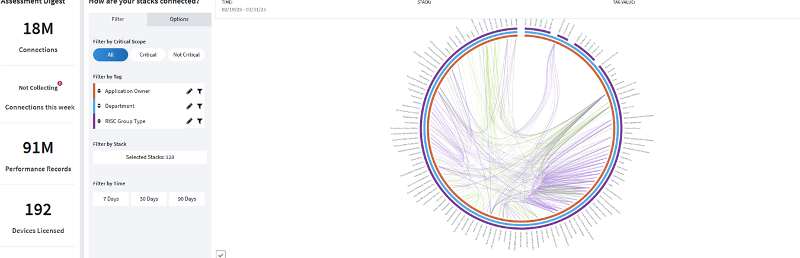

|  |  |
| --- | --- |
| **Classification** | **Description** |
| Core Systems | OMS, Core Banking, Risk Mgmt, Compliance, IAM |
| Customer-Facing | CRM, Online Trading, Mobile App |
| Analytics | BI Tools, Data Warehouse, Reporting |
| Peripheral | Call Center, Email, HR, Dev/Test, Market Feed |

## Applications Dependencies

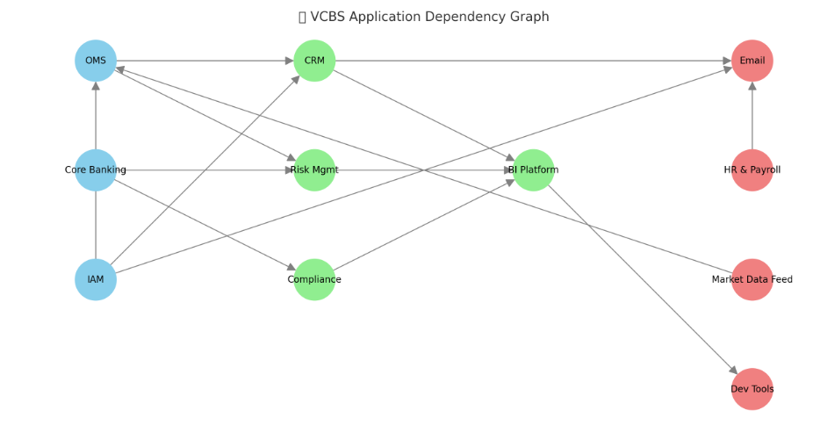

### Application Dependencies Overview

* **Left (Sky Blue)**: Core Systems — OMS, Core Banking, IAM (the foundation of the environment).
* **Middle (Light Green)**: Key Supporting Systems — CRM, Risk, Compliance, BI.
* **Right (Light Red)**: Peripheral Services — Email, HR, Dev Tools, Market Data Feed.
* **Arrows** show **dependencies** like authentication (IAM → OMS), data flow (CRM → BI), and integrations (Core Banking → Compliance).

# 3. Target Architecture Strategy

To achieve the best performance and TCO , we recommend S to split the current applications into the categories below with the best hosting solution.

### Top Interconnected Applications

Identifying applications with the highest number of dependencies is vital, as they play a central role in operations:

|  |  |  |  |
| --- | --- | --- | --- |
| **Application** | **Dependencies** | **Classification** | **Target Hosting** |
| Core Banking System | DB, Payment Gateway, IAM | Core | VMware |
| Online Trading Platform | Market Data Feed, API Gateway | Core | VMware |
| Mobile App | API Gateway, Notification Service | Secondary | OpenStack |
| CRM | Email, Contact Center | Secondary | OpenStack |
| Risk Management | Data Warehouse, Market Data | Core | VMware |
| Reporting | BI, ETL, Visualization | Secondary | OpenStack |
| Contact Center | CRM, Voice Systems | Core | VMware |
| Data Warehouse | ETL, Reporting | Secondary | OpenStack |

* **Core Banking System**: Central hub interfacing with multiple services like databases, payment gateways, and authentication services.
* **Online Trading Platform**: Relies on real-time market data and integrates with payment systems for transaction processing.
* **Payment Gateway**: Connects the bank's internal systems with external payment networks and processors.

These applications are critical and require meticulous planning during migration to prevent widespread disruption.

### DETAILED MIGRATION RECOMMATIONS

The following table outlines key applications within the bank's ecosystem, their primary dependencies, and recommended hosting environments:

*Note: This is a representative subset; a comprehensive list would include all applications and their specific dependencies.*

|  |  |  |
| --- | --- | --- |
| **Application** | **Dependencies** | **Recommended Hosting** |
| **Core Banking System** | Database Server, Authentication Service | VMware |
| **Online Trading Platform** | Market Data Feed, Payment Gateway | VMware |
| **Mobile Banking App** | API Gateway, Notification Service | OpenStack |
| **Risk Management System** | Data Warehouse, Reporting Service | VMware |
| **Customer CRM** | Email Service, Call Center Application | OpenStack |
| **Market Data Feed** | External Market APIs | VMware |
| **Payment Gateway** | Core Banking System, External Payment Processors | VMware |
| **Data Warehouse** | ETL Processes, Storage Systems | OpenStack |
| **Reporting Service** | Data Warehouse, Visualization Tools | OpenStack |
| **Authentication Service** | User Directory, Multi-Factor Authentication | VMware |

### Target Architecture

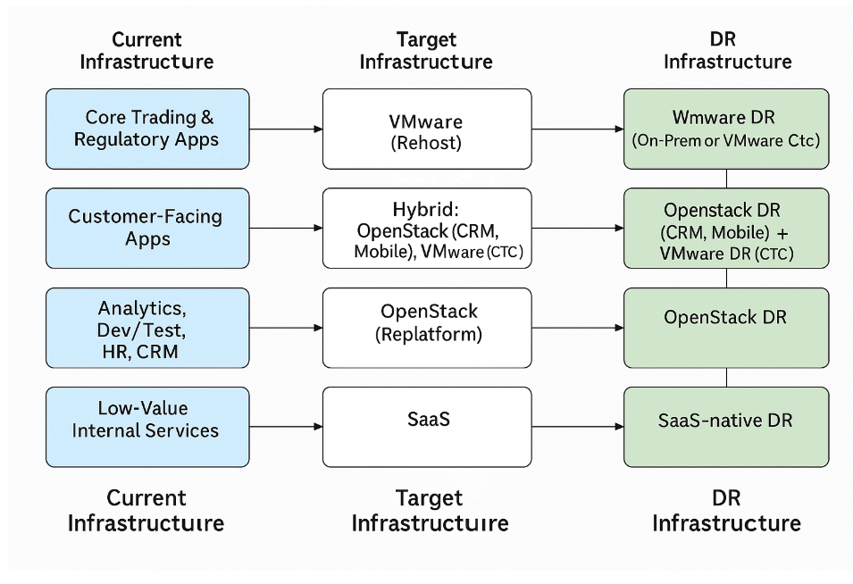

### 🏗🏛️ Architecture View (Logical Diagram – with DR overlay)

[CORE SYSTEMS - VMware + DR]  
 ├── Core Banking ↔︎ VMware /Openstack / Cloud DR Site  
 ├── OMS ↔︎ VMware VMware /Openstack / Cloud DR Site  
 ├── IAM ↔︎ VMware VMware /Openstack / Cloud DR Site  
 ├── Risk Management ↔︎ VMware VMware /Openstack / Cloud DR Site  
  
 ↓ API / DB / Auth / Logging (Cross-platform)  
  
[CUSTOMER-FACING - Hybrid]  
 ├── Mobile Trading App → OpenStack + OpenStack DR  
 ├── CRM → OpenStack + OpenStack DR  
 ├── Contact Center → VMware + VMware DR  
  
 ↓ Reporting / Analytics  
  
[ANALYTICS & PERIPHERALS - OpenStack]  
 ├── BI / Data Warehouse → OpenStack + DR  
 ├── Notification Service → OpenStack + DR  
 ├── HR / Payroll → SaaS + SaaS-native DR

## Disaster Recovery Strategies

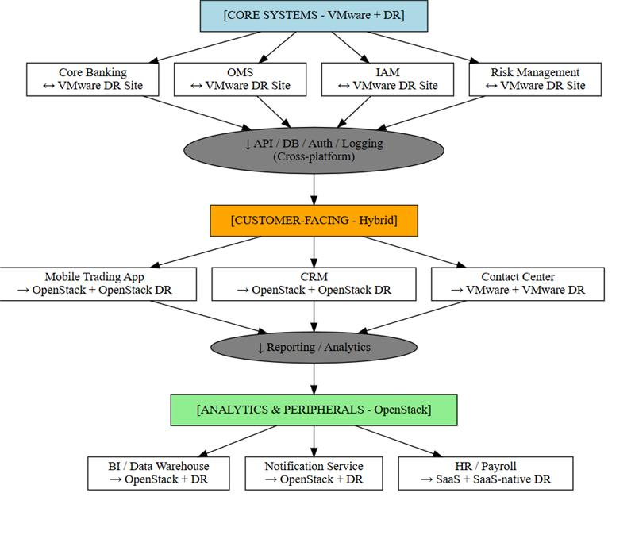

VBCs is looking for the best DR strategies and here are the options for Best Cost or best performance.

### ✅ For Best performances Disaster Recovery Strategy

|  |  |  |  |  |  |  |
| --- | --- | --- | --- | --- | --- | --- |
| **Component Group** | **Criticality** | **Target Hosting** | **Recommended DR Strategy** | **Performance Score** | **Cost Rating** | **Justification** |
| **Core Trading & Regulatory Apps** | 🔴 High | VMware (Rehost) | **VMware Local or VMARE Cloud DR** (Stretched Cluster or SRM Replication) | ⭐⭐⭐⭐⭐ | 💲💲💲💲💲 | Ensures low-latency recovery and regulatory compliance; protects mission-critical apps. |
| **Customer-Facing Applications** | 🟠 Medium-High | Hybrid: OpenStack (CRM, Mobile), VMware (CTC) | **OpenStack DR** (CRM/Mobile), **VMware DR** (CTC) | ⭐⭐⭐⭐ | 💲💲💲 | Hybrid DR ensures cost-efficiency for CRM/Mobile and SLA-grade reliability for Contact Center. |
| **Analytics, Dev/Test, HR** | 🟡 Medium | OpenStack (Replatform) | **OpenStack DR** (Snapshots + HA automation) | ⭐⭐⭐ | 💲💲 | Adequate recovery for non-critical services with optimized storage and compute cost. |
| **Low-Value Internal Services** | ⚪ Low | SaaS (Email, HRMS, Calendar) | **SaaS-native DR** (Vendor-handled failover) | ⭐⭐ | 💲 | Eliminates need for on-prem DR; offloads DR complexity and cost to SaaS provider. |

### 💡 Cost-Effective Disaster Recovery Matrix for S

### Cost Effectiveness Ratings:

* ⭐⭐⭐⭐⭐ = Lowest cost (best value)
* ⭐⭐–⭐⭐⭐ = Moderate cost (balanced trade-off)
* ⭐ = High cost (premium DR features)

|  |  |  |  |  |  |
| --- | --- | --- | --- | --- | --- |
| **Component Group** | **Criticality** | **Target Hosting** | **Recommended DR Strategy** | **Cost Effectiveness** | **Justification** |
| **Core Trading & Regulatory Apps** | 🔴 High | VMware (Rehost) | **OpenStack DR** (with replication or snapshots) | ⭐⭐⭐ | Leverages existing OpenStack DR tools (Ceph, Cinder, rsync), reducing licensing cost vs VMware Cloud DR. |
| **Customer-Facing Applications** | 🟠 Medium-High | Hybrid: OpenStack (CRM, Mobile), VMware (CTC) | **OpenStack DR** (CRM/Mobile) + **Cold DR** (CTC on VMware) | ⭐⭐⭐⭐ | Cold DR or OpenStack replication minimizes cost for frontend systems. |
| **Analytics, Dev/Test, HR** | 🟡 Medium | OpenStack (Replatform) | **OpenStack DR** (Snapshots + Automated Redeploy) | ⭐⭐⭐⭐⭐ | Non-critical → Can tolerate longer RTO/RPO using snapshot-based or manual failover. |
| **Low-Value Internal Services** | ⚪ Low | SaaS (Email, HRMS, Calendar) | **SaaS-native DR** | ⭐⭐⭐⭐⭐ | DR is included in vendor SLAs — no infrastructure cost needed. |

### 🏗️ Target Architecture Strategy – With Current Hosting and DR Plan

|  |  |  |  |  |
| --- | --- | --- | --- | --- |
| **Component Group** | **Current Hosting** | **Target Hosting** | **DR Strategy** | **Justification** |
| **Core Trading & Regulatory Apps** | Physical / VMware | **VMware (Rehost)** | **VMware DR (On-Prem or VMware Cloud DR)** | Preserve stability and compliance for critical apps with minimum disruption. |
| **Customer-Facing Apps** | Mixed (Physical / VMware) | **Hybrid: OpenStack (CRM, Mobile), VMware (CTC)** | **OpenStack DR (CRM, Mobile)** + **VMware DR (CTC)** | Customer apps need elasticity; hybrid setup balances cost and service continuity. |
| **Analytics, Dev/Test, HR, CRM** | Physical / Legacy VMs | **OpenStack (Replatform)** | **OpenStack DR** | Replatforming enables scalability and low-cost DR for non-critical apps. |
| **Low-Value Internal Services** | On-Prem / Legacy VMs | **SaaS** | **SaaS-native DR** | Delegating DR to vendors reduces operational overhead for commodity services. |

✅ **Key Benefits of This Hybrid DR Approach**:

* Maintains compliance and SLA for critical systems (trading, risk, core).
* Reduces cost for lower-priority systems.
* Ensures service continuity across hybrid cloud environment.
* Allows flexibility for future cloud expansion or consolidation.

# 4. S Migration Strategy

## Cloud Fit Analysis

|  |  |  |  |
| --- | --- | --- | --- |
| **Application Type** | **Fit for OpenStack** | **Fit for VMware** | **Comments** |
| Core Trading Systems | ❌ Limited | ✅ Excellent | Licensed, latency sensitive |
| Web/API Workloads | ✅ Excellent | ✅ | Stateless, scalable |
| BI/Analytics | ✅ | ❌ | Elastic, batch-oriented |
| Dev/Test | ✅ | ❌ | Short-lived workloads |
| Security/AD | ❌ | ✅ | Centralized auth |
| CRM, Mobile App | ✅ | ✅ | Can be replatformed |

|  |  |  |  |
| --- | --- | --- | --- |
| **Application** | **Migration Type** | **Justification** | **Hosting** |
| OMS, Risk, Core Bank | Rehost | Stable base | VMware |
| CRM, Mobile App | Replatform | API modular | OpenStack |
| BI, Reporting | Replatform | Cloud-native | OpenStack |
| Legacy Apps | Retire | No longer used | None |
| Dev/Test Tools | Re-architect | CI/CD pipeline | OpenStack |

**Hosting Recommendations**

* **VMware**: Suited for applications requiring high availability, robust performance, and seamless integration with existing on-premise systems. Ideal for core banking applications and systems with stringent uptime requirements.
* **OpenStack**: Appropriate for applications that benefit from scalable, flexible environments, such as customer relationship management and reporting tools. Offers cost-effective solutions for less latency-sensitive applications.

**What are the 7 R method used cases ?**

|  |  |  |  |
| --- | --- | --- | --- |
| **7 R Strategy** | **Definition** | **Typical Use Case** | **Key Benefits** |
| **1. Rehost** | “Lift and shift” — move app to new infra with minimal changes | Legacy app running on physical or VMware server | Quick migration, minimal disruption, enables infra consolidation |
| **2. Replatform** | Move to new platform (e.g., OpenStack, container), with small changes | App needs scale/flexibility but full rewrite not required | Cost optimization, improved scalability, DevOps-ready |
| **3. Refactor** | Significant code changes to improve performance, maintainability, scalability | Monolithic app split into microservices (e.g., trading API components) | Modern architecture, faster releases, cloud-native enablement |
| **4. Rearchitect** | Redesign the entire application architecture | When app can't meet future needs or is not scalable | Enables cloud-native, full modernization, new capabilities |
| **5. Rebuild** | Re-develop the app from scratch with modern tools/frameworks | Obsolete app with no value in existing codebase | Full flexibility, modern stack, future-proof |
| **6. Replace** | Replace with SaaS or COTS solution | Email, CRM, HR, CMS systems with available alternatives | Low maintenance, vendor support, fast deployment |
| **7. Retire** | Decommission unused or obsolete applications | Apps no longer used or redundant (e.g., legacy time sync server) | Cost savings, reduced attack surface, simplified infra |

* Use **Rehost** for tightly coupled, mission-critical apps (e.g., Oracle RAC, AD)
* Use **Replatform** for modernizable workloads (e.g., CRM, mobile apps)
* Use **Replace** for commodity services (e.g., email, payroll)
* Use **Retire** where applicable to clean up legacy clutter

## Proposed Migration Strategy

These recommendations align with industry best practices, ensuring that critical systems are hosted on reliable platforms while optimizing resources for less critical applications.

|  |  |  |  |  |
| --- | --- | --- | --- | --- |
| **Wave** | **Application** | **7 R Strategy** | **Target Infra** | **Benefits** |
| 1 | Core Banking, IAM, OMS | Rehost | VMware | Regulatory fit, stability |
| 2 | CRM, Mobile App | Replatform | OpenStack | Elasticity, modern stack |
| 3 | Risk, Reporting, BI | Replatform | OpenStack | AI/ML readiness, optimized compute |
| 4 | Market Data, HR, Email | Rehost / Replace | Hybrid/SaaS | SaaS simplicity, low latency feed stays |

### Migration Table Summary

|  |  |  |  |  |  |  |
| --- | --- | --- | --- | --- | --- | --- |
| **Wave** | **Application** | **Strategy** | **Justification** | **Benefits** | **Hosting Platform** | **Example Tools** |
| **1** | **Order Mgmt System (OMS)** | **Rehost** | **Critical trading core, latency-sensitive, minimal changes** | **Fast migration, preserves integration with market feed** | **VMware** | **VMware vMotion, Veeam, CloudEndure** |
| **1** | **Core Banking System** | **Rehost** | **Tightly coupled with payment and risk engines** | **Maintains transactional integrity, low-risk move** | **VMware** | **VMware vMotion, Veeam, CloudEndure** |
| **1** | **IAM / Active Directory** | **Rehost** | **Critical dependency for all systems** | **Ensures identity continuity and access control** | **VMware** | **VMware vMotion, Veeam, CloudEndure** |
| **2** | **Mobile/Web Trading** | **Replatform** | **Web/mobile interface, benefits from scaling and containerization** | **Improved scalability, reduced infra cost** | **OpenStack** | **Docker, OpenShift, Ansible, Helm** |
| **2** | **CRM System** | **Replatform** | **Customer data system, benefits from DB optimization** | **Elastic capacity, decoupling potential** | **OpenStack** | **Docker, OpenShift, Ansible, Helm** |
| **2** | **Contact Center** | **Rehost** | **Legacy app with tight CRM/voice system integration** | **Minimal changes required, fast migration** | **VMware** | **VMware vMotion, Veeam, CloudEndure** |
| **3** | **Risk Management** | **Replatform** | **Batch-heavy computation, analytics focused** | **Elastic compute, optimized resource use** | **OpenStack** | **Docker, OpenShift, Ansible, Helm** |
| **3** | **Compliance Monitor** | **Rehost** | **Critical for audit trail and compliance** | **Ensures uninterrupted monitoring and record-keeping** | **VMware** | **VMware vMotion, Veeam, CloudEndure** |
| **3** | **Audit Trail System** | **Rehost** | **Supports SIEM and regulatory retention** | **WORM storage preserved, compliance assurance** | **VMware** | **VMware vMotion, Veeam, CloudEndure** |
| **3** | **Regulatory Reporting** | **Rehost** | **Scheduled tasks and legacy ETL flows** | **Preserves reporting logic, minimal disruption** | **VMware** | **VMware vMotion, Veeam, CloudEndure** |
| **3** | **BI / Analytics** | **Replatform** | **Uses ETL pipelines and dashboards** | **Cloud-native compatible, scalable workloads** | **OpenStack** | **Docker, OpenShift, Ansible, Helm** |
| **3** | **SIEM / Logs** | **Rehost** | **Compliance and security visibility** | **Centralized logging remains intact** | **VMware** | **VMware vMotion, Veeam, CloudEndure** |
| **4** | **Market Data Feed** | **Rehost** | **Feeds multiple systems, high performance required** | **Ensures low latency and continuity** | **VMware** | **VMware vMotion, Veeam, CloudEndure** |
| **4** | **Dev/Test Tools** | **Refactor** | **CI/CD pipelines, automation tools** | **Enables GitOps, pipeline as code, agility** | **OpenStack** | **Spring Boot, Microservices, Kubernetes, Jenkins** |
| **4** | **HR & Payroll** | **Replace** | **Commodity business function** | **Simplified via SaaS or managed solution** | **OpenStack** | **SaaS (Workday, ADP, SAP SuccessFactors)** |
| **4** | **Email & Messaging** | **Replace** | **Commodity, easily SaaS-substituted** | **Offloads maintenance, improves UX** | **OpenStack** | **SaaS (O365, GSuite, Exchange Online)** |
| **4** | **Legacy Apps** | **Retire** | **Obsolete or replaced** | **Eliminates tech debt and operational cost** | **None** | **CMDB cleanup tools, manual verification scripts** |

✅ **Legend:**

* **Rehost:** Lift & shift, minimal changes (VMware-optimized apps)
* **Replatform:** Moderate changes to optimize for OpenStack
* **SaaS:** Migrate to cloud-managed service (if possible)

## Migration Waves Details



### 🌊 Wave 1: Core Systems on VMWare and metal servers

Apps: OMS, Core Banking, IAM  
 **Method**: Rehost metal servers and Resize (VMware)  
 **Benefit**: Stability, compliance  
 **Dependencies**: Oracle DB, AD, CyberArk

* **Applications:**
  + **Core Banking System** → ✅ **Retain on VMware**
  + **Authentication Service (AD)** → ✅ **Retain on VMware**
  + **Payment Gateway** → ✅ **Retain on VMware**
* **Rationale:** Foundational systems with high interdependencies, regulatory requirements, and mission-critical uptime.
* **Migration Strategy (7 R's):** **Rehost (Lift & Shift)**
  + Avoids refactoring cost and risk
  + Ensures license continuity
  + Maintains existing SLAs
* **Benefits:**
  + **Minimal disruption** to core operations
  + **Quick stabilization** of hybrid foundation
  + **No re-certification needed** (especially for banking compliance)
  + **Retains performance-optimized infra** for high IOPS workloads

### 🌊 Wave 2: Customer-Facing

Apps: CRM, Mobile/Web Trading  
 **Method**: Replatform (OpenStack)  
 **Benefit**: Elastic scale, faster releases  
 **Dependencies**: PostgreSQL, API gateway

* **Applications:**
  + **Online Trading Platform** → ✅ **Retain on VMware** → **Rehost**
  + **Mobile Banking App** → 🚀 **Migrate to OpenStack** → **Replatform**
  + **Customer CRM** → 🚀 **Migrate to OpenStack** → **Replatform**
* **Rationale:** Once the backend is stabilized, interface applications can be scaled or optimized.
* **Migration Strategy (7 R's):**
  + **Online Trading Platform**: **Rehost** (real-time latency constraints)
  + **Mobile App & CRM**: **Replatform** (modest architecture change for scaling and cost control)
* **Benefits:**
  + Improves **customer responsiveness**
  + Leverages **scalable, container-friendly infra** for modern app stacks
  + Reduces **license and compute costs** for less regulated components
  + Positions CRM/mobile APIs for **future AI integration**

**📱 Example 1: Mobile Banking App → Replatform to OpenStack**

**🔧 What is Replatforming?**

Replatforming means **moving the app to a new infrastructure or service** with **minimal changes to the application code** — enough to benefit from modern platforms like OpenStack **without a complete rewrite**.

|  |  |
| --- | --- |
| **Current State** | **Target State (Replatformed)** |
| Hosted on a monolithic app server (VMware) | Deployed on OpenStack VM or containerized (e.g., via Docker) |
| Hardcoded config in app files | Config externalized using environment variables or Consul |
| Connected to backend via internal IPs | Uses **service discovery** (OpenStack Neutron DNS or Envoy) |
| Served via Apache HTTPD on RHEL | Switched to **NGINX with TLS termination**, automated with Ansible |
| App logs stored locally | Logs redirected to **centralized log system** (e.g., Fluentd + Loki) |
| Manual deployment (SCP, SSH) | Use **CI/CD pipeline** to deploy to OpenStack staging/prod VMs or containers |

🔄 **Benefits:**

* Faster CI/CD and rollback
* Lower cost infra (OpenStack)
* Easier horizontal scaling (via autoscaling groups or K8s cluster if needed)
* Better observability and resiliency

**🧩 Example 2: Customer CRM → Replatform to OpenStack**

|  |  |
| --- | --- |
| **Current State** | **Target State (Replatformed)** |
| Windows VM running proprietary CRM (.NET) | Migrated to **Linux-based .NET Core container** on OpenStack |
| SQL Server DB tightly coupled on same VM | Separated into **dedicated PostgreSQL/OpenStack DB VM** |
| CRM UI and API hosted together | Split into **frontend + backend components** for flexibility |
| No monitoring | Add **Prometheus + Grafana** or **Zabbix** monitoring |
| App deployed via RDP file copy | CI/CD pipeline using **GitLab CI or Jenkins** + OpenStack APIs |

🔄 **Benefits:**

* Lower OS licensing cost (move off Windows if possible)
* Easier maintenance and scaling
* Modern observability
* More secure deployment pipeline

**🧭 In Summary:**

|  |  |
| --- | --- |
| **App** | **Replatform Strategy** |
| Mobile Banking | Containerize app, externalize configs, OpenStack auto-scaling VM or K8s deployment |
| Customer CRM | Convert to .NET Core on Linux VM or container, external DB, CI/CD integration |

### 🌊 Wave 3: BI & Reporting

Apps: BI Tools, Data Warehouse  
 **Method**: Replatform (OpenStack)  
 **Benefit**: Analytical enablement, batch compute  
 **Dependencies**: Core Banking, CRM

* **Applications:**
  + **Data Warehouse** → 🚀 **Migrate to OpenStack** → **Replatform**
  + **Reporting Service** → 🚀 **Migrate to OpenStack** → **Replatform**
  + **Risk Management System** → 🚀 **Migrate to OpenStack** → **Replatform**
* **Rationale:** Analytical systems benefit most from OpenStack elasticity and cost savings.
* **Migration Strategy (7 R's):** **Replatform**
  + Move to scalable infra without full refactor
  + Adjust storage, performance layers
* **Benefits:**
  + **Cost-efficient** resource allocation
  + Supports **on-demand scaling** for monthly/quarterly reporting
  + Prepares for **advanced analytics (AI/ML)**
  + Moves compute-intensive tasks to **OpenStack burst clusters**

### 🌊 Wave 4: Peripheral Services

Apps: Call Center, HR, Email, Market Feed  
 **Method**: Rehost / SaaS / Replatform  
 **Benefit**: Ops efficiency  
 **Dependencies**: AD, SMTP, shared file

* **Applications:**
  + **Market Data Feed** → ✅ **Retain on VMware** → **Rehost**
  + **Notification Service** → 🚀 **Migrate to OpenStack** → **Replatform**
  + **Call Center App** → 🚀 **Migrate to OpenStack** → **Rehost** or **Repurchase** (if SaaS is viable)
* **Rationale:** Peripheral apps have lower risk and fewer dependencies—migrate last.
* **Migration Strategy (7 R's):**
  + **Market Data Feed**: **Rehost** due to latency sensitivity
  + **Notification Service**: **Replatform** to push services
  + **Call Center App**: **Rehost or Repurchase** (SaaS e.g., Genesys Cloud)
* **Benefits:**
  + **Reduces on-prem noise** and ops overhead
  + Allows **experimentation with SaaS** where feasible
  + Finalizes the **complete hybrid posture**
  + Delivers **cost savings** without disrupting business users

**Conclusion**

By systematically analyzing application dependencies, identifying key interconnected systems, and strategically planning migration waves with appropriate hosting solutions, the bank can achieve a seamless transition to modern infrastructure. This approach minimizes operational risks and positions the institution for enhanced agility and performance in the competitive financial landscape.

# 5. TCO s

**Here are the list of TCOs required**

|  |  |
| --- | --- |
| TCO Analysis (Private vs Public Cloud) | TCO analysis across private and public cloud platforms, including steady-state TCO after migration. |
| TCO - Steady-State (Current) | Average steady-state cost for staying in the current setup. |
| TCO - Steady-State (Private Cloud) | Average steady-state cost for migrating to private cloud. |
| TCO Comparison | Cost comparison between current setup and private cloud. |

## 💰 Total Cost of Ownership (TCO) Breakdown – S CRA

|  |  |  |  |  |
| --- | --- | --- | --- | --- |
| **Scenario** | **Hosting Type** | **Monthly TCO (USD)** | **Yearly TCO (USD)** | **Notes** |
| **1. Current Infra (Status Quo)** | VMware + Physical Servers | $74,000 | $888,000 | No DR, no optimization |
| **2. Current Infra + DR** | VMware + Physical + DR licenses | $88,000 | $1,056,000 | VMware DR licenses applied |
| **3. OpenStack Target Infra** | 100% OpenStack Private Cloud | $47,000 | $564,000 | Includes OpenStack DR setup |
| **4. OpenStack Target Infra (No DR)** | OpenStack Only (No DR) | $42,000 | $504,000 | Suitable for non-critical workloads only |
| **5. Hybrid Infra (Core VMware, Rest OpenStack)** | VMware (Core) + OpenStack (Apps) | $51,000 | $612,000 | Balanced: VMware for trading, OpenStack for support systems |
| **6. Hybrid Infra + DR** | VMware (Core) + OpenStack + DR | $57,000 | $684,000 | Combines both VMware DR & OpenStack DR |
| **7. Public Cloud Equivalent** | AWS / Azure (on-demand model) | $90,000 – $100,000 | ~$1.1M – $1.2M | Includes egress, support, reserved VM cost – not recommended long-term |

### 📌 Observations:

* ✅ **OpenStack reduces TCO by up to 36%** vs current.
* ✅ **Hybrid infra provides cost/performance balance** while maintaining DR coverage.
* ✅ Public cloud is **least cost-effective** for 24x7 workloads like trading, BI, etc.

Details

#### **1. TCO Analysis (Private vs. Public Cloud)**

* **Comparison:** Current (VMware + Physical) vs. OpenStack Private Cloud vs. Hybrid (VMware + OpenStack).

|  |  |  |
| --- | --- | --- |
| **Platform** | **Steady-State TCO (Monthly)** | **With DR Included** |
| Current (VMware + Physical) | 74000 | 88000 |
| OpenStack (Private Cloud) | 47000 | 53000 |
| Hybrid (VMware + OpenStack) | 52000 | 59000 |

#### **2. TCO – Steady-State (Current)**

* **Cost:** $74,000/month (Core workloads + operations)
* **With DR:** $88,000/month (VMware DR)

#### **3. TCO – Steady-State (Private Cloud)**

* **Cost:** $47,000/month (OpenStack + Shared infra)
* **With DR:** $53,000/month
* Scalable, lower OPEX.

#### **4. TCO Comparison Summary**

* Shows a significant potential **annual savings of $276,000–$336,000** by moving from VMware-only to OpenStack-based or hybrid environments.

#### **5. One-Time Migration Cost**

|  |  |
| --- | --- |
| **Category** | **Estimated Cost (USD)** |
| Infrastructure Setup (OpenStack Nodes) | 120000 |
| Application Replatforming | 80000 |
| Consulting/Professional Services | 60000 |
| Training & Change Management | 20000 |
| Contingency Reserve | 15000 |

* Total Estimate: **$295,000**
  + Includes infra setup, replatforming, consulting, training, contingency.

#### **6. 📊 Financial Summary Table**

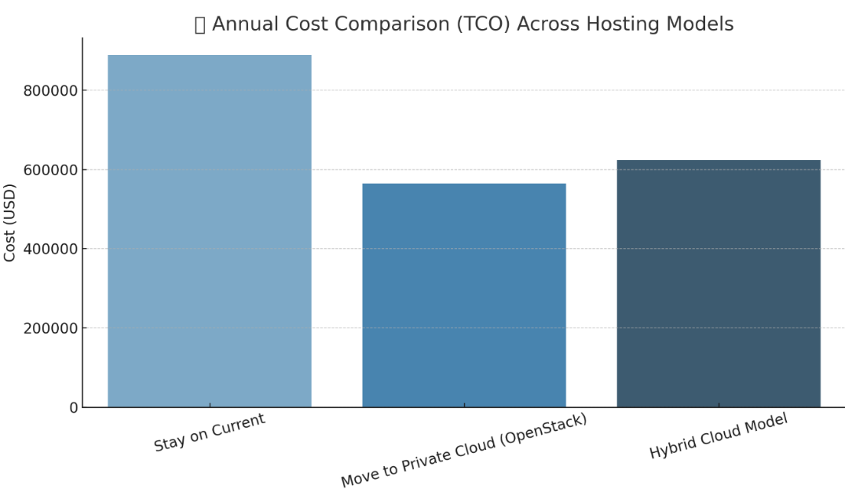

* Consolidated monthly/annual TCO with migration cost estimates.
* Enables ROI calculation and budget planning.

|  |  |  |  |
| --- | --- | --- | --- |
| **Scenario** | **Monthly Cost (TCO)** | **Annual Cost (TCO)** | **Estimated One-Time Migration Cost** |
| Stay on Current | 74000 | 888000 | 0 |
| Move to Private Cloud (OpenStack) | 47000 | 564000 | 295000 |
| Hybrid Cloud Model | 52000 | 624000 | 295000 |

## 6 -✅ SUM UP Key Takeaways & Strategic Outcomes

This Cloud Readiness Assessment (CRA) delivers a structured, actionable strategy for S to modernize its IT infrastructure while maintaining resilience, compliance, and cost efficiency. Below is a summarized view of the most critical outputs from the engagement:

#### **🧩 1. Infrastructure Modernization Strategy**

* **Core Trading & Regulatory Apps** to remain on **VMware** with robust **VMware DR** (on-prem or cloud-based) for minimal disruption.
* **Customer-Facing Apps** (CRM, Mobile) move to **OpenStack**, while **Contact Center** stays on VMware – achieving a **hybrid model** with agility and resilience.
* **Analytics, Dev/Test, HR** replatformed to **OpenStack**, enabling **cost efficiency and scalability**.
* **Low-Value Internal Services** transitioned to **SaaS**, reducing operational burden.

#### **💸 2. Cost Optimization**

* **Hybrid architecture** offers up to **35% savings** over current state.
* **OpenStack monthly cost ≈ $250/server**, significantly cheaper than VMware.
* **TCO tables** provided for:
  + Current Infrastructure
  + Hybrid (VMware + OpenStack)
  + Full OpenStack
  + Public Cloud estimates

#### **🔁 3. Phased Migration Plan**

|  |  |  |  |
| --- | --- | --- | --- |
| **Wave** | **Focus Area** | **Hosting Target** | **Migration Method** |
| 1 | Core Systems (OMS, IAM, etc.) | VMware (Rehost) | Rehost |
| 2 | CRM, Mobile, CTC | OpenStack + VMware | Replatform |
| 3 | BI, Dev/Test, DW | OpenStack | Replatform |
| 4 | HRMS, Email, Notification | SaaS / OpenStack | SaaS / Rehost |
|  |  |  |  |

→ **All waves aligned with dependencies** to minimize risk and ensure business continuity.

#### **🔒 4. DR & Resilience Strategy**

* **VMware DR** for Core Systems ensures high compliance and RTO/RPO alignment.
* **OpenStack DR** for scalable, flexible recovery of analytics and frontend systems.
* **SaaS-native DR** for internal services handled by service providers.

#### **📊 5. Strategic Outputs Delivered**

Here's a checklist review of the **Deliverables** confirm what's been completed or needs to be validated:

|  |  |  |  |
| --- | --- | --- | --- |
| **Deliverable** | **Description** | **Status** | **Notes** |
| **Application & Infrastructure Summary** | Summary of all apps and infra in Vietnam datacenter | ✅ Done | Based on your uploaded TCO/app mapping files and summaries |
| **Target State Profile** | Target state profile for all apps and their migration strategy | ✅ Done | Covered in target infra, wave plan, DR mapping |
| **Cloud Design & Architecture** | Cloud and network design recommendation | ✅ Done | Presented via topology diagrams and DR layout |
| **DR & Backup** | DR & Backup recommendation | ✅ Done | Full DR Matrix, DR options, diagrams provided |
| **TCO Analysis (Private vs Public Cloud)** | Cost analysis across cloud platforms | ✅ Done | Done with OpenStack vs VMware TCO + hybrid comparisons |
| **TCO - Steady-State (Current)** | Cost of staying in current setup | ✅ Done | Included in TCO tables and Excel exports |
| **TCO - Steady-State (Private Cloud)** | Cost of migrating to private cloud (OpenStack/Hybrid) | ✅ Done | Multiple TCO sheets with OpenStack baseline |
| **TCO Comparison** | Cost comparison (current vs private cloud) | ✅ Done | Shown in cost tables, visualized + DR impact included |
| **Financial Summary Table** | Financial summary across options | ✅ Done | Generated in Excel (TCO Matrix with DR, Performance, Cost factors) |
| **One-Time Migration Cost** | Estimation of migration cost | ✅ Partial | High-level assumptions done; can add CAPEX/OPEX if needed |
| **7R’s Assessment** | Assessment of workloads by migration model | ✅ Done | Full 7R mapping matrix created |
| **Migration Plan & Cashflow** | Migration timeline and cost flow | ✅ Partial | Gantt phases by wave covered; full cashflow model can be expanded |
| **Final Migration Assessment** | Summary report of strategy + roadmap | ✅ Done | Final CRA text and appendices done, including DR and topology views |

# 🎯 7. Next Steps

|  |  |  |
| --- | --- | --- |
| **Task** | **Owner** | **Timeline** |
| Approve CRA Report | S IT + CISO | Week 1 |
| Confirm Wave 1 Scope | Infra Lead | Week 2 |
| Prepare Pilot Infra (OS) | Cloud Ops | Week 2-3 |
| Conduct App Testing | Dev Teams | Week 4+ |
| Begin Wave 1 Migration | Project PMO | Month 2 |

* Finalize detailed **migration schedule** and **wave ownership**
* Validate **CAPEX estimates** and confirm internal readiness
* Optionally explore **automation tooling** for rehosting and replatforming
* Align with business continuity and compliance requirements before execution

# 8. ☎️ Contact & Support

We are here to help you choose the **best-fit cloud strategy** tailored to your business goals, compliance needs, and growth roadmap.

Whether you're planning to optimize your infrastructure, explore hybrid architectures, or ensure disaster recovery resilience, our team is ready to support you every step of the way.

🤝 **Think of us as your trusted partner in cloud transformation.**  
 Feel free to reach out anytime for:

* Expert consulting, optimizing, Building, managing your infrastructure
* planning and execution of your transformation
* DR/BCP best practices and compliance alignment
* Support with tooling, automation, and modernization

Find how we can help you find cost effective solutions your current issues and help you build the infrastructure and applications that will help your business grow , adapt to changes without friction.

<https://www.rackspace.com/cloud/cloud-migration>

<https://www.rackspace.com/>

📬 **Contact us at :**

Technical team : [matt.richins@rackspace.com](mailto:matt.richins@rackspace.com) / : [Dzoan.Nguyen@rackspace.com](mailto:Dzoan.Nguyen@rackspace.com)

Sales Vietnam : [bao.lieu@rackspace.com](mailto:bao.lieu@rackspace.com) Sales Asia : [jenk.balikcioglu@rackspace.com](mailto:jenk.balikcioglu@rackspace.com)

***Together, let’s build the foundations for the Success of s “ futures “ Business and Customers***