Online System

Use Case Specification Document

UC-3
Station Info Page
Version No. 1.0

Project Document Revision History
VersionNumber | Date | Revision Author | Description of Revision
1.0 | 05/17/2018 | Derek Dai | Initial Creation

Table of Contents
1. Introduction 4
2. Use Case Information 4
2.1 Actors 4
2.2 Use Case Interaction 4
3. Trigger 5
4. Pre-condition(s) 5
5. Post-condition(s) 5
6. Use Case Swimlane (Activity) Diagram 6
6.1 Show brief info of all stations 6
The following Swimlane diagram covers the showing records functionality 6
6.2 Insert/Update/View detailed info about certain station 7
6.3 Delete station 8
6.4 Other use cases 8
7. Use Case Specification Review and Signoff 8

Introduction
The purpose of this use case is to let the user view/delete/insert/update information of station in the QA Lab. The functionalities are categorized into either functional or non-functional requirement. The functional ones listed are as follows:
- Show the brief information about each station in the table
- Allow user to sort the records in table
- Allow user to search certain station based on key word
- Allow user to delete existing station
- Allow user to update existing station
- Allow user to insert new station
- Allow user to mark his or her favorite
- When user type key words in search fields, suggestions should be shown to the user
- A new window should be prompted if user wants to know the detail info about certain station
- A new window should be prompted if user wants to insert new station
- A new window should be prompted if user wants to update certain station
- Allow user to refresh the table
- Allow user to turn on/off the auto refresh

As for the non-functional requirement:
- Navigation bar should still be there
- The progress bar should be shown when loading data
- Auto refresh period should around certain period

The Online System is a web-based project. The user interface is to be function properly on all platforms, including desktop computers, notebooks, and mobile devices.

Use Case Information

Actors
The Online System will allow all registered users to view or update information of every station in the lab. All actors in the following table will be able to make full use of all functionalities in this use case:
Actor Name | Role | Description
Registered User | Main | Any user with an active account

Use Case Interaction
This use case is independent from other use cases without any predecessor or successor.

Trigger
Functionality | Trigger
Search suggestions | User type in the search filed
Delete station | Corresponding delete button is pressed
Insert station | Insertion button is pressed
Update station | Corresponding update button is pressed
Search for certain station | Search button is pressed
Sort records in table | User make changes in the drop down menu
Refresh | Refresh button pressed
Auto refresh | Auto refresh toggle is on/off

Pre-condition(s)
Main page

Post-condition(s)
The system will enter 6 different post-conditions based on user’s action
- If user logout, then the system will enter the login page
- If user use navigation bar, he or she will be navigate to another page (among Main page, Document & Manuals page, test status page, and bookkeeping page)
- It is more common that the user will continuously working on the current page
- If user presses update button, the system will go to the update station page
- If user presses insertion button, the system will go to the create station page
- If user presses detailed info button, the system will go to the station detailed info page
Notice, the three conditions above can use a same module to achieve

Use Case Swimlane (Activity) Diagram

Show brief info of all stations

The following Swimlane diagram covers the showing records functionality
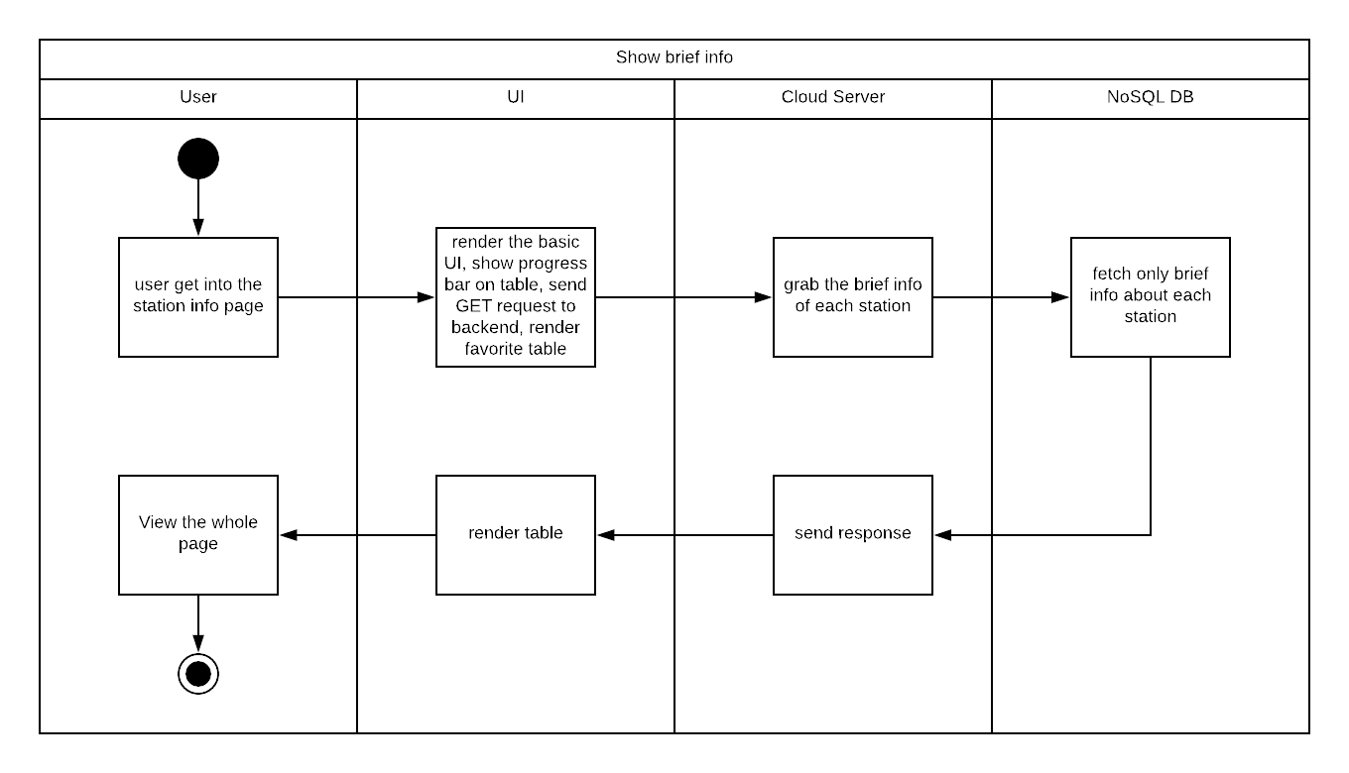
Diagram 6.1 Version 1.0 05/16/2018

Insert/Update/View detailed info about certain station
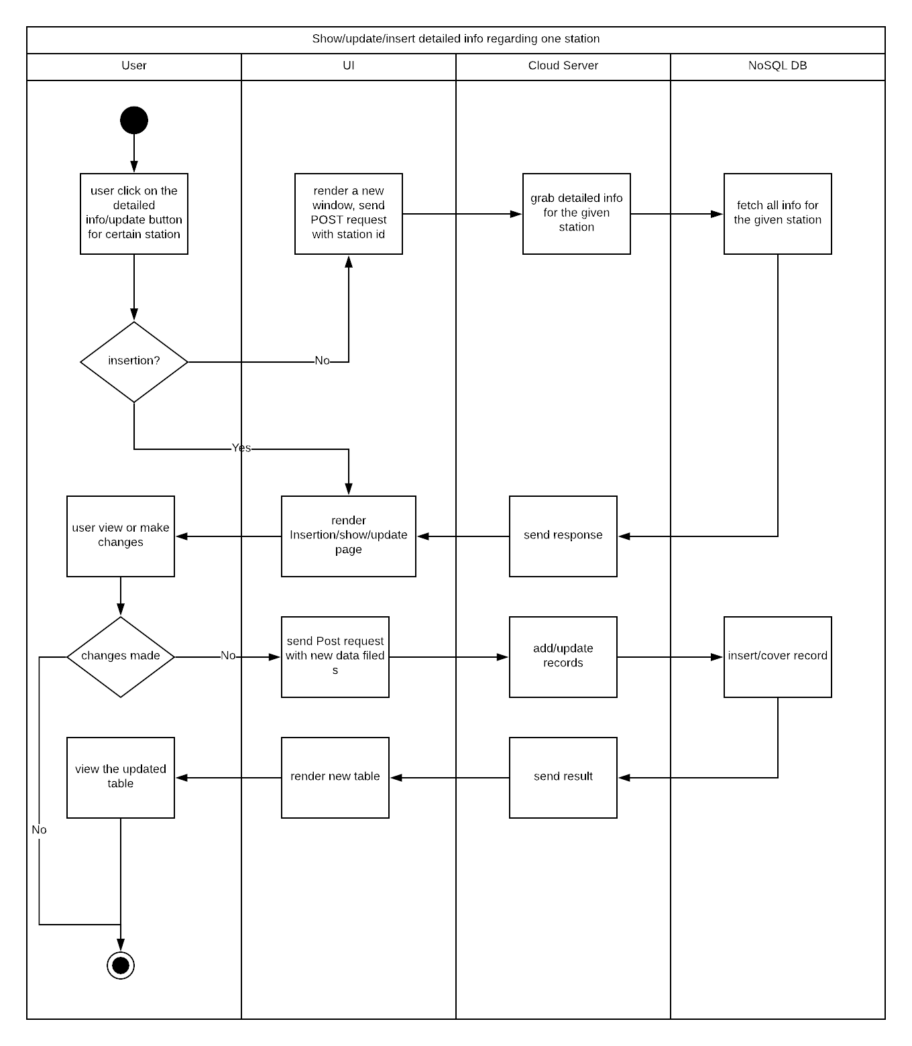
Diagram 6.2 Version 1.0 05/16/2018

Delete station
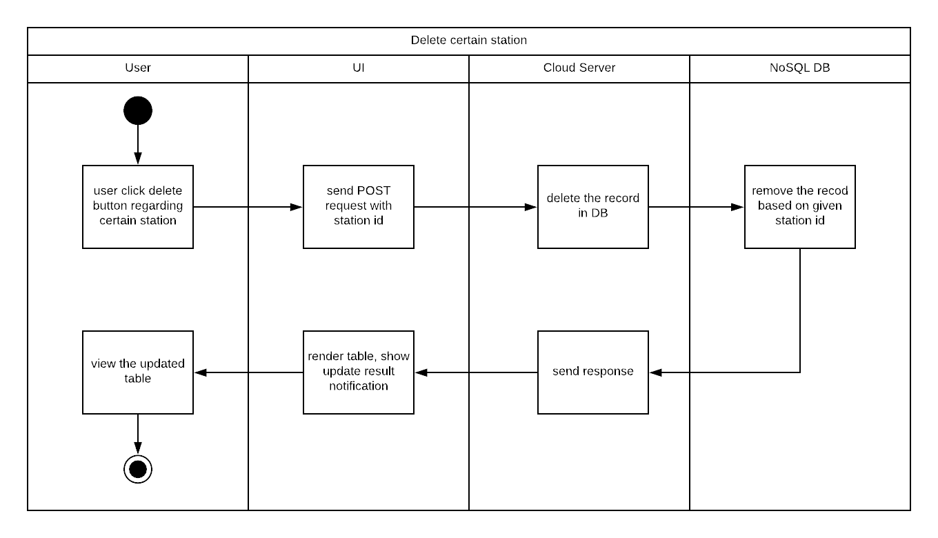
Diagram 6.3 Version 1.0 11/21/2015

Other use cases
Since other use cases only regarding User and UI, we do not draw those simple swim lane diagrams

Use Case Specification Review and Signoff
Review and Signoff of the Use Case Specification
Name | Project Team Role | Signature | Date
Yue Dai | Developer | YD | 05/18/2018

