Online System

Use Case Specification Document

UC-5
Bookkeeping
Version No. 1.0

Project Document Revision History
VersionNumber | Date | Revision Author | Description of Revision
1.0 | 05/23/2018 | Derek Dai | Initial Creation

Table of Contents
1. Introduction 4
2. Use Case Information 4
2.1 Actors 4
2.2 Use Case Interaction 4
3. Trigger 5
4. Pre-condition(s) 5
5. Post-condition(s) 5
6. Use Case Swimlane (Activity) Diagram 6
6.1 User Login Online System 6
The following Swimlane diagram covers the login functionality 6
6.2 Forget Password 7
6.3 Go to Registration 8
7. Main/Basic Flow(s) of Events (Happy Path) 8
7.1 User login: 8
7.2 Forget password 9
7.3 Got to Registration 9
8. Alternate/Exception Flow of Events 9
8.1 Invalid Data Entry 9
9. Assumptions/Business Rules including Non-Functional Requirements 10
10. Use Case Specification Review and Signoff 10

Introduction
The purpose of this use case is to let the user view or borrow the tools or components from lab. The functionalities are categorized into either functional or non-functional requirement. The functional ones listed are as follows:
- Show the tools that are being used
- Show the tools that are available
- Show the tools that are borrowed by the current user
- Borrow new tools
- Return tools that borrowed by the current user
- Show the detailed info about certain tool
- Make reservation about certain tool in lab and send notification to the user when the tool is available
- Add new tool and delete broken tool

As for the non-functional requirement:
- Progress bar should be shown when loading the data
- The system should update the list or charts immediately after user make actions
- Just like previous system, the bookkeeping should also fetch brief info about tools, and fetch the detailed info if the user wants to know about it.
The Online System is a web-based project. The user interface is to be function properly on all platforms, including desktop computers, notebooks, and mobile devices.

Use Case Information

Actors
The Online System will allow all registered users to view or update information of every station in the lab. All actors in the following table will be able to make full use of all functionalities in this use case:
Actor Name | Role | Description
Registered User | Main | Any user with an active account

Use Case Interaction
This use case is independent from other use cases without any predecessor or successor.

Trigger
Functionality | Trigger
Search suggestions | User type in the search filed
Return tool | Return button pressed on certain tool borrowed
Borrow tool | Borrow button pressed on certain tool available
Add new tool | Corresponding button pressed
Search for certain tool | Search button is pressed
Sort records in table | User make changes in the drop down menu
Delete broken tool | Corresponding button pressed
Reservation | Reservation button pressed on certain borrowed tool

Pre-condition(s)
Main page

Post-condition(s)
The system will enter 3 different post-conditions based on user’s action
- If user logout, then the system will enter the login page
- If user use navigation bar, he or she will be navigate to another page (among Main page, Document & Manuals page, test status page, and bookkeeping page)
- It is more common that the user will continuously working on the current pageUse Case Swimlane (Activity) Diagram

Show brief info of all stations

The following Swimlane diagram covers the showing records functionality
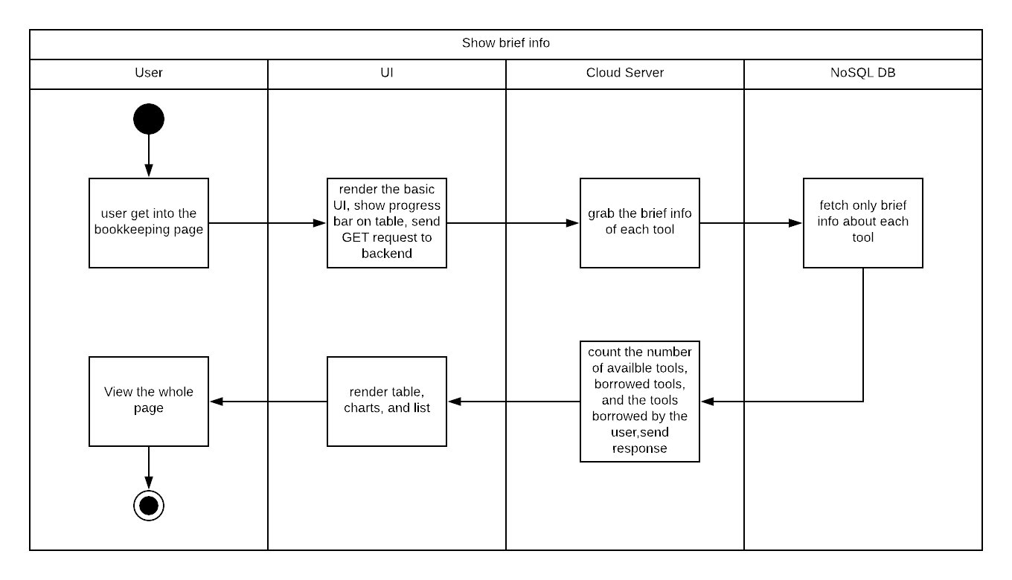
Diagram 6.1 Version 1.0 05/16/2018

Insert/Update/View detailed info about certain station
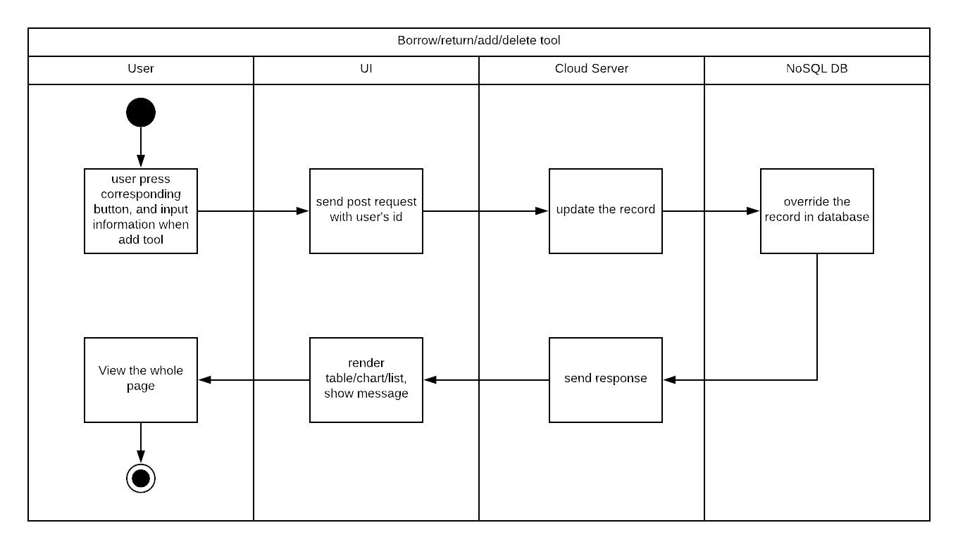
Diagram 6.2 Version 1.0 05/16/2018

Delete station
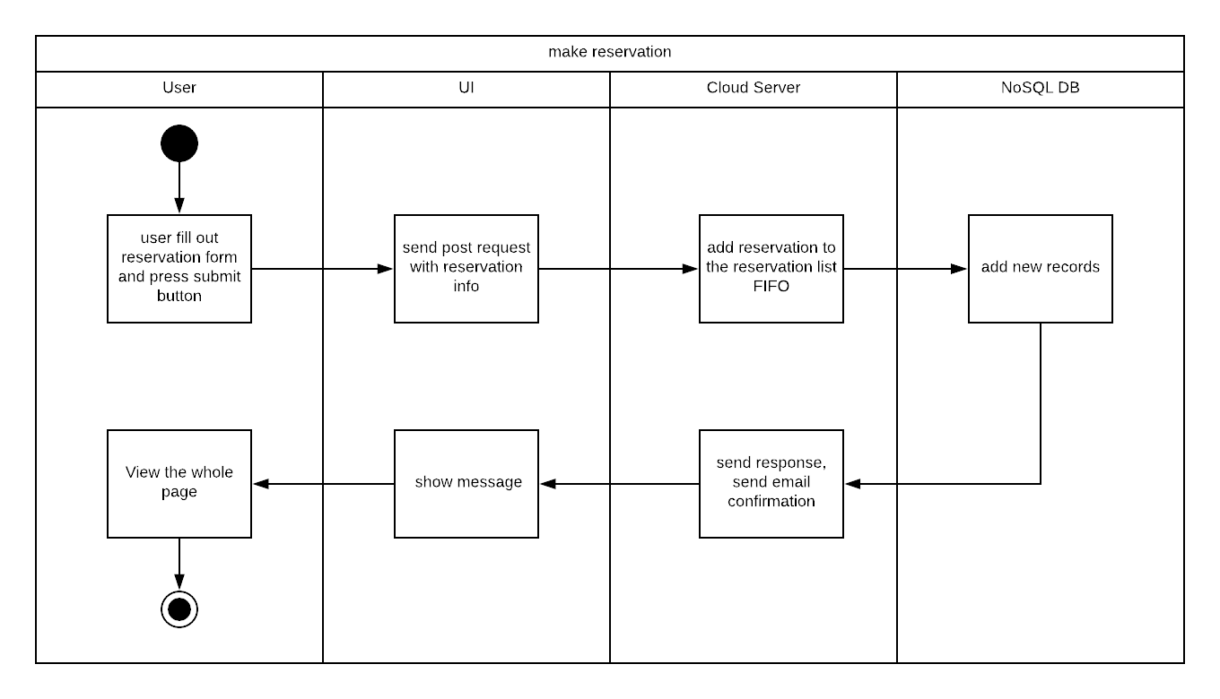
Diagram 6.3 Version 1.0 11/21/2015

Other use cases
Since other use cases only regarding User and UI, we do not draw those simple swim lane diagrams

Use Case Specification Review and Signoff
Review and Signoff of the Use Case Specification
Name | Project Team Role | Signature | Date
Yue Dai | Developer | YD | 05/18/2018

